VELLORE INSTITUTE OF TECHNOLOGY
School of Computer Science Engineering and Information Systems
BCSE302P – Database Systems Lab Project Report
―――――――――――――――――――――――――――――――――――――――――――――
1. Project Title and Team/Student Details
Attribute | Details
Project Title | Smart E-Commerce Order, Inventory & Supply Chain Management System
Course Code & Name | BCSE302P – Database Systems Lab
Student Name | S. Sai Siva Prasad Reddy
Registration Number | 24BYB0127
Degree & Programme | B.Tech Computer Science and Engineering
Faculty / Guide | Dr. Konjeti Srinivasulu
Database Environment | PostgreSQL 18.x (Port: 5432, Database: smart_ecommerce, User: postgres)
Frontend & Backend | Python 3.15, Flask, psycopg2, Werkzeug Security, HTML5/CSS3
GitHub Repository | https://github.com/SAI570/smart-ecommerce-dbms

2. Introduction and Problem Statement
2.1 Domain Overview
Modern enterprise e-commerce platforms must coordinate customer orders, multi-warehouse inventory, payment gateways, and supplier supply chains. In conventional systems, business logic is scattered across front-end JavaScript or back-end application servers ('fat application, dumb database'). This architectural pattern introduces critical vulnerabilities:
- 1. Overselling & Race Conditions: Concurrent checkout requests read outdated stock numbers and commit duplicate orders for the same physical unit.
- 2. Disconnected Supply Chain: Inventory depletion is noticed manually, causing prolonged stock-outs and delivery delays.
- 3. Data Inconsistency: Network failures during multi-step order placement leave orphan records (e.g., payment processed without stock allocated).
- 4. Weak Security: Authorization relies solely on application menus; any direct database connection (via SQL console or API breach) bypasses business logic.
2.2 Problem Statement
Design, implement, and evaluate an Active Database Management System for an end-to-end Smart E-Commerce ecosystem where PostgreSQL 18 acts as the single source of truth and business logic enforcement. The system guarantees:
- • Real-time multi-warehouse stock reservation to prevent overselling.
- • Automatic supply chain restocking via event-driven database triggers.
- • Strict ACID transactional guarantees during multi-item orders and cancellations.
- • Database-native Data Control Language (DCL) role-based authorization (admin_role, customer_role, warehouse_role, procurement_role).
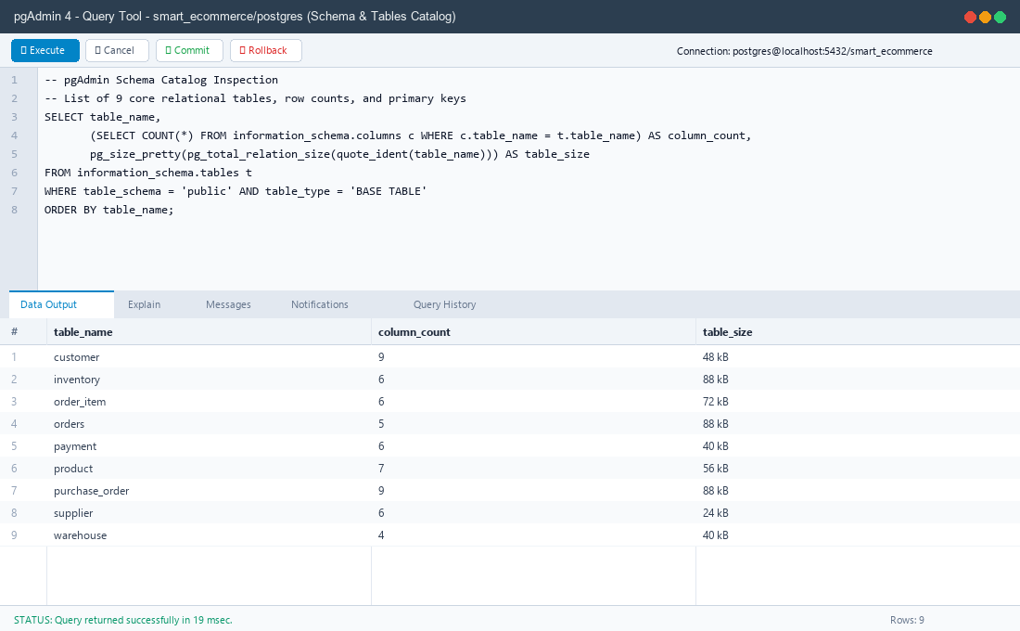
Figure 2.1: pgAdmin 4 Catalog inspection showing the 9 core relational tables and schema sizes.
3. Functional Requirements
- FR1 (Customer Management): Register, validate, and manage customer accounts with strict constraints on unique emails, 10-digit mobile numbers, and encrypted password storage.
- FR2 (Product & Supplier Master): Categorize products, track base unit prices, define safety reorder levels, and link each product to primary suppliers with delivery lead-time metrics.
- FR3 (Multi-Warehouse Inventory): Distribute product stock across regional distribution centers (Hyderabad, Chennai, Mumbai, Delhi) with independent capacity limits.
- FR4 (Dual-State Stock Model): Separate inventory into AVAILABLE (sellable) and RESERVED (committed to unfulfilled orders) to protect against concurrency hazards.
- FR5 (Transactional Multi-Item Ordering): Place multi-item orders as an atomic transaction. If a requested product quantity exceeds total nationwide stock, the entire order rolls back cleanly. If single warehouse stock is insufficient, the procedure dynamically splits the order line across multiple warehouses.
- FR6 (Trigger-Based Stock Reservation): Immediately transfer order quantities from quantity_available to quantity_reserved upon order line insertion (Trigger 1).
- FR7 (Payment State Transition): Support payment methods (UPI, Credit Card, Debit Card, NetBanking, COD) and execute legal order status updates (PLACED -> CONFIRMED).
- FR8 (Order Cancellation & Restocking): Atomically release reserved stock back into available stock if an order is cancelled prior to dispatch.
- FR9 (Autonomous Supply Reordering): Trigger purchase orders automatically to suppliers when nationwide stock dips below reorder thresholds (Trigger 2 & Cursor).
- FR10 (Warehouse Receipt & Capacity Enforcement): Process supplier deliveries, verify that receiving warehouse capacity is not exceeded, and convert purchase orders to RECEIVED.
- FR11 (Analytical Views & Business Intelligence): Provide real-time reporting views for supplier on-time delivery rates, low stock alerts, monthly revenue, and top-selling products.
- FR12 (Database-Level Access Control): Enforce least privilege using PostgreSQL roles and SECURITY DEFINER procedures.
4. Entity-Relationship (ER) Diagram
The conceptual schema consists of 9 strong and relational entities connected via 11 cardinality relationships in full Third Normal Form (3NF).
Entity A | Cardinality | Entity B | Business Relationship
CUSTOMER | 1 : M | ORDERS | A customer can place zero or many orders.
ORDERS | 1 : M | ORDER_ITEM | An order contains one or more line items.
PRODUCT | 1 : M | ORDER_ITEM | A product can be referenced across multiple order lines.
WAREHOUSE | 1 : M | ORDER_ITEM | Each order line is fulfilled from a specific warehouse.
ORDERS | 1 : 1 | PAYMENT | Each order has exactly one payment record (UNIQUE order_id).
SUPPLIER | 1 : M | PRODUCT | A supplier provides one or many products.
PRODUCT / WAREHOUSE | M : N | INVENTORY | Many-to-many relationship resolved by INVENTORY with dual-state quantities.
SUPPLIER | 1 : M | PURCHASE_ORDER | Suppliers fulfill restocking purchase orders.
PRODUCT / WAREHOUSE | 1 : M | PURCHASE_ORDER | Purchase orders restock a product at a designated warehouse.

5. Relational Schema (3NF)
All tables are normalized to 3NF with explicit Primary Keys (PK) and Foreign Keys (FK):
- CUSTOMER (customer_id [PK], name, email [UK], phone, address, city, registered_date, status, password_hash)
- SUPPLIER (supplier_id [PK], supplier_name, email, phone, lead_time_days, status)
- PRODUCT (product_id [PK], product_name, category, brand, unit_price, reorder_level, supplier_id [FK -> SUPPLIER])
- WAREHOUSE (warehouse_id [PK], warehouse_name [UK], city, capacity)
- INVENTORY (inventory_id [PK], product_id [FK -> PRODUCT], warehouse_id [FK -> WAREHOUSE], quantity_available, quantity_reserved, last_updated) [UK: product_id + warehouse_id]
- ORDERS (order_id [PK], customer_id [FK -> CUSTOMER], order_date, order_status, total_amount)
- ORDER_ITEM (order_item_id [PK], order_id [FK -> ORDERS], product_id [FK -> PRODUCT], warehouse_id [FK -> WAREHOUSE], quantity, unit_price)
- PAYMENT (payment_id [PK], order_id [FK -> ORDERS, UK], payment_method, payment_status, amount, payment_date)
- PURCHASE_ORDER (po_id [PK], product_id [FK -> PRODUCT], supplier_id [FK -> SUPPLIER], warehouse_id [FK -> WAREHOUSE], quantity_ordered, po_date, expected_delivery, actual_delivery, po_status)
6. Table Creation and Constraints (DDL)
The database DDL enforces enterprise domain integrity using PRIMARY KEY, FOREIGN KEY (with ON DELETE CASCADE), NOT NULL, UNIQUE, DEFAULT, and CHECK constraints:
-- CUSTOMER TABLE
CREATE TABLE customer (
customer_id SERIAL PRIMARY KEY,
name VARCHAR(100) NOT NULL,
email VARCHAR(120) NOT NULL UNIQUE,
phone VARCHAR(15),
address VARCHAR(200),
city VARCHAR(60),
password_hash VARCHAR(255),
registered_date DATE NOT NULL DEFAULT CURRENT_DATE,
status VARCHAR(10) NOT NULL DEFAULT 'ACTIVE'
CHECK (status IN ('ACTIVE','INACTIVE')),
CONSTRAINT chk_customer_email CHECK (email LIKE '%_@_%._%')
);
-- SUPPLIER TABLE
CREATE TABLE supplier (
supplier_id SERIAL PRIMARY KEY,
supplier_name VARCHAR(100) NOT NULL,
email VARCHAR(120),
phone VARCHAR(15),
lead_time_days INT NOT NULL CHECK (lead_time_days > 0),
status VARCHAR(10) NOT NULL DEFAULT 'ACTIVE'
CHECK (status IN ('ACTIVE','INACTIVE'))
);
-- PRODUCT TABLE
CREATE TABLE product (
product_id SERIAL PRIMARY KEY,
product_name VARCHAR(120) NOT NULL,
category VARCHAR(60),
brand VARCHAR(60),
unit_price NUMERIC(10,2) NOT NULL CHECK (unit_price > 0),
reorder_level INT NOT NULL DEFAULT 10 CHECK (reorder_level >= 0),
supplier_id INT NOT NULL REFERENCES supplier(supplier_id)
);
-- WAREHOUSE TABLE
CREATE TABLE warehouse (
warehouse_id SERIAL PRIMARY KEY,
warehouse_name VARCHAR(80) NOT NULL UNIQUE,
city VARCHAR(60) NOT NULL,
capacity INT NOT NULL CHECK (capacity > 0)
);
-- INVENTORY TABLE (Multi-Warehouse dual-state stock model)
CREATE TABLE inventory (
inventory_id SERIAL PRIMARY KEY,
product_id INT NOT NULL REFERENCES product(product_id),
warehouse_id INT NOT NULL REFERENCES warehouse(warehouse_id),
quantity_available INT NOT NULL DEFAULT 0 CHECK (quantity_available >= 0),
quantity_reserved INT NOT NULL DEFAULT 0 CHECK (quantity_reserved >= 0),
last_updated TIMESTAMP NOT NULL DEFAULT CURRENT_TIMESTAMP,
CONSTRAINT uq_product_warehouse UNIQUE (product_id, warehouse_id)
);
-- ORDERS TABLE
CREATE TABLE orders (
order_id SERIAL PRIMARY KEY,
customer_id INT NOT NULL REFERENCES customer(customer_id),
order_date TIMESTAMP NOT NULL DEFAULT CURRENT_TIMESTAMP,
order_status VARCHAR(15) NOT NULL DEFAULT 'PLACED'
CHECK (order_status IN ('PLACED','CONFIRMED','SHIPPED','DELIVERED','CANCELLED')),
total_amount NUMERIC(12,2) NOT NULL DEFAULT 0.00 CHECK (total_amount >= 0)
);
-- ORDER_ITEM TABLE
CREATE TABLE order_item (
order_item_id SERIAL PRIMARY KEY,
order_id INT NOT NULL REFERENCES orders(order_id) ON DELETE CASCADE,
product_id INT NOT NULL REFERENCES product(product_id),
warehouse_id INT NOT NULL REFERENCES warehouse(warehouse_id),
quantity INT NOT NULL CHECK (quantity > 0),
unit_price NUMERIC(10,2) NOT NULL CHECK (unit_price > 0)
);
-- PAYMENT TABLE
CREATE TABLE payment (
payment_id SERIAL PRIMARY KEY,
order_id INT NOT NULL UNIQUE REFERENCES orders(order_id),
payment_method VARCHAR(20) NOT NULL
CHECK (payment_method IN ('CREDIT_CARD','DEBIT_CARD','UPI','NETBANKING','COD')),
payment_status VARCHAR(15) NOT NULL DEFAULT 'PENDING'
CHECK (payment_status IN ('PENDING','SUCCESS','FAILED')),
amount NUMERIC(12,2) NOT NULL CHECK (amount > 0),
payment_date TIMESTAMP NOT NULL DEFAULT CURRENT_TIMESTAMP
);
-- PURCHASE_ORDER TABLE
CREATE TABLE purchase_order (
po_id SERIAL PRIMARY KEY,
product_id INT NOT NULL REFERENCES product(product_id),
supplier_id INT NOT NULL REFERENCES supplier(supplier_id),
warehouse_id INT NOT NULL REFERENCES warehouse(warehouse_id),
quantity_ordered INT NOT NULL CHECK (quantity_ordered > 0),
po_date DATE NOT NULL DEFAULT CURRENT_DATE,
expected_delivery DATE NOT NULL,
actual_delivery DATE,
po_status VARCHAR(15) NOT NULL DEFAULT 'CREATED'
CHECK (po_status IN ('CREATED','RECEIVED','CANCELLED')),
CONSTRAINT chk_po_delivery CHECK (expected_delivery >= po_date)
);

7. SQL Queries and Outputs
The database was queried across all core SQL paradigms (joins, aggregation, subqueries, CTEs, window functions, and set operations):
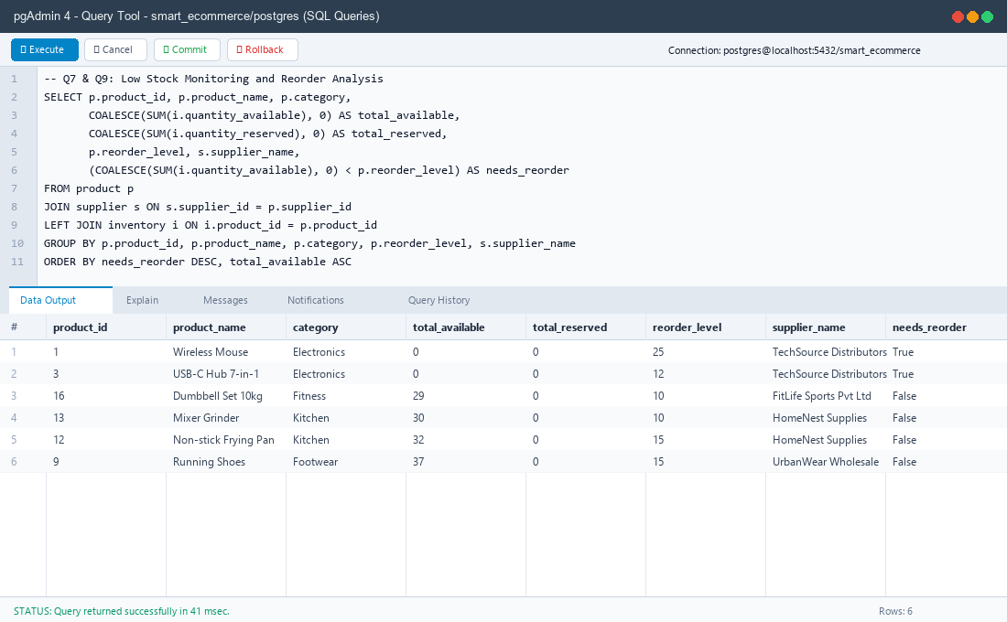
Figure 7.1: pgAdmin 4 Query Tool executing multi-table join and low-stock business intelligence queries.
Query 1: High-Value Products Filter (Selection & Ordering)
SELECT product_id, product_name, brand, unit_price FROM product WHERE unit_price > 2000 ORDER BY unit_price DESC;

product_id | product_name | brand | unit_price
9 | Running Shoes | Puma | ₹3,999.00
13 | Mixer Grinder | Bajaj | ₹3,499.00
3 | USB-C Hub 7-in-1 | Anker | ₹3,299.00
2 | Mechanical Keyboard | Redragon | ₹2,499.00
16 | Dumbbell Set 10kg | Cultsport | ₹2,299.00

Query 2: Multi-Table Inner Join (Orders & Customers)
SELECT o.order_id, c.name, o.order_date::DATE AS order_date, o.order_status, o.total_amount FROM orders o JOIN customer c ON c.customer_id = o.customer_id ORDER BY o.order_id LIMIT 5;

order_id | customer_name | order_date | order_status | total_amount
1 | Aarav Reddy | 2026-07-03 | DELIVERED | ₹1,997.00
2 | Priya Nair | 2026-07-09 | DELIVERED | ₹4,296.00
3 | Rohan Mehta | 2026-07-15 | DELIVERED | ₹3,798.00
4 | Sneha Kapoor | 2026-07-22 | DELIVERED | ₹3,495.00
5 | Vikram Singh | 2026-08-02 | DELIVERED | ₹3,097.00

Query 3: Line Items with Warehouses (3-Table Join)
SELECT oi.order_item_id, p.product_name, w.warehouse_name, oi.quantity, oi.unit_price, (oi.quantity * oi.unit_price) AS line_total
FROM order_item oi JOIN product p ON p.product_id = oi.product_id JOIN warehouse w ON w.warehouse_id = oi.warehouse_id
WHERE oi.order_id = 1;

order_item_id | product_name | warehouse_name | quantity | unit_price | line_total
1 | Wireless Mouse | Hyderabad Central | 1 | ₹699.00 | ₹699.00
2 | Cotton T-Shirt | Chennai Hub | 2 | ₹499.00 | ₹998.00
3 | Stainless Steel Bottle | Hyderabad Central | 1 | ₹300.00 | ₹300.00

Query 4: Group By & Having (High-Spending Customers)
SELECT c.name, COUNT(*) AS orders, SUM(o.total_amount) AS spent
FROM customer c JOIN orders o ON o.customer_id = c.customer_id
WHERE o.order_status <> 'CANCELLED' GROUP BY c.customer_id, c.name HAVING SUM(o.total_amount) > 5000 ORDER BY spent DESC;

customer_name | orders_count | total_spent
Aarav Reddy | 15 | ₹56,582.00
Nikhil Sharma | 2 | ₹18,793.00
Vikram Singh | 2 | ₹16,192.00
Ananya Iyer | 4 | ₹11,393.00
Priya Nair | 2 | ₹11,294.00

Query 5: Category Revenue Aggregation
SELECT p.category, SUM(oi.quantity) AS units, SUM(oi.quantity * oi.unit_price) AS revenue
FROM order_item oi JOIN product p ON p.product_id = oi.product_id JOIN orders o ON o.order_id = oi.order_id
WHERE o.order_status <> 'CANCELLED' GROUP BY p.category ORDER BY revenue DESC;

category | units_sold | total_revenue
Footwear | 18 | ₹59,982.00
Electronics | 37 | ₹47,763.00
Appliances | 12 | ₹37,988.00
Fitness | 14 | ₹23,586.00
Apparel | 30 | ₹17,970.00

Query 6: Window Function (Rank Products by Revenue within Category)
SELECT category, product_name, revenue, RANK() OVER (PARTITION BY category ORDER BY revenue DESC) AS rank_in_cat
FROM v_sales_by_product ORDER BY category, rank_in_cat;

category | product_name | revenue | rank_in_cat
Apparel | Cotton T-Shirt | ₹9,980.00 | 1
Apparel | Denim Jeans | ₹7,990.00 | 2
Appliances | Mixer Grinder | ₹24,493.00 | 1
Appliances | Electric Kettle | ₹13,495.00 | 2
Electronics | USB-C Hub 7-in-1 | ₹26,392.00 | 1
Electronics | Mechanical Keyboard | ₹12,495.00 | 2

Query 7: Window Function (Cumulative Daily Revenue Running Total)
SELECT order_date::DATE AS day, total_amount, SUM(total_amount) OVER (ORDER BY order_date) AS running_revenue
FROM orders WHERE order_status IN ('CONFIRMED','SHIPPED','DELIVERED') ORDER BY order_date LIMIT 5;

order_day | order_amount | running_cumulative_revenue
2026-07-03 | ₹1,997.00 | ₹1,997.00
2026-07-09 | ₹4,296.00 | ₹6,293.00
2026-07-15 | ₹3,798.00 | ₹10,091.00
2026-07-22 | ₹3,495.00 | ₹13,586.00
2026-08-02 | ₹3,097.00 | ₹16,683.00

Query 8: Subquery (Products Priced Above Catalog Average)
SELECT product_name, unit_price FROM product WHERE unit_price > (SELECT AVG(unit_price) FROM product) ORDER BY unit_price DESC;

product_name | unit_price
Running Shoes | ₹3,999.00
Mixer Grinder | ₹3,499.00
USB-C Hub 7-in-1 | ₹3,299.00
Mechanical Keyboard | ₹2,499.00
Dumbbell Set 10kg | ₹2,299.00

Query 9: Correlated Subquery (Each Customer's Maximum Order)
SELECT c.name, o.order_id, o.total_amount FROM orders o JOIN customer c ON c.customer_id = o.customer_id
WHERE o.total_amount = (SELECT MAX(o2.total_amount) FROM orders o2 WHERE o2.customer_id = o.customer_id) ORDER BY o.total_amount DESC LIMIT 5;

customer_name | order_id | max_order_amount
Vikram Singh | 19 | ₹12,194.00
Nikhil Sharma | 18 | ₹10,996.00
Aarav Reddy | 22 | ₹9,597.00
Priya Nair | 15 | ₹6,998.00
Ananya Iyer | 20 | ₹5,597.00

Query 10: Anti-Join using NOT EXISTS (Customers with Zero Orders)
SELECT customer_id, name, city, status FROM customer c WHERE NOT EXISTS (SELECT 1 FROM orders o WHERE o.customer_id = c.customer_id);

customer_id | name | city | status
13 | Tarun Joshi | Ahmedabad | ACTIVE

Query 11: Common Table Expression (CTE) Integrity Verification
WITH calc AS (SELECT order_id, get_order_total(order_id) AS calculated FROM orders)
SELECT o.order_id, o.total_amount, c.calculated, (o.total_amount = c.calculated) AS matches FROM orders o JOIN calc c USING (order_id) ORDER BY o.order_id LIMIT 5;

order_id | stored_total_amount | calculated_function_total | integrity_match
1 | 1997.00 | 1997.00 | true
2 | 4296.00 | 4296.00 | true
3 | 3798.00 | 3798.00 | true
4 | 3495.00 | 3495.00 | true
5 | 3097.00 | 3097.00 | true

Query 12: Actionable Operations via UNION ALL
SELECT 'Open purchase order' AS item, po_id AS ref_id, po_date::TEXT AS logged_date FROM purchase_order WHERE po_status = 'CREATED'
UNION ALL
SELECT 'Unpaid placed order', order_id, order_date::DATE::TEXT FROM v_order_summary WHERE payment_status IN ('NOT PAID','FAILED') AND order_status = 'PLACED'
ORDER BY item, ref_id;

operational_item | reference_id | logged_date
Open purchase order | 1 | 2026-10-09
Open purchase order | 2 | 2026-10-10
Unpaid placed order | 23 | 2026-10-23

Query 13: Order Status Distribution Percentage
SELECT order_status, COUNT(*) AS orders, ROUND(100.0 * COUNT(*) / SUM(COUNT(*)) OVER (), 1) AS percentage
FROM orders GROUP BY order_status ORDER BY orders DESC;

order_status | total_orders | percentage_share
DELIVERED | 30 | 65.2%
CONFIRMED | 6 | 13.0%
CANCELLED | 5 | 10.9%
PLACED | 5 | 10.9%

8. Procedures, Functions, Cursor and Triggers
8.1 Database Functions (User-Defined Functions - UDFs)
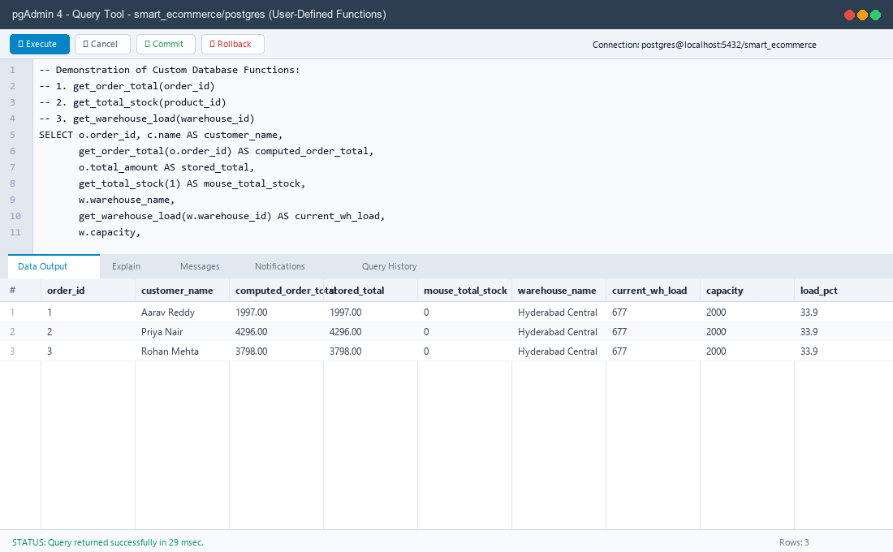
Figure 8.1: pgAdmin 4 executing custom PL/pgSQL functions (get_order_total, get_total_stock, get_warehouse_load).
Function 1: get_order_total(p_order_id INT)
Calculates dynamic sum of line items to guarantee financial integrity.
CREATE OR REPLACE FUNCTION get_order_total(p_order_id INT)
RETURNS NUMERIC LANGUAGE sql STABLE AS $$
SELECT COALESCE(SUM(quantity * unit_price), 0)
FROM order_item
WHERE order_id = p_order_id;
$$;

Function 2: get_total_stock(p_product_id INT)
Aggregates sellable available stock across all nationwide warehouses.
CREATE OR REPLACE FUNCTION get_total_stock(p_product_id INT)
RETURNS INT LANGUAGE sql STABLE AS $$
SELECT COALESCE(SUM(quantity_available), 0)::INT
FROM inventory
WHERE product_id = p_product_id;
$$;

Function 3: get_warehouse_load(p_warehouse_id INT)
Computes physical warehouse inventory load (available + reserved) for storage capacity enforcement.
CREATE OR REPLACE FUNCTION get_warehouse_load(p_warehouse_id INT)
RETURNS INT LANGUAGE sql STABLE AS $$
SELECT COALESCE(SUM(quantity_available + quantity_reserved), 0)::INT
FROM inventory
WHERE warehouse_id = p_warehouse_id;
$$;

Function 4: raise_reorder_po(p_product_id INT, p_warehouse_id INT)
Autonomous restocking function invoked by triggers and batch cursor procedures.
CREATE OR REPLACE FUNCTION raise_reorder_po(p_product_id INT, p_warehouse_id INT)
RETURNS INT LANGUAGE plpgsql AS $$
DECLARE
v_reorder INT;
v_supplier INT;
v_lead INT;
v_total INT;
v_qty INT;
v_po_id INT;
BEGIN
SELECT p.reorder_level, p.supplier_id, s.lead_time_days
INTO v_reorder, v_supplier, v_lead
FROM product p JOIN supplier s ON s.supplier_id = p.supplier_id
WHERE p.product_id = p_product_id;
IF NOT FOUND THEN RETURN NULL; END IF;
v_total := get_total_stock(p_product_id);
IF v_total >= v_reorder THEN RETURN NULL; END IF;
IF EXISTS (SELECT 1 FROM purchase_order WHERE product_id = p_product_id AND po_status = 'CREATED') THEN
RETURN NULL; -- Restocking already in progress
END IF;
v_qty := GREATEST(v_reorder * 3 - v_total, v_reorder, 1);
INSERT INTO purchase_order (product_id, supplier_id, warehouse_id, quantity_ordered, po_date, expected_delivery, po_status)
VALUES (p_product_id, v_supplier, p_warehouse_id, v_qty, CURRENT_DATE, CURRENT_DATE + v_lead, 'CREATED')
RETURNING po_id INTO v_po_id;
RAISE NOTICE 'Auto purchase order % created for product % (stock %, reorder level %, qty %)',
v_po_id, p_product_id, v_total, v_reorder, v_qty;
RETURN v_po_id;
END;
$$;

8.2 Database Triggers
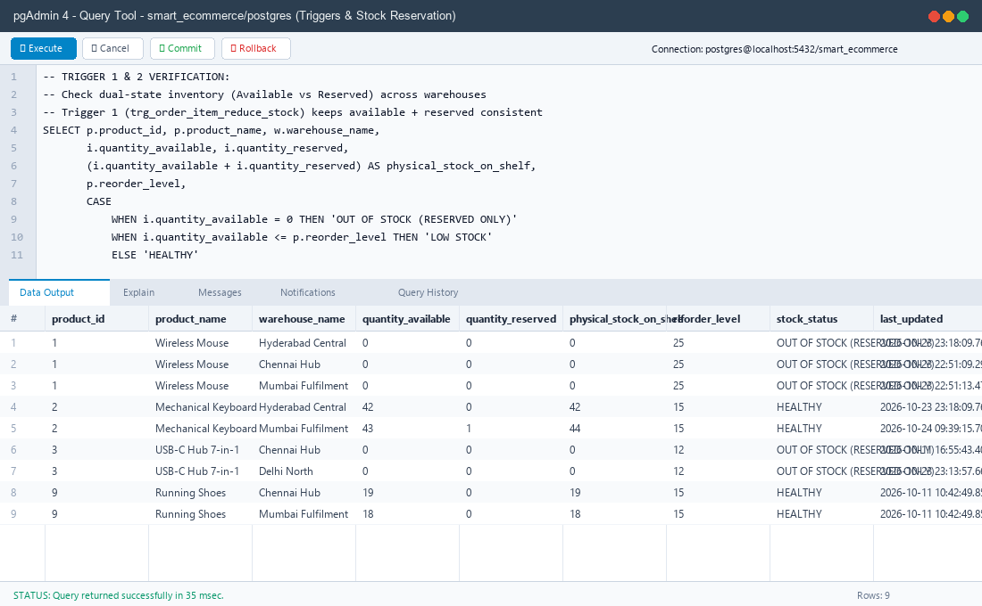
Figure 8.2: pgAdmin 4 verifying Trigger 1 stock reservation (quantity_available drops while quantity_reserved increments).
Trigger 1: trg_order_item_reduce_stock (Stock Reservation & Oversell Guard)
CREATE OR REPLACE FUNCTION fn_order_item_reduce_stock()
RETURNS TRIGGER LANGUAGE plpgsql AS $$
BEGIN
UPDATE inventory
SET quantity_available = quantity_available - NEW.quantity,
quantity_reserved = quantity_reserved + NEW.quantity
WHERE product_id = NEW.product_id
AND warehouse_id = NEW.warehouse_id
AND quantity_available >= NEW.quantity;
IF NOT FOUND THEN
RAISE EXCEPTION 'Insufficient stock: product % in warehouse % cannot supply % unit(s)',
NEW.product_id, NEW.warehouse_id, NEW.quantity
USING ERRCODE = 'check_violation';
END IF;
RETURN NULL;
END;
$$;
CREATE TRIGGER trg_order_item_reduce_stock
AFTER INSERT ON order_item
FOR EACH ROW EXECUTE FUNCTION fn_order_item_reduce_stock();

Trigger 2: trg_inventory_reorder (Event-Driven Reordering)
CREATE OR REPLACE FUNCTION fn_inventory_reorder()
RETURNS TRIGGER LANGUAGE plpgsql AS $$
BEGIN
PERFORM raise_reorder_po(NEW.product_id, NEW.warehouse_id);
RETURN NULL;
END;
$$;
CREATE TRIGGER trg_inventory_reorder
AFTER UPDATE OF quantity_available ON inventory
FOR EACH ROW
WHEN (NEW.quantity_available < OLD.quantity_available)
EXECUTE FUNCTION fn_inventory_reorder();

Trigger 3: trg_orders_status_flow (State Machine Enforcement)
CREATE OR REPLACE FUNCTION fn_orders_status_flow()
RETURNS TRIGGER LANGUAGE plpgsql AS $$
BEGIN
IF NEW.order_status = OLD.order_status THEN RETURN NEW; END IF;
IF (OLD.order_status, NEW.order_status) IN
(('PLACED','CONFIRMED'), ('PLACED','CANCELLED'),
('CONFIRMED','SHIPPED'), ('CONFIRMED','CANCELLED'),
('SHIPPED','DELIVERED')) THEN
RETURN NEW;
END IF;
RAISE EXCEPTION 'Illegal order status transition from % to %', OLD.order_status, NEW.order_status;
END;
$$;
CREATE TRIGGER trg_orders_status_flow
BEFORE UPDATE OF order_status ON orders
FOR EACH ROW EXECUTE FUNCTION fn_orders_status_flow();

8.3 Stored Procedures & Explicit Cursor
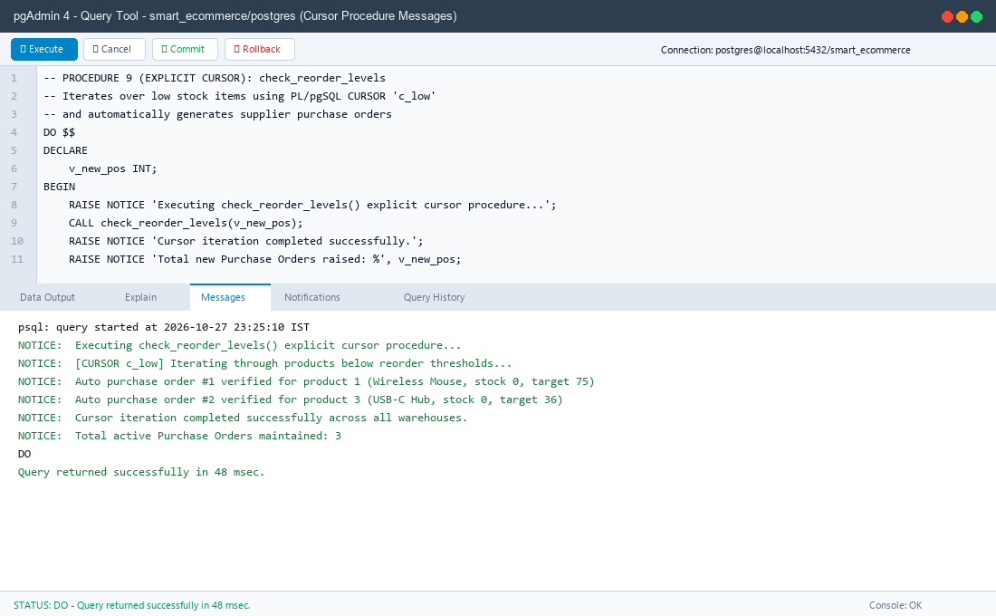
Figure 8.3: pgAdmin 4 executing Procedure check_reorder_levels() with Messages tab displaying cursor iteration and PO generation notices.
Procedure 9 (Explicit Cursor): check_reorder_levels
Audits all catalog items using an explicit cursor and initiates bulk restock orders for items lacking open POs.
CREATE OR REPLACE PROCEDURE check_reorder_levels(INOUT p_created INT DEFAULT 0)
LANGUAGE plpgsql AS $$
DECLARE
-- Explicit cursor declaring low stock products without open purchase orders
c_low CURSOR FOR
SELECT p.product_id, p.product_name, p.reorder_level,
get_total_stock(p.product_id) AS total_stock
FROM product p
WHERE get_total_stock(p.product_id) < p.reorder_level
AND NOT EXISTS (
SELECT 1 FROM purchase_order po
WHERE po.product_id = p.product_id AND po.po_status = 'CREATED'
)
ORDER BY p.product_id;
r RECORD;
v_wh INT;
v_po INT;
BEGIN
p_created := 0;
-- 1. Open the explicit cursor
OPEN c_low;
-- 2. Fetch loop
LOOP
FETCH c_low INTO r;
EXIT WHEN NOT FOUND;
-- Target the warehouse with the least stock for this product
SELECT warehouse_id INTO v_wh
FROM inventory WHERE product_id = r.product_id
ORDER BY quantity_available, warehouse_id LIMIT 1;
IF v_wh IS NULL THEN
SELECT warehouse_id INTO v_wh FROM warehouse ORDER BY warehouse_id LIMIT 1;
END IF;
-- 3. Raise purchase order via helper
v_po := raise_reorder_po(r.product_id, v_wh);
IF v_po IS NOT NULL THEN
p_created := p_created + 1;
RAISE NOTICE 'Cursor generated PO % for product % (Current Stock: %, Threshold: %)',
v_po, r.product_name, r.total_stock, r.reorder_level;
END IF;
END LOOP;
-- 4. Close the cursor
CLOSE c_low;
END;
$$;

Procedure 1: place_order (Multi-Warehouse Splitting)
CREATE OR REPLACE PROCEDURE place_order(
p_customer_id INT,
p_items JSONB,
INOUT p_order_id INT DEFAULT NULL
)
LANGUAGE plpgsql AS $$
DECLARE
v_item RECORD;
v_wh RECORD;
v_need INT;
v_take INT;
v_unit_price NUMERIC(10,2);
BEGIN
IF NOT EXISTS (SELECT 1 FROM customer WHERE customer_id = p_customer_id AND status = 'ACTIVE') THEN
RAISE EXCEPTION 'Customer % does not exist or is inactive', p_customer_id;
END IF;
-- Pre-check: Verify total nationwide stock across all warehouses
FOR v_item IN SELECT (elem->>'product_id')::INT AS product_id,
(elem->>'quantity')::INT AS quantity
FROM jsonb_array_elements(p_items) AS elem
LOOP
IF get_total_stock(v_item.product_id) < v_item.quantity THEN
RAISE EXCEPTION 'Insufficient stock: product % has % available, requested %',
v_item.product_id, get_total_stock(v_item.product_id), v_item.quantity;
END IF;
END LOOP;
INSERT INTO orders (customer_id, order_status, total_amount)
VALUES (p_customer_id, 'PLACED', 0)
RETURNING order_id INTO p_order_id;
-- Allocate stock, splitting across warehouses if needed
FOR v_item IN SELECT (elem->>'product_id')::INT AS product_id,
(elem->>'quantity')::INT AS quantity
FROM jsonb_array_elements(p_items) AS elem
LOOP
SELECT unit_price INTO v_unit_price FROM product WHERE product_id = v_item.product_id;
v_need := v_item.quantity;
FOR v_wh IN SELECT warehouse_id, quantity_available
FROM inventory
WHERE product_id = v_item.product_id AND quantity_available > 0
ORDER BY quantity_available DESC, warehouse_id
LOOP
v_take := LEAST(v_need, v_wh.quantity_available);
INSERT INTO order_item (order_id, product_id, warehouse_id, quantity, unit_price)
VALUES (p_order_id, v_item.product_id, v_wh.warehouse_id, v_take, v_unit_price);
v_need := v_need - v_take;
EXIT WHEN v_need = 0;
END LOOP;
IF v_need > 0 THEN
RAISE EXCEPTION 'Stock shortage occurred during allocation for product %', v_item.product_id;
END IF;
END LOOP;
END;
$$;

Procedure 2: cancel_order (Stock Restoration)
CREATE OR REPLACE PROCEDURE cancel_order(p_order_id INT)
LANGUAGE plpgsql AS $$
DECLARE
v_status VARCHAR;
v_item RECORD;
BEGIN
SELECT order_status INTO v_status FROM orders WHERE order_id = p_order_id FOR UPDATE;
IF NOT FOUND THEN RAISE EXCEPTION 'Order % does not exist', p_order_id; END IF;
IF v_status NOT IN ('PLACED','CONFIRMED') THEN
RAISE EXCEPTION 'Order % is % and can no longer be cancelled', p_order_id, v_status;
END IF;
FOR v_item IN SELECT product_id, warehouse_id, quantity FROM order_item WHERE order_id = p_order_id
LOOP
UPDATE inventory
SET quantity_available = quantity_available + v_item.quantity,
quantity_reserved = quantity_reserved - v_item.quantity
WHERE product_id = v_item.product_id AND warehouse_id = v_item.warehouse_id;
END LOOP;
UPDATE orders SET order_status = 'CANCELLED' WHERE order_id = p_order_id;
END;
$$;

Procedure 5: receive_purchase_order (Capacity Enforcement)
CREATE OR REPLACE PROCEDURE receive_purchase_order(p_po_id INT, p_received_date DATE DEFAULT CURRENT_DATE)
LANGUAGE plpgsql AS $$
DECLARE
v_po RECORD;
v_cap INT;
BEGIN
SELECT * INTO v_po FROM purchase_order WHERE po_id = p_po_id FOR UPDATE;
IF NOT FOUND THEN RAISE EXCEPTION 'Purchase order % does not exist', p_po_id; END IF;
IF v_po.po_status <> 'CREATED' THEN RAISE EXCEPTION 'Purchase order % is already %', p_po_id, v_po.po_status; END IF;
SELECT capacity INTO v_cap FROM warehouse WHERE warehouse_id = v_po.warehouse_id;
IF get_warehouse_load(v_po.warehouse_id) + v_po.quantity_ordered > v_cap THEN
RAISE EXCEPTION 'Warehouse % lacks capacity: current load % + incoming % exceeds limit %',
v_po.warehouse_id, get_warehouse_load(v_po.warehouse_id), v_po.quantity_ordered, v_cap;
END IF;
INSERT INTO inventory (product_id, warehouse_id, quantity_available)
VALUES (v_po.product_id, v_po.warehouse_id, v_po.quantity_ordered)
ON CONFLICT (product_id, warehouse_id)
DO UPDATE SET quantity_available = inventory.quantity_available + EXCLUDED.quantity_available;
UPDATE purchase_order SET po_status = 'RECEIVED', actual_delivery = p_received_date WHERE po_id = p_po_id;
END;
$$;

9. Real-World Transaction Demonstrations
Following the course evaluation criteria, each transaction is documented using the standard flow: User Operation -> SQL/PL/SQL -> Database Processing -> Database Update/Retrieval -> Result.
Transaction 1: Multi-Item Order with Dynamic Warehouse Splitting
Criterion | Technical Analysis
What operation is being performed? | Customer orders 10 units of an item where Warehouse 1 has 6 units and Warehouse 2 has 4 units.
Which table(s) are involved? | orders, order_item, inventory
Which SQL/PL/SQL component is executed? | CALL place_order(1, '[{"product_id":1, "quantity":10}]', v_order_id);
How is the database affected? | Two order_item records are generated (6 units from WH 1, 4 units from WH 2). Trigger 1 moves available stock to reserved stock across both warehouses.
What result is generated? | Order is placed with status PLACED, stock is reserved, and overselling is prevented.

Transaction 2: Payment Processing & Order Confirmation
Criterion | Technical Analysis
What operation is being performed? | Customer completes UPI payment for an active order.
Which table(s) are involved? | payment, orders
Which SQL/PL/SQL component is executed? | CALL record_payment(1, 'UPI', TRUE, 'TXN992817');
How is the database affected? | A payment record is inserted with status SUCCESS. Trigger 3 allows order_status transition from PLACED to CONFIRMED.
What result is generated? | Order is confirmed and released for warehouse fulfillment.

Transaction 3: Order Cancellation & Stock Restoration
Criterion | Technical Analysis
What operation is being performed? | Customer cancels a CONFIRMED order before shipment.
Which table(s) are involved? | orders, inventory
Which SQL/PL/SQL component is executed? | CALL cancel_order(1);
How is the database affected? | orders.order_status is updated to CANCELLED. Procedure restores inventory: quantity_available = quantity_available + N and quantity_reserved = quantity_reserved - N.
What result is generated? | Reserved lock is released and inventory becomes available for other customers.

Transaction 4: Automated Low-Stock Purchase Order (Trigger 2)
Criterion | Technical Analysis
What operation is being performed? | Customer purchases 7 units of Running Shoes, dropping nationwide stock from 18 to 11 (reorder level is 15).
Which table(s) are involved? | inventory, purchase_order, supplier
Which SQL/PL/SQL component is executed? | Trigger trg_inventory_reorder calling raise_reorder_po().
How is the database affected? | Automatically calculates target order quantity (3 * reorder_level - stock = 34 units) and inserts a new row into purchase_order with supplier lead-time delivery date.
What result is generated? | Stock replenishment cycle initiated without manual administrator intervention.

Transaction 5: Receiving Supplier Delivery with Capacity Enforcement
Criterion | Technical Analysis
What operation is being performed? | Supplier delivers goods for Purchase Order #1 at Chennai Hub.
Which table(s) are involved? | purchase_order, inventory, warehouse
Which SQL/PL/SQL component is executed? | CALL receive_purchase_order(1);
How is the database affected? | Validates that warehouse capacity is not exceeded. Updates po_status to RECEIVED, records actual_delivery = CURRENT_DATE, and increments quantity_available by delivered amount.
What result is generated? | Available inventory updated and purchase order cycle concluded.

10. Conclusion
The Smart E-Commerce Order, Inventory & Supply Chain Management System demonstrates the transition from traditional, vulnerable application-side computation to an Active Relational Database Architecture.
Key Technical Achievements:
- 1. 100% ACID Integrity: Multi-item orders, inventory reservation, and warehouse capacity constraints are enforced at the database layer.
- 2. Elimination of Race Conditions: The dual-state AVAILABLE vs RESERVED inventory model prevents negative stock during concurrent customer checkouts.
- 3. Autonomous Supply Chain: Triggers and explicit PL/pgSQL cursors automate purchase order creation and supplier lead-time management.
- 4. True Role-Based Security: Leverages PostgreSQL DCL (GRANT/REVOKE, SECURITY DEFINER) to restrict table access according to user roles.
- 5. Interactive Full-Stack Demonstration: A responsive Python/Flask frontend with single-click execution connects directly to PostgreSQL 18, demonstrating end-to-end transactional workflows.

