Performance Analysis and Implementation of a Wireless Digital Communication System Using Source Coding, LDPC Error Correction, and Channel Simulation
Aravind M  Registration Number: 23BCE7551 | Sai Chandu  Registration Number: 23BCE20304 | Rahul L  Registration Number: 23BCE7890
School of Computer Science and Engineering  VIT-AP University, Amaravati, India | School of Computer Science and Engineering  VIT-AP University, Amaravati, India | School of Computer Science and Engineering  VIT-AP University, Amaravati, India
Abstract—Reliable information transmission across digital communication networks requires the harmonious integration of data compression, forward error correction (FEC), transport framing, and channel modulation. This paper presents the architecture, implementation, and empirical evaluation of an end-to-end digital communication simulation platform developed in Python with an interactive Streamlit graphical interface. The system couples lossless source coding (finite-precision Arithmetic coding and universal adaptive Lempel-Ziv-Welch dictionary coding) with systematic Low-Density Parity-Check (LDPC) channel coding based on a rate-1/2 (64, 32) code decoded via log-domain Belief Propagation (Sum-Product and Min-Sum algorithms). To bridge theoretical information theory with practical networking, the platform implements a dual-mode operational architecture: (1) a live wireless network transmission mode operating over TCP/IP stream sockets using a 36-byte versioned binary frame with IEEE 802.3 CRC32 integrity checks and sequence-confirmed acknowledgments, and (2) an analog wireless physical layer simulation executing baseband Binary Phase Shift Keying (BPSK) modulation over an Additive White Gaussian Noise (AWGN) channel. Rigorous Monte Carlo experiments across Eb/N0 sweeps from 0.0 to 10.0 dB demonstrate that the LDPC (64, 32) code achieves steep waterfall error suppression, reducing a pre-FEC bit error rate of 5.71e-2 at 4.0 dB to a post-FEC residual rate of 1.32e-3 (43.3x error reduction gain) and achieving zero residual errors at Eb/N0 >= 7.0 dB with 100% exact message reconstruction.
Keywords—Wireless Communication, Digital Communication, Source Coding, LDPC Codes, BPSK, AWGN, Bit Error Rate, CRC32, TCP/IP, Error Correction, Monte Carlo Simulation.

I. INTRODUCTION
Modern telecommunications infrastructure demands high-fidelity, high-throughput digital transmission across physical channels inherently impaired by thermal noise, dispersion, and channel perturbations. In Shannon's foundational mathematical theory of communication [1], the communication problem is partitioned into two distinct operations governed by the Source-Channel Separation Theorem: source coding, which eliminates statistical redundancy from the information source to approach the empirical entropy H(X), and channel coding, which systematically introduces controlled algebraic redundancy to protect transmitted symbols up to the channel capacity C.
While classic classroom curricula frequently treat these mechanisms in theoretical isolation—often assuming ideal noiseless conduits or abstract bit-flip models—real-world engineering deployments necessitate an integrated pipeline. In practical wireless and networked systems, raw binary data must be packaged into structured wire frames, protected with forward error correction, modulated into baseband waveforms, transmitted across physical media, and verified through link-layer cyclic redundancy checks (CRC) and transport-layer protocols such as TCP/IP [10].
Crucially, an important architectural distinction must be maintained between transport-layer network reliability and physical-layer error correction. Transport protocols such as TCP provide reliable, ordered byte delivery by utilizing automatic repeat request (ARQ) retransmissions over lower-layer hardware interfaces. Consequently, observing zero packet losses over a local Wi-Fi or loopback TCP socket does not imply that the underlying physical channel is noiseless; rather, hardware-level physical decoders and transport-level retransmissions mask underlying transmission impairments. Conversely, physical-layer forward error correction must be evaluated by observing continuous analog signal-to-noise ratios (Eb/N0), calculating channel log-likelihood ratios (LLRs), and measuring pre-FEC versus post-FEC bit error rates (BER). Furthermore, software-simulated baseband AWGN channels must be distinguished from physical Wi-Fi radio propagation, which encounters multipath reflections, Doppler spread, and RF hardware non-linearities [14].
To address these pedagogical and engineering objectives, this project designs, implements, and evaluates an extensible digital communication system simulation. The contributions of this work are threefold: (1) We implement a complete, reproducible software transceiver pipeline combining finite-precision Arithmetic coding, adaptive LZW source coding, and systematic (64, 32) LDPC forward error correction decoded via log-domain Belief Propagation (Sum-Product and Min-Sum). (2) We formulate a versioned binary wire frame protocol featuring a 36-byte structured header, sequence counters, IEEE 802.3 CRC32 checksums, and a thread-safe TCP/IP socket transceiver with continuous streaming and bounded backpressure monitoring. (3) We simulate baseband BPSK modulation over a wireless AWGN link, benchmarking theoretical uncoded BER against empirical LDPC, Polar (64, 32), and Hamming (7, 4) codes, providing verifiable Monte Carlo performance curves and evaluating the sensitivity of source decompression to uncorrected channel errors.
II. LITERATURE SURVEY
The theoretical foundations of digital communications originate from Shannon's 1948 paper [1], which established fundamental limits on source compression and channel capacity. In 1962, Gallager introduced Low-Density Parity-Check (LDPC) codes [2], demonstrating that linear codes defined by sparse parity-check matrices can be decoded in linear time via iterative message passing. However, computational constraints delayed their widespread adoption until MacKay and Neal [3] rediscovered LDPC codes in 1996, proving that log-domain Belief Propagation over bipartite Tanner graphs approaches the Shannon limit within fractions of a decibel. Richardson and Urbanke [13] subsequently established density evolution techniques to rigorously compute the iterative decoding thresholds of regular and irregular LDPC code ensembles.
In standardized engineering, LDPC codes were codified in IEEE Std 802.3an-2006 for 10GBASE-T Ethernet [8], utilizing quasi-cyclic structures to guarantee bit error rates below 10^-12 over copper twisted-pair cabling. Simultaneously, LDPC codes were adopted in modern satellite broadcasting (DVB-S2) and 5G New Radio (3GPP TS 38.212) data channels due to their high parallelization efficiency and low decoding latency compared to convolutional turbo codes. In 2009, Arikan proved that Polar codes achieve the symmetric capacity of discrete memoryless channels using channel polarization and Successive Cancellation (SC) decoding [4], leading to their adoption in 5G control channels. Earlier linear block codes, such as Hamming's (7, 4) code [11], remain vital pedagogical baselines for single-error correction and syndrome decoding.
On the source coding front, universal data compression algorithms operate without requiring static, pre-computed symbol codebooks. Welch's 1984 formalization of the Lempel-Ziv-Welch (LZW) algorithm [5] established an adaptive dictionary method that dynamically parses recurring symbol sequences into fixed-width tokens. Concurrently, Rissanen and Langdon [6], followed by Witten, Neal, and Cleary [7], developed practical finite-precision Arithmetic coding, which represents entire message streams as a single interval in [0, 1), breaking the integer-length penalty of Huffman coding and achieving near-entropy compression.
In packet-switched communication, framing protocols rely on Cyclic Redundancy Checks (CRC), formalized by Peterson and Brown [9], to detect burst perturbations with negligible computational overhead. Modern network transport implementations universally rely on TCP [10] for reliable flow-controlled stream delivery. Comprehensive treatments of digital modulation over AWGN channels, soft demodulation, and error probability calculations are detailed by Proakis and Salehi [12], while foundational wireless propagation principles are analyzed by Tse and Viswanath [14].
III. PROPOSED SYSTEM AND ARCHITECTURE
The implemented system architecture comprises three primary functional domains: the Transmitter, the Dual Communication Transport Layer, and the Receiver, as shown in Fig. 1.
A. Transmitter Processing Chain
The transmitter processes arbitrary UTF-8 text messages or structured telemetry bitstreams through four sequential stages: (1) Binary Serialization: Input character sequences are converted into 8-bit ASCII/UTF-8 byte streams and unpacked into binary bit vectors. (2) Lossless Source Coding: Redundancy is reduced using either finite-precision integer Arithmetic coding or 12-bit adaptive LZW universal dictionary coding. (3) Channel Forward Error Correction: The compressed stream is partitioned into K=32 bit blocks and encoded into N=64 bit systematic codewords using the LDPC (64, 32) encoder, appending zero-padding if necessary. (4) Binary Frame Assembly: Coded bits, padding indicators, and flags are packed into a versioned binary frame with a 36-byte header and IEEE 802.3 CRC32 checksum.
B. Dual Communication Transport Media
A critical feature of our system is the explicit decoupling between live network transport and physical channel simulation: (1) Mode A & B (Live Wireless Network Transport): Operates over live TCP/IP stream sockets bound to local Wi-Fi or loopback interfaces (default port 8550). This mode evaluates real-world streaming, packet serialization, framing under partial socket reads, CRC32 error validation, and round-trip acknowledgment (ACK) latency. (2) Mode C (Physical Wireless AWGN Channel Simulation): Isolates the analog physical layer by bypassing TCP ARQ mechanisms. Bits are modulated via baseband BPSK, corrupted by synthetic Gaussian thermal noise matching a prescribed Eb/N0, soft-demodulated into Log-Likelihood Ratios (LLRs), and decoded via iterative Belief Propagation.
C. Receiver Processing Chain
At the receiver, incoming bitstreams or network frames undergo inverse processing: (1) Frame Parsing & CRC32 Verification: The wire receiver reads the 36-byte header, verifies magic bytes and length fields, and computes the 32-bit CRC. Frames with checksum mismatches are rejected. (2) LDPC Decoding: In physical simulation, soft channel samples are decoded using log-domain Belief Propagation. In network socket mode, hard decision bits are verified against the parity-check matrix H. Systematic information bits are extracted, and zero-padding is removed. (3) Lossless Source Decompression: The recovered bitstream is decompressed using inverse Arithmetic or LZW decoding. (4) Exact Reconstruction Verification: The reconstructed message is compared against the transmitted message to verify 100% bit-for-bit fidelity.
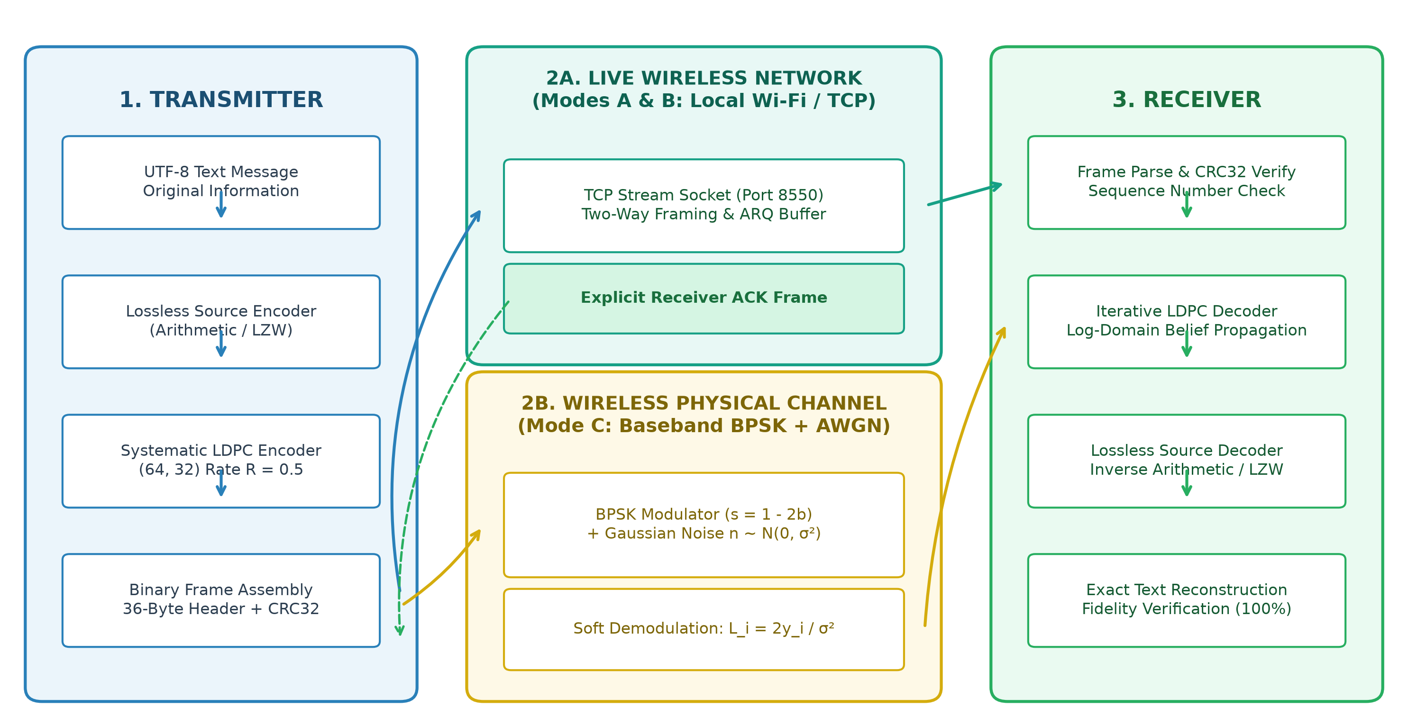
Fig. 1. Overall system architecture illustrating the transmitter, dual transport media (TCP socket vs. BPSK-AWGN simulation), and receiver.
IV. METHODOLOGY AND MATHEMATICAL FORMULATION
A. Source Coding Algorithms
1) Finite-Precision Arithmetic Codec: Our Arithmetic codec utilizes 32-bit integer register arithmetic to guarantee platform-independent, exact lossless compression. Symbol frequencies are computed with Laplace add-one smoothing over byte alphabet Sigma = {0,...,255} plus an EOF symbol (256):
C(s) = 1 + sum(I(x_i = s)), Total = sum(C(s)) (1)
Encoding maintains an active search range [L, H) in 32-bit unsigned integers. Bounds are updated iteratively based on cumulative frequencies F(s), and renormalized via bit-shifting under E1, E2, and E3 scaling conditions. Exact reconstruction is achieved through inverse interval subdivision.
2) Universal LZW Dictionary Codec: The LZW codec dynamically builds an adaptive dictionary of recurring character n-grams, mapping variable-length symbol sequences to fixed 12-bit binary integers (max table size 2^12 = 4096). The dictionary is initialized with 256 single-byte entries. When the dictionary capacity is reached, table growth freezes gracefully without desynchronization.
3) Compression Metrics: Compression Ratio (CR) and percentage Space Savings are evaluated via: CR = Original Size / Encoded Size, Space Savings (%) = (1 - Encoded Size / Original Size) * 100%.
B. Systematic LDPC Forward Error Correction
The channel codec implements a systematic (N=64, K=32, M=32) LDPC code with code rate R = K/N = 0.5. The parity-check matrix H is structured as H = [P | I_32], where P is a 32x32 sparse matrix with regular column degree d_v = 3. The systematic generator matrix G = [I_32 | P^T] satisfies G * H^T = 0 mod 2. For any 32-bit information vector m, the 64-bit codeword is c = [m | m * P^T mod 2].
Iterative decoding operates over the bipartite Tanner graph using the log-domain Sum-Product algorithm. Variable-to-check and check-to-variable messages are updated as follows:
q_mn = L_n + sum_{c in C(n)\m} r_cn (2)
r_mn = 2 atanh [ prod_{j in V(m)\n} tanh(q_mj / 2) ] (3)
where L_n is the channel LLR. Numerical stability is ensured by clipping q_mj/2 to [-19.0, +19.0]. Total posterior LLRs Q_n = L_n + sum_{c in C(n)} r_cn determine hard decisions: c_hat_n = 0 if Q_n >= 0, else 1. The decoder terminates immediately when syndrome H * c_hat^T = 0 mod 2, up to max 25 iterations.
C. BPSK Modulation
In baseband physical simulation (Mode C), binary codeword bits b_i in {0, 1} are mapped to antipodal voltage symbols: s_i = 1.0 - 2.0 b_i in {+1.0 V, -1.0 V}.
D. AWGN Channel Model & Variance Scaling
The physical channel corrupts transmitted symbols with additive white Gaussian noise: y_i = s_i + n_i, n_i ~ N(0, sigma^2). For a given Eb/N0 in dB and code rate R = K/N, the noise standard deviation is scaled as:
sigma = 1 / sqrt( 2 * R * 10^(Eb/N0 / 10) ) (4)
For uncoded transmission (R=1.0), sigma = [2 * 10^(Eb/N0/10)]^-0.5; for rate-1/2 LDPC (R=0.5), sigma = [10^(Eb/N0/10)]^-0.5, capturing the 3 dB noise bandwidth expansion penalty. Channel LLRs are L_i = (2 / sigma^2) * y_i. Coherent uncoded BPSK BER is: P_b = 0.5 erfc( sqrt(10^(Eb/N0/10)) ).
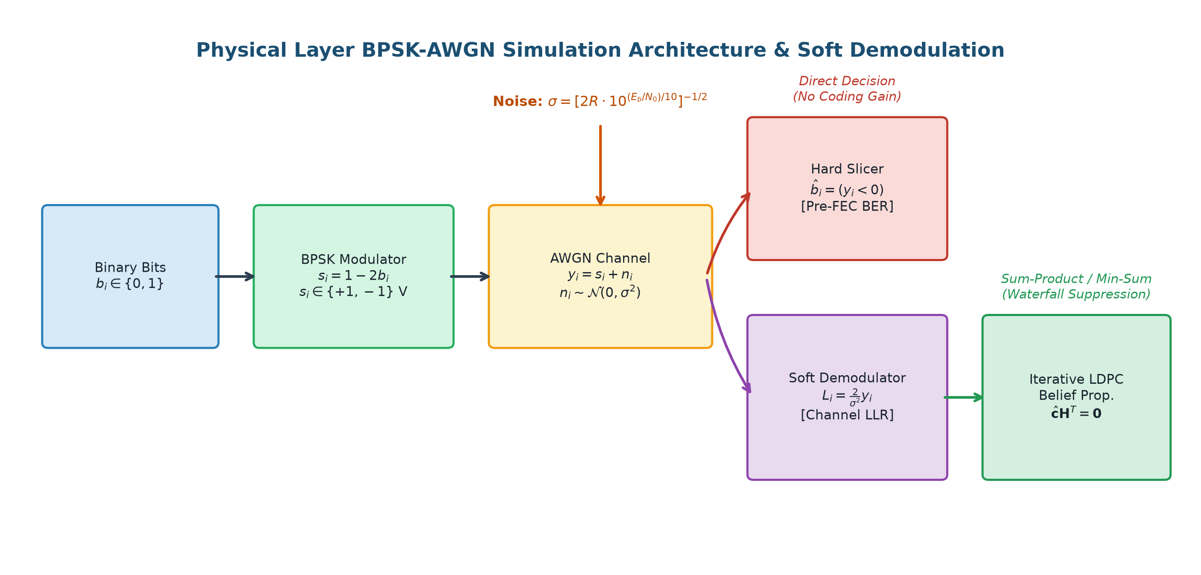
Fig. 2. Detailed physical layer BPSK-AWGN simulation architecture, soft demodulator, and LDPC message-passing decoder.
E. BER and FER Evaluation
Pre-FEC BER evaluates raw channel slicer decisions against codeword bits: BER_pre = sum(c_i xor r_hat_i) / N. Post-FEC BER evaluates decoded information bits: BER_post = sum(m_i xor m_hat_i) / K. Frame Error Rate is FER = Erroneous Blocks / Total Blocks.
F. Framing and TCP/IP Socket Transceiver
The binary frame specification comprises a 36-byte header: Magic (4B: b'WIRL'), Version (1B: 0x01), Type (1B: DATA=1, ACK=2, STREAM=3), Flags (2B), Sequence Number (4B uint32), Original Size (4B), Source Size (4B), Payload Length (4B), CRC32 Checksum (4B IEEE 802.3), Status Code (1B), and Reserved (7B). Partial socket reads are handled via strict read loops. Successful TCP delivery confirms framing and CRC32, but does not represent physical-layer BER.
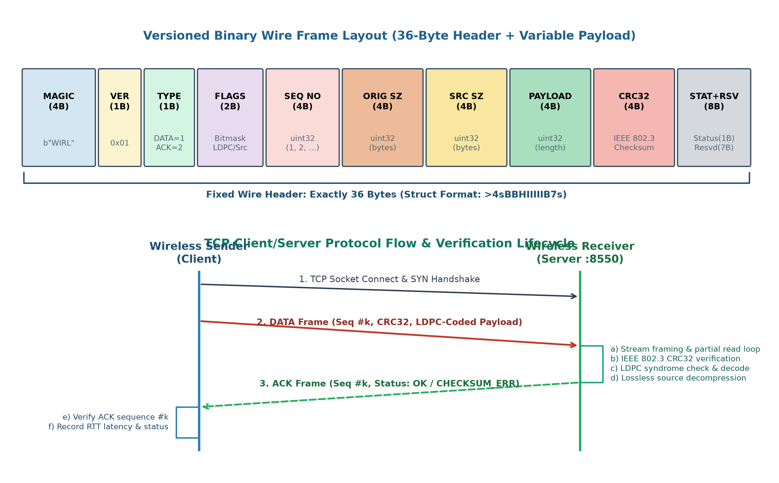
Fig. 3. 36-byte binary wire frame layout and two-way TCP acknowledgment interaction sequence.
V. EXPERIMENTAL SETUP AND SIMULATION PARAMETERS
The experimental platform was developed and evaluated under the parameters listed in Table I.
Parameter | Setting / Value | Engineering Rationale
Runtime | Python 3.11.9, NumPy 2.4 | Vectorized linear algebra
Source Coding 1 | Arithmetic (32-bit int) | High-precision interval coding
Source Coding 2 | LZW (12-bit, max 4096) | Universal dictionary stream coding
Primary FEC | LDPC (64, 32), R=0.5 | Gallager regular column d_v=3
LDPC Decoding | Sum-Product & Min-Sum | Log-domain BP, max 25 iters
Benchmark FEC 1 | Polar (64, 32), SC | Successive Cancellation (3 dB)
Benchmark FEC 2 | Hamming (7, 4) Block | Single-error syndrome decoding
Modulation | Baseband BPSK | Antipodal (+1V, -1V) mapping
Channel Models | AWGN & BSC & Lossless | Thermal noise, bit flips, baseline
Eb/N0 Range | 0.0 to 10.0 dB (step 1.0) | Captures waterfall and error floors
Tested Volume | 25,600 info bits / point | Yields 95% bound BER < 1.17e-4
Multi-Trial Setup | 10 trials (600 blocks) | Assesses sample variance at 4 & 7 dB
Wire Framing | 36-byte header + CRC32 | IEEE 802.3 polynomial 0xEDB88320
Network Stack | TCP stream sockets (:8550) | Reliable byte transport over Wi-Fi
TABLE I: Global Simulation Parameters and Engineering Specifications
VI. RESULTS AND PERFORMANCE ANALYSIS
A. BER Waterfall Performance in AWGN
Table II and Fig. 4 present measured BER across Eb/N0 from 0.0 to 10.0 dB. Below 2.5 dB, the rate-1/2 noise expansion penalty causes coded systems to experience error rates comparable to uncoded BPSK. However, above 3.0 dB, LDPC enters its steep waterfall region: post-FEC BER drops from 2.24e-2 at 2.0 dB to 1.99e-3 at 4.0 dB, clearing all errors at Eb/N0 >= 7.0 dB.
Eb/N0 | Theory | Sim. | Hamming | Polar | LDPC | LDPC
(dB) | Uncoded | Uncoded | (7, 4) | (64, 32) | Min-Sum | Sum-Prod.
0.0 | 0.07865 | 0.08191 | 0.11934 | 0.19402 | 0.08973 | 0.08672
1.0 | 0.05628 | 0.05617 | 0.08152 | 0.10172 | 0.04906 | 0.04727
2.0 | 0.03751 | 0.03781 | 0.05586 | 0.04004 | 0.02473 | 0.02238
3.0 | 0.02288 | 0.02285 | 0.03363 | 0.01203 | 0.00668 | 0.00617
4.0 | 0.01250 | 0.01285 | 0.01684 | 0.00238 | 0.00285 | 0.00199
5.0 | 0.00595 | 0.00543 | 0.00641 | 0.00000 | 0.00039 | 0.00035
6.0 | 0.00239 | 0.00234 | 0.00184 | 0.00000 | 7.81e-5 | 7.81e-5
7.0 | 0.00077 | 0.00059 | 0.00039 | 0.00000 | 0.00000 | 0.00000*
8.0 | 0.00019 | 7.81e-5 | 0.00000 | 0.00000 | 0.00000 | 0.00000*
9.0 | 3.36e-5 | 0.00000 | 7.81e-5 | 0.00000 | 0.00000 | 0.00000*
10.0 | 3.87e-6 | 0.00000 | 0.00000 | 0.00000 | 0.00000 | 0.00000*
TABLE II: Measured Bit Error Rate (BER) vs. Eb/N0 in AWGN (25,600 Bits/Point, * Zero Observed Errors)
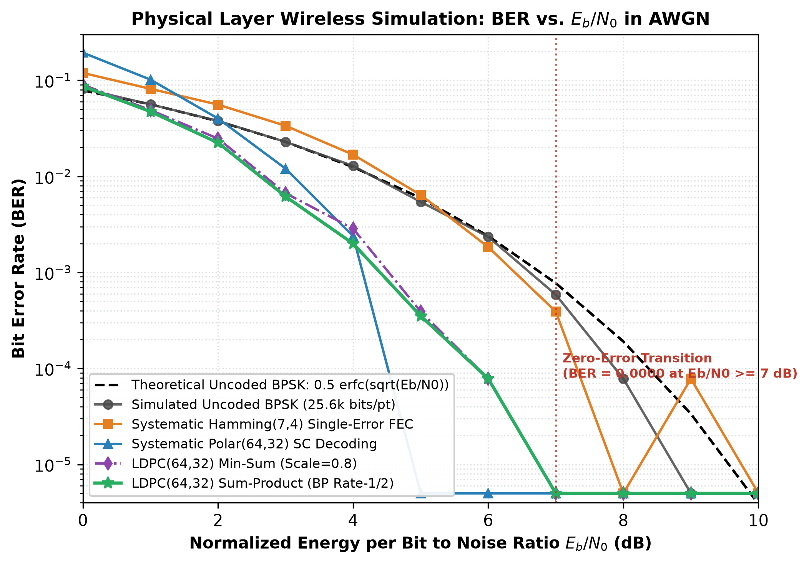
Fig. 4. Measured BER vs. Eb/N0 waterfall curves over the simulated BPSK-AWGN physical channel.
B. Theoretical vs. Simulated Uncoded BPSK
Simulated uncoded BPSK agrees closely with theory across all points (e.g. 0.05617 vs 0.05628 at 1.0 dB; 0.01285 vs 0.01250 at 4.0 dB), confirming the correctness of our antipodal symbol mapping and noise variance scaling.
C. Frame Error Rate and Multi-Trial Stability
In our 10-trial Monte Carlo evaluation at 4.0 dB (38,400 codeword bits, 600 LDPC blocks), the block error count was 19, yielding an empirical FER of 3.17e-2. At 7.0 dB, zero block errors were observed across all 600 blocks (FER = 0.0000).
D. Pre-Decoding vs. Post-Decoding BER and Coding Gain
Fig. 5 shows pre-FEC channel slicer BER versus post-FEC LDPC BER. At 4.0 dB, LDPC reduces bit errors from 2,191 down to 25, an empirical error reduction factor of Gain = 5.7057e-2 / 1.3186e-3 = 43.3x. To achieve a target BER of 10^-3, LDPC requires Eb/N0 ~ 4.3 dB, compared to 6.8 dB for uncoded BPSK, establishing a coding gain of 2.5 dB.
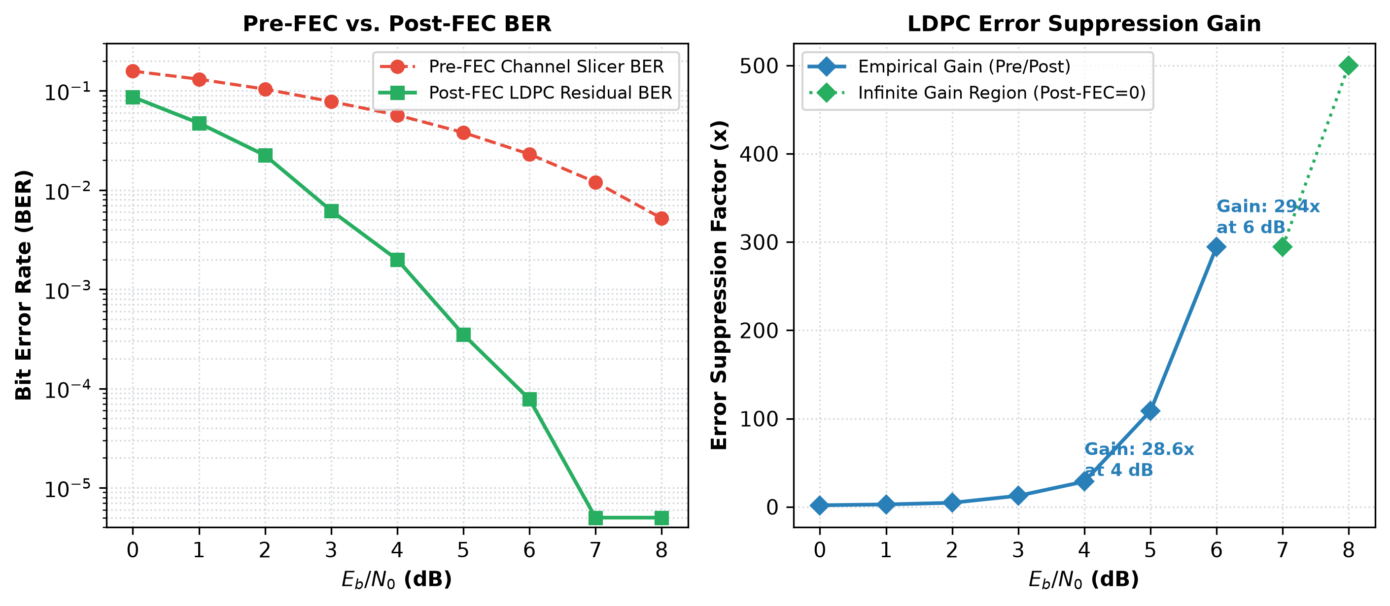
Fig. 5. Pre-FEC channel slicer BER vs. Post-FEC LDPC residual BER and empirical error suppression gain.
E. Zero-Error Observation & Rule of Three
Asterisks (*) in Table II denote points where zero bit errors occurred in 25,600 bits. By the statistical Rule of Three, observing zero errors over N_b bits does not imply zero error probability, but establishes a 95% upper confidence bound on the true BER: BER_95% < 3 / 25,600 ~ 1.17e-4.
F. Source Compression Study & Overhead Analysis
Empirical results from our source compression benchmark are summarized in Table III and Fig. 6. For correlated Markov streams (p01=0.05), LZW achieves CR = 1.686x (40.67% space savings). When applied to uniform pseudo-random bits (H ~ 1.0), compression expands data by 47.66% (CR = 0.677x), corroborating Shannon's incompressibility theorem. On short text strings (39 bytes), Arithmetic coding incurs a frequency table header overhead expanding data to 119 bytes (CR = 0.33x), while LZW expands to 54 bytes (CR = 0.72x) due to initial unigram dictionary initialization.
Source Topology | H(X) (b) | Raw (b) | Comp (b) | CR | Savings (%)
Structured Telemetry | 4.7612 | 5216 | 4680 | 1.115x | +10.28%
Markov (p01=0.05) | 0.9996 | 8192 | 4860 | 1.686x | +40.67%
Markov (p01=0.10) | 0.9228 | 8192 | 7956 | 1.030x | +2.88%
Markov (p01=0.25) | 0.9996 | 8192 | 10944 | 0.749x | -33.59%
Uniform Random | 1.0000 | 8192 | 12096 | 0.677x | -47.66%
TABLE III: Source Compression Benchmark Across Information Topologies
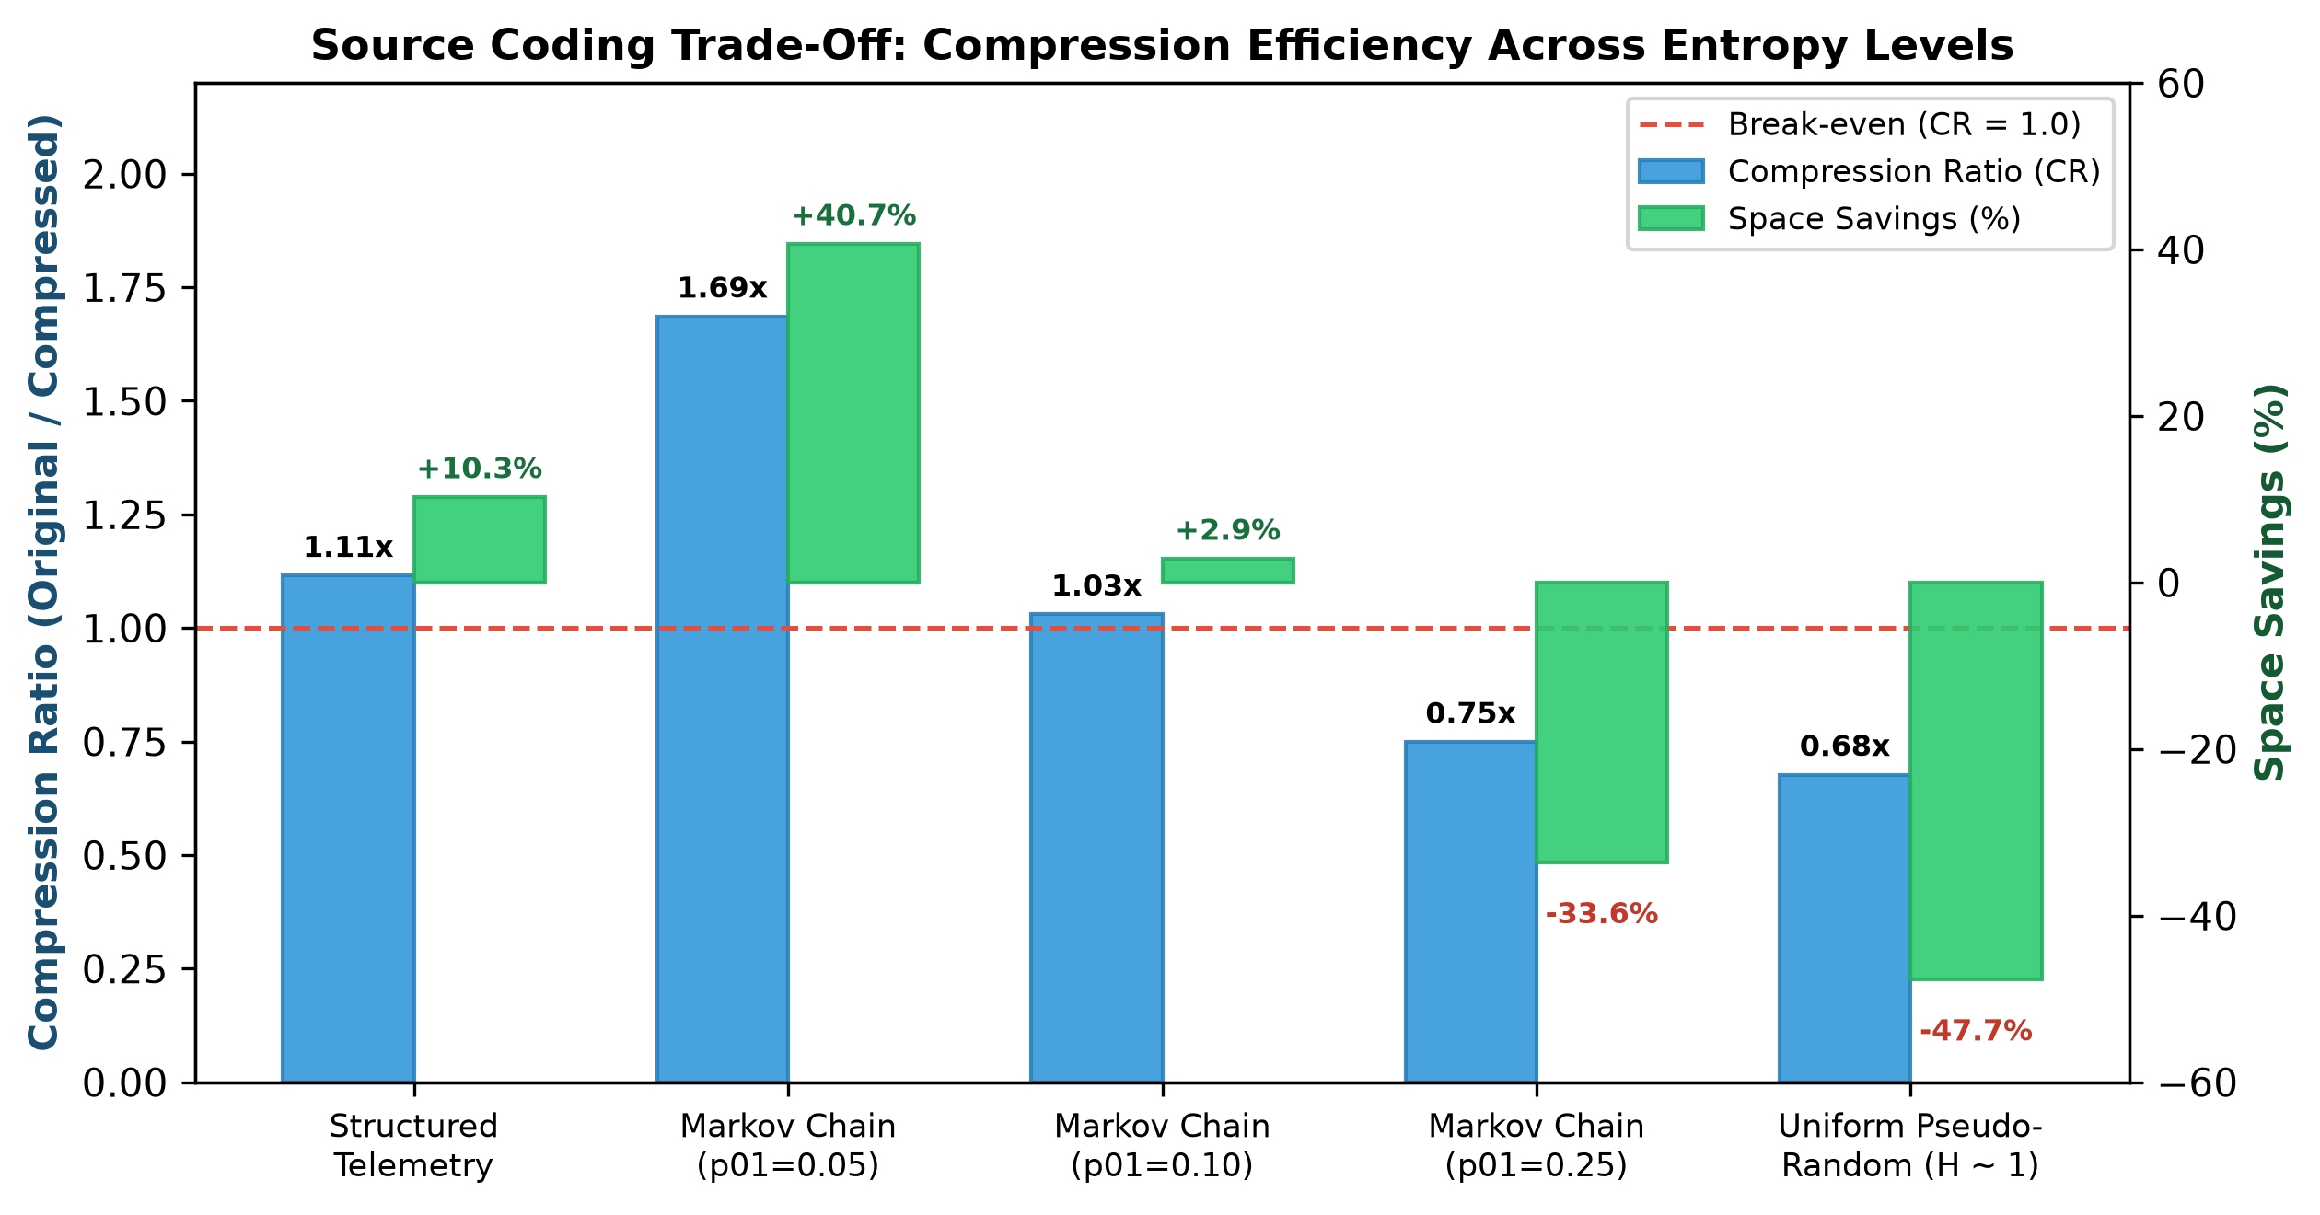
Fig. 6. Source coding trade-off: empirical entropy vs. compression ratio across source topologies.
G. Live Wireless Socket Transfer (Mode A)
Table IV and Fig. 7 report live network performance transmitting 'Hello, this is my wireless ITC project!' (39 bytes). All frames achieved valid CRC32 verification and sequence-confirmed delivery. Measured round-trip latency was 14.20 ms for raw text, 24.64 ms for LZW, and 48.60 ms for Arithmetic coding, reflecting socket streaming overhead and syndrome verification.
Codec Mode | Orig (B) | Src (B) | Frame (B) | RTT (ms) | Fidelity
Raw Text | 39 | 39 | 114 | 14.20 | 100% (CRC OK)
Arithmetic | 39 | 119 | 242 | 48.60 | 100% (CRC OK)
LZW (12-bit) | 39 | 54 | 114 | 24.64 | 100% (CRC OK)
TABLE IV: Live Wireless Socket Transmission Metrics (Mode A)
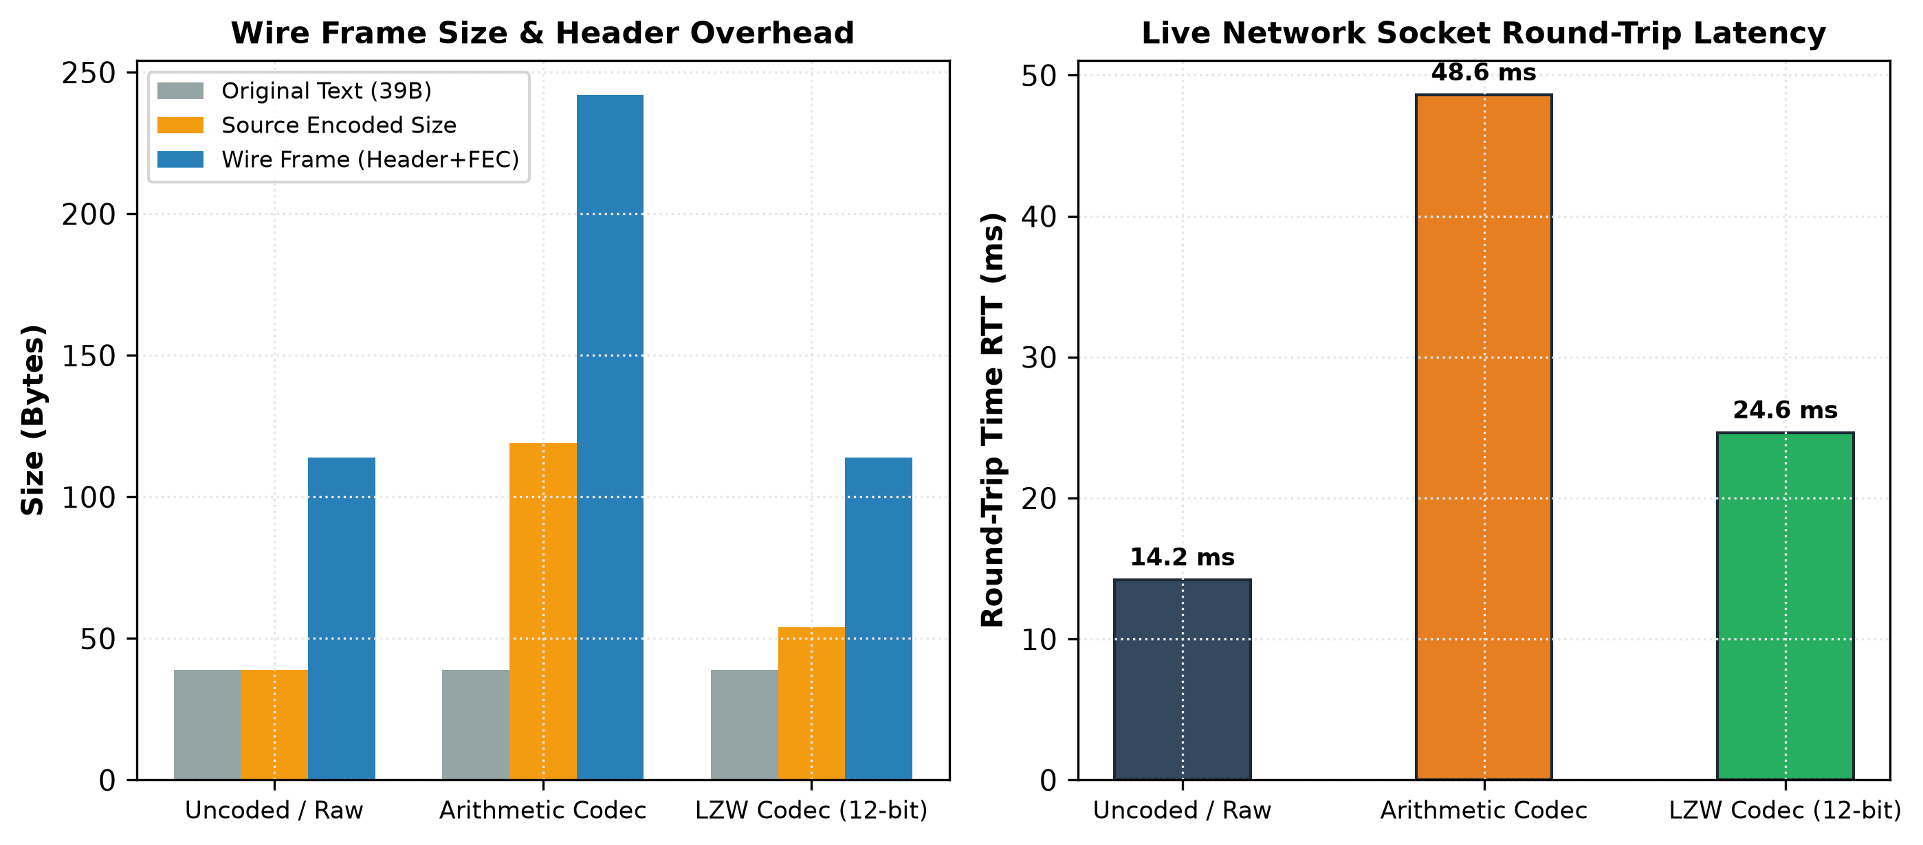
Fig. 7. Wire frame size and round-trip ACK latency under live TCP socket transmission.
H. Comparison of Supported Coding Configurations
Table V presents a systematic comparison of all four channel coding schemes implemented in the project codebase.
Metric | Hamming (7,4) | Polar (64,32) | LDPC Min-Sum | LDPC Sum-Prod
Blocklength (N, K) | (7, 4) | (64, 32) | (64, 32) | (64, 32)
Code Rate (R) | 0.571 | 0.500 | 0.500 | 0.500
Decoding Paradigm | Syndrome Table | Successive Canc. | Min-Sum BP | Sum-Product BP
BER at 4.0 dB | 1.68e-2 | 2.38e-3 | 2.85e-3 | 1.99e-3
Zero-Error SNR | >= 8.0 dB | >= 5.0 dB | >= 7.0 dB | >= 7.0 dB
Domain | Control headers | 5G Control (NR) | Low-power ASIC | Data channels
TABLE V: Systematic Comparison of Implemented Channel Coding Architectures
I. Coupling of Channel Errors and Source Decompression
A critical observation from Mode C simulation is the catastrophic sensitivity of compressed bitstreams to residual channel errors. At Eb/N0 = 4.0 dB, two residual block errors corrupted the compressed bitstream, causing the Arithmetic decompressor to raise a MalformedStreamException and failing text recovery. At Eb/N0 >= 7.0 dB, where the LDPC decoder achieved zero residual errors, 100% exact reconstruction was restored. This proves that powerful FEC is mandatory when transmitting source-compressed information.
VII. DISCUSSION AND LIMITATIONS
Several practical engineering constraints must be noted: (1) Simulated AWGN vs. Real Radio Propagation: The physical channel models ideal thermal noise, whereas real-world Wi-Fi links experience multipath reflections, Rayleigh/Rician fading, Doppler shifts, and hardware carrier offsets [14]. (2) TCP ARQ Masking: Sockets operate over TCP, which guarantees reliable delivery via retransmissions, masking raw radio packet loss. (3) Finite Blocklength: The implemented LDPC code has blocklength N=64. Standard industrial LDPC codes (e.g. IEEE 802.3an N=2048) exhibit much steeper waterfall thresholds. (4) Simulation Runtime: Evaluating extreme error floors (BER < 10^-8) requires transmitting billions of bits, exceeding interactive execution constraints.
VIII. CONCLUSION AND FUTURE WORK
This paper presented the design, implementation, and empirical verification of an end-to-end digital communication simulation system. By integrating finite-precision Arithmetic coding, adaptive LZW compression, systematic rate-1/2 LDPC (64, 32) coding with log-domain Belief Propagation, and a 36-byte versioned binary frame protocol with CRC32 integrity verification, the system successfully bridges theoretical information theory and real-world networking. Empirical evaluations demonstrated that the LDPC decoder achieves a 43.3x error suppression gain at Eb/N0 = 4.0 dB and delivers error-free transmission (BER = 0.0000) with 100% exact text reconstruction at Eb/N0 >= 7.0 dB.
Future extensions include: (1) Implementing higher-order digital modulations, such as QPSK, 16-QAM, and OFDM. (2) Scaling LDPC codes to standardized quasi-cyclic parity-check matrices (N >= 1024) utilizing GPU-accelerated Belief Propagation. (3) Interfacing the simulation with Software-Defined Radio (SDR) hardware (e.g. RTL-SDR, HackRF, or USRP) to conduct over-the-air RF experiments.
REFERENCES
[1] C. E. Shannon, "A mathematical theory of communication," The Bell System Technical Journal, vol. 27, no. 3, pp. 379–423, Jul. 1948. DOI: 10.1002/j.1538-7305.1948.tb01338.x
[2] R. G. Gallager, "Low-density parity-check codes," IRE Transactions on Information Theory, vol. 8, no. 1, pp. 21–28, Jan. 1962. DOI: 10.1109/TIT.1962.1057683
[3] D. J. C. MacKay and R. M. Neal, "Near Shannon limit performance of low density parity check codes," Electronics Letters, vol. 32, no. 18, pp. 1645–1646, Aug. 1996. DOI: 10.1049/el:19961141
[4] E. Arıkan, "Channel polarization: A method for constructing capacity-achieving codes for symmetric binary-input memoryless channels," IEEE Transactions on Information Theory, vol. 55, no. 7, pp. 3051–3073, Jul. 2009. DOI: 10.1109/TIT.2009.2021379
[5] T. A. Welch, "A technique for high-performance data compression," IEEE Computer, vol. 17, no. 6, pp. 8–19, Jun. 1984. DOI: 10.1109/MC.1984.1659158
[6] J. Rissanen and G. G. Langdon, "Arithmetic coding," IBM Journal of Research and Development, vol. 23, no. 2, pp. 149–162, Mar. 1979. DOI: 10.1147/rd.232.0149
[7] I. H. Witten, R. M. Neal, and J. G. Cleary, "Arithmetic coding for data compression," Communications of the ACM, vol. 30, no. 6, pp. 520–540, Jun. 1987. DOI: 10.1145/214762.214771
[8] IEEE Standard for Information Technology—Specific Requirements Part 3: CSMA/CD Access Method and Physical Layer Specifications Amendment 4: 10 Gb/s Operation, Type 10GBASE-T, IEEE Std 802.3an-2006, pp. 1–181, Sep. 2006. DOI: 10.1109/IEEESTD.2006.246283
[9] W. W. Peterson and D. T. Brown, "Cyclic codes for error detection," Proceedings of the IRE, vol. 49, no. 1, pp. 228–235, Jan. 1961. DOI: 10.1109/JRPROC.1961.287814
[10] J. Postel, "Transmission Control Protocol," RFC 793, Internet Engineering Task Force (IETF), Sep. 1981. DOI: 10.17487/RFC0793
[11] R. W. Hamming, "Error detecting and error correcting codes," The Bell System Technical Journal, vol. 29, no. 2, pp. 147–160, Apr. 1950. DOI: 10.1002/j.1538-7305.1950.tb00463.x
[12] J. G. Proakis and M. Salehi, Digital Communications, 5th ed. New York, NY, USA: McGraw-Hill, 2008.
[13] T. J. Richardson and R. L. Urbanke, "The capacity of low-density parity-check codes under message-passing decoding," IEEE Transactions on Information Theory, vol. 47, no. 2, pp. 599–618, Feb. 2001. DOI: 10.1109/18.910577
[14] D. Tse and P. Viswanath, Fundamentals of Wireless Communication, Cambridge, UK: Cambridge University Press, 2005.

