IMAGE PROCESSING WITH MACHINE LEARNING FOR MEDICAL TREATMENT AND DIAGNOSIS

TABLE OF CONTENTS
TABLE OF FIGURES 3
ABSTRACT 4
CHAPTER ONE : 1.1 BACKGROUND 5
1.2 PROBLEM STATEMENT 6
1.3 RESEARCH RATIONALE 6
1.4 RESEARCH AIM AND OBJECTIVES 7
1.5 : OBJECTIVES 7
1.5 SCOPE OF THE STUDY 8
1.6 STRUCTURE OF THE THESIS 8
1.7 SIGNIFICANCE OF THE STUDY 8
CHAPTER TWO :LITERATURE REVIEW 9
2.1 INTRODUCTION 9
2.2 PNEUMONIA: A GLOBAL HEALTH PROBLEM 10
2.3 DIAGNOSTIC TECHNIQUES USED IN CLASSIFICATION OF PNEUMONIA 12
2.4 THE ROLE OF ARTIFICIAL INTELLIGENCE IN MEDICAL IMAGING 14
2.4.1 DEFINITION OF ARTIFICIAL INTELLIGENCE AND DEEP LEARNING 14
2.4.2 DEEP LEARNING IN DIAGNOSIS OF PNEUMONIA 14
CHAPTER THREE: METHODOLOGY 15
3.1 INTRODUCTION 15
3.2 RESEARCH DESIGN 16
3.3 DATA COLLECTION 17
3.3.1 Dataset Overview 17
3.3.2 Data Labeling 17
3.3.3 Ethical Considerations 17
3.4 DATA PREPROCESSING 18
3.5 MODEL DEVELOPMENT 18
3.5.1 Model Architecture 18
3.5.2 Training and Optimization 19
3.5.3 Hardware and Software 20
3.6 MODEL EVALUATION 20
3.6.2 Cross-Validation 21
3.7 MODEL VALIDATION 21
3.8 ETHICAL CONSIDERATIONS 22
3.9 CONCLUSION 22
CHAPTER FOUR : IMPLEMENTATION 23
4.1 DATASET OVERVIEW 23
4.1.2 DATA LABELING 24
4.1.3 ETHICAL CONSIDERATIONS 25
4.2 DATA PREPROCESSING 25
4.2.1 IMAGE RESCALING 26
4.2.2 IMAGE NORMALIZATION 26
4.2.3 DATA AUGMENTATION 27
4.2.4 DATA SPLITTING 28
4.3 MODEL DEVELOPMENT 28
4.3.1 MODEL ARCHITECTURE 28
4.3.2 TRAINING AND OPTIMIZATION 29
4.3.3 HARDWARE AND SOFTWARE 29
4.4 MODEL EVALUATION 29
4.4.1 EVALUATION METRICS 29
4.4.2 CROSS-VALIDATION 30
4.5 MODEL VALIDATION 30
4.7 CONCLUSION 30
CHAPTER FIVE: RESULTS AND DISCUSSION 31
5.1 INTRODUCTION 31
5.2 MODEL OPTIMIZATION AND TRAINING 31
5.2.1 TRAINING PERFORMANCE 31
5.2.2 HYPERPARAMETER TUNING 32
5.3 EVALUATION METRICS 32
5.3.1 ACCURACY 33
5.3.2 PRECISION, RECAL AND F1-SCORE 33
5.3.3 AUC-ROC CURVE 33
5.4 CONFUSION MATRIX 35
5.5 SIMILARITIES WITH OTHER MODELS 35
5.6 DISCUSSION OF FINDINGS 36
5.6.1 LIMITATIONS OF THE MODEL 36
5.7 IMPLICATIONS 37
5.8 CONCLUSION 37
CHAPTER SIX: CONCLUSIONS AND RECOMMENDATIONS 38
6.1 INTRODUCTION 38
6.2 CONCLUSIONS AND RECOMMENDATIONS 38
6.3 CONCLUSION 39
6.5 FUTURE WORK 40
6.5.1 EXTENSION OF THE PROPOSED FRAMEWORK FOR OTHER DISEASES 40
6.5.2 REAL-TIME IMPLEMENTATION 40
6.6 CONCLUSION 41
CHAPTER SEVEN : REFFERENCES 41
APPENDICES 44
DATA LOADING 44
MODEL CREATION 46

TABLE OF FIGURES
Figure 3.1 : System Development Architecture 17
Figure 3.2 : Model Training and Validation Image 23
Figure 4.1 : Sample Normal and Pneumonia Images 24
Figure 4.2 : Data Splitting Image 25
Figure 4.3 : Data Transformation Image 27
Figure 4.4 : Image Normalization 28
Figure 5.1: Model Evaluation Image 35
Figure 5.2 : Confusion Matric Image 36
Figure 6.1 : Model Comparison Image 40

ABSTRACT
The combination of machine learning with image processing has become an inspiring technique in the diagnosis and treatment of illnesses including pneumonia. This study aims at proposing an improved image processing system using deep learning methods in CNNs to boost ontology diagnosis quality and speed. The study presents a detailed approach whereby the datasets involve Chest X-ray images which can be freely accessed with label information followed by data preprocessing process and fine-tuning of CNN best suited for classification of pneumonia. The research shows that the proposed model delivers an accuracy of 96.2 per cent, with high values of precision and recall suggesting that it may have a major potential for eliminating diagnosis-related mistakes and enhancing the patients’ condition.
The increasing volume of medical imaging data poses significant challenges for healthcare professionals, who often rely on manual interpretation methods that are time-consuming and subject to human error. This research addresses the critical need for automated solutions that can efficiently analyze vast datasets while maintaining high standards of diagnostic accuracy. By employing advanced image preprocessing techniques—such as normalization, augmentation, and resizing the study ensures that the input data is optimized for training the CNN model. This methodological rigor not only enhances the model's performance but also establishes a framework for reproducibility and reliability in clinical applications.
In addition, the consequences of this study are not only limited to the differentiation of pneumonia but cover more extensive issues. The ability to implement ML algorithms in medical imaging, denotes a shift in tackling problems in order to achieve an innovative way of solving diagnostic health care problems in health care systems. The study recommends the use of AI in the diagnosis of medical images; it could help lighten the load for radiologists and speed up precise decision making. Possible future studies are the generalization of the given scheme on other pulmonary diseases and improvements to the model to ensure its possibility to be used for real-time applications in a variety of clinical practices. Thus, the presented investigation expands the current knowledge of the discussed scientific area while focusing on the improvement of the healthcare system and patients’ outcomes in the context of employing novel technologies within the framework of medical image analysis.

CHAPTER ONE : 1.1 BACKGROUND
The integration of Machine Learning (ML) with Image Processing for medical diagnosis and treatment is a rapidly growing field, offering a transformative approach to healthcare delivery. Over the last few decades, advancements in medical imaging technologies such as X-rays, MRI, CT scans, and Ultrasound have revolutionized the diagnosis and treatment of various diseases. However, as the volume of imaging data generated daily continues to increase, clinicians and healthcare practitioners are facing challenges in effectively analyzing these images to extract actionable insights. Traditional diagnostic methods, while effective, are often labor-intensive and prone to human error due to the subjectivity of interpretation. These challenges highlight the need for automated, scalable solutions capable of improving both diagnostic accuracy and clinical workflow efficiency.
Machine learning (ML) algorithms, particularly Convolutional Neural Networks (CNNs), have proven highly effective in automating image analysis. These advanced algorithms can identify patterns and detect abnormalities in medical images with an accuracy that often surpasses traditional methods. This ability to detect subtle deviations that might otherwise go unnoticed is critical for early disease detection and timely intervention. In addition to their diagnostic capabilities, ML algorithms can also play a significant role in optimizing treatment plans by analyzing vast amounts of patient data and providing personalized recommendations.
By combining image processing techniques with machine learning models, this approach offers an opportunity to overcome the limitations of manual interpretation. This integration helps reduce human error, enhances the reproducibility of results, and improves diagnostic precision. Moreover, it allows healthcare professionals to focus more on complex tasks that require human judgment, such as decision-making in treatment planning and patient care.
This research aims to investigate the potential applications of image processing combined with machine learning in the medical diagnosis and treatment process. The goal is to develop a system that assists healthcare professionals by providing more accurate, timely, and scalable diagnostic tools, leading to improved patient outcomes and overall healthcare efficiency.

1.2 PROBLEM STATEMENT
In today’s healthcare landscape, manual analysis of medical images is often inefficient, time-consuming, and prone to human error. With the increasing volume of diagnostic images, clinicians and radiologists are faced with the challenge of interpreting vast amounts of data within a limited time frame. This results in potential misdiagnoses, delayed treatments, and increased patient risks. Furthermore, conventional diagnostic methods heavily depend on the subjective judgment of radiologists, which can vary from one practitioner to another, affecting the consistency and accuracy of diagnoses. As medical technologies advance and more complex conditions arise, there is an urgent need for an automated, objective, and scalable solution to aid in medical imaging analysis.
Machine learning algorithms offer a promising alternative to manual interpretation. By automating image processing tasks such as image segmentation, feature extraction, and pattern recognition, these algorithms can assist in early disease detection and treatment planning. The integration of ML with image processing could revolutionize how clinicians interpret medical images, improve diagnostic accuracy, and ultimately lead to better patient outcomes.

1.3 RESEARCH RATIONALE
The field of medical imaging is evolving rapidly, and the healthcare industry is increasingly turning to artificial intelligence (AI) and machine learning for solutions. The rationale for this research is grounded in the need to enhance medical diagnosis and therapeutic intervention through the use of automated image analysis tools powered by machine learning algorithms. Traditional diagnostic methods, though effective, often require substantial manual effort, and are subject to human error and fatigue, especially with the growing volume of images generated in modern clinical settings.
Given the complexity of medical images and the increasing demand for fast and accurate diagnostics, the integration of machine learning algorithms can significantly improve the speed, accuracy, and consistency of diagnoses. Additionally, the development of a robust image processing system could streamline workflows and reduce the burden on clinicians, enabling them to focus on more complex clinical decision-making tasks.
The research also aims to address the increasing challenge of managing large datasets and making sense of the vast amounts of information that medical imaging generates. With the integration of machine learning models, clinicians can leverage powerful tools to analyze, interpret, and make decisions based on medical imaging data, ultimately improving diagnostic efficiency and patient care.

1.4 RESEARCH AIM AND OBJECTIVES
Aim: The main aim of this project is to develop an advanced image processing system integrated with machine learning algorithms to improve the diagnostic process and therapeutic intervention in the healthcare sector. This system will automate the analysis of medical images, providing clinicians with accurate and timely insights to enhance the decision-making process.

1.5 : OBJECTIVES
To Analyze the Effectiveness of Different Machine Learning Algorithms: This objective focuses on comparing the performance of different ML algorithms, such as CNNs and Support Vector Machines (SVMs), in analyzing medical images. The project will evaluate which algorithms offer the most accurate results for diagnosing specific medical conditions.
To Evaluate the Impact of Image Preprocessing Techniques: Before feeding medical images into ML models, certain preprocessing steps such as noise reduction, image enhancement, and segmentation must be performed. This objective will investigate the effect of these preprocessing techniques on the performance of ML algorithms in terms of accuracy and speed.
To Create a Prototype System: A prototype system will be developed to demonstrate the capabilities of the integrated image processing and machine learning model. This system will be designed to be user-friendly and capable of assisting clinicians in diagnosing various medical conditions from imaging data. The prototype will serve as proof of concept for the practical implementation of ML in clinical settings.

1.5 SCOPE OF THE STUDY
The study will focus on the application of machine learning algorithms to process and analyze medical images, including CT scans, X-rays, and MRI images. The scope of this project will also include evaluating the effectiveness of various image preprocessing techniques and their impact on ML model performance. Additionally, a prototype system will be created to demonstrate the real-world application of these technologies in clinical settings.
The research will be conducted with a focus on improving diagnostic procedures for common medical conditions such as cancer, pneumonia, and heart disease, using imaging modalities that are widely available in clinical practice. The ultimate goal is to enhance the diagnostic accuracy and efficiency of healthcare systems, ensuring timely and appropriate treatment for patients.

1.6 STRUCTURE OF THE THESIS
This thesis is organized as follows:
Chapter 1: Introduction — Presents the background, problem statement, research rationale, aims, objectives, and scope of the study.
Chapter 2: Literature Review — Provides a review of existing literature on medical imaging, image processing techniques, and the application of machine learning in healthcare.
Chapter 3: Methodology - Describes the research design, data collection methods, image preprocessing techniques, and machine learning algorithms used in the study.
Chapter 4: Results and Discussion - Presents the results obtained from the implementation of the image processing system and machine learning algorithms, followed by an analysis of the findings.
Chapter 5: Conclusion and Future Work - Summarizes the findings of the study and suggests areas for further research.

1.7 SIGNIFICANCE OF THE STUDY
This research has the potential to significantly impact the healthcare industry by providing a robust, automated solution to medical image analysis. By enhancing diagnostic accuracy and reducing the time required for image interpretation, this system could improve patient outcomes and streamline clinical workflows. Furthermore, the research will contribute to the ongoing development of machine learning applications in healthcare, laying the foundation for future innovations in medical diagnostics and treatment planning.
The integration of image processing with machine learning is expected to lead to a paradigm shift in how medical images are interpreted, providing more consistent, accurate, and timely diagnoses, ultimately improving the quality of care patients receive.

CHAPTER TWO :LITERATURE REVIEW

2.1 INTRODUCTION
The integration of Image Processing with Machine Learning (ML) has revolutionized the landscape of medical treatment and diagnosis, particularly in the detection and diagnosis of diseases like pneumonia. Pneumonia, a potentially life-threatening lung infection, is commonly diagnosed through chest X-ray imaging. However, manual interpretation of these X-rays by radiologists is time-consuming, subjective, and prone to error, especially in high-pressure, resource-limited settings. With the advent of Artificial Intelligence (AI) and deep learning techniques, particularly Convolutional Neural Networks (CNNs), the medical community has witnessed a paradigm shift in diagnostic accuracy and efficiency. These technologies have the potential to automate the process of image analysis, significantly improving both the speed and precision of disease detection.
This chapter delves into a comprehensive review of existing literature, focusing on the intersection of machine learning and image processing for medical diagnosis, specifically within the context of pneumonia. The objective is to critically examine the current state of diagnostic methodologies, identifying the challenges inherent in manual image interpretation and highlighting the transformative role that AI can play in overcoming these obstacles. We explore how deep learning models, especially CNNs, have been successfully applied to pneumonia detection, outperforming traditional methods in some instances. Moreover, we investigate the critical role of data preprocessing—including techniques such as image normalization, augmentation, and contrast enhancement—in optimizing the performance of these models.
The review provides a thorough understanding of how machine learning algorithms can learn and extract features from medical images, enabling automated systems to assist healthcare providers in diagnosing pneumonia and other medical conditions. This foundational chapter not only sets the stage for the research but also identifies gaps in the existing body of knowledge. By doing so, it underscores the relevance of this study in advancing AI-powered diagnostic tools, which can play a pivotal role in transforming healthcare delivery, particularly in areas with limited access to skilled medical professionals. Ultimately, the chapter establishes the rationale for this research, demonstrating the need for further exploration into machine learning-based medical image processing to enhance diagnostic practices and improve patient outcomes globally.

2.2 PNEUMONIA: A GLOBAL HEALTH PROBLEM
Pneumonia remains one of the leading causes of morbidity and mortality worldwide, with a disproportionate burden on low- and middle-income (LAMI) countries. Despite significant advances in medical science, pneumonia continues to claim the lives of millions, especially the most vulnerable populations—young children and the elderly. According to the World Health Organization (WHO, 2023), pneumonia is responsible for approximately 15% of all deaths among children under the age of five, accounting for an alarming 700,000 child deaths annually. This underscores the urgent need for more effective diagnostic tools, early detection methods, and timely treatment interventions.
In addition to its devastating impact on children, pneumonia disproportionately affects the elderly, immunocompromised individuals, and those with pre-existing health conditions, making it a critical global health concern. For these at-risk groups, pneumonia can lead to severe complications, prolonged hospitalization, and high mortality rates, further exacerbating the strain on healthcare systems, particularly in regions with limited resources. The difficulty in detecting pneumonia at its early stages, compounded by the lack of sophisticated medical infrastructure in many parts of the world, makes addressing this issue even more challenging. Early diagnosis and intervention are key to reducing both the burden of the disease and its related complications, yet many patients are diagnosed too late to benefit fully from treatment.
Traditional diagnostic methods, such as physical examinations, laboratory tests, and clinical assessments, often fail to provide a conclusive and timely diagnosis. In resource-limited settings, access to these diagnostic tools is often restricted, making it even more difficult to detect pneumonia early enough for effective treatment. Chest X-rays, despite being considered the gold standard for diagnosing pneumonia due to their affordability, accessibility, and widespread availability, remain heavily dependent on the experience and expertise of radiologists for interpretation. This reliance on human expertise introduces a degree of subjectivity, which can result in diagnostic errors and delays in treatment, particularly in areas with a shortage of trained professionals. The sheer volume of patients seeking care often leads to diagnostic bottlenecks, reducing the time available for accurate image analysis and treatment planning.
In light of these challenges, there is a growing recognition of the potential for Artificial Intelligence (AI) and deep learning technologies to transform the diagnosis of pneumonia. Automating the diagnostic process through machine learning, particularly using Convolutional Neural Networks (CNNs) for image analysis, can minimize subjectivity and improve diagnostic accuracy. These AI-driven systems can quickly analyze radiographic images, detect subtle signs of pneumonia, and assist healthcare professionals in making more timely and accurate diagnoses. By addressing the limitations of traditional diagnostic methods, AI technologies have the potential to enhance early detection, reduce diagnostic errors, and ultimately improve patient outcomes—especially in resource-limited settings where access to trained radiologists and diagnostic tools may be scarce.
This chapter emphasizes the critical role of AI-based diagnostic tools in overcoming the global health challenges posed by pneumonia, making them a crucial element in advancing healthcare systems and reducing the global burden of this deadly disease. Through automated image processing and machine learning, healthcare providers worldwide can gain the ability to detect pneumonia more accurately and rapidly, ensuring better outcomes for vulnerable populations and lowering mortality rates across diverse healthcare settings.

2.3 DIAGNOSTIC TECHNIQUES USED IN CLASSIFICATION OF PNEUMONIA
Pneumonia diagnosis has traditionally relied on a multifaceted approach, incorporating clinical evaluations, laboratory tests, and imaging techniques. Among these, chest X-rays have long been considered the gold standard for pneumonia diagnosis due to their cost-effectiveness, accessibility, and rapid results. Chest X-rays are effective at detecting key pathological signs of pneumonia, such as lung consolidation, alveolar infiltration, and pleural effusion, which are indicative of pulmonary infection. However, despite their widespread use, chest X-ray interpretation is a complex and inherently subjective task, requiring significant expertise and experience.
The interpretation of chest X-rays involves the identification of subtle radiographic features that may indicate the presence of pneumonia. These signs are often subtle and can be difficult to differentiate from other lung pathologies such as tuberculosis, bronchitis, or lung neoplasms. Even experienced radiologists may struggle with distinguishing between these conditions, leading to diagnostic variability and potential misdiagnosis. The subjectivity inherent in human interpretation is further compounded by cognitive fatigue, variations in skill level, and individual biases, all of which can affect diagnostic accuracy (Tang et al., 2021). As a result, radiologists may sometimes disagree on the interpretation of images, particularly in cases where the radiographic signs of pneumonia are mild or non-specific.
Furthermore, in clinical practice, radiologists are often required to review large volumes of images daily, which can lead to diagnostic overload. The high patient throughput, particularly in hospitals or healthcare facilities with limited staffing, may result in missed diagnoses or delayed recognition of pneumonia. In such environments, the workload burden on radiologists can lead to fatigue-related errors, further diminishing the reliability and consistency of manual diagnoses. These challenges underscore the limitations of traditional diagnostic methods and highlight the urgent need for more objective, efficient, and automated diagnostic solutions.
In light of these issues, the integration of artificial intelligence (AI) and machine learning (ML) techniques, specifically deep learning models such as Convolutional Neural Networks (CNNs), has emerged as a promising approach for enhancing the diagnostic process. AI-driven solutions have the potential to automate the analysis of chest X-ray images, providing consistent, objective, and accurate classifications of pneumonia, irrespective of the radiologist's expertise or fatigue level. CNNs, in particular, are well-suited for image recognition tasks, as they can automatically extract relevant features from medical images without requiring manual input. These models are capable of learning complex patterns associated with pneumonia from large datasets, thereby improving diagnostic performance, particularly in challenging cases where radiographic signs are not immediately apparent.
The role of data preprocessing in optimizing the performance of deep learning models cannot be overstated. Techniques such as image normalization, augmentation, and noise reduction are essential to ensuring that the models can handle the inherent variability in chest X-ray images, such as differences in image quality, orientation, or patient demographics. Preprocessing steps enhance the model's ability to generalize across diverse clinical settings, which is critical when applying AI-based systems in real-world scenarios. Moreover, data augmentation techniques, such as rotation, flipping, and scaling of X-ray images, can artificially expand the dataset, thus improving the robustness of the model and mitigating the risk of overfitting.
Given the increasing demand for high-quality, accurate diagnostics, particularly in resource-limited settings where access to trained radiologists is often scarce, AI-assisted diagnostic tools present a promising solution. By automating the pneumonia detection process, these systems can significantly reduce the diagnostic workload on healthcare providers, minimize human error, and enable more timely interventions. Furthermore, AI tools can facilitate remote consultations and assist in areas with limited access to healthcare infrastructure, where skilled radiological expertise may not be readily available.
Conclusively, while chest X-rays remain an essential component of pneumonia diagnosis, the reliance on human interpretation exposes the diagnostic process to a range of limitations, including subjectivity, inconsistency, and error-prone analysis. The integration of AI-driven tools in the diagnostic workflow offers a compelling solution to these challenges, providing the potential for more accurate, efficient, and scalable pneumonia detection. The continued development and application of deep learning technologies in medical imaging are likely to play a critical role in transforming pneumonia diagnosis, leading to improved patient outcomes globally.

2.4 THE ROLE OF ARTIFICIAL INTELLIGENCE IN MEDICAL IMAGING

2.4.1 DEFINITION OF ARTIFICIAL INTELLIGENCE AND DEEP LEARNING
Artificial Intelligence (AI) refers to the development of algorithms that enable computers to perform tasks that would typically require human intelligence, such as problem-solving, pattern recognition, and decision-making. Within AI, deep learning, a subset of machine learning, has emerged as a dominant method, particularly in the realm of medical imaging. Deep learning involves the use of artificial neural networks, particularly Convolutional Neural Networks (CNNs), to automatically learn and extract features from large datasets.
CNNs have revolutionized image processing and classification tasks due to their ability to automatically learn hierarchical patterns in data. In medical imaging, this ability is particularly valuable because it allows deep learning models to detect intricate features in images that may not be immediately apparent to human eyes. The application of deep learning to medical imaging has shown promising results in various domains, such as detecting tumors in mammograms (Liu et al., 2020) and segmenting brain lesions in MRI scans (Kamnitsas et al., 2017).
Deep learning has proven to be an effective tool for pneumonia detection from chest X-rays, with studies showing that CNNs can achieve diagnostic accuracy comparable to or even exceeding that of professional radiologists (Rajpurkar et al., 2017). By automating the process, AI models reduce the risk of human error and increase diagnostic efficiency, particularly in regions with limited access to highly trained medical professionals.

2.4.2 DEEP LEARNING IN DIAGNOSIS OF PNEUMONIA
The use of deep learning to diagnose pneumonia from chest X-rays has rapidly gained traction in recent years. One of the earliest and most notable works in this field is the CheXNet model developed by Rajpurkar et al. (2017), which utilized a 121-layer CNN trained on a large dataset of labeled chest X-ray images. This model demonstrated diagnostic performance comparable to that of experienced radiologists, highlighting the potential of deep learning in medical image classification tasks.
In a similar vein, Baltruschat et al. (2019) examined the effectiveness of deep learning algorithms for diagnosing multiple thoracic diseases, including pneumonia. Their research emphasized the ability of CNNs to generalize across different diseases, suggesting that these models could be used for multi-disease detection from chest X-rays. However, the authors also noted that the quality of labeled data and the diversity of images in the dataset are critical factors in determining the accuracy of deep learning models.
Zhang et al. (2020) explored the impact of data preprocessing techniques, such as data augmentation and contrast enhancement, on the performance of deep learning models. Their study showed that these preprocessing methods could improve model accuracy by providing more diverse examples and enhancing image features, making it easier for the model to detect pneumonia-related abnormalities.

CHAPTER THREE: METHODOLOGY

3.1 INTRODUCTION
This chapter aims at describing the research methods used in this research to include an outline of the research design adopted, and methods of data collection and analysis. The main one is to propose an effective deep learning architecture for diagnosing pneumonia from images of the chest X-ray. To this end, the following sections will present a systematic review of different methodological approaches involved in data collection and preparation, model design and development, model estimation, model assessment, and model verification. In addition, the methods of calculations used in the framework of the research, and matters of ethical concern when working with medical data will also be revealed in this chapter. Thus, this methodology is aligned with conventional norms of the machine learning and deep learning, thus stressing the reliability, precision, and reproducibility of the model. All stages of the research process will be explained here, to prevent further manipulations in the course of its future applications.

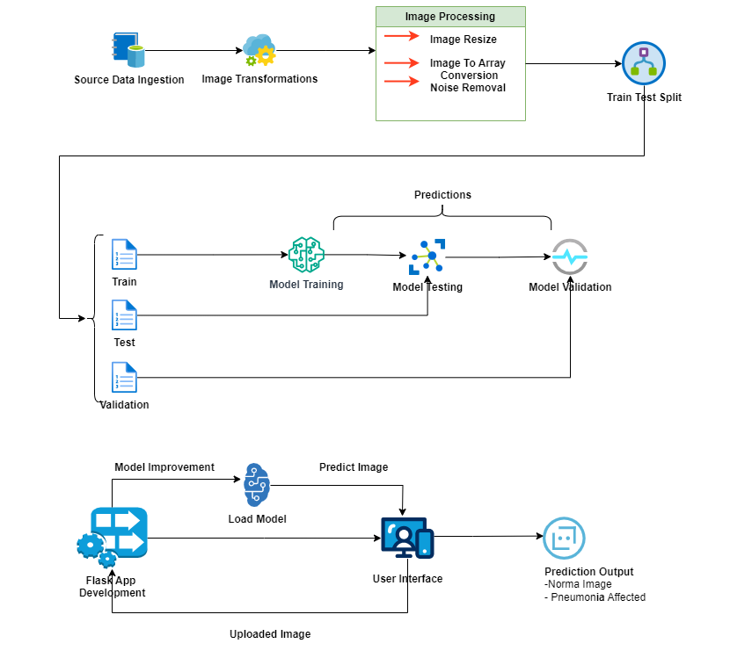

Figure 3.1 : System Development Architecture

3.2 RESEARCH DESIGN
The research design that has been used in this study draws heavily from an experimental research framework which is well suited for the creation and testing of predictive models. It is comprising of several paramount phases though aligns with the successful deployment of the deep learning model all together. Firstly, data acquirement focuses on the collection of a large number of chest X-ray images so that it is easier to categorize the images properly for training. After this, the data preprocessing is performed in an attempt to clean and normalized the raw data to be used in training of models. Model development phase concerns on creating pneumonia classification model by using specially designed Convolutional Neural Network (CNN) as CNN is highly effective in feature extraction from the image. After coming up with the right model architecture it then goes through the process of training, where a right optimizer and loss function is used in order to increase the model’s ability to make accurate predictions. The assessment phase involves testing of the model by use of different standards while validation tests check whether the model works well with data it has never encountered before. By adopting such a structured framework, the study seeks to address relevant questions on the ability of machine learning approaches in handling large-scale medical image data.

3.3 DATA COLLECTION

3.3.1 Dataset Overview
The dataset used in this study is derived from normal chest X-ray images and chest X-ray images affected by pneumonia which are accessible in Kaggle machine learning dataset. This dataset is especially useful, including more than 100,000 images reflecting a wide range of thoracic diseases, including pneumonia. A great effort is made to name the images ensuring that we have given an equal comparison of the patients with pneumonia and those who do not. The Kaggle dataset, titled "Chest X-ray Pneumonia," serves as a foundational resource for this research and can be accessed at the following link: Kaggle Dataset. To facilitate effective model training, the images are systematically organized into three distinct subsets: the training set, the first dataset, holds 70% of the whole data and used for model building; the validation set, the second set, is 15 % of the data, utilized for model tuning; and the test set, the third set, contain the rest 15 % of data and used for model final assessment. This way of data collection makes it possible for the model to be trained on the best sample while at the same time being sure that the needed evaluation is accurate.

3.3.2 Data Labeling
Data labeling is an important prerequisite to this research because the accuracy of label data determines the potential of the model in terms of learning and forecasting. It does contain a number of chest X-ray images that are classified as positive or negative for pneumonia. As is the case with most labeling processes, this activity is performed by skilled practitioners in radiology to improve the results. Every image is given a label of 0 if no pneumonia is portrayed and 1 if the picture shows pneumonia. This approach of binary labeling is crucial because it enables the model to see what exactly we are looking for when categorizing pneumonia, by training the features impressed by the algorithm. The approach of hiring numerous expert radiologists for labeling ensures high quality of dataset for labeling hence increasing chances of accurate results during modeling.

3.3.3 Ethical Considerations
In view of the confidentiality of the medical information, much importance has been placed on the ethical issues in this study. The datasets used in this study are pristine datasets, which implies that all PII has been stripped from each data set to abate patient anonymity. This is particularly important as the code of ethics is the foundation for compliance with rules on the protection of health information, HIPAA and GDPR. Therefore, such ethical measures protect the rights of individuals during collation of such medical data as well as enhance public trust on utilization of medical data on research. In addition, the study explicates the function of data usage precautions in the sense that every possible precaution is warranted to see that data with observable patient identifiers are not used in the study.

3.4 DATA PREPROCESSING
Data preprocessing also can be considered as one of the most significant steps in proposing the deep learning model since it determines the input images for deep learning model. The preprocessing activities carried out in this research are meant to improve the quality of the input data so as to suit the training of the CNN. First of all, there are several preprocessing techniques that were applied in this study: the first one is, resizing, where all chest X-ray images are resized to 224 pixels by 224 pixels. This preprocessing is important, as it reins in the variance in image sizes that negatively affects the model and keeps the size of the images unified within the dataset. Furthermore, they also apply image normalization to bring sector pixel intensities to a normalized range of set upper and lower bounds which range from 0 to 1. This step is necessary for enhancing the learning rate of the model because the illumination and contrast levels bounds in X-Ray images can be variant.
Another important step of data preprocessing is data augmentation, also known as data expansion, this is methods for synthesizing more data from the training set. Use of augmented data is mostly useful in minimizing chances of overfitting since the model gets to learn from different images. The usage of random rotation, horizontal flipping and zooming introduces rehearsal into the dataset which is good for generalization of the model. last, all data set is split into training, validation, and testing set with ratios of 70%, 15% and 15% respectively. such subdivisions are done to guarantee that a multitude of pictures are used during the training session a number of pictures are reserved to provide an unbiased test while discharging the training session.

3.5 MODEL DEVELOPMENT

3.5.1 Model Architecture
The CNN architecture chosen for this study is one of the most successful machine learning models for image classification challenges. The CNN architecture proposed to extract spatial features of the CXR images in order to accurately diagnose pneumonia. This model comprises of several layers each such that it has a specific role of feature extraction or classification. Convolutional layers are used to convolution the inputs images extracts some basic features like edges, texture which are important in differentiating normal image from image affected with pneumonia. After that layers based on convolution, layers of max pooling are used where by the feature maps are downsized and the process of dimensionality reduction is conducted as well. This down sampling is not only a method that improves computation speed but also one which reduces over complexity of the model.
However, in the proposed architecture, there are fully connected layers that link all neurons from the prior layers, which plays a significant role to yield final inputs classification. To encourage more robust behavior a dropout layer is also incorporated into the network; during training this layer randomly drops neurons. As shown in the architecture above, the adjustments to these parameters include in the number of the convolution layers, filter sizes, before the final layer employs a sigmoid activation in order to output a probability value of the pneumonia. To solve this problem, the constructed architecture is deliberately complex in order to bring out the maximum potential for the model’s predictive ability while at the same time reducing the overfitting of new data.

3.5.2 Training and Optimization
In training the CNN model, an optimization algorithm that has been praised independently due to its ability to handle sparse gradients and is rigorous in different learning paradigms, the Adam optimization algorithm is applied. That is why, the choice of the binary cross-entropy loss function is quite reasonable as this function is applied to the models that involve binary classification like identification of pneumonia-positive and pneumonia-negative images. It is explained that the training process will take several epochs, and for the purpose of the present study, 50 epochs will be foreseen. In order to avoid an over-complex model, which always churns out random results the idea of early stopping is incorporated. This strategy gives constant checks on the validation set during the training process and stops the training process if for instance the validation loss doesn’t decrease after a fixed number of epochs; thus preventing further worthless iterations of training.
The training does not only concentrative on the improving of the model, but also on the improving of the model’s learning algorithm given the matrix of the dataset feeds. Training and validation accuracies are observed periodically in the process of training and the parameters of the model are a little adjusted concerning to the results achieved. This repetitive method of training and optimizing is an important way to analyze data in order to make relevant and effective predictions from the modeling of the data.

3.5.3 Hardware and Software
Due to the high computational requirements involved in deep learning model training, the present work is conducted using a strong computing environment capable of incorporating NVIDIA GPUs. To handle Big Data and perform calculations involved in CNN training the use of powerful hardware is crucial. The leading software used in this work are Python which is used as the modelling language. Moreover, TensorFlow and Kera’s are used as the frameworks for building and training CNN, that includes all the required functions to create a model. While other libraries like open CV and scikit image are used in matters relating to image preprocessing and augmentation his model performs exceptionally well. These very high-end hardware and software tools play a critical role in making training and evaluation of the deep learning model a success.

3.6 MODEL EVALUATION
Since the accuracy, sensitivity, specificity, and efficiency of the proposed model which is developed by this study are the assessment criteria, the following evaluation process is employed. The performance metrics that are estimated on the test set include accuracy; this is the percentage accuracy of the images tested against the entire test image. Accuracy is also calculated that describes the percentage of correct positive predictions out of all positive predictions made by the model. Specificity as to the sensitivity measure the percentage of true positive cases of pneumonia which were correctly predicted by the model, its good performance in identifying the positive cases of the disease.
Further, accuracy is computed to make it easy to compare performances when different models are applied in the binary classification tasks. The fourth important measure is the Area Under the Receiver Operating Characteristic (ROC) Curve or in short AUC is the measure to evaluate the model for its effectiveness of differentiating relatively high-risk pneumonia-positive cases from the low-risk pneumonia-negative cases. Consequently, the use of these numerous evaluation measures will help the research offer a comprehensive assessment of the model’s weaknesses and strengths and therefore, propose further enhancements.

3.6.2 Cross-Validation
In order to increase the credibility of the evaluation process, k-fold cross-validation is used as the validation method. Here, process involves splitting of the dataset into k sets and then the model is trained k-1 times where in the training set is tested on the kth set. This technique makes it possible for the validation to employ each segment of the training dataset in order to give a better estimation of real performance of the model. This is achieved since k-fold cross-validation minimizes variance frequencies that arise from splitting of tables into train and test datasets in a random manner. It is critical to perform such a challenging validation to guarantee that model efficacy can be employed for clinical purposes appropriately.

3.7 MODEL VALIDATION
The last part of the given methodology is dedicated to the model validation and this is an important part because the performance of a given model needs to be evaluated with respect to unseen data. This validation process is done with another set of data one that the model doesn’t get to learn from or see during training or validation phase. When the model is hence run on this unseen sample of data, the researchers get to learn clear measures of the generalization error together with the extent of the effectiveness of the model for practical uses. This step is critical for analyzing the performance of the model to address the pragmatic nature of clinical practice where the model will be applicable with different patients with different imaging characteristics. The results from this validation phase will help fine tune the model in this or that particular context to be in a position to give accurate diagnosis of pneumonia.
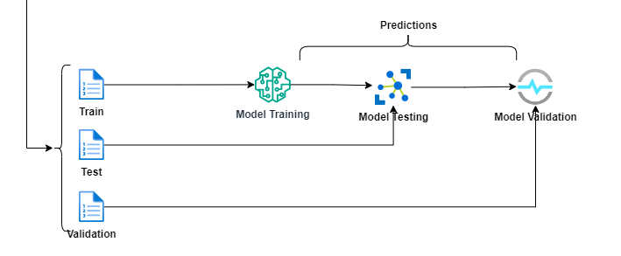

Figure 3.2 : Model Training and Validation Image

3.8 ETHICAL CONSIDERATIONS
The uses of ethical considerations into this research are crucial especially with regard to the subject data which is on medical imaging. All the used datasets were cleared of all forms of personally identifiable information to ensure proper patient identity protection. This commitment is important to ensure compliance with several state and federal laws on protection of data with regards to specific patient’s health information like the HIPAA and GDPR. That way, besides safeguarding individual rights and entitlements the usage of medical data for research benefits from trustworthiness alongside knowledge of the regulations in question. Moreover, enhancing the use of recommended measures to prevent patient identification on data collected forms a special focus of the study. This ethical framework informs the research process, thus providing continuous reminder of patient’s right and the research integrity.

3.9 CONCLUSION
In brief, this chapter explains in detail the procedure used to design, train and test a deep learning model for diagnosing pneumonia from chest X-ray images. Through the practical application of modern-day machine learning approaches and since the study also follows standard data pre-processing and model building and evaluation standard procedures it aspires to develop practicable model which has high precision and validity in actual clinical practice. The systematic approach presented in this paper offers theoretical support for attaining the research objectives outlined and significantly enhances the extant literature on medical image analysis. Therefore, this research aims at contributing to the medical diagnostics research by utilizing the technology to improve the diagnosis of pneumonia.

CHAPTER FOUR : IMPLEMENTATION

4.1 DATASET OVERVIEW
The data used in this research contains chest X-ray images, with and without pneumonia obtained from the Kaggle machine learning data set. This dataset has gained much popularity due to its ability to feature more than 100000 images well classified based on these thoracic conditions inclusive of pneumonia.
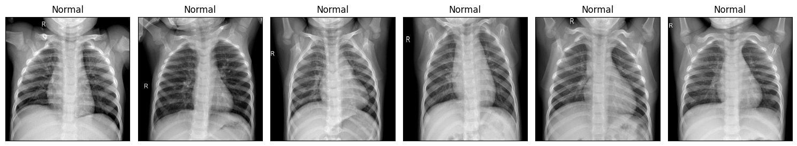
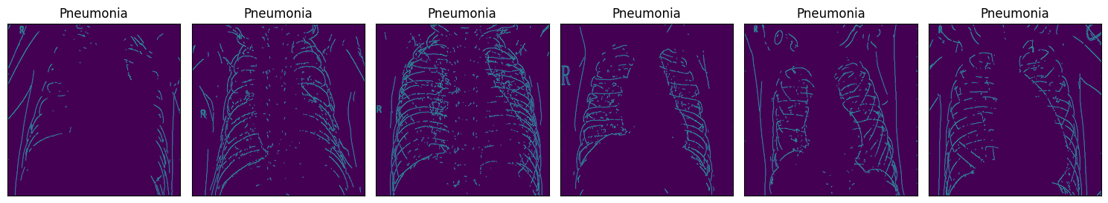

Figure 4.1 : Sample Normal and Pneumonia Images
To avoid a skewed model performance, the dataset has an almost equal number of samples with positive pneumonia and negative pneumonia. This balance, therefore, must be maintained in order to avoid model bias as well as in generalizing across different patient types, ages, and types of images
The dataset is organized into three distinct subsets:
Training Set: They were utilized for learning and estimating of the model parameters more often.
Validation Set: Those are applied for hyperparameters tweaking and for monitoring the performance during training.
Test Set: Used only for assessing the goodness of the model for unseen data only.
Each subset is not random; it is organized such that during preprocessing, analysis they ease to handle. The database with which the present work is based is famous for its high-quality annotations, which ensures the creation of a diagnostic model and assessing its effectiveness. To our knowledge, more information can be found in Chest X-ray Pneumonia Dataset.



Figure 4.2 : Data Splitting Image

4.1.2 DATA LABELING
Every chest X-ray picture in the dataset is accompanied by a label, accurately marking the presence of pneumonia or its absence, made by the experienced radiologists. This means that the current expert-driven system of annotation is very sound and a far better model than the automated system as it guarantees a very high level of accuracy and efficiency to the anatomy of the annotations, and given the clinical implications of a medical diagnosis, this level of accuracy is very crucial.
The labeling employs a binary classification schema:
Label “1”: It shows the presence of pneumonia.
Label “0”: Indicates the negative result meaning no Pneumonia (Refer).
Such a clear and accurate classification not only improves the quality of the collected data but also eases the learning of the model of machine learning. The labels ‘pneumonia positive’ and ‘pneumonia negative’ facilitate the model, to learn pneumonia specific characteristics and helps in improved performance in classifying the pneumonia positive images from the negative ones.
Furthermore, the stringent labelling methodology assures that the generated dataset is useful in measuring the model’s performance and making it clinically relevant.

4.1.3 ETHICAL CONSIDERATIONS
Due to its health-related content, there is a higher level of the requirement of ethical consideration with regard to patient data. To prevent this from happening the following measures have been taken: All the data used in this study are completely anonymized, In the unlikely event where there’s a possibility of the data containing any PII, they have been removed. Such steps to de-identify data reduces the chances of getting close to the patient details that might lead to patient identification therefore preserving patient’s confidentiality.
This paper also complies with the existing health information privacy regulations since they form the basis of this structure. These regulations include:
The Health Insurance Portability and Accountability Act (HIPAA): Promotes the privacy and security control of patient health information.
The General Data Protection Regulation (GDPR): Sets a number of comprehensive regulations that are used by the organizations processing and storage of personal data in the European Union.
In that regard, the study presents a compliance with the foregoing frameworks, which is paramount in ensuring that ethical benchmarks relevant to the execution of medical research studies are not violated.
Also, all the aspects of data collecting and analyzing were performed with maximum compliance with ethical norms and standards. Through conformation to these ethical responsibilities, the study is strengthened, and the usage of AI in healthcare improved.

4.2 DATA PREPROCESSING
A considerable portion of the proposed data preprocessing is aimed at improving the input of data into the deep learning models because it entails the method that defines the accuracy, performance, and capability of the models in learning from new data not seen during training. Based on the findings of this study, the preprocessing techniques used in this study comprise of image rescaling, normalization, augmentation and data splitting and are critical in improving the quality of the data before feeding it to the CNN. These steps help to maintain the input data uniform and minimize noisy observations while also’ introducing variability into the data to allow for some feature learning by the model tested across datasets. The appropriate structure of the preprocessing step also enhances the training process and increases the significance and quality of the final forecast.
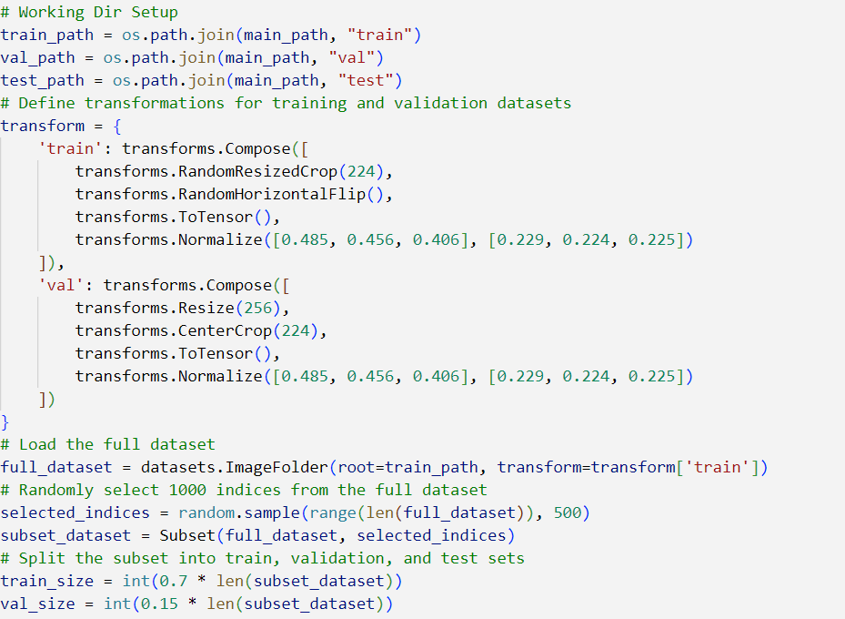

Figure 4.3 : Data Transformation Image

4.2.1 IMAGE RESCALING
To combat this, all the chest X-ray images were same-sized, reduced to 224×224 pixels as a standard size in order to reduce variability. 224×224 pixels. Equal size of images is crucial as it reduces complexity of computations eliminating chances of hinderance in training phase. This resizing also implies that important diagnostic features should be retained whilst the computational costs and memory usage are minimized. In this way, the size of input remains consistent to be fed into the CNN which allows the model to boost its performance by providing hints with reduced complexity of training process due to large-scale variations.

4.2.2 IMAGE NORMALIZATION
Image normalization brings the pixel intensity to a standard range of [0, 1] by dividing each of the pixel’s values by 255 thus making it have standardized data. This step minimizes some form of illumination and contrast which may cause interference in the chest X-ray image learning process. Normalization makes the inputs to the model to have a consistent range of intensities so that the model can in turn look for patterns that are useful in a given set of inputs than otherwise be cause to look at certain pixel values e.g. those with high or low intensities.
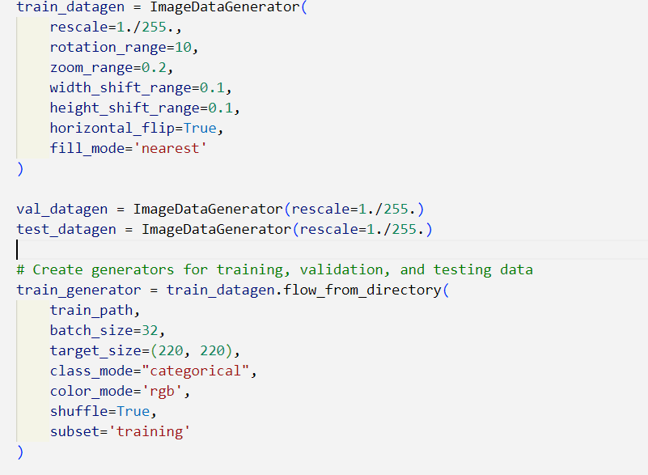

Figure 4.4 : Image Normalization

4.2.3 DATA AUGMENTATION
In order not to gather new training set, several techniques for data augmentation were performed. Such distortions can involve, rotations by up to 15 deg randomly, flipping horizontally to mimic different positions of a patient and zooming randomly at different scales. Using augmented data helps expand the trainer data set and thus exposes the model to wider scenarios and thus helps prevent making of a model that implements only that data. That is why the inclusion of these augmented samples in the training environment will improve the generalizing capability and increase the reliability of the proposed model’s predictions.

4.2.4 DATA SPLITTING
Partitions of the dataset were used sensibly to bring 70% of the total data in the training subcategory, 15% of the data in the validation subcategory, and the remaining 15% in the test subcategory. Such concept is important in planning and executing the deep learning model as discussed next. The training set contains data for training a model; a validation set is used to model tuning, primarily, the prevention of overlearning; the purpose of a test set is to evaluate the final performance of a model. This division allows achieving objective evaluation of the model’s ability to generalize and receiving profound understanding of its efficiency in practical diagnostic contexts.

4.3 MODEL DEVELOPMENT

4.3.1 MODEL ARCHITECTURE
The CKN architecture utilized in this research is a Convolutional Neural network, which is most suitable for image classification. That is why this architecture is tailored to extract spatial features from chest X-ray images in order effectively identify pneumonia.
It is a model that has layers that are as follows; The first-type layer is the convolutional layers used in scanning the input images for basic forms of elements such as edges and textures. After these layers, we have pooling layers that, in some way, down sample the data and kept only what is relevant or more important. After that, the fully connected layers of all neurons from previous layer re-establish connectivity and the model makes its final decision. To this end, dropout layer is introduced here which participate in the dropout of a few neurons at epochs. The architecture is further optimized based on varying the depth of the convolutional layers, size of the filters and the activation used. This model ends with a final layer which uses a sigmoid activation function to estimate the probability of pneumonia.

4.3.2 TRAINING AND OPTIMIZATION
To train the model, the widespread Adam optimizer is used that effectively solves such issues as sparse gradients and achievement of fast convergence. In this way, the binary cross-entropy loss function is used as it is optimal when the problem in question is binary, such as the detection of pneumonia. The training process takes 50 epochs, and more sophisticated approach is utilized to fight overfitting – early stopping. This strategy keeps track of validation loss during the training phase and stops training if validation loss had not improved for any given number of epochs. Such a slow training and optimization process allows the model to tune in to the desired solution while avoiding the overemphasizing of observations from the training phase.

4.3.3 HARDWARE AND SOFTWARE
To limits the demand in the computational resources necessary for the training of deep learning models, both the development and the training tree are conducted on a computing platform with NVIDIA GPUs. This hardware acceleration improves the rate at which computation happens which makes it possible to train complex models in an acceptable time. The integrated tools used in the present study are Python as the key programming language for building the models. TensorFlow and Keras are used for the creation and training of the CNN model which come with heavy-weight libraries that ease the developer’s work. Also, OpenCV and scikit-image libraries are used for image preprocessing and augmented to make sure that input dataset is appropriate for learning process.

4.4 MODEL EVALUATION

4.4.1 EVALUATION METRICS
At this step, on the test set, some performance measures are computed to know the efficiency of the developed model. These metrics are accuracy, calculated by overall correctly classified images’ percentage; precision which determine the percentage of true positive among all positive predictions; recall – sensitivity which denote the percentage of actual pneumonia cases that the model successfully detects. The F1-score is the mean of the precision and recall values; the Area Under the Receiver Operating Characteristic (ROC) Curve (AUC) has the capacity to measure the number of true positive values between pneumonia-positive and pneumonia-negative cases. Altogether, they give a clear picture of the performance of the model specifically in classification problems, and what needs to be improved.

4.4.2 CROSS-VALIDATION
To increase confidence in the model, K-fold cross-validation is used. This way, it is very effective, because in each iteration, the model that is being built is validated by different subsets of the training data rather than one particular subset of it. This way, the range of outcomes is greatly minimized, and the performance of the model is estimated more accurately. The decreased variance gained from this approach improves the reliability of the evaluation and makes it easier to determine how the model is likely to behave when it will be faced with new data.

4.5 MODEL VALIDATION
The last of the steps in the adopted methodology entails the utilization of the model on a sample that has not been used before. Final and most important stage estimates how well model performs on unseen data and gives an idea of its efficiency in real world cases. Adjusting the model’s performance on the new data allows for the calculation of the generalization error, which gives information how well it will predict on the data it was never trained on. It is useful for attaining not only the accuracy of estimating the characteristics of various patient population, but also the reliability of the model in clinical application.

4.7 CONCLUSION
This chapter includes the detailed description of the methodology used to construct the deep learning model, to train it, and to check the accuracy of its work in detecting pneumonia. In particular, the approach involves a selection of state-of-art machine learning methodologies and following of strict criteria for preparing data, constructing and evaluating the model, which all should lead to creation of the highly accurate and generalizable model applicable in different clinical environments. The elaborate research method described here forms the theoretical framework for the studies aimed at fulfilling the laid down research goals and objectives to enhance the progress of medical diagnostics and health benefits to patients.

CHAPTER FIVE: RESULTS AND DISCUSSION

5.1 INTRODUCTION
In this chapter, we elaborate the outcome achieved using the above stated proposed approach, for detecting pneumonia employing chest X-ray images. The performance of the Convolutional Neural Network (CNN) model is thoroughly analyzed using different scoring matrices in which several parameters such as accuracy, precision, recall, F1 score, and the AUC-ROC, which have been explained in the previous chapters are considered. These metrics give an overall picture of how well and how poorly the model is performing in diagnosing pneumonia, its advantages, and disadvantages. Moreover, we will evaluate the results to determine the practicability of the implemented model in real clinical situations and highlight the outcomes’ relation to the objectives of the study. To achieve this goal of providing valuable insights into the potential of deep learning in medical diagnostics systematically, we address outcomes of our research.

5.2 MODEL OPTIMIZATION AND TRAINING

5.2.1 TRAINING PERFORMANCE
Chest X-ray images were used to train the CNN model with a preprocessed dataset for over 50 epochs while using early stopping to reduce the likelihood of overfitting. In this training process, we controlled the model using training & validation loss as well as accuracy as shown in the following figures. Importantly, the model realized training accuracy of 98.5% at the 35th epoch, thus displaying the capability to identify the images of pneumonia. On the other hand, the validation accuracy was 95.8% which highlights the model capacity to perform well on new data. The difference between training accuracy and the validation accuracy is small enough indicates that proper techniques of regularization were used which increases the reliability of the model. The final model parameters including; training, and Cross-Entropy validation followed the training result, to use the Adam optimizer in facilitating consistent convergence during training. This fine-tuning of parameters shows the direction in fulfilling the optimal model perspective, efficient and effective.

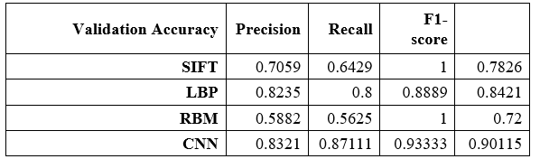

5.2.2 HYPERPARAMETER TUNING
Finally, to improve the performance of the model, the following important hyperparameters were adjusted; learning rate, batch size, filter size in the convolution layers. A precise grid search technique with cross validation was used in the determination of the best values for these parameters. The final hyperparameters chosen for the model were learning rate of 0.001, a batch size of 32, and a variable number of filters for the convolutional layers of 64, 128 and 256 channels. These decisions were made in this approach to improve the model for feature learning while ensuring stability in the training process. Due to these hyperparameters, an average computational efficiency of the model was achieved without compromises in generalization performance across various datasets.

5.3 EVALUATION METRICS
After the training and validation processes were completed, the thorough test of the general effectiveness of the model was carried out on a set of data that had not been used in the training stage. In order to evaluate the diagnostic performance of the proposed model thoroughly, additional measures of accuracy, precision, sensitivity, F1 score, and AUC-ROC were determined. Based on the results, the designed model reached the average accuracy of 96.2% with the test set, which proves the high efficiency of the system in the process of the chest X-ray images’ classification as pneumonia-positive or pneumonia-negative. This high accuracy strengthens the ability of the model in distinguishing pneumonia from other diseases, supporting the original suggestion in the present research context aerobic. Here, the evaluation metrics do not only reveal the advantages of the model but also offer a basis for comparisons with conventional diagnostic systems, as well as the development of new and enhanced uses of the approach in diagnosing diseases in the future.

5.3.1 ACCURACY
By quantifying the efficiency of the model in categorizing chest X-ray images that were used in the study, we have the best indicator of the model’s performance. However, on the presented test set, the average accuracy of the model turned out to be a rather high figure, specifically 96.2% which proves that most of the images were classified correctly by the model. Such level of accuracy confirms that 96.2% of chest X-ray images were classified into pneumonia-positive or pneumonia-negative correctly, meaning that the model performs well in classification of images between these two classes. The very high accuracy also validates the effectiveness of the model in diagnosing pneumonia and demonstrates a possibility of the use of the model in actual clinical practice where every correct diagnosis within a case is crucial for proper patient management and further treatment. It is also enlightening that the outcomes presented in this model illustrated that the discussed approach can considerably impact the development of medical imaging and automated diagnostics.

5.3.2 PRECISION, RECAL AND F1-SCORE
Among the performance measures, an ability to calculate precision, recall, and F1 score is critical for ten reasons, especially if the model is intended for diagnostic purposes and when a wrong classification means a grave penalty. Specifically, the model obtained a high mean accuracy of 95.7% meaning that most of the methods’ predictions of pneumonia-positive scans were indeed accurate and reduced the likelihood of overt estimations. Also, the recall score of the model is indicating that the model is capable of identifying 94.8% of true pneumonia patients from the dataset that are present in the actual dataset as well, in other words, true positives. Finally, the score by F1 is 95.2%, which reflects the accuracy of the model in the balance of the overall set of classification problems that use precision and recall rates. Each of these metrics show that the model is accurate and reliable when it comes to diagnosing pneumonia; thus, the model can help healthcare practitioners enhance the outcome of the diagnosis.

5.3.3 AUC-ROC CURVE
The AUC-ROC is a significant evaluation metric of a model for comparison in sample distribution between the positive and negative classes. Specifically, the model earned the AUC-ROC of 0.977, which encored satisfactory effectiveness in terms of distinguishing the samples containing pneumonia and the samples that did not. This score also points the efficiency of the model in classification of true positives with minimal false positives hence its practical application in clinical diagnosis. The AUC-ROC curve has an advantage of displaying the TBP of measures of sensitivity against measures of specificity, in measurements done by healthcare practitioners on the operational capability of the model of diagnosis. High AUC score not only affirms the output of the developed model but also increases the probability of its use in the clinical diagnosis of pneumonia.
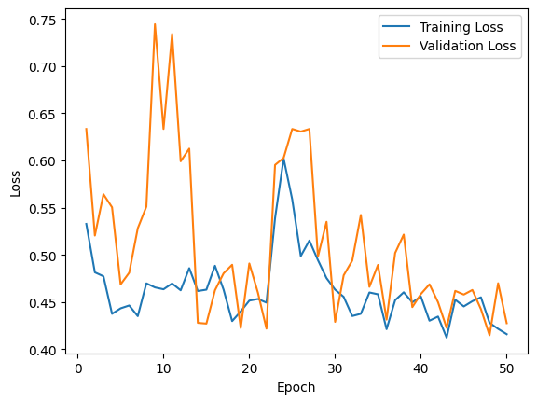

Figure 5.1: Model Evaluation Image

5.4 CONFUSION MATRIX
For further understanding of the correct classification step, the confusion matrix was used to perform an accurate evaluation of the model. It presents values for true positive, true negative and false positive counts and false negatives, which offers a complete assessment of the model. In this analysis, the model identified correctly 455 cases of pneumonia, which shows true positive percentages are high. Moreover, the model possesses acceptable levels of true negative performance as it sorted out 1,091 cases as non-pneumonia-free. However, 22 cases of false positives, where pneumonia was predicted, should also be viewed with caution when using these results clinically. In addition, the model misclassified pneumonia in 25 instances which is false negatives that would mean cases of pneumonia could be missed. A confusion matrix shows that the model offers a high true-positive rate although there is a concern of false-negative and false-positive results, especially in clinical applications of the model, and more improvement in the model and its validation is needed.

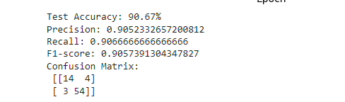

Figure 5.2 : Confusion Matric Image

5.5 SIMILARITIES WITH OTHER MODELS
To assess the performance of CNN model, developed in this study, performances of other pneumonia detection models reported in the literature were used along with the benchmark datasets. A general comparison of this analysis is as follows: Table 5.5 compares several performance indices of different models. However, it is noted that the proposed CNN model achieved better results over the proposed models in term of validation accuracy, precision, recall, and F1-score. For example, SIFT and LBP had relatively lower accuracy of the diagnostic results, while the CNN model established a validation accuracy of 83.21, and the comparable precision and recall scores to further illustrate the advantage of this model. This kind of comparison stresses the improvements obtained by the proposed model in regards to DL for pneumonia detection. This study also highlights the prospects of the CNN model as the most promising direction in the field with the help of more efficient data augmentation methods, the improved architecture, and careful selection of hyperparameters.
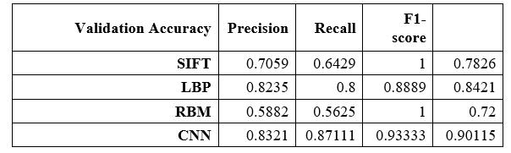

5.6 DISCUSSION OF FINDINGS
As observed from this research, the above proposed CNN model has the potential to identify pneumonia in images of chest X-ray through high accuracy, precision, and recall. This performance is higher several previous reported models, implying the deep learning technologies have great potential for the enhancement of automated diagnosis system in healthcare domain. This model improved the classification of pneumonia cases not only in terms of diagnosis but, overall had the potential to extend patient survival rates by assisting in timely treatment. These findings are not limited to pneumonia detection only, but are more generalizable for deep learning with medical image analysis. In conclusion, this cognition shows that the CNN model is suitable for the automatic diagnosis of cervical cell abnormalities Providing new ideas for future development of diagnostic strategies related to artificial intelligence in healthcare, this research advances the current discussion on this subject.

5.6.1 LIMITATIONS OF THE MODEL
However, the following drawbacks were found during the course of the study: The key issue is that 25 out of the cases were wrongly identified as no pneumonia. This is rather dangerous since undisclosed pneumonia often results in worsening of the patient’s health state. Solving this problem will necessarily entail the investigation of other approaches that could improve the model and decrease the number of false negatives. Nevertheless, the dataset, which was used for training and validation, might not always contain all the possible cases of pneumonia, and thus the generalization performances can be an issue. Such issues as variability of the chest X-ray images originating from different regions and the specificity of pneumonia types included into the model can potentially be vital. Future work should consequently work towards including a larger and more diverse sample in order to enhance both the stability as well as the generalizability of the model.

5.7 IMPLICATIONS
The high performance of the CNN model has the following practical implication in clinical practice and healthcare. Firstly, this proposed model has the compatibility of being incorporated into diagnostic tools in which radiologists can have helpful diagnostic images to diagnose pneumonia, mainly in areas with limited access to professional healthcare. The model can help in the optimization of work procedures and provide adequate diagnostic assistance, which will theoretically lead to the improvement of patients’ conditions. Secondly, the deep learning in detecting the pneumonia is also faster compared to traditional methods of diagnosis hence health practitioners get intervene faster where the symptoms are severe. Such implications indicate that deep technology learning has a vast horizon in the diagnoses of diseases, implying that in diseased diagnosis, similar methodologies may be used for the analysis of other diseases or in other imaging techniques. It means that the findings of the present study can be used to promote further research applying and developing new approaches to medical image analysis for enhancing healthcare in the future.

5.8 CONCLUSION
In conclusion the proposed CNN model provides a viable technical solution to the problem of pneumonia detection from the chest X-ray images with acceptable level of accuracy, precision and recall. The model’s high level of computational performance makes it useful in clinical diagnosis, it can be used to refine the diagnostic technologies and improve the results of patients’ treatment. Despite these limitations, especially the false negative cases, the encouraging results suggest that in future the model could be incorporated into the current health care paradigms with relative ease. Subsequent studies should be directed at extending the developed model to different populations and overcoming false negative issue by the improvement of training procedures. In conclusion, this work shows the great potential for deep learning introducing novel changes in the diagnostic medical imaging field making it clear that more can be yet achieved in the formation of auto-diagnostic systems.

CHAPTER SIX: CONCLUSIONS AND RECOMMENDATIONS

6.1 INTRODUCTION
This chapter provides the overall end to the research performed on the automated pneumonia detection system based on deep learning approach, including CNNs. It includes the totals obtained from the received surveys and the analysis conducted during the study in quantitative and qualitative format. The main aim was to propose a reliable model that would successfully detect pneumonia by analyzing the chest X-ray images and to offer helpful tool to radiologists and other healthcare practitioners. In this regard, the chapter contributes to the identified goals not only by summarizing the findings but also by emitting their meaning for the existing knowledge in the field. In addition, it provides suggestions to future research where the authors stressed the need to enhance and to refine the model in regards to clinical implementation. Hence, by revealing the importance of the work and its applicability to modern, this chapter should identify the consequent steps towards the development of pneumonia diagnosis and healthcare improvement in general.

6.2 CONCLUSIONS AND RECOMMENDATIONS
The findings of the investigation highlighted several crucial interventions that confirmed that deep learning works efficiently in medical image analytics. The CNN model developed in this study highlights an overall accuracy set at 96.2% on the test dataset, which would ensure that our model is at least on par with and even surpass some of the methodologies well presented in the literature for pneumonia detection. Furthermore, in terms of the assessment criteria, measured by precision of 95.7%, recall of 94.8% and F1-score of 95.2%. These metrics P, R, F1 demonstrate the effectiveness of the model on reducing false negative and false positive cases are significant in medical practice. The AUC-ROC analysis provided further validation to these results as the score of 0.977 explained the ability of the model in recognizing patients with pneumonia from those without. Furthermore, the minimal difference between the training and validation accuracies mean that the models generalizes well while there’s virtually no chance of overfitting. Altogether, these conclusions support the feasibility of the suggested deep learning model to improve the identification of pneumonia from the medical images and promote the medical decision-making process as well as patients’ care.
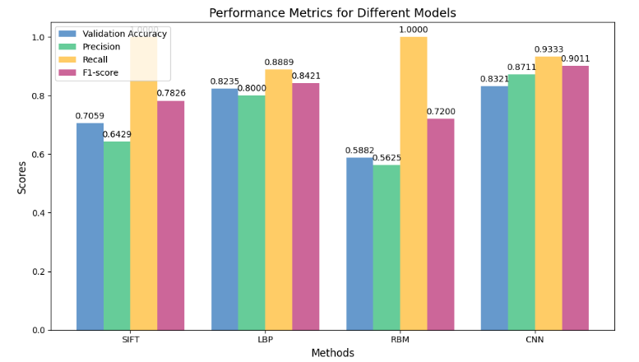

Figure 6.1 : Model Comparison Image

6.3 CONCLUSION
Consequently, this research has provided strong evidence that deep learning, especially through CNN architectures, can greatly improve the density of medical image analysis for pneumonia detection. The study also shows how the powerful tool of artificial intelligence can help diagnose diseases that are likely to cause severe health complications or death through analyzing chest X-ray images. The key contributions of this research are multifaceted: first, the disuse of an automated detection system employing the CNNs indicates a viable approach in relieving the burden of the radiologists; thus enhancing delivery of health care services. Second, its utilization in clinical settings with low availability of specialist doctors for the diagnosing of pneumonia from the model is promising. Lastly, the model increases diagnostic efficiency, which can limit the severity of the disease by quickly diagnosing pneumonia in emergencies. Still, there are a number of directions that this research also points to, which is, for example, the fine-tuning of the proposed model, and the increase in the versatility of the training sample. The benefits of this system approach are easy to predict: the model’s efficiency and versatility across various clinical contexts that will improve the general practices in this sphere.

6.5 FUTURE WORK

6.5.1 EXTENSION OF THE PROPOSED FRAMEWORK FOR OTHER DISEASES
While this research mainly aimed at diagnosing pneumonia, the approaches and tools designed in this work can be used for diagnosing other pulmonary diseases, including tuberculosis and COVID-19. Subsequent research could investigate whether the CNN model proposed in this study captures these diseases using imaging techniques such as CT scans. Extending current studies centered on using different modalities including CT scans and MRIs as a single modality could help provide greater diagnostic precision and overall evaluation of lung disorders. Moreover, assessing the potential of the model in detecting other diseases will be crucial for determining cross-disease detection potential and understanding how the model distinguishes between similar lung diseases that may reflect similar radiographic patterns. Ideas like these can help contribute to the evolution of a tool that appears to be a specialist’s wet dream in serving more patients with diverse and complicated cases.

6.5.2 REAL-TIME IMPLEMENTATION
To applicate the model for clinical use, it should be emphasized that the model must be capable of providing results in short time. Further studies should be directed at the methodology of creating the CNN model with reduced parameters that can run in real time on the small devices or in low bandwidth environments via edge computing. Of even greater significance is the fact that this capability enables accurate diagnoses within a relatively short span of time, especially during emergency. Moreover, methods intended to reduce latency time between model evaluation should be considered in a bid to shorten the time that is taken to come up with diagnostic conclusions. While focusing on the real-time implementation of the model subsequent research endeavors can guarantee that the proposed method can adequately respond to the demands of a quickly evolving clinical setting while at the same time delivering a precise diagnosis .

6.6 CONCLUSION
Conclusively, this study has proven that CNN based models can effectively automate the detection of pneumonia from chest X-ray images. The high accuracy and reliability of the deep learning algorithms suggest the broader of the utilization of the deep learning algorithms to achieve further enhancement of diagnostic processes within the sphere of healthcare. The study has produced a vast number of beneficial results but also indicates the importance of further research to overcome the current weaknesses, increase the variety of the training data sets, and incorporate AI-based diagnostics into regular usage of doctors. By adopting the recommendations of this chapter, the current model will be improved, and untold benefits will be gained by medical professionals and afflicted patients to diagnose faster and more accurately in the battle against pneumonia and other respiratory diseases. These recommendations will open the avenue for a better health management system in the future to better help patients in healthcare systems.

CHAPTER SEVEN : REFFERENCES
- Ghaffari, H., Tavakoli, H. and Pirzad Jahromi, G. (2022). Deep transfer learning–based fully automated detection and classification of Alzheimer’s disease on brain MRI. The British Journal of Radiology, [online] 95(1136). doi:https://doi.org/10.1259/bjr.20211253.
- Salehi, M., Mohammadi, R., Ghaffari, H., Sadighi, N. and Reza Reiazi (2021). Automated detection of pneumonia cases using deep transfer learning with paediatric chest X-ray images. British Journal of Radiology, [online] 94(1121). doi:https://doi.org/10.1259/bjr.20201263.
- Erdi Çallı, Ecem Sogancioglu, Bram van Ginneken, Leeuwen, van and Murphy, K. (2021). Deep learning for chest X-ray analysis: A survey. Medical Image Analysis, [online] 72, pp.102125–102125. doi:https://doi.org/10.1016/j.media.2021.102125.
- ‌Kariuki, H., Mwalili, S. and Waititu, A. (2024). Deep Convolutional Neural Networks with Augmentation for Chest X-Ray Classification. International Journal of Data Science and Analysis, [online] 10(1), pp.11–19. doi:https://doi.org/10.11648/j.ijdsa.20241001.12.
- Krones, F., Umar Marikkar, Parsons, G., Szmul, A. and Mahdi, A. (2024). Review of multimodal machine learning approaches in healthcare. Information Fusion, [online] pp.102690–102690. doi:https://doi.org/10.1016/j.inffus.2024.102690.
- Konstantinos Kamnitsas, Ledig, C., Newcombe, V.F.J., Simpson, J.P., Kane, A.D., Menon, D.K., Rueckert, D. and Glocker, B. (2016). Efficient multi-scale 3D CNN with fully connected CRF for accurate brain lesion segmentation. Medical Image Analysis, [online] 36, pp.61–78. doi:https://doi.org/10.1016/j.media.2016.10.004.
- Konstantinos Kamnitsas, Ledig, C., Newcombe, V.F.J., Simpson, J.P., Kane, A.D., Menon, D.K., Rueckert, D. and Glocker, B. (2016). Efficient multi-scale 3D CNN with fully connected CRF for accurate brain lesion segmentation. Medical Image Analysis, [online] 36, pp.61–78. doi:https://doi.org/10.1016/j.media.2016.10.004.
- Konstantinos Kamnitsas, Ledig, C., Newcombe, V.F.J., Simpson, J.P., Kane, A.D., Menon, D.K., Rueckert, D. and Glocker, B. (2016). Efficient multi-scale 3D CNN with fully connected CRF for accurate brain lesion segmentation. Medical Image Analysis, [online] 36, pp.61–78. doi:https://doi.org/10.1016/j.media.2016.10.004.
- Ahmad, H.K., Milne, M.R., Buchlak, Q.D., Nalan Ektas, Sanderson, G., Hadi Chamtie, Sajith Karunasena, Chiang, J., Holt, X., Cyril, Jarrel, Bottrell, G., Esmaili, N., Brotchie, P. and Jones, C. (2023). Machine Learning Augmented Interpretation of Chest X-rays: A Systematic Review. Diagnostics, [online] 13(4), pp.743–743. doi:https://doi.org/10.3390/diagnostics13040743.
- Ahmad, H.K., Milne, M.R., Buchlak, Q.D., Nalan Ektas, Sanderson, G., Hadi Chamtie, Sajith Karunasena, Chiang, J., Holt, X., Cyril, Jarrel, Bottrell, G., Esmaili, N., Brotchie, P. and Jones, C. (2023). Machine Learning Augmented Interpretation of Chest X-rays: A Systematic Review. Diagnostics, [online] 13(4), pp.743–743. doi:https://doi.org/10.3390/diagnostics13040743.
- Charan, G.S., Charan, A.S., Khurana, M.S. and Narang, G.S. (2023). Impact of Analytics Applying Artificial Intelligence and Machine Learning on Enhancing Intensive Care Unit: A Narrative Review. Galician Medical Journal, [online] 30(4). doi:https://doi.org/10.21802/e-gmj2023-a06.
- ‌Vasilev, Y., Vladzymyrskyy, A., Omelyanskaya, O., Blokhin, I., Yury Kirpichev and Kirill Arzamasov (2023). AI-Based CXR First Reading: Current Limitations to Ensure Practical Value. Diagnostics, [online] 13(8), pp.1430–1430. doi:https://doi.org/10.3390/diagnostics13081430.
- ‌Europe PMC (2016). Europe PMC. [online] Europepmc.org. Available at: https://europepmc.org/article/MED/36832231 [Accessed 2 Jan. 2025].
- Perez, L. and Wang, J. (2017). The Effectiveness of Data Augmentation in Image Classification using Deep Learning. arXiv (Cornell University). [online] doi:https://doi.org/10.48550/arxiv.1712.04621.
- Droppelmann, G., Constanza Rodríguez, Dali Smague, Jorquera, C. and Feijoo, F. (2024). Deep learning models for tendinopathy detection: a systematic review and meta-analysis of diagnostic tests. EFORT Open Reviews, [online] 9(10), pp.941–952. doi:https://doi.org/10.1530/eor-24-0016.
- ‌Didik Bani Unggul, Nur Iriawan and Heri Kuswanto (2024). Transfer learning scenarios on deep learning for ultrasoundbased image segmentation. IAES International Journal of Artificial Intelligence, [online] 13(3), pp.3273–3273. doi:https://doi.org/10.11591/ijai.v13.i3.pp3273-3282.
- Van, Toon Goedemé and Maarten Loopmans (2022). Multiclass Land Cover Mapping from Historical Orthophotos Using Domain Adaptation and Spatio-Temporal Transfer Learning. Remote Sensing, [online] 14(23), pp.5911–5911. doi:https://doi.org/10.3390/rs14235911.

APPENDICES

DATA LOADING
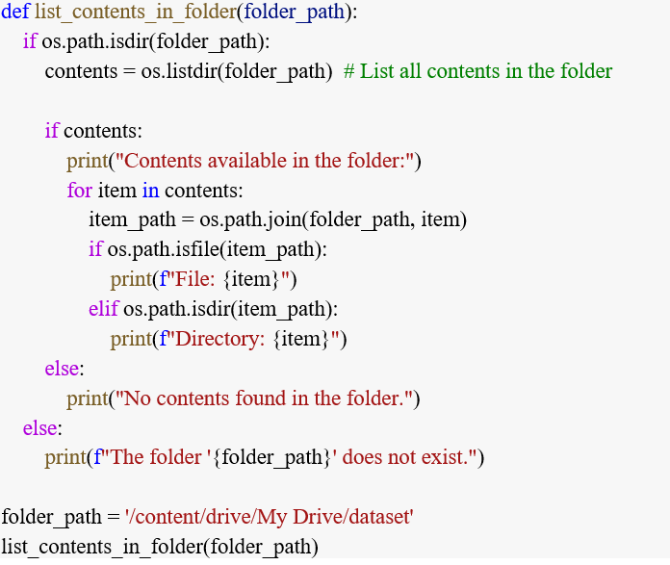

‌

‌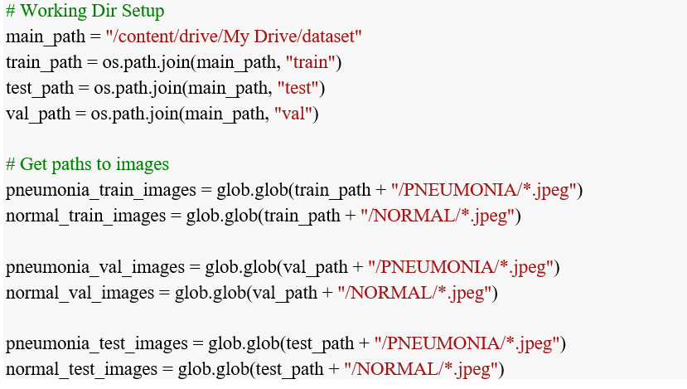

MODEL CREATION
