RAHEE
Week 4 Project Progress Report (Final Report)
Project | RAHEE, an online digital version of a travel board game
Team | Team 31 (5 members)
Report period | Week 4 (8 October - 15 October 2026)
Live game | https://rahee.onrender.com/

Current stage
This is our final report. All three bugs raised at the 7 October meeting are fixed and covered by automated tests, and the work planned for this week is complete. While fixing the Gwalior bug (B1) we checked every road on the board against the printed map and corrected 21 road records in total: 8 false roads removed, 2 missing roads added and 11 road lines redrawn. Players can now see where the other travellers are heading, a player whose connection drops can return to their own seat, and a server restart no longer interrupts anyone's game. The game is deployed and can be played from any network at https://rahee.onrender.com/. On the final build, the rules test suite and a full multiplayer play-through of 10 complete games both pass with no failures.

1. Work Completed This Week
Items 1 to 3 fix the bugs raised at the 7 October meeting. Item 4 is the board check that grew out of bug B1. Items 5 to 9 complete the remaining work planned in Week 2 and Week 3.
- Road-first route search (bug B2): The route search now runs in two passes. It first looks for a route that uses only roads and ships within the card's allowance, and allows flights only if no such route fits. A road route is chosen even when a flight would take fewer steps. The set of cities a card can reach is unchanged; only the route chosen is different. New Delhi to Mumbai on a 10 now goes by road through Agra, Gwalior, Bhopal, Aurangabad and Daman (6 steps). With only 1 step allowed, the flight is still offered as the fallback.
- Spare high cards set aside (bug B3): After each player receives their one guaranteed high card (a 10, or a J or 10 with 5 or 6 players), every other 10 and J is removed from the deck before the rest of the hands are dealt. Every hand now holds exactly one high card. The removed cards are kept in their own pile, separate from the undealt cards, so the test can still check that no card is missing or dealt twice.
- Gwalior route (bug B1): The cause was a false Bhopal-Lucknow road in the board data. The tool that traced roads from the printed map had followed two real roads end to end through Gwalior and recorded them as one road that skips Gwalior. We removed it, which leaves the real Bhopal-Gwalior and Gwalior-Lucknow roads. Sawai Madhopur to Madikeri on a 4 now goes Sawai Madhopur, Gwalior, Lucknow, a flight to Bengaluru, then Madikeri.
- Check of every road on the board: We checked every road against the printed map for the same tracing fault and corrected 20 more road records (listed in section 2). Amritsar-Jammu and Aizwal-Imphal were also flagged but kept, because they are separate printed roads. All corrections are kept in one file (tools/route-fixes.json) and the board data is rebuilt from it, so they are not lost when the board is rebuilt.
- Other players' destinations (Week 3 requirement 1): A Destinations tab on the left edge of the map opens a panel that lists every other player with their character, current city and how many of their six destinations they have reached. Clicking a player shows their six destinations with the reached ones ticked, and clicking a destination moves the map to it. The panel marks whose turn it is and who is offline, and it stays open from one turn to the next. It uses only public game information; no player's hand is shown.
- Reconnection: When a player creates or joins a room, the server gives that browser tab a secret seat token and keeps only a scrambled (hashed) copy of it. If the page is refreshed or the connection drops, the page reconnects by itself, waiting a little longer after each failed try and trying again at once when the network returns or the tab is shown again. It then uses the token to return to the same seat with the current game. A player who closed the tab can get their seat back by entering the room code and the same name. This works only for a seat that is currently disconnected, and it issues a new token. If the same seat is opened in a second window, the newer window takes over and the older one is told why.
- Connection status: While a player is disconnected, a “Connection lost — reconnecting…” banner shows at the top of their screen and the game stays visible underneath. The other players see an offline tag next to that player in the lobby, the turn indicator and the destinations panel. The server checks every connection every 25 seconds and closes any that stop answering, so a phone that loses signal is shown as offline instead of staying online forever. A malformed message from one browser can no longer stop the server.
- Room code for the host: The host's sidebar now shows the room code during the game, so the host can give it to a player who needs to rejoin. The start page tells players how to get their seat back.
- Deployment (Week 2 item 4): The game is live at https://rahee.onrender.com/ and can be played from any network, not only the local Wi-Fi. We checked that the deployed board data and rules engine are identical to the current build, and that the live server answers the reconnection messages.
- Regression tests: The rules test suite now has tests for B1, B2, B3 and the board corrections, so none of these can come back unnoticed (section 8).

Status of the items planned in Week 3
# | Item (from the Week 3 plan) | Status
1 | Fix B2: prefer road paths, offer a flight only when no road path fits | Completed
2 | Fix B3: set aside the leftover 10-valued cards, with a test for every player count | Completed (2 to 6 players, 200 deals each)
3 | Fix B1: re-check the routes around Gwalior against the printed board | Completed, plus a check of every road
4 | Regression tests for B1, B2 and B3 | Completed
5 | Click-to-open panel showing other players' destinations | Completed
6 | Reconnection so a dropped player can rejoin their seat | Completed
7 | Deploy so the game works outside the local network (Week 2 item 4) | Completed: https://rahee.onrender.com/

2. Bugs Fixed
The three bugs raised at the 7 October meeting with the POC and the design faculty member are fixed. Each one now has automated tests.
ID | Bug | What we changed | How we checked | Status
B1 | The route from Sawai Madhopur to Madikeri does not pass through the Gwalior node. | Removed the false Bhopal-Lucknow road. The real Bhopal-Gwalior and Gwalior-Lucknow roads remain. | Tests: no Bhopal-Lucknow road; Bhopal-Gwalior and Gwalior-Lucknow exist; the route on a 4 passes through Gwalior. Checked in the browser (screenshots 3 and 4). | Fixed
B2 | A flight is offered as the shortest path even when a road path exists. | Two-pass search: roads and ships first, flights only when no road route fits the card. | Tests: New Delhi to Mumbai uses no flight; with 1 step the flight is the fallback; no route exceeds the card. Checked in the browser (screenshot 5). | Fixed
B3 | Leftover 10-valued cards are shuffled back into the deck instead of being set aside. | Every spare 10 and J is set aside before the rest of the hands are dealt. | Tests for 2 to 6 players: no high card left in the deck and exactly one per hand, over 1,000 deals (200 for each player count). | Fixed

Board route corrections
These are the road records changed after checking every road against the printed map. A false road is one the tracing tool recorded across a city it does not stop at. After these changes the board has 153 roads, 48 flights and 3 ship routes (204 routes, down from 210).
Change | Road | Reason
Removed | Bhopal - Lucknow | Two printed roads through Gwalior (bug B1)
Removed | Kochi - Madikeri | Two printed roads through Wayanad
Removed | Bengaluru - Wayanad | Two printed roads through Udupi
Removed | Daman - Pune | Two printed roads through Mumbai
Removed | Badrinath - Rishikesh | Two printed roads through New Delhi
Removed | Coimbatore - Wayanad | The printed road bends through Kochi
Removed | Madurai - Thiruvananthapuram | No printed road; the route now goes through Kanniyakumari
Removed | Dharamshala - Jammu | No printed road; the route now goes through Amritsar
Added | Nagapattinam - Madurai | Printed road the tracer missed (hidden behind artwork)
Added | Kochi - Coimbatore | Printed road the tracer missed (hidden behind artwork)
Redrawn | Bhopal - Indore, Aurangabad - Bhopal, Lucknow - Gorakhpur, Gulbarga - Ratnagiri, Siliguri - Guwahati, Gandhinagar - Vadodara, Bilaspur - Rourkela, Srinagar - Jammu, Udupi - Wayanad, Hisar - Jaipur, Hisar - New Delhi | The road was correct, but its line on the screen did not follow the printed road (11 roads)
Kept | Amritsar - Jammu, Aizwal - Imphal | Separate printed roads that only pass near Dharamshala and Silchar

We then checked the corrected board again. No drawn road passes within 12 pixels of a city it does not stop at, and the routes named in the meeting now go through the expected cities: for example Daman to Pune goes through Aurangabad, Kochi to Madikeri through Wayanad, and Madurai to Thiruvananthapuram through Kanniyakumari.

Issues found during final testing
We found these while playing the final build. They do not stop a normal game.
- Clicking an airport one flight away still takes the flight. When a player clicks a city that is one move away, the game moves there directly, and every airport is one flight away from every other airport. So a player at New Delhi with a 10 who clicks Mumbai flies there for ₹4,200 instead of taking the 6-step road. The road-first search from B2 is only used when the clicked city is more than one move away, for example New Delhi to Pune (screenshot 5).
- The server trusts the player and the price named in a tourist visit. The visit message names who visits and whether the half price applies, and the server accepts both as sent. The game's own screens always send the right values, but a modified browser could charge another player ₹2,000 or claim the ₹1,000 shared price outside a road trip.
- The first visit after a quiet period is slow. The free hosting plan puts the server to sleep when nobody is playing; the first page load after that took about 23 seconds.

3. Deployment
Live address | https://rahee.onrender.com/
Hosting | Render web service, serving both the game pages and the game server
How to play | One player opens the address and creates a room; the others open the same address on their own devices, from any network, and join with the four-character room code.
Checked on | 15 October 2026: page loads, board data and rules engine match the current build, and the server answers the reconnection messages.

4. Remaining Work
The project is complete for this course. If work continues, these are the next steps:
- Send a click on a city one flight away through the same road-first search, and add a test for New Delhi to Mumbai through the screen.
- Have the server take the tourist visitor from the sender's seat (or check that the sender drove the road trip that just ended) and work out the price itself, and add a test.
- Keep the server awake during demonstrations, or move to a hosting plan that does not sleep.

5. Time Spent by Each Team Member, last Week
Hours are divided equally across the team for the previous week's work, covering the task areas below.
Name | Task(s) | Approx. Hours/week
Tanuj Sharma | Road-first route search for bug B2 and its tests (engine.js, test-engine.mjs) | 3
Sai Gawali | Fix for bug B1 and the check of every road on the board: removed, added and redrawn roads (build-board.mjs, route-fixes.json, board.json) | 3
Siddhesh Patil | Reconnection: seat tokens, resume and rejoin by name, connection checks (backend/rooms.js, handlers.js, protocol.js, app.js, net.js) | 3
Mukesh Dewangan | Other players' destinations panel, host room code, offline tags and reconnecting banner, and the Render deployment (sidebar.js, main.js, screens.js, styles.css) | 3
Kshitij Kasodkar | Dealing fix for bug B3 and its tests, and final testing of the build (engine.js, test-engine.mjs) | 3

6. Last Meeting with the POC
Date of last meeting | 14 October 2026 (Wednesday), 2:00 pm
Meeting cadence | Weekly, every Wednesday at 2:00 pm.
Mode | Offline

Key discussion / action items
- We demonstrated the fix for bug B1: the route from Sawai Madhopur to Madikeri now passes through Gwalior.
- We demonstrated the fix for bug B2: a road route is offered before a flight when one fits the card.
- We demonstrated the fix for bug B3: the spare 10-valued cards are set aside after the guaranteed ones are dealt.
- We showed the panel of other players' destinations and reconnection to a player's own seat.
- The POC accepted the fixes.

7. Date of the Current Build
Current build date | 13 October 2026
Build / version identifier | Commit 74dd80d, main branch
Live build | https://rahee.onrender.com/

8. Test Results on the Current Build
The rules test suite plays a large number of complete random games and checks the rules after every one of them. This week it also gained regression tests for the three bugs and the board corrections. It was run on the current build.
Total tests | 80 complete random games, each checked against every rule (deck composition, legal movement, scoring, and the two worked examples from the manual), plus the new tests for B1, B2, B3 and the board: 3,514 checks in all
Unsuccessful tests | 0
Successful tests | 80 games (3,514 checks)

We also played complete multiplayer games through the real game server, with one simulated player per seat, each sending exactly the messages a browser sends. For this run the database was replaced by a local file so that the server could be restarted during a game.
Total tests | 10 complete games (two each with 2, 3, 4, 5 and 6 players, using all six characters): 2,201 checks
Unsuccessful tests | 0
Successful tests | 2,201

What the play-through covered:
- Play: 198 turns, all moves made by choosing a destination; 21 road trips with accept, counter and decline replies, early and automatic drop-off, and a driver cancelling; Aces as a booster and as an extra memory; 92 flights; 153 tourist visits and 12 shared visits; 27 undos. Games ended both ways (8 on the last card, 2 on five destinations), the final round was played out so everyone had the same number of turns, and every score added up.
- Rules the server must refuse: acting out of turn, an illegal step, a road-trip destination out of reach, answering an invitation twice, a character already taken, starting before everyone has a character, a non-host starting the game, a wrong room code, and a new name joining a game that has started.
- Privacy: other players' hands arrive only as a card count, and the deck, the board and the random seed are never sent.
- Reconnection: refresh and resume with the token, offline and back online for the other players, a second window taking over the seat, a wrong token refused, rejoining by room code and name (with the old token stopping working), a connected player's seat protected from someone typing their name, a server restart in the middle of a game with every player resuming exactly where they were, and a silent connection dropped by the connection check.

Screenshots of the game
- Start page, with the note on how to rejoin a game
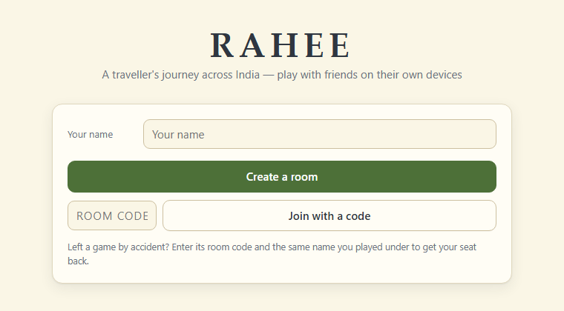
- The other players' destinations panel (left), with the host's room code in the sidebar and an offline player
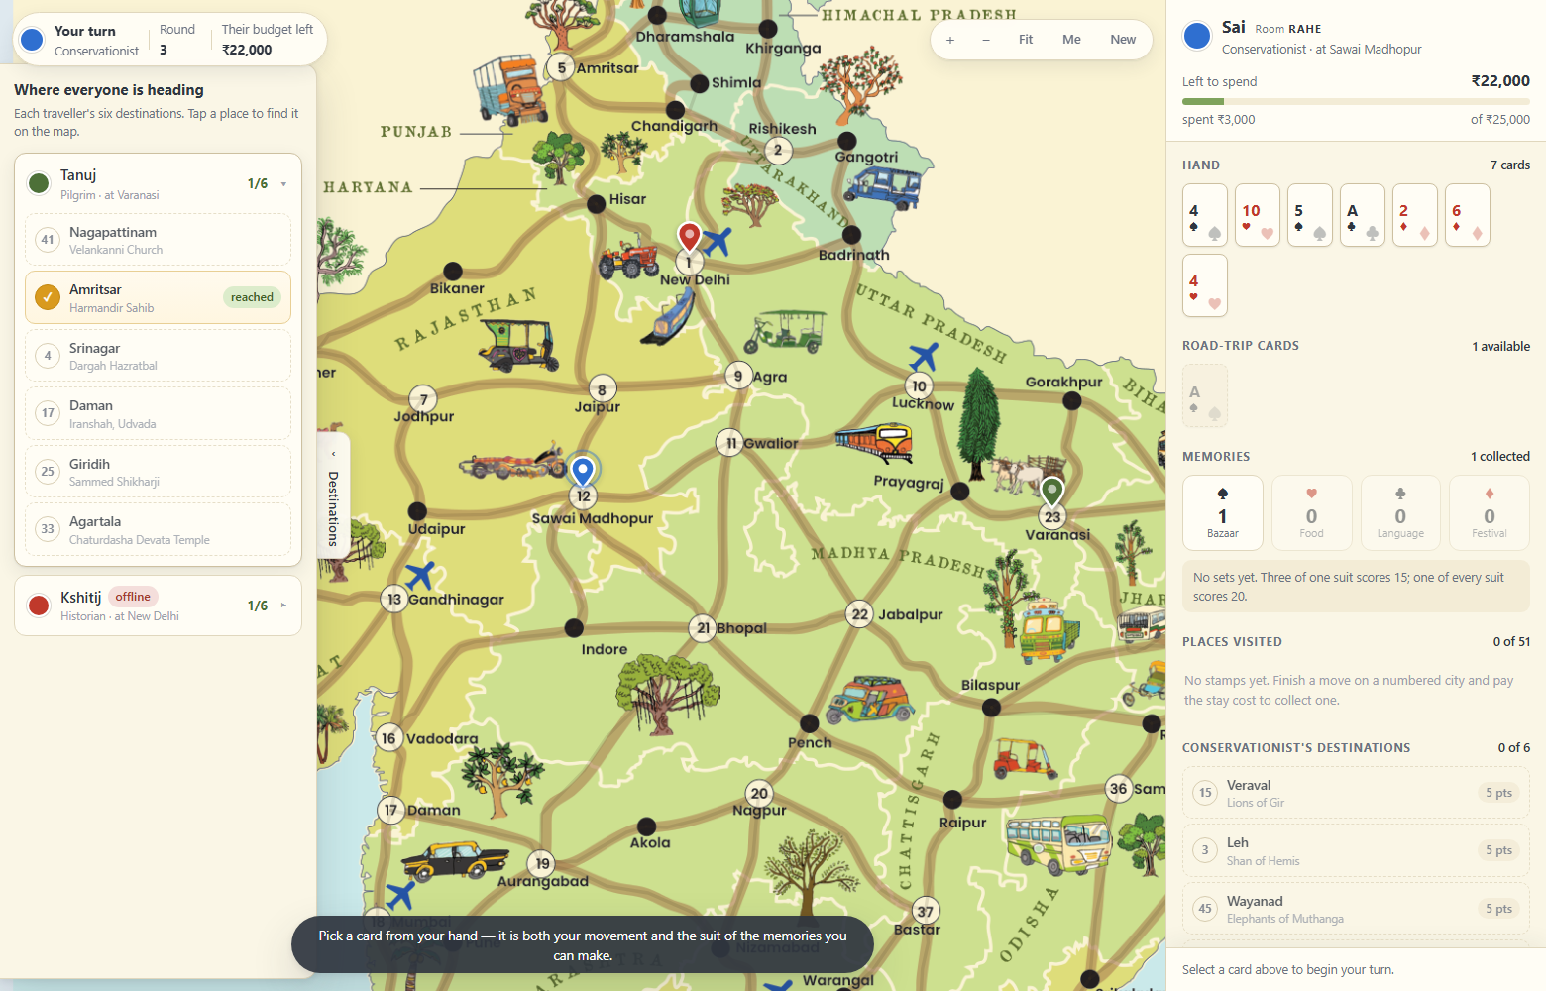
- Bug B1 fixed: the route from Sawai Madhopur to Madikeri on a 4 now goes through Gwalior
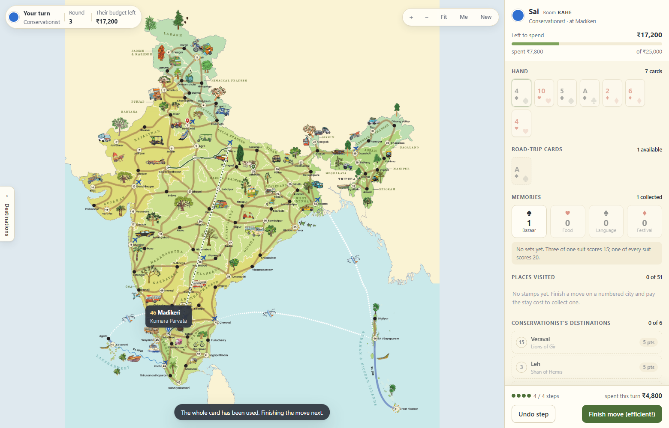
- Close-up of the same route: Sawai Madhopur, Gwalior, Lucknow, then the flight towards Bengaluru
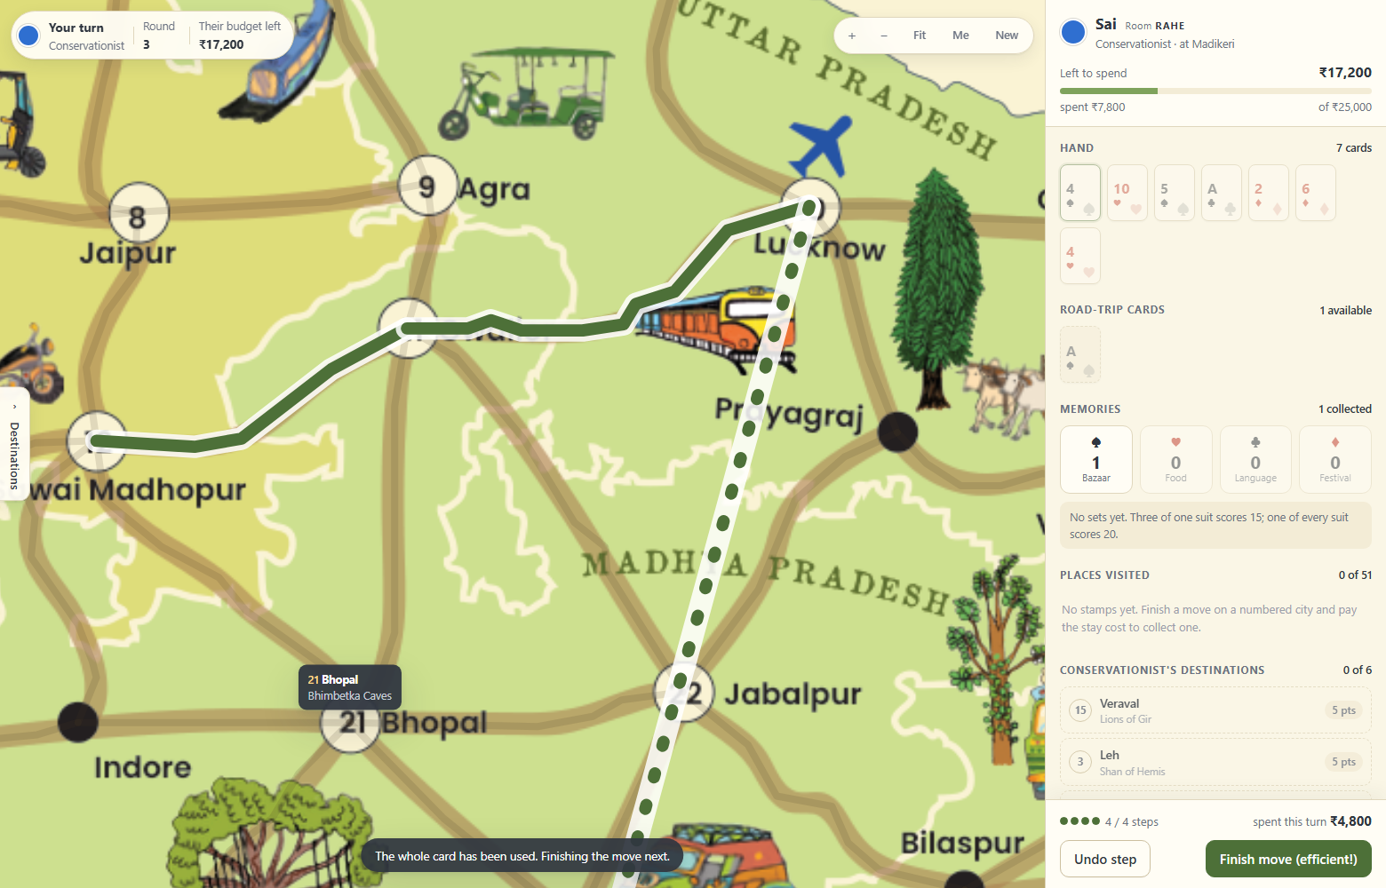
- Bug B2 fixed: New Delhi to Pune on a 10 goes by road (5 steps, ₹1,000) instead of flying through Mumbai
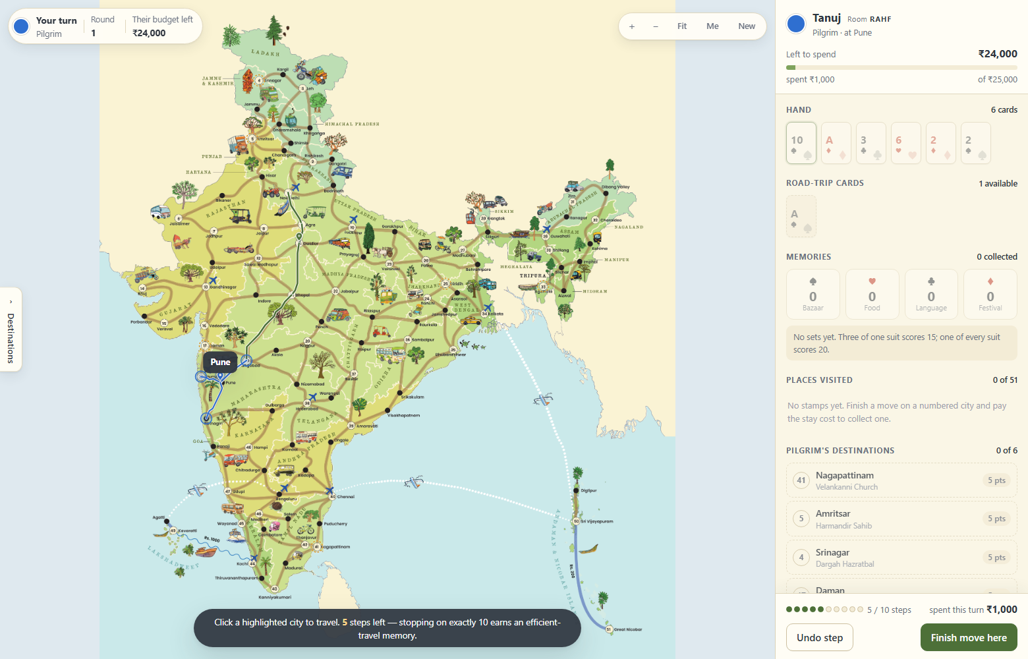
- Connection lost: the game stays on screen under the banner while it reconnects, and the player who left is marked offline
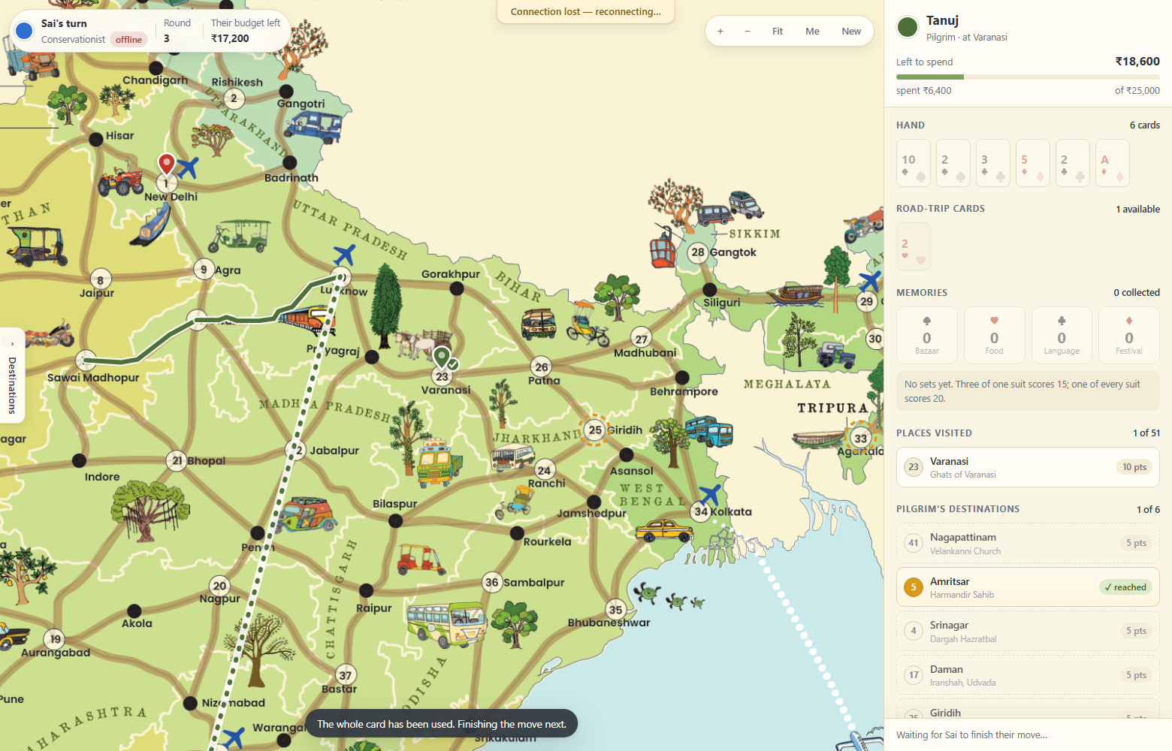
- The final scoreboard at the end of a 4-player game


