Implementing and Managing Active Directory in Windows Server

Objective:
To set up and manage Active Directory in Windows Server, including configuring domain controllers, structuring organizational units, managing user accounts, and implementing security policies.

Description:
This project highlights the value of centralized identity management, security, and resource allocation. Implementing Active Directory enhances authentication, enforces security policies, and simplifies user and group management for better cybersecurity and efficiency.

Problem Statement:
Organizations often struggle with managing user authentication, resource access, and security policies in large-scale IT environments. Without a structured Active Directory (AD) implementation, companies face challenges such as unauthorized access, inefficient user management, and weak policy enforcement, leading to security vulnerabilities and operational inefficiencies.
This project focuses on deploying and managing Active Directory in a Windows Server environment to centralize authentication, define organizational units, and enforce security policies through Group Policy Objects (GPOs). By structuring the AD environment, the project enhances network security, streamlines administrative tasks, and ensures compliance with enterprise security standards.

Tools Used:
- Windows Server 2022 — operating system for managing Active Directory and the enterprise network.
- Active Directory Domain Services (AD DS) — centralized user authentication and policy enforcement.
- Group Policy Objects (GPOs) — enforcing security policies and system configurations.
- Windows Defender Firewall — protecting the network by enforcing security rules and monitoring traffic.

Environment:
Two Windows Server 2022 virtual machines were used. The domain controller (DC001, 10.0.2.6) hosts the mydomain.local domain, and a client (client001, 10.0.2.7) joins it. The client uses the domain controller as its DNS server (10.0.2.1 gateway, DNS pointed to the DC).

Implementation:
The following sections document each task from the project brief, in order, with the configuration steps and corresponding output screenshots.

Task 1 Installing & Configuring AD DS (Domain Controller)
A static IP address was assigned to the server so it can act as a stable domain controller.
IP address: 10.0.2.6
Subnet mask: 255.255.255.0
Default gateway: 10.0.2.1
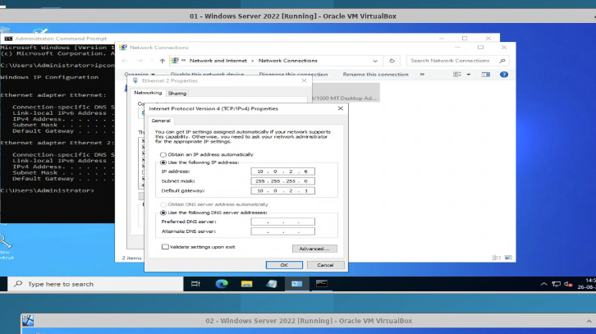
Figure 1
The server was renamed to DC001 to give the domain controller a clear, identifiable hostname.
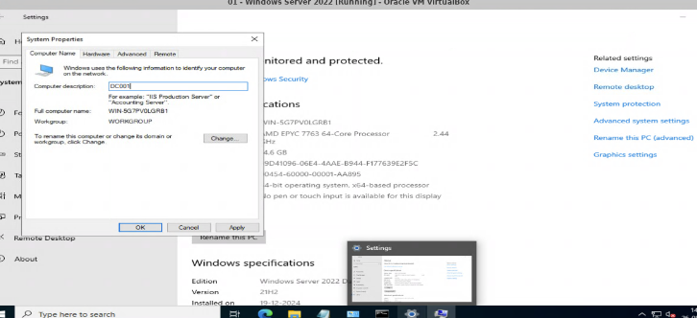
Figure 2
The Add Roles and Features Wizard was launched from Server Manager to begin installing the AD DS role.
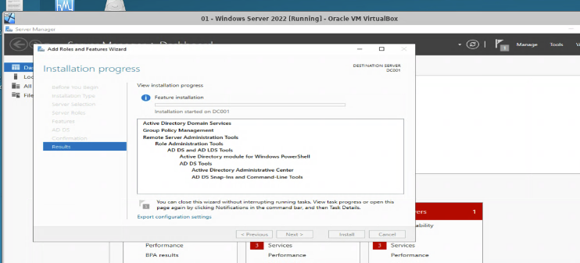
Figure 3
The Active Directory Domain Services role was selected, and the required management features were added when prompted.
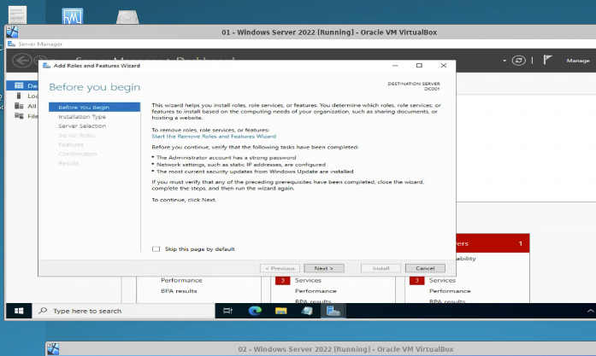
Figure 4 — Selecting AD DS and adding the required features.
The installation completed successfully, adding AD DS and its administration tools to the server.
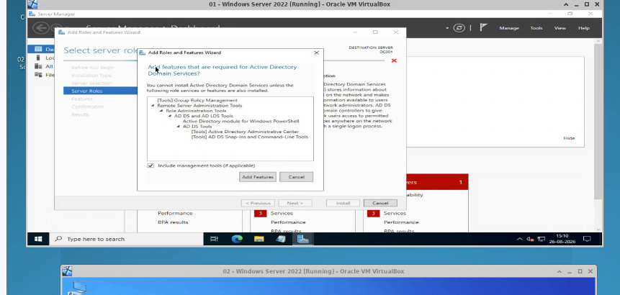
Figure 5 — AD DS installation results.
After the role install, the server was promoted to a domain controller, creating the new forest and domain mydomain.local.
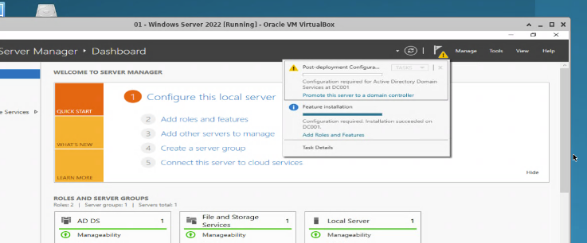
Figure 6 — Promoting the server to a domain controller for mydomain.local.

Task 2 Organizational Units, Users & Security Groups
Organizational Units (OUs) such as NOC and SOC were created in Active Directory Users and Computers to structure the domain by function. User accounts (trainer, watson) were created and added to the appropriate security groups to define their roles and access. The confirmation below shows the users being added to a group successfully.
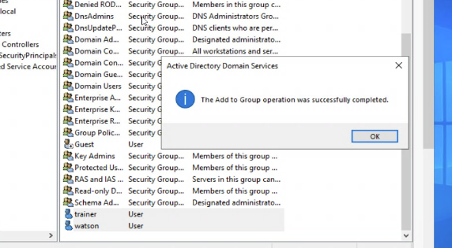
Figure 7 — Adding the trainer and watson accounts to a security group.

Task 3 Group Policy Objects (GPOs)
Group Policy was used to enforce domain-wide security. In the Group Policy Management Editor, the Account Lockout Policy was configured under the Default Domain Policy setting the account lockout threshold to 3 invalid logon attempts, with a lockout duration and reset counter of 30 minutes. Password policies (minimum length, complexity, and age) were similarly enforced through GPOs.
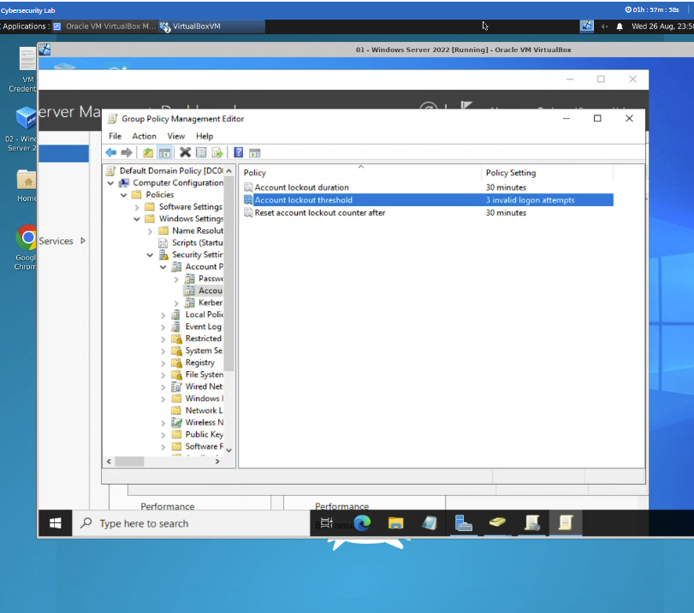
Figure 8 — Enforcing the Account Lockout Policy (3 invalid logon attempts) via GPO.

Task 4 Joining Client Systems to the Domain
The client was given a static IP and, crucially, its preferred DNS server was pointed to the domain controller (10.0.2.1) so it can resolve and locate the domain.
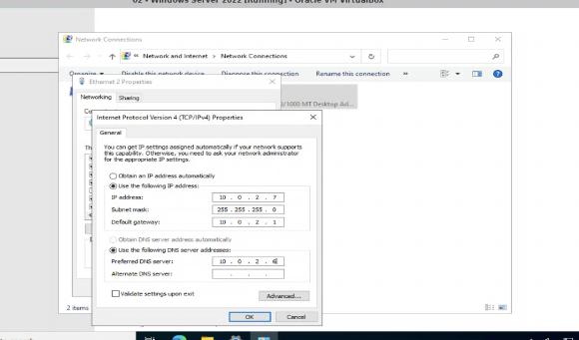
Figure 9
In System Properties, the Computer Name / Domain Changes dialog was opened to move the client from a workgroup to the domain.
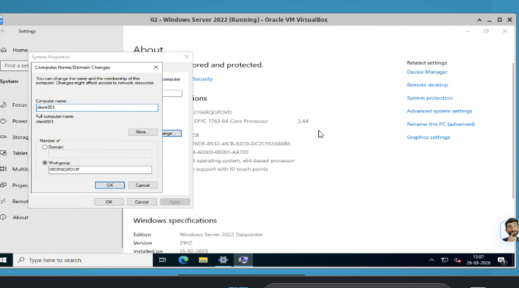
Figure 10
The client was joined to mydomain.local, and a restart was prompted to apply the change.
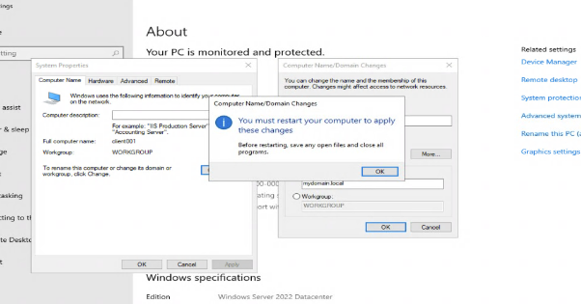
Figure 11
After restarting, a domain account was used to sign in for the first time, applying the domain user settings.
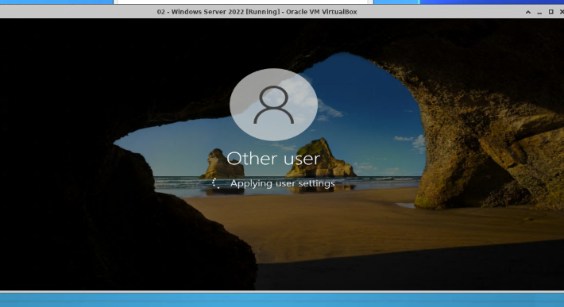
Figure 12
Domain authentication was verified from the client. Signing in as the domain administrator and running whoami returned mydomain\administrator, confirming the client authenticates against Active Directory.
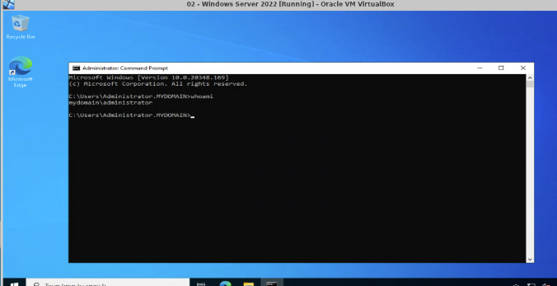
Figure 13
A standard domain user was also tested signing in as watson and confirming the identity with whoami -> mydomain\watson.
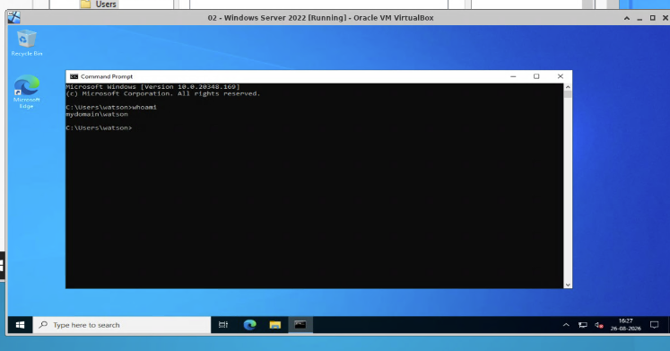
Figure 14
The trainer domain account was likewise able to sign in and load its desktop session.
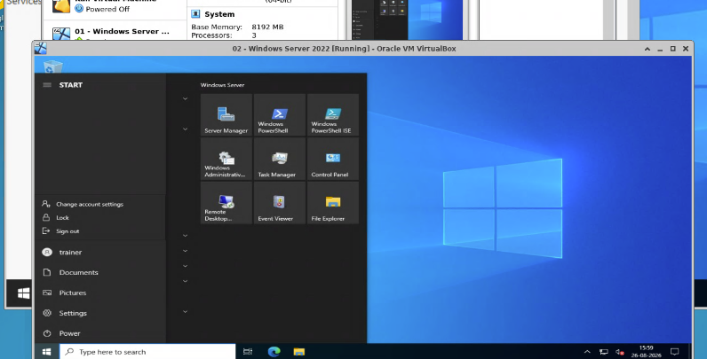
Figure 15 — trainer domain user session on the client.

Task 5 Security Measures (Login Restrictions, Lockout & Account State)
Logon-hour restrictions were configured for watson in the account properties, controlling the days and times the user is permitted to sign in.
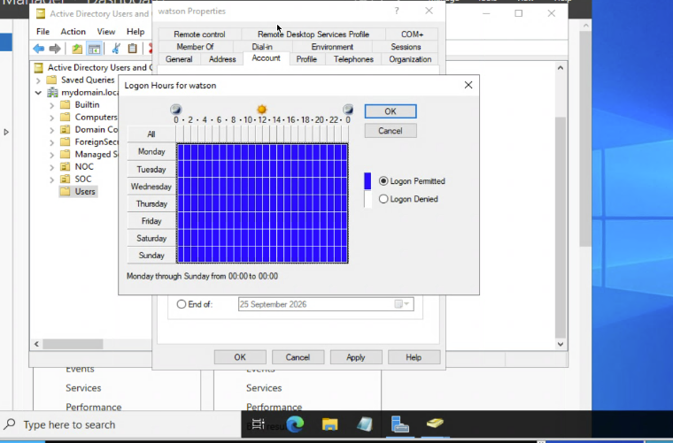
Figure 16
Accounts can also be disabled when access must be revoked. With the trainer account disabled, sign-in is blocked with the message that the account has been disabled.
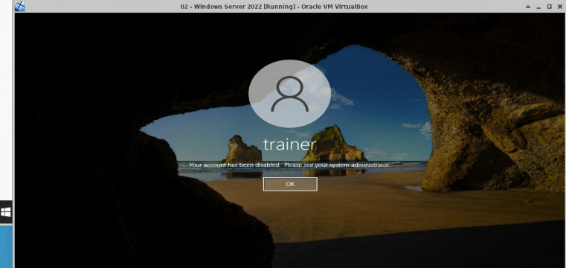
Figure 17
Finally, the account lockout policy was validated. After exceeding 3 invalid logon attempts, the watson account was automatically locked out, preventing further sign-in until reset.
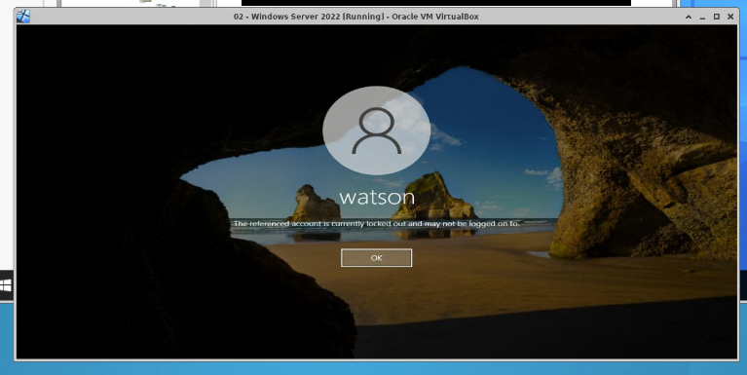
Figure 18 — Account locked out after 3 invalid logon attempts.

Conclusion:
This project delivered a working Active Directory environment on Windows Server 2022. AD DS was installed and the server promoted to a domain controller for mydomain.local, with a static IP and clear hostname for stability. Organizational Units, user accounts, and security groups were then created to centralize identity and structure access by role.
Group Policy Objects enforced domain-wide security including an account lockout policy of three invalid attempts and password requirements while client systems were joined to the domain and successfully authenticated using AD credentials. Additional security measures such as logon-hour restrictions, account disabling, and lockout enforcement were verified in practice.
Together these steps centralize authentication, strengthen access control, and simplify administration reducing security risks and improving IT efficiency in an enterprise setting.

