# **Jon Frederick Gray Ginsberg**

[jfghtx@gmail.com](mailto:jfghtx@gmail.com) / 281-870-2963

# **Professional Experience** -

# IT, IS, Mobile Application Dev, Azure CLoud, .Net, **Dev Ops**, SSIS ETL, T-SQL, Project Mgmt., Business Intelligence (BI), Microsoft Business Partner ID# 2019378, AWS S3, Route 53, AWS Lambda, AWS AI Lex Chat Bot, AWS DynamoDB, CodeStar, CodeCommit, CodeBuild, CodeDeploy, CodePipeline, X-Ray

# 20+ years working in the IT, IS, and Dev Ops environments on Windows (.Net), Mac (iOS), UNIX, and RedHat Linux Kernel Operating Systems for Applications Development

# 16+ years of experience in Software Development, Release Management, Build Automation, Batch Script, Continuous Integration, Testing, Microsoft Dynamics, Software Packaging Deployment Development (MS Exchange, SQL Server, T-SQL. SSIS / SSRS, SharePoint, Active Directory, Oracle, Java, JavaScript, Citrix, Perl, Python, Ruby, PHP, VB, C, Obj C, C++, C#, MorphX, HTML, CSS, MVC, Webforms, WinForms, WCF, WPF, Microsoft Enterprise Libraries 2-6, & Visual Studio 2005-2015, Dreamweaver IDS, Netbeans) for x86, RISC, ARM, Intel, Qualcomm, and Snapdragon Processors in Configuration Management / DevOps departments (Agile/Scrum - TFS, Quick Build, Jenkins, PMease, Chef, Puppet, Git, Confluence (Atlassian) Jira / TFS Work items / Rally) vNext Build, Core.Net, TeamCity (recent).

* 12+ years of Oil and Gas Business / Mining Technology Consulting Services, and Mortgage Banking Programming and Deployment, working closely with both the business process, development process, and testing processes as a TFS Admin, required to contribute to CBA (cost benefit analysis) reporting, (ERP / CRM/ MS Accounting).
* 11+ years configuring, compiling, building, and developing with .NET / Java technologies for the Oil & Gas (Production, Distribution, Process Safety, and Refining), Real Estate, Government, Media, and Service Industries.
* 9+ years SQL Server (2005, 2008, 2012, 2014), including SSRS, SSIS, and Crystal Reporting tools, entity framework, including working with SQL Management Studio, and Oracle Plugins.
* 10+ years with Agile / Scrum / KanBan through the PLMP and SDLC Iteration Management.
* 9+ years programming in C# (4.0 / 4.5) with .Net Framework 2.0, 3.5, 4.0, and 4.5.2., 4.6, .Net Core, NService Bus
* 3+ years utilizing Angular, AngularJS, Knockout & Polymer, React, Spine
* 3+ years AWS, Azure, and IBM cloud services, using web API. Azure cloud services, Azure message queue (Rest, FIFO), Azure bot service (Bot Framework) (API Cognitive Services – Cortana, Luis, Lex, Polly), Azure search service - Bing (Document DB, Azure ML service (Machine Learning - IoT using Arduino R3 Microcontrollers) (Azure IoT Hub)developing Browser Extensions. AWS S3, EC2, Route 53.
* 3+ years Microsoft Azure for Cloud Computing, including using WebMatrix. (Navision 2013 as a replacement for SAP - with integration for Microsoft BI and Azure cloud hosting used in MS Dynamics / NAV.
* 9+ years SAP and Microsoft SME (Navision 5.0 and Navision 5.0 / SQL Server and Client - GP and SL 2005) then Navision 2009 for the tailored client with CRM and GP (MS Great Plains). - Role Center, Sales, and MS accounting modules for Microsoft Dynamics SL for ERP.
* 8+ years SCM - Team Foundation Server (TFS), Subversion (SVN), GIT, Jenkins, Visual Source Safe, including PMEASE - Quickbuild, Node.JS for Web Servers, JBoss for Red Hat, Chef, and Puppet - For Continuous Integration builds
* 6+ years Microsoft SharePoint and Microsoft CRM, ERP, Dynamics (AX, GP, SL, and Nav) technologies.
* 7+ years developing Installer Packages and MSI type installers with InstallShield, Wix, Wise, working with transformation files and tokenization.
* 5+ years VM Virtualization, including VSphere, VMWare, ESX 5.5 Server, and Microsoft Hyper-V.
* 5+ years developing with ASP.Net, MVC, Silverlight (XAML), Phone Gap, Web Forms, Node.JS, JQuery, HTML, CSHTML, HTML5, CSS, JavaScript, Angularjs, and KnockoutJS
* 3+ years with Apache Hadoop / HIVE (SQL type Computations) (Pig) (Map-reducing / HDFS Configuration, Cordova.
* 4+ years with Google AdWords for Marketing Analytics and Metrics. Expert at Google Analytics and Google Adwords for AirBNB and Marketing the Wildcatter App.
* 4+ years Microsoft Release Management Software, Chef Software for Web Application Deployment, Apache Hadoop.
* 3+ years with Agile.net Obfuscator security encryption tool for code protection.
* 7+ years Developing Mobile Applications using Web API’s (22 and 23) for Android, Google Cloud Services, Windows Mobile, and Iphone (iOS) platforms, with Applications at the Google Play App store currently. I have approved Developer Accounts established with Google, Apple, and Microsoft. Experience programming API for Ok Google, Siri, and Cortana.
* 3+ years with Xamarin Studio and Xamarin Plugins for Visual Studio, Android Studio, MAC Swift / Obj. C, Windows Mobile SDK, iOS SDK, .APK’s, API 22,23, and Emulators for Cross Platform Android and Mobile Development.
* 1+ years working with Azure Bot Service, Luis, and AI, including API cognitive services with Bing Speech.

**EDUCATION**: (Business Programming Specialist) SMU, Dallas, TX. 1988

BBA Bachelor Degree Business, Southern Methodist University from the Cox School of Business, Dallas, TX

BFA Bachelor Degree in Fine Arts/Computer Emphasis, Meadows School at SMU, Dallas, TX

Certification: Certified Microsoft MSDN Developer and MSDN / MS Partner since 2000 - 17 years

2 MCP certifications - (Microsoft Certified Professional) MSDN / MS Business Partner

Microsoft Business Partner Certifications - ID# 2019378, Microsoft Tech Developer – ID #671320, MSDN

I have certified developer Accounts with Apple, Microsoft, and Google in my name.

**EXPERIENCE:**

**Computerberg Technologies, Inc. (Houston, TX) Current**

**Cloud Architect, Sr. Software Developer, DevOps, TFS Admin**

[www.Computerberg.com](http://www.computerberg.com) **– The Consulting Corporation where I am currently employed (website created by me with Angular JS, CSS, HTML5, AWS S3, AWS Lex, AWS Lamda, AWS Route53, AWS Cloudformation) - (EIN 47-3300280)**

**Federal US Post Office - Dispatched to Avon, CO Nov. - 2017**

**(Govt. Contractor)**

**Cisco Router Configuration ISE Project with Cisco 2960 utilizing Putty to program**

**Contracted through Concert Technologies, Inc. and Computerberg Technologies, Inc.**

**Raytheon, Inc.**

**(Govt. Defense Contractor)**

**Dispatched to Richardson, TX (Sept., 2017) / Dispatched to Billerica, MA (Oct. 2017) Sept. 2017/Oct. 2017**

**TFS Admin consultant for TFS migration from TFS 2013 to TFS 2017.**

**Contracted through Insight Global and Computerberg Technologies**

Cloud Architect - troubleshooted, configured, programmed, migrated Microsoft TFS 2013 source code to 2017 Repositories for Business / Corporate Unit development. Migrated VS 2013 code and Sharepoint 2013 code from TFS 2013 to TFS 2017. Utilized Microsoft Azure, Visual Studio 2017, HyperV and VMWare Virtual Machines,, and SQL Server 2012.

**Energy Transfer Partners, Inc. Houston, TX June/July 2017**

**Contracted project through Consultis and Computerberg**

Build and Release Manager, DevOps, Updated TFS Scrum Template, Developed, Consulted, and repaired .Net MVC 5 / ASP.net application and SSRS (BI) Business Intelligence reporting services for web based software to report on Utility Requests and Utility Accounts for National Oil Pipeline.

**Microsoft Consultancy Services (MCS) for Sabre, Inc. May 2017**

**Contracted project through Computerberg Technologies (1099) and Hanu Software**

**to Sabre, Inc. in Dallas, TX through Microsoft MCS**

Consulted on Artificial Intelligence (AI) Chat BOT Proof of Concept Project using NodeJS, Visual Studio, Azure Hosting, AWS, and VSTS.

**A House of Orange – Real Estate**

**Contracted through Computerberg Technologies, Inc. April, 2017**

[www.FriscoHouseOfOrange.com](http://www.friscohouseoforange.com)

AngularJS developer for customer facing real estate website through Computer Technologies, including developing PayPal payment APIs to work with website, including developing an AI chat bot to quote prices.

**Calpine Energy, Houston, TX March 2017**

<http://calpine.com/operations/retail>

**Contracted project through Computerberg Technologies (1099) and MRE Consulting**

Consulted DevOps, Cloud Services (Azure, Google) Consultant – Atlassian (Chef, BitBucket, Jira, PHP, Java) Microsoft TFS, Team City for Calpine Customer Facing Website, including Business Intelligence (BI) reporting. AngularJS front end customer facing website.

**Wildcatter Services, Houston, TX** - **Direct with Computerberg Technologies, Inc.** **2013-Current in off time**

(Android and Mac App) Consultant (part time)

Oil and Gas Software Mobile Application - Solo Developer for real time business intelligence reporting / Microsoft Power BI module which is part of Microsoft Nav; similar to Navision RSS reporting

* “Wildcatter” Mobile software for Android, Windows Phone, and IPhone platforms - *software currently under revision.* Lead developer for this mobile software application utilizing Angular2, Angular JS, C#, PHP, Xamarin, Swift, Android Studio, Android SDK, IoS SDK, Eclipse, MVC 4 and Spine, ASP.Net, Web API, WPF, WCF, RSS, JQuery, SQL, CSS, MSMQ, MS Expressions, MS Blend, Webforms, and utilized Google Cloud and AZURE for hosting. Also utilized Knockout & Polymer, React, Spine. Additionally, utilized Google Adwords and Google Analytics extensively to promote the Wildcatter App. Also used dex2jar, JAD - Java Decompiler, apktool, zip/unzip.

Mobile, cross platform Apps available for the Oil and Gas Business (offering real time business intelligence).

* Android Google Play Store: <https://play.google.com/store/apps/details?id=com.ima5.fantastic.wildcatter&hl=us>
* Itunes Store: <https://itunes.apple.com/us/app/wildcatter/id816021032?mt=8>
* HTML5 website: <http://h.fanapp.mobi/index.php?app=wildcatter>

# **Vail Valley Medical Center** (Contracted Dispatched consultant for Vail Valley Medical Center, CO.) **08/2016 - 09/2016**

# **Concert Technologies, Inc. and Computerberg Technologies, Inc.** CO.

* Data Center Consulting, Dynamics Nav integration and migration to new Data Center in hospital for Navision 2015 upgrade as well as complete Enterprise upgrade for Hospital BI reporting and operations.

# **Rocky Mountainside Water Company (RMWC), CO. - Direct** (part time consultant) **10/2015 – current offsite consultant**

# “Flumine” (water stream) to gallon scientific software (Frisco, CO).

Dev Ops, Arduino R3, IoT, Machine Learning, Mega, and Yun (C programming) for microcontroller to servos and water sensors (temp, water flow) to cloud data (Microsoft BI - Business Intelligence, Temboo cloud based API’s to work with MS BI - used in MS Dynamics Navision). Current Beta Release Version of the software as an HTML5 website with logic in the “back end.” <https://h.theapp.mobi/index.php?bypass=1&preview=true&app=fluminetogalloncfmscientificcalculator>

<http://fluminecfmscientificcalculator.azurewebsites.net/webpageseperated.aspx>

* Azure bot service (Bot Framework) (API Cognitive Services for Cortana), Azure search service (Bing) (Document DB, Azure ML service (Machine Learning for IoT using Arduino R3 Microcontrollers) (Azure IoT Hub)

# **Randstad Technologies**

# **NationStar Mortgage / Greenlight Mortgage,** Irving, TX **04/2015-09/2015**

# Through Randstad Technologies. (Frisco, TX). (TFS / Dev Ops Build Manager)

# .Net - **Dev Ops** software Build Manager in Full Time Contract position implementing Microsoft Release Management (TFS, RDP, VMs, Release Management, Chef, Puppet, GIT, and Visual Studio 2013/ 2015). Software Build Manager of “Customer Facing” team and “Originations” Teams for Greenlight Loans and NationStar Mortgage Websites. Specializing in transformation and tokenization for *.config files. Worked with MS CRM and Nav 2013, and implemented portions of MS Office 365 and MS BI (Microsoft Business Intelligence) integration for reporting to management and sales divisions.

# <https://www.greenlightloans.com>/ - Division of NationStar Mortgage

# Building and deploying approximately 200 different software builds (solution .sln files) for web application server deployment.

# <https://www.nationstarmtg.com/>

# Repaired and architected TFS 2013, currently updating Build and DevOps to Server 2012, SQL Server 2014, Azure 2015, Release Management 2015.

# Working with Microsoft Azure Cloud services and NAV integration for sales / management dashboards.

# **Direct Energy / Centrica Energy,** Houston, TX (Contracted through Compunnel & Computerberg Technologies., I **3/2015**

# Dev Ops Term Contract, TFS Build Architect and InstallShield Consultant in Configuration Management (Corp to Corp.)

# Repaired and architected TFS 2013, upgrade from TFS 2010. Implemented Microsoft Biz Talk Servers.

# Worked with Budget and Timeline, developing CBA (Cost Benefit Analysis) reports.

# Worked with AWS and IBM Cloud services

# Assisted development of Microsoft Nav upgrade Nav 2009 to Microsoft Dynamics AX 2012 and 2013 CRM

**Siemens Energy (Oil and Gas),** Houston, TX(Iconma / Randstad Professional Consultant) **3/2014-1/2015**

<http://rockymountaincomputer.com/JG/JG_Siemens_BCARD.pdf>

Release Management / Configuration Management Dept.

* Exclusive Microsoft TFS (Team Foundation Server) Dev Ops Build Manager and TFS Repository Administration, working with Build Automation and Automated Testing for Desktop Applications (Server / Client, NTier). Microsoft SharePoint and Microsoft GP Dynamics and AX 2012, reporting for Management and Sales Team, including CRM / Outlook development, AIF. SSIS and SSRS for SQL Server reporting and SQL integration.
* Co-Managed software development teams leading the upgrade Change Management process to TFS (Team Foundation Server) build SDLC process, while working closely with the budgeting process to determine software license budgets.
* Exclusive Software Deployment Package Developer (PS PPM, OGM, UltraPIPE, PS AIM software)
* <http://www.energy.siemens.com/hq/pool/hq/industries-utilities/oil-gas/consulting/siemens-og-consult/process-safety-management/webinars/ps-pressure-protection-manager.pdf>

<http://www.energy.siemens.com/nl/pool/hq/industries-utilities/oil-gas/consulting/siemens-og-consult/software/ps-aim/PS%20AIM%20Extended%20Brochure.pdf>

<https://w3.siemens.com/markets/global/en/oil-gas/PublishingImages/technologies/digitalization/oil-gas-manager_factsheet.pdf>

<http://www.energy.siemens.com/us/pool/hq/industries-utilities/oil-gas/consulting/siemens-og-consult/software/ps-aim/PS%20AIM%20FAQ.pdf>

* Led the software build and build planning process, reviewing product requirements and working with team members to implement product code according to Microsoft MSDN standards, by configuring the TFS build Servers and controllers for the final TFS build mechanism and software creation (VS 2013), synchronizing with MS mobility suite.
* Administered and Configured VSphere VMWare ESX 5.5 to deploy Production and Test VM (Virtual Machines)
* Utilized the agile methodology to plan (TFS Kan Ban), implement, and lead software builds, including developing the complete software deployment packages for the Software PS PPM used by BP and Exxon refineries.
* Worked with architects, leads, and other team members to accurately estimate the size and scope of engineering tasks / software requirements, while developing and building the Deployment Software Packages for Siemens PS PPM, PS AIM, OGM, Change Manager, and UltraPIPE Software releases.
* Communicated with team members on a regular basis, ensuring their project efforts were prioritized properly based on company objectives and Agile Iterations.
* Implemented TFS software builds, “smoke tests”, and documented procedures which were completed in a thorough and timely manner.
* Ensured complete documentation provided in the form of commented code, problem status information, functional specifications, software requirements, Webforms, Winforms and design documents.
* Verified designs and code were implemented in an optimal fashion for performance, reliability, testability, compliance, and supportability while minimizing complexity.
* Participated in the testing process through written test cases, automated tests, manual testing, analysis of results, and certification of all software releases.
* Provided Cyber Security Analysis (Norton, Trend Micro) scans of the final release software packages.

**Halliburton Oilfield Services / Landmark Graphics, Houston, TX** **2011 – 2013**

**Senior Software Developer/ Full Time** (Employee until company layoffs)

Insite Mobile software – Google Cloud Services<https://play.google.com/store/apps/details?id=com.halliburton.corp.insitemobile&hl=en>

Landmark Graphics Software Dev Ops Developer and Build Manager, working in the Software Release Management Department for Desktop Applications (Server / Client, NTier). Assigned Technical TFS Build Manager of 6 different software development teams as the TFS build lead, utilizing a Rackspace type data center utilizing TFS, PMease, Jenkins, and PMease Quickbuild. Chief packaging developer using Flexera Installshield Spring 2012

New DecisionSpace WITSML (Silverlight) and Legacy WITSML (Winforms) software releases. <http://rockymountaincomputer.com/JG/JG_Halliburton_BCARD.pdf>

<https://www.landmark.solutions/Portals/0/LMSDocs/Brochures/Landmark_Drilling-and-Completions-Portfolio.pdf>

<https://www.landmark.solutions/DecisionSpace-Production-Monitoring>

* Developed and built - Insite Software, WITSML (Shell) and DecisionSpace WITSML (Statoil), Insite Anywhere (Sperry);
* Mobile Application Development - Insite (Google Play Store) Android Studio
* Managed up to 25 different developers as a TFS build technical Administrator, including administration of Active Directory for Microsoft Dynamics NAV 2009, including using SSRS for reporting and SSIS for Database integration.
* Configured and Automated daily and nightly Team Foundation Server (TFS) builds of Solution (.SLN files) which included Unit Testing using MSTEST.exe. as well as Code Coverage. Utilized Lab Manager.
* Created Unit Test and VS 2012.sln compilation logs for developers.
* Implemented SQL Server 2008 Queries and Stored Procedures
* Utilized Visual Studio 2012 Ultimate / Server 2012
* Configured and Managed Azure VM’s, VMware VSphere VM’s for virtualization.
* Implemented unit testing and Code Coverage
* Administered and Configured VMWare, VSphere ESX 5.5 to deploy Production and Test VM (Virtual Machines)
* Completely developed the installer program / “Packaging software” with Installshield by Flexera, including software installation testing. Utilized bat scripting, vbscripting, Install Shield scripting. Migrated from Wise to Install Shield.
* Worked with Architectural Controls and Design Patterns Repository Pattern and Dependency Injection.
* Architected around MVC (Model View Controller) – DecisionSpace WITSML
* Supported WPF (Windows Presentation Foundation)
* Implemented WCF (Windows Communication Foundation), Webforms, Winforms
* Programmed with Silverlight Interface (XAML); Configured Silverlight SDK (ver. 4 and 5)
* Implemented .XAML Silverlight custom controls; Implemented Silverlight.js files for use in HTML
* Debugged in Silverlight Tools (SDK) - IE and Chrome browsers (.XAP)
* Compiled with MFC 9.0 and Visual C++ (included to Installer Packages)
* Compiled C# and C++ Project Files within VS 2010/2012 Solution files
* Implemented Microsoft Project Agile Management
* Managed Agile/Scrum TFS work items, Architecture/.NET Development
* Configured and Administered SQL Server 2005/2008, 2010, 2012 -
* Provided day-to-day operational and maintenance support to the dev. teams during around the clock software builds.
* Advised International Software Engineers on the usage and best practices for SCM hosted tools.
* Utilized AGILE / SCRUM methodology with 2 week iterations in TFS
* Implemented building web services (IIS) 7.0, and 7.5 into the software installer for installation run time.
* Utilized jQuery, AJAX, APACHE, XML, JavaScript, SOAP, XHTML, and CSS
* Checked/Automated nightly TFS and/or PMease QuickBuild Software builds
* Tested software builds and worked with Q and A (quality and assurance)
* Created multiple CI (Continuous Integration) Builds for Developers
* Identified bugs in developer compilations through build logs
* Programmed translational files that used variables in placeholders (ie., web.config)
* Implemented LogiGear Testing with the International Vietnam office

Project:

**TFS Project Build Manager: DecisionSpace Production Monitoring (British Petroleum)**

<https://www.landmarksoftware.com/Pages/DecisionSpaceProductionAllocation.aspx>

**TFS Project Build Manager: DecisionSpace Production Allocation (Shell)**

* Dev Ops Head Packing developer using Flexera Install Shield 2012
* Configured and Automated daily and nightly Team Foundation Server (TFS) builds of Solution (.SLN files) which including Unit Testing using XAML workflow.
* Technical manager of 2 different off-shore development groups in upgrading and implementing Team Foundation Server and TFS Agile SDLC.
* Developed and Created the Installer / Installshield software Package, while implementing .SQL scripts during install run time.
* Utilized MVC ASP.NET, ASP.NET (Razor 1 and 2), VB.NET , PowerShell, SQLCMD
* Worked with Object Orientated Design (OOD)
* Implemented SQL Server Queries, Foreign Keys, and Stored Procedures
* Configured LinQ, Entity Framework, ADO.NET for SQL Server
* Utilized VBscripting, VB6, .Bat scripts, Install Shield Script, and XAML Workflows
* Implemented SharePoint Foundation 2010 through PowerShell
* Provided, configured, and maintained dev. environments (Active Directory)
* Maintained source code management tools and repositories
* Maintained code review tools, metrics gathering tools, build management tools
* Performed upgrades/updates to the SCM tools in the least disruptive manner
* Executed compilation, staging, packaging, notifying, and analysis
* Developed and supported backup and recovery strategies for the SCM system
* Applied Agile best practices while supporting integration of source code
* Utilized Apache Server Admin, and Enterprise Architecture Implementation

Project:

**Object Reservoir – Resolve (Chesapeake)**;

* Dev Ops Head Packaging Developer using Flexera Install Anywhere for Linux
* Configured, Compiled, Built, and Developed with .NET , Java, and Red Hat Linux to create Release Software
* Built and Configured with Java 1.6 and 1.7, Eclipse, NetBeans, ANT, and Maven
* Created packager Installer/Installshield,
* Utilized Subversion (SVN) and TFS SCM for Windows and Linux software builds
* Compiled in Linux with QuickBuild software for Red Hat OS version
* Compiled with Visual Studio 2012, C# for Windows version
* Utilized Rally for Agile Development iterations
* Tested Software

Software Build Manager (Misc. Project)

* Petris – Recall; Utilized Flexera’s InstallAnywhere: - Migrated from IBM Clear Case to Subversion (SVN) and Pmease QuickBuild
* Common Ground.NET TFS build – Migrated SCM and daily build from Subversion to Team Foundation Server (TFS)

**Robert Half Technologies, Houston, TX** 10/2011 – 12/2011

* Houston Independent School District Headquarters - .net Developer, Winforms, and Microsoft Dynamics GP consultant
* 2011 Harris County Elections – IT Computer Poll Technician

**Rocky Mountain Computer and Cable, Frisco, CO and Denver, CO 05/1997 – 03/2011**

(Frisco, CO. Facility) (Denver Facility) 08/2005 – 12/2007

Contractor through - Concert Technologies (2008, 2009, 2010, 2011, 2016)

**Company Manager/Founder** (Managed 2 concurrent locations with up to 10 employees).

**Project Manager** of over 50 projects for small to medium size companies implementing SAP, CRM, Microsoft Dynamics, and SharePoint Projects.

* 11+ years with Rocky Mountain Computer in charge of Product Management, specializing in SMB (CRM, Dynamics SL, GP, and MS Accounting, and MS CRM, including Microsoft NAV 2009, AX 2012 ,2013, SharePoint Server, WCF and AIF / Net Business Connector).
* Currently licensed / certified with Dynamics CRM Workgroup Server 2013 with Rocky Mountain Computer.

**PROJECTS: at Rocky Mountain Computer and Cable**, (409 Main Street, Frisco, CO) **1997-2011**

Developed Dynamics (4.0, 5.0, GP) SharePoint / CRM / ERP Software with Implementation:

**KFC**, Setup SharePoint business portals to work with KFC Frisco, CC. location and KFC headquarters after rebuilding franchise store’s MS Business Server and SQL 2005 server. Implemented Microsoft Dynamic Business CRM Configuration

**D.M.E Institute** (Natural Gas to Petroleum Company), Implemented and Architected Microsoft Dynamic CRM 4.0 Business Analytics.

* Utilized Visual Studio .NET and C# programming to implement custom configuration of CRM with SharePoint 2007 server integration for this project
* Migrated .pst data from old computers to new CRM Outlook client/computer rollout

**Climax Mine**, Leadville, CO., programmed proprietary .NET framework for safety unit(s), data recovery and reprogrammed of Mine Enterprise computers for Mine Engineers

**Century 21**, Architected Microsoft CRM 3.0 Dynamic to work with Dillon, Colorado Century 21 Broker/Agents to integrate with MS Outlook on main company 2005 SQL server, while architecting and setup MS SharePoint 2007 for Broker / Agents

* Worked with Microsoft Dynamics (CRM, GP, SL, AX variations)
* Setup Microsoft Dynamics, including SharePoint 2007 Server Admin, CRM for sales integrated with MS Outlook, and ERP for MS Accounting Reporting within Frisco Real Estate Office (Slifer Smith) networked to Vail office.
* Responsible for integrating Frisco, CO. office “Real Fast” Real Estate Contract software into CRM .NET framework 2.0 based on Server 2005 Small Business Servers hosted in Vail office.
* Assisted in Development, Configuration, and Implementation of REALFAST software for the Real Estate Business (Install Shield scripting and configuration). 2005-2010. - This was done in conjunction with Microsoft CRM / Outlook which was integrated in Microsoft Dynamics

**Robert Diaz Design Firm,** Denver, CO., Architected, implemented Dynamic CRM for sales integration with MS Outlook

* Reprogrammed two Office Servers, 20 workstations to work with new CRM sales components, with 2005 SQL Server
* Implemented Crystal Reporting from Excel Spreadsheets
* Worked with SSRS, SSIS, and SSAS for SQL reporting services
* Worked extensively with Server 2005, Server 2008 x86, Server 2008R2
* Utilized SharePoint Server, SQL, SQL Server management studio, SQL Developer tools
* Programmed Share Point and CRM applications (X++ and MorphX scripting)
* Info Path (forms), Visio Designer (workflow), Entity Framework, Web services, and Java (JSON)
* Configured SharePoint; Implemented SharePoint (SharePoint Designer, InfoPath, Visio, and Nintex)
* Assisted in development and testing of GPS Mobile application along with Jeff Preston for Windows Phone 5 and 6, using Windows Mobile SDK. 2006-2009 <http://mytrackingonline.com/>

**AZURE CLOUD SERVICES / MICROSOFT DYNAMICS HOSTING - Expert**

Performed Azure cloud development and architectural work, and MSDN training, worked with Azure and the following Azure Services that are part of and used in conjunction with MS Nav AX:

Azure Web Apps, Virtual Machines (Hyper V and ESX Vsphere), Mobile Services (Wildcatter App), Cloud Services, Batch Services, SQL Databases, Storage, Hindsight, Media Services, Service Bus, Traffic Manager, Data Lake, Engagement, Visual Studio online, Cache, Biztalk Services, Recovery Services, CDN, Automation, Scheduler, API Management, Machine Learning, Stream Analytics / Google Analytics for Metrics, Operations Insights, Networks, Traffic Manager, RemoteApp / Google Chrome Remote Desktop, Management Services, Active Directory, Windows MarketPlace, Azure Key Vault, and Storsimple.

**Network System Administration Configuration (Wi-Fi, LTE, and LAN configurations):**

* AT&T IT Contractor Dispatched by the Federal Govt. to US Post Offices (Dillon, Colorado, Rifle, Colorado, and Silverthorne, Colorado)
* Configured T1 DEMARC and Cisco Router 1600/2800 Firewall Enterprise System Architecture (POS – Point of Sale) upgrade into the Snowmass, Colorado US Post Office (March, 2011), and Silverthorne, Colorado Post Office (July, 2011) through agents Concert Technologies
* Configured Verizon Vsat backup IDUs and upgraded POS (Point of Sale) Ace workstations
* Coordinated with AT&T
* Cisco hardware expert on Cisco 3900, 2900, 1900, 890, 880, and 860 series Routers, including Load Balancing.
* Experienced with Cisco WAN series ASR 1000 Series, 7200 and 6500 Catalyst Routers as well as Verizon VSat Backup IDU
* Extensive wireless programming experience, including b/g/n Linksys/D-Link/Belkin networking implementation, and have also installed wayport management devices, AP (access point), and enhanced wayport devices (switches)
* Experience with SOA "Service Oriented Architecture" and Simple Access Object Protocol (SOAP), including ESB "Enterprise Service Bus"
* Extensive cabling experience with T1 / DMARC Cabling, RJ11/12, Cat 5, and optical cable fabrication and installation

**Configuration Management / Release Management / Project Management**

* Halliburton – technical project manager in Release Mgmt. department assigned to 6 different projects (TFS Build Manager for Microsoft Configuration Project Management).
* Siemens – technical project manager in Release Mgmt. department assigned to 4 different projects
* Dispatched AT&T Consultant for McDonalds upgrading (Access Point) wi-fi networks at Rifle, CO., Glenwood Springs CO., and Dillon, CO

<http://rockymountaincomputer.com/US_Post_Office_IT_work_Order_Silverthorne_CO.pdf>

* McDonalds restaurants by upgrading Cisco 2800 series routers

<http://rockymountaincomputer.com/MacDonalds_5234_WO_53882.doc>

* Installed Enhanced Wayport (24 port switch), CAT-5 cabling, and Network Interface Device for T1 Demarc
* Replaced Bantam NBD with Portwell NMD (network management devices)

**HP/Compaq, Dell, IBM, Gateway, Toshiba Hardware Warranty Contractor 1997-2003**

_______________

**Press articles / awards mentioning me from Rocky Mountain Computer and Cable (1998-2009), CO.**

<http://rockymountaincomputer.com/press/1998article.jpg> - 1998 misc. newspaper article about the company Rocky Mountain Computer of which I was a founder

<http://rockymountaincomputer.com/press/Bestofsummitcounty2006.jpg>

<http://rockymountaincomputer.com/press/Bestofsummitcounty2006b.jpg>

2006 “Best of Award” after local vote in newspaper – Rocky Mountain Computer for which I was one of the owners – my picture

<http://rockymountaincomputer.com/press/JonG_RMCC_press08.pdf>

- 2008 “Best of Award” after local vote in newspaper – Rocky Mountain Computer for which I was one of the owners – my picture

<http://rockymountaincomputer.com/press/Best_Of_2009.jpg>

<http://rockymountaincomputer.com/press/Best_Of_2009B.jpg>

- 2009 “Best of Award” after local vote in newspaper – Rocky Mountain Computer for which I was one of the owners – my picture

**1990-1997 – Walt Disney Corporation, Erecter Set Studio, & Viacom – IT, Development, CA.**

<http://rockymountaincomputer.com/press/1989DTH.JPG> - 1989 Dallas Times Herald about my “communications company” I operated after finishing Southern Methodist University

<http://rockymountaincomputer.com/press/DisneyAnimationedited.JPG>

Disney Corporation Agent’s Time Card during part of my IT work during “Beauty and the Beast” – 1990

<http://rockymountaincomputer.com/press/viacombusinesscard.jpg> - Viacom Business card – 1991, for “Programming Development”

<http://rockymountaincomputer.com/press/hollywoodreporter.jpg> - Head of Production (IT) at Erecter Set Studios/ Monopoli Studios, Hollywood, CA. – 1992 – during work for “Men In Black” prototype – did programming work (see credits).

<http://rockymountaincomputer.com/MIB/MenInBlack_NEW.wmv>

Microsoft Partner / MSDN Account for Jon Ginsberg -

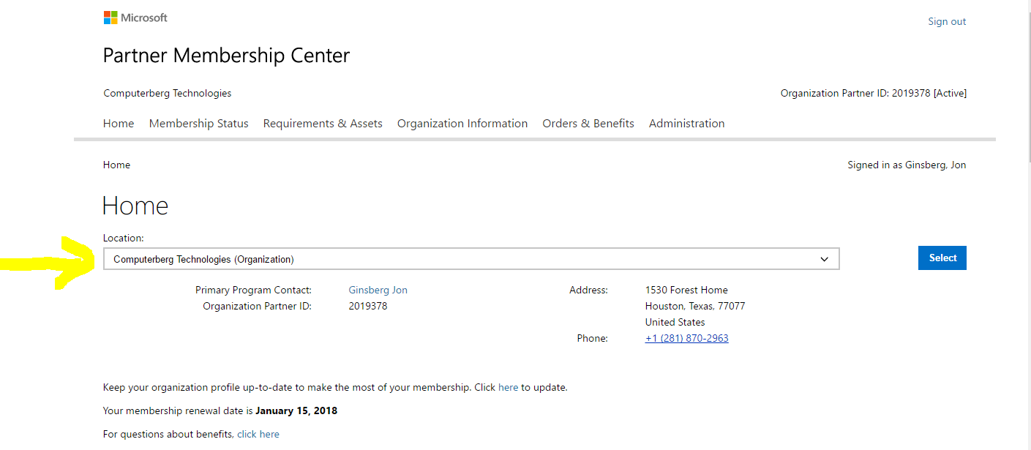

Microsoft Azure Account for Jon Ginsberg - Cloud Services

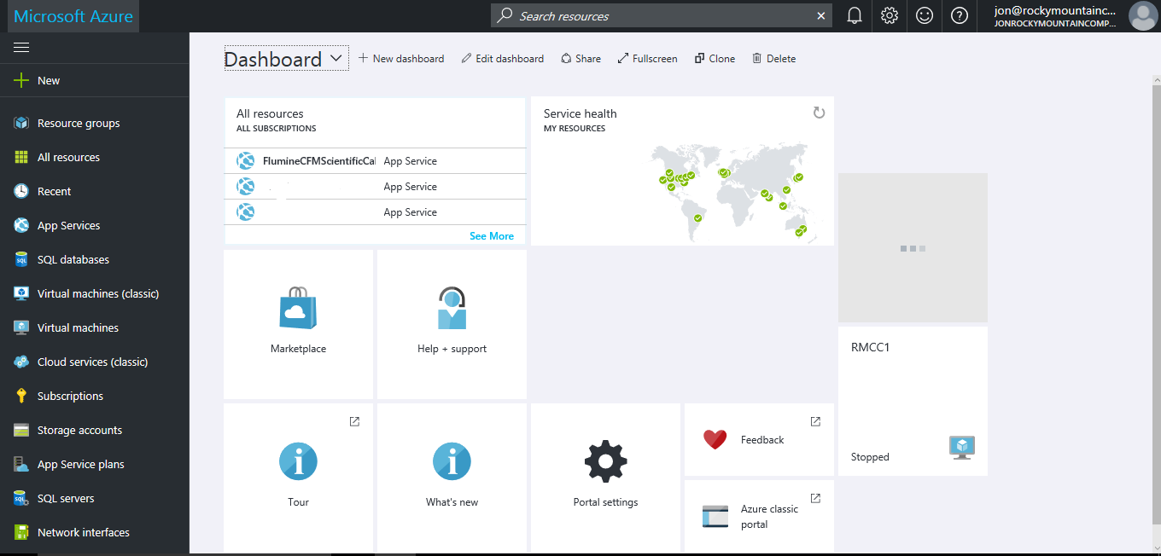

Amazon AWS Account for Jon Ginsberg - Cloud Services

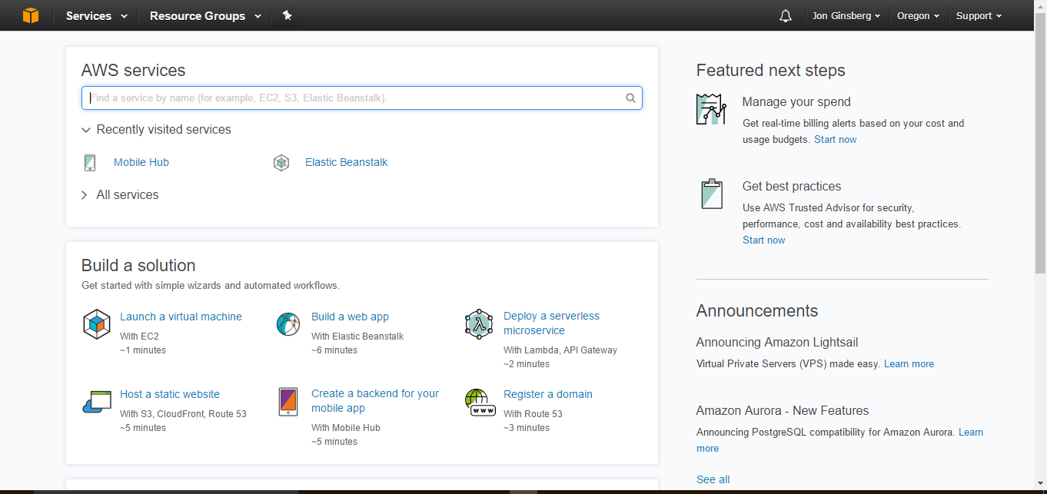

My Google Cloud Services Account for which I administer Wildcatter

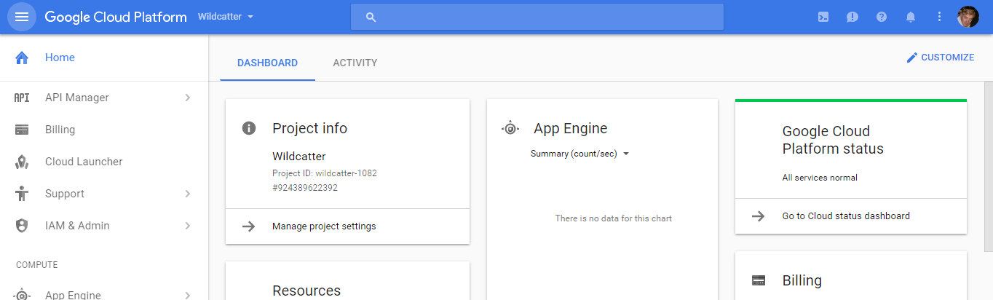

My Google Analytics Account

