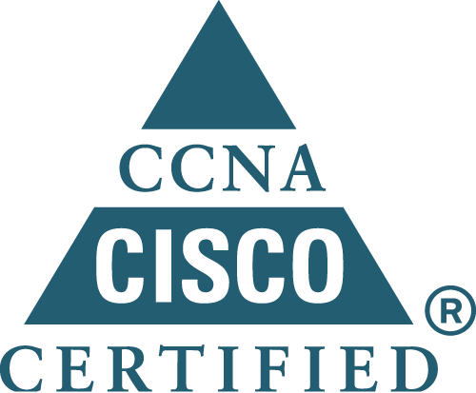

ADEEB SAEED KHAN
2116 Sagebrush Dr.
Flower Mound, TX. 75028

Phone: (214) 952-9140
Email: adeeb_saeed@yahoo.com

Objective:
- Seeking a position in a team which encourages hard work, continuous learning and a potential for growth.
Summary:
- More than 9 years of experience in Quality Assurance and team-leadership.
- Extensive experience in writing test plans, test cases/scenarios, executing scripts, creating and publishing daily and weekly bug reports.
- Performed Functional, Integration, Regression, DB, API/Web Services, XML, UAT and Compatibility testing manually and using automated testing tools.
- Extensive experience in defect tracking tools like Mercury WinRunner, Quick Test Pro 9.0, Mercury Test Director 7.6 & 8.0, Mercury Quality Center 8.0 & 8.2, Rational Clear DDTS Rational Clear Quest, Verizon BOSS, CMIS and Verizon Test ware
- Site System Administrator of Mercury TD and MQC for creating and maintaining the projects and user accounts. Created scripts for backup schemes for servers.
- Hands-on experience with various OS for servers Windows, Unix and Linux with shell scripting.
- Cisco Certified Network Associate hands-on knowledge of router and switches configuration, IP addressing, access control lists, routing protocols (RIP, IGRP, OSPF etc.), VLAN and trouble-shooting. Lab setup and network testing.
- Certified Oracle DBA and hands-on experience of SQL Server 2000
- Working knowledge of programming languages Visual Basic, .NET, VB Scripting, SQP, PL/SQL, Java, PHP, HTML, DHTML, C, Flash, C#.

Education:
- 2001-2003: Associate Degree in Computer Information Technology with major in Unix system Administration from North Lake College Dallas, TX. U.S.A.
- 1992 – 1993 Postgraduate Diploma in Public Administration from Karachi University.
- 1989 – 1990 Bachelor of Commerce from Karachi University with a major in Economics.
System Tester / QA Analyst – 05/2008 till Present JC-Penney (contracting through BCS)
- Presently working in System Testing and the installation and configuration management group by testing and deploying application/software changes to development, test, alpha, beta, and production environments.
- Ensure that all installs meet established standards
- I have been involved extensively in system testing, regression testing besides performing e-commerce testing on jcp.com, azjeans.com and POSR.
- Have been involved in system requirements gathering and performed reviews over test cases developed by the business users and developers to ensure that the business requirements are met.
- Extensively worked with managers and developers across various teams to resolve technical issues and possible defects.
- Touch bases constantly with QA and Load testing teams.
- Attends install meeting on a regularly basis with cross functional teams’ managers and their representatives.
- Perform system, functional and regression testing on various applications
- Assess scope of work associated with testing application changes and provide timely, meaningful estimates for the completion of testing lifecycle.
- Using in house tools like Genbatch to install the code on server(s), J-sync and J-control beside third party tools like Beyond Compare to develop the testing harness by synching the server with the production and development environment for testing.
- Work with Project managers and Developers to assess technical challenges with code and content changes
- Analyze and troubleshoot code problems; recommend and implement corrective solutions

Work Experience with Global IT Inc:
- Presently working in support within the company, since completing my projects with Verizon from June ‘07, by covering the other resources of the company in their absence (providing floating technical support)

Quality Assurance Leader – 4/2003 to 6/2007 Verizon Inc.
- Led a team of 5-9 testers based On and Off-shore sites. Responsible for assigning test-plans, integrating results into product quality reports for management and requirements team in marketing.
- Worked as a lead tester for Microsoft IPG as well as Verizon IPG, Verizon IPG, Media Manager, Widgets, IT Workbench and iobi Plug Ins
- Performed UAT, Black Box, Grey Box, Dynamic and Static Testing, XML testing, API/ Web Services using Verizon in house Tool (Test ware) as well as Integration testing between Client, Web and Voice. Developed and executed automation scripts using QTP and Win Runner.
- Developed SQL queries for databases verification through Create, Read, Update and Delete (CRUD) operations.
- Trained new resources in the IT as well as Business groups about the products and quality assurance tools and processes in Verizon.
- Worked with the Network team for building a new testing lab for testing different projects.
- Coordinated between the Network Security team in the US and Verizon India for firewalls and port related issues for different projects.

Project Manager/DBA – 12/1999 to 3/2001 Naylor Parkes Associates
- Project managed development and launch of http://www.accountancyworld.com and http://www.b2b.com.ro.
- Supervised the team of 18 professional developers and administrators.
- Maintained a liaison between the head office in UK and the branch office in Pakistan by providing a day to day progress report and assigning tasks to team members.

Quality Assurance Tester – 4/`997 to 5/1999
- Tested Web based applications built in HTML, DHTML, XML, JavaScript and Java with Linux, Oracle and MySQL at the back end.
- Performed regression testing, general functionality and stability testing and as well as compatibility testing and constructed SQL code to test different databases.

References:
- Can be provided on request.

