Eswar  Mobile: 512-270-4960  E-Mail: Softwaredeveloper418@gmail.com | 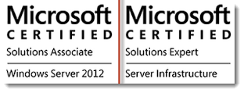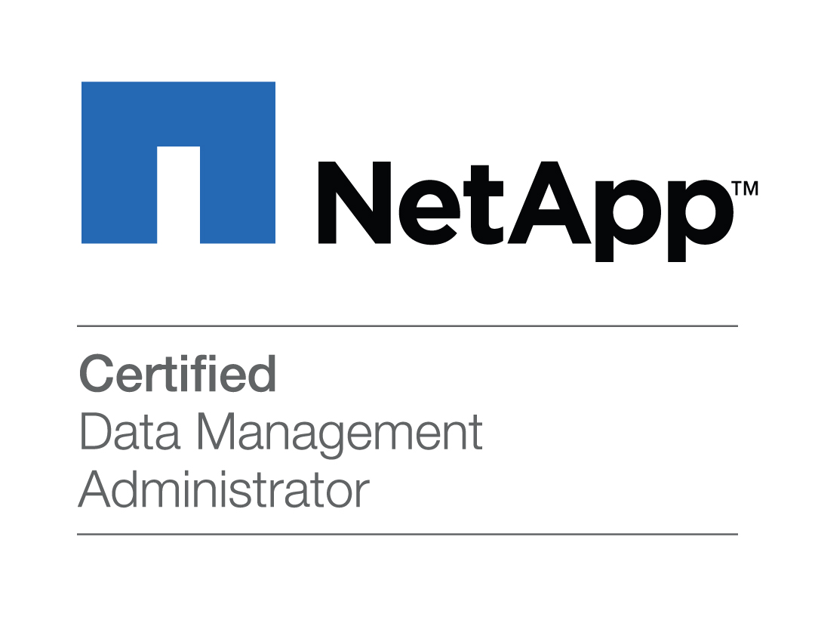

Professional Summary
Proven Professional with11+ years of Experience in Information Technology, which includes 5+ Years on VMware, Citrix, Virtualization environment, 5+years in Server environment (Windows, Linux).1year on Storage environment. Experience in VMware,virtualization Planning, implementation and ongoing management with early and current versions of VMware solutions, vCenter Operations. Managed large Datacenter projects including planning, scheduling, business continuity unit facilitation and overall client management.

- Strong knowledge on ESXi Architecture, guest OS installation, setting Configure, monitor and upgrade a VMware View Virtual Desktop Infrastructure (VDI) environment.
- Implement Management server (vCenter Server) instances to enable centralized management of multiple hosts.
- Design; implement VMware High Availability, VMware Distributed Resource Scheduling, Enhanced vMotion (EVC), VMware Fault tolerance.
- Implement and troubleshoot solutions to allow provisioning of legacy applications in a VDI environment.
- Implement virtualization on ESXi 5.5,vSphere 5.5, vCenter, and vMotion.
- Experienced in performing Cloning, Cold Migrations and Hot Migrations and taking Snapshots.
- Experienced in creating Virtual Machine Templates and deploy virtual machines from templates and allocate resources.
- Worked with the infrastructure team in support of the vCenter hosting the VDI environment.
- Design, implement and deliver applications to virtual desktops using App volumes.
- Test, troubleshoot and deploy applications, upgrades and operating system security updates in the virtual desktop environment while working with application teams to minimize user impact.
- Creating Virtual machines, installing operating systems inside VM's and installing tools and configure these VM's based on customer requirements.
- Experienced in performing Cloning, Cold Migrations and Hot Migrations and taking Snapshots.
- Experienced in creating Virtual Machine Templates and deploy virtual machines from templates and allocate resources.
- Implement Management server (vCenter Server) instances to enable centralized management of multiple hosts.
- Maintained vmware virtual infrastructure using vCenter/vSphere web client.
- Configure, manage, test, troubleshoot and deploy thin client devices for use with VMware View virtual desktops.
- Handled Multiple Executive level escalations for vRA, vCloud , vROPS , VIO and vSphere products.
- Extensive experience of file level migration in multi domain environment.
- Very good understanding of NetApp hardware architecture and its different tools from Worked on Change Management and Disaster Recovery management
- Data Migration using NDMP, Snapmirrors and Qtree Snapmirror across same and different domains within the Enterprise, as well as Virtual Storage Console in the migration of VMs.
- Configuration and administration of Business Copy and Continuous Access.
- Monitoring, troubleshooting & reporting daily backup status for all critical production servers enterprise-wide.
- Worked on Configuration and administration of NetApp Filers, and Storage Arrays.
- Knowledge of NFS and CIFS share creation using Filer view/OCI and CLI interface on FAS filers and Isilon GUI and on CLI.
- Proficient in design & implementing scripts and procedures to automate and enhance the monitoring and failure recovery for system services.
- Backup monitoring and reviewing backup policies through Data Protector S/W.
- Worked on Cloud environment to manage Virtual Machines, vApps

PROFESSIONAL CERTIFICATIONS:
- NetApp Certified 7-Mode Data Administrator
- MCSA Windows Server 2012
- Microsoft Certified Systems Engineer MCSE 2000 ID: 3110960

EDUCATION:
- Bachelor of Science, from Tamilnadu Open University

PROFESSIONAL EXPERIENCE
Client : Merck Health Care Charlotte NC
Titel : Windows /VMware Engineer
Type : Maintenance & Administration for Vmware & Disaster Recovery
Platform : VMware vSphere ESXi 5.5
July 2017 Oct 2017
Responsibilities:
- Disaster Recovery & planning, design, implementation and testing.
- Working on Disaster recovery of VMware ESXI and Windows Physical Servers.
- Working on HP iLO s Firmware upgrade and O/S instalations.
- Performance Reports, troubleshooting Performance Issue (Memory, CPU, Disk Space )
- Installation / Uninstallation, Firmware, Hotfix installation of VMs and Physical machines.
- Working Experience with VMware ESXi 5.1 and 6.0.
- Creating and Configuration virtual machines, installing VM Tools into VMs and allocating for end user.
- Creating and Deployed Templates and Snapshots for Virtual Machines.
- Experience in working with resource and performance monitoring tools for VMs, Servers and VMware infrastructure.
- OS Troubleshooting, Mount Data store, Unmounts Data store.
- New Server Build request, Decommission, Server Provision 2008R2,2012R2.
- Used different Administration and support tools(Veeam Backup)to perform regular backup and restore of the virtual machines disks and data.
- Veeam v9.x Backup Administration, Troubleshooting, and Maintenance
- Worked on Commvault Back up Recovery,and BMR.
- Worked on Server O/S,Hardening and Antivirus.
- Administration windows 2003, 2008R2 and 2012.
- Worked on adding new malware rules to McAfee antivirus
- Actively involved in Win2003/2008R2 Server deployment in DR environment
- Test and recommend Replication/Backup solutions for VMware, SAN and Disaster Recovery.
- Provision VMware Datastore’s and configure storage for Virtual Machines.

Client : Dell Inc Round Rock TX
Title : VMware Admin
Type : Maintenance & Administration for Vmware & Backup Infrastructure
Platform : VMware vSphere ESXi 5.5
Duration : March 2016 to June 2017
Responsibilities:
- Expertise on Creating virtual machines, installing operating systems inside VM's and installing tools and configure these VM's based on customer requirements.
- Installation and troubleshooting of VMware.
- Provisioning virtual machines.
- Deploying virtual machines from Templates and by cloning.
- Installing and upgrading VMware tools.
- Upgrading virtual machine hardware version.
- Creating and deleting of vm's snapshots.
- Assigning LUNs to ESX/ ESXi servers and creating data stores.
- Adding virtual machine memory and vcpu.
- Migrating VM's through Vmotion and SVmotion.
- Convert physical machines to virtual machines (P2V) and virtual machines to virtual machines (V2V) with VMware converter.
- Responsible for maintaining user access in VMware virtual Center, configuring mail alert for any failure in HA, DRS, CPU and memory.
- Configured VMware on clustered environment, implemented migration of virtual machines using VMotion, Virtualized Windows servers using VMware Converter and Plate Spin.
- Administration and support on (Veeam Backup) to perform regular backup and restore of the virtual machines disks and data.
- Analyzing the VMsupport logs for ESXi servers and Virtual Center logs to diagnose the root cause for the problem.
- Performing initial Cisco UCS setup and provide management IP addresses for blade servers.
- Installed, Configured and administered ESXi 5.x on HP Blade servers using HP onboard administrator for the HP Blade chasis & enclosures and Cisco UCS blades.

Microsoft, Redmond, VA Nov2014–Feb2016
Windows / Virtualization Engineer
Responsibilities:
- Windows Server 2003, 2008 and 2012 administrations.
- Windows 2008and 2012 Servers deployment, troubleshooting and configuration.
- Managing windows Services – AD, Group policy, DNS, DHCP, Terminal Services and WINS.
- Implemented WSUS/SCCM integration and created a monthly phased patching process.
- Troubleshoot failed SCCM deployments and SCCM health issues.
- Troubleshooting client connectivity and package installation issues by analysis of logs.
- Administered backend SCCM servers.
- Working knowledge of PowerShell, VB, Batch scripting.
- Disaster Recovery planning, design, implementation and testing
- AntiVirus updates and MS Patches Management.
- Active Directory Services – Managing Users & Other Resource objects.
- Managing Cluster Services – Installation & Administration
- Web Server Administration – IIS 5.0 / IIS 6.0/ IIS 7.0
- Managing IIS 6.0/IIS 7.0 Web servers and hosted web sites.
- Creating and configuring new internal & external websites (HTTP and HTTPS).
- Website content and application release management and heath check of the servers.
- Application support for asp, .NET based hosted internal & external websites.
- Planning and implementing the disaster recovery and resolve web architectural issues.
- Deploying and troubleshooting of .Net based Applications on large IIS web server farms.
- Creating, deploying, renewing and Import & export of the SSL certificates.
- Optimization and performance and resolve performance bottlenecks.
- Replication/update of content with Site server/ Interwoven/Wansync in the web server farm.
- Involved in data center migration project Moved several UNIX and Linux servers from old data center to new data center using P2P, P2V and V2V migration.
- Experienced in performing Cloning, Cold Migrations and taking Snapshots.
- Experienced in creating Virtual Machine Templates and deploy virtual machines from templates and allocate resources.
- Managing and Installation of VMware ESXi 5.5 server, Installation and configuration of virtual center database and installation of VMware infrastructure virtual machines.
- Implemented the migrations of ESXi servers to ESX5.1 and to 5.5.
- Responsible for keeping all VMware ESX/ESXi more than 100+ hosts up to date with patches and updates with minimal downtime using vMotion for SAN attached VMs and Storage vMotion for Local storage VMs.
- Install & troubleshoot patches and updates on ESX/ ESXi hosts and virtual machine using VMware Update manager.
- Participate in regular VMware administration & provisioning activities on 2000+ virtual servers VMware environment.

Client : Secure24 Southfield, MI
Title : Storage/ Vmware Admin
Type : Maintenance & Administration support for Storage Infrastructure
Duration : Feb 2012 - Oct 2014
Worked as a Storage and Virtualization Admin for a Client Project. Work involves managing Storage& VMs in Datacenter
Responsibilities:
- Storage administration – Creating Luns, Expanding Luns (Metaluns), Lun masking.
- Assigning LUNs to HOST.
- Creating Snaps and exporting to required hosts.
- Configuring & maintaining rcopys(Remote copys) for DR.
- Storage allocations & de-allocations i.e., create & manage LUN's, Aggregate, volumes and Qtrees on Netapp filers.
- Managing Snapshots, Snap vault and data recovery using Snap restore.
- Configuring replications of volumes, qtree and Vfiler using Snap mirror.
- Performed volcopy, ndmpcopy and aggrcopy FAS filers.
- Managing and troubleshooting SAN performance, Configure, administers, and troubleshoots CIFS & NFS shares.
- Performing Ontap upgrades on Netapp filers.
- Vendor management for Netapp.
- Managing ONTAP 8.0 cluster mode filers.
- Configuring & troubleshooting FC zoning on Brocade & Cisco switches using both CLI & DCNM.
- Configuring FC & iSCSI Luns on EMC & Netapp arrays.
- Monitoring NetApp storage environment using DFM & System manager. Also provisioning storage, providing access, reporting on space utilization.
- Responsible for planning, implementing vfilers and Migrating the volumes in case of Aggregate space issues.
- Performing day to day administration like Snapviews, snapshot maintenance, qtree creation, snap drive, de-duplication.
- Worked using Distributed File Manager (DFM) to monitor & report on volume and qtree capacity trending.
- Expertise on Creating virtual machines, installing operating systems inside VM's and installing tools and configure these VM's based on customer requirements.
- Installed and configured Citrix XenServer, Provisioning Servers and XenDesktop to include CitrixProfile Manager, redirect user files using Microsoft GPO, configure and created PVS Golden Images and Personal Virtual Disk ,Experience in Installation manage and publishing applications on Citrix.
- Install, configure and Manage XenServer version 6.5.
- Responsibilities include creating and maintaining Images.
- Maintenance and troubleshooting of Xen Server and VMs.
- Installing and testing applications in Citrix environment
- Installation and troubleshooting of VMware.
- Provisioning virtual machines.
- Deploying virtual machines from Templates and by cloning.
- Installing and upgrading VMware tools.
- Upgrading virtual machine hardware version.
- Creating and deleting of vm's snapshots.
- Assigning LUNs to ESX/ ESXi servers and creating data stores.
- Adding virtual machine memory and vcpu.
- Migrating VM's through Vmotion and SVmotion.
- Convert physical machines to virtual machines (P2V) and virtual machines to virtual machines (V2V) with VMware converter
Client : Xpress Docs, Dallas, TX
Title : Storage Admin
Type : Maintenance & Administration support for Linux, VMs & Storage.
Platform : Linux(HP-blades), EMC OE for Block & File, ONTAP.
Duration : Oct10, 2010 to Jan, 2012.
Work involves managing team of Storage & System administrators in Datacenter. The hardware includes EMC VNX 5300, 5700, 7500, Clarion CX4-480, CX4-240 Storage, IBM DS8K, v7000, SVC, Brocade switches, Spark & X86 machines.
Responsibilities:
- Configure servers with Linux & User Application Server for Test Engineers.
- Install and Configure Virtual Machines and VApp's.
- Build Virtual Machines using Clone & Templates.
- Modify, Migrate & Manage Virtual Machines.
- Monitor the performance of VM’s & ESX Host (CPU, RAM and HDD Utilization).
- Manage Vcenter server & VCD (Virtual Cloud Director)..
- Troubleshoot Virtual Machine Startup issues, adding new resources to VM's.
- Storage administration – Creating Luns, Expanding Luns (Metaluns), Lunmasking.
- Storage allocations & de-allocations i.e., create & manage LUN's, Aggregate, volumes and Qtrees on Netapp filers.
- Manage Snapshots, Snap vault and data recovery using Snap restore.
- Configure replications of volumes, qtree and Vfiler using Snap mirror.
- Manage and troubleshoot CIFS & NFS shares and SAN performance.
- Performing Ontap upgrades on Netapp filers, Code upgrades on EMC arrays.
- Vendor management for Netapp & EMC.
- Managing ONTAP 8.0 cluster mode filers.
- Configuring & troubleshooting FC zoning on Brocade & Cisco switches using both CLI & DCNM.
- Configuring FC & iSCSI Luns on EMC & Netapp arrays.
- Monitoring NetApp storage environment using DFM & System manager. Also provisioning storage, providing access, reporting on space utilization.
- Maintaining the growth of volumes and qtrees on daily basis and working with aggregates.
- Carry out Helpdesk calls logged in RTT ticket management system. Maintain minimum downtime and resolve calls within SLA.
Client : Tecra Systems Pvt Ltd, Hyderabad, India
Title : Senior System Admin
Type : Maintenance & Administration support
Platform : Operating System Windows2008,SQL 2008,Oracle9i,10g
Duration : July, 2006 to Sep, 2010.
Work involves managing team of Windows systems administration of the production infrastructure in Tecra Datacenter.
Responsibilities:
- Monitoring Resource Utilization on Production servers using various tools.
- Installing Windows, Linux Operating System.
- Implement, Troubleshoot and Administer NFS, NIS based network.
- User & Network administration
- Configure and manage Business Copy and Continuous Access.
- Data backup and restore administration.
- LVM administration & Management.
- Manage M/C Service guard cluster & packages.
- Hardening Windows servers.
- Backup monitor and review backup policies through Data Protector S/W.
- Carry out Helpdesk calls logged in CCM call management system. Maintain minimum downtime and resolve calls within SLA.
- Developing agreed solutions and implementing new systems.
- Presenting solutions in written or oral reports.
- Designing, testing, installing and monitoring new systems.
- Preparing documentation and presenting progress reports.
- Implementing web server for Dev Teams,
- Providing databases recommendations and database tuning for Dev Teams.
- Ensure that network devices and solutions were aligned with the company's global policy (i.e. network polices, Security policies etc.)
- Part of a global team that maintains Corporate Enterprise Storage systems and Backups.
- Install and configuring MS SQL servers for Development, QA, and PRODUCTION environments.
- Supporting windows servers for production and Development environment includes.
- MS SQL servers, IIS servers and third party applications.
- Day to day SQL Server duties as well as major projects including hardware migration, replication, and upgrades.
- Maintained Management Server for R&D, Development and QA environments for Tecra internal applications.
- Installation, configuration Active directory.
- System performance Monitoring and Management.
- Installing and Configuring Terminal Server for Remote desktop.
- Updating Security patches for Operating system and all other Applications.
- Installing and Configured access rules on Kaspersky Antivirus Corporate edition.
- Creating Disk cloning for servers with help of Ghost software.
- Troubleshooting Windows Time related issues.
- Configuring and managing Domain Naming System (DNS).
TECHNICAL SKILLS:

VMware Products: Design and implement Virtual Infrastructure 4/5 with Virtual Center, ESXi 4.x, ESXi 5.x vMotion, HA, DRS, Resource pools, VMware Converter, Virtual Center, ESXi Patch management (VUM) VMware Converter: Expert Level in Physical to Virtual migration of datacenter, Virtual to Virtual Migration (VMware 3.x to VMware 4.x), Physical to Physical Hardware refresh.
Microsoft: Windows Server (2012,2008 and 2003),ADDS,DNS,DHCP, Windows 7,8,10, Windows XP, SCCM, SCOM, WSUS.IIS, MSSQL 2008,2005,
Storage: iSCSI SAN, FC SAN, NAS, NetApp 6240, 6040 FAS Solutions.
Microsoft Hyper-V, VMware Update Manager, Plate spin migrator, Quest Vconvertor, vCloud director, vOPS, and vshield Edge., Remote Management: ILO/DRAC/IMM/RIB/OBA/UCSM/Vcenter/Unisphere.
Linux: Red Hat Linux. Cent Os, Ubuntu
Hardware: Dell PowerEdge R710’s, Cisco UCS B200’s B250’s M1’s M2’s HP BL460C, C-7000, DL580’s. Racks and Cabling: Installation of Hardware, Cable Management
Network: Cisco Catalyst switches, L3 and L2 switches, Checkpoint, Net gear, HP Switches (Flex switches), NSX 6.1, Cisco switches 7000 10GB , 710 1 GB, Cisco 2960 series.Cyberoam
Storage: Dell Power Vault, Equal Logic PS Series, NetApp, EMC Clarions, LUNs, Storage arrays, Hitachi Storage HUS 150, Storage EMC VNX 5300, 5400, SAS, Dell EMC Xtrem IO, Simplivity Omni cube, Dell EMC Unity
Servers: UCS cisco servers, Dell PowerEdge, HP ProLiant DL Series, ML Series, ACP Thin Clients, IBM
servers, Air watch console, Dell Blades M1000e, Power Edge R610 blades, power edge M 620, Power Edge
R710, Power edge R730.
Backup Tools: Symantec Backup, VEEAM Backup, Commvault.
AntiVirus: TrendMicro,Symantec,McAffe,Kaspersky Corporate Editions.

