Course: Python
Course Code: 5.0CE202E02H

PROJECT TITLE
ReConnect – Smart Campus Lost & Found System

Submitted by
Name | Roll No.
S. Saikumar | 060
B. Saicharan | 054
Tanish Rawat | 059
M. Akshay Kumar | 053

Semester – III
Date: November 02, 2026
Submitted to: ______________________________
Department / College: ______________________________

1. Introduction

1.1 Brief introduction to the problem or topic (SDG alignment):
Students and staff can misplace items such as identity cards, wallets, books, keys, bottles, and bags around a college campus. Details about lost and found belongings are often shared through friends, messaging groups, or notice boards, so information can become scattered and difficult to search. ReConnect provides one digital place to submit lost-item and found-item reports and search available records. The project aligns conceptually with UN Sustainable Development Goal 11 (Sustainable Cities and Communities) by supporting a more organized campus community.

1.2 Objective(s) of the project:
• Create a simple campus interface for reporting lost and found belongings.
• Store item reports in an organized SQLite database.
• Allow users to search records using keywords and filters.
• Display report statistics and recent records on a dashboard.
• Allow records to be updated to Open, Claimed, or Returned.

1.3 Real-world relevance or motivation behind choosing this topic:
Losing personal belongings is a common campus inconvenience. A centralized application can reduce dependence on scattered messages and make it easier to find possible matches. ReConnect was selected because it addresses a familiar campus problem while demonstrating Python programming, interface development, data storage, and search operations.

2. Methodology / Project Design & Logic

2.1 Block Diagram/Flow Diagram:
Student / Staff
↓
ReConnect Streamlit Interface
↓
Python Application Logic
↓
SQLite Database (items table)
User flow: Open application → choose Dashboard / Report Lost / Report Found / Search Items / Manage Records → enter details or search criteria → validate input → save, retrieve, or update records → display result.

2.2 Tools/Platform/ Libraries used:
Tool / Library | Use
Python | Application logic and processing.
Streamlit | Interactive web-based user interface.
SQLite / sqlite3 | Local database storage and database operations.
Pandas | Loading and displaying records in tables.
Visual Studio Code | Writing and running the project.

2.3 Algorithm Steps:
1. Start the Streamlit application and initialize the SQLite database.
2. Display the dashboard and navigation options.
3. If Report Lost or Report Found is selected, collect item details.
4. Check required fields, including item name and campus location.
5. Save valid reports in the items table with an initial Open status.
6. If Search Items is selected, filter records by keyword, report type, category, or status.
7. If Manage Records is selected, choose a report and update its status.
8. Refresh the displayed information and continue until the application is stopped.

3. Results and Analysis

3.1 Implementation and Functionality
The application was implemented and launched locally in a web browser through Streamlit. The supplied screenshots show the Dashboard, Report Lost form, Report Found form, Search Items page, and Manage Records page. The dashboard shows 3 total reports: 2 lost items, 1 found item, and 2 open reports. The visible records include a Black Wallet report marked Open, a Blue Water bottle found report marked Returned, and a Blue water bottle lost report marked Open.

3.2 User Interface and User Experience
The interface has a left-side navigation menu and separate pages for each task. The dashboard uses summary cards to show report counts. Forms provide fields for item name, category, description, campus location, date, and optional contact details. Search filters help narrow the displayed records. The Manage Records page provides controls to select a report and update its status.

3.3 Screenshots of program execution/output, graphs, or tables:
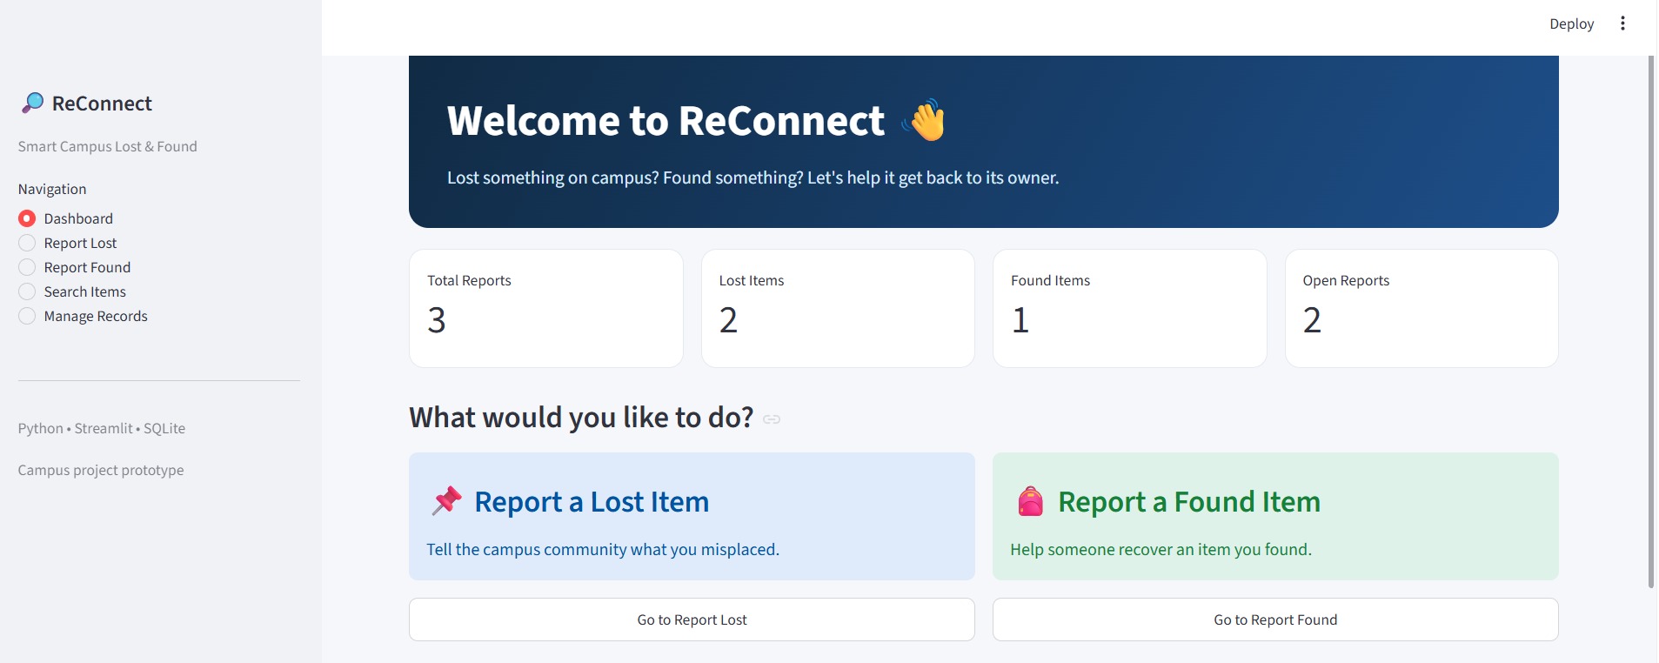
Figure 1. ReConnect dashboard with report statistics.
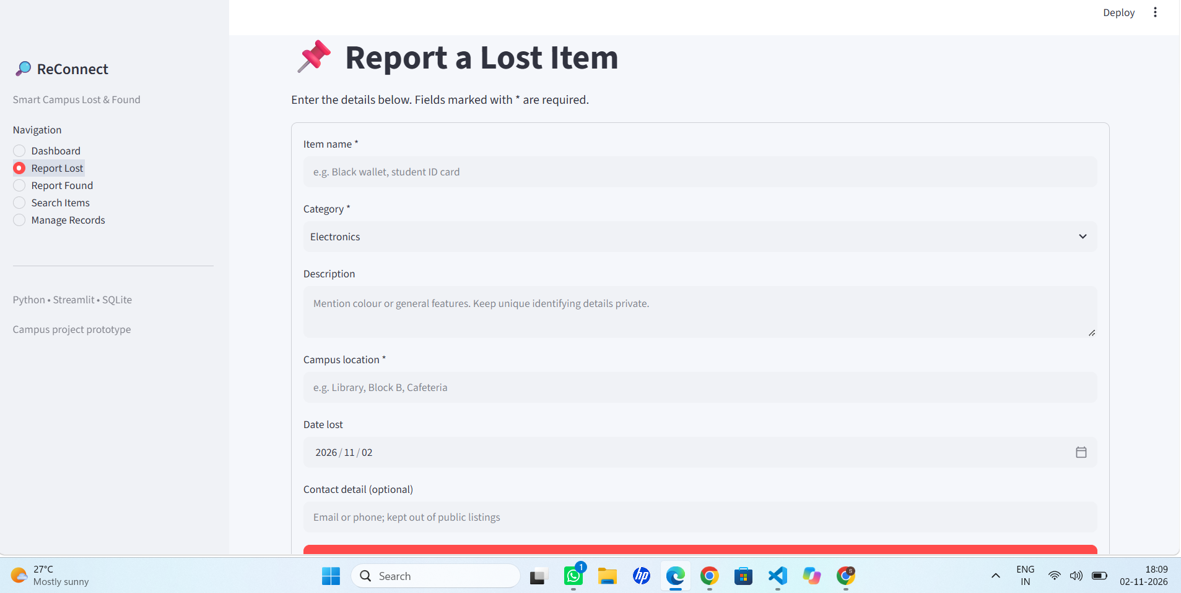
Figure 2. Report Lost form.

3.3 Screenshots of program execution/output, graphs, or tables (continued):
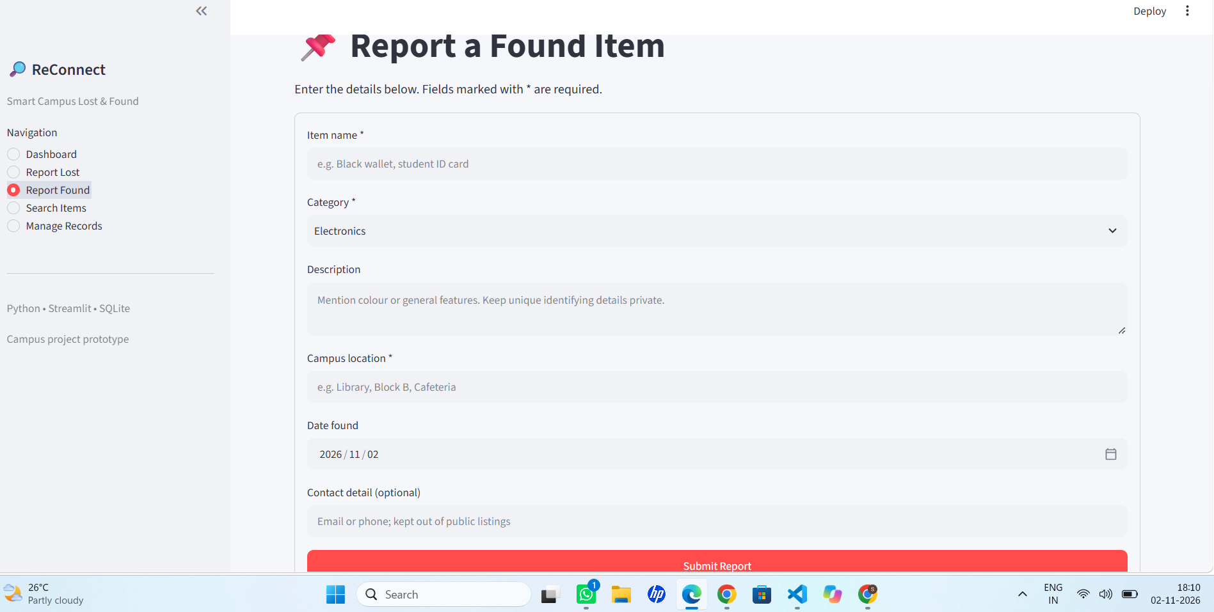
Figure 3. Report Found form.
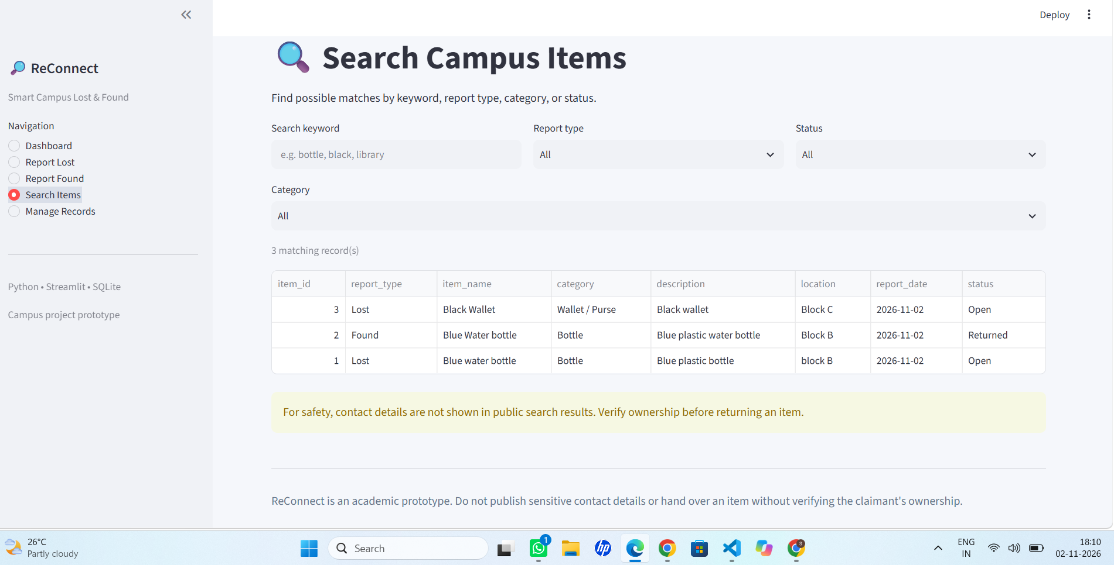
Figure 4. Search Items page.
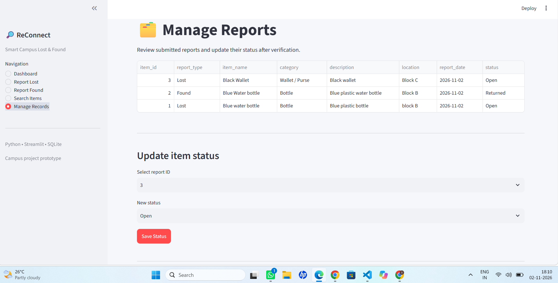
Figure 5. Manage Records page.

3.4 Analysis of the Results (Trends Observed/ Insights Gained):
The captured dashboard shows three reports in the database at the time of the screenshots. Two reports were of type Lost and one was of type Found. Two reports remained Open and one Found report had been marked Returned. The Search Items page displayed three matching records when no restrictive keyword or filter was applied. These counts describe sample data entered for demonstration and are not campus-wide statistics.

3.5 Link of the project on Github:
GitHub URL: ______________________________________________
If the project has not been uploaded to GitHub, upload the source code and add its repository URL here.

3.6 Challenges Faced and Solutions Implemented:
• Folder navigation: the terminal initially opened in the outer folder, so requirements.txt was not found. This was resolved by changing into the inner project folder containing main.py and requirements.txt.
• Environment setup: required Python packages were installed using the requirements file before launching the application.
• Testing: sample lost and found reports were entered to check that records appeared in the dashboard, search results, and management table.

4. Conclusion
ReConnect demonstrates a practical way to organize campus lost-and-found reports using Python. The application provides separate functions for reporting lost items, reporting found items, searching records, viewing dashboard statistics, and updating report status. The submitted screenshots show the application running and displaying sample records. The prototype meets the demonstration goal of providing a searchable and manageable local record system.

Highlight Key Learnings and Outcomes
• Learned to build a web interface with Streamlit.
• Practised Python functions, input validation, and conditional logic.
• Learned to create and use an SQLite database through sqlite3.
• Used Pandas to display stored records in tables.
• Practised testing application modules and resolving setup issues.

Mention how the project enhances understanding of Python programming
The project connects Python fundamentals with a working application. It uses functions to separate tasks, conditional statements to control page behaviour, database queries to insert and retrieve data, and data filtering to support searching. It also demonstrates how Python libraries can be combined to build an interactive application.

5. References:
• Python Documentation – https://docs.python.org/3/
• Streamlit Documentation – https://docs.streamlit.io/
• SQLite Documentation – https://www.sqlite.org/docs.html
• Pandas Documentation – https://pandas.pydata.org/docs/

