Use this form to assist you to complete risk assessments for hazardous activities and processes. Any serious or ongoing hazards should be reported via RiskWare to ensure that appropriate corrective actions are tracked and completed.

Faculty/School: | {{ meta.faculty_school }} | Initial Issue Date: {{ meta.issue_date }}
 |  | Next Review Date: {{ meta.next_review_date }}
Risk Assessment Reference Number: | {{ meta.reference }}
Risk Assessment Name: | {{ meta.title }}
Prepared by: | {{ meta.prepared_by }}
Responsible supervisor/s: | {{ meta.supervisors | join(", ") }}

Identify the activity and the location | Identify who may be at risk  This might include fellow workers, students, visitors, contractors, patients, research participants and the public
Activity or process:  {{ ra.activity }} | Persons at risk:  {{ ra.persons_at_risk | join(", ") }}
Location:  {{ ra.location }} | Risk assessment team (who was consulted?):  {{ ra.team | join(", ") }}

List of Legislation, Code of Practice, Australian Standards, Guidance Materials used to determine control measures
{%p for ref in ra.references %}
{{ ref }}
{%p endfor %}

Risk Assessment Methodology

Assessing the risk is a brainstorming exercise, which is most effectively carried out in a team environment with the people required to complete the activity or process. Most activities or processes are broken down into a variety of separate tasks. For each task, consider the hazards, the potential harm or negative outcomes and the conditions required for those negative outcomes to occur.

Whenever assessing the health and safety risks associated with a task, always consider the following primary risk factors.
- The physical activities required to complete the task e.g. repetitive movement, high force, physical exertion, awkward posture
- The work environment e.g. lighting, layout, traffic flow, ventilation, access to support (isolation)
- The nature of the hazard itself e.g. working with chemicals, microorganisms, radiation, use of plant and equipment, sharps, working with potentially aggressive clients, patients or research participants
- The people involved, e.g. level of training, supervision, experience, health, age, physical capacity.
The information gathered from the risk assessment process must be used to develop a Safe Work Procedure (SWP) or clinical protocol for the activity.

Task or scenario | Hazard/s | Associated harm, e.g. what could go wrong? | Existing Risk Controls | Current risk rating  Use the Risk Matrix | Any additional controls are required? | Residual risk rating  Use the Risk Matrix
{%tr for r in ra.risks %}
{{ r.task }} | {{ r.hazards }} | {{ r.harm }} | {{ r.controls }} | {{ r.current_rating }} | {{ r.additional_controls }} | {{ r.residual_rating }}
{%tr endfor %}

Implementation of Additional Risk Controls

Additional controls needed | Resources required | Responsible person | Date of implementation | RiskWare Reference
Write the Safe Work Procedure (SWP) or clinical protocol for the relevant activity | Time (approx 1 hour) | Supervisor | {{ ra.implementation_date }} | N/A
Education and training for workers to complete process in accordance with SWP | Time – supervisor and workers | Supervisor | {{ ra.implementation_date }} | N/A
{%tr for c in ra.additional_controls %}
{{ c.control }} | {{ c.resources }} | {{ c.responsible }} | {{ c.date }} | {{ c.riskware_ref }}
{%tr endfor %}

List emergency controls
These might include how to deal with fires, spills, emergency shutdown of equipment, exposure to hazardous materials and adverse reactions or the deteriorating condition of a patients/research participants in our care.

{%p for e in ra.emergency_controls %}
{{ e }}
{%p endfor %}

REVIEW

Scheduled review date | 1 year | 2 years | 3 years
Are control measures in place (YES/NO)
Are controls eliminating or minimizing the risk (YES/NO)
Are there any new problems with the risk (YES/NO)
Reviewed by:
Actual Review date:

Risk Matrix.

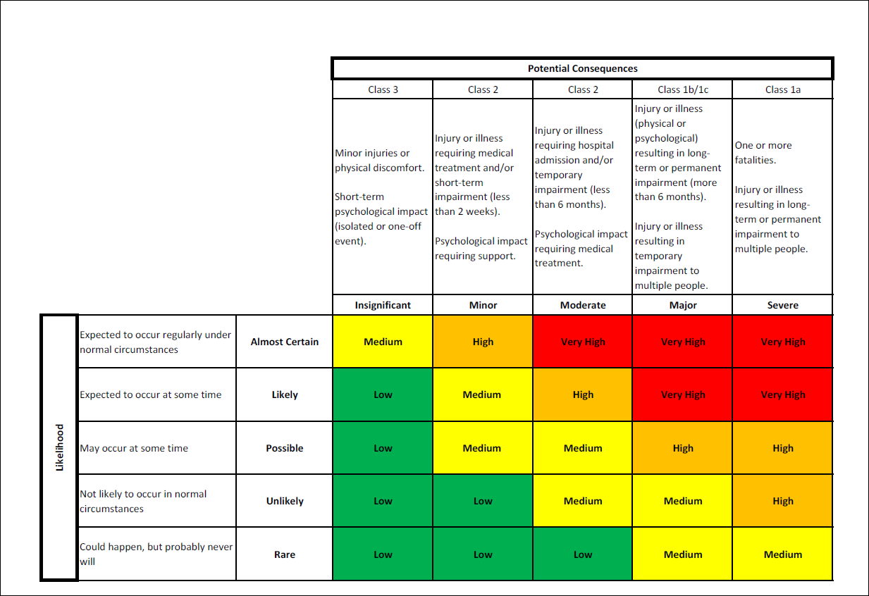

This tool should also be used to assess the risk associated with clinical activities. Information gathered will be used to guide the classification of clinics in accordance with the University’s Health Clinics and Clinical Services Policy and Procedures 2020.
Always consider whether it is possible to eliminate the hazard or hazardous task altogether. If this is not possible, refer to the hierarchy of risk controls.

