Final Project Report

Patient Guarding System
CSC_9025_001
CSC_9021_001
Fall 2017
Sailaja Chagarlamudi
Villanova University

Abstract:

My Blog:
Below is the link to my blog where I have updated my project status and details.
https://sailajachagarlamudi.wordpress.com/status/

Project Specifications:
The purpose of my application is to offer various services for doctors and patients. Below are the complete details regarding various services offered, technologies used and pages developed in order to provide the services.
Overview:
My project for the course Grand Challenges of Computing/Independent Study is the website ‘Patient Guarding System’. The website provides various services
For Doctors:
- Adding prescriptions.
- Monitor the feedback given by patients.
- Checking their appointments.
For Patients:
- Fetching prescriptions.
- Reporting their compliance to the prescription.
- booking appointments.
For Admin:
- Send reminders to Patients.
A daily reminder will be sent to patient’s everyday morning by admin of the website reporting all their medications and specifications for the medications they have to take on that day according to the prescription.
There are three roles for the users of the website. They are Doctors, patients and Admin. Every person has to register to access the website except Admin. Admin has separate credentials to access the website.
Technologies used:
Web Technologies: HTML, CSS, JAVASCRIPT, AJAX, JSP
Database: MY SQL
Server: Tomcat8

Website Pages & Funtionaality:
- elogin.html : Main page to login for the users of the website. After login credentials are given control goes to eloginCheck.jsp
- eloginCheck.jsp : LoginID and password are validated against database values and redirects to different pages based on the role of the login user. If the values don’t match a message will be displayed that the values entered are not valid and takes back to login page.
  - I am registering session variable, as shown below, to store the login ID of the user who logged in. session.setAttribute("logged",request.getParameter("username")); [“username”]
- eregistration.html: This is the page where the new users(Doctors/Patients) register to access the website.
  - Registrationvalidator.js:
    - This script page contains JavaScript code to validate the format of First name, Last name, Login Id, Verification of equality of the passwords entered and Mobile numbers entered by the users while registering.
    - It also contains the AJAX script which is used to give suggestions for the ExternalID/LoginId entered by the users while registering. This script checks the LoginID entered by the user against values in the database table ‘persons’ and suggests to select another ID if the entered value already exists saying “UserID already exists” or shows a message as ‘’ UserID is valid. It also checks for the length of the LoginId which should be 6.
- edoctor.jsp: Page displaying the options available for users whose role is ‘Doctor’. Three options are available for doctors, ‘Add Prescription’, ‘Get Patient Feedback’ and ‘Check Appointments’. With ‘Add Prescription’ option doctors provide online prescriptions to patients. Values in the drop-down fields of the form are populated from the database tables where ever required. Doctors select the values from drop down to give prescriptions. With ‘Get Patient Feedback’ doctors can access the feedback provided by the patients. With ‘Check Appointments’ doctors can check the appointments they have. While loading the data into the database when the logged in user is doctor, I am using the session variable ‘logged’ for loading the doctor UserId where ever required.
- epatient.jsp : Page displaying the options available for users whose role is ‘Patient’. Three options are available for Patients, ‘Get Prescription’, ‘Give Feedback’ and ‘Book Appointment’. With ‘Get Prescription’ patients can access their latest prescription. I am using session variable “session.getAttribute("logged")” to fetch the latest prescription for the logged in user. With ‘Give Feedback’ patients report, through the options available in the form, their compliance to the prescription provided by the doctor. With ‘Book Appointments’ patients can book appointments with doctors.
- eregistrationLoad.jsp : Loads registered users data into ‘persons’ table.
- eprescriptionLoad.jsp : Loads prescription provided by doctors , through Add Prescription’ option, into ‘prescriptionid’ and ‘prescriptions’ table.
- efeedbackGet.jsp : Fetches the feedback of the requested patient from the ‘feedback’ table when ‘Get Patient Feedback’ is clicked .
- egetAppointments.jsp : Fetches the appointments based on the requested date from the ‘appointments’ table for the doctor who logged in when ‘Check Appointments’ is clicked.

- eprescriptionGet.jsp : Fetches the latest prescription of the logged in user from ‘prescriptions’ and ‘prescriptionid’ when ‘Get Prescription’ option is clicked.
- efeedbackLoad.jsp : Loads feedback data provided by patients into ‘feedback’ table when the fields in the form are filled and Submit button is clicked .
- eappointmentLoad.jsp : Loads appointment details r selected by the user into ‘appointments’ table when submit button is clicked.
- eadmin.jsp : Page displaying options available for Admin. Admin has ‘Send E-mails’ option, when clicked an e-mail will be sent to all the patients reporting their medications for that day and the specifications for medications.
- eRemind.jsp : Send e-mail to patients upon action by the Admin(on Send E-mails option).
- eLogout.jsp : User logs out from the session. Using session.invalidate() to destroy session.
- edoctorstyle.css: style sheet for my web page.
- UserHint.jsp : File containing code to check the Loginid specified while registering with the database values and provide suggestions based on the comparision.
- eaboutus.html : Page giving the information about the website
- econtactus.html : Page giving the contact details
- eForgot.jsp : When the user clicks on ‘Click Here’ link in home page of website when they forgot their password, control goes to this page where user has to enter security code and click submit
- eForgotActi.jsp : The security code which the user has entered is validated against database values in this page
- epasswordReset.jsp : After the security code validation , if the values match this page will be displayed where the user has to enter LoginId and new password.
- epasswordChange.jsp: This page is used to update the new password entered into the database table ‘persons’ for the corresponding user.

Database tables and details:
1. persons : Table containing data about the users of the system(registered users).The data entered by users while registering goes into this table.
2. prescriptionid : prescriberid and patient id for each prescription is stored. Prescriptionid is auto-generated by this table.
3. prescriptions: Details about all the prescriptions such as time of intake,mode of intake, medicine name,quantity etc are stored in this table
4. drugs: Details about all the drugs, diseases, dosage, dosage units, frequency ,actions which are required for the doctor to give prescription are stored in this table. Data from this table is fetched and populated to all the drop-down menu’s in the ‘Give prescription’ options of doctors page.
5. feedback: Table where the feedback given by patients is stored. Data is fetched from this table when ‘Get patient Feedback’ option is clicked by the doctor.
6. appointments: This table contains details about all the appointments booked by the patients. Details include the patient id, doctor id with whom they booked the appointment, date and time of appointment.

Note:
- Used session.getAttribute("logged") where ever required while loading data into the tables without taking value from the user specially.
- All the data is encrypted while loading into database and decrypted while fetching from the database. Used AES_ENCRYPT() and AES_DECRYPT() for encryption and decryption respectively and the code used for encryption and decryption is ‘Jammula’.

Sample code :
Code to retrieve the latest prescription of the user(patient) who logged in:
<!DOCTYPE HTML PUBLIC "-//W3C//DTD HTML 4.01 Transitional//EN">
<%@ page import="java.sql.*" %>
<%@ page import="java.io.*" %>

<html>
<head>
<meta http-equiv="content-type" content="text/html; charset=windows-1250">
<meta name="generator" content="PSPad editor, www.pspad.com">
<title> Prescription database loading form</title>
<link rel="stylesheet" href="edoctorstyle.css" type="text/css">

</head>
<body id="pbody">
<div id="hom">
<form action="http://localhost:8080/PRSystem/epatient.jsp">
<input type="submit" value="HOME &nbsp" />
</form> </div>
<div id="Logout">
<form action="http://localhost:8080/PRSystem/eLogout.jsp">
<input type="submit" value="LOG OUT" />
</form> </div>
<div id="pcontent">

<%
String Pid= (String)session.getAttribute("logged");

String connectionURL = "jdbc:mysql://localhost:3306/sjammula";

Connection connection = null;

PreparedStatement pstatement = null;

Class.forName("com.mysql.jdbc.Driver").newInstance();
int updateQuery = 0;
try {
connection = DriverManager.getConnection(connectionURL, "sjammula", "sjammula");

String queryString = "SELECT max(PRESCRIPTION_ID) as preesct,AES_DECRYPT(PRESCRIBER_ID,'Jammula') as PEID "+
"from prescriptionid WHERE PATIENT_ID = AES_ENCRYPT(?,'Jammula')";
pstatement = connection.prepareStatement(queryString);
pstatement.setString(1,Pid);

ResultSet rs = pstatement.executeQuery();
rs.next();
int presid = rs.getInt("preesct");
String preesbrid = rs.getString("PEID");

String queryString1 = "SELECT AES_DECRYPT(firstname,'Jammula') as firstname,AES_DECRYPT(Middlename,'Jammula') as Middlename, "+
"AES_DECRYPT(lastname,'Jammula') as lastname,AES_DECRYPT(speciality,'Jammula') as speciality,AES_DECRYPT(telephone_number,'Jammula') as telephone_number "+
"from persons where pERsONid = AES_ENCRYPT(?,'Jammula')";
pstatement = connection.prepareStatement(queryString1);
pstatement.setString(1,preesbrid);
rs = pstatement.executeQuery();
rs.next();
String doctor_FN = rs.getString("firstname");
String doctor_MN = rs.getString("Middlename");
String doctor_LN = rs.getString("lastname");
String doctor_speciality = rs.getString("speciality");
String doctor_telnumber = rs.getString("telephone_number");

String queryString2 = "SELECT AES_DECRYPT(firstname,'Jammula') as firstname,AES_DECRYPT(Middlename,'Jammula') as Middlename,AES_DECRYPT(street_address,'Jammula') as street_address, "+
"AES_DECRYPT(lastname,'Jammula') as lastname,AES_DECRYPT(speciality,'Jammula') as speciality,AES_DECRYPT(telephone_number,'Jammula') as telephone_number,"+
"AES_DECRYPT(city,'Jammula') as city,AES_DECRYPT(state,'Jammula') as state,AES_DECRYPT(country_code,'Jammula') as country_code,AES_DECRYPT(zip,'Jammula') as zip "+
"from persons where pERsONid = AES_ENCRYPT(?,'Jammula')";
pstatement = connection.prepareStatement(queryString2);

pstatement.setString(1,Pid);

rs = pstatement.executeQuery();
rs.next();
String PersonFname1 = rs.getString("firstname");
String PersonMname1 = rs.getString("Middlename");
String PersonLname1 = rs.getString("lastname");

String address = rs.getString("street_address");
String city = rs.getString("city");
String state = rs.getString("state");
String country_code = rs.getString("country_code");
String zip = rs.getString("zip"); %>

<div><div><div id="pgD"><%= doctor_FN %><%= doctor_MN %><%= doctor_LN %> <%= doctor_speciality %><br/> Ph no:
<%= doctor_telnumber %></div><div id="pgP"> <%= PersonFname1 %>&nbsp <%=
PersonMname1 %>&nbsp <%= PersonLname1 %> &nbsp&nbsp<br /><%=
address %><br /> <%= city %>&nbsp&nbsp<%= state %> <%=
country_code %> <%= zip %><br />Prescription ID: <%= presid %></div><br /><br /><br /><br /><br />
<%

String queryString3 = "SELECT AES_DECRYPT(DIAGNOSIS_CODE,'Jammula') as DIAGNOSIS_CODE,AES_DECRYPT(DRUG_DESCRIPTION,'Jammula') as DRUG_DESCRIPTION, "+
"AES_DECRYPT(STRENGTH,'Jammula') as STRENGTH,AES_DECRYPT(ACTION,'Jammula') as ACTION, "+
"AES_DECRYPT(DOSE,'Jammula') as DOSE,AES_DECRYPT(DOSE_UNITS,'Jammula') as DOSE_UNITS, "+
"AES_DECRYPT(ROUTE,'Jammula') as ROUTE,AES_DECRYPT(FREQUENCY,'Jammula') as FREQUENCY, "+
"AES_DECRYPT(AUXILLARY_INFO,'Jammula') as AUXILLARY_INFO,AES_DECRYPT(DAYS_SUPPLY,'Jammula') as DAYS_SUPPLY,AES_DECRYPT(EFFECTIVE_DATE,'Jammula') as EFFECTIVE_DATE "+
"FROM prescriptions WHERE PRESCRIPTION_ID = ?";
pstatement = connection.prepareStatement(queryString3);

pstatement.setInt(1,presid);

rs = pstatement.executeQuery();
%>
<div><p><table border='1'> <tr><th>S.No</th><th>DIAGNOSIS_CODE </th><th> DRUG_DESCRIPTION <br /> STRENGTH</th>
<th>DETAILS </th><th>AUXILLARY_INFO</th><th>DAYS_SUPPLY</th><th>EFFECTIVE_DATE</th></tr>

<%
int k =0;
while(rs.next()){ k += 1;
%>

<tr><td> <%= k %></td><td><%= rs.getString("DIAGNOSIS_CODE")%> </td>
<td><%= rs.getString("DRUG_DESCRIPTION") %><%= rs.getString("STRENGTH")%></td><td>&nbsp&nbsp&nbsp&nbsp&nbsp<%=
rs.getString("ACTION") %><%= rs.getString("DOSE") %> <%=
rs.getString("DOSE_UNITS") %><br /> <%= rs.getString("ROUTE") %><br /><%=
rs.getString("FREQUENCY") %></td><td><%= rs.getString("AUXILLARY_INFO") %></td><td> <%=
rs.getString("DAYS_SUPPLY") %></td><td> <%= rs.getString("EFFECTIVE_DATE") %></td>

<% }%>

</tr></table></p><br /></div>
<br />No of Refills :_________ <p style=\"float:right\">
Signature:_________ <br />Date:__________</p></div>

<%
}
catch (Exception ex) {
out.println(ex);
out.println("Sorry for the inconvenience.");

}
finally {

pstatement.close();
connection.close();
}
%>
</div>

</body>

Code to send e-mails to patients reminding their prescription:
<html xmlns = "http://www.w3.org/1999/xhtml">

<%@ page language="java" import="javax.naming.*,java.io.*,javax.mail.*,
javax.mail.internet.*,com.sun.mail.smtp.*, java.util.*,
javax.activation.*"
%>
<%@ page import="java.sql.*" %>
<%@ page import="java.io.*" %>
<%@ page import = "java.io.*,java.util.*" %>
<%@ page import = "javax.servlet.*,java.text.*" %>

<head>
<title> Feedback loading into database form </title>
</head>
<body>

<%
String host="", user="", pass="";
host = "smtp.gmail.com";
user = "SIPADACC"; //"email@removed" // email id to send the emails
pass = "Qwerty1!"; //Your gmail password
String SSL_FACTORY = "javax.net.ssl.SSLSocketFactory";
//String to = "manoj.sdev@gmail.com"; out going email id ae //AES_DECRYPT(a.EFFECTIVE_DATE,'Jammula') >= ?";
String from = "Sailaja.c01@gmail.com"; //Email id of the recipient
String subject = "Good Morning! Today' s prescription reminder";

String dctrid = (String)session.getAttribute("logged");
java.util.Date dNow = new java.util.Date();;
SimpleDateFormat ft = new SimpleDateFormat ("yyyy-MM-dd");
String td = ft.format(dNow);
String connectionURL = "jdbc:mysql://localhost:3306/sjammula";

Connection connection = null;

PreparedStatement pstatement = null;

Class.forName("com.mysql.jdbc.Driver").newInstance();
int updateQuery = 0;

int i=0;
try {
connection = DriverManager.getConnection(connectionURL, "sjammula", "sjammula");
String queryString = "SELECT distinct a.PRESCRIPTION_ID as prescid,AES_DECRYPT(b.PATIENT_ID,'Jammula') as pati,"+
"AES_DECRYPT(c.EMAIL_ADDRESS,'Jammula') as emai "+
"FROM prescriptions a,prescriptionid b,persons c "+
"WHERE a.PRESCRIPTION_ID = b.PRESCRIPTION_ID and "+
"AES_DECRYPT(b.PATIENT_ID,'Jammula') = AES_DECRYPT(c.pERsONid,'Jammula') and DATE_ADD(AES_DECRYPT(a.EFFECTIVE_DATE,'Jammula'), INTERVAL AES_DECRYPT(a.DAYS_SUPPLY,'Jammula') DAY) >= ?";

pstatement = connection.prepareStatement(queryString);

pstatement.setString(1,td);

ResultSet rs = pstatement.executeQuery();

while(rs.next()){
String content="<table border=\"1\"><tr><th>S.No</th><th>DIAGNOSIS_CODE</th><th>DRUG_DESCRIPTION <br/>STRENGTH</th><th>DETAILS</th><th>AUXILLARY_INFO</th></tr>";
String reqdata = rs.getString("prescid");
String req_email = rs.getString("emai");
String to = rs.getString("emai");// out going email id
String queryString1 = "SELECT AES_DECRYPT(STRENGTH,'Jammula') as stre, AES_DECRYPT(NPIE,'Jammula') as npie, AES_DECRYPT(DRUG_DESCRIPTION,'Jammula') as drugdesc, "+
"AES_DECRYPT(DAYS_SUPPLY,'Jammula') as dayssupp, AES_DECRYPT(WRITTEN_DATE,'Jammula') as wrtndtee, AES_DECRYPT(DIAGNOSIS_CODE,'Jammula') as diagcode, AES_DECRYPT(EFFECTIVE_DATE,'Jammula') as efde, "+
"AES_DECRYPT(ACTION,'Jammula') as acti, AES_DECRYPT(DOSE,'Jammula') as dosee, AES_DECRYPT(DOSE_UNITS,'Jammula') as doseuits, AES_DECRYPT(ROUTE,'Jammula') as rute, "+
"AES_DECRYPT(FREQUENCY,'Jammula') as freqe, AES_DECRYPT(AUXILLARY_INFO,'Jammula') as aulif "+
"FROM prescriptions WHERE PRESCRIPTION_ID = ?";

pstatement = connection.prepareStatement(queryString1);

pstatement.setString(1,reqdata);

ResultSet rs1 = pstatement.executeQuery();
i += 1;

while(rs1.next()){
content += "<tr><td>"+(i)+"</td><td>"+rs1.getString("diagcode")+"</td><td>"+rs1.getString("drugdesc")+"<br />"+rs1.getString("stre")+"</td><td>"+rs1.getString("acti")+
"<br />"+rs1.getString("dosee")+"<br />"+rs1.getString("doseuits")+"<br />"+rs1.getString("rute")+"<br />"+rs1.getString("freqe")+"</td><td>"+rs1.getString("aulif")+
"</td></tr>";
}
content += "</table>";
String messageText = "<html><head><title>HTML email</title></head><body><p>This email contains Daily reminder!</p>"+ content + "</body></html>";

//String fileAttachment "C:/workspace/WEBTESTING/WebContent/Output-File/SmartHome.txt";
boolean WasEmailSent ;
boolean sessionDebug = true;
Properties props = System.getProperties();
props.put("mail.host", host);
props.put("mail.transport.protocol.", "smtp");
props.put("mail.smtp.auth", "true");
props.put("mail.smtp.", "true");
props.put("mail.smtp.port", "465");
props.put("mail.smtp.socketFactory.fallback", "false");
props.put("mail.smtp.socketFactory.class", SSL_FACTORY);
Session mailSession = Session.getDefaultInstance(props, null);
mailSession.setDebug(sessionDebug);
Message msg = new MimeMessage(mailSession);
msg.setFrom(new InternetAddress(from));
InternetAddress[] address = {new InternetAddress(to)};
msg.setRecipients(Message.RecipientType.TO, address);
msg.setSubject(subject);
msg.setContent(content, "text/html"); // use setText if you want to send text
//DataSource source = new FileDataSource(fileAttachment);
//msg.setDataHandler(new DataHandler(source));
//msg.setFileName("Sugam.txt");
Transport transport = mailSession.getTransport("smtp");
transport.connect(host, user, pass);

try {
transport.sendMessage(msg, msg.getAllRecipients());
WasEmailSent = true; // assume it was sent
out.println("Message sent");
}
catch (Exception err) {
WasEmailSent = false; // assume it's a fail
}
transport.close();
}
%>
<script type="text/javascript">

var aptmtid="<%=td%>";
window.alert('Reminders has been sent to patients successfully to.'+ aptmtid );
document.location.href='http://localhost:8080/PRSystem/eadmin.jsp';
</script>
<%

}
catch (Exception ex) {
out.println(ex);
out.println("Sorry for the inconvenience");

}
finally {

pstatement.close();
connection.close();
}
%>

</div>

</body>
</html>

Screen Shots :
1.Login Page:

2. Registration Page:
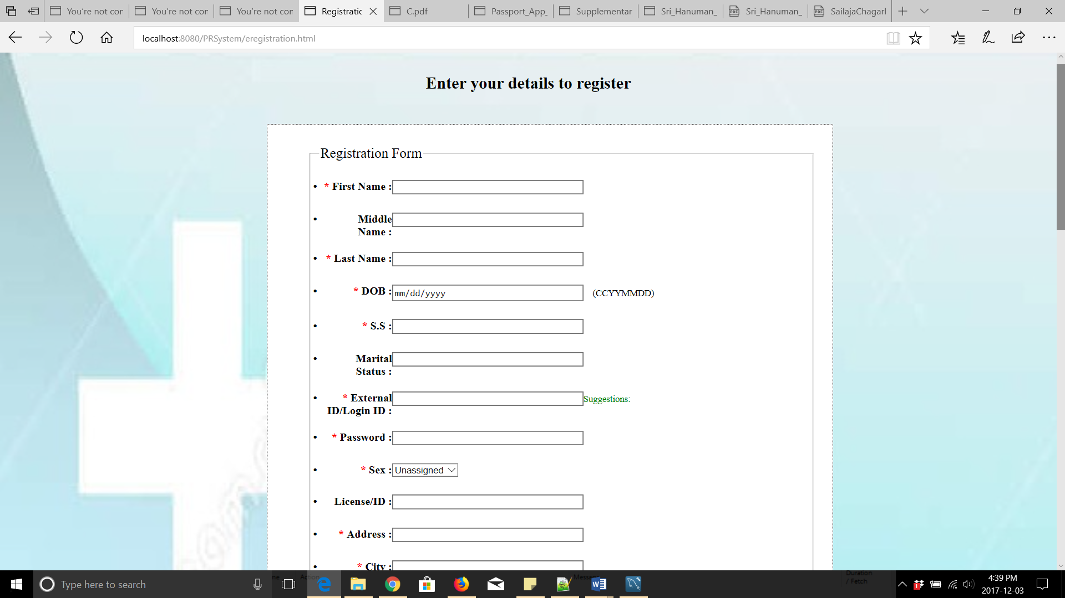
3.Doctor’s Menu/Services:
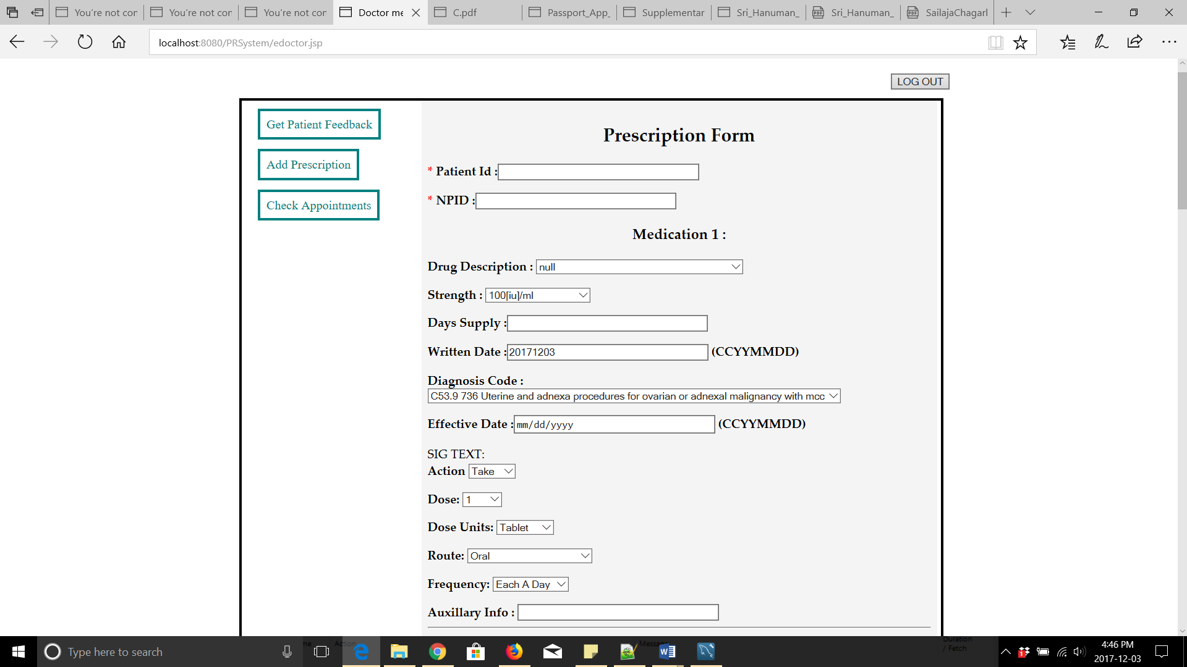

4.Patient’s Menu/Services:
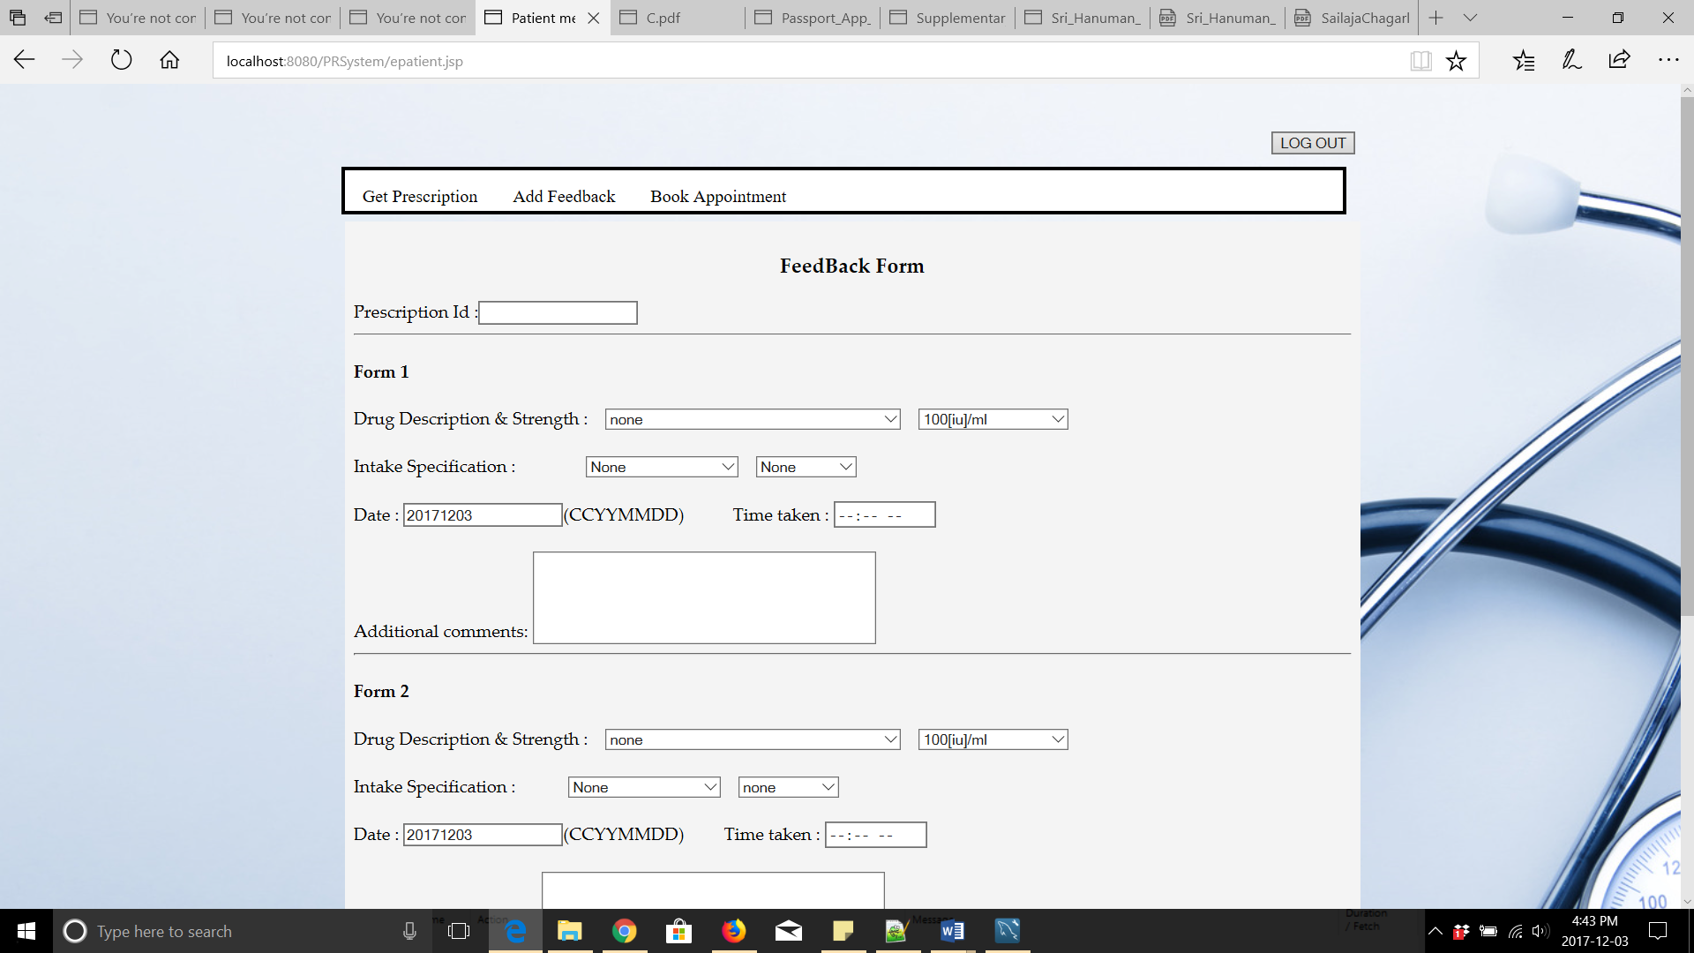
5.Patient Prescription form:
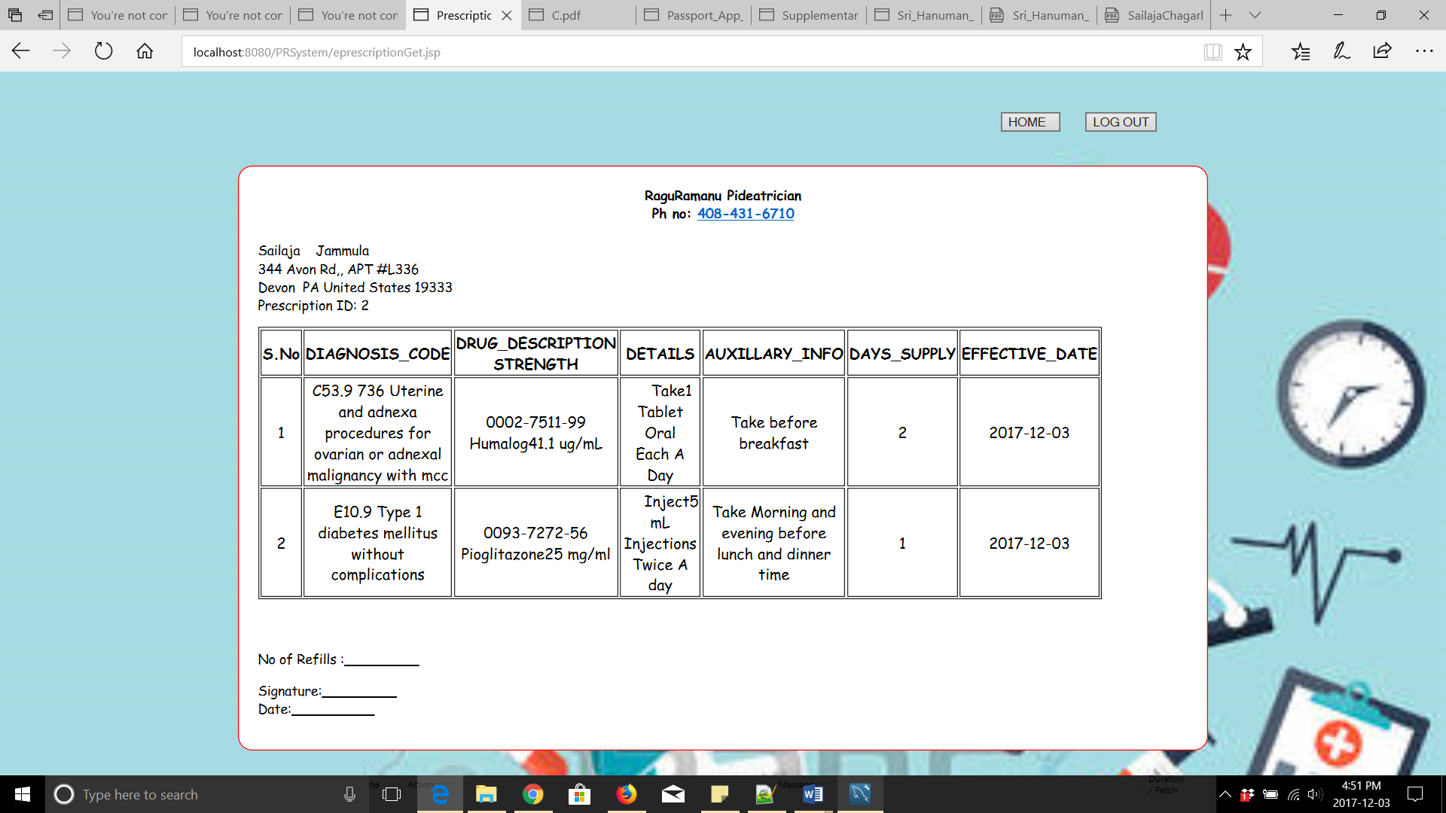
6.E-mail sent to patients reminding their prescription:
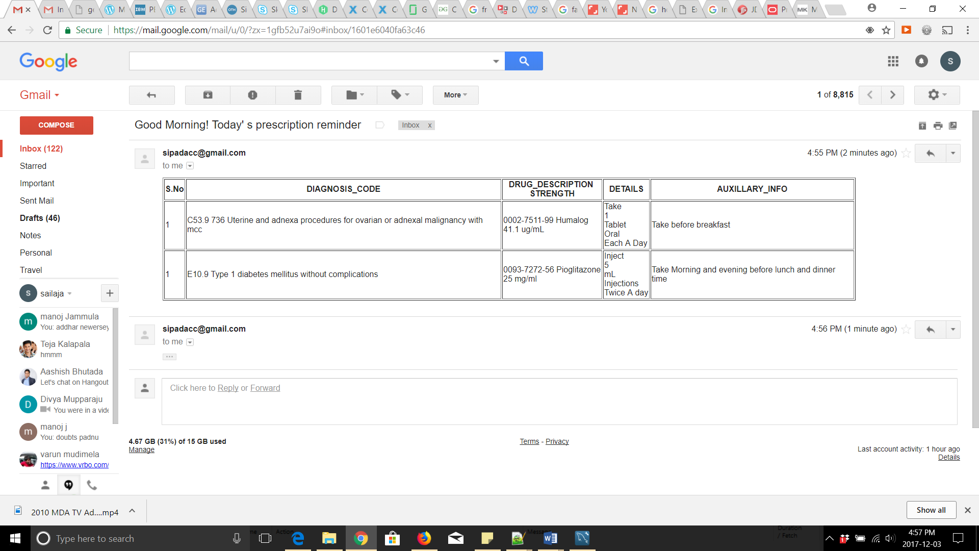
7.Appointments report for doctors:
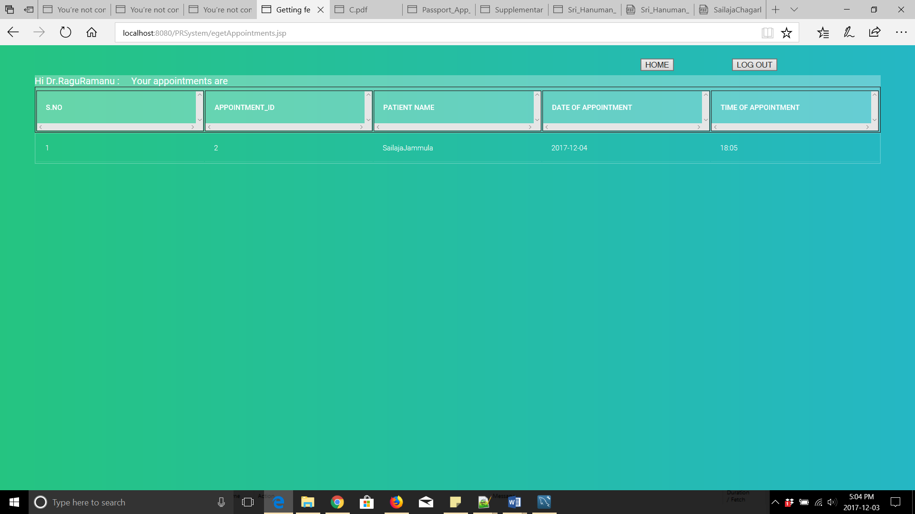

Summary :
In the process of developing this project, I have gained more knowledge technically. I initially planned to develop a web application using Java. To accomplish this, I have learned on basic programming using Java. I then learned object oriented concepts, like inheritance, polymorphism, static binding, dynamic binding, and implemented those using Java through the practice exercises available in various websites. I have also learned Java Servlet Programming to start with development of the website. I have learned on how to setup the environment and various requirements to develop a web application. Installed TOMCAT 8 server and MYSQL database and integrated both of them. I learned on how to connect to database in Java programming, storing the fetched results from database into variables and how to retrieve & use the stored results to accomplish various tasks. I have learned various options available to execute database queries, which are ‘JDBC statements’ and ‘prepared statements’, in Java programming and also the possibility of SQL INJECTION through which hacking can happen if we use JDBC statements which can be avoided by using ‘prepared statements’. I have learned how to pass the user inputs as parameters to the queries, through various in-built methods available for prepared statements, to fetch results based on the inputs. Also learned on how to send e-mails to the users of the system through java programming. Learned how to store the values in session variables and use them where ever required as long as the user is active i.e ; until the user log’s out of the system. Learned how to integrate JSP and HTML code in the same page to obtain required results.
Also learned how to validate the values given by the user using Javascript and how to associate the events and actions to trigger to execute the Javascript code. Learned on how execute the AJAX script code based on the events triggered to provide suggestions to the users of the system.

While developing the project, I came to know that
- Technical expertise is not enough to complete a project successfully.
- A well-integrated project plan is the primary tool for effective coordination and it is the key document as a basis of reference.
- Project planning helps in proceeding to subsequent phases of the project smoothly.
- A good project brief will set out the goals, objectives and scope of the project,its deliverables and how these are to be achieved technically.

