LAB Logbook

Lab 1
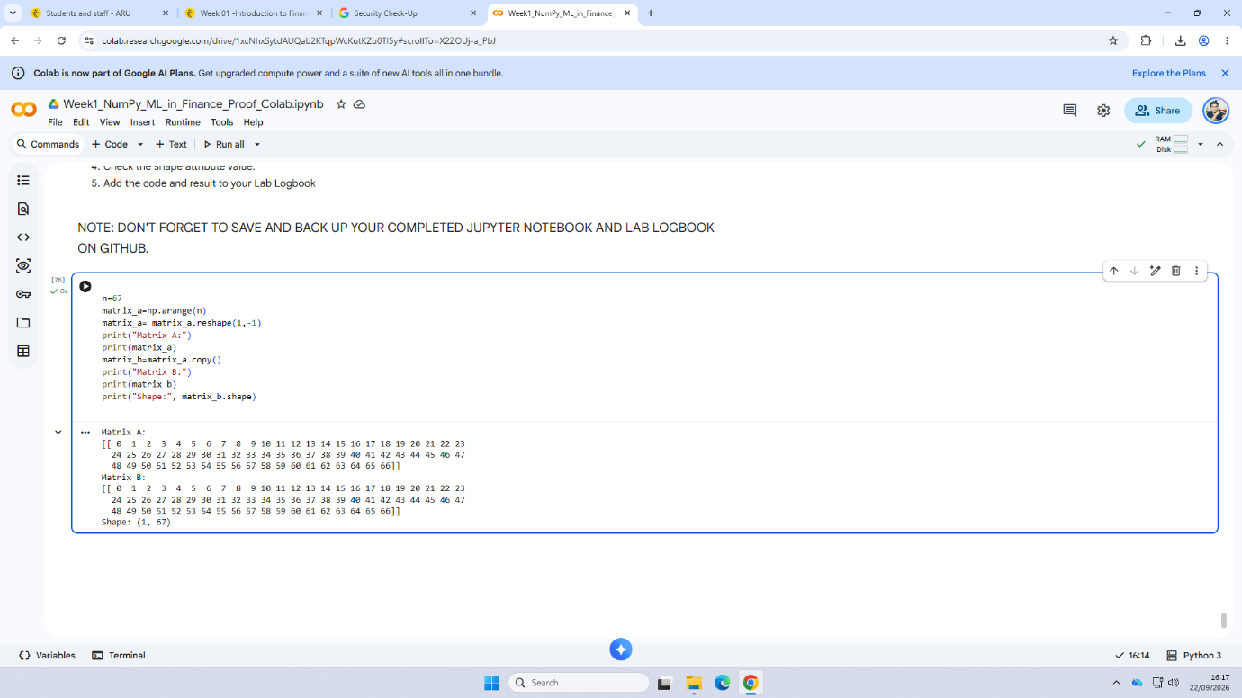
Lab 2
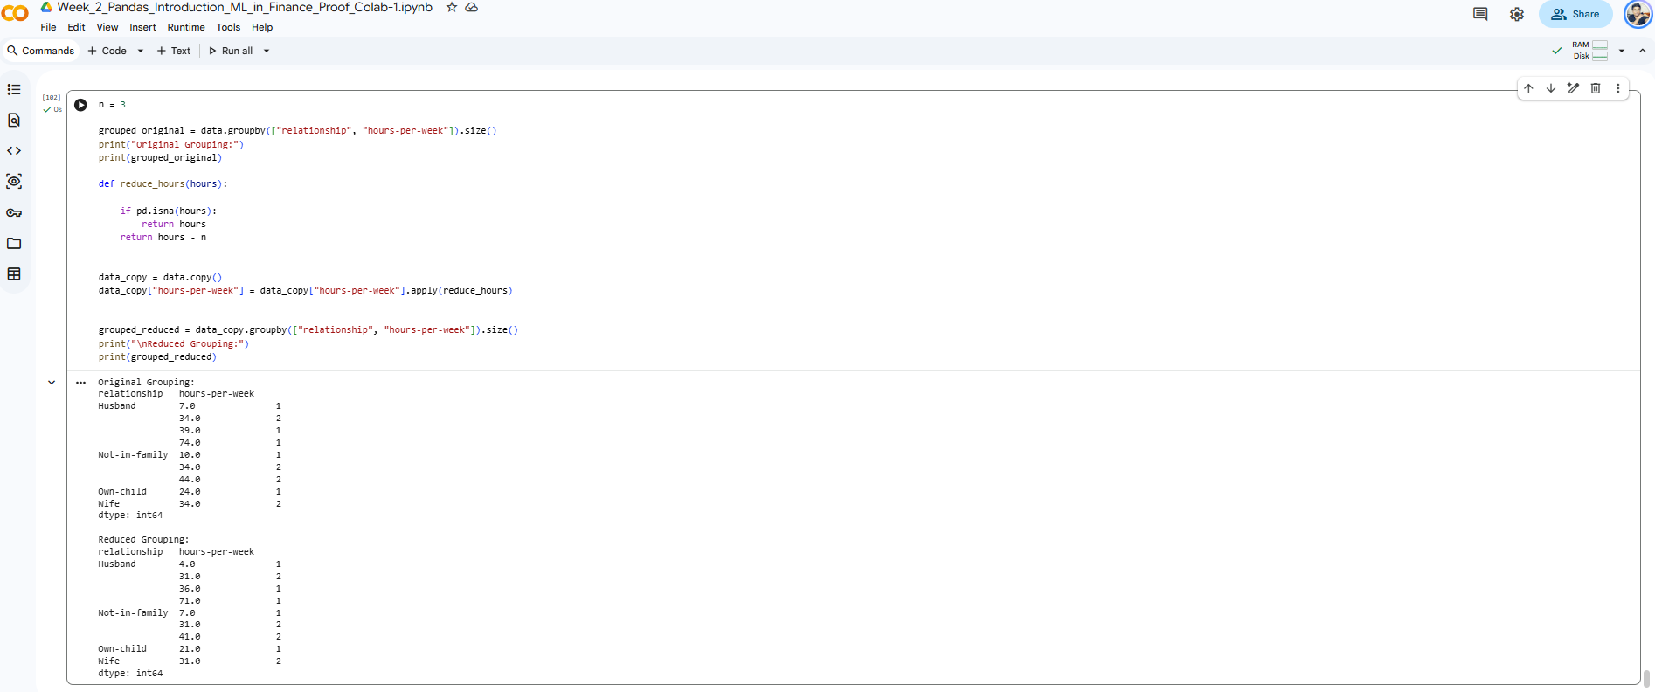

Lab 3
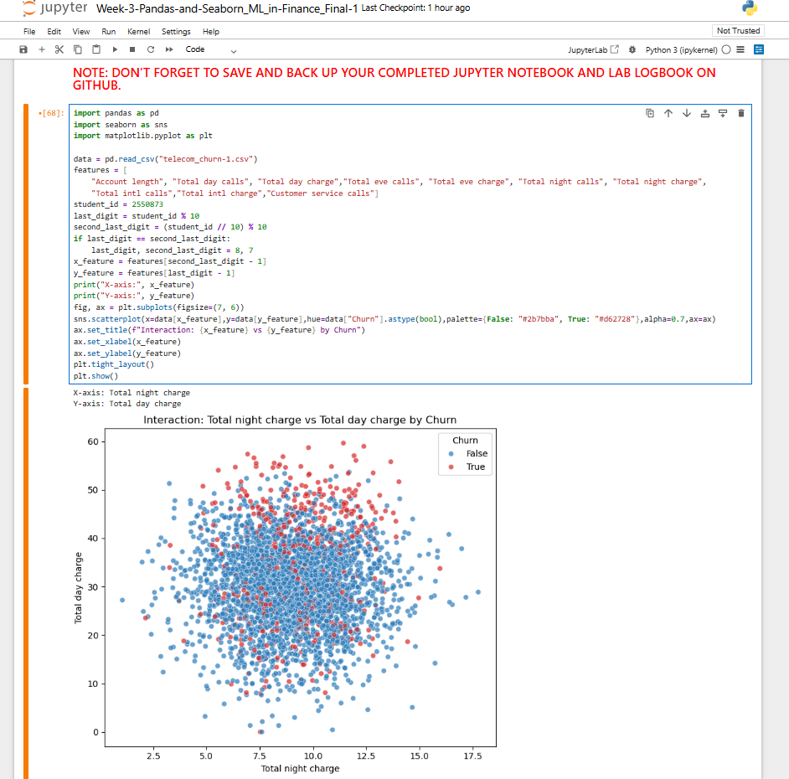

Lab 4
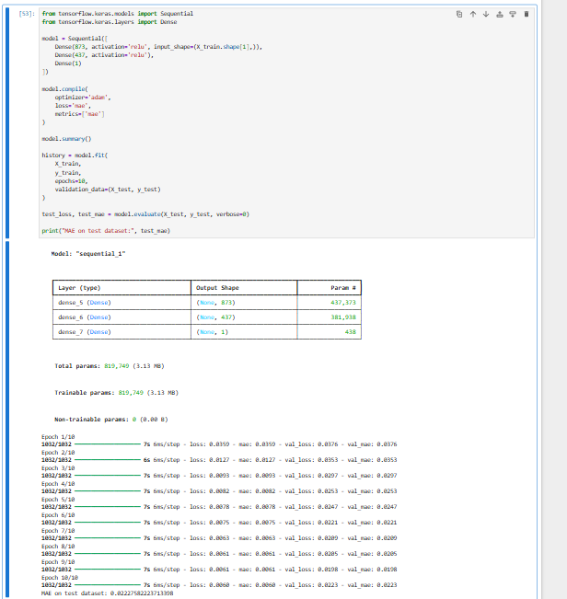
Lab 5
SID is 2550873.
- $Z=7$ and $Y=3$ (the last two digits of SID).
- Number of epochs = $Z+Y=7+3=10$.
- Convolutional core size: 5.

- CNN ARCHITECTURE

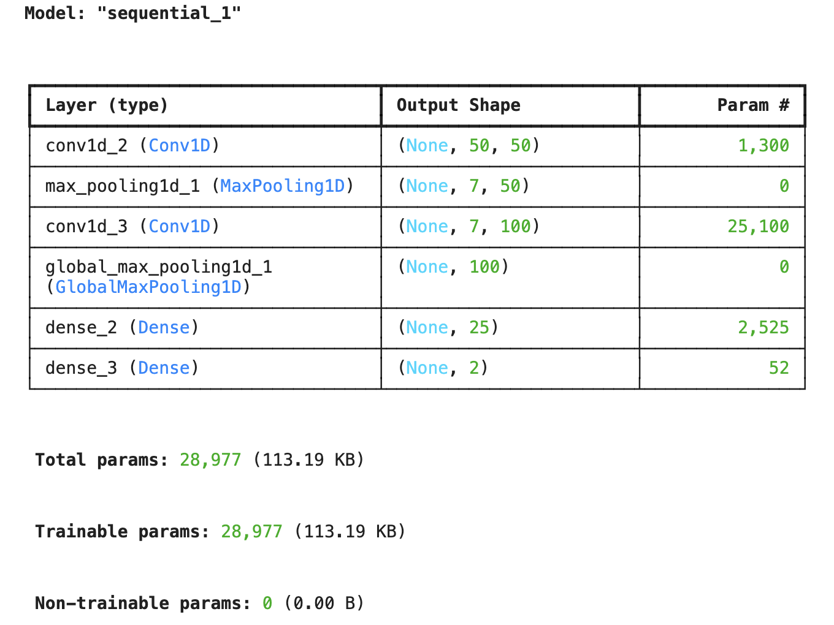
- CNN TRAINING
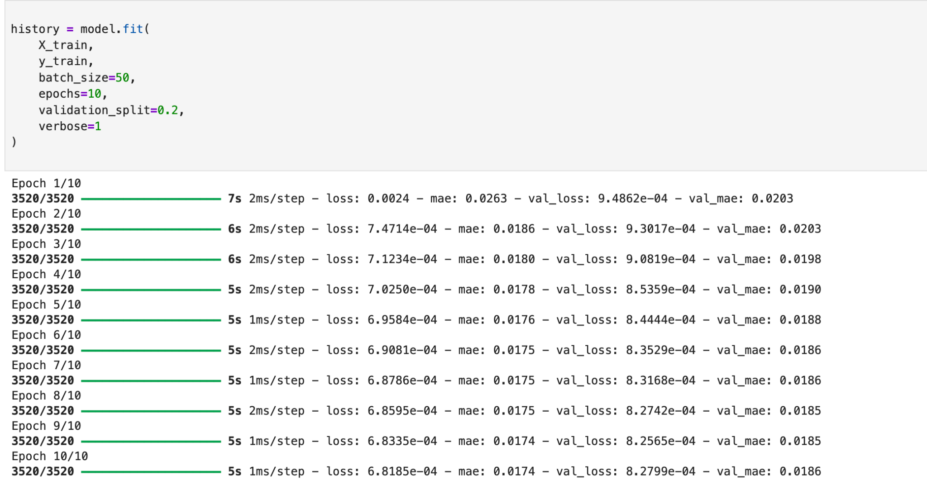
- MAE RESULT
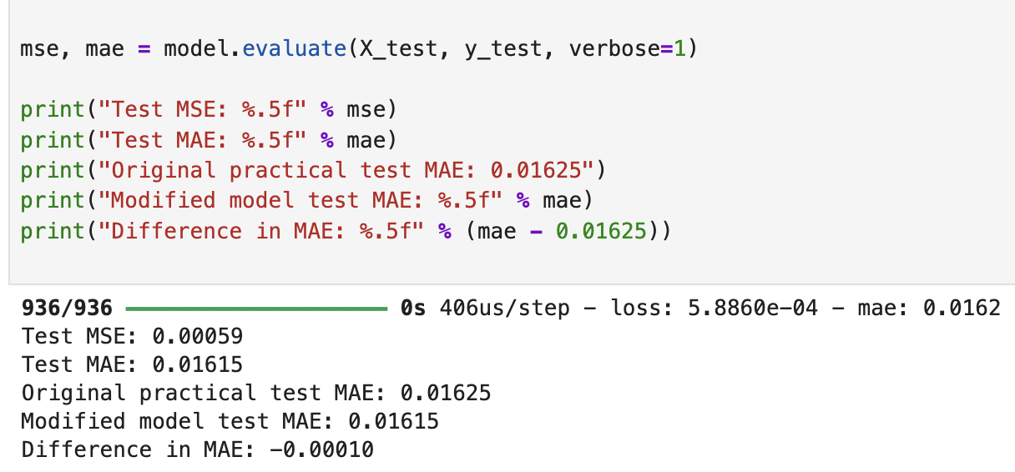
- MAE HISTOGRAM
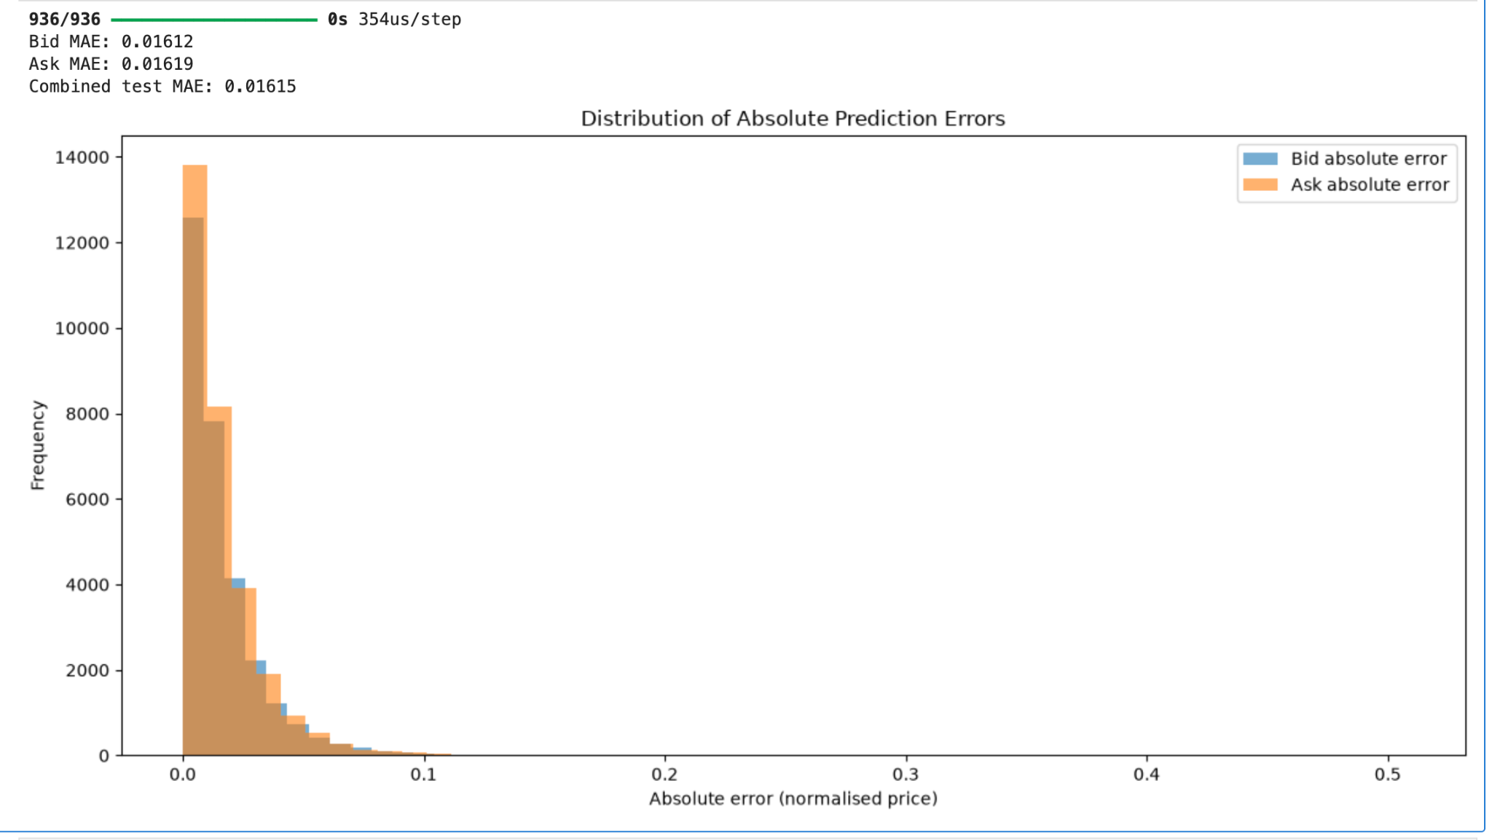

Lab 6
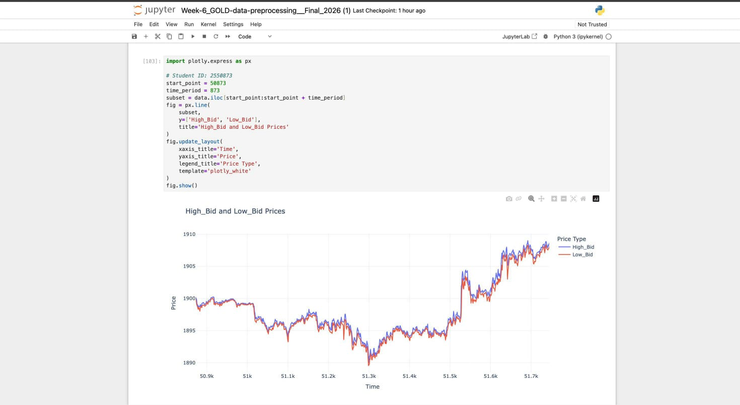

Lab 7

1. LSTM architecture
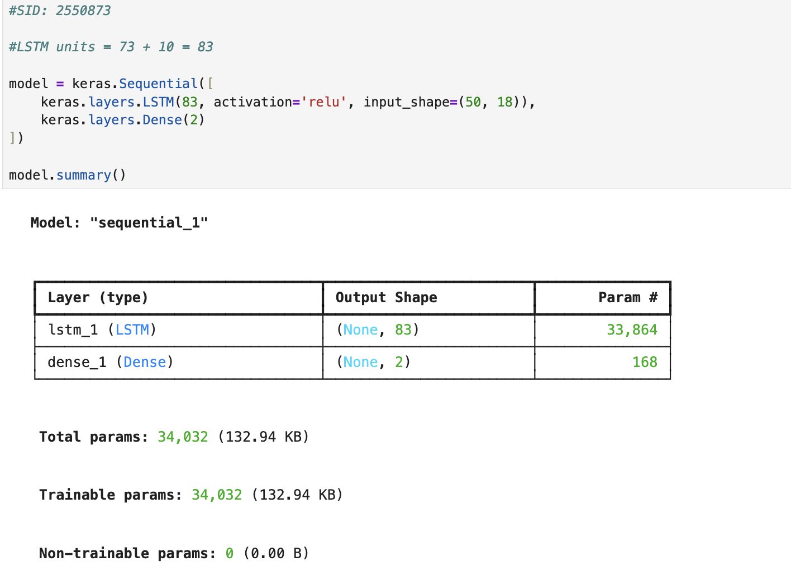

2. Training process

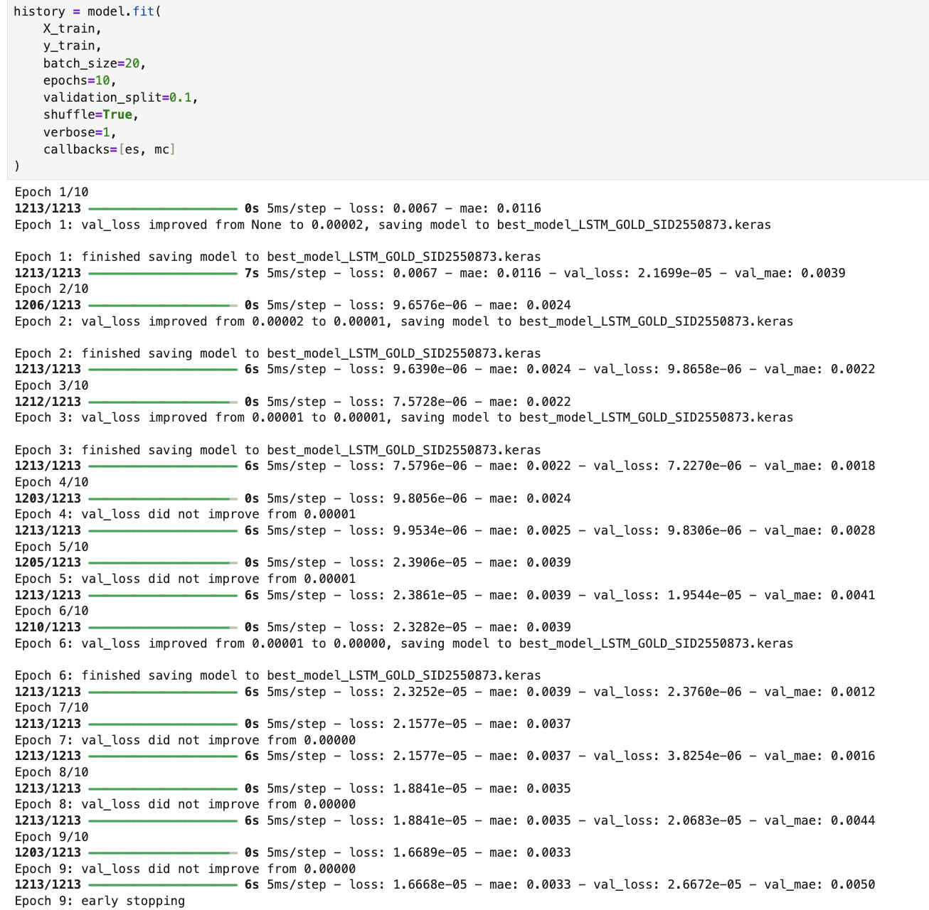

3. Test MSE and MAE

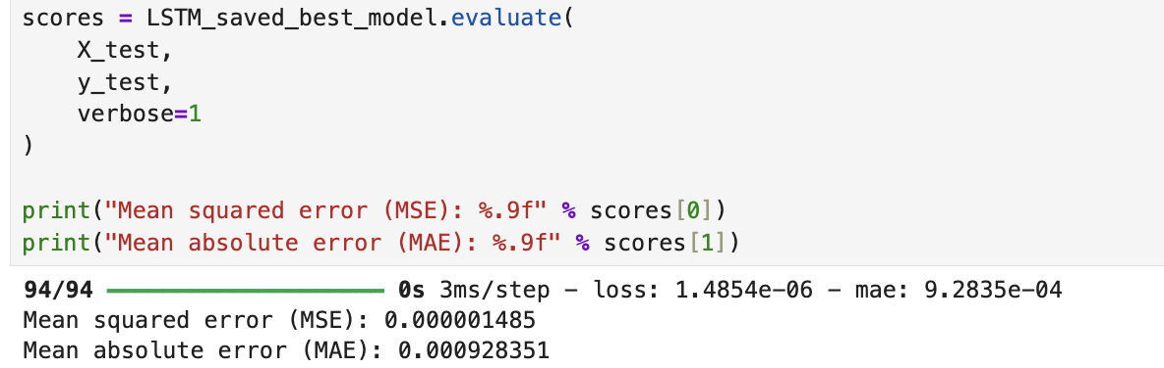
4. Detailed MAE graph

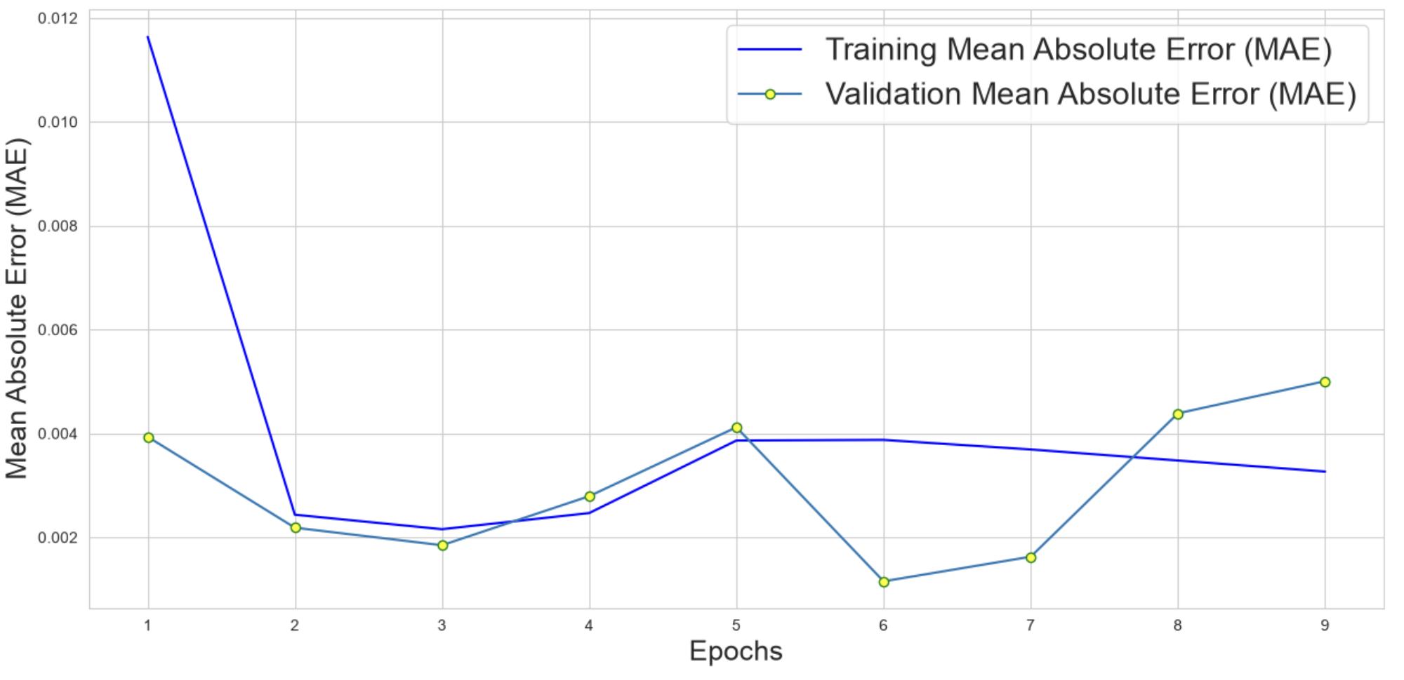

Lab 8
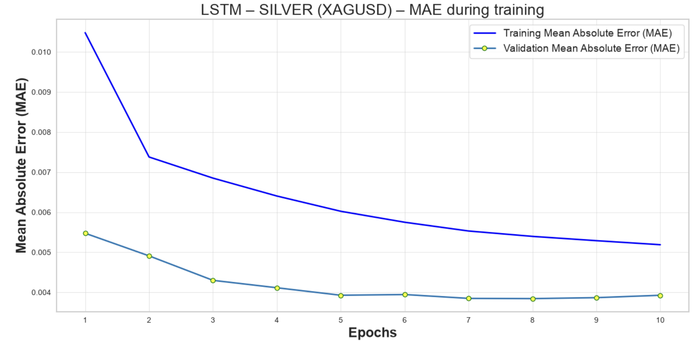
Lab 9

Lab 10

Lab 11

Lab 12

