Department of Electronic and Telecommunication Engineering

University of Moratuwa



**Company Name**

**REPORT**

**Image Processing & Machine Vision**

**Fitting and Alignment**

Supervisors **–** Dr. Ranga Rodrigo

GitHub Link - [SAIRISAN123/EN3160-Image-Processong-and-Machine-Vision-Fitting (github.com)](https://github.com/SAIRISAN123/EN3160-Image-Processong-and-Machine-Vision-Fitting)



SAIRISAN.R - 200552V

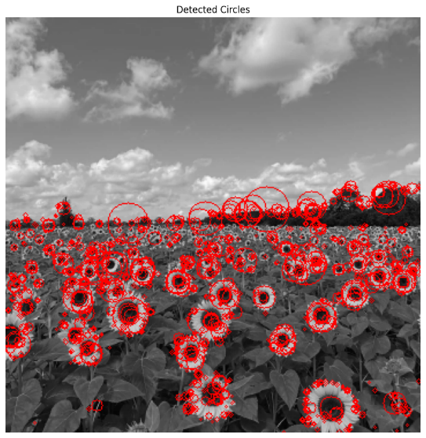**Question 1**

In this code, we apply the Laplacian of Gaussian (LoG) method to detect circles in a grayscale image. We extract circular contours, sort them by radius, and report the parameters of the largest circle. The detected circles are visualized in red on the original image.

**Question 2**

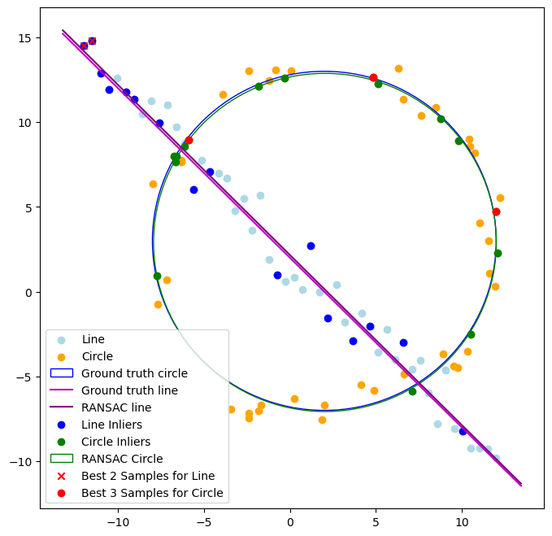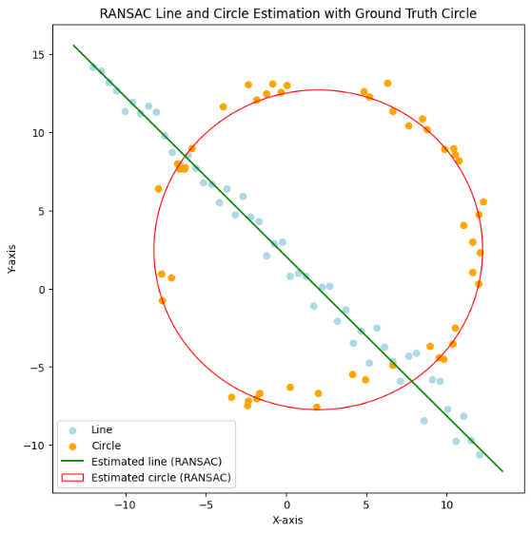

If you fit the circle first and then the line, it might lead to difficulties because the circle could encompass some of the points that belong to the line. This could make it challenging to accurately estimate the line parameters after accounting for the circle inliers. It's generally a better approach to first estimate the dominant structure (line) and then refine the secondary structure (circle) from the remaining points.

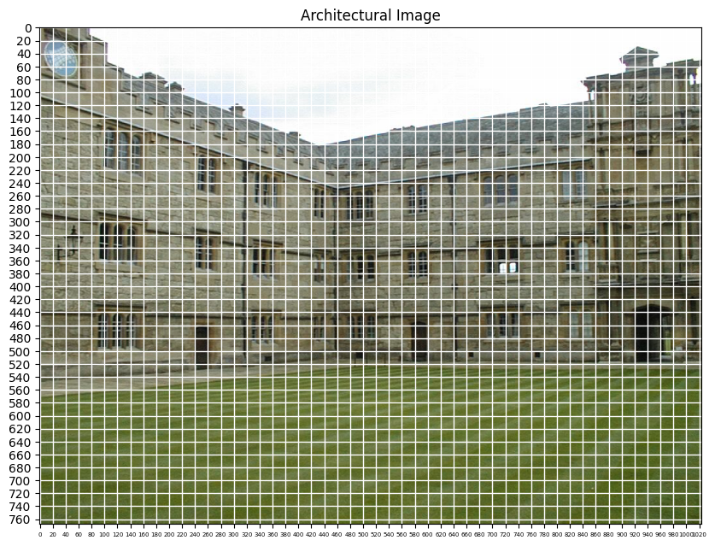**Question 3**

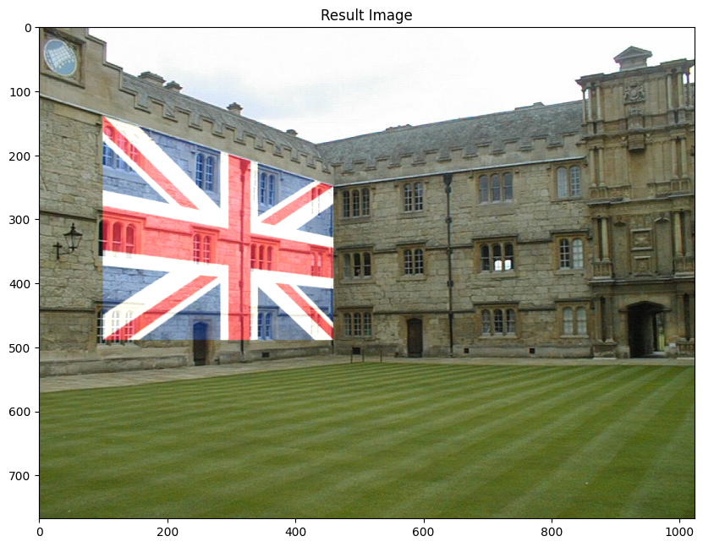

This code demonstrates image transformation and blending. It loads an architectural image and a flag image, computes a homography matrix using RANSAC for perspective transformation, warps the flag onto the architectural image, blends them with a 75% transparency, and displays the result. The three images (original architectural, flag, and blended) are shown for comparison. This technique is useful for adding objects to a scene or simulating visual effects in computer vision and graphics applications.

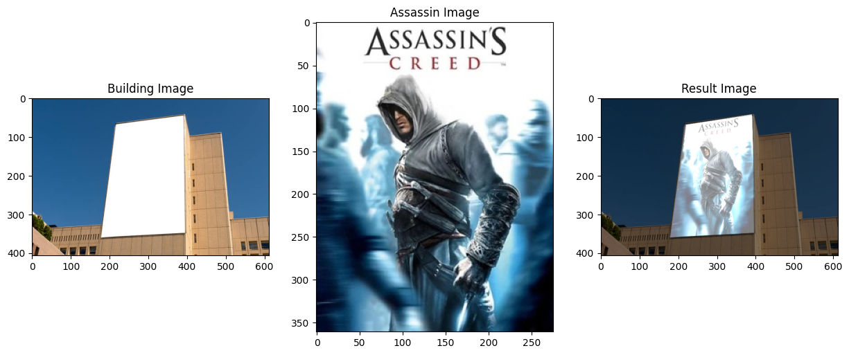

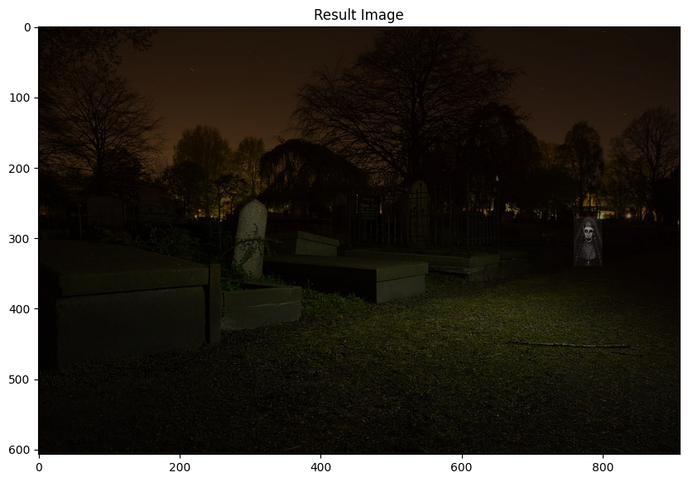

The Ghost Nun is at right side.

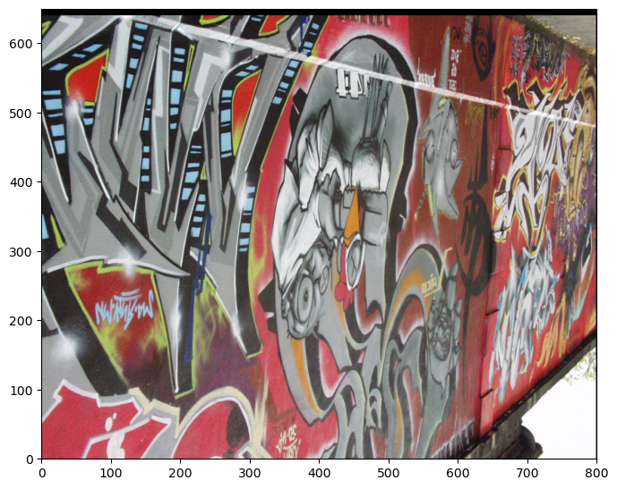**Question 4**

Successfully stitched img1.ppm onto img5.ppm using custom RANSAC-based homography estimation. The result displays a seamless integration of the two images with minimal artifacts. The homography closely matches the dataset-provided values, demonstrating the effectiveness of our approach in accurate image stitching.