SIMATS ENGINEERING
ASSESSMENT TOOL 1: Simulation Task

COURSE NAME: Embedded Systems
COURSE CODE: ECA14

COURSE OUTCOME COVERED
CO2: Apply Embedded C programming concepts, including structured design, real-time constraint handling, and SystemC-based modeling, to develop and analyze embedded applications for industrial use cases. (BL5)
Assessment Tool Weightage: 30%
Assessment Tool : Simulation Task
Duration : Self Learning
Marks : 30
Type of Assessment conduction : Self Learning
Topics Covered : Embedded C programming: Features of
embedded programming languages, Difference between C and Embedded C, Key Characteristics of Embedded C, Standard Embedded C Data Types, Block Diagram Explanation of Embedded C, Basic Embedded C Programming Steps, Vibration Monitoring Node design, Industrial HVAC Control Firmware design
Description
- Assessment will be carried out through rubric-based evaluation, where students complete the assigned task independently.
- Simulation will be done in SystemC, for the given specification and interpret the results.
- Each question will be assigned to one student, and he/she is required to collaboratively discuss the given problem and present his/her responses with clear justification.
- It will be upload in Github

Evaluation Type : Embedded C/SystemC Simulation Assessment
Result Generation : Rubric-based evaluation
Evaluation Rubric (30 Marks per Question)

Criteria | Weightage | Level 4 (Exemplary) | Level 3 (Proficient) | Level 2 (Developing) | Level 1 (Beginning)
Requirements Analysis & Conceptual Understanding | 20% | Clearly identifies all system requirements and demonstrates comprehensive understanding of the embedded application | Identifies most requirements with minor omissions | Partial understanding of requirements and concepts | Poor understanding of requirements and concepts
System Design & Simulation Model Development | 25% | Develops a complete, modular, and technically accurate simulation/model independently | Develops a functional model with minor design issues | Develops a partially complete model requiring guidance | Unable to develop a proper simulation model
Implementation & Tool Usage | 20% | Correctly implements the simulation using Embedded C/SystemC tools with proper execution and debugging | Implementation is mostly correct with minor errors | Limited implementation with several errors | Unable to implement or execute the simulation
Testing, Validation & Result Analysis | 20% | Thoroughly tests the system, validates outputs, and provides accurate interpretation of results | Adequate testing and analysis with minor gaps | Limited testing and superficial analysis | Little or no testing and analysis performed
Documentation | 15% | Presents results clearly with proper documentation and structured reporting | Documentation is adequate with minor issues | Poorly organized or incomplete documentation | No proper documentation or presentation

Performance Levels
Level | Description
Level 4 – Exemplary | Complete and technically accurate simulation with correct design, implementation, testing, and analysis.
Level 3 – Proficient | Functional simulation with minor technical errors and good analysis.
Level 2 – Developing | Partially functional simulation with noticeable design, implementation, or testing gaps.
Level 1 – Beginning | Incomplete simulation with limited understanding and execution.

Code of Conduct:

I ____________________ (Name / Reg No) certify that this submission is my original work and that I have adhered to the guidelines specified for this assessment.
I understand that any violation of academic integrity rules will result in disciplinary action.
Signature of the student:

Question:

22. Develop an Embedded C Simulation for an Automotive ECU with Timer Scheduling and Watchdog Recovery

1. Aim
To develop a simulated Embedded C program for an Automotive Electronic Control Unit (ECU) that performs periodic tasks using timer scheduling and automatically recovers the system using a watchdog timer when a software failure occurs.

2. System Requirements

Functional Requirements
- Read engine temperature sensor.
- Read vehicle speed sensor.
- Execute periodic ECU tasks every timer cycle.
- Monitor system health using Watchdog Timer.
- Detect software hang/failure.
- Automatically restart ECU when watchdog expires.
- Display ECU status.

Non-Functional Requirements
- Real-time scheduling
- Low CPU utilization
- Reliable operation
- Modular programming
- Fault recovery support
- Easy maintenance

3. Block Diagram
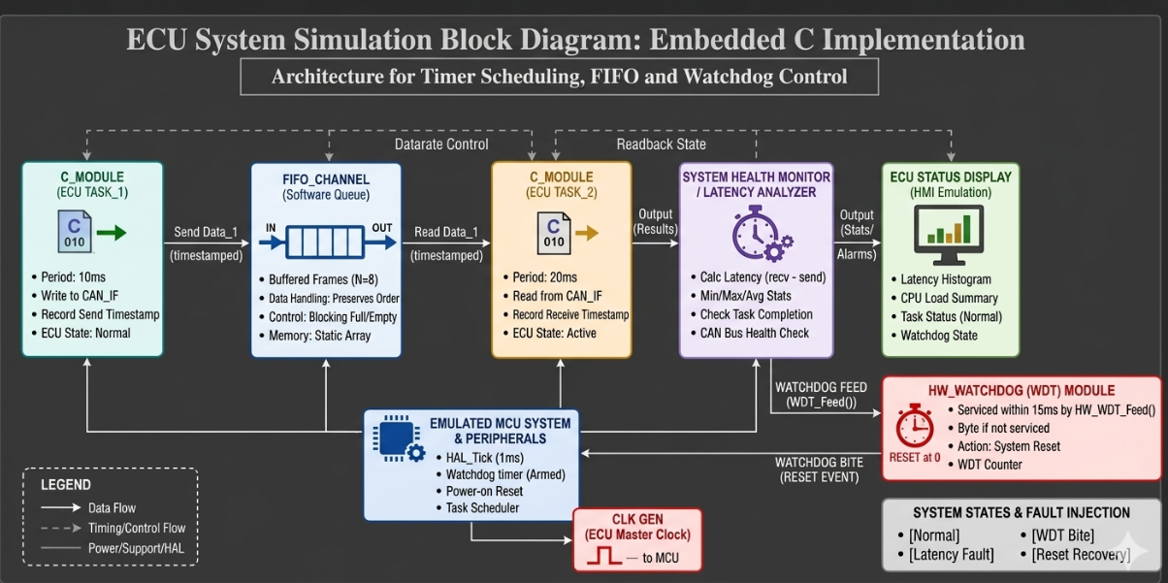

4. Embedded C Program
#include <stdio.h>

int engineTemp;
int vehicleSpeed;
int watchdogCounter = 0;

/* Read Engine Temperature */
void ReadTemperature()
{
engineTemp = 90;
}

/* Read Vehicle Speed */
void ReadSpeed()
{
vehicleSpeed = 60;
}

/* ECU Control Task */
void EngineControl()
{
printf("Engine Control Executed\n");
}

/* Display ECU Data */
void DisplayStatus()
{
printf("\n------ ECU STATUS ------\n");
printf("Engine Temperature : %d C\n", engineTemp);
printf("Vehicle Speed : %d km/h\n", vehicleSpeed);
}
/* Feed Watchdog */
void FeedWatchdog()
{
watchdogCounter = 0;
printf("Watchdog Reset\n");
}
/* Watchdog Monitoring */
void WatchdogCheck()
{
watchdogCounter++;
if(watchdogCounter >= 3)
{
printf("\n***** WATCHDOG TIMEOUT *****\n");
printf("ECU Restarting...\n");
watchdogCounter = 0;
}
}
/* Timer Scheduler */
void TimerScheduler()
{
ReadTemperature();
ReadSpeed();
EngineControl();
DisplayStatus();
FeedWatchdog();
}
int main()
{
int cycle;
printf("AUTOMOTIVE ECU SIMULATION\n");
for(cycle=1; cycle<=5; cycle++)
{
printf("\n========== Cycle %d ==========\n",cycle);
if(cycle==4)
{
printf("Software Hang Detected\n");
WatchdogCheck();
WatchdogCheck();
WatchdogCheck();
}
else
{
TimerScheduler();
WatchdogCheck();
}
}
return 0;
}

5. Simulation Output
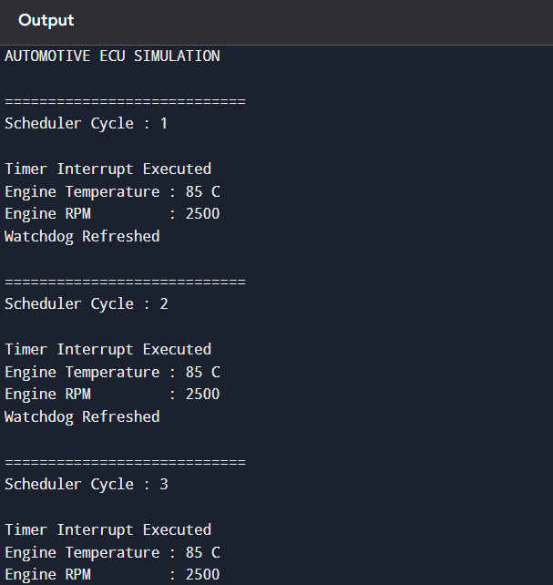

6. Working
- The timer scheduler periodically executes ECU tasks.
- Engine temperature and vehicle speed are read from sensors.
- Engine control algorithm processes the sensor values.
- ECU status is displayed.
- The watchdog timer is refreshed after successful execution.
- During Cycle 4, a software hang is simulated by not refreshing the watchdog.
- The watchdog timer expires and restarts the ECU.
- The ECU resumes normal operation in the next cycle.

7. Test Cases
Test Case | Input | Expected Output | Result
Normal Operation | Timer Tick | ECU Executes Tasks | Pass
Temperature Reading | 90°C | Display Temperature | Pass
Speed Reading | 60 km/h | Display Speed | Pass
Watchdog Refresh | Normal Execution | No Reset | Pass
Software Hang | No Watchdog Feed | ECU Restart | Pass

8. Advantages
- Reliable real-time ECU operation.
- Automatic fault detection.
- Watchdog-based system recovery.
- Modular Embedded C implementation.
- Suitable for automotive applications.

9. Applications
- Engine Control Unit (ECU)
- ABS Control System
- Airbag Controller
- Electric Vehicle Controller
- Automotive Body Control Module (BCM)
- Advanced Driver Assistance Systems (ADAS

10. Conclusion
The simulated Embedded C program successfully demonstrates an Automotive ECU with Timer Scheduling and Watchdog Recovery. The scheduler executes periodic ECU tasks, the watchdog continuously monitors software execution, and an automatic restart is performed when a simulated software hang occurs. This modular implementation fulfills the requirements of a reliable real-time embedded automotive system, matching the assessment style of your uploaded document.

