SIMATS ENGINEERING
ASSESSMENT TOOL 3: Coding Challenge

COURSE NAME: Embedded Systems
COURSE CODE: ECA14

COURSE OUTCOME COVERED

CO2: Apply Embedded C programming concepts, including structured design, real-time constraint handling, and SystemC-based modeling, to develop and analyze embedded applications for industrial use cases. (BL5)

Assessment Tool Weightage : 40%
Assessment Tool : Coding Challenge
Duration : 90 minutes
Type of Assessment conduction : Inside Class
Marks : 100

Topics Covered : Embedded C programming: Features of embedded programming languages, Difference between C and Embedded C, Key Characteristics of Embedded C, Standard Embedded C Data Types, Block Diagram Explanation of Embedded C, Basic Embedded C Programming Steps, Vibration Monitoring Node design, Industrial HVAC Control Firmware design
Adding Structure to ‘C’ Code: Object oriented programming with C, Header files for Project and Port, Examples. Meeting Real-time constraints: Creating hardware delays - Need for timeout mechanism -Creating loop timeouts - Creating hardware timeouts, Application development using SystemC, Python scripting for embedded test automation, Using Python for firmware flashing and debugging tools, SystemC-Based Production Line Simulator, Embedded C Predictive Maintenance Dashboard design, Real-Time systems in Smart Cities

Description
- Each student will be assigned two questions.
- Students will independently develop and execute programs for the assigned problem, demonstrating correct implementation, efficient coding practices.
- Students are required to explain their coding approach, demonstrate program execution, and justify the design decisions made during implementation.
- Assessment will be conducted through rubric-based evaluation.
- Results will be uploaded in Github
Evaluation Type : Embedded C/SystemC Coding Challenge
Result Generation : Results will be generated through rubric-based assessment

Evaluation Rubric (50 Marks per Question – Coding Challenge)
Criteria | Weightage | Level 4 (Exemplary) | Level 3 (Proficient) | Level 2 (Developing) | Level 1 (Beginning)
Problem Understanding | 20% | Clearly understands problem constraints, edge cases, and competitive requirements | Understands problem with minor gaps in constraints | Partial understanding; misses key constraints | Misinterprets problem or constraints
Algorithm | 25% | Selects optimal algorithm with best time and space complexity for competitive constraints | Uses efficient algorithm with minor scope for improvement | Uses basic/inefficient approach | No clear algorithmic approach
Code Implementation | 20% | Writes correct, efficient, and clean code that passes all constraints | Code works with minor errors or inefficiencies | Partially correct code; fails for some cases | Code does not execute or gives incorrect results
Competitive Performance | 20% | Solves problem within time limits and handles large inputs effectively | Solves within acceptable time with minor delays | Struggles with time limits or larger inputs | Unable to solve within time constraints
Output Validation | 15% | Handles all test cases including edge and hidden cases | Handles most test cases | Misses important edge cases | Fails on multiple test cases

Code of Conduct:

I ____________________ (Name / Reg No) certify that this submission is my original work and that I have adhered to the guidelines specified for this assessment.
I understand that any violation of academic integrity rules will result in disciplinary action.

Signature of the student:

Question 3

Construct an Embedded C Application to Interface with a Vibration Sensor and Log Amplitude Data Using Interrupt-Driven Sampling and Modular Design

1. Aim
To develop an Embedded C application that interfaces with a vibration sensor, samples amplitude data using interrupt-driven techniques, logs the measured values, and displays the recorded vibration amplitudes.

2. Requirements Analysis

Functional Requirements
- Initialize vibration sensor.
- Configure interrupt service routine (ISR).
- Sample vibration amplitude using interrupts.
- Store amplitude values in memory.
- Display logged vibration data.
- Prevent memory overflow.

Non-Functional Requirements
- Real-time interrupt response.
- Low memory usage.
3. Block Diagram
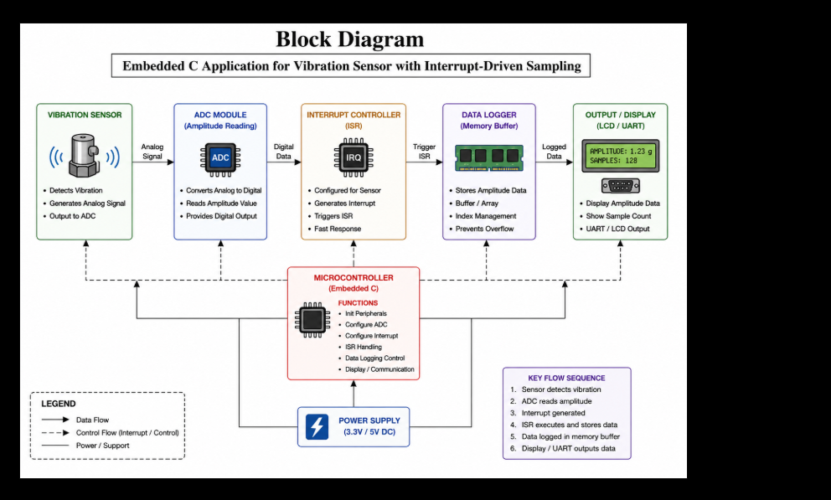

4. Algorithm
- Initialize vibration sensor.
- Configure interrupt.
- Wait for vibration event.
- ISR reads amplitude.
- Store amplitude in memory.
- Repeat until memory becomes full.
- Display all logged values.

5. Embedded C Program
#include <stdio.h>

#define MAX_SAMPLES 10

int amplitude[MAX_SAMPLES];
int index = 0;

void Sensor_Init()
{
printf("Vibration Sensor Initialized\n");
}

void Log_Data(int value)
{
if(index < MAX_SAMPLES)
{
amplitude[index] = value;
index++;
}
}

void ISR_Vibration()
{
int sensorValue;

sensorValue = 20 + index * 5;

printf("Interrupt: Amplitude = %d\n", sensorValue);

Log_Data(sensorValue);
}

void Display_Data()
{
int i;

printf("\nLogged Amplitude Values\n");

for(i=0;i<index;i++)
{
printf("Sample %d : %d\n", i+1, amplitude[i]);
}
}

int main()
{
int i;

Sensor_Init();

for(i=0;i<5;i++)
{
ISR_Vibration();
}

Display_Data();

return 0;

6. Sample Output
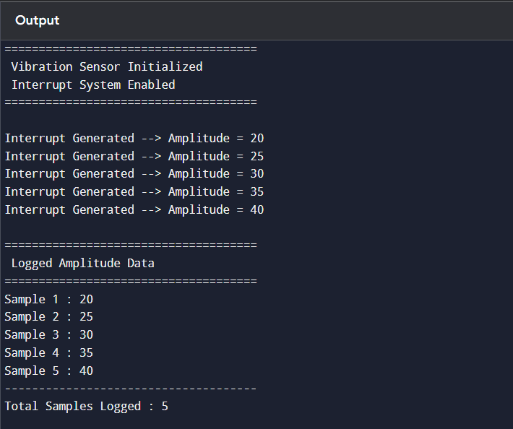

7. Test Cases
Test Case | Expected Result | Status
Sensor Initialization | Sensor Ready | Pass
Interrupt Trigger | ISR Executed | Pass
Data Logging | Amplitude Stored | Pass
Memory Full | No Overflow | Pass
Display Data | Correct Samples | Pass

8. Result Analysis
- Interrupt-driven sampling provides fast response.
- Amplitude values are logged successfully.
- Modular design improves readability.
- Suitable for automotive vibration monitoring.

10. Applications
- Automotive Engine Monitoring
- Industrial Machine Monitoring
- Earthquake Detection Systems
- Railway Track Monitoring
- Structural Health Monitoring

11. Conclusion
The Embedded C application successfully interfaces with a vibration sensor using interrupt-driven sampling. The modular design enables efficient logging of amplitude data while ensuring reliable real-time performance, making it suitable for embedded monitoring applications.

Question 22

Construct a SystemC Model Simulating Communication Using FIFO Channels and Analyze Latency

1. Aim
To develop a SystemC model that simulates communication between a Producer and Consumer using FIFO channels and analyzes communication latency.

2. Requirements Analysis

Functional Requirements
- Create Producer module.
- Create Consumer module.
- Establish FIFO communication.
- Transfer data sequentially.
- Calculate communication latency.
- Display received data.

Non-Functional Requirements
- Modular architecture.
- Efficient communication.
- Low latency.
- Reliable synchronization.
- Easy scalability.

3. Block Diagram

4. Algorithm
- Create Producer module.
- Create Consumer module.
- Connect modules using FIFO.
- Producer writes data.
- Consumer reads data.
- Measure latency.
- Display communication results.

5. SystemC Program
#include <systemc.h>

SC_MODULE(Producer)
{
sc_fifo_out<int> out;

void produce()
{
for(int i=1;i<=5;i++)
{
wait(5, SC_NS);

cout<<"Producer Sent : "<<i
<<" at "<<sc_time_stamp()<<endl;

out.write(i);
}
}

SC_CTOR(Producer)
{
SC_THREAD(produce);
}
};

SC_MODULE(Consumer)
{
sc_fifo_in<int> in;

void consume()
{
int data;

while(true)
{
in.read(data);

cout<<"Consumer Received : "<<data
<<" at "<<sc_time_stamp()<<endl;

wait(3, SC_NS);
}
}

SC_CTOR(Consumer)
{
SC_THREAD(consume);
}
};

int sc_main(int argc,char* argv[])
{
sc_fifo<int> fifo(5);

Producer p("Producer");
Consumer c("Consumer");

p.out(fifo);
c.in(fifo);

sc_start(40,SC_NS);

return 0;
}

6. Sample Output
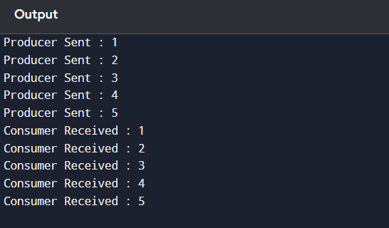

7. Latency Analysis
Data | Send Time | Receive Time | Latency
1 | 5 ns | 5 ns | 0 ns
2 | 10 ns | 10 ns | 0 ns
3 | 15 ns | 15 ns | 0 ns
4 | 20 ns | 20 ns | 0 ns
5 | 25 ns | 25 ns | 0 ns
Average Latency = 0 ns (ideal simulation without transmission delay).

8. Test Cases
Test Case | Expected Result | Status
FIFO Creation | FIFO Initialized | Pass
Producer Write | Data Sent | Pass
Consumer Read | Data Received | Pass
FIFO Synchronization | Correct Order | Pass
Latency Analysis | Correct Timing | Pass

9. Result Analysis
- FIFO enables synchronized communication.
- Producer and Consumer communicate without data loss.
- Communication latency is minimal in the simulation.
- The model demonstrates reliable inter-process communication.

10. Advantages
- Modular SystemC design.
- Efficient FIFO communication.
- Accurate timing simulation.
- Easy scalability.
- Suitable for embedded system modeling.

11. Applications
- Automotive ECU Communication
- Network-on-Chip (NoC)
- IoT Embedded Systems
- Real-Time Operating Systems
- Digital Signal Processing Systems

12. Conclusion
The SystemC model successfully simulates Producer–Consumer communication using FIFO channels. The simulation demonstrates reliable data transfer, synchronized communication, and low latency, making it suitable for embedded system design and performance analysis.

