https://github.com/SAISHA28/Kubernetes_Saisha.git
Objective: Deploy a full-stack application in a local Kubernetes cluster using Minikube.

Project Architecture
The application consists of an Express frontend and a Flask backend. Both applications are containerized using Docker and deployed as Kubernetes workloads in a local Minikube cluster.
Flow:
User Browser → Express Frontend → Flask Backend → JSON Response
Project Structure
Kubernetes_Saisha/
│
├── backend/
│ ├── app.py
│ ├── data.json
│ ├── requirements.txt
│ └── Dockerfile
│
├── frontend/
│ ├── server.js
│ ├── package.json
│ ├── Dockerfile
│ └── public/
│ └── index.html
│
└── kubernetes/
├── backend-deployment.yaml
├── backend-service.yaml
├── frontend-deployment.yaml
└── frontend-service.yaml

Task
- Deploy your previous assignment's Flask frontend and Express backend in a Kubernetes cluster locally using minikube.

Verification of Minikube Kubernetes cluster node
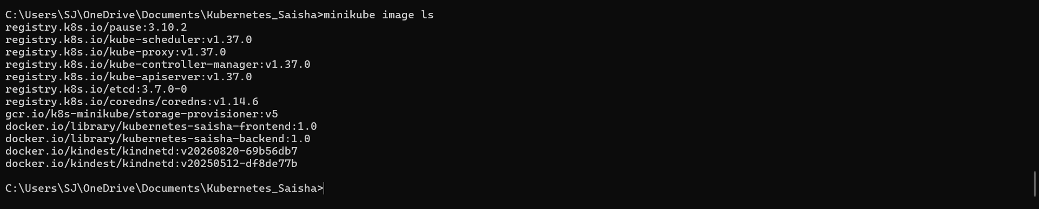
Docker Images Available in Minikube.
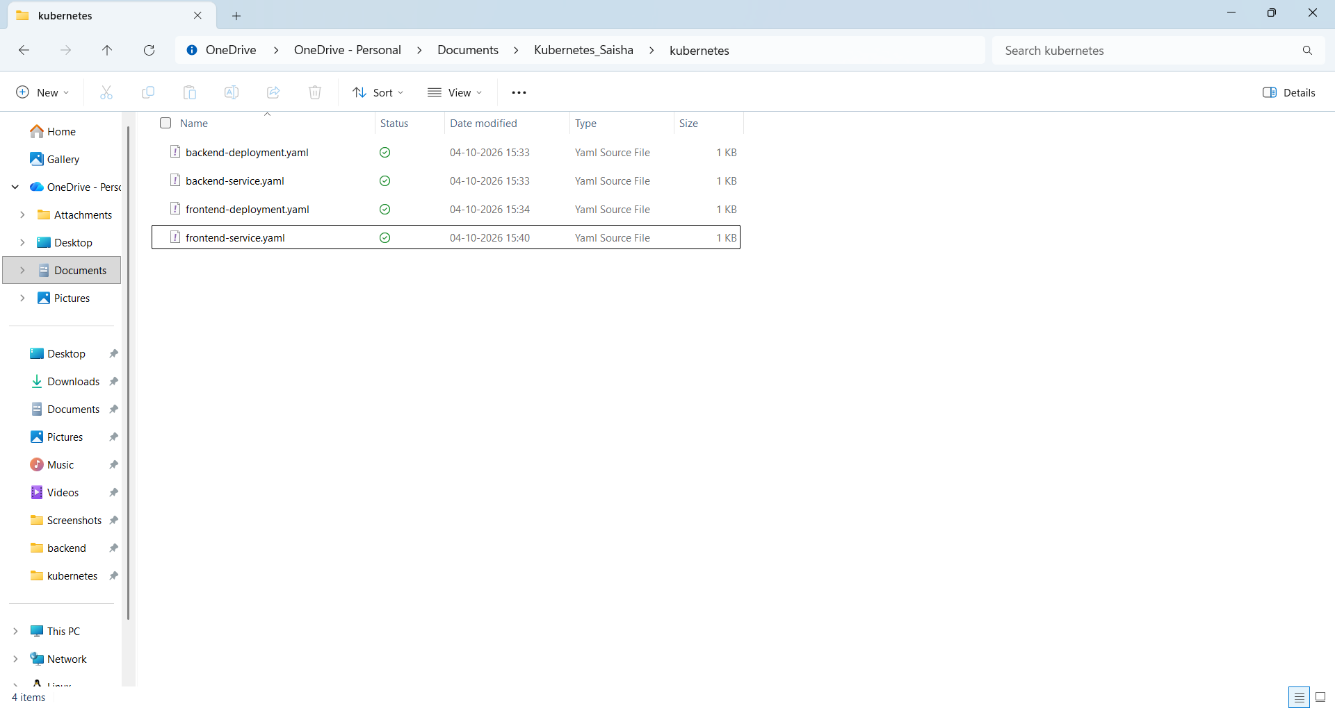
Separate Deployment and Service YAML files were created for the Flask backend and Express frontend.

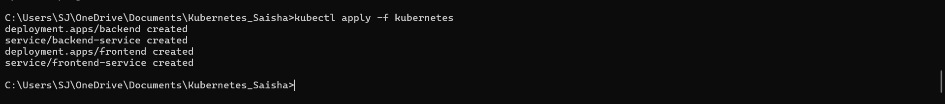
Kubernetes resources created using manifests
Kubernetes Pods running successfully in the Minikube cluster

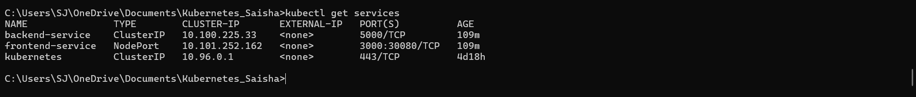
Verification of Kubernetes Services
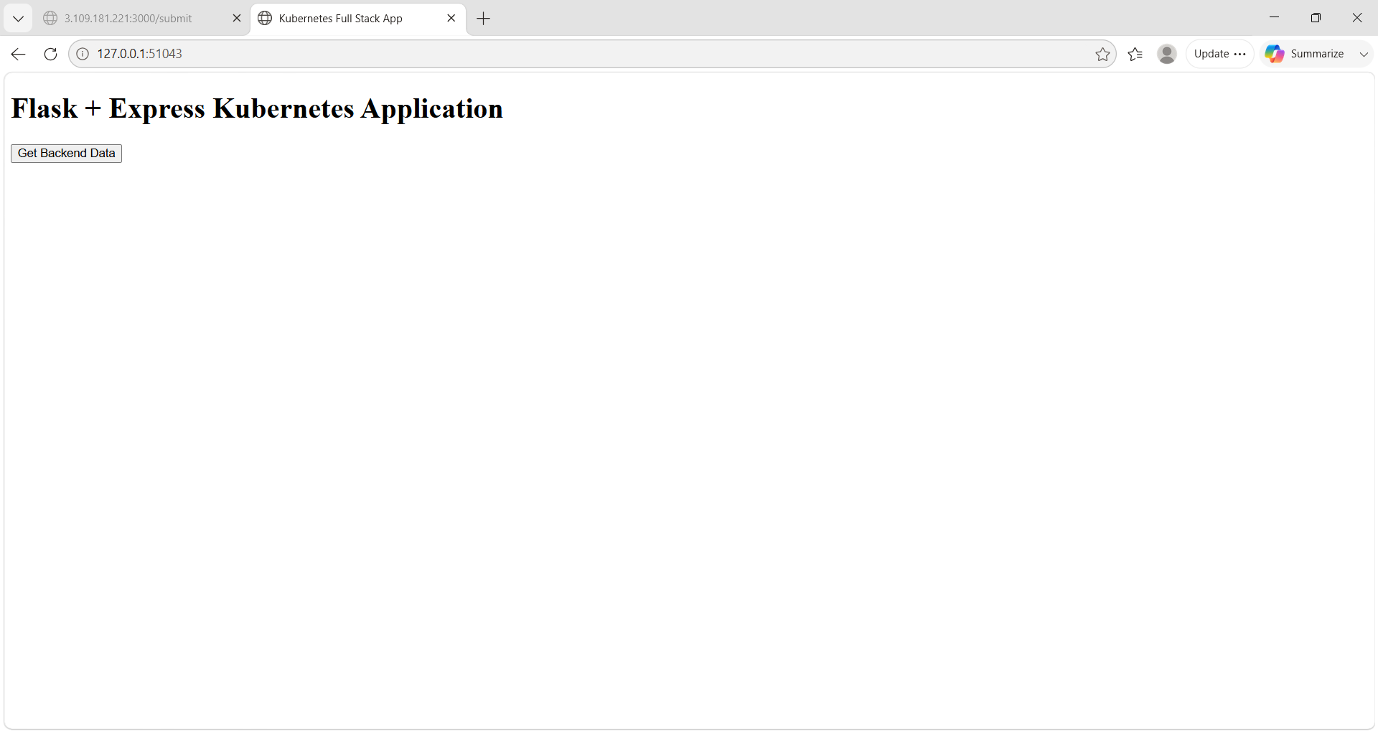

Express frontend successfully deployed and accessed through the Kubernetes NodePort service using Minikube.

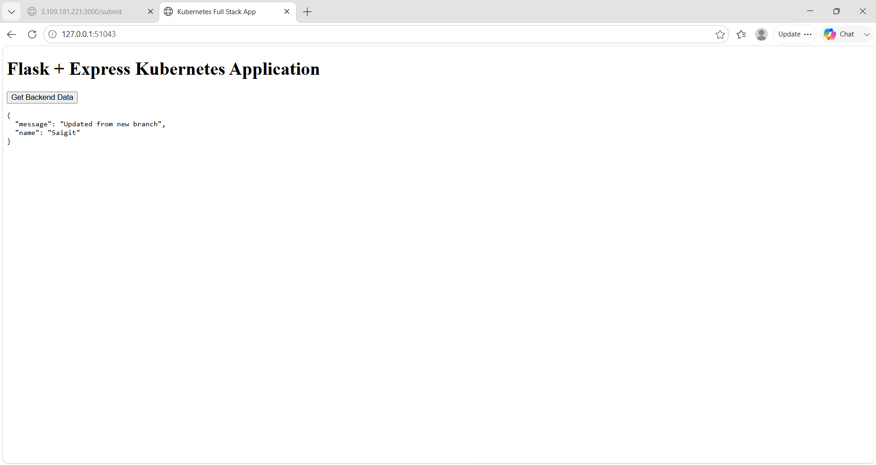
Express frontend successfully communicates with the Flask backend through the Kubernetes Service and displays the backend JSON response.
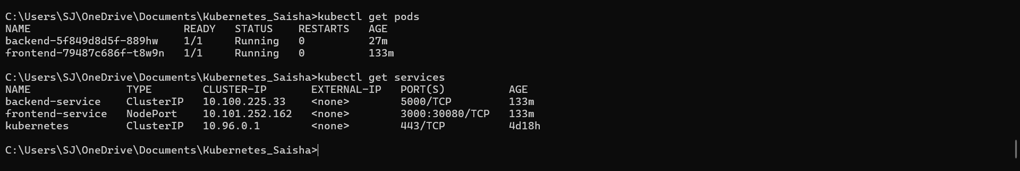
Verification of running Kubernetes Pods and Services using kubectl get pods and kubectl get services.

Conclusion
The full-stack application was successfully containerized and deployed on a local Kubernetes cluster using Minikube. Kubernetes Deployments were created for the Flask backend and Express frontend, while Services provided network connectivity between the components. The Pods and Services were verified successfully, and the application was accessed through the Minikube NodePort service.

