1. Frontend (Node.js with Express):
- Create a frontend using Express and Node.js.
ss
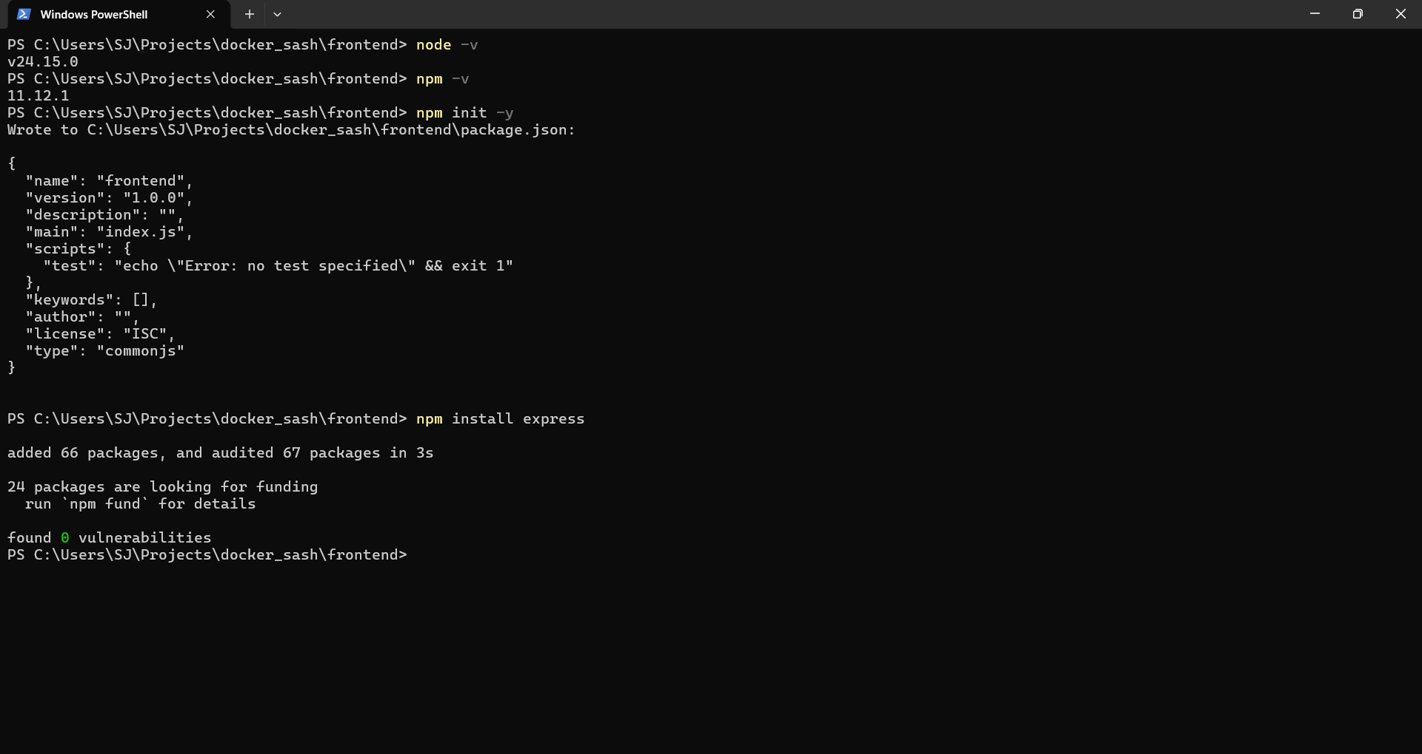
Explanation - Successfully set up the frontend environment using Node.js and Express by verifying installations, initializing the project, and installing required dependencies.
- Include a form similar to the one from the Flask Assignment 2.
ss
- Configure the form to send a request to the Flask backend. 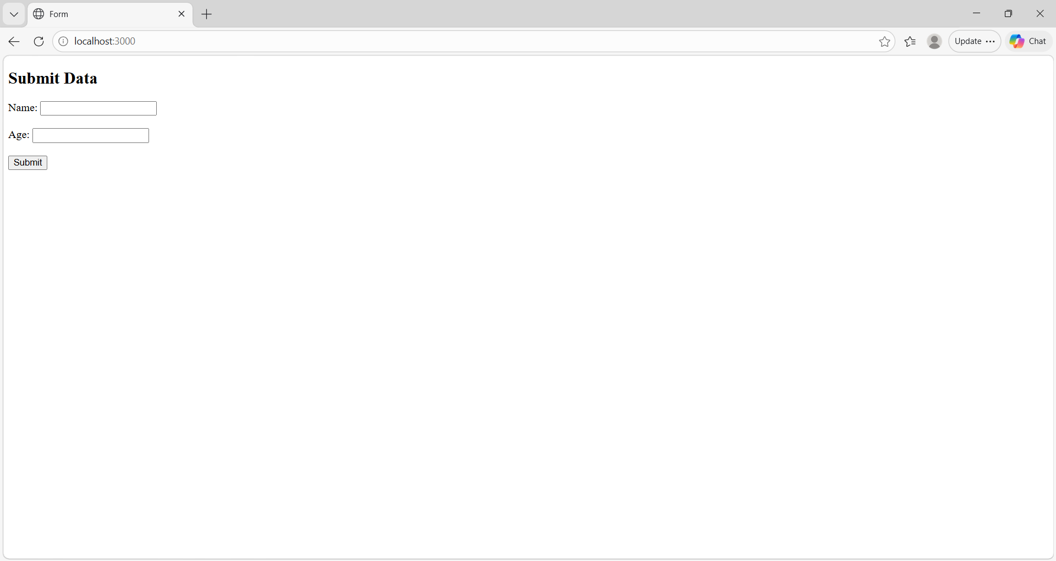
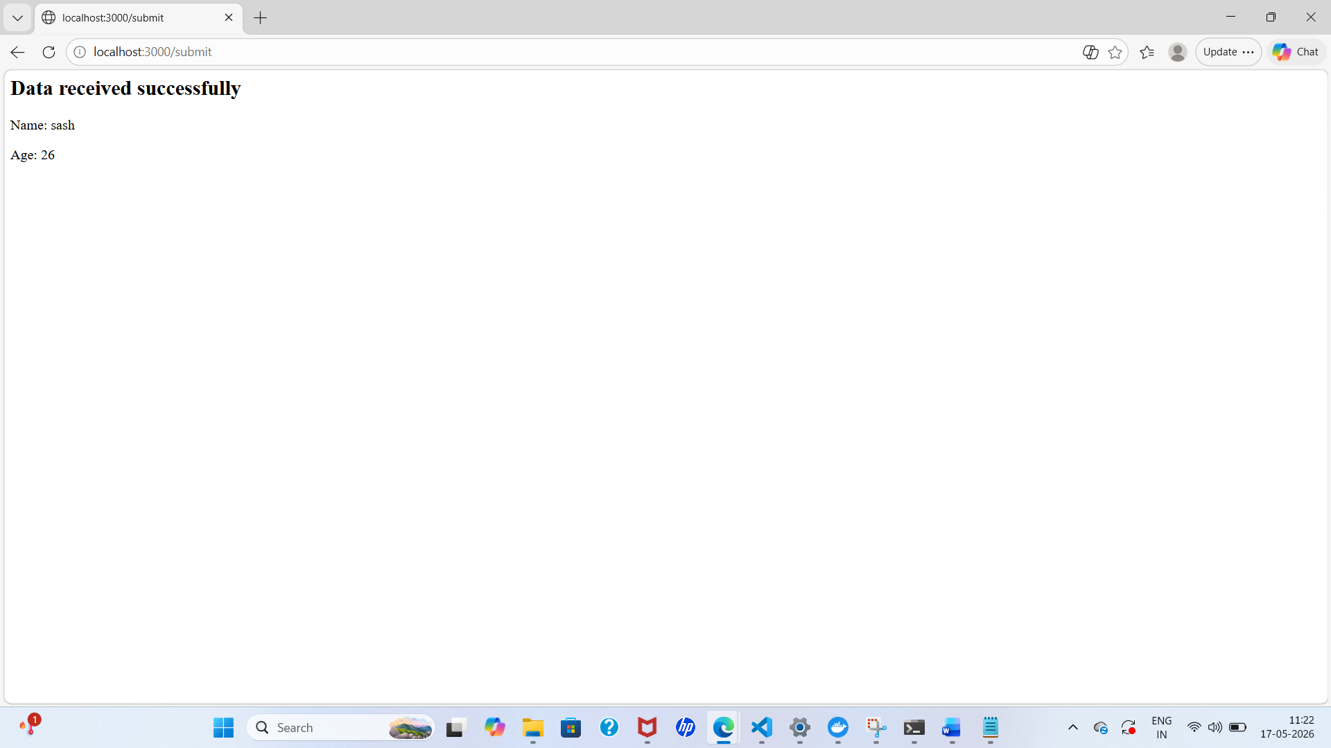
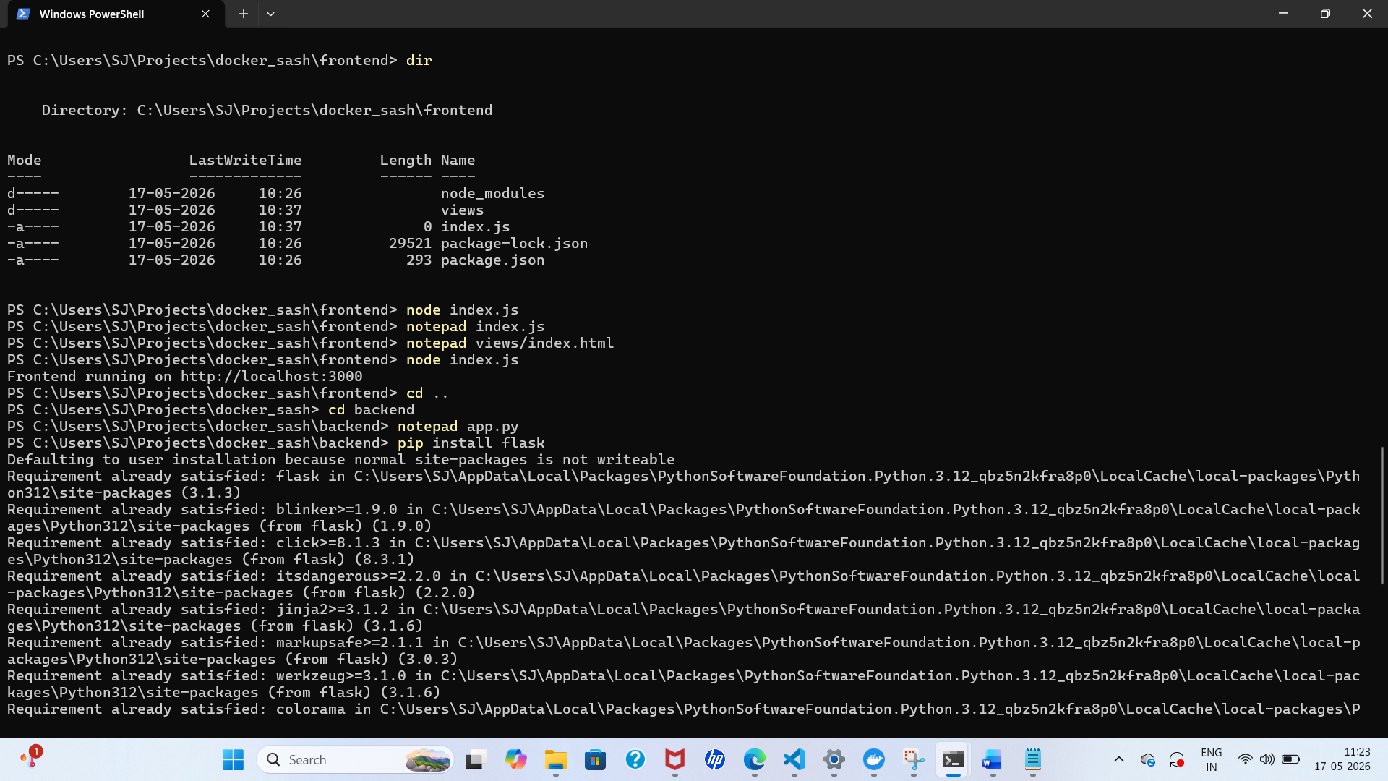
Explanation-
Frontend built using Express sends form data to Flask backend via POST request.
Backend processes data and sends response back. Response is displayed on browser.
- Backend (Flask):
- Use the Flask backend to handle the form submission and process the data.
ss-
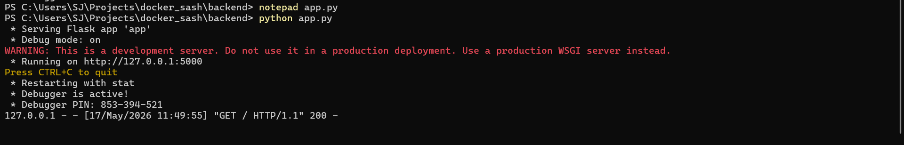
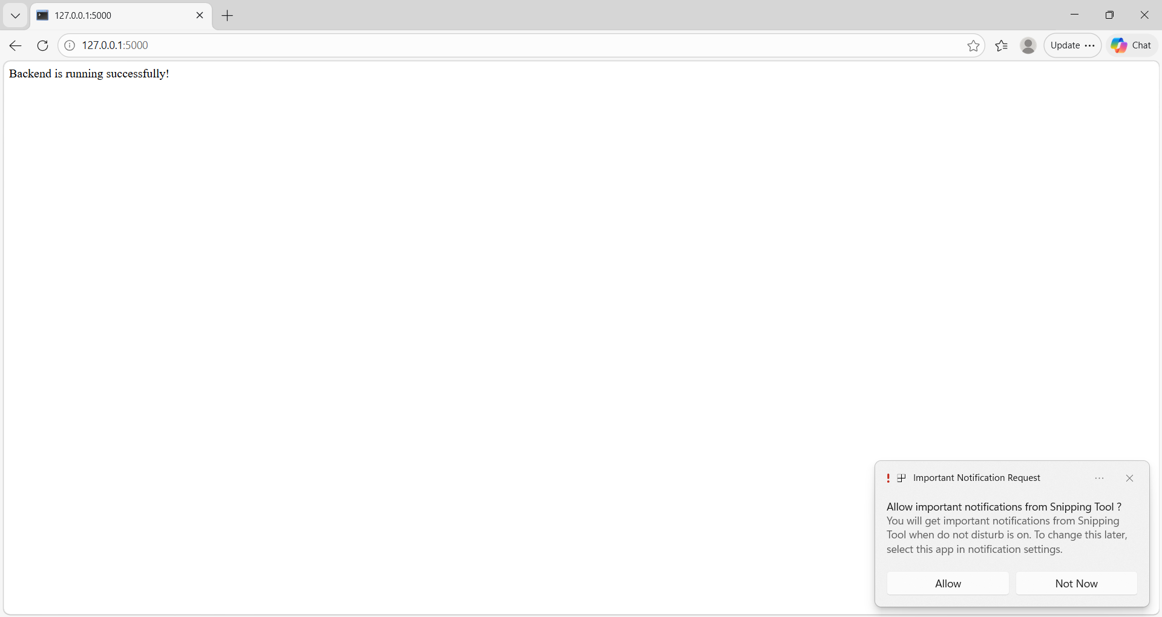
Explanation -
The Flask backend receives form data submitted from the Node.js frontend using HTTP requests. It processes the input values (such as name and age) and generates a response, demonstrating backend data handling.
- Folder Structure:
- Organize the project with separate folders for the frontend and backend.
Ss -
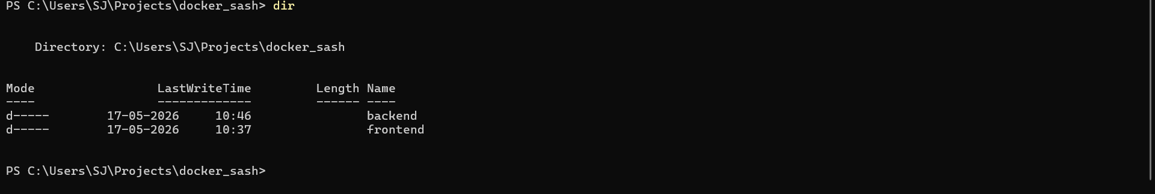

Explanation - The project is organized using separate folders for the frontend and backend applications.
- Docker Configuration:
- Create a Dockerfile for both the frontend and backend.
ss -
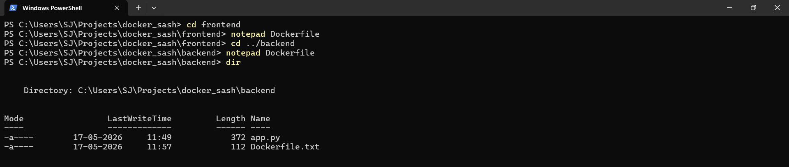
- Write a .yaml file (Docker Compose) to connect both services in the same network.
ss-
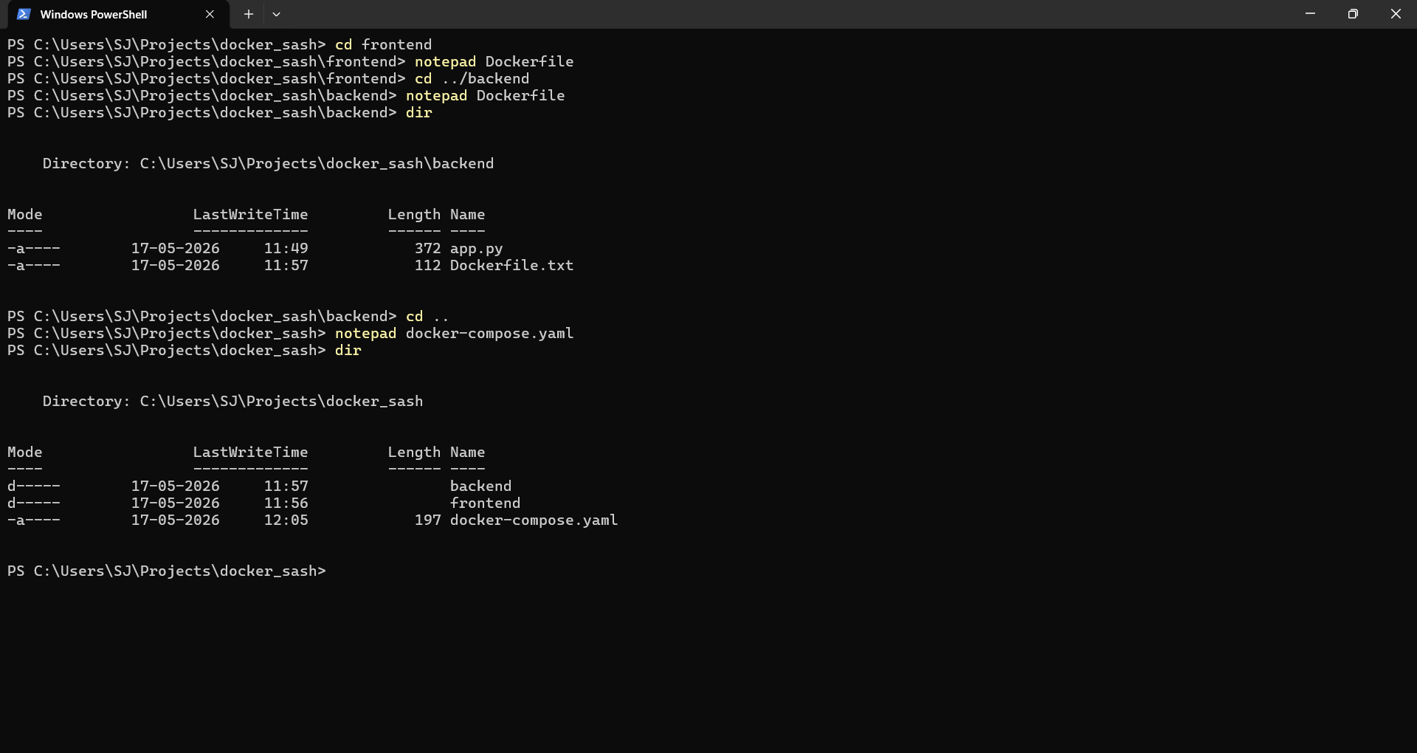
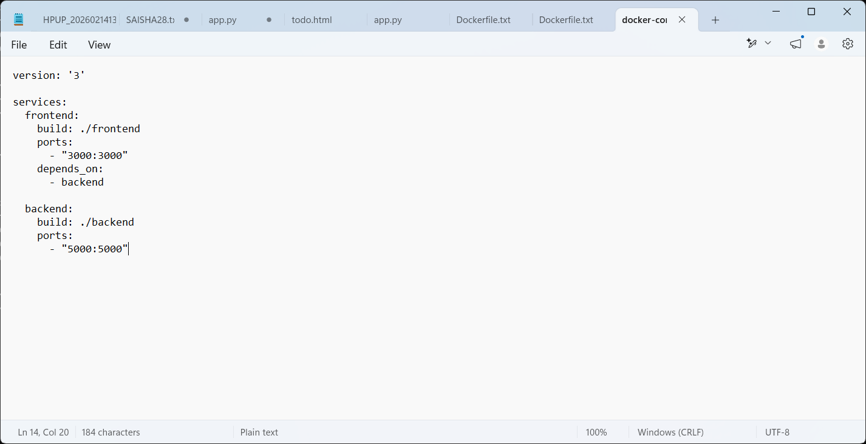
Explanation - The Docker Compose YAML file is used to define and manage multiple services in the project. It connects the frontend and backend containers in the same network and allows both services to run together.
- Upload both images to docker hub and push your whole code to github and add the node_modules and other non required files(.vscode) in .gitignore
Ss -
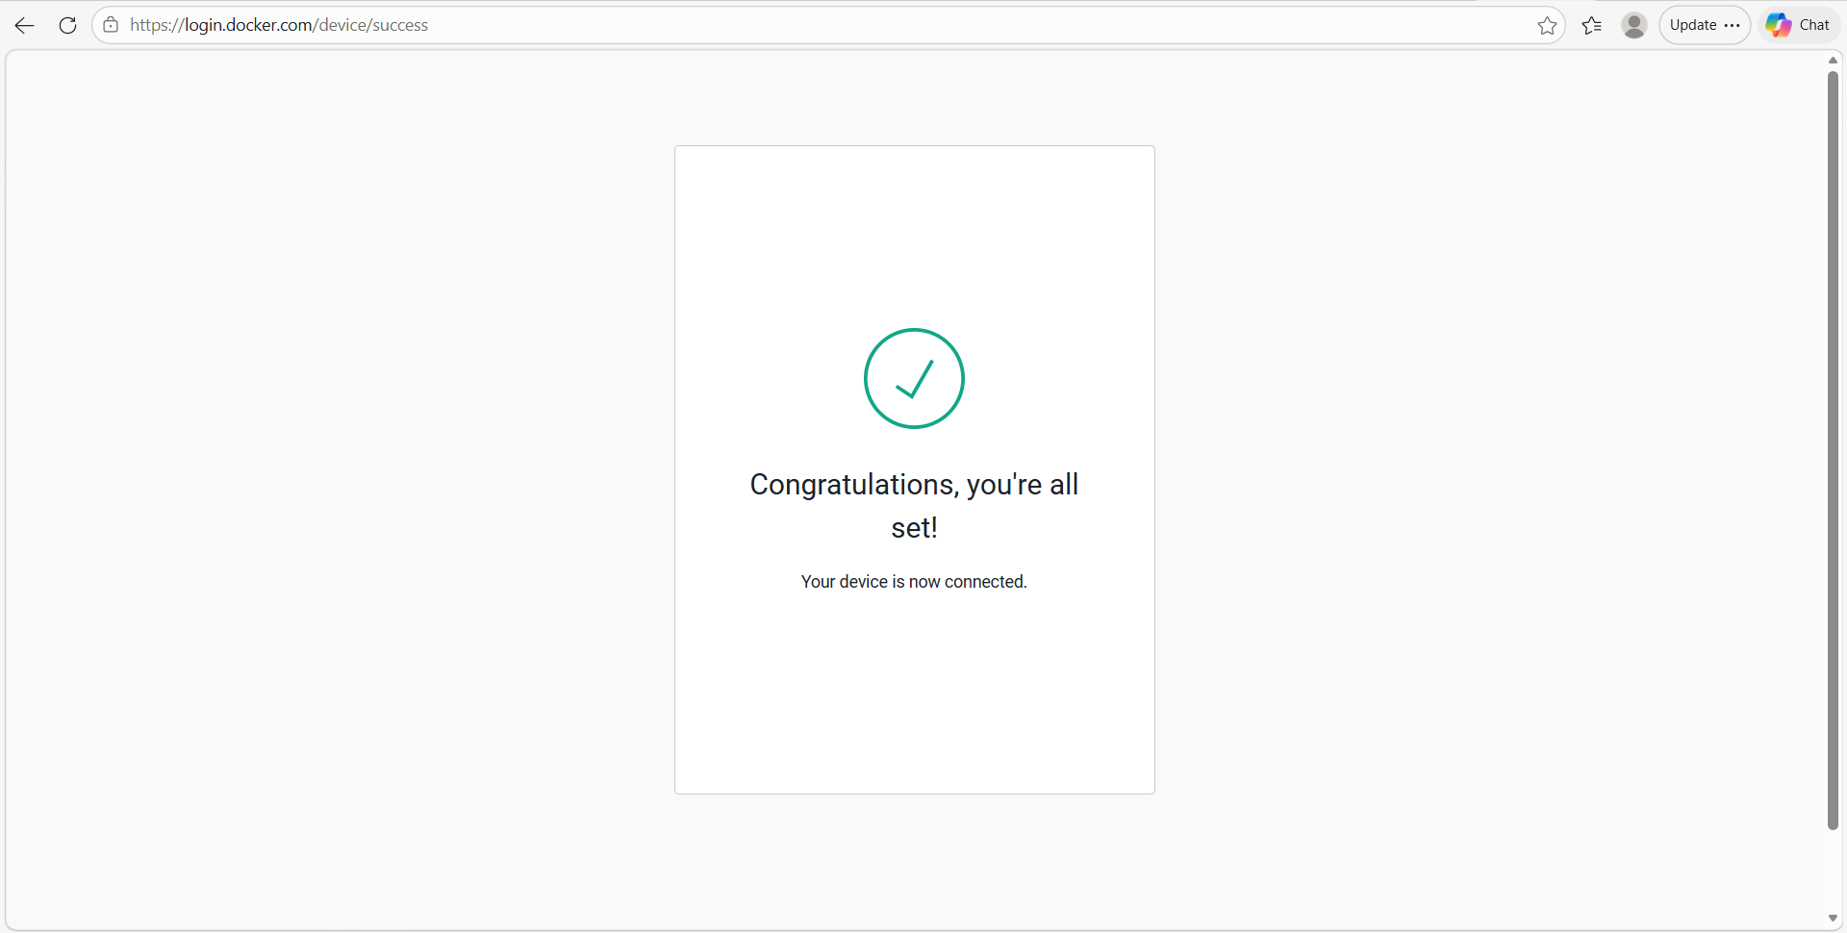
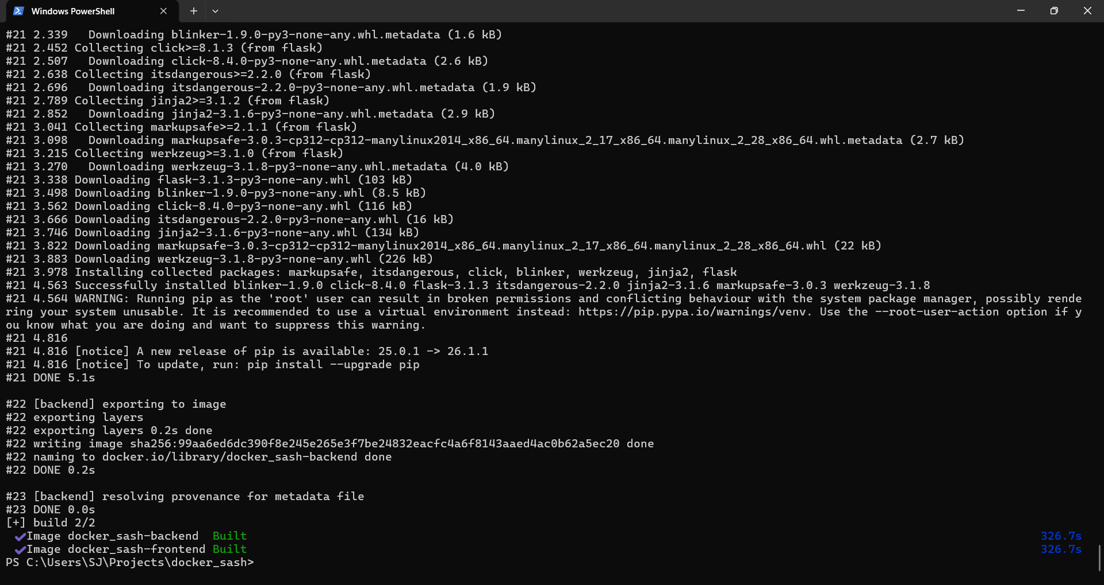
Explanation - Dockerfiles were created separately for the frontend and backend services.

