1. Create a new GitHub repository.
- Clone the repository to your local machine using SSH (generate an SSH key if needed, add the public key to your GitHub account).
A repository is a central place where your project files and version history are stored.
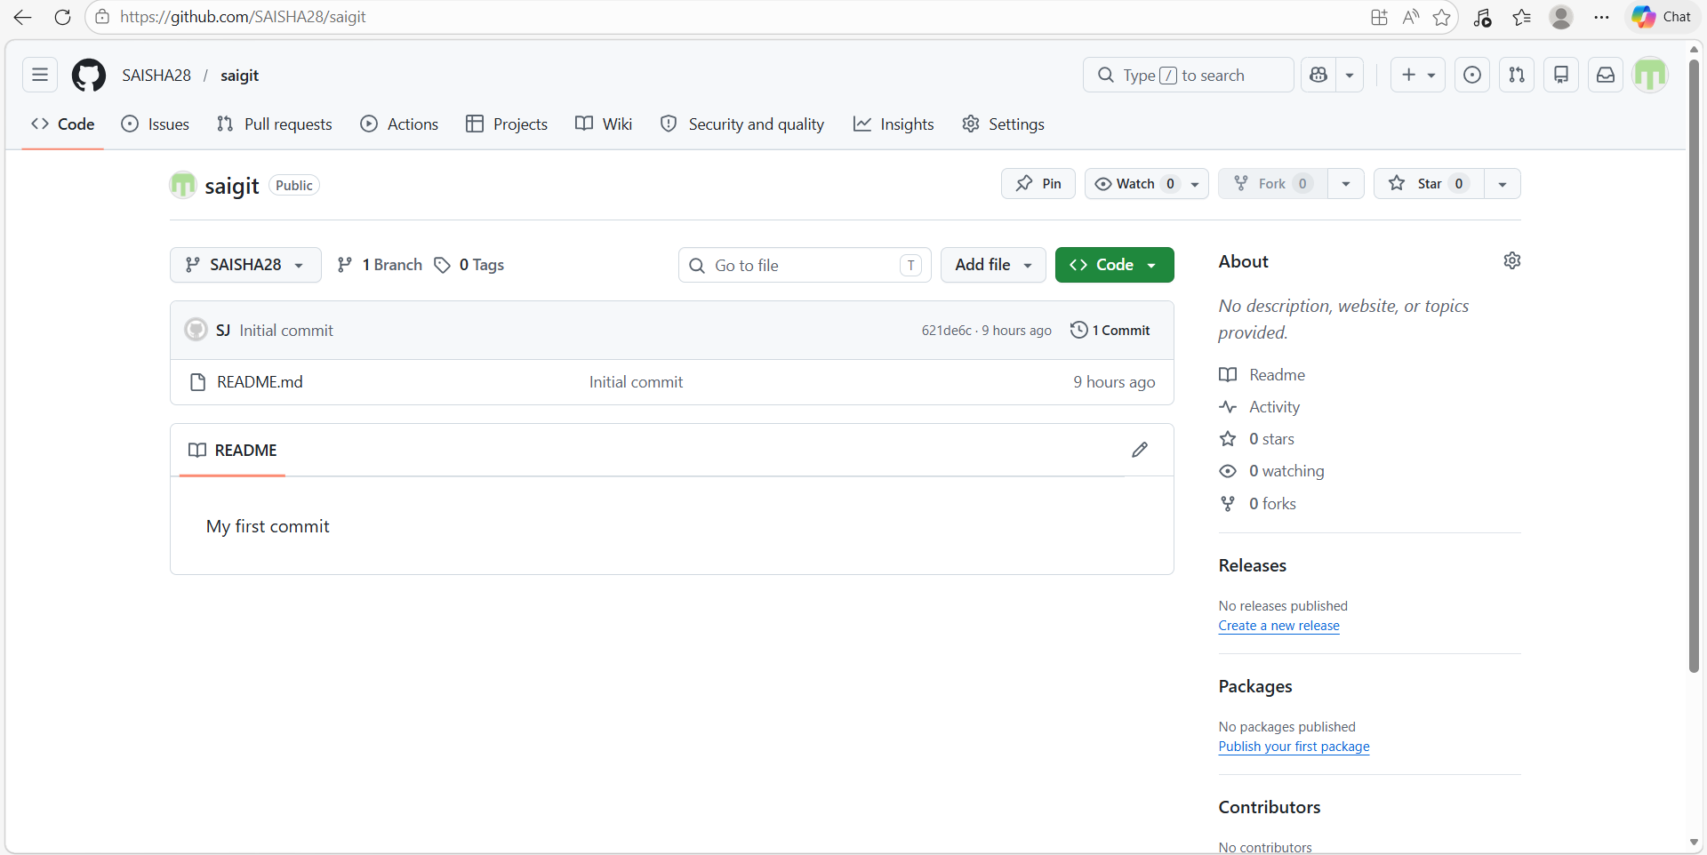
SSH key added page
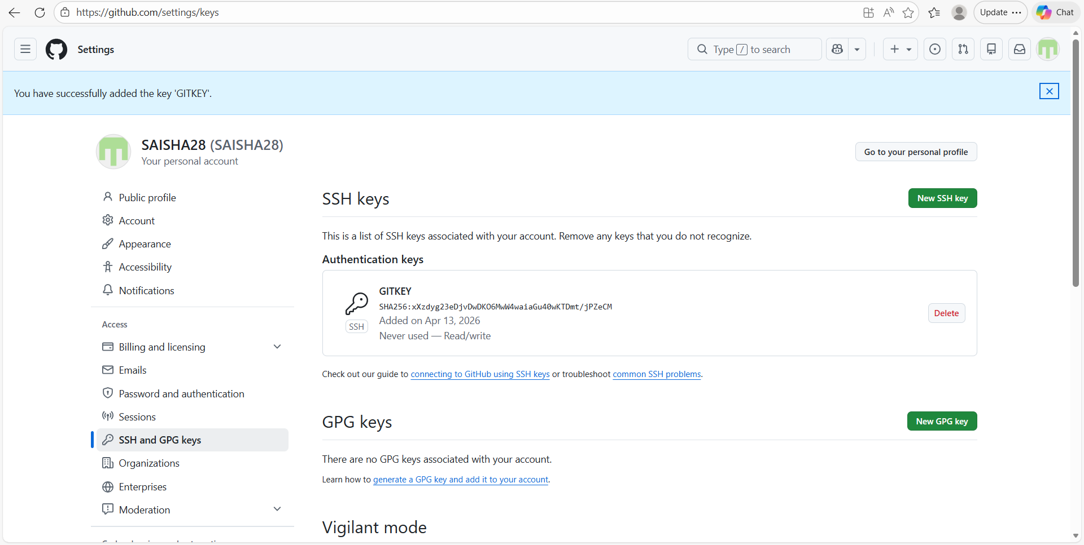
- Create a new branch named after your username (e.g., Tutedude).
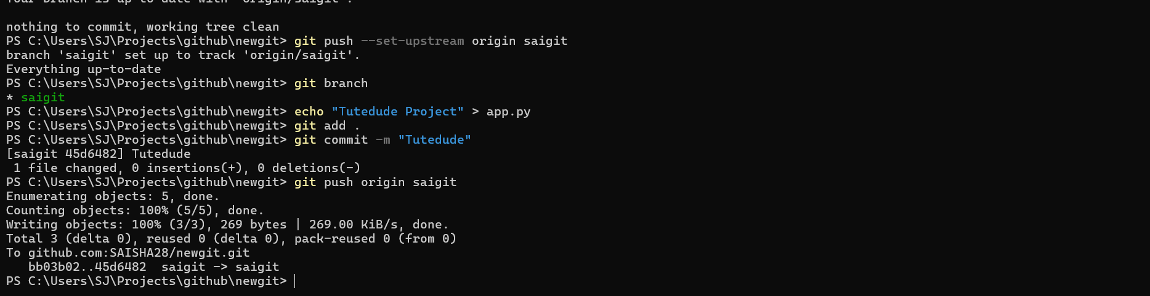
- Add your Flask project files to this branch.
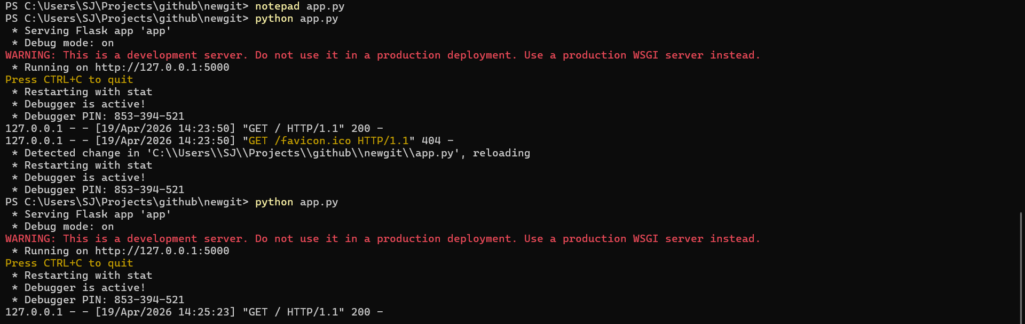
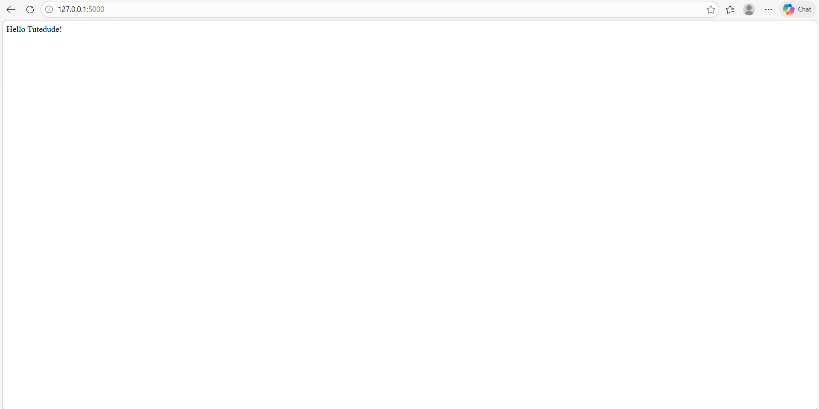
- Commit the changes and merge the branch into the main branch.
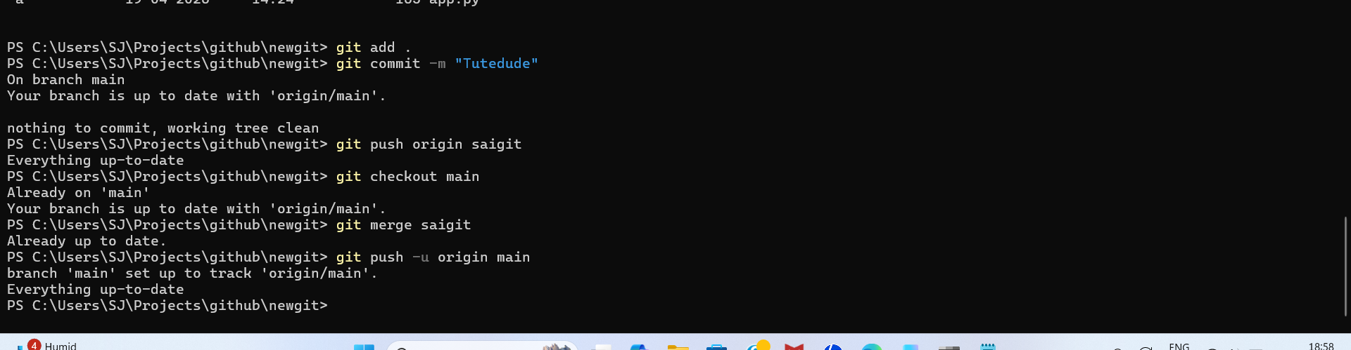

2. Create a new branch named <your_name>_new (e.g., Tutedude_new).
Cmd - git checkout -b saigit_new
- Update the content of the JSON file used for the /api route in this branch.
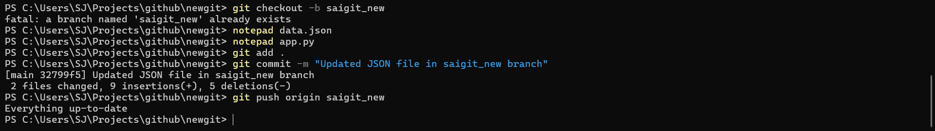
- Merge the <your_name>_new branch into the main branch.
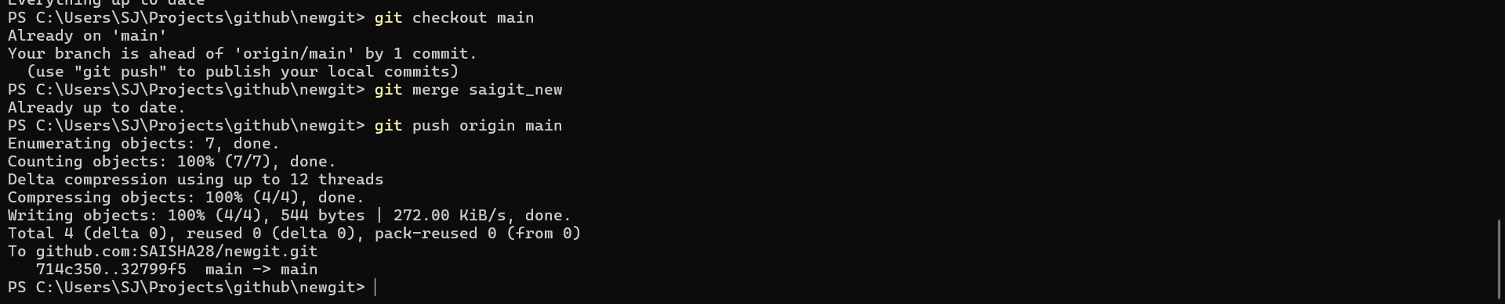
- If there are conflicts during the merge, resolve them by accepting the changes from the <your_name>_new branch.
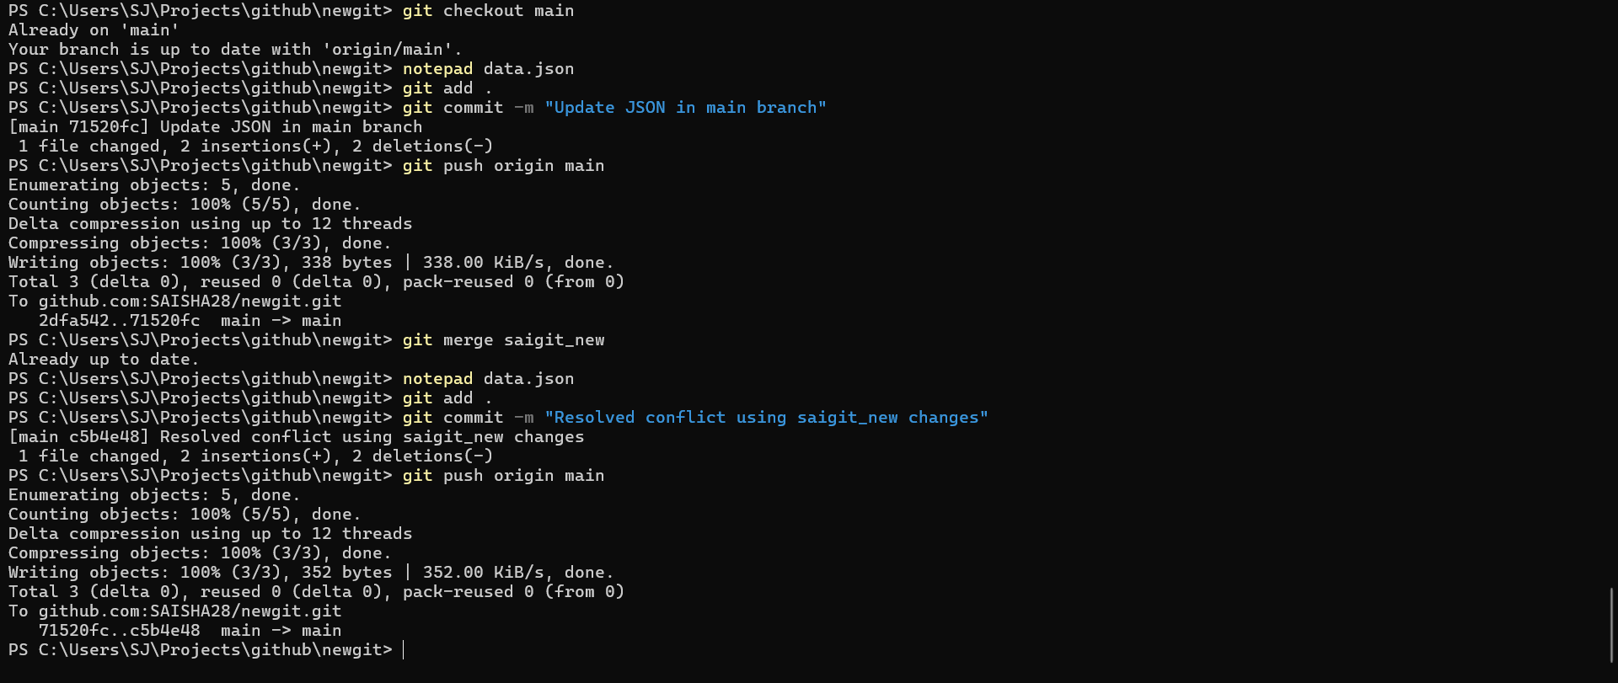
- Add the resolved changes to the staging area, commit them, and push the updates to the remote repository.

Explanation - Created a new branch and updated the JSON file for /api route. Then merged it into main and resolved conflicts.
3. Branch Creation:
- Create two branches: master_1 and master_2 from the main branch.
Cmd-
git checkout -b master_1
git checkout -b master_2
Explanation - Created two branches:
- master_1 → frontend (To-Do form)
- master_2 → backend (API)
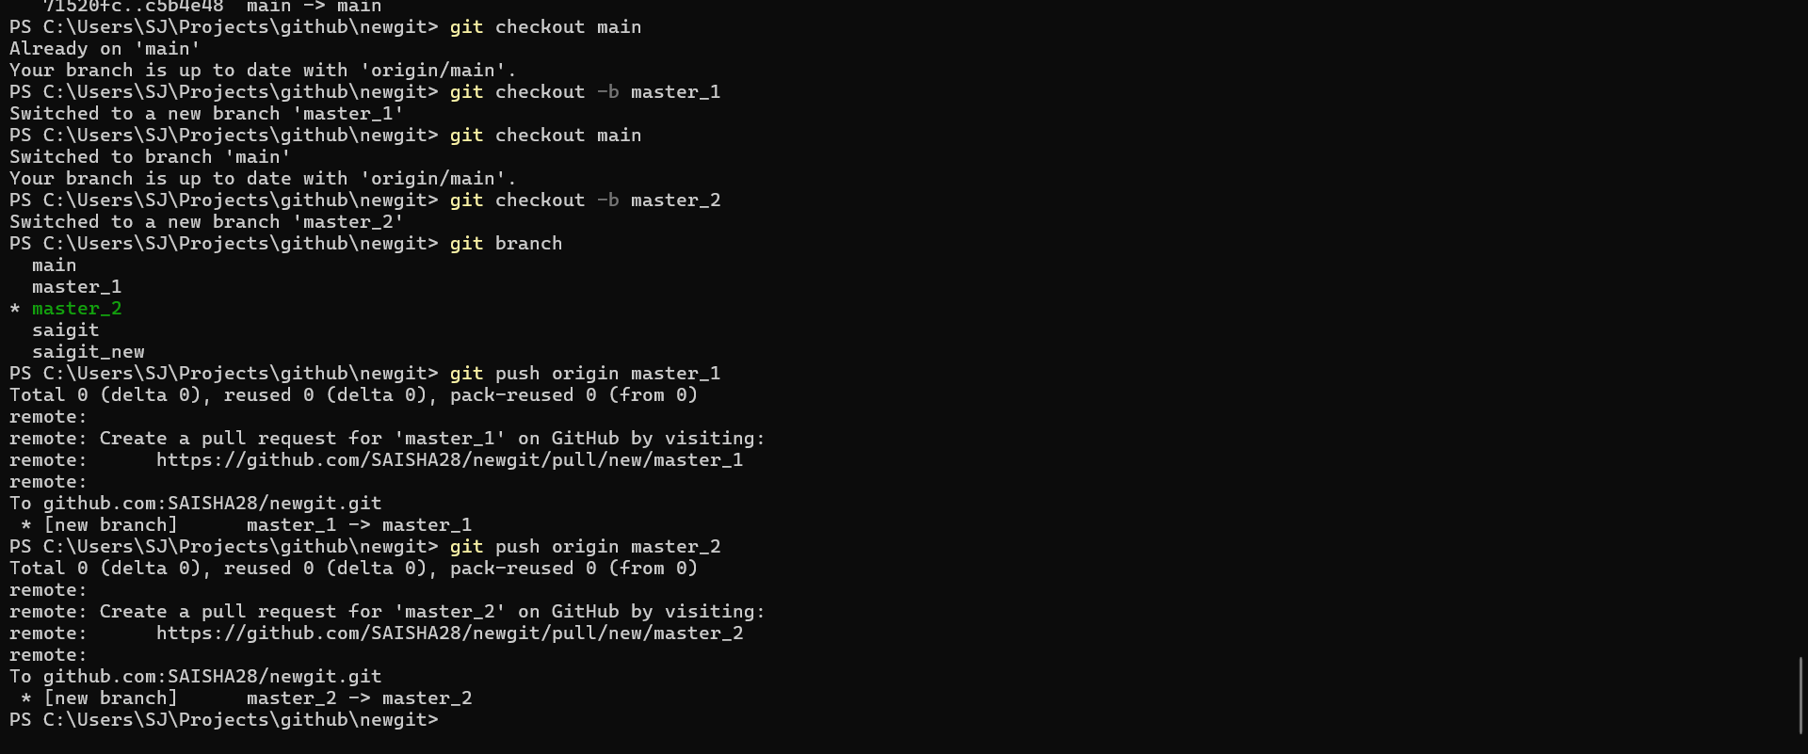
- Feature Development in master_1:
- In the master_1 branch, create a To-Do Page in the frontend.
  - The page should contain a form with the following fields:
    - Item Name
    - Item Description
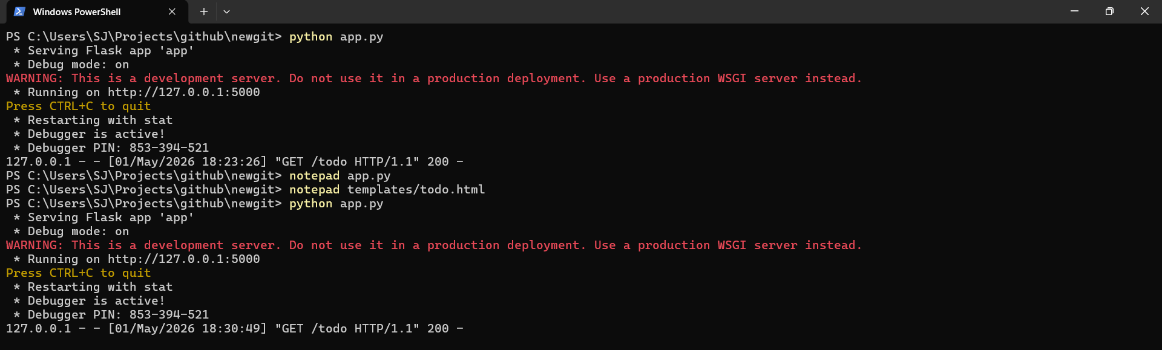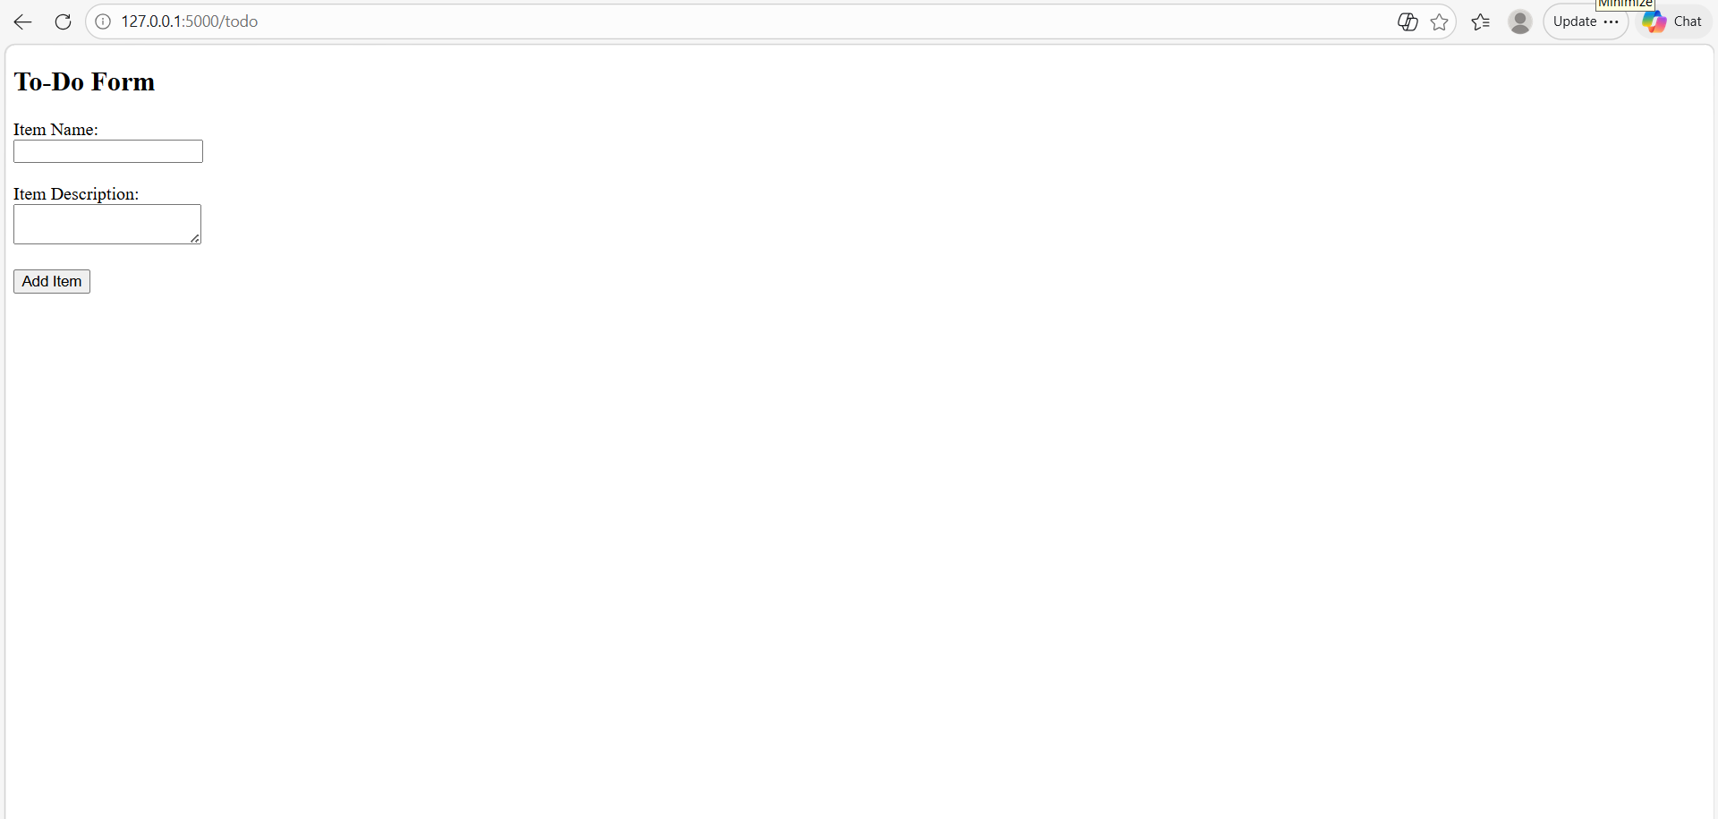
- Backend API in master_2:
- In the master_2 branch, create a backend route named /submittodoitem.
- This route will:
  - Accept itemName and itemDescription via a POST request.
  - Store these details in a MongoDB database.
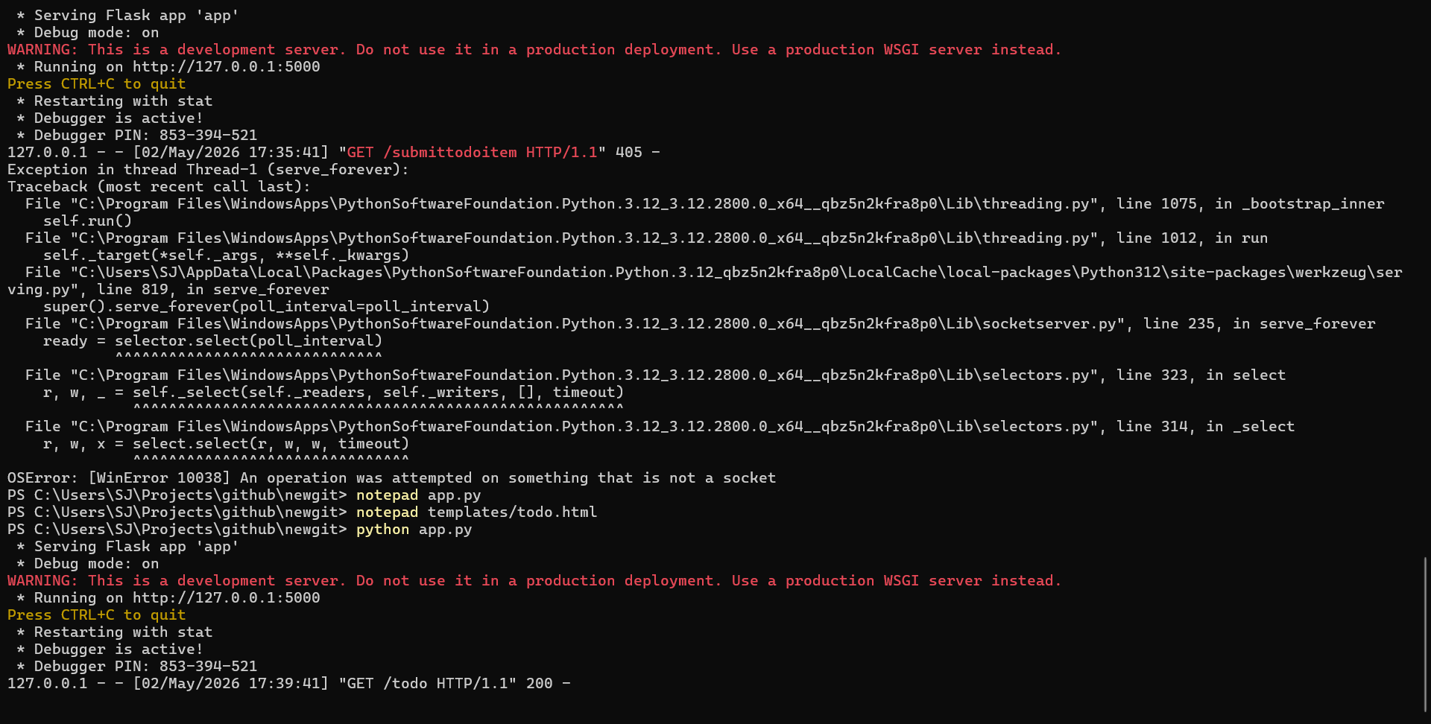
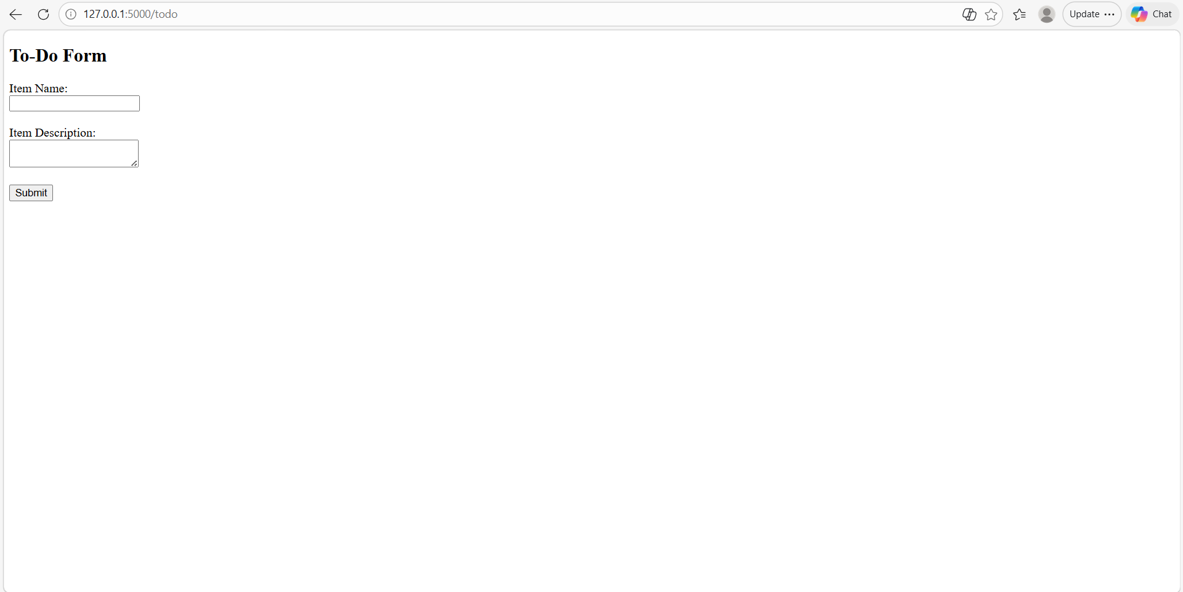
- Merging Changes:
- Merge the changes from both master_1 and master_2 into the main branch.
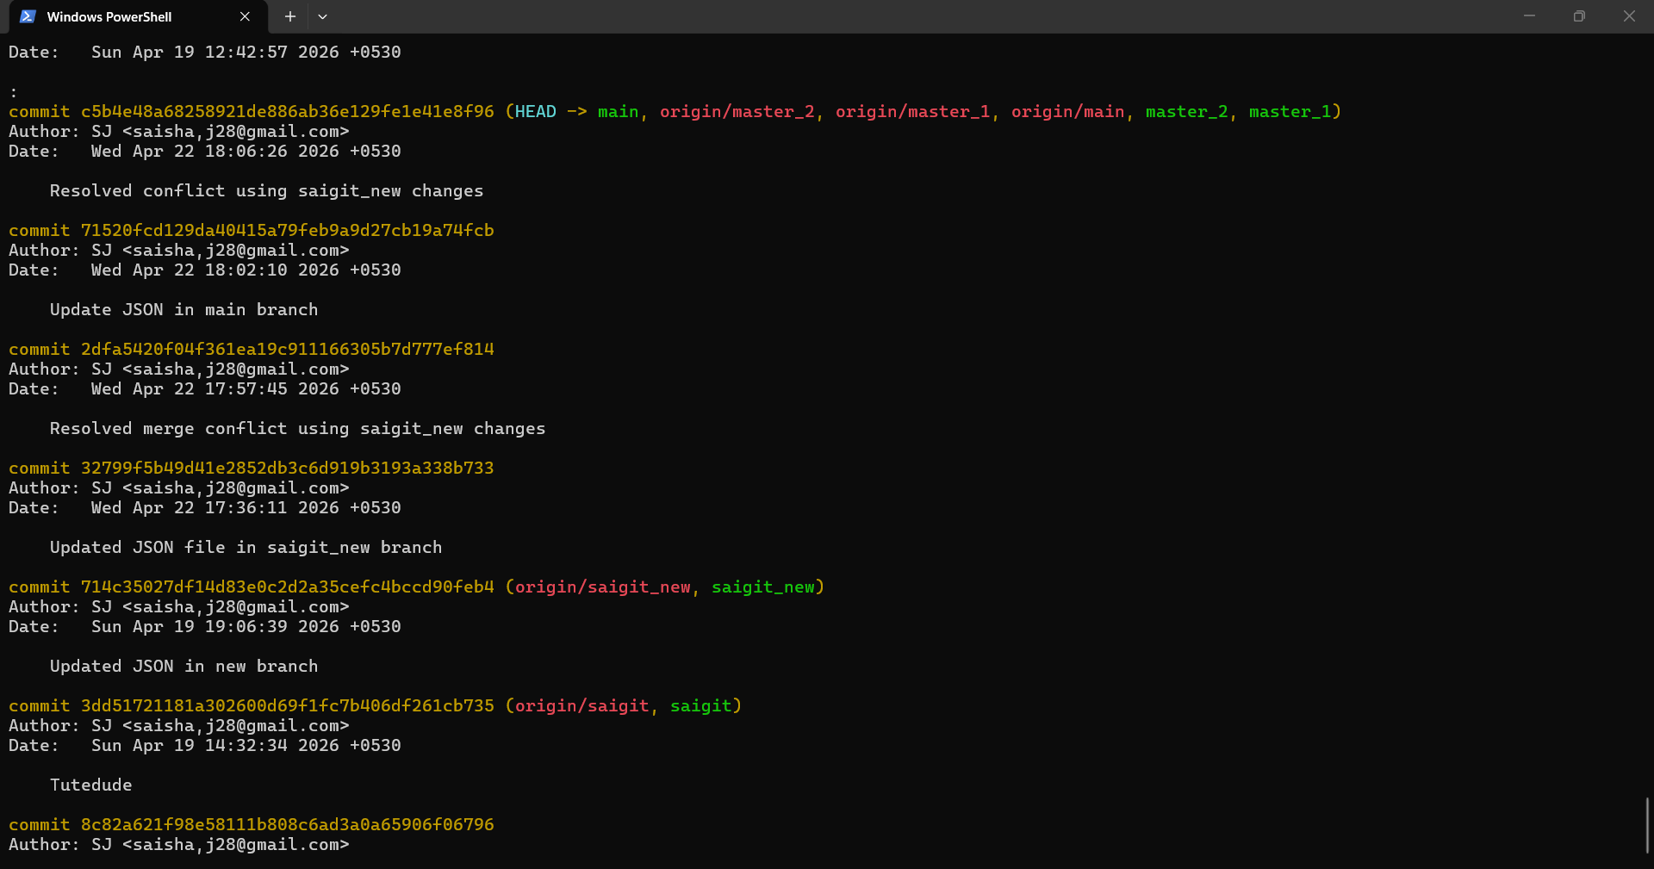
4. Enhancing the To-Do Form in master_1:
- In the master_1 branch, add the following fields to the To-Do form:
  - Item ID
  - Item UUID

Cmd - git add .
git commit -m "Added Item ID field"
  - Item Hash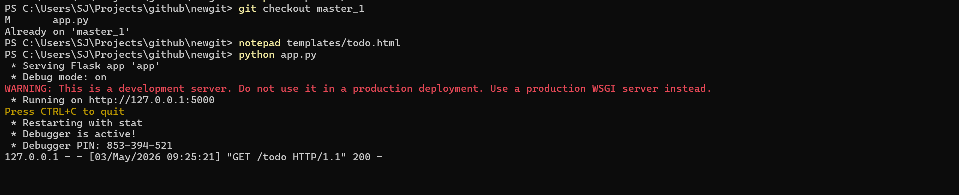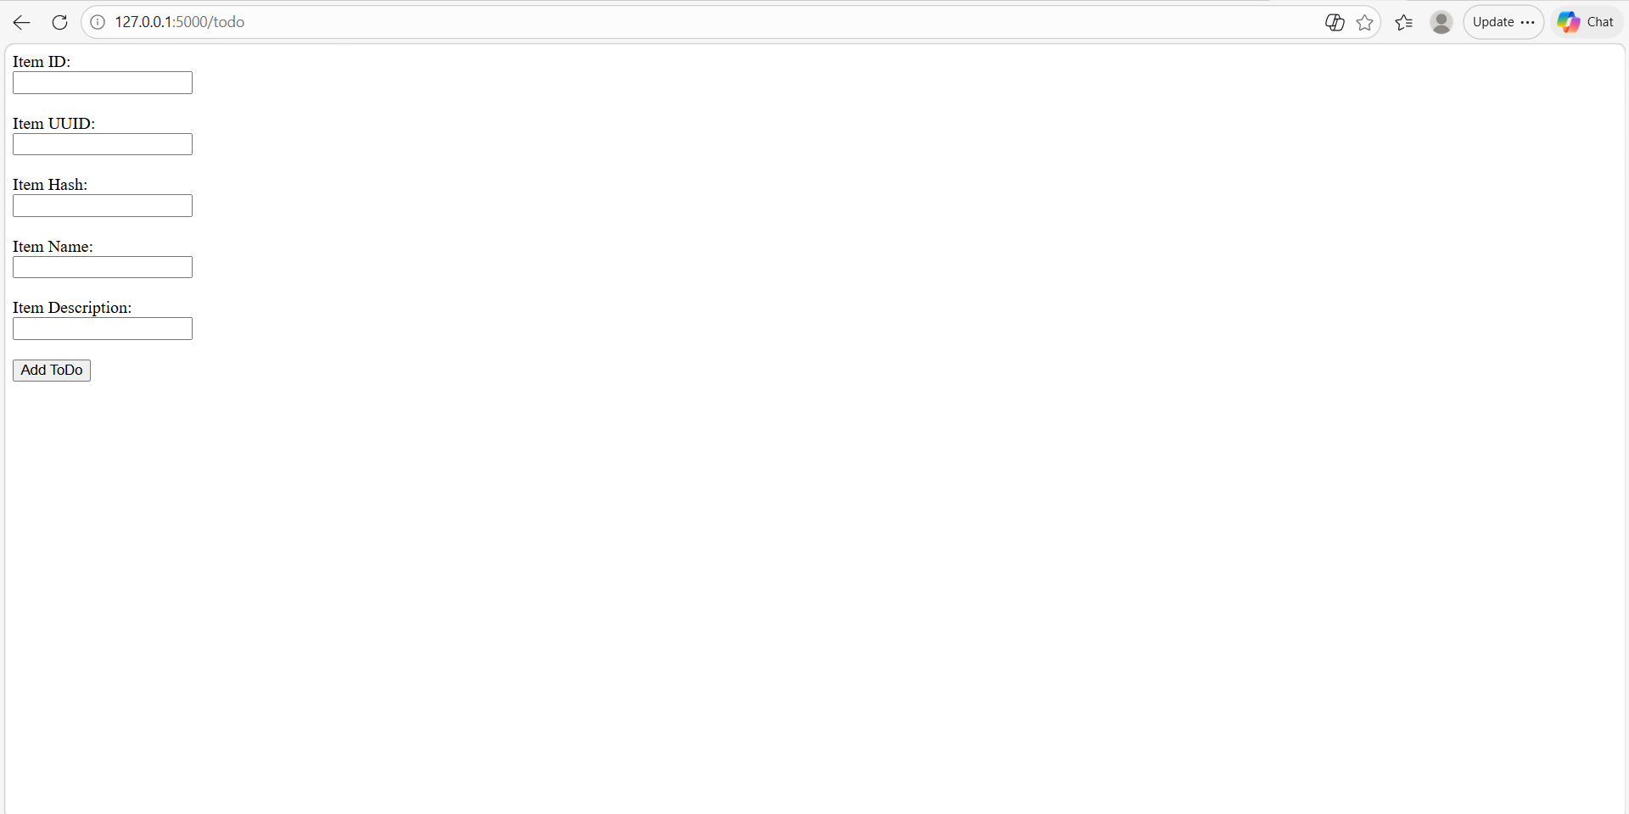
- Committing in Sequence:
- Add and commit each field separately in the following order:
  - First commit: Add Item ID field.
  - Second commit: Add Item UUID field.
  - Third commit: Add Item Hash field.
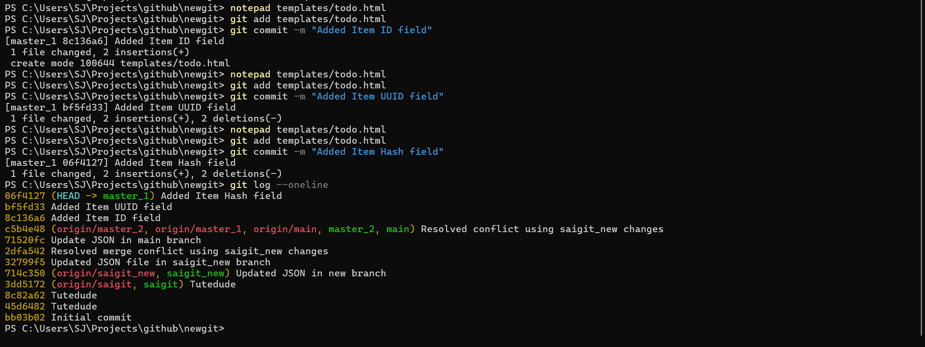
- Merging to main:
- Merge the master_1 branch into the main branch.
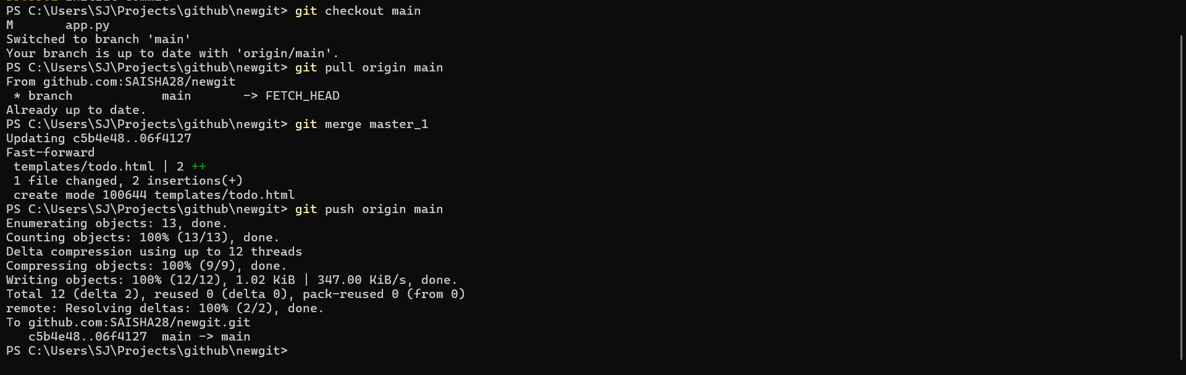
- Git Reset and Commit Deletion:
- In the main branch, use Git Reset to roll back to the commit where only the Item ID field was added.
- Use git reset --soft to ensure changes remain staged.
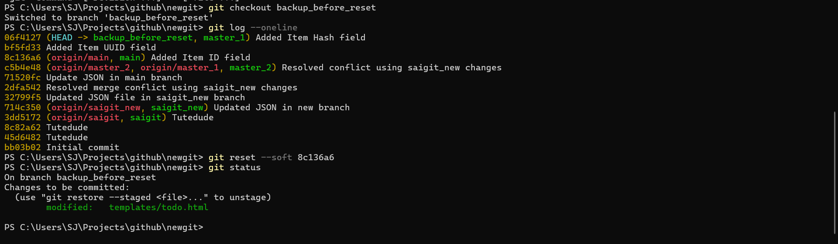
- Re-commit this state to the main branch.
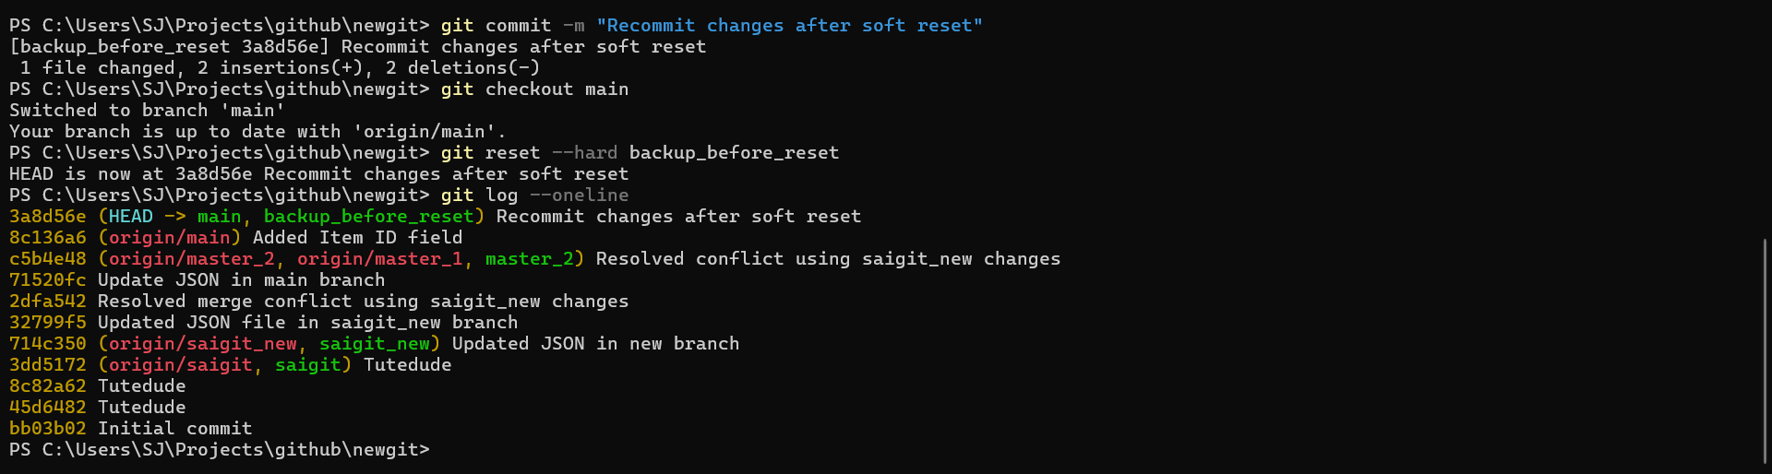
- Merge this updated state to the main branch.
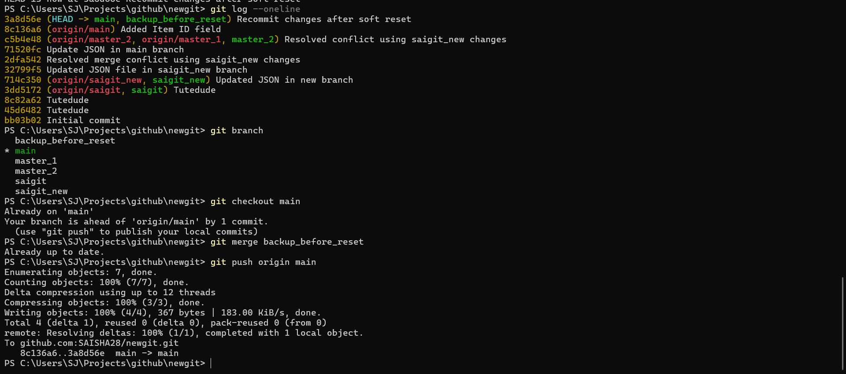
- Rebasing Changes:
- Rebase the updated changes in the main branch to the master_1 branch.
Clarification:
  - During rebasing, preserve individual commits to maintain the commit history for each change (i.e., do not squash commits).
  - Use git rebase main master_1 to integrate changes from the main branch back into the master_1 branch.
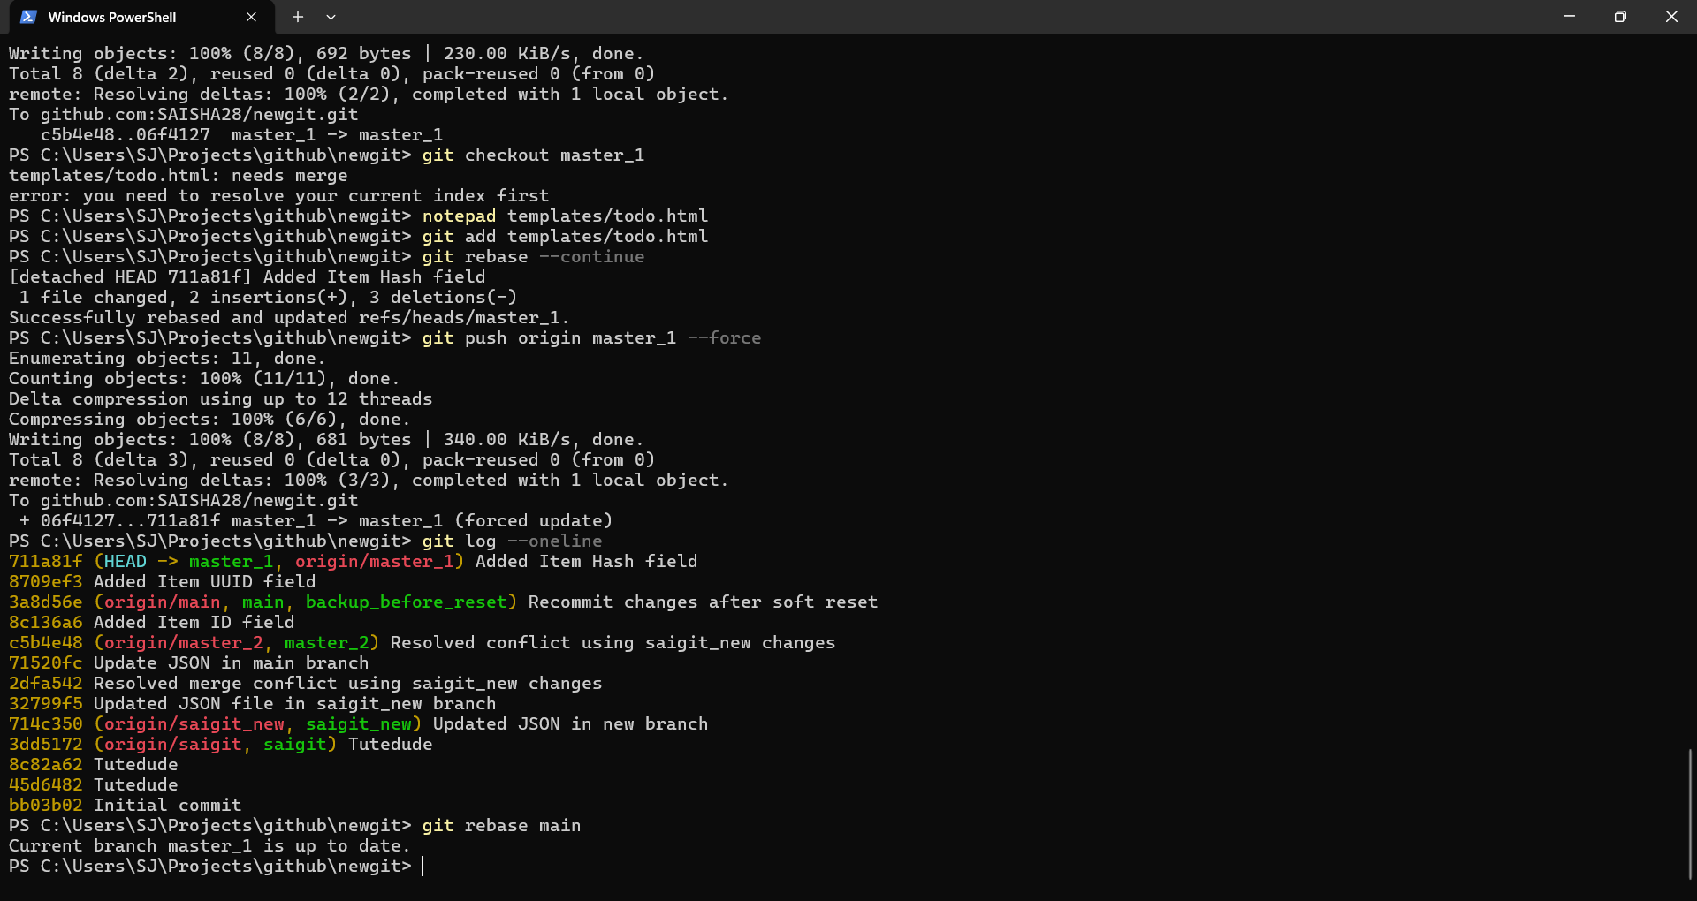

Submission Guidelines -: Attach Screenshots or command along with explanation and submit in doc(google doc or microsoft doc) format , also share link of your github repo

