Name: Saisha Jadhav
Platform Used: Play with Docker

1. Creating and Renaming Files/Directories
Create a directory named test_dir using mkdir.
Explanation-
mkdir Command used to create directories in Linux
touch Create blank/empty files
mv Move or rename files in Linux
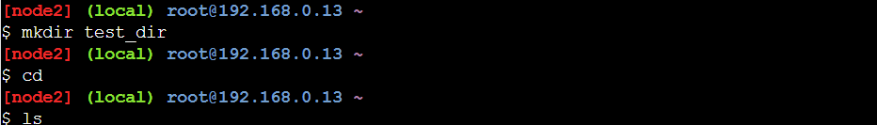

Inside test_dir, create an empty file called example.txt.
Explanation-
cat displays full file contents.
head Return the specified number of lines from the top.
tail Return the specified number of lines from the bottom.
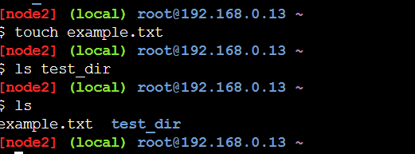

Rename example.txt to renamed_example.txt using mv
Explanation -
grep Search for a string within an output

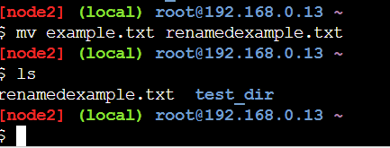

2. Viewing File Contents
Use cat to display the contents of /etc/passwd.
Explanation -
cat displays full file contents.
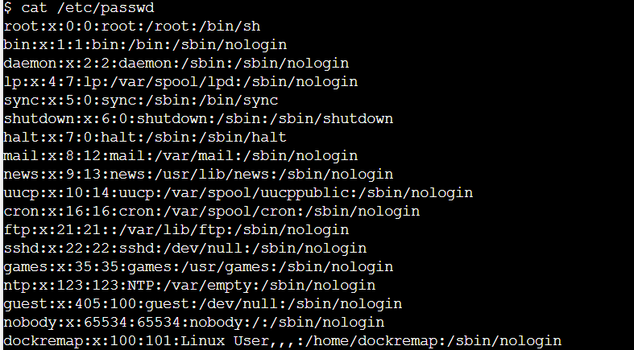
Display only the first 5 lines of /etc/passwd using head.
Explanation -
head Return the specified number of lines from the top.
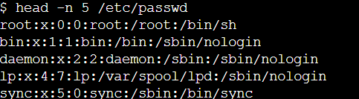
Display only the last 5 lines of /etc/passwd using tail.
Explanation -
tail Return the specified number of lines from the bottom.
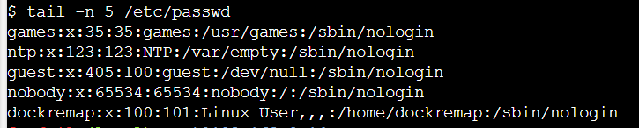
3.Searching for Patterns
Use grep to find all lines containing the word "root" in /etc/passwd.
Explanation-
grep - Search for a string within an output
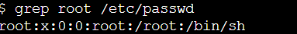

4. Zipping and Unzipping
Compress the test_dir directory into a file named test_dir.zip using zip.
Explanation -
zip Zip files in Linux
zip -r compresses directory recursively.
Screenshot-
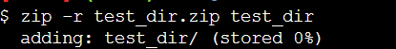
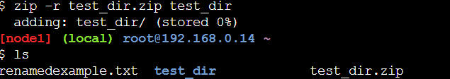

Unzip test_dir.zip into a new directory named unzipped_dir.
Explanation-
unzip - Unzip files in Linux
unzip -d extracts into a specific directory.

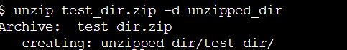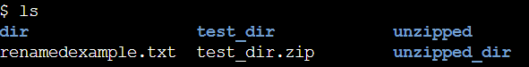
5. Downloading Files
Use wget to download a file from a URL (e.g., https://example.com/sample.txt).
Explanation -
wget - Direct download files from the internet
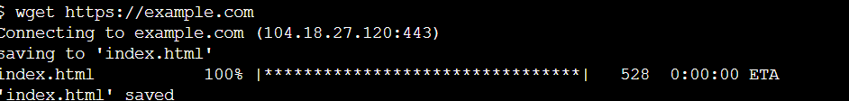
6. Changing Permissions
Create a file named secure.txt and change its permissions to read-only for everyone using chmod.
Explanation -
chmod - Command to change file permissions
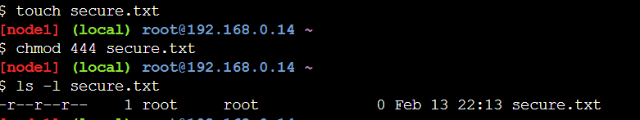
7. Working with Environment Variables
Use export to set a new environment variable called MY_VAR with the value "Hello, Linux!".
Explanation -
export - Export environment variables in Linux
MY_VAR is assigned the value "Hello, Linux!".
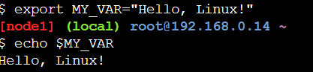
Github repo link - SAISHA28/centralgit: code for me

