React.js Component Creation

Name : Sadavala Venkata Sai Shashank

Email : saishashank300@gmail.com

Roll NO : 20KH1A0592 (CSE)

College Name : Sri Venkateswara College Of Engineering, Kadapa

source code :

CARD COMPONENT :
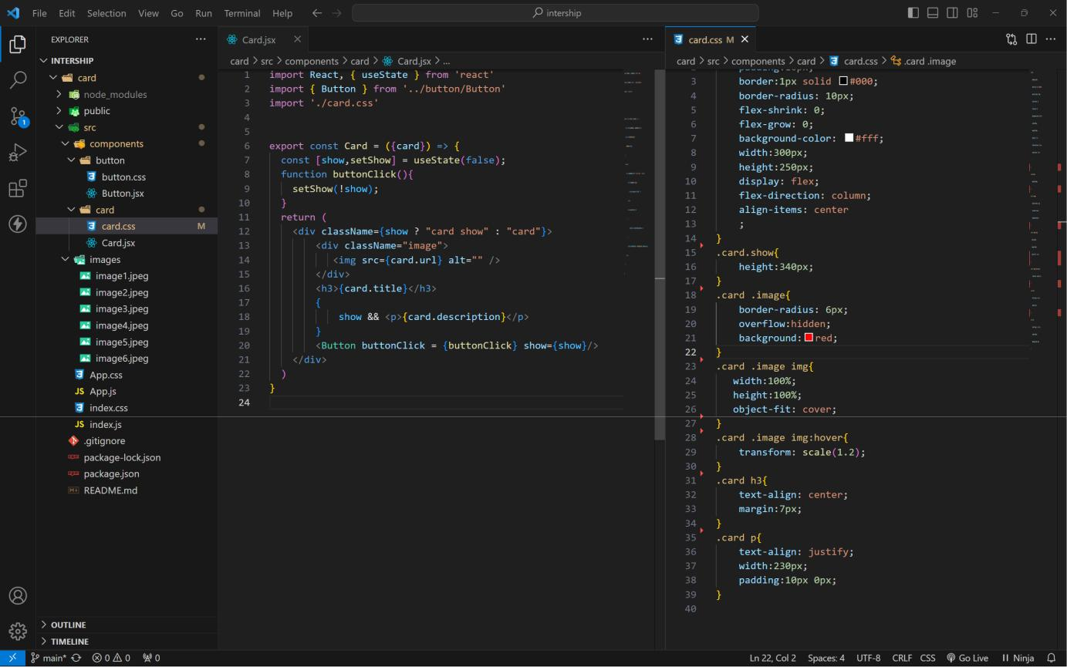

BUTTON COMPONENT :

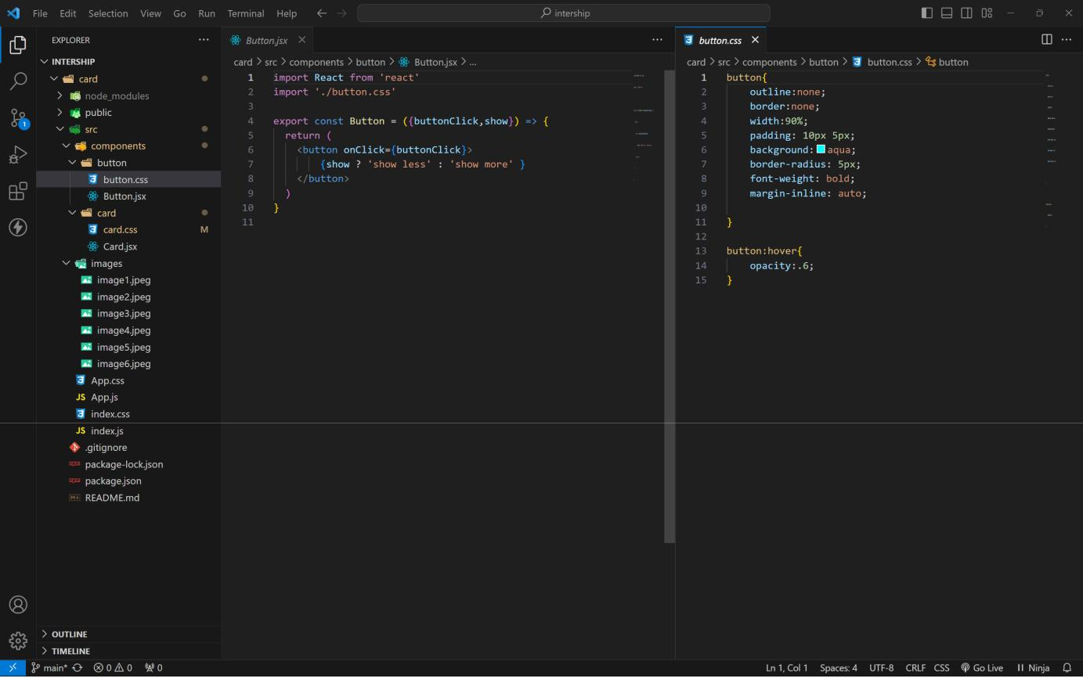

APP COMPONENT :
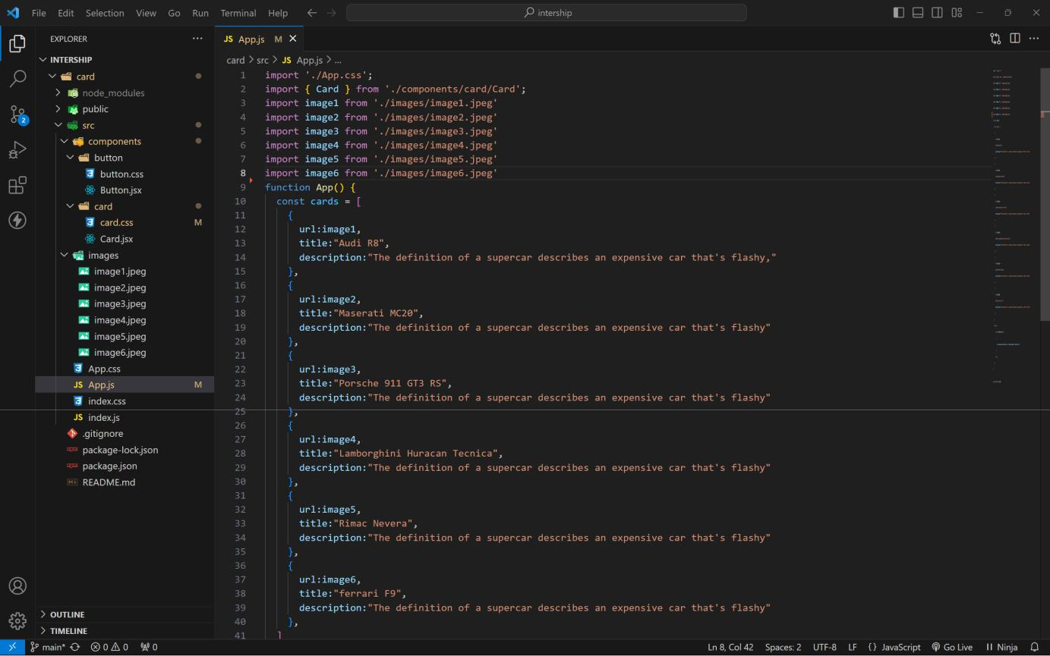
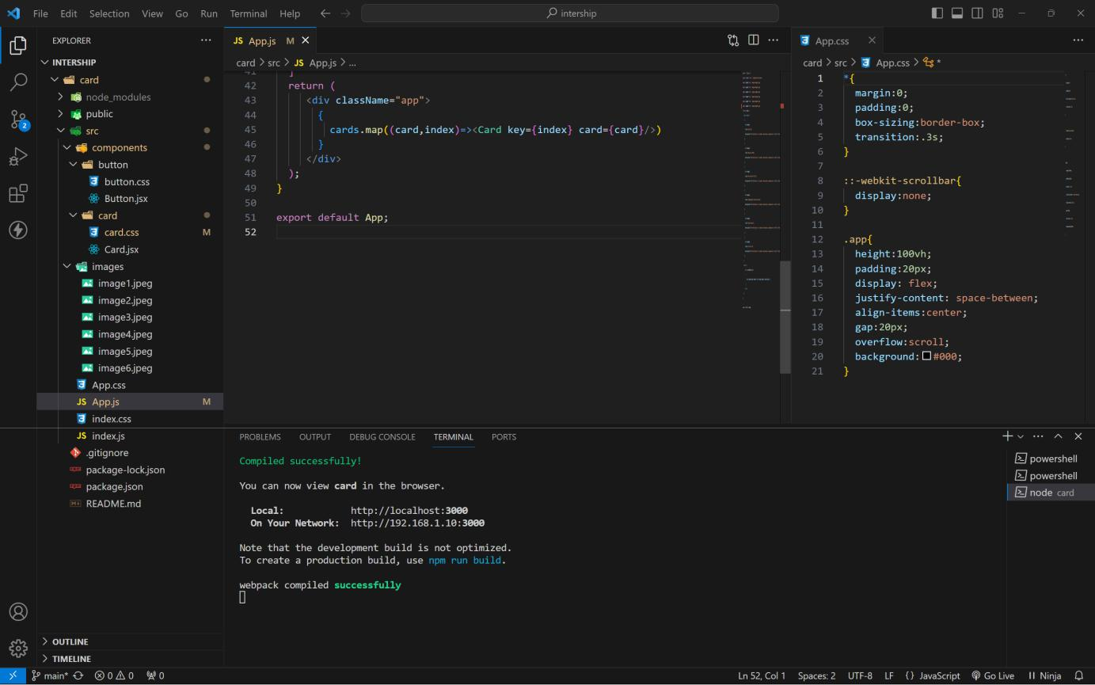

approach :

1 . initially taking an array of objects like below
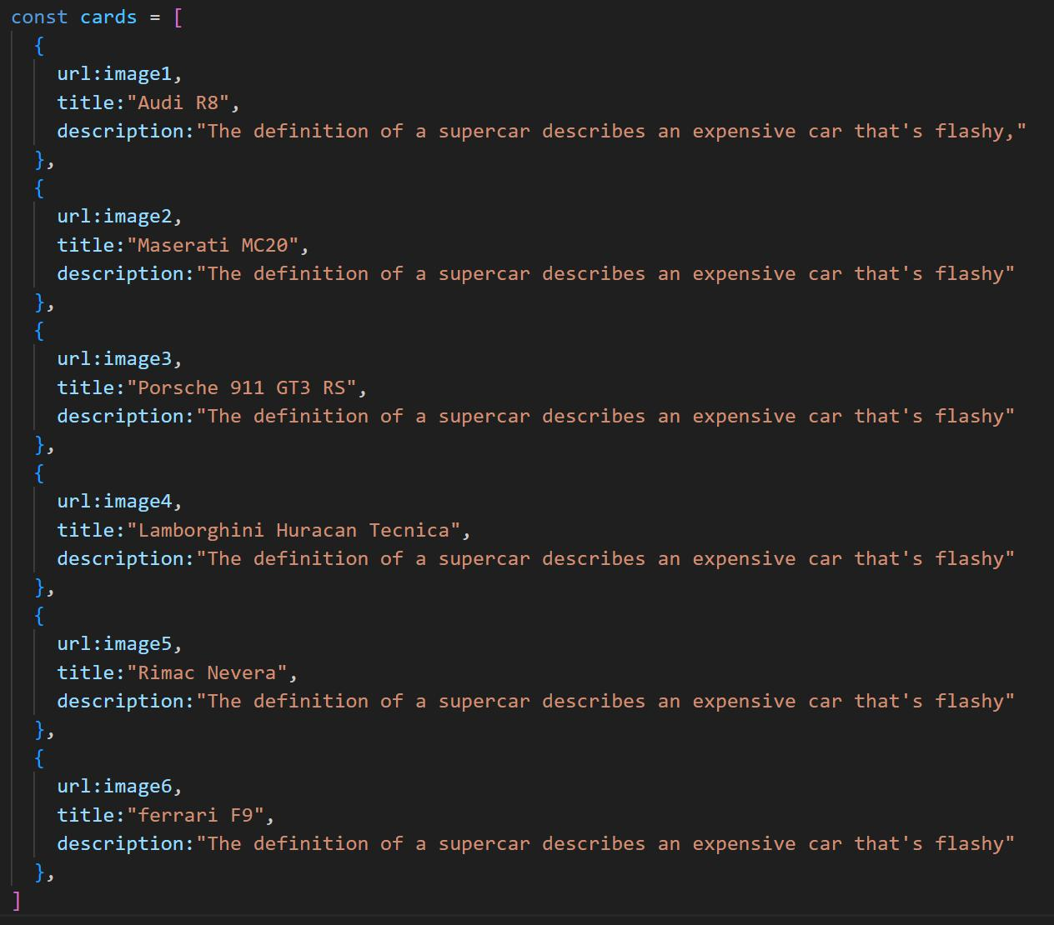

2 . Passing this card array to child (card component) of App component by using props;
3 . getting data as argument like {card} in card component.

4 . in card component i use one state [show, setShow] to get extra info as description.
5 . When we click the button then show becomes true by assigning setShow (!show) .

OUTPUT :
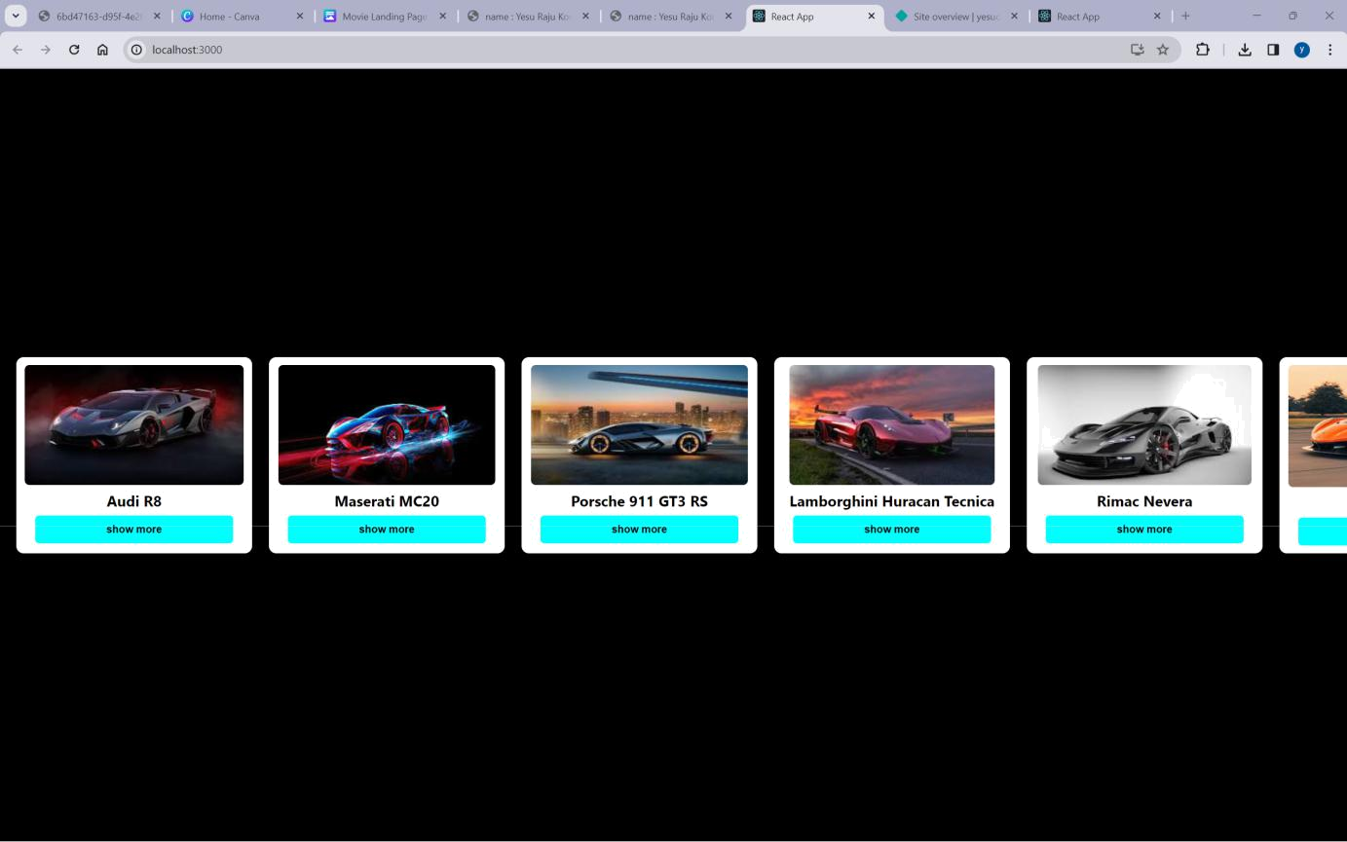

AFTER BUTTON CLICKS :
