**Chapter-1**

**1.1 Automation of power systems through SCADA**

Aim: The aim of the project is to control the 3 ph-Induction motors (star delta contactors) through the PLC-SCADA system.

**The Technologies are used:**

Project was developed in Siemens PLC and the SCADA system was WinCC 6.4

Details are given below:

PLC : S7-315 2 PN/DP

Communication : Profibus

PLC Coding software : Step7 5.5

Coding Language : Ladder Logic

SCADA : WinCC 7.4

Communication : Ethernet TCP/IP

OS : Windows 10 pro

**Programmable Logic Controller (PLC):**

This was very popular CPU which is very rugged for industrial mid-range applications

**Technical specifications of PLC:**

Model No: 6ES7 315-2EH14-0AB0

384 KB work memory; 0.05ms/1000 instructions; PROFINET connection; S7 Communication (loadable FBs/FCs); PROFINET IO-Controller; supports RT/IRT; PROFINET interface and 2 ports; MRP; PROFINET CBA; PROFINET CBA-Proxy; TCP/IP transport protocol; combined MPI/DP connection (MPI or DP master or DP slave); multi-tier configuration up to 32 modules; constant DP bus cycle time; routing; firmware V3.2

**1.2 PLC Hardware Configuration:**

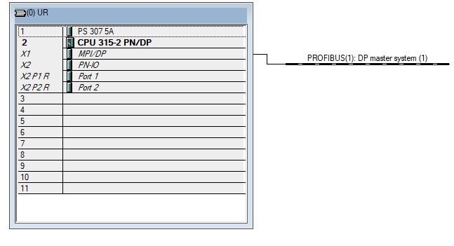

Slot 1 added power supply module for CPU:

Slot 2 added CPU module:

Which is having the MPI/Profibus and Profinet communication with port-1 & port-2

In the project we used Profibus communication, we assigned Profibus address as 2, so CPU will communicate with WinCC SCADA through this address.

**PLC code development details:**

**Step:1**

Digital inputs (DI’s )

Motor start : M10.0

Motor stop : M10.1

**Step:2**

**Digital output’s (DI’s )**

Main Contactor ON : M10.2

Star Contactor ON : M10.5

Delta Contactor ON : M10.6

**Step:3**

Data variable: Run timer : DB2.DBD22 (32-bit real value)

**Step:4**

**1.3 Creation of data block (DB), function call (FC), and function block (FB):**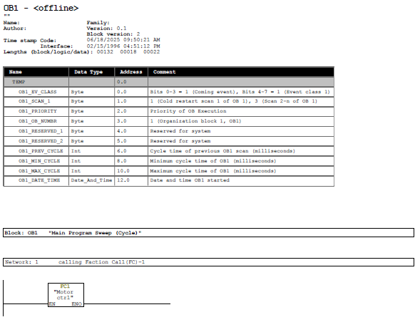

**Data Block (DB2):**

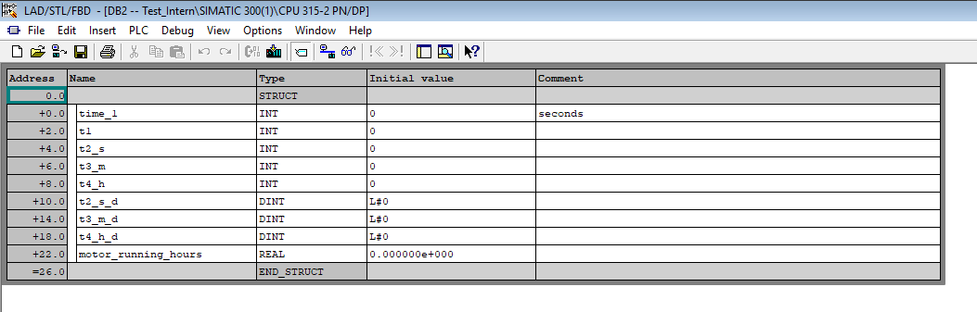

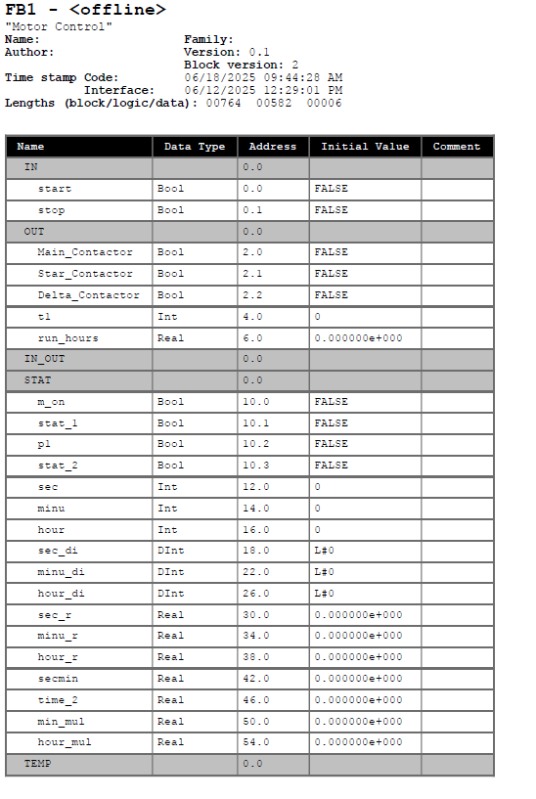**Function Block (FB1):**

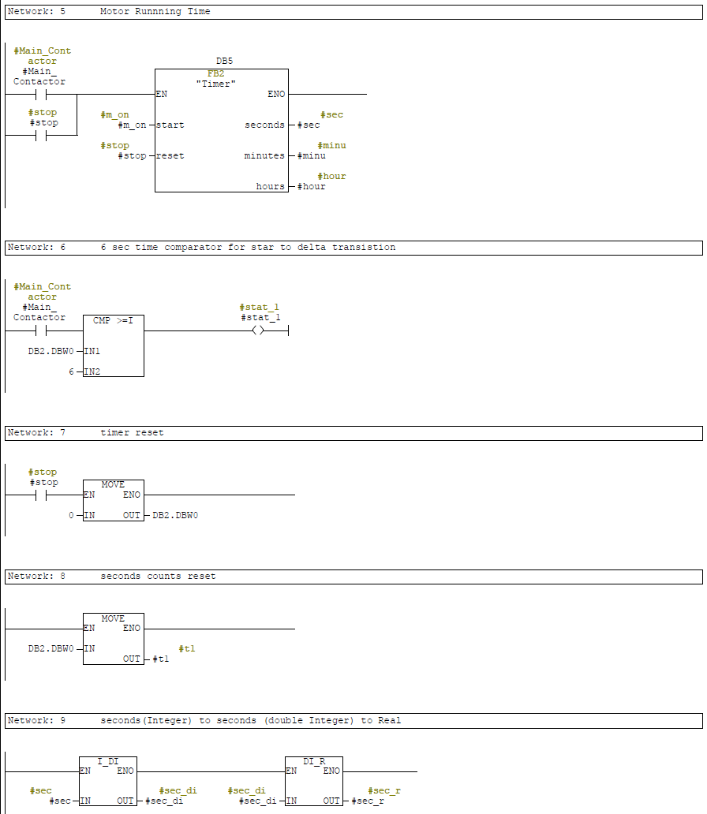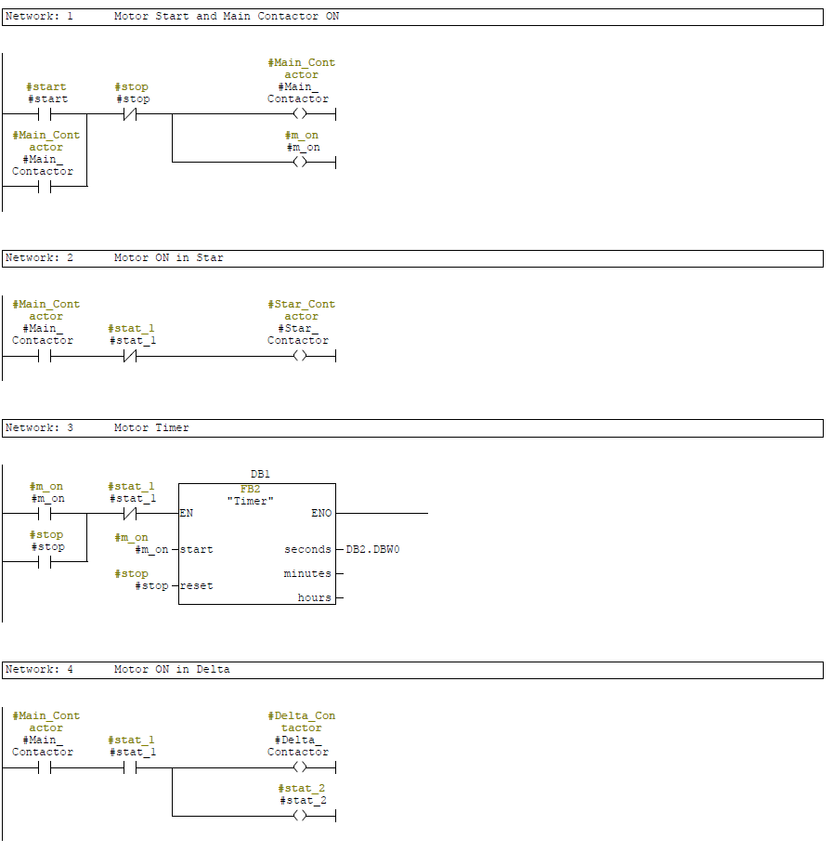

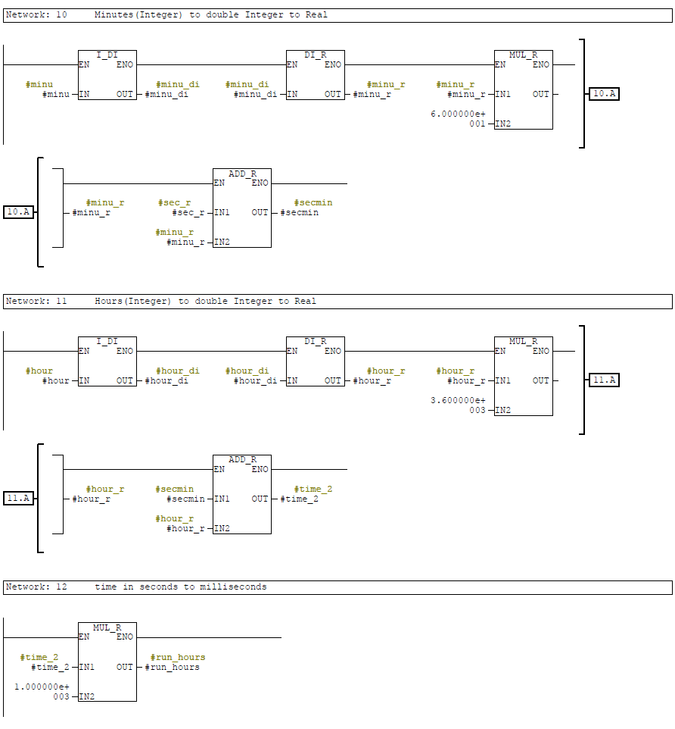

**Function Block (FB2):**

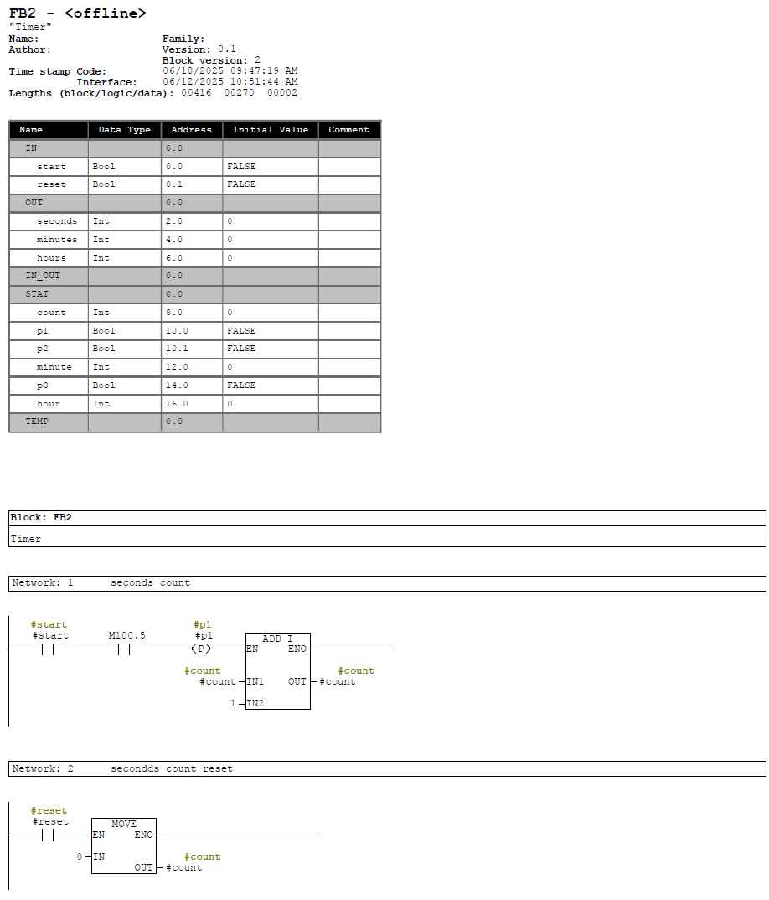

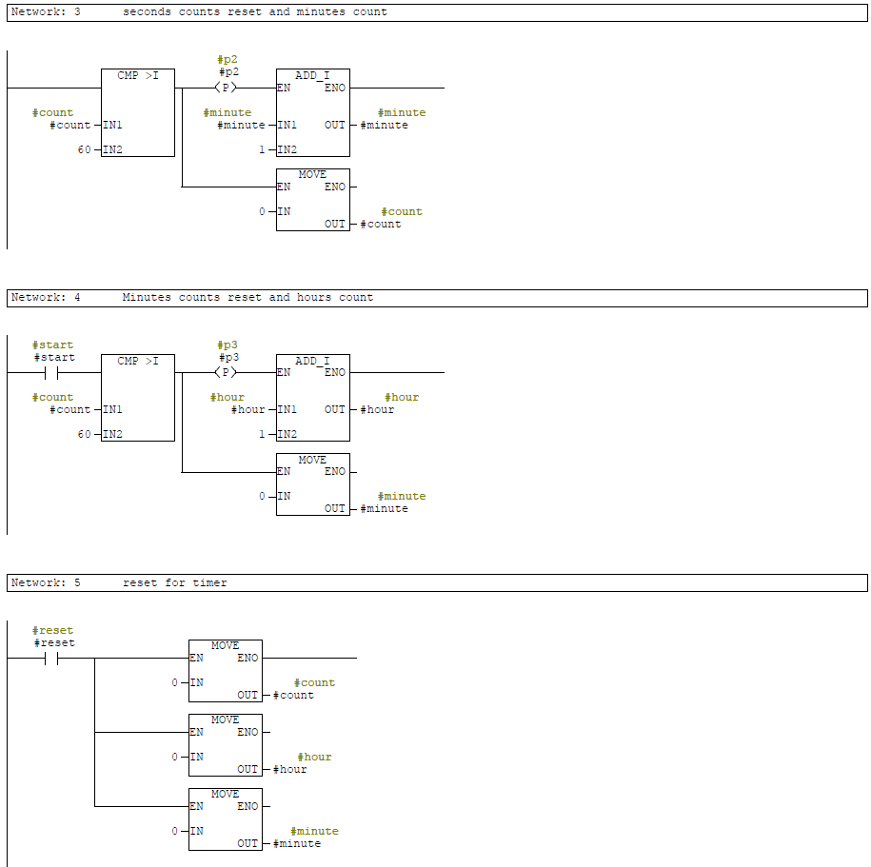

**Step:5**

Creation of Tags in the SCADA

**Step:6**

Creation of SCADA Mimics

**Main Screen:**

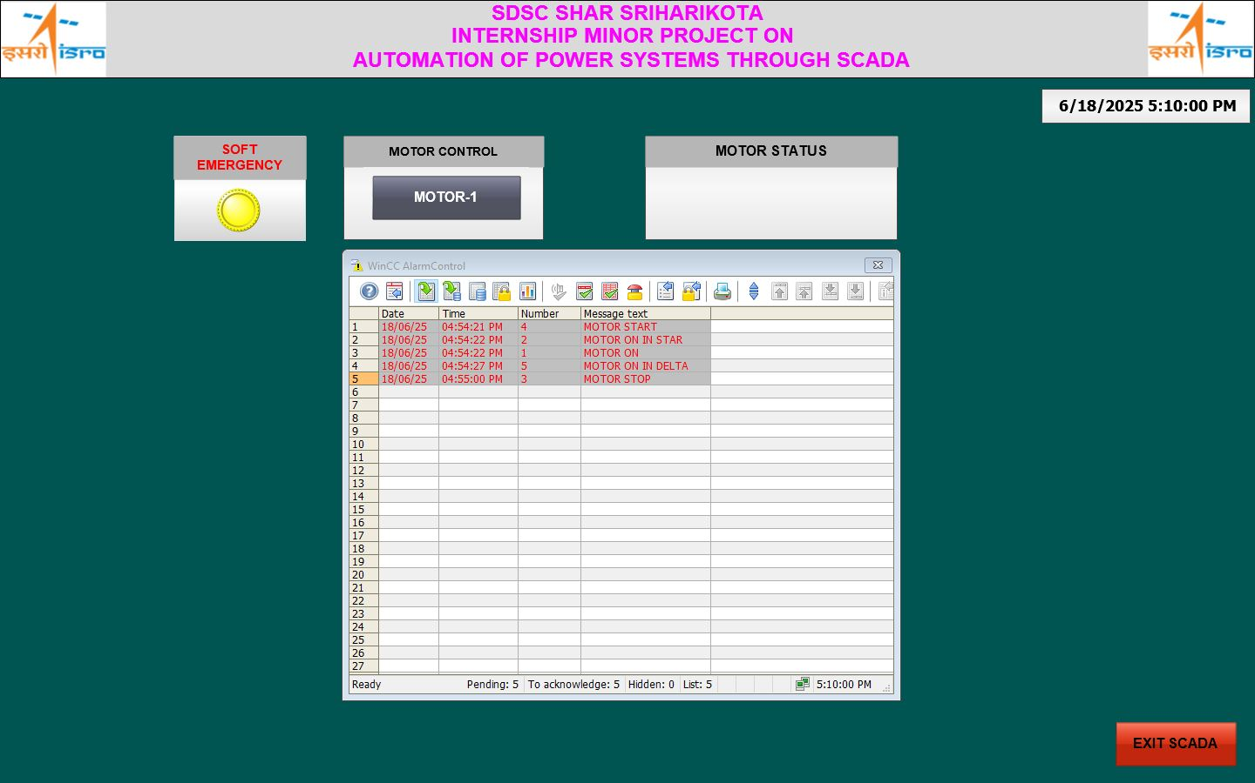

The Screens are developed in WinCC Graphics Designer, soft emergency, motor control, motor status, and alarm view mimics are added in the main screen. Individual tag assignments and their properties are added.

For soft button of motor control pop-up activation purpose mouse left click was used, and dynamic assignment of tag was added.

**WinCC Tags:**

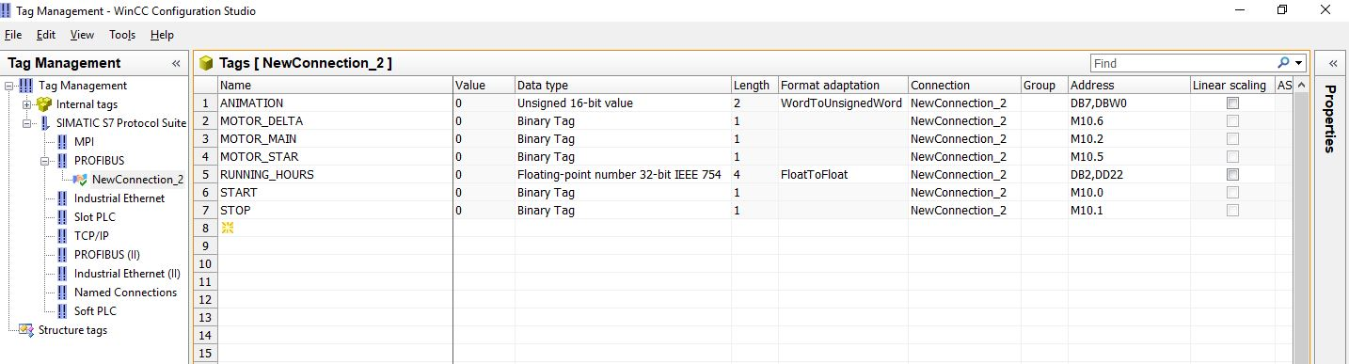

**1.4 The overview of the main screen:**

The main screen contains motor control menu, soft emergency, Exit SCADA and alarm control screens

From the main screen motor control menu, click mouse left key, a pop-up of motor control menu will be appeared, which contains the start, stop, animation of status of motor and motor running time were displayed.

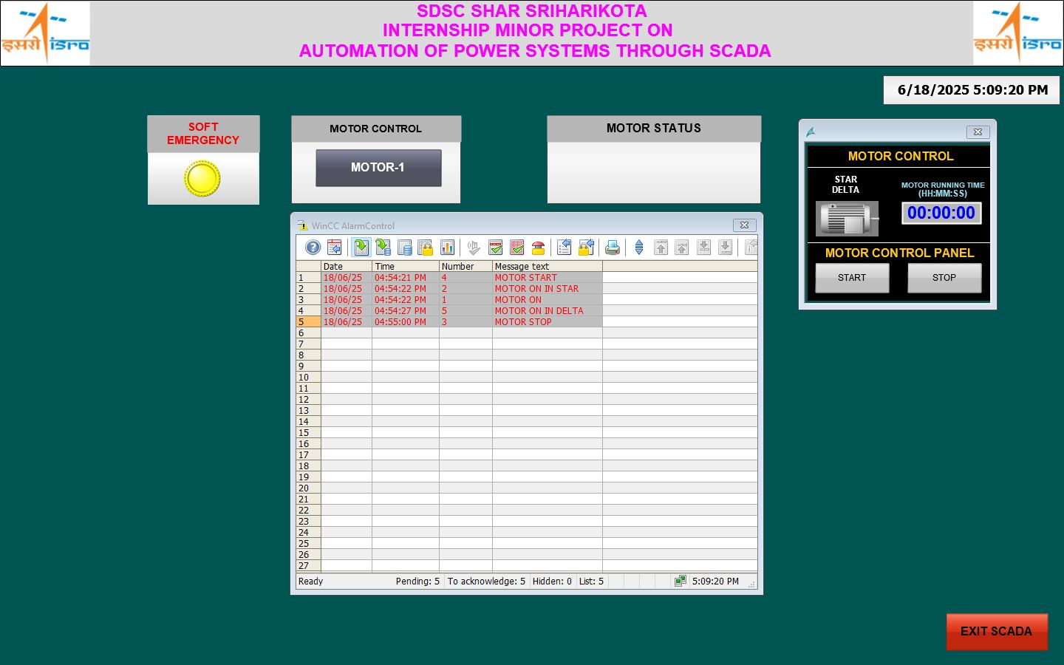

Motor Control menu along with soft button was created for pop-up activation:

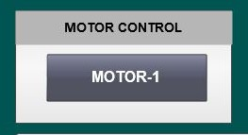 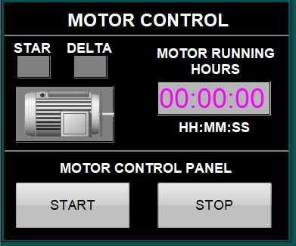

**Motor Control Menu Motor Control Pop-up**

Once motor start pressed with mouse left click, then the PLC logic will run for motor. Corresponding animation of motor status also visualised form the pop-up menu. The sequence of operation as follows

At first motor main contactor & motor star contactor will on, after a 6 seconds delay,

Star contactor will de-activated and Delta contactor will on, the main contactor remains on continuously.

Whenever main contactor ON, with this status, a timer also will start run automatically, for motor running time calculation purpose.

The above changed can be observed from SCADA main Screen.

If STOP button from pop-up menu clicked with mouse left key, motor will be stopped and running time also will be reset.

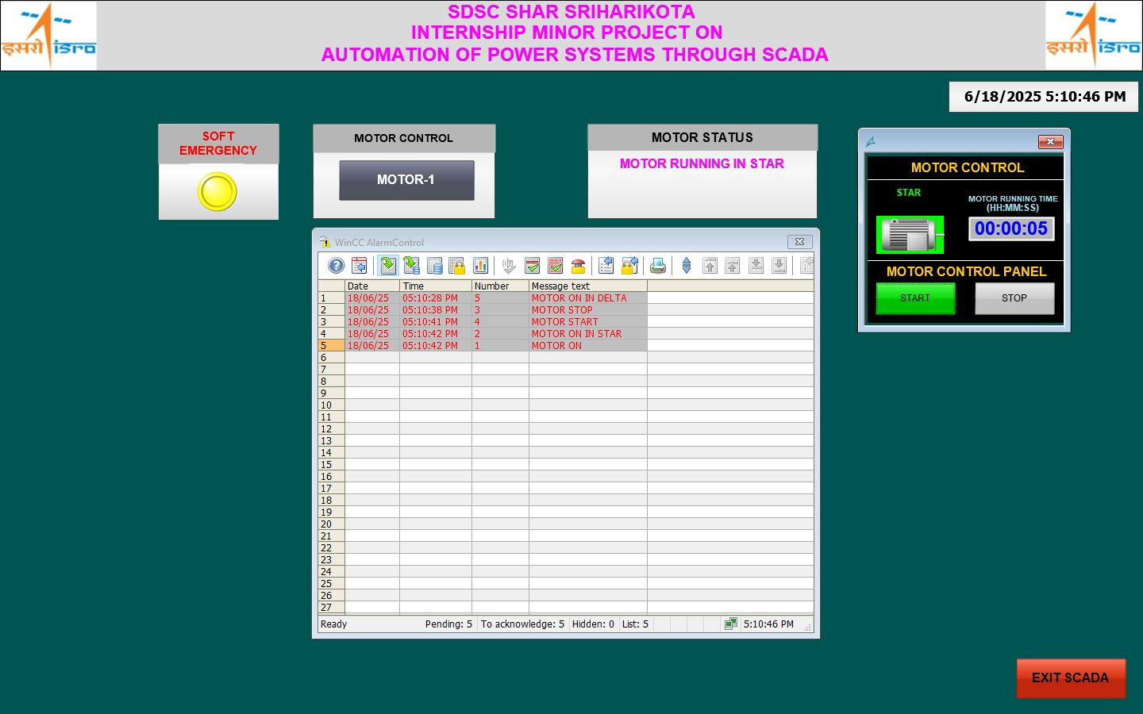

**Motor running with star**

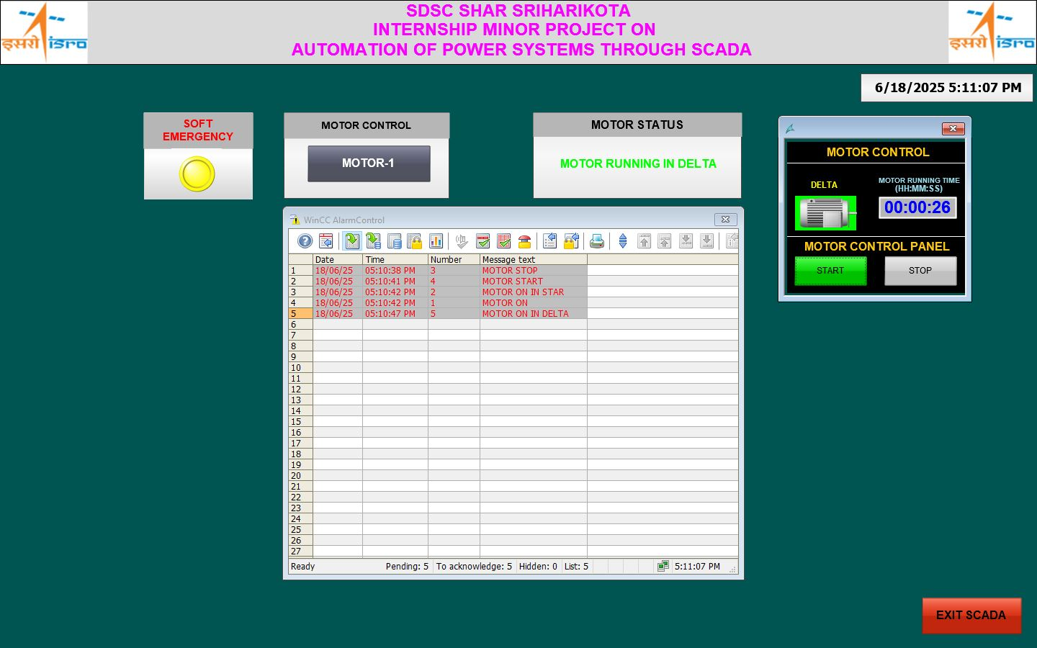

**Motor running with Delta**

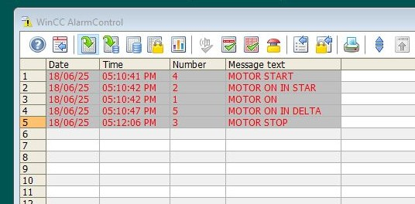

**Alarm events also observed through alarm control menu**

If in case, any emergency, we need to protect the system from failure, for that purpose, an emergency soft button also provided in the main menu.

If emergency soft button pressed with mouse left key, then a pop-up message will be appeared in the main screen as “Do you want to activate emergency” yes (or) no

If No pressed, no action,

If Yes pressed, then motor will be stopped.

**Emergency Soft Button Pop-Up**

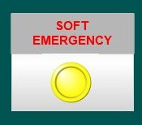 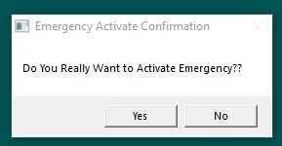

The emergency button actions were programmed through C script.

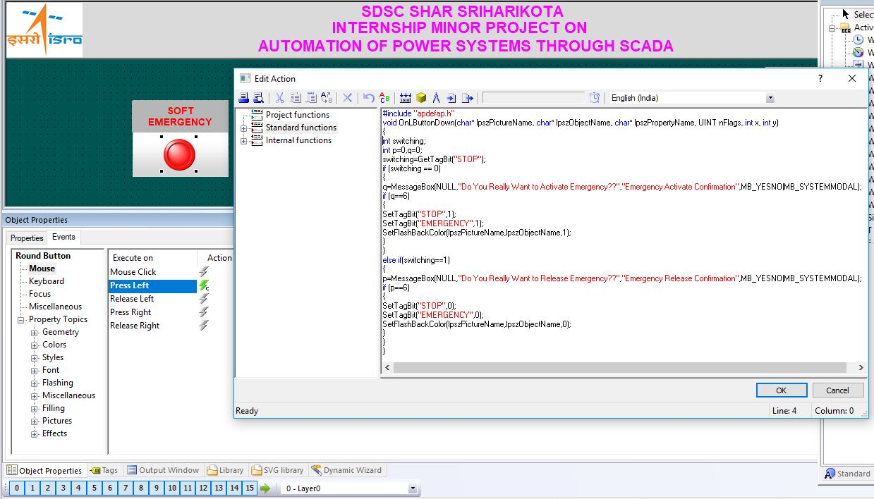

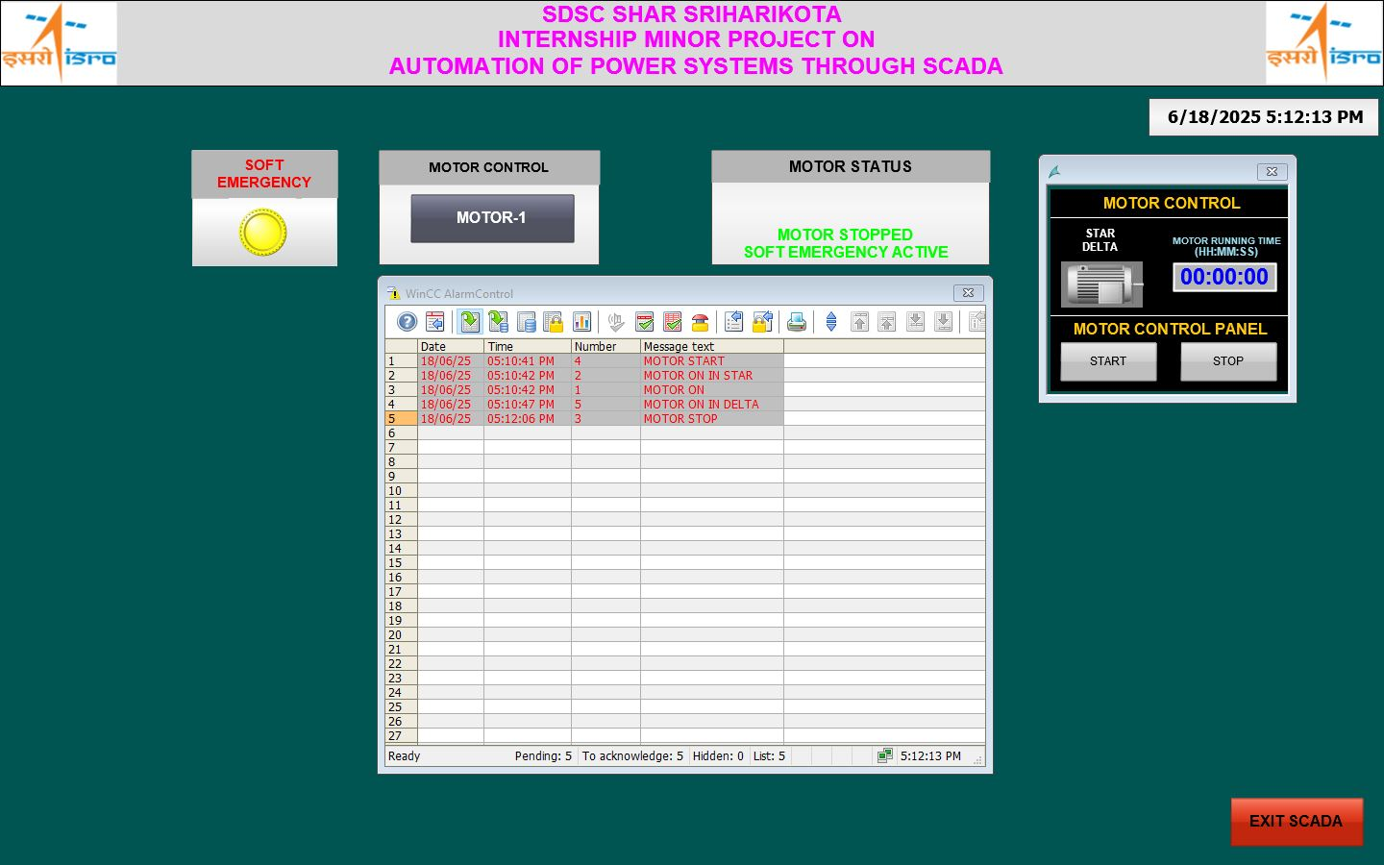

With emergency pressed motor stop can be seen in the main screen

EXIT Soft button also programmed in C script, once this button pressed with mouse left key, SCADA can be exit from run time.

**Exit soft button: pop-up**

 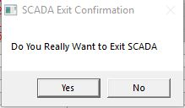

**C Script for exit SCADA:**

#include "apdefap.h"

void OnLButtonDown(char* lpszPictureName, char* lpszObjectName, char* lpszPropertyName, UINT nFlags, int x, int y)

{

int p=0;

p=MessageBox(NULL,"Do You Really Want to Exit SCADA","SCADA Exit Confirmation",MB_YESNO|MB_SYSTEMMODAL);

if (p==6)

{

ExitWinCC ();

//DeactivateRTProject ();

}

}

**1S.5 WinCC Project Documentation**

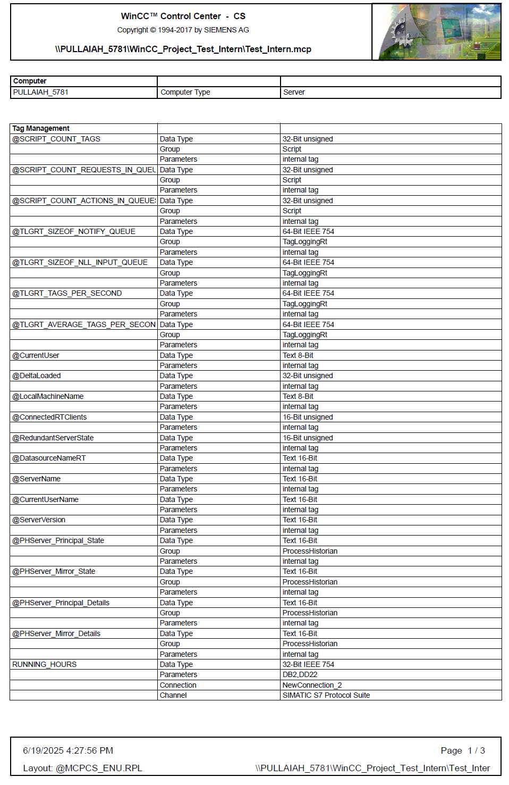

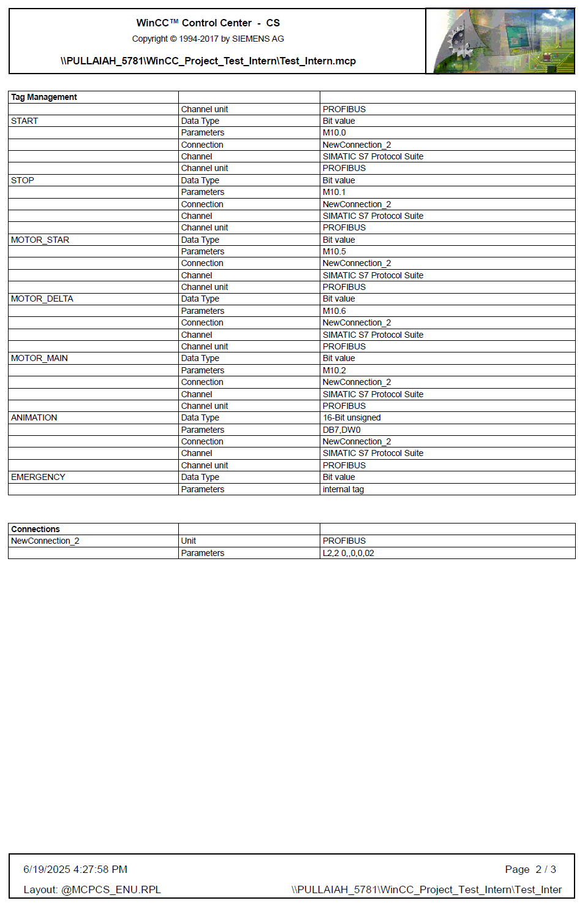

**Conclusion:**

The “study of electrical systems in the SMPC-Unit-II” were studied meticulously, and based on the knowledge acquired from our study, “automation of power system through SCADA” project was carried out by me.

The incorporation of PLC based SCADA system was developed by me and carry out the extensive study about the PLC hardware configuration, PLC code development, testing and simulation was carried out, the same was interfaced with SCADA, and creation of SCADA Configuration, Tag assignments, scripting were done and the project was successfully created and demonstrated.

Motor control in star-delta operation, was programmed in the PLC, and the operator console also developed in the SCADA. The outcome of project was, induction motor operations are done through SCADA locally, and also, can be operated through remotely using winCC web browser.

**Future scope:**

The created project can be used for not only motors can be used for different type of 2 stage actuators, ON/OFF final control elements, solenoid valves, display of various status in annunciators and also various industrial electrical elements.