**2016 Fall UMKC Hackathon**

**Team Doritos (ASE – Team 16):**

Rajesh Gupta, Kollipara (21)

Sai Sriharsha Sudulaguntla (50)

Lava Kumar, Surparaju (52)

Raghu Pavan, Vallamkonda (54)

**Investment Plan Analytics**

* Develop an app/webpage or mobile tool to collect and manage 401k data and provide an investment plan based on the individual’s input criteria. Utilize any programming language of your choice. This app can be focused toward a particular market such as millenials (which will focus your input criteria).
* Utilize data inputs to create analaytical tables.
* Utilize the data in graphical outputs for easy consumer availability.
* Limit the project to one fund family as a proof.
* Allow user input required for criteria needed:   
  Example: Current Age, Retirement age, Desired goal, Acceptable risk level, Family size(if applicable).

**Investment Plan Analytics:**

**Problem statement:**

Design a web application to collect the customer information and to process them and obtain a best possible to the investor.

**Implementation details:**

* Designed a web application using java servlet application.
* Collected the sample 401k data, analyzed & processed the data using MySQL DB.
* Collected the input criteria from customer and provided a best possible investment plan.

**Web Application**:

Home Screen:

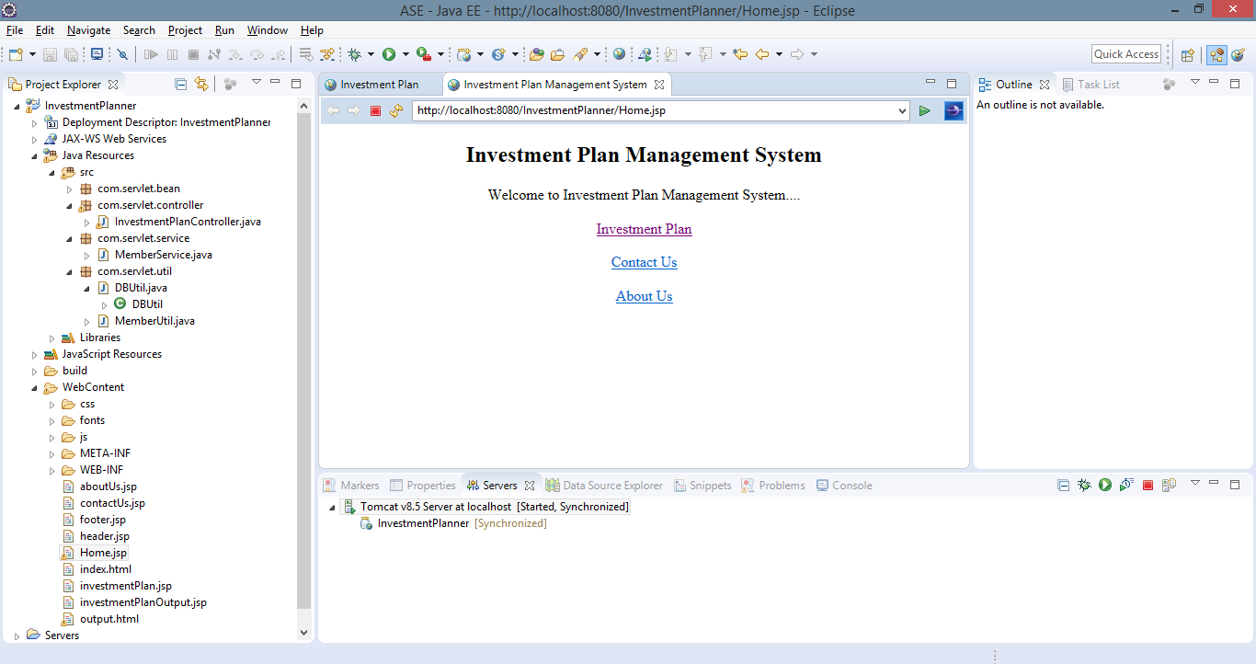

Customer Input screen:

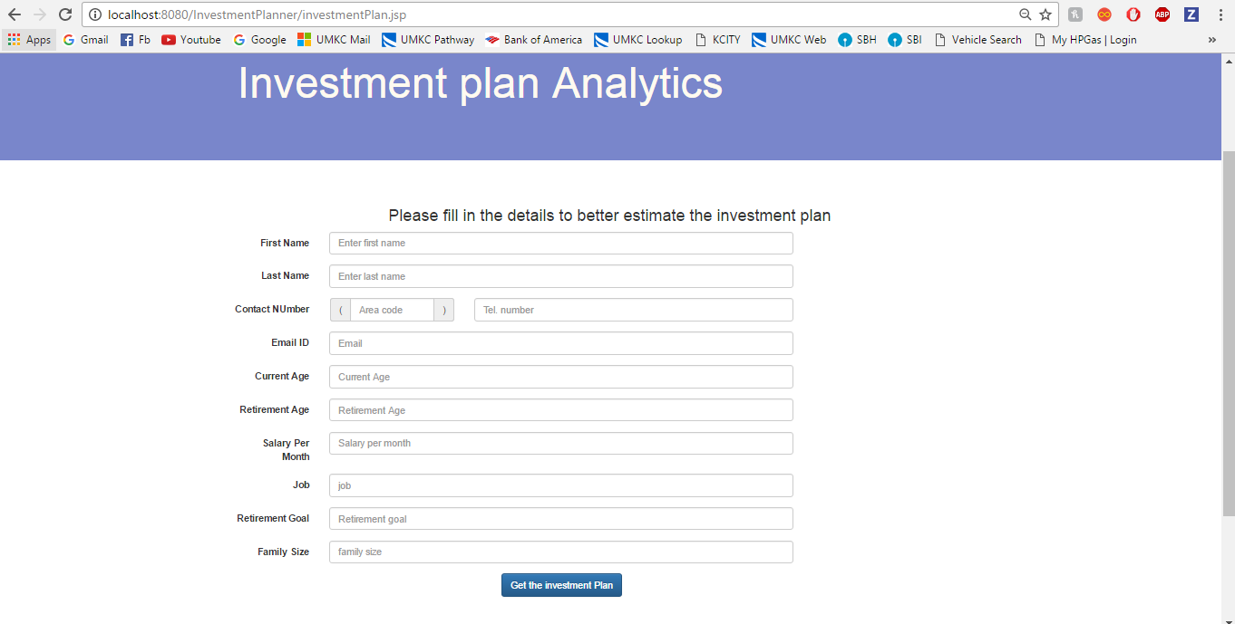

Customer Input data:

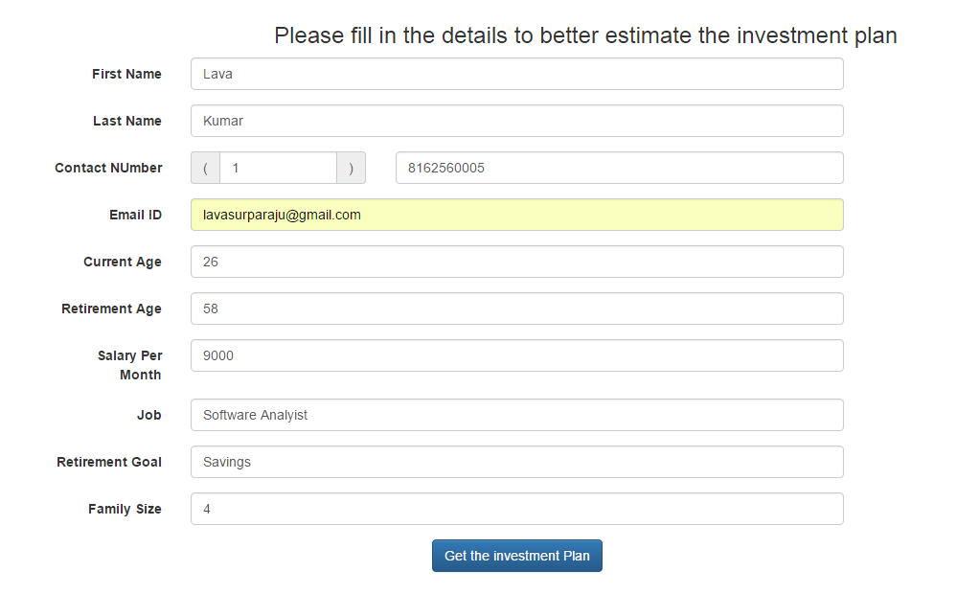

Investment Plan:

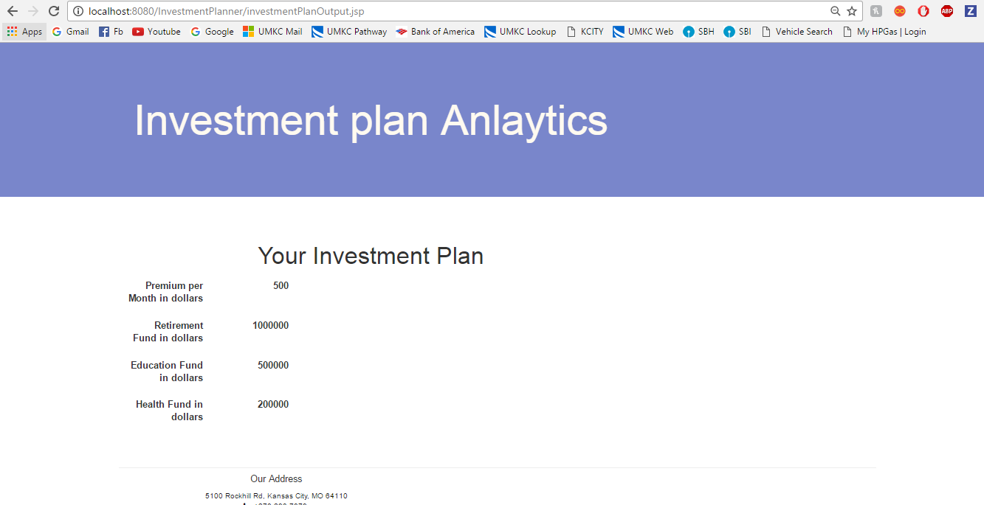

SQL Data base:

