Table of Contents

CapFinLoan — Low Level Design (LLD)
Project: FastTrack CapFinLoan Version: 2.0 Date: 2026-05-06 Author: CapFinLoan Architecture Team

Table of Contents
- Architecture Overview
- Service Breakdown
- Database Schema
- Class Diagrams
- Key Sequence Flows
- Messaging Topology
- Saga State Machine
- API Reference
- Error Handling
- Configuration Reference

1. Architecture Overview
CapFinLoan follows Clean Architecture across all five microservices. Each service is independently deployable with its own database.
Each microservice is structured into four layers:
- API Layer — Controllers, Middleware, Consumers, Publishers
- Application Layer — Services, DTOs, Interfaces, Events
- Domain Layer — Entities, Business Rules
- Persistence Layer — DbContext, Repositories, EF Core Migrations
Dependency Rule: Inner layers never reference outer layers. The Domain layer has zero external dependencies.

2. Service Breakdown
Service | Port | Database | Responsibility
AuthService | 5000 | CapFinLoanAuth | Identity, JWT, OTP, Google OAuth
ApplicationService | 5001 | CapFinLoanApplication | Loan lifecycle, Saga, AI Chat
DocumentService | 5002 | CapFinLoanDocument | Upload, storage, verification
AdminService | 5003 | CapFinLoanAdmin | Queue, decisions, reporting
WalletService | 5005 | CapFinLoanWallet | Razorpay, balance, withdrawals
API Gateway | 5021 | — | Ocelot routing, JWT auth

2.1 Inter-Service Communication
Synchronous (HTTP)
Caller | Calls | Purpose
ApplicationService | AuthService /auth/me | Profile completeness check
AdminService | ApplicationService /applications/queue | Fetch application list
AdminService | DocumentService /documents/application/{id} | Fetch document counts
AdminService | AuthService /auth/users/identifiers | Resolve user names/emails
AdminService | ApplicationService /applications/{id}/status | Update status after decision
AdminService | DocumentService /documents/{id}/verify-status | Update document status
Asynchronous (RabbitMQ)
Publisher | Event | Consumer
ApplicationService | application.submitted | AdminService
AdminService | admin.decision.made | ApplicationService
DocumentService | document.uploaded | AdminService
DocumentService | document.replaced | AdminService
DocumentService | document.status.changed | AdminService
DocumentService | document.deleted | AdminService

3. Database Schema

3.1 AuthService — CapFinLoanAuth
Table: Users
Column | Type | Constraints
Id | int | PK, Identity
Name | nvarchar(200) | NOT NULL
Email | nvarchar(256) | NOT NULL, UNIQUE
PasswordHash | nvarchar(255) | NULL (Google users have no password)
Role | nvarchar(50) | NOT NULL — APPLICANT / ADMIN
IsActive | bit | DEFAULT 1
MobileNumber | nvarchar(20) | NULL
Address | nvarchar(500) | NULL
DateOfBirth | datetime2 | NULL
EmploymentStatus | nvarchar(50) | NULL
BankName | nvarchar(100) | NULL
BankAccountNumber | nvarchar(30) | NULL
IfscCode | nvarchar(20) | NULL
AnnualIncome | decimal(18,2) | NULL
ProfilePhotoDataUrl | nvarchar(max) | NULL
IsProfileComplete is computed: all KYC fields (MobileNumber through AnnualIncome) must be non-null.

3.2 ApplicationService — CapFinLoanApplication
Table: LoanApplications
Column | Type | Constraints
Id | int | PK, Identity
UserId | int | NOT NULL
Amount | decimal(18,2) | NOT NULL
TenureMonths | int | NOT NULL
Status | nvarchar(50) | PENDING / SUBMITTED / UNDER_REVIEW / APPROVED / REJECTED
DecisionReason | nvarchar(500) | NULL
DecidedAtUtc | datetime2 | NULL
CreatedAt | datetime2 | NOT NULL
Table: ApplicationStatusHistories
Column | Type | Constraints
Id | int | PK
ApplicationId | int | FK → LoanApplications
UserId | int | NOT NULL
Status | nvarchar(50) | NOT NULL
ChangedAtUtc | datetime2 | NOT NULL
Note | nvarchar(500) | NULL
Table: ApplicationSubmissionSagas
Column | Type | Constraints
Id | int | PK
SagaId | uniqueidentifier | UNIQUE
ApplicationId | int | NOT NULL
UserId | int | NOT NULL
State | nvarchar(100) | STARTED / AWAITING_DECISION / COMPLETED / COMPENSATED
IsCompleted | bit | DEFAULT 0
IsCompensated | bit | DEFAULT 0
LastError | nvarchar(1000) | NULL
StartedAtUtc | datetime2 | NOT NULL
UpdatedAtUtc | datetime2 | NOT NULL
CompletedAtUtc | datetime2 | NULL

3.3 DocumentService — CapFinLoanDocument
Table: Documents
Column | Type | Constraints
Id | int | PK, Identity
ApplicationId | int | NOT NULL, INDEX
UserId | int | NOT NULL, INDEX
FileName | nvarchar(255) | NOT NULL (original name)
StoredFileName | nvarchar(255) | NOT NULL (GUID-based, collision-safe)
ContentType | nvarchar(100) | NOT NULL
FileSize | bigint | NOT NULL
Status | nvarchar(20) | PENDING / VERIFIED / REJECTED
UploadedAt | datetime2 | NOT NULL
DocumentType | nvarchar(50) | PAN / ITR / SALARY_SLIP / BANK_STATEMENT / AADHAAR

3.4 AdminService — CapFinLoanAdmin
Table: AdminDecisions
Column | Type | Constraints
Id | int | PK, Identity
ApplicationId | int | NOT NULL
Decision | nvarchar(50) | APPROVED / REJECTED / UNDER_REVIEW
Remarks | nvarchar(500) | NULL
ApprovedAmount | decimal(18,2) | NOT NULL
TenureMonths | int | NOT NULL
InterestRate | decimal(5,2) | NOT NULL
CreatedBy | int | NOT NULL (AdminUserId)
CreatedAtUtc | datetime2 | NOT NULL
Table: ApplicationStatusHistories
Column | Type | Constraints
Id | int | PK
ApplicationId | int | NOT NULL
OldStatus | nvarchar(50) | NULL
NewStatus | nvarchar(50) | NOT NULL
Remarks | nvarchar(500) | NULL
ChangedBy | int | NOT NULL
ChangedAtUtc | datetime2 | NOT NULL

3.5 WalletService — CapFinLoanWallet
Table: Wallets
Column | Type | Constraints
Id | int | PK
UserId | int | UNIQUE
AvailableBalancePaise | bigint | DEFAULT 0
PendingBalancePaise | bigint | DEFAULT 0
CreatedAt | datetime2 | NOT NULL
UpdatedAt | datetime2 | NOT NULL
Table: Transactions
Column | Type | Constraints
Id | int | PK
UserId | int | NOT NULL
Type | nvarchar(10) | CREDIT / DEBIT
Category | nvarchar(30) | SIGNUP_BONUS / APPLICATION_FEE / TOPUP / WITHDRAWAL / REFUND
AmountPaise | bigint | NOT NULL
Status | nvarchar(10) | SUCCESS / FAILED
ReferenceId | nvarchar(200) | NULL (Razorpay payment ID)
Note | nvarchar(500) | NULL
CreatedAt | datetime2 | NOT NULL
Table: WithdrawalRequests
Column | Type | Constraints
Id | int | PK
UserId | int | NOT NULL
AmountPaise | bigint | NOT NULL
Status | nvarchar(20) | PENDING / APPROVED / REJECTED / DISBURSED
BankAccount | nvarchar(50) | NULL
IfscCode | nvarchar(20) | NULL
AccountHolderName | nvarchar(200) | NULL
AdminNote | nvarchar(500) | NULL
ReviewedByAdminId | int | NULL
CreatedAt | datetime2 | NOT NULL
UpdatedAt | datetime2 | NOT NULL
All monetary amounts are stored in paise (1 INR = 100 paise) to avoid floating-point precision issues.

Class Diagrams

4.1 AuthService
AuthController depends on AuthService, which depends on IUserRepository, IJwtService, IOtpService, and IGoogleTokenValidator.
Class | Key Responsibilities
AuthController | Exposes signup, login, Google auth, profile, password reset endpoints
AuthService | Orchestrates signup, login, OTP verification, profile updates, password reset
IUserRepository | CRUD operations on the Users table
IJwtService | Generates and validates HS256 JWT tokens
IOtpService | Generates, stores (MemoryCache), and validates OTPs; sends email via SMTP
IGoogleTokenValidator | Validates Google ID tokens against Google’s OAuth API

4.2 ApplicationService
ApplicationController depends on ApplicationService, which depends on IApplicationRepository, IApplicationEventPublisher, and IApplicationSubmissionSagaCoordinator.
Class | Key Responsibilities
ApplicationController | CRUD and submit endpoints for loan applications
ApplicationService | Loan lifecycle management, status transitions, saga initiation
SagaCoordinator | Manages STARTED → AWAITING_DECISION → COMPLETED / COMPENSATED states
ChatService | Builds context from application data and queries Ollama LLM

4.3 AdminService
AdminController depends on AdminService, which aggregates decisions, history, queue reading, event publishing, and email sending.
Class | Key Responsibilities
AdminController | Decision, queue, history, document verify, report endpoints
AdminService | Orchestrates decision recording, HTTP calls to downstream services, email dispatch
IApplicationQueueReader | Calls ApplicationService and DocumentService to build enriched queue
IAdminEventPublisher | Publishes admin.decision.made to RabbitMQ
IApplicantDecisionEmailSender | Sends decision email via Gmail SMTP

4.4 WalletService
WalletController depends on WalletService, which directly uses WalletDbContext and the Razorpay API.
Class | Key Responsibilities
WalletController | Wallet, order, payment verify, fee deduct, transaction, withdrawal endpoints
WalletService | Wallet creation, Razorpay order/verify, fee deduction, withdrawal management

5. Key Sequence Flows

5.1 User Signup (OTP Flow)
- User submits email → AuthService generates 6-digit OTP, stores in MemoryCache (5 min TTL), sends via Gmail SMTP.
- User submits OTP → AuthService validates, generates short-lived VerificationToken (JWT).
- User submits name + password + VerificationToken → AuthService validates token, BCrypt-hashes password, inserts User record, returns JWT (HS256, 60 min).

5.2 Application Submission with Saga
- User calls POST /applications/{id}/submit.
- ApplicationService validates status is PENDING or REJECTED.
- Saga record created (State = STARTED).
- WalletService called to deduct ₹500 application fee.
- Application status updated to SUBMITTED.
- Event application.submitted published to RabbitMQ.
  - Success path: Saga updated to AWAITING_DECISION. Returns 200 OK.
  - Failure path: Status rolled back to PENDING, Saga updated to COMPENSATED. Returns 500.
- AdminService consumes the event and inserts a history record.

5.3 Admin Decision Flow
- Admin calls POST /admin/applications/{id}/decision with decision, remarks, approved amount, tenure, interest rate.
- AdminService inserts AdminDecision and ApplicationStatusHistory records.
- AdminService calls ApplicationService POST /applications/{id}/status to sync the status.
- AdminService publishes admin.decision.made to RabbitMQ.
- AdminService sends decision email to applicant via Gmail SMTP.
- ApplicationService consumes admin.decision.made, performs idempotent status check, and completes the Saga (State = COMPLETED).

5.4 Razorpay Wallet Top-up
- User calls POST /wallet/razorpay/order with amount in rupees.
- WalletService creates a Razorpay order (amount converted to paise).
- Frontend opens Razorpay Checkout; user completes payment.
- User calls POST /wallet/razorpay/verify with paymentId, orderId, signature.
- WalletService verifies HMAC-SHA256 signature.
- On success: wallet balance credited, Transaction record inserted. Returns TransactionDto.

6. Messaging Topology
Exchange: capfinloan.events — Topic, Durable
Routing Key | Publisher | Queue | Consumer
application.submitted | ApplicationService | admin.application.submitted.queue | AdminService — ApplicationSubmittedConsumer
admin.decision.made | AdminService | application.admin.decision.queue | ApplicationService — AdminDecisionConsumer
document.uploaded | DocumentService | admin.document.uploaded.queue | AdminService — DocumentLifecycleConsumer
document.replaced | DocumentService | admin.document.replaced.queue | AdminService — DocumentLifecycleConsumer
document.status.changed | DocumentService | admin.document.status.changed.queue | AdminService — DocumentLifecycleConsumer
document.deleted | DocumentService | admin.document.deleted.queue | AdminService — DocumentLifecycleConsumer
Consumer Reliability: All consumers use BasicAck on success and BasicNack (requeue=false) on exception. Consumers retry RabbitMQ connection every 10 seconds on startup. All consumers are idempotent — safe to replay.
Event Payloads (key fields)
ApplicationSubmittedEvent: EventId, ApplicationId, UserId, Amount, TenureMonths, NewStatus, OccurredAtUtc
AdminDecisionMadeEvent: EventId, ApplicationId, Decision, ApprovedAmount, TenureMonths, InterestRate, OccurredAtUtc
DocumentEvent: DocumentId, ApplicationId, UserId, DocumentType, EventType, CurrentStatus, OccurredAtUtc

7. Saga State Machine
The ApplicationSubmissionSaga manages the distributed transaction for loan submission.
State | IsCompleted | IsCompensated | Description
STARTED | false | false | Saga created, fee deducted
AWAITING_DECISION | false | false | Event published, waiting for admin
COMPLETED | true | false | Admin decision received
COMPENSATED | false | true | Publish failed, status rolled back
Transitions:
- STARTED → AWAITING_DECISION: application.submitted published successfully
- STARTED → COMPENSATED: publish failed, application status rolled back to PENDING
- AWAITING_DECISION → COMPLETED: admin.decision.made consumed by ApplicationService

8. API Reference

8.1 AuthService — Port 5000
Method | Endpoint | Auth | Description
POST | /auth/signup/request-otp | None | Send OTP to email
POST | /auth/signup/verify-otp | None | Verify OTP, get verification token
POST | /auth/signup | None | Create account
POST | /auth/login | None | Email/password login
POST | /auth/google | None | Google OAuth login
GET | /auth/me | JWT | Get own profile
PUT | /auth/profile | JWT | Update KYC profile
POST | /auth/forgot-password | None | Request reset OTP
POST | /auth/verify-reset-otp | None | Verify reset OTP
POST | /auth/reset-password | None | Set new password
GET | /auth/users/identifiers | JWT (Admin) | Bulk user lookup

8.2 ApplicationService — Port 5001
Method | Endpoint | Auth | Description
POST | /applications | JWT | Create application
PUT | /applications/{id} | JWT | Update draft
GET | /applications/{id} | JWT | Get by ID
GET | /applications/my | JWT | Get own applications
POST | /applications/{id}/submit | JWT | Submit application
GET | /applications/{id}/timeline | JWT | Status history
GET | /applications/queue | JWT (Admin) | Admin queue
POST | /applications/{id}/status | JWT (Admin) | Update status
POST | /chat/message | JWT | AI chat

8.3 DocumentService — Port 5002
Method | Endpoint | Auth | Description
POST | /documents/upload | JWT | Upload document
PUT | /documents/{id} | JWT | Replace document
GET | /documents/application/{appId} | JWT | List by application
GET | /documents/{id}/download | JWT | Download file
DELETE | /documents/{id} | JWT | Delete document
PUT | /documents/{id}/verify-status | JWT (Admin) | Verify/reject

8.4 AdminService — Port 5003
Method | Endpoint | Auth | Description
GET | /admin/applications | JWT (Admin) | Application queue
POST | /admin/applications/{id}/decision | JWT (Admin) | Make decision
GET | /admin/applications/{id}/history | JWT (Admin) | Status history
PUT | /admin/documents/{id}/verify | JWT (Admin) | Verify document
GET | /admin/reports/summary | JWT (Admin) | Report summary

8.5 WalletService — Port 5005
Method | Endpoint | Auth | Description
GET | /wallet | JWT | Get wallet balance
POST | /wallet/razorpay/order | JWT | Create payment order
POST | /wallet/razorpay/verify | JWT | Verify and credit
POST | /wallet/deduct-fee | JWT | Deduct application fee
GET | /wallet/transactions | JWT | Transaction history
POST | /wallet/withdraw | JWT | Request withdrawal
GET | /wallet/withdrawals | JWT | Own withdrawals
GET | /admin/wallet/summary | JWT (Admin) | Wallet analytics
POST | /admin/wallet/withdrawals/{id}/review | JWT (Admin) | Review withdrawal

9. Error Handling

9.1 Middleware Pipeline
All services share the same middleware stack in this order:
CorrelationIdMiddleware → ApiExceptionMiddleware → RequestLoggingMiddleware → JWT Authentication → Controller
- CorrelationIdMiddleware: Reads or generates X-Correlation-ID header, attaches to all logs and response headers.
- ApiExceptionMiddleware: Catches all unhandled exceptions, returns RFC 7807 ProblemDetails JSON.
- RequestLoggingMiddleware: Logs HTTP method, path, status code, and duration for every request.

9.2 HTTP Status Code Mapping
Scenario | Status
Success | 200 OK
Resource created | 201 Created
Validation failure | 400 Bad Request
Missing or invalid JWT | 401 Unauthorized
Insufficient role | 403 Forbidden
Resource not found | 404 Not Found
Business rule violation | 422 Unprocessable Entity
Unhandled exception | 500 Internal Server Error

9.3 Error Response Format (RFC 7807)
All error responses follow the RFC 7807 Problem Details standard with fields: type, title, status, detail, instance, and traceId. Validation errors include an additional errors map keyed by field name.

10. Configuration Reference

10.1 Environment Variables
Variable | Auth | App | Doc | Admin | Wallet
ConnectionStrings__Default | Yes | Yes | Yes | Yes | Yes
Jwt__Key | Yes | Yes | Yes | Yes | Yes
Jwt__Issuer | Yes | Yes | Yes | Yes | Yes
RabbitMq__HostName | No | Yes | Yes | Yes | No
Services__Auth__BaseUrl | No | Yes | No | Yes | No
ServiceUrls__DocumentService | No | No | No | Yes | No
Smtp__Host | Yes | No | No | Yes | No
Uploads__RelativePath | No | No | Yes | No | No
Ollama__BaseUrl | No | Yes | No | No | No
Razorpay__KeyId | No | No | No | No | Yes
Razorpay__KeySecret | No | No | No | No | Yes

10.2 JWT Token
- Algorithm: HS256
- Expiry: 60 minutes
- Shared Key: Same Jwt__Key across all services — AuthService issues, all others validate
- Claims: sub (userId), role (APPLICANT/ADMIN), email
- Clock Skew: 30 seconds tolerance

10.3 Service Startup Order
- RabbitMQ
- AuthService
- ApplicationService and DocumentService
- AdminService and WalletService
- API Gateway
- Frontend
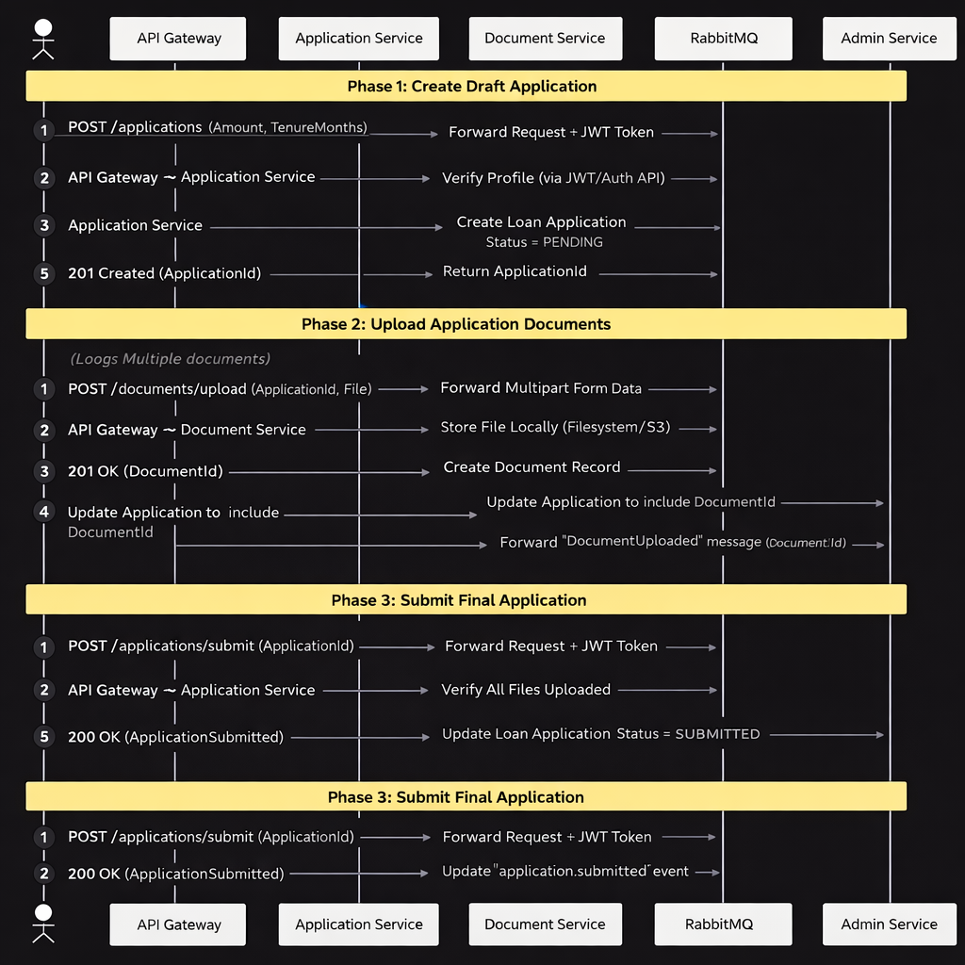

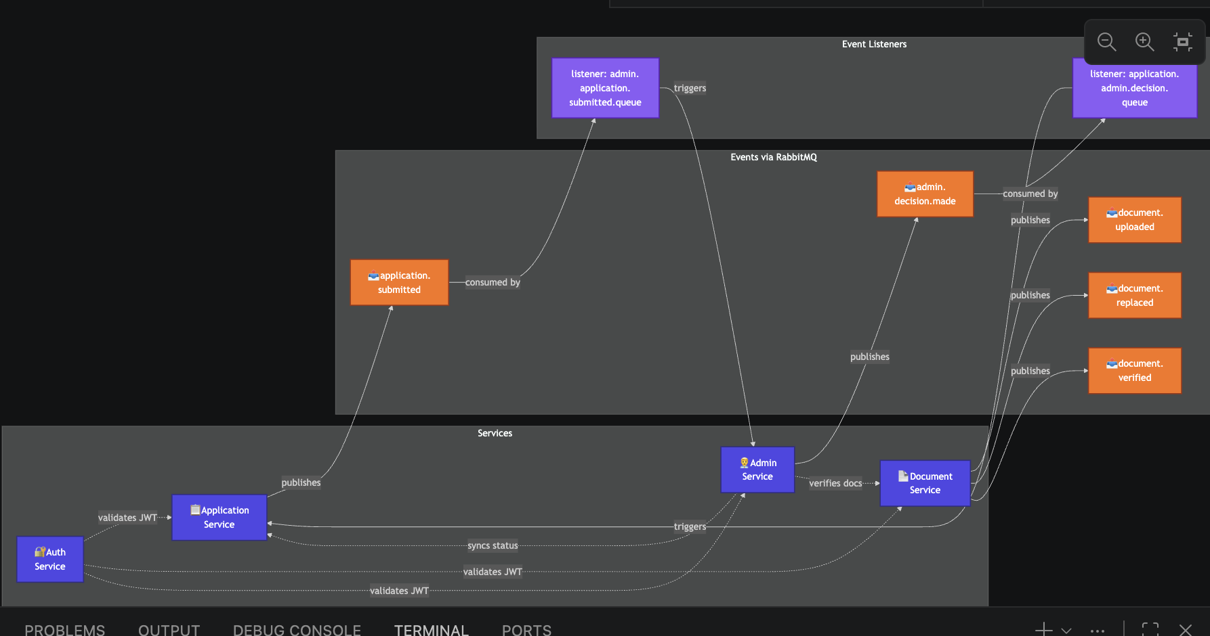
Er diagram:
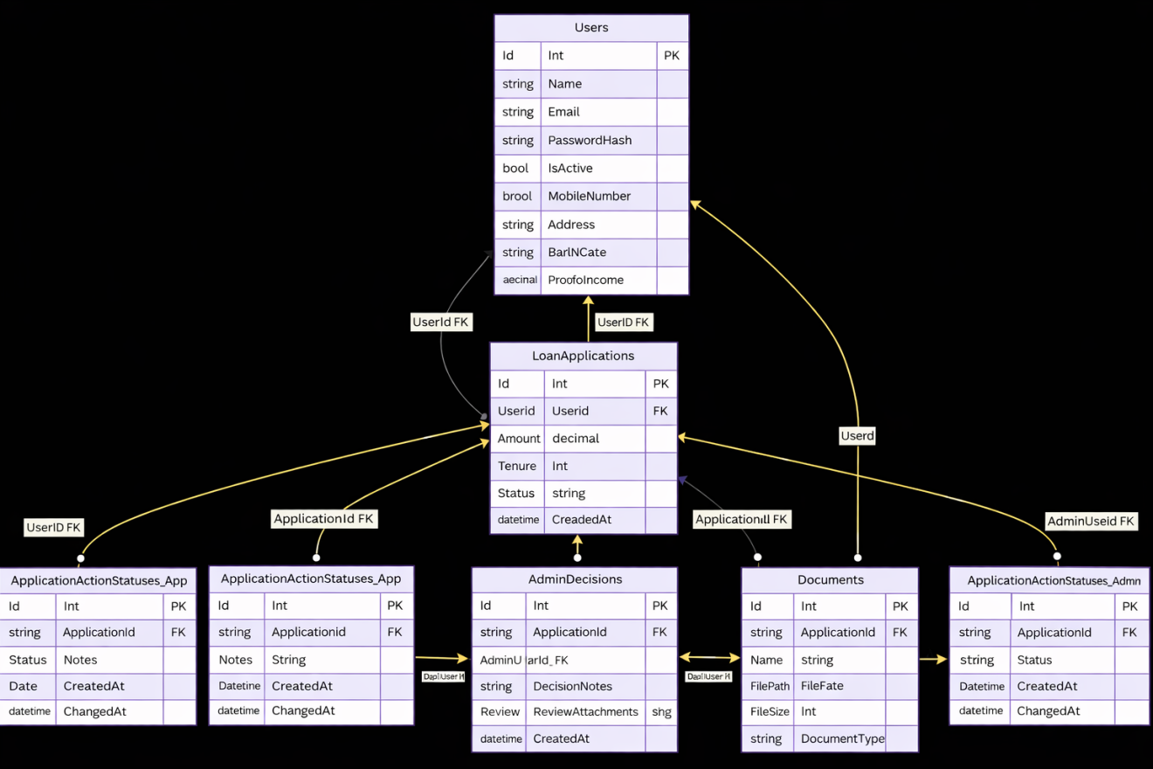
Class Diagram 