Simple Java Console App (Baseline CI/CD)
TASK : Create Maven project with Junit tests
• Create a Maven based application by following standard Maven directory structure.
• Write the code in Visual Studio and push it to your GITHUB repository.
• Modify the code and commit the updates back in GITHUB.
• Using Jenkins configure the job as pipeline and create the stages for the Continuous Integration process.
• Containerize the application using Dockerfile and display the stages in stage view in Jenkins.

a. Addition operation
Open vscode -> folder addition-app
addition-app/
├── src/
│ ├── main/java/com/example/App.java
│ └── test/java/com/example/AppTest.java
└── pom.xml
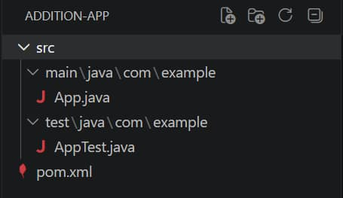
pom.xml
<project xmlns="http://maven.apache.org/POM/4.0.0">
<modelVersion>4.0.0</modelVersion>
<groupId>com.example</groupId>
<artifactId>addition-app</artifactId>
<version>1.0</version>
<dependencies>
<dependency>
<groupId>junit</groupId>
<artifactId>junit</artifactId>
<version>4.13.2</version>
<scope>test</scope>
</dependency>
</dependencies>
</project>
App.java
package com.example;
public class App {
public int add(int a, int b) {
return a + b;
}
public static void main(String[] args) {
App obj = new App();
System.out.println("Result = " + obj.add(5, 3));
}
}
AppTest.java
package com.example;
import static org.junit.Assert.assertEquals;
import org.junit.Test;
public class AppTest {
@Test
public void testAdd() {
App obj = new App();
assertEquals(8, obj.add(5, 3));
}
}

Terminal -> mvn clean package
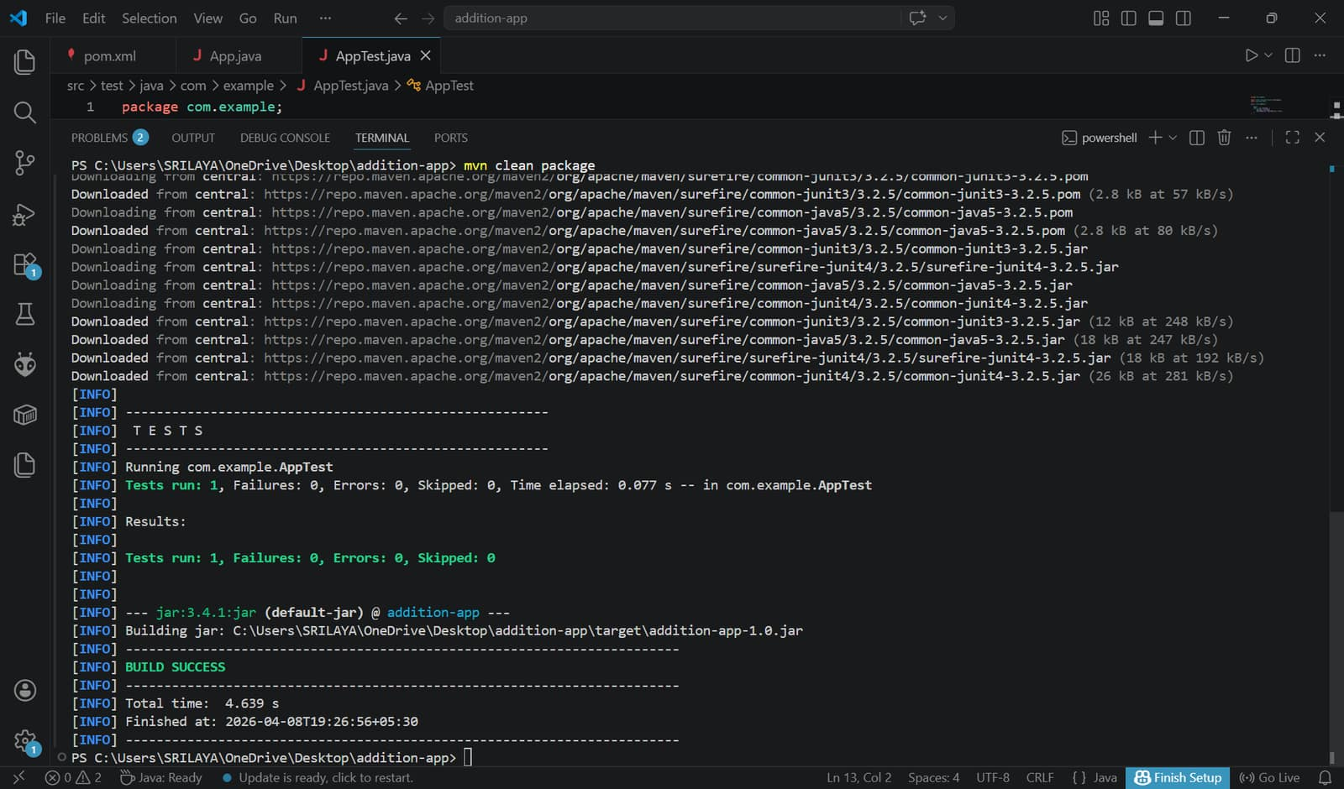
Create git repo, then in terminal
git init
git add .
git commit -m "first commit"
git branch -M main
git remote add origin https://github.com/Srilaya18/add.git
git push -u origin main
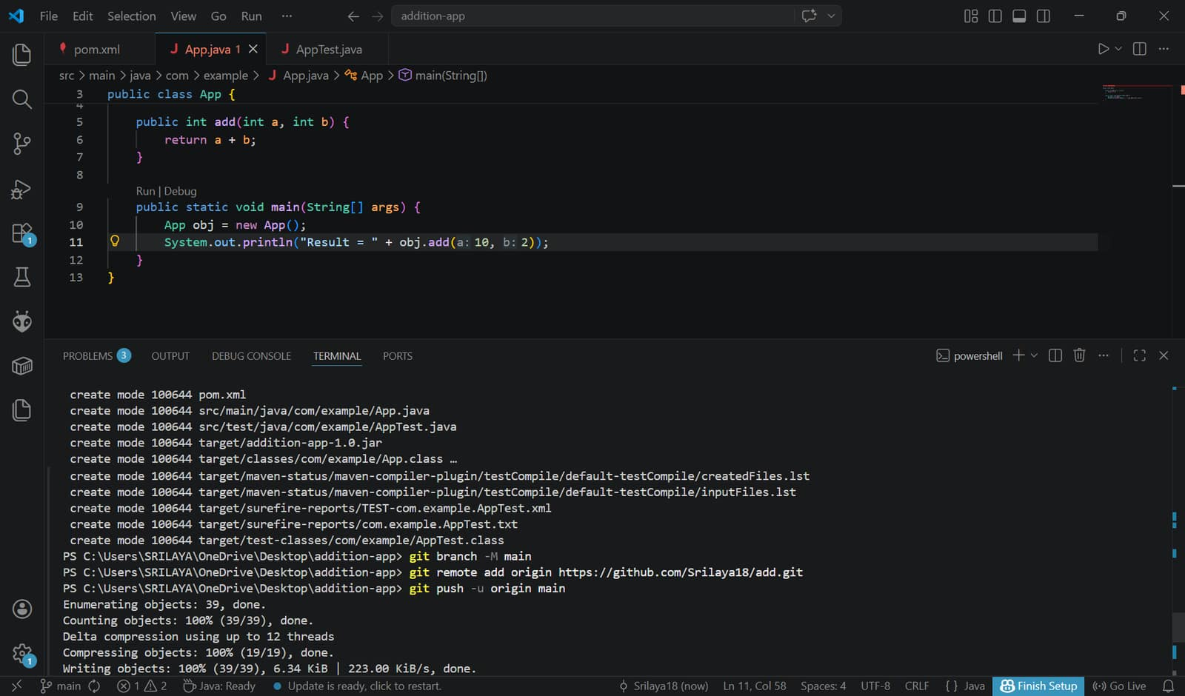

Modify Code & Commit Again
In App.java -> System.out.println("Result = " + obj.add(10, 2));
git add .
git commit -m "Updated addition"
git push
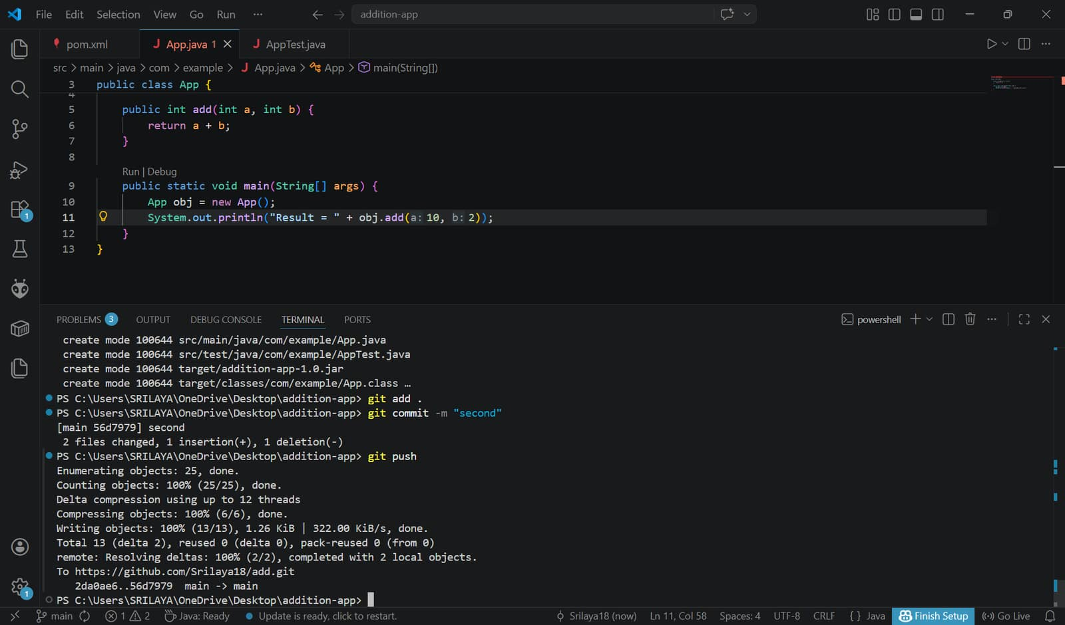

Create pipeline and script
pipeline {
agent any
stages {
stage('Clone') {
steps {
git branch: 'main',
url: 'https://github.com/Srilaya18/add' //our git repo
}
}
stage('Build') {
steps {
bat 'mvn clean package'
}
}
stage('Test') {
steps {
bat 'mvn test'
}
}
}
}
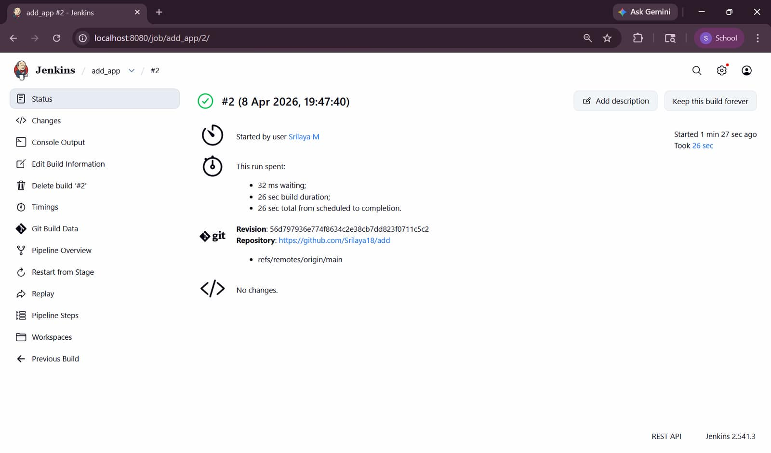

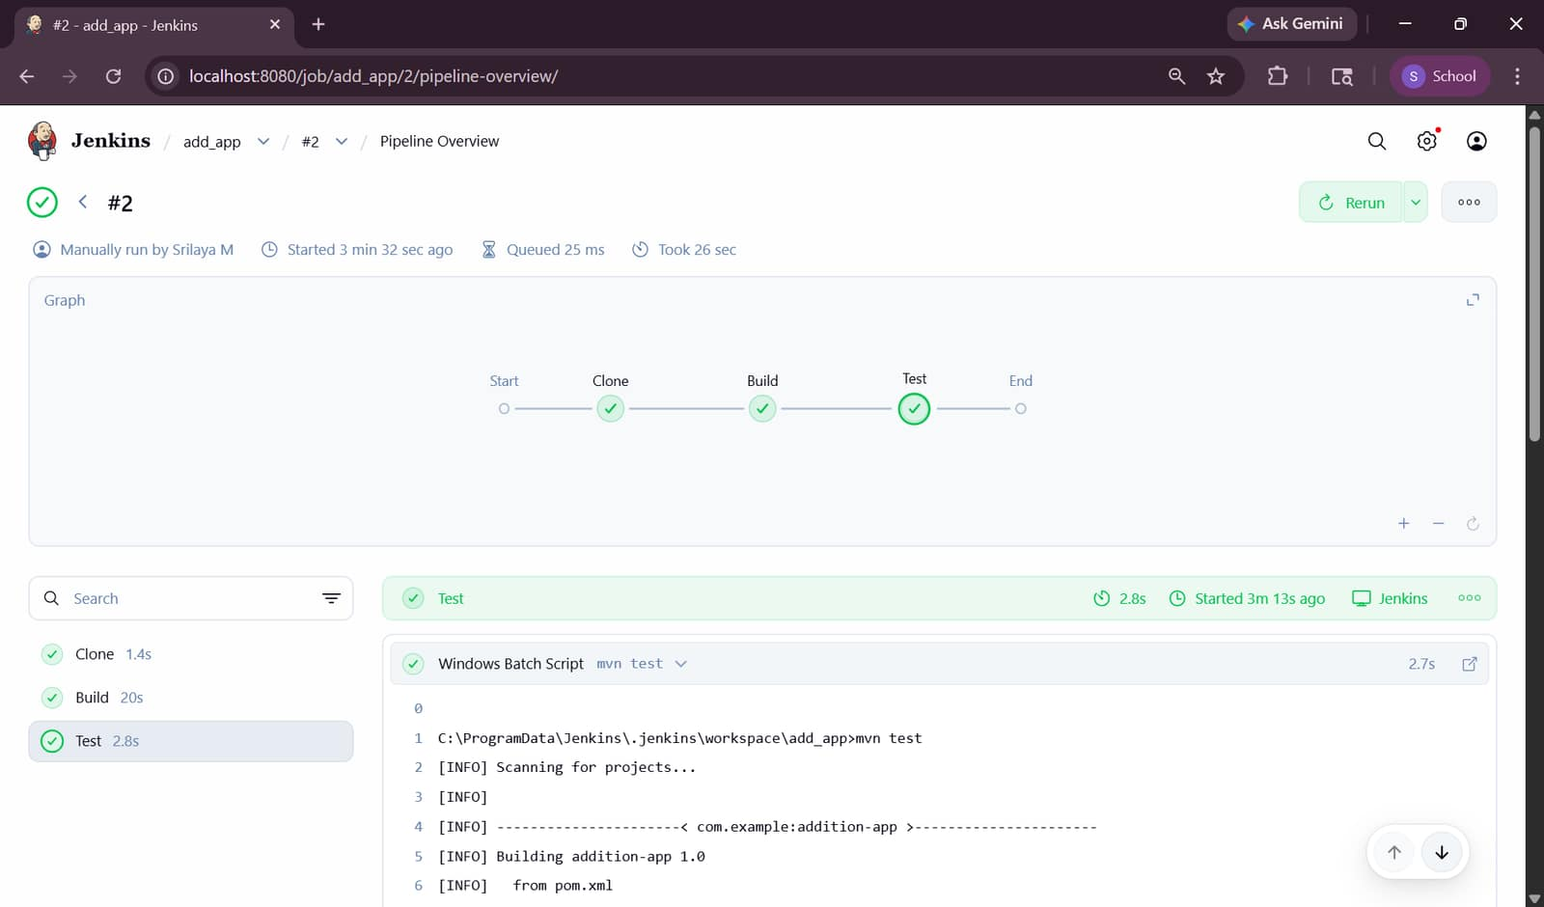

Create Dockerfile
FROM eclipse-temurin:17-jdk
WORKDIR /app
COPY target/addition-app-1.0.jar app.jar
CMD ["java", "-jar", "app.jar"]

Commit Again
git add .
git commit -m "Updated"
git push

Update the pipeline script completely
pipeline {
agent any
stages {
stage('Clone') {
steps {
git branch: 'main',
url: 'https://github.com/Srilaya18/add' //git repo
}
}
stage('Build') {
steps {
bat 'mvn clean package'
}
}
stage('Test') {
steps {
bat 'mvn test'
}
}
stage('Docker Build') {
steps {
bat 'docker build -t addition-app .'
}
}
}
}
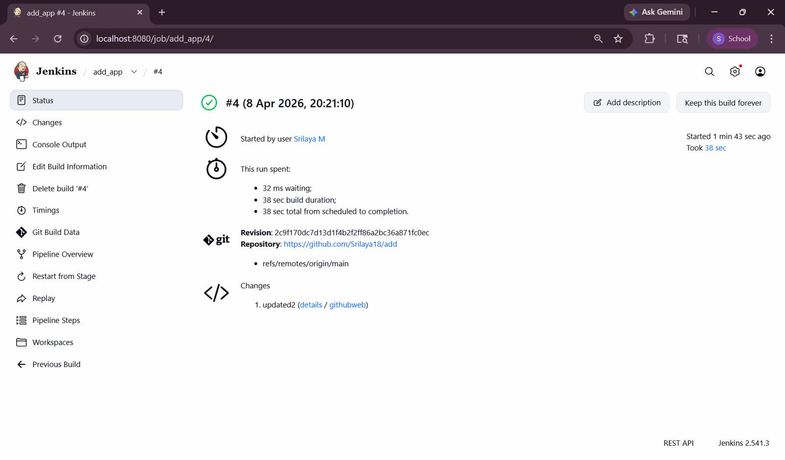
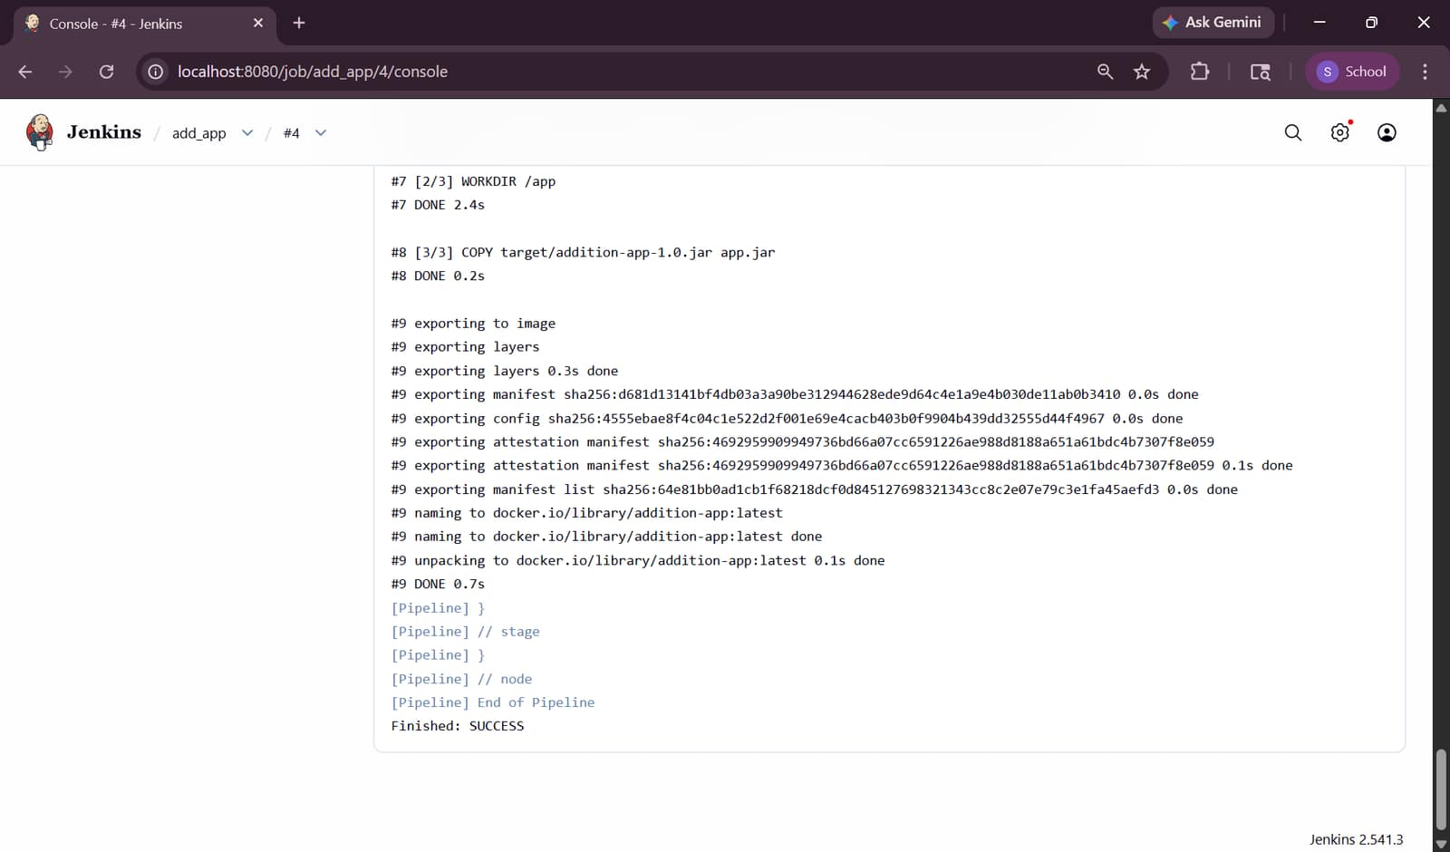
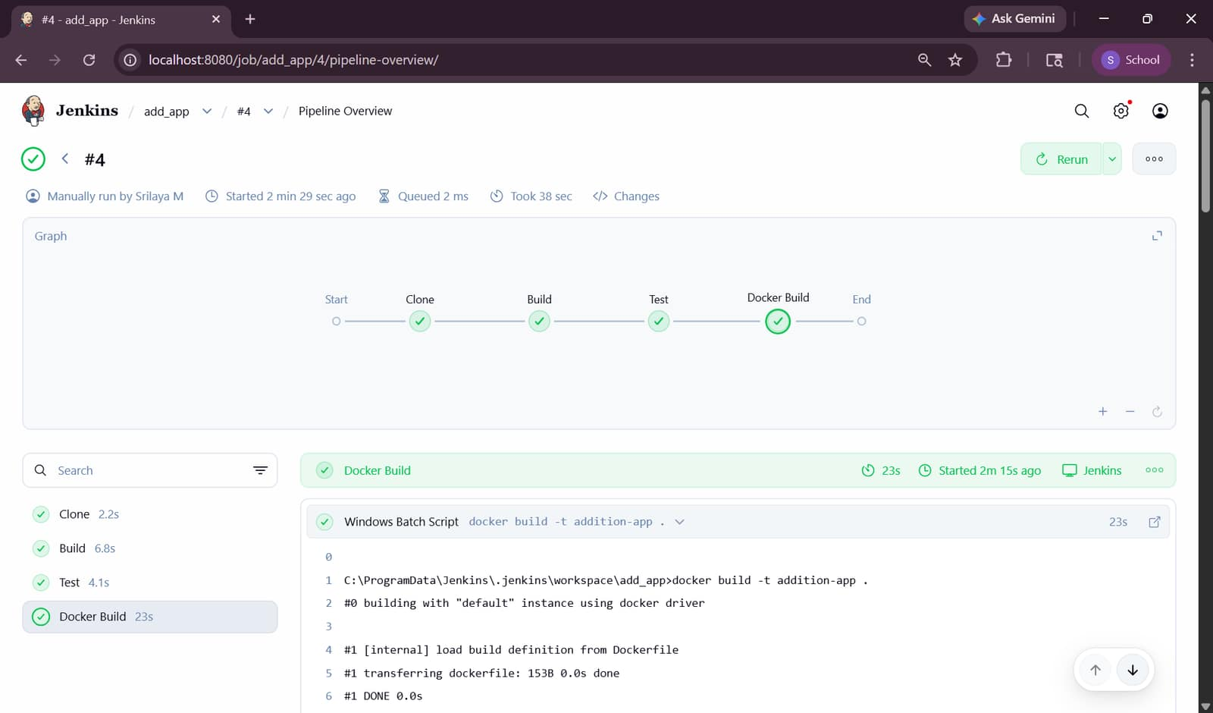
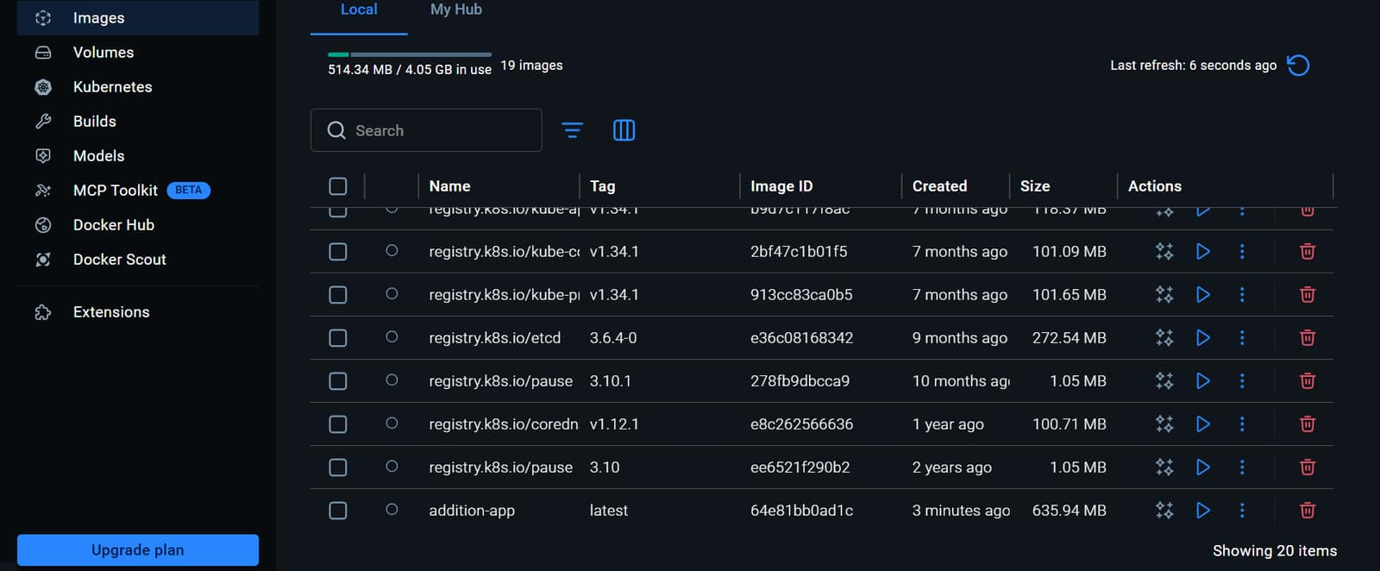
b. Evenodd numbers
App.java
package com.example;

public class App {
public String checkEvenOdd(int num) {
if (num % 2 == 0)
return "Even";
else
return "Odd";
}
public static void main(String[] args) {
App obj = new App();
System.out.println(obj.checkEvenOdd(4));
}
}
AppTest.java
package com.example;
import static org.junit.Assert.assertEquals;
import org.junit.Test;
public class AppTest {
@Test
public void testEvenOdd() {
App obj = new App();
assertEquals("Even", obj.checkEvenOdd(4));
}
}
c. Multiplication
App.java
package com.example;
public class App {
public int multiply(int a, int b) {
return a * b;
}
public static void main(String[] args) {
App obj = new App();
System.out.println("Result = " + obj.multiply(5, 3));
}
}
AppTest.java
package com.example;
import static org.junit.Assert.assertEquals;
import org.junit.Test;
public class AppTest {
@Test
public void testMultiply() {
App obj = new App();
assertEquals(15, obj.multiply(5, 3));
}
}
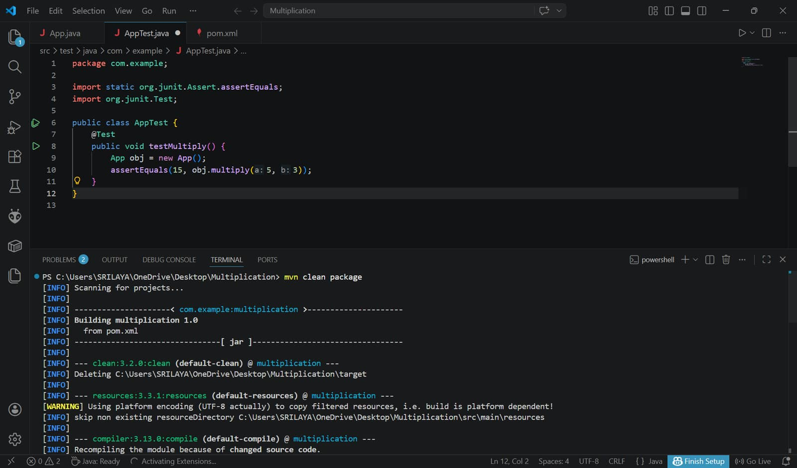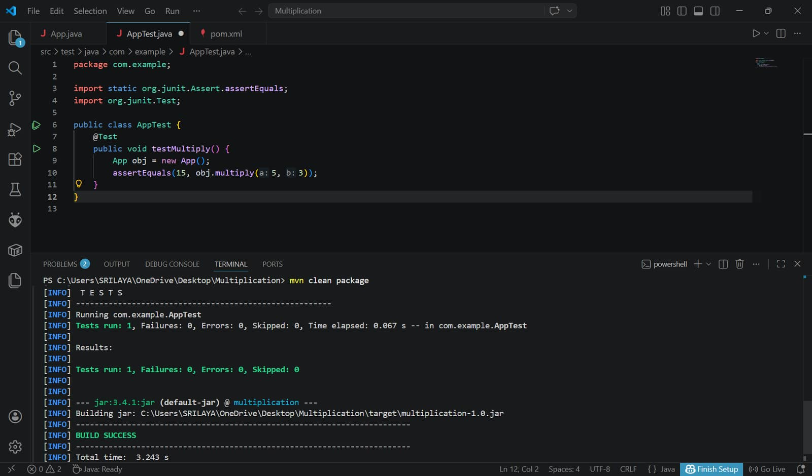
git remote add origin https://github.com/SAITEJASWI2323/multiplication.git
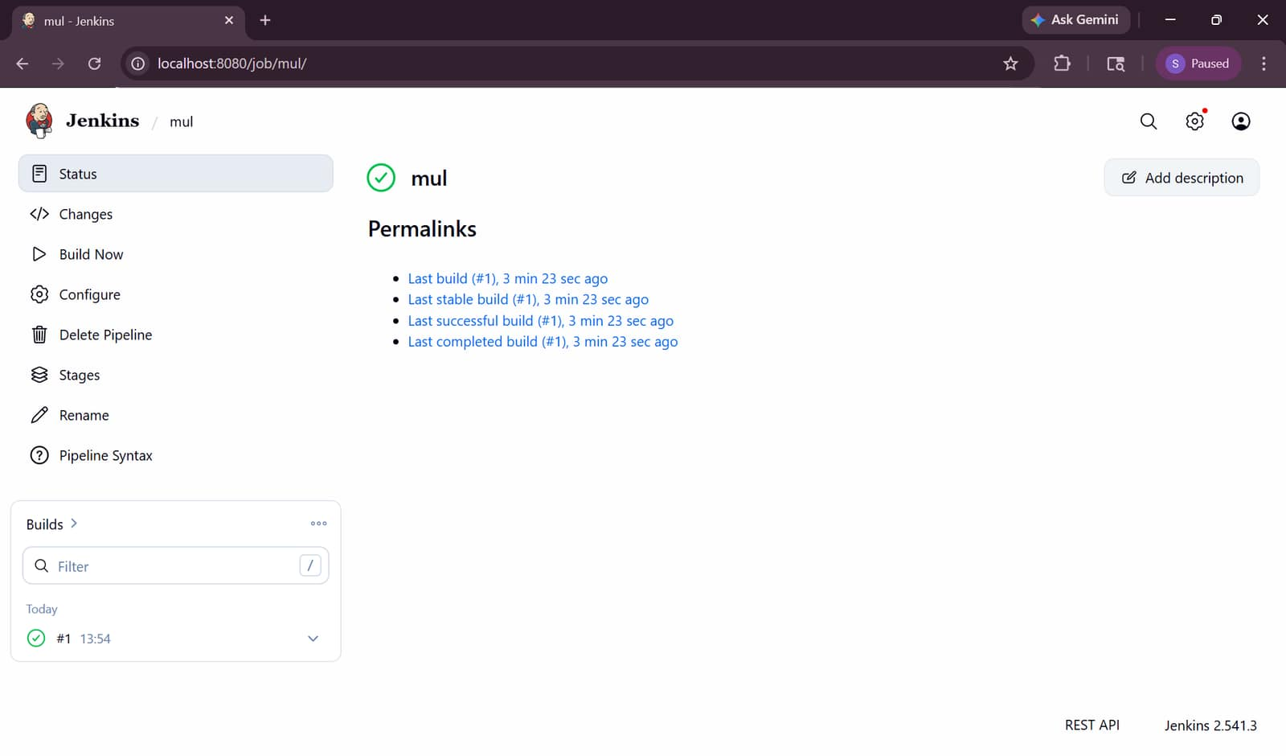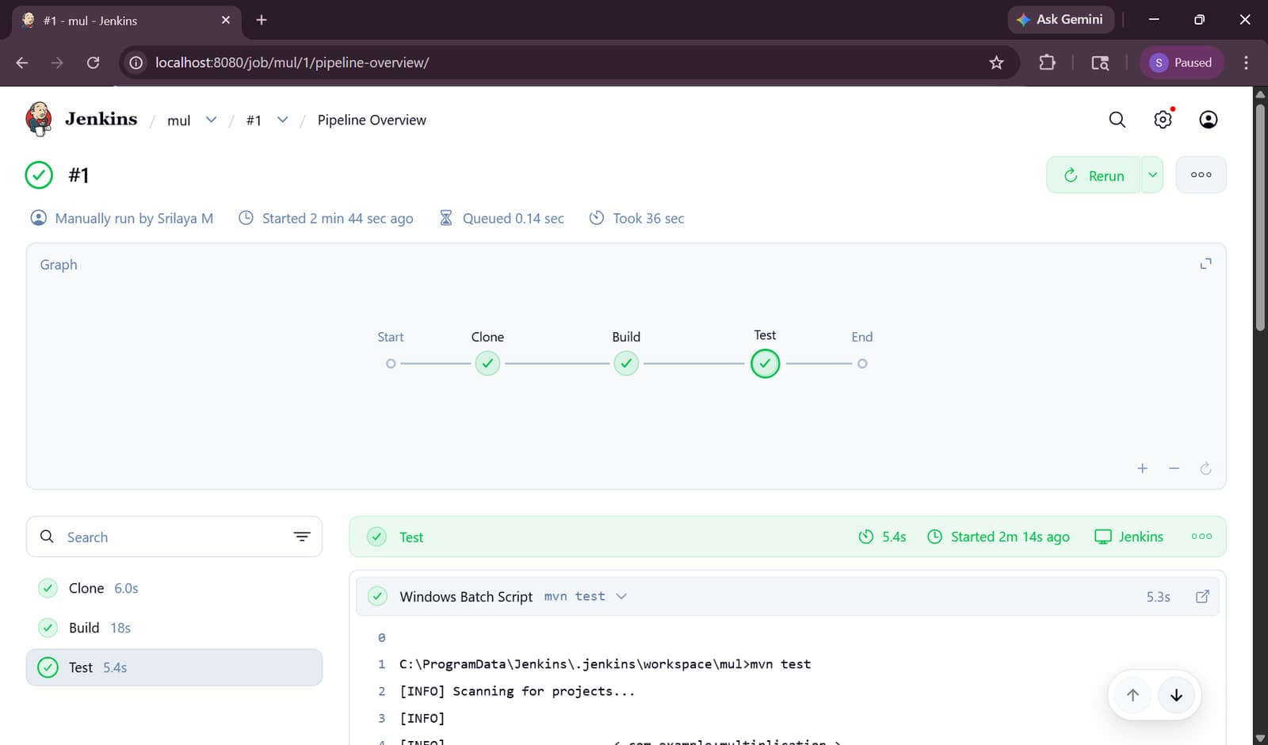
After second pipeline
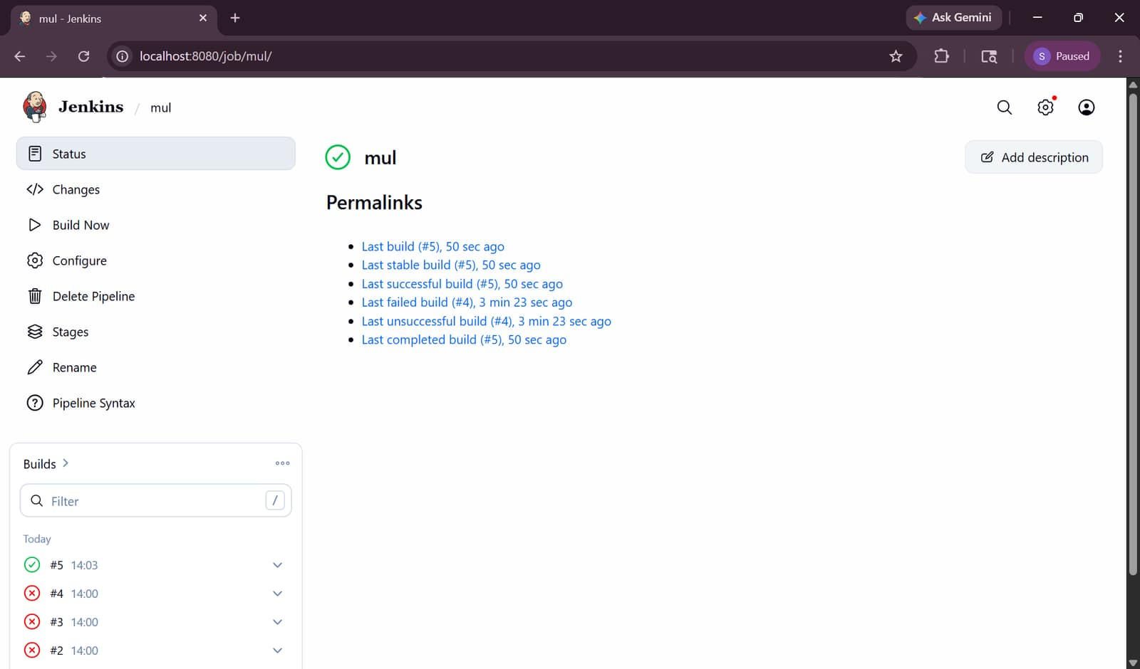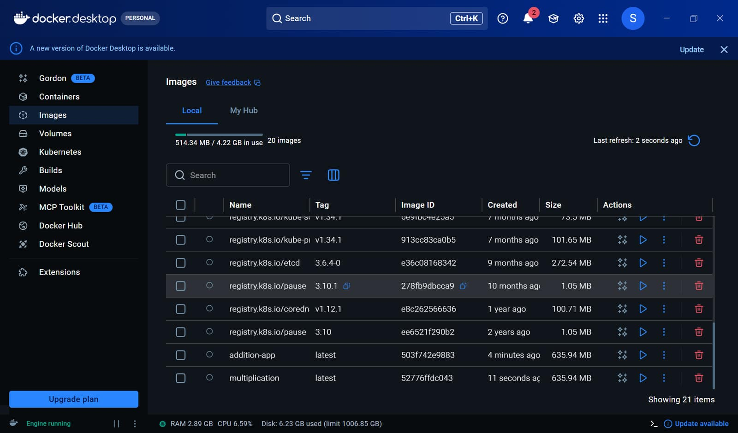
d. Factorial of the given numbers
App.java
package com.example;
public class App {
public int factorial(int n) {
int fact = 1;
for (int i = 1; i <= n; i++) {
fact = fact * i;
}
return fact;
}
public static void main(String[] args) {
App obj = new App();
System.out.println("Result = " + obj.factorial(5));
}
}
AppTest.java
package com.example;
import static org.junit.Assert.assertEquals;
import org.junit.Test;
public class AppTest {
@Test
public void testFactorial() {
App obj = new App();
assertEquals(120, obj.factorial(5));
}
}
e. Prime number.
App.java
package com.example;
public class App {
public boolean isPrime(int n) {
if (n <= 1)
return false;
for (int i = 2; i < n; i++) {
if (n % i == 0)
return false;
}
return true;
}
public static void main(String[] args) {
App obj = new App();
System.out.println(obj.isPrime(7));
}
}
AppTest.java
package com.example;
import static org.junit.Assert.assertEquals;
import org.junit.Test;
public class AppTest {
@Test
public void testPrime() {
App obj = new App();
assertEquals(true, obj.isPrime(7));
}
}

2. Simple Static Web page.
TASK : CI and CD
• Write the code in Visual Studio and push it to your GITHUB repository.
• Modify the code and commit the updates back in GITHUB.
• Using Jenkins configure the job as pipeline and create the stages for the CI and CD process.
• Containerize the application using Dockerfile and display the stages in stage view in Jenkins.
• Create kubernetes cluster and visualize the deployment in the given node port.

a. The student results
Open vscode -> folder student-results
Create index.html
<!DOCTYPE html>
<html>
<head>
<title>Student Results</title>
<style>
body {
font-family: Arial;
text-align: center;
background-color: #f2f2f2;
}
table {
margin: auto;
border-collapse: collapse;
width: 60%;
}
th, td {
border: 1px solid black;
padding: 10px;
}
th {
background-color: #4CAF50;
color: white;
}
</style>
</head>
<body>
<h1>Student Results</h1>
<table>
<tr>
<th>Name</th>
<th>Subject</th>
<th>Marks</th>
<th>Grade</th>
</tr>
<tr>
<td>Srilaya</td>
<td>Maths</td>
<td>90</td>
<td>A</td>
</tr>
<tr>
<td>Rahul</td>
<td>Science</td>
<td>85</td>
<td>A</td>
</tr>
<tr>
<td>Anu</td>
<td>English</td>
<td>78</td>
<td>B</td>
</tr>
</table>
</body>
</html>
Open in browser and check locally
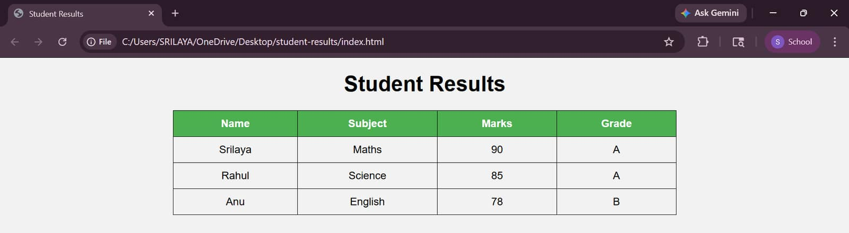
Create repo and push to it
git init
git add .
git commit -m "first commit"
git branch -M main
git remote add origin https://github.com/Srilaya18/student.git
git push -u origin main
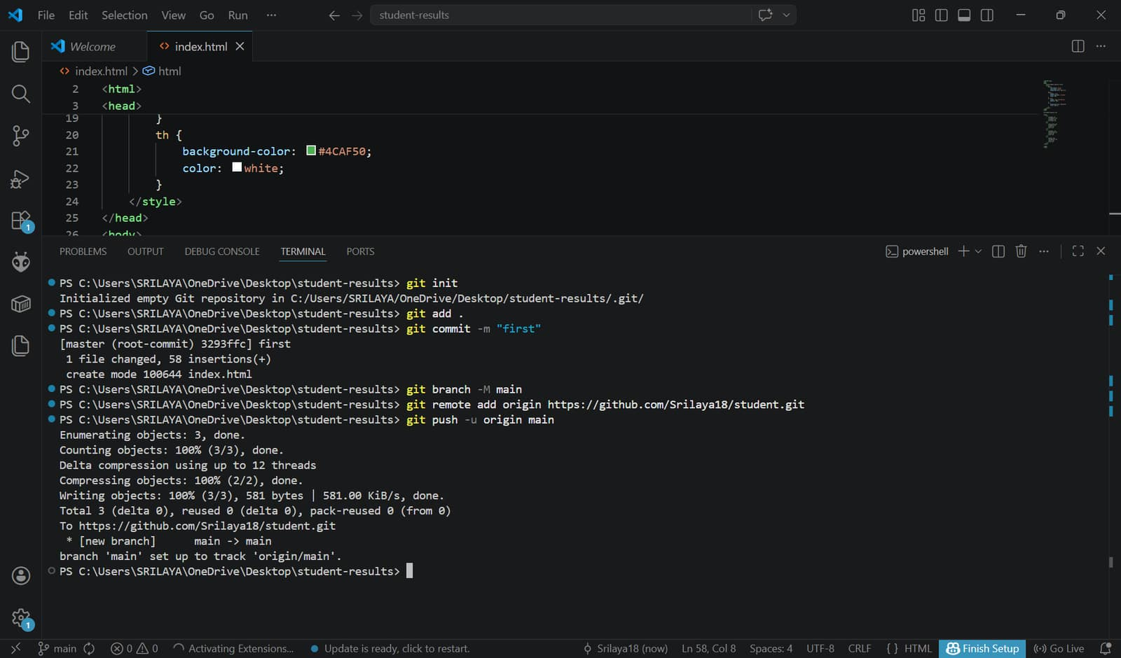

Create Dockerfile
FROM nginx:latest
COPY index.html /usr/share/nginx/html/index.html
EXPOSE 80

Create deployment.yaml
apiVersion: apps/v1
kind: Deployment
metadata:
name: student-results
spec:
replicas: 2
selector:
matchLabels:
app: student-results
template:
metadata:
labels:
app: student-results
spec:
containers:
- name: student-results
image: srilayam/student-results:latest # ⚠️ MUST match DockerHub image
ports:
- containerPort: 80
--- # ⚠️ IMPORTANT: YOU MISSED THIS LINE (VERY IMPORTANT)
apiVersion: v1
kind: Service
metadata:
name: student-service
spec:
type: NodePort
selector:
app: student-results
ports:
- port: 80
targetPort: 80
nodePort: 30007

Push to git again
git add .
git commit -m "Added Dockerfile and Kubernetes config"
git push
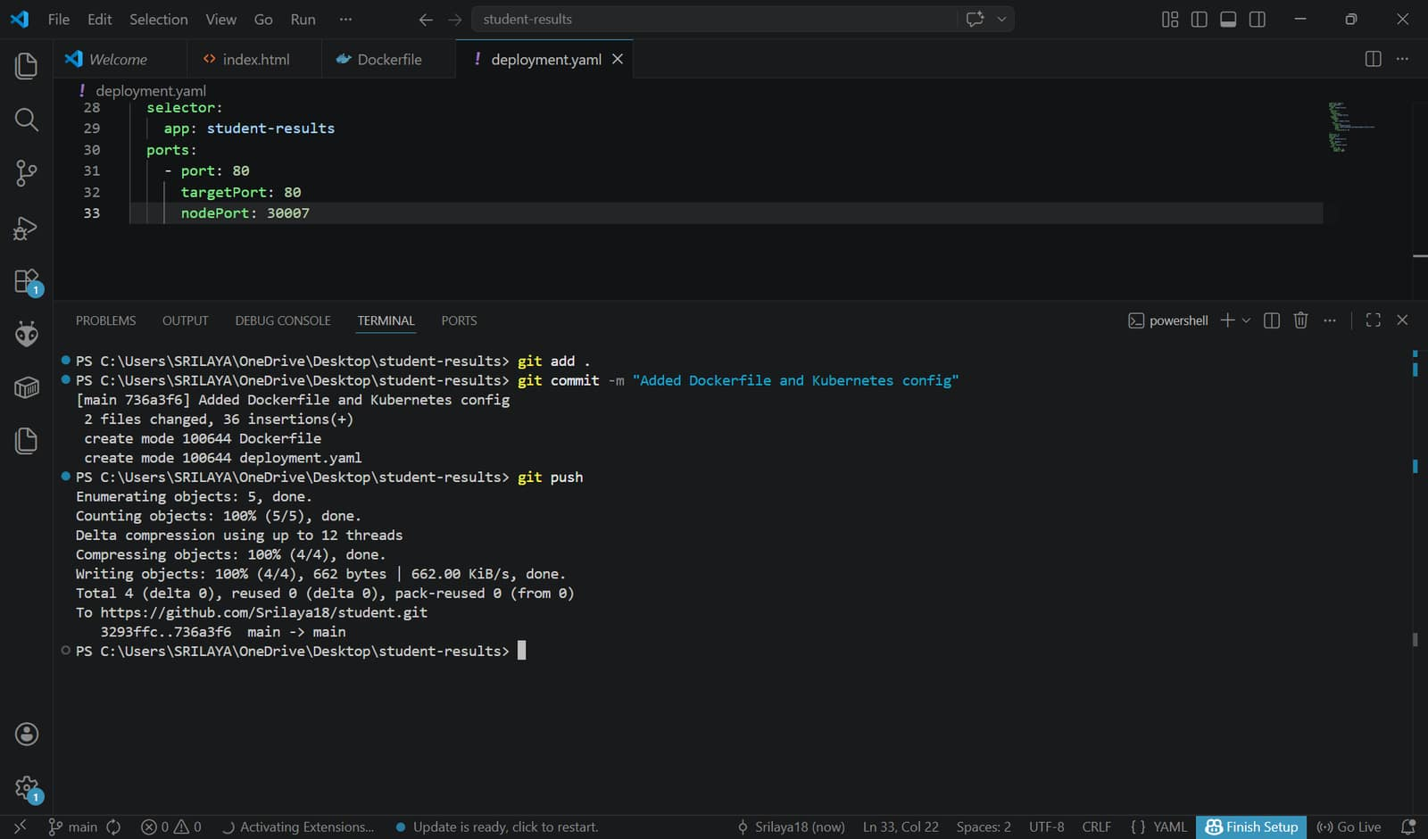

Install Kubernetes CLI plugin, Docker and Docker Pipeline
Steps
Manage Jenkins - Credentials - (System) -Global credentials (unrestricted) - Add Credentials
Fill like this:
Kind: Username with password
Scope: Global
Username: srilayam
Password: sridocker@123
ID: dockerhub-creds
Description: DockerHub Login

Create pipeline and add script
pipeline {
agent any
environment {
DOCKER_IMAGE = "srilayam/student-results:latest" //add docker username
}
stages {
stage('Clone Code') {
steps {
git branch: 'main',
url: 'https://github.com/Srilaya18/student.git' //repo link change
}
}
stage('Build Docker Image') {
steps {
bat 'docker build -t %DOCKER_IMAGE% .'
}
}
stage('Push Image') {
steps {
withCredentials([usernamePassword(
credentialsId: 'dockerhub-creds',
usernameVariable: 'USER',
passwordVariable: 'PASS'
)]) {
bat 'docker login -u %USER% -p %PASS%'
bat 'docker push %DOCKER_IMAGE%'
}
}
}
stage('Deploy to Kubernetes') {
steps {
bat 'kubectl apply -f deployment.yaml'
}
}
}
post {
success {
echo 'CI/CD Pipeline executed successfully!'
}
failure {
echo 'Pipeline failed. Please check logs.'
}
}
}
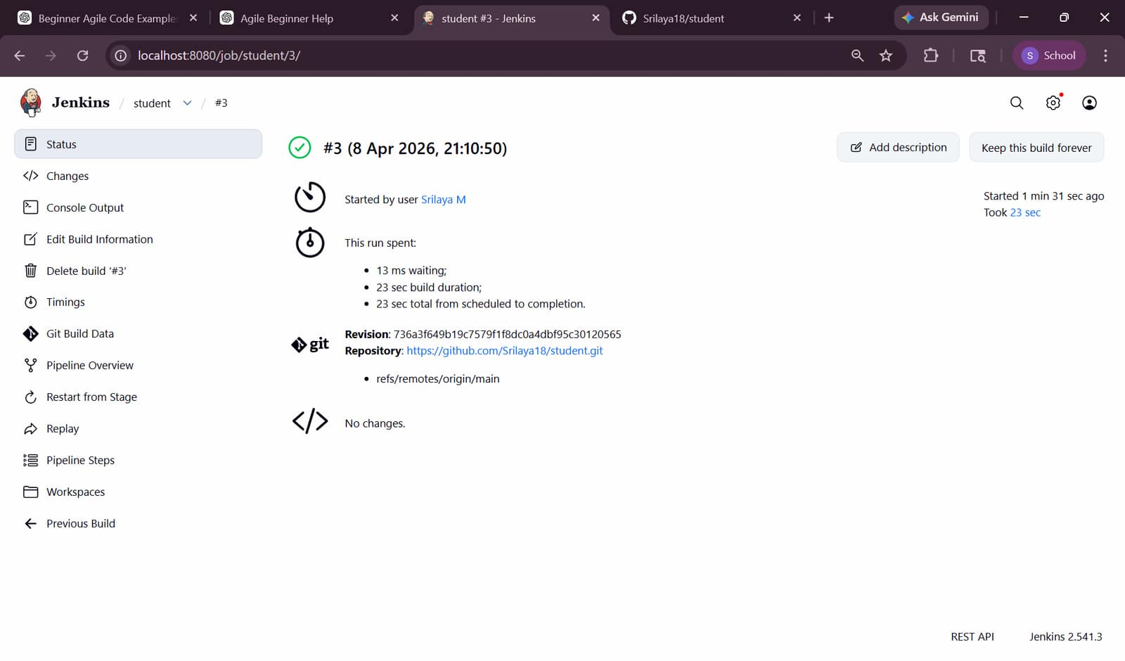
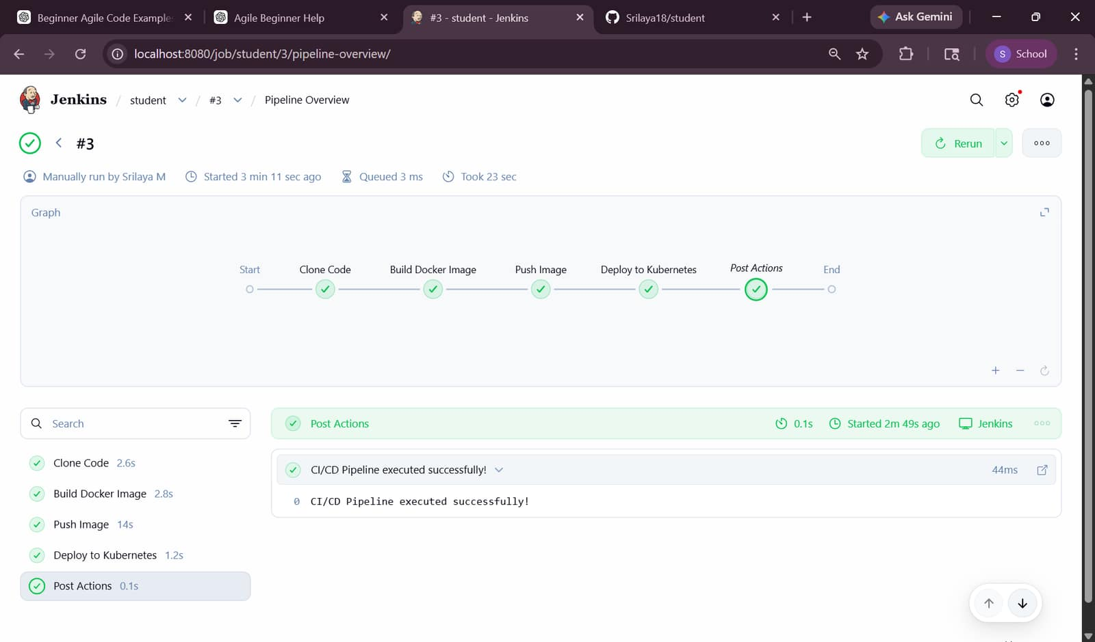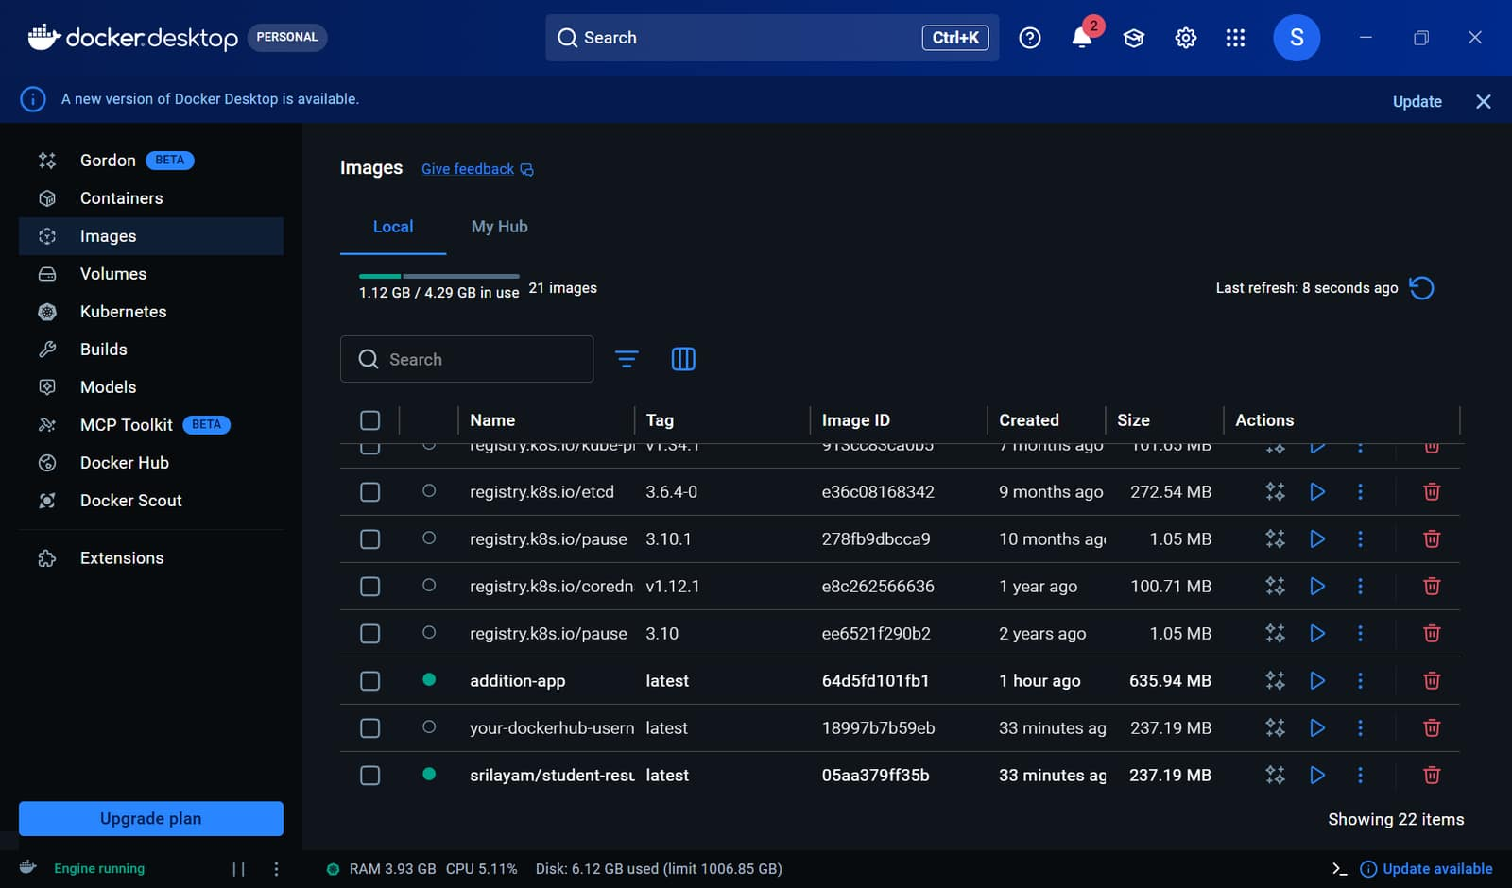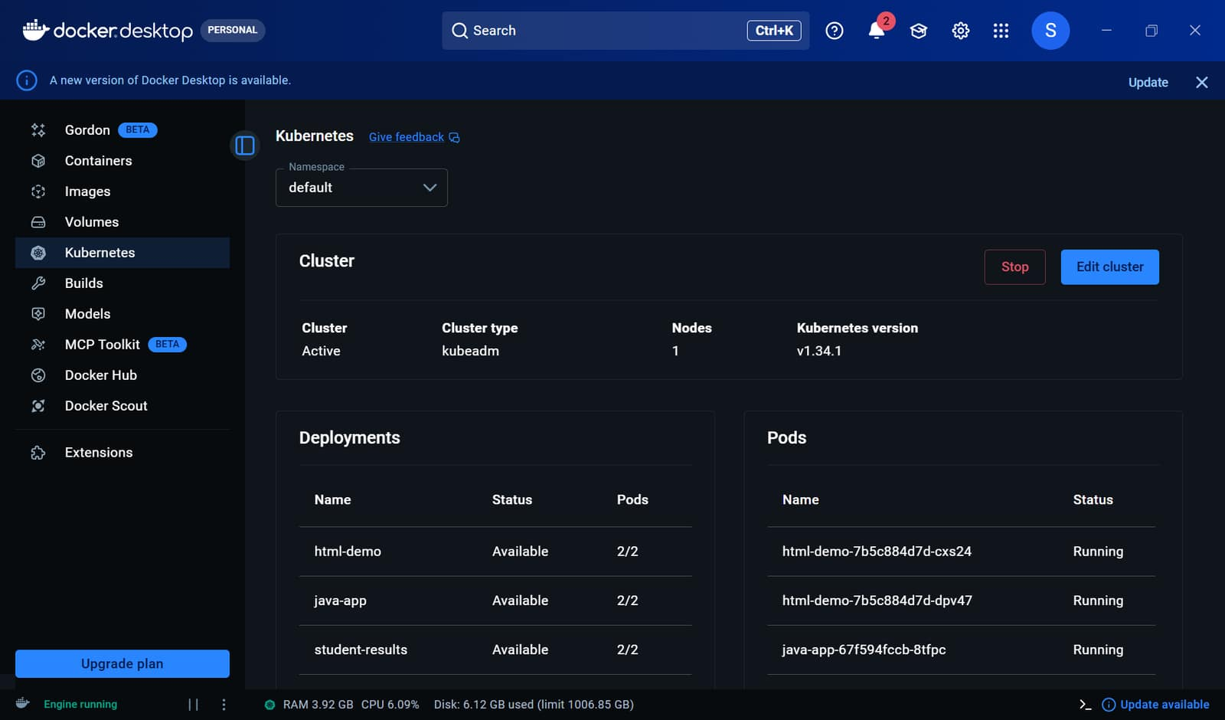
In terminal
Check pods- kubectl get pods (must get 1/1 then only working)
Check service- kubectl get svc
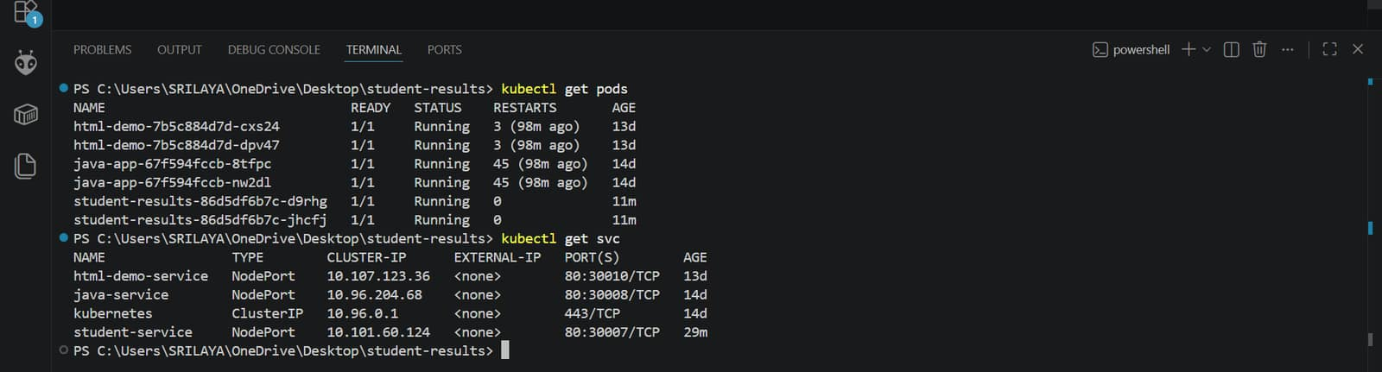
Website link is- http://localhost:30007
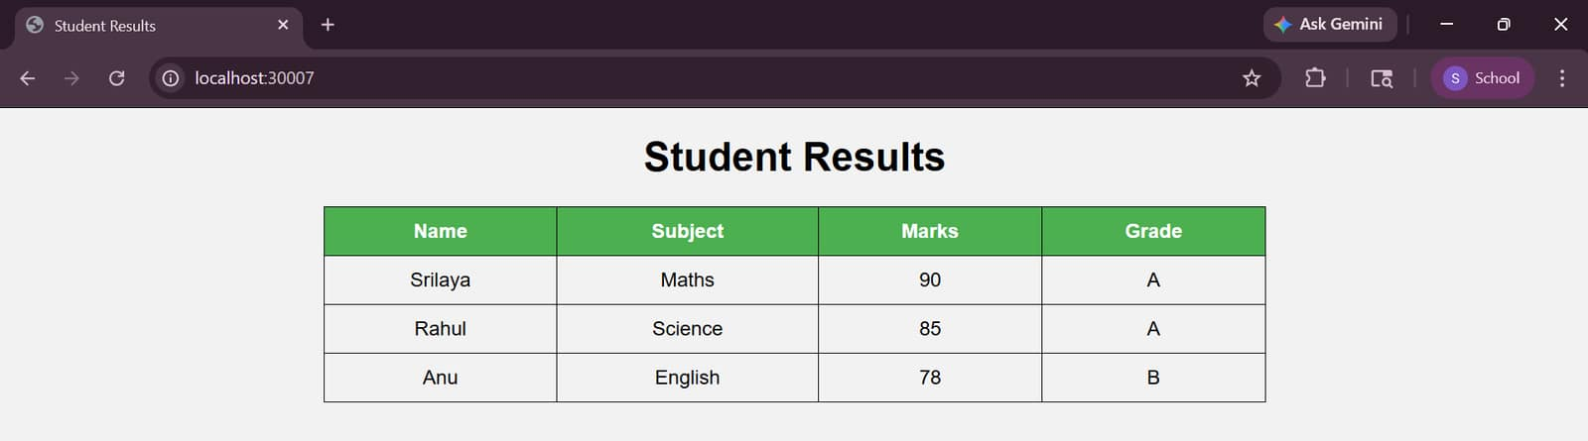

b. Create some five events during Rivera.
Open vscode -> folder rivera-events
Create index.html
<!DOCTYPE html>
<html>
<head>
<title>Rivera Events</title>
<style>
body {
font-family: Arial;
text-align: center;
background-color: #f2f2f2;
}
table {
margin: auto;
border-collapse: collapse;
width: 70%;
}
th, td {
border: 1px solid black;
padding: 10px;
}
th {
background-color: #2196F3;
color: white;
}
</style>
</head>
<body>
<h1>Rivera Events</h1>
<table>
<tr>
<th>Event Name</th>
<th>Category</th>
<th>Date</th>
</tr>
<tr>
<td>Dance Battle</td>
<td>Cultural</td>
<td>10 March</td>
</tr>
<tr>
<td>Hackathon</td>
<td>Technical</td>
<td>11 March</td>
</tr>
<tr>
<td>Music Night</td>
<td>Entertainment</td>
<td>12 March</td>
</tr>
<tr>
<td>Photography Contest</td>
<td>Creative</td>
<td>13 March</td>
</tr>
<tr>
<td>Gaming Tournament</td>
<td>Fun</td>
<td>14 March</td>
</tr>
</table>
</body>
</html>
Open in browser and check locally
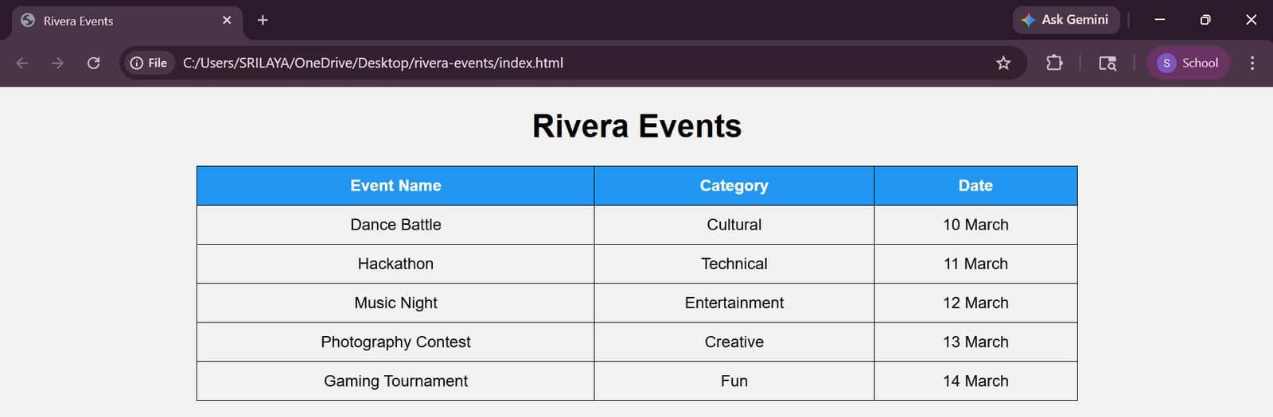

Create repo and push to it
git init
git add .
git commit -m "first commit"
git branch -M main
git remote add origin https://github.com/Srilaya18/rivera.git
git push -u origin main
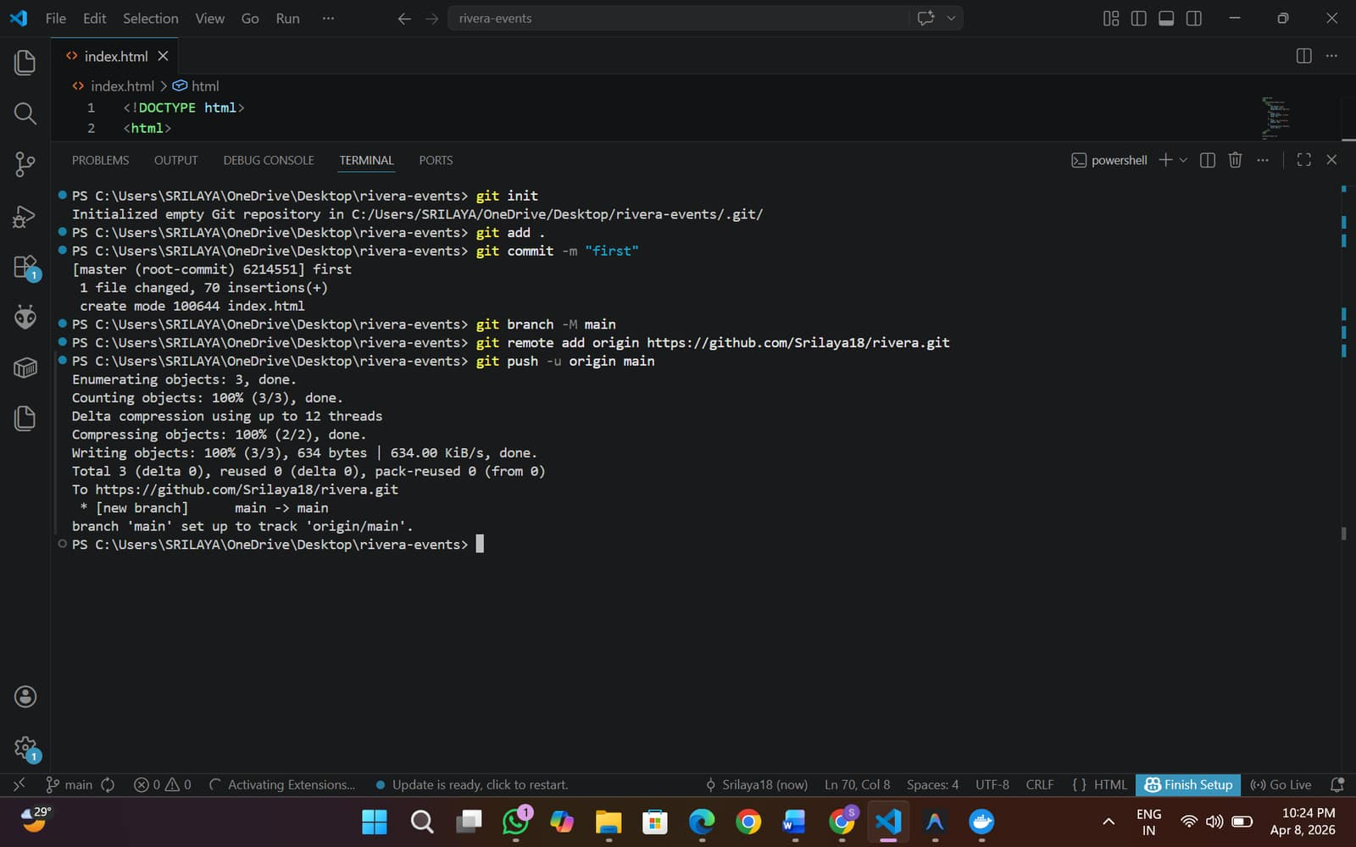

Create Dockerfile
FROM nginx:latest
COPY index.html /usr/share/nginx/html/index.html
EXPOSE 80

Create deployment.yaml
apiVersion: apps/v1
kind: Deployment
metadata:
name: rivera-events
spec:
replicas: 2
selector:
matchLabels:
app: rivera-events
template:
metadata:
labels:
app: rivera-events
spec:
containers:
- name: rivera-events
image: srilayam/rivera-events:latest # ⚠️ change username
ports:
- containerPort: 80

---
apiVersion: v1
kind: Service
metadata:
name: rivera-service
spec:
type: NodePort
selector:
app: rivera-events
ports:
- port: 80
targetPort: 80
nodePort: 30009

Push to git again
git add .
git commit -m "Added Dockerfile and Kubernetes config"
git push
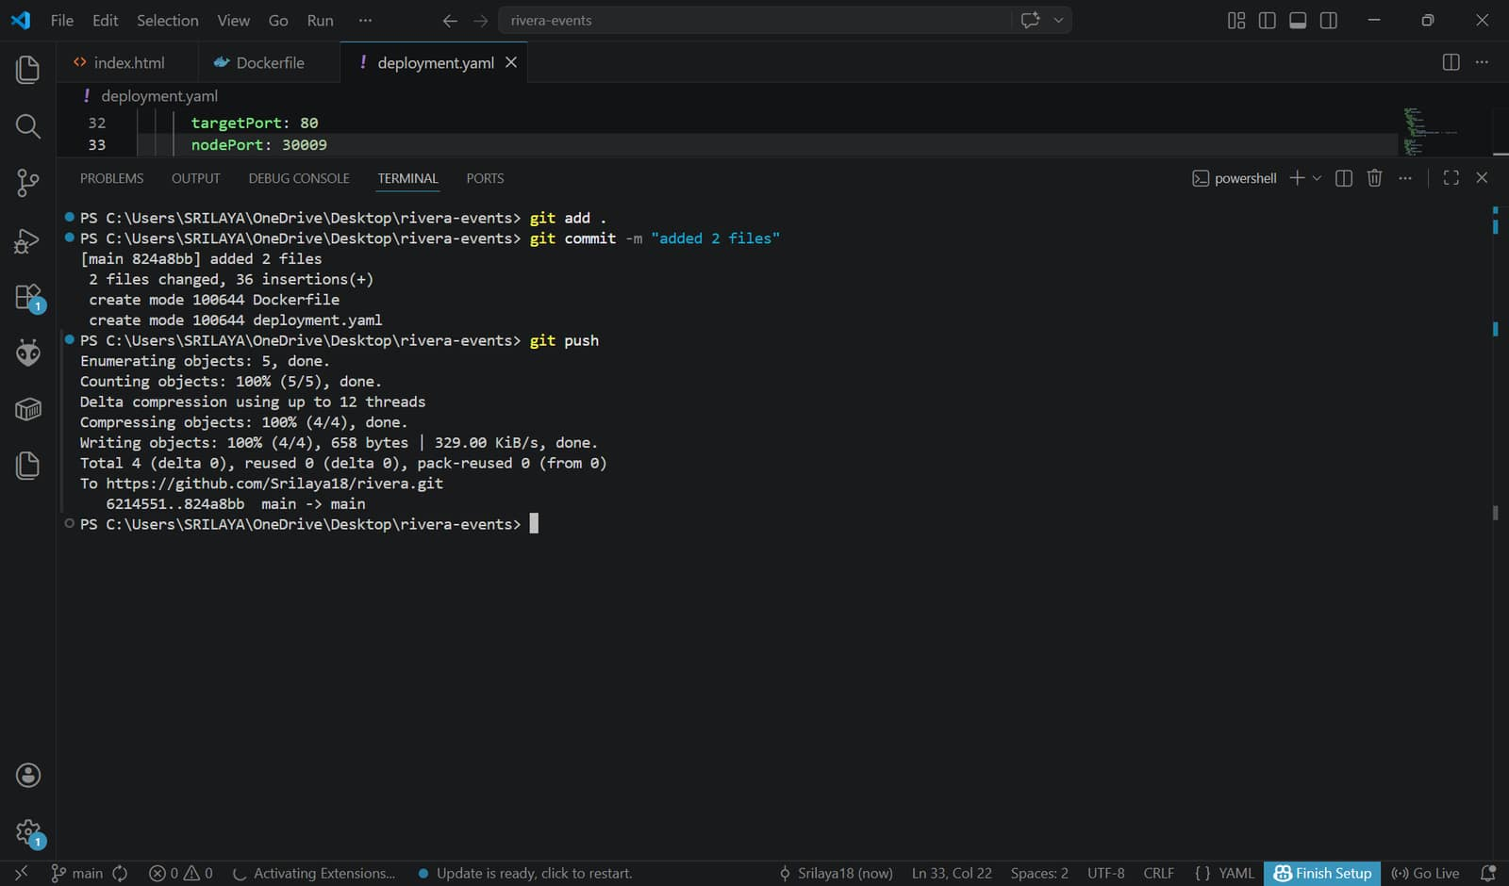

Install Kubernetes CLI plugin, Docker and Docker Pipeline
Steps
Manage Jenkins - Credentials - (System) -Global credentials (unrestricted) - Add Credentials
Fill like this:
Kind: Username with password
Scope: Global
Username: srilayam
Password: sridocker@123
ID: dockerhub-creds
Description: DockerHub Login

Create pipeline and add script
pipeline {
agent any
environment {
DOCKER_IMAGE = "srilayam/rivera-events:latest" //add docker username
}
stages {
stage('Clone Code') {
steps {
git branch: 'main',
url: 'https://github.com/Srilaya18/rivera.git' //repo link change
}
}
stage('Build Docker Image') {
steps {
bat 'docker build -t %DOCKER_IMAGE% .'
}
}
stage('Push Image') {
steps {
withCredentials([usernamePassword(
credentialsId: 'dockerhub-creds',
usernameVariable: 'USER',
passwordVariable: 'PASS'
)]) {
bat 'docker login -u %USER% -p %PASS%'
bat 'docker push %DOCKER_IMAGE%'
}
}
}
stage('Deploy to Kubernetes') {
steps {
bat 'kubectl apply -f deployment.yaml'
}
}
}
post {
success {
echo 'CI/CD Pipeline executed successfully!'
}
failure {
echo 'Pipeline failed. Please check logs.'
}
}
}
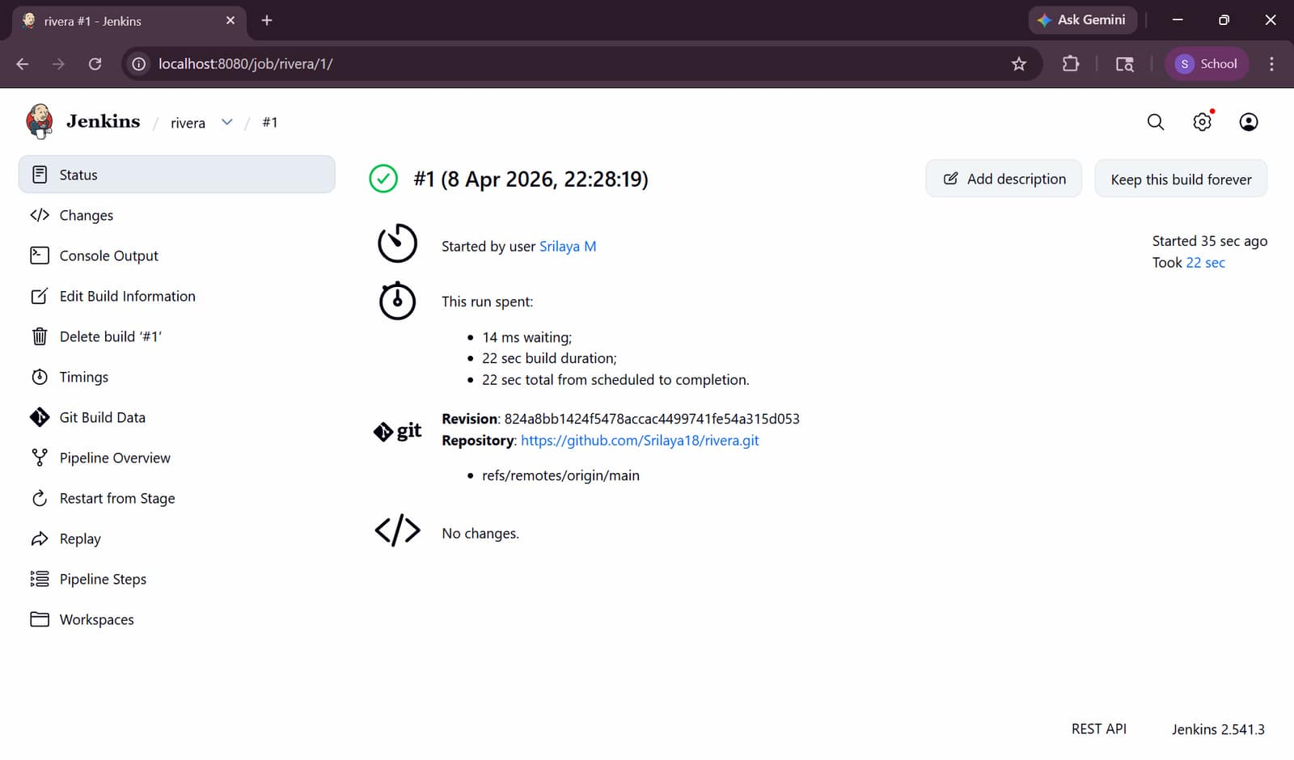
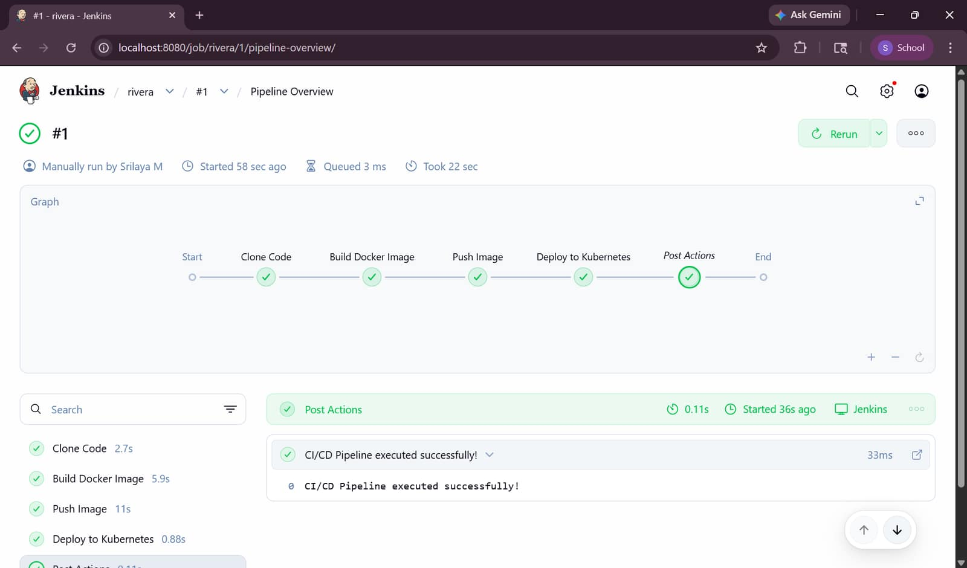
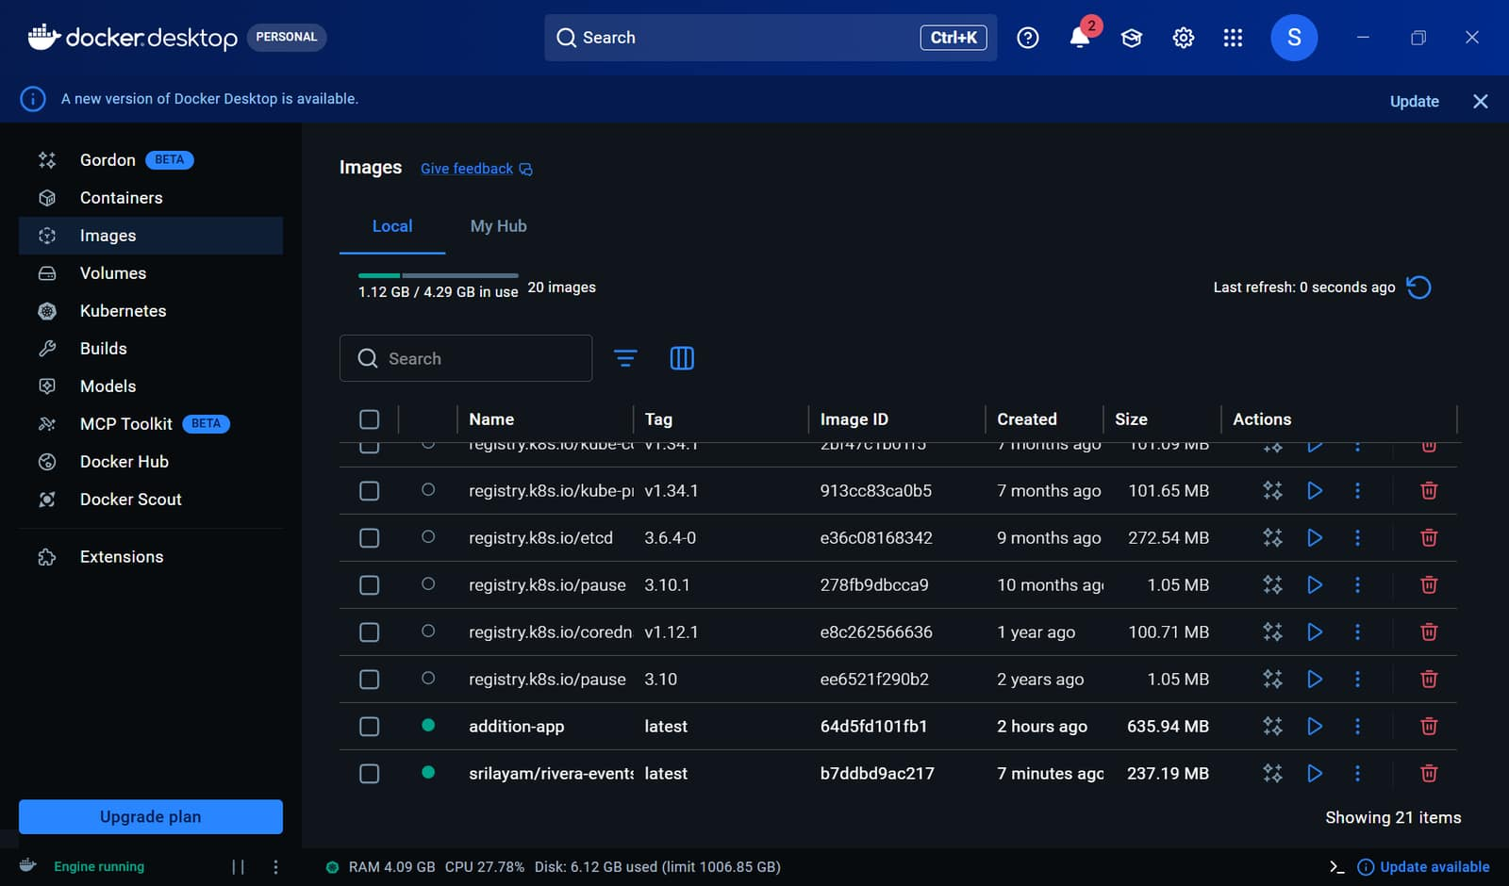

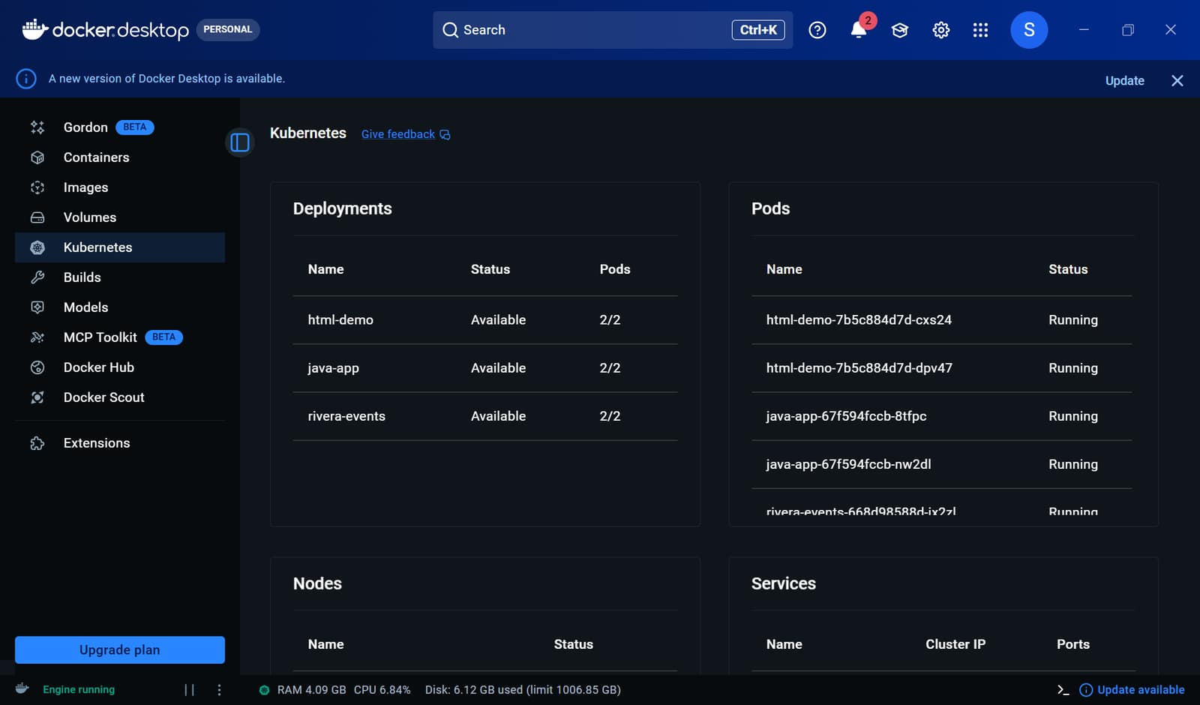
In terminal
Check pods- kubectl get pods (must get 1/1 then only working)
Check service- kubectl get svc
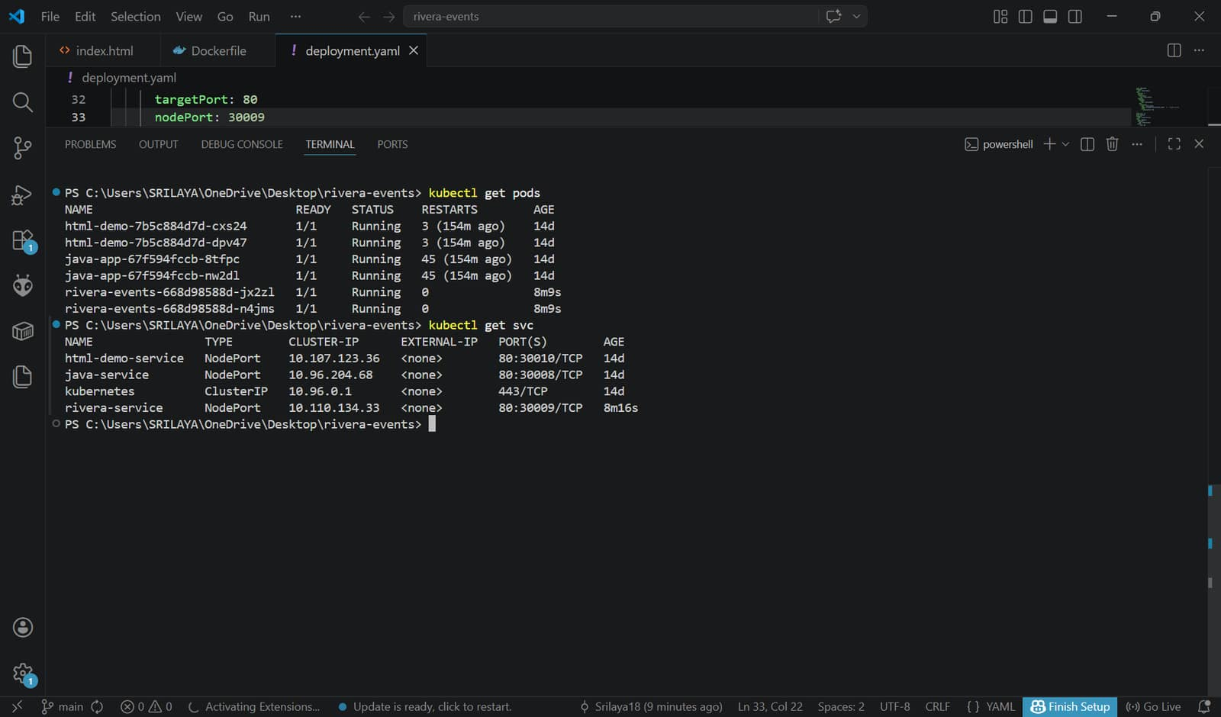
Website link is- http://localhost:30009
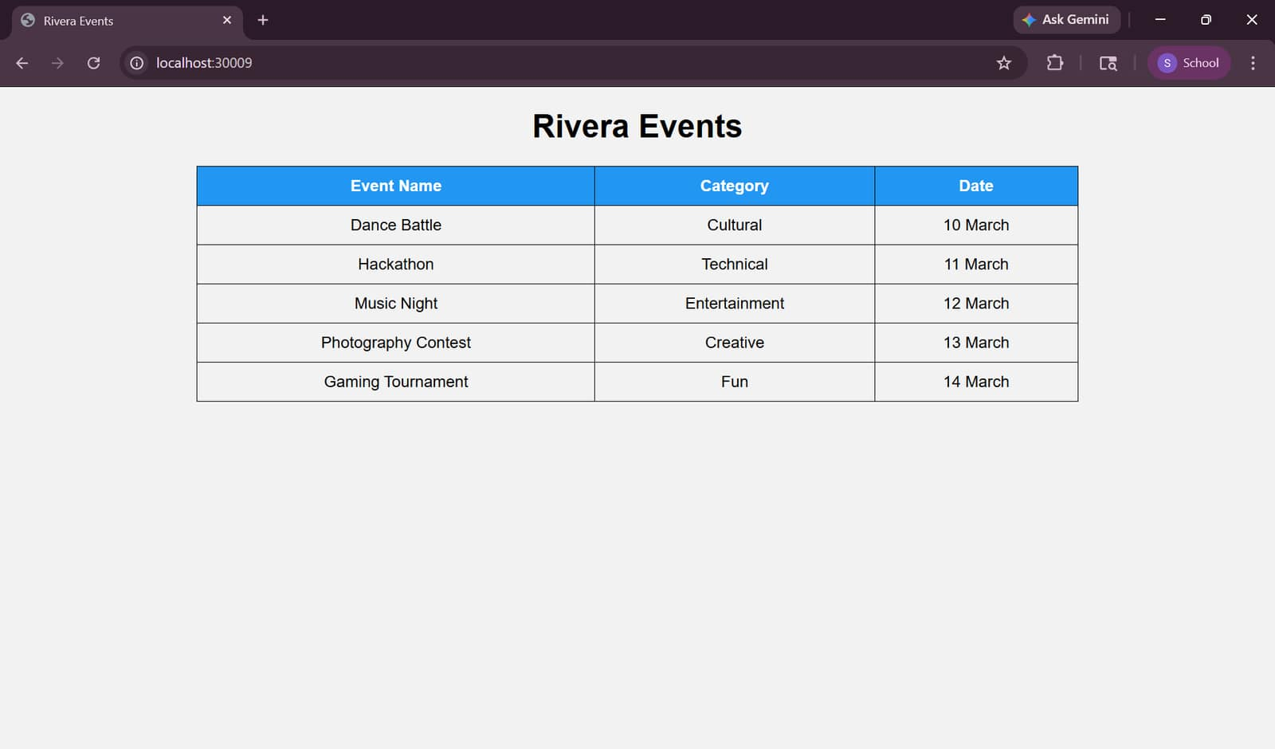

c. The Conference information and its full details.
Open vscode -> folder conference-info
Create index.html
<!DOCTYPE html>
<html>
<head>
<title>Conference Details</title>
<style>
body {
font-family: Arial;
text-align: center;
background-color: #f2f2f2;
}
table {
margin: auto;
border-collapse: collapse;
width: 70%;
}
th, td {
border: 1px solid black;
padding: 10px;
}
th {
background-color: #ff5722;
color: white;
}
</style>
</head>
<body>
<h1>International Tech Conference 2026</h1>
<table>
<tr>
<th>Detail</th>
<th>Information</th>
</tr>
<tr>
<td>Conference Name</td>
<td>International Tech Conference</td>
</tr>
<tr>
<td>Date</td>
<td>20 April 2026</td>
</tr>
<tr>
<td>Location</td>
<td>Chennai, India</td>
</tr>
<tr>
<td>Chief Guest</td>
<td>Dr. A. Kumar</td>
</tr>
<tr>
<td>Topics</td>
<td>AI, Cloud Computing, Cyber Security</td>
</tr>
<tr>
<td>Organized By</td>
<td>XYZ University</td>
</tr>
</table>
</body>
</html>
Open in browser and check locally
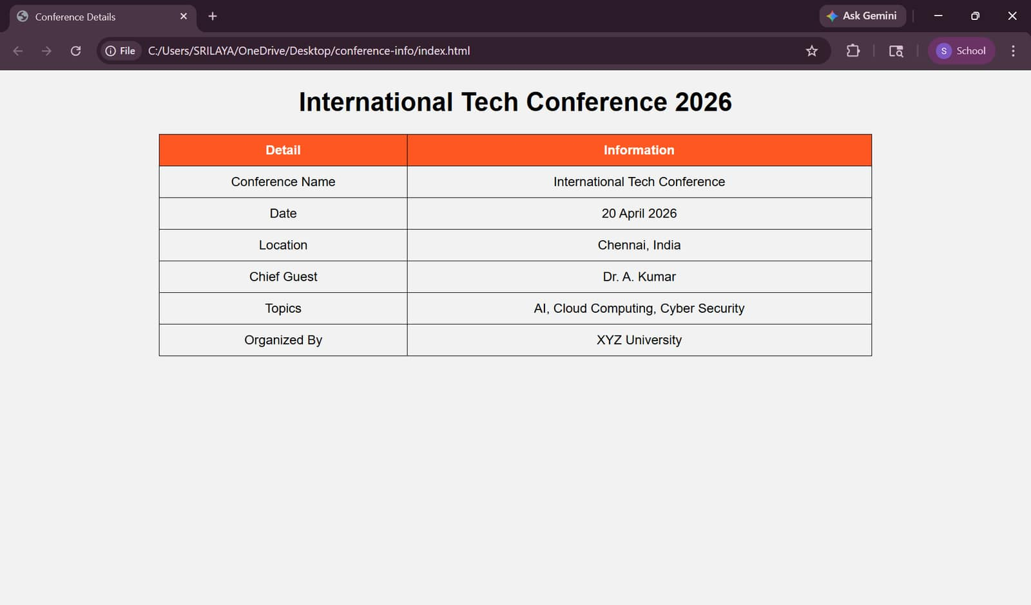

Create repo and push to it
git init
git add .
git commit -m "first commit"
git branch -M main
git remote add origin https://github.com/Srilaya18/conference.git
git push -u origin main
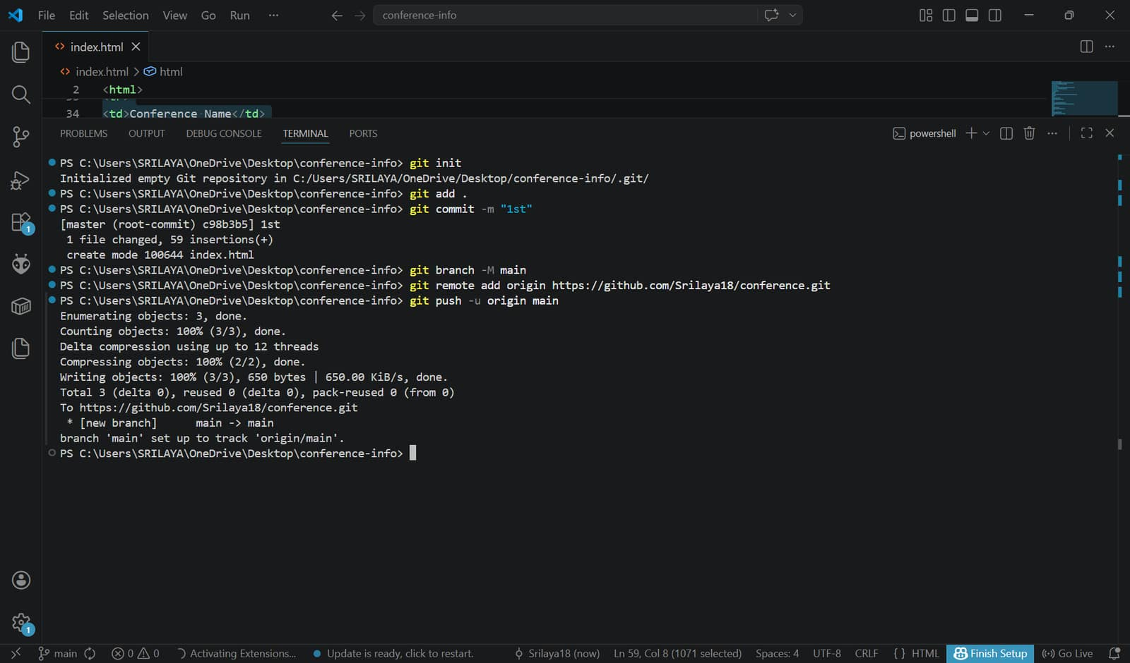

Create Dockerfile
FROM nginx:latest
COPY index.html /usr/share/nginx/html/index.html
EXPOSE 80

Create deployment.yaml
apiVersion: apps/v1
kind: Deployment
metadata:
name: conference-app
spec:
replicas: 2
selector:
matchLabels:
app: conference-app
template:
metadata:
labels:
app: conference-app
spec:
containers:
- name: conference-app
image: srilayam/conference-app:latest # ⚠️ your DockerHub username
ports:
- containerPort: 80

---
apiVersion: v1
kind: Service
metadata:
name: conference-service
spec:
type: NodePort
selector:
app: conference-app
ports:
- port: 80
targetPort: 80
nodePort: 30011

Push to git again
git add .
git commit -m "Added Dockerfile and Kubernetes config"
git push
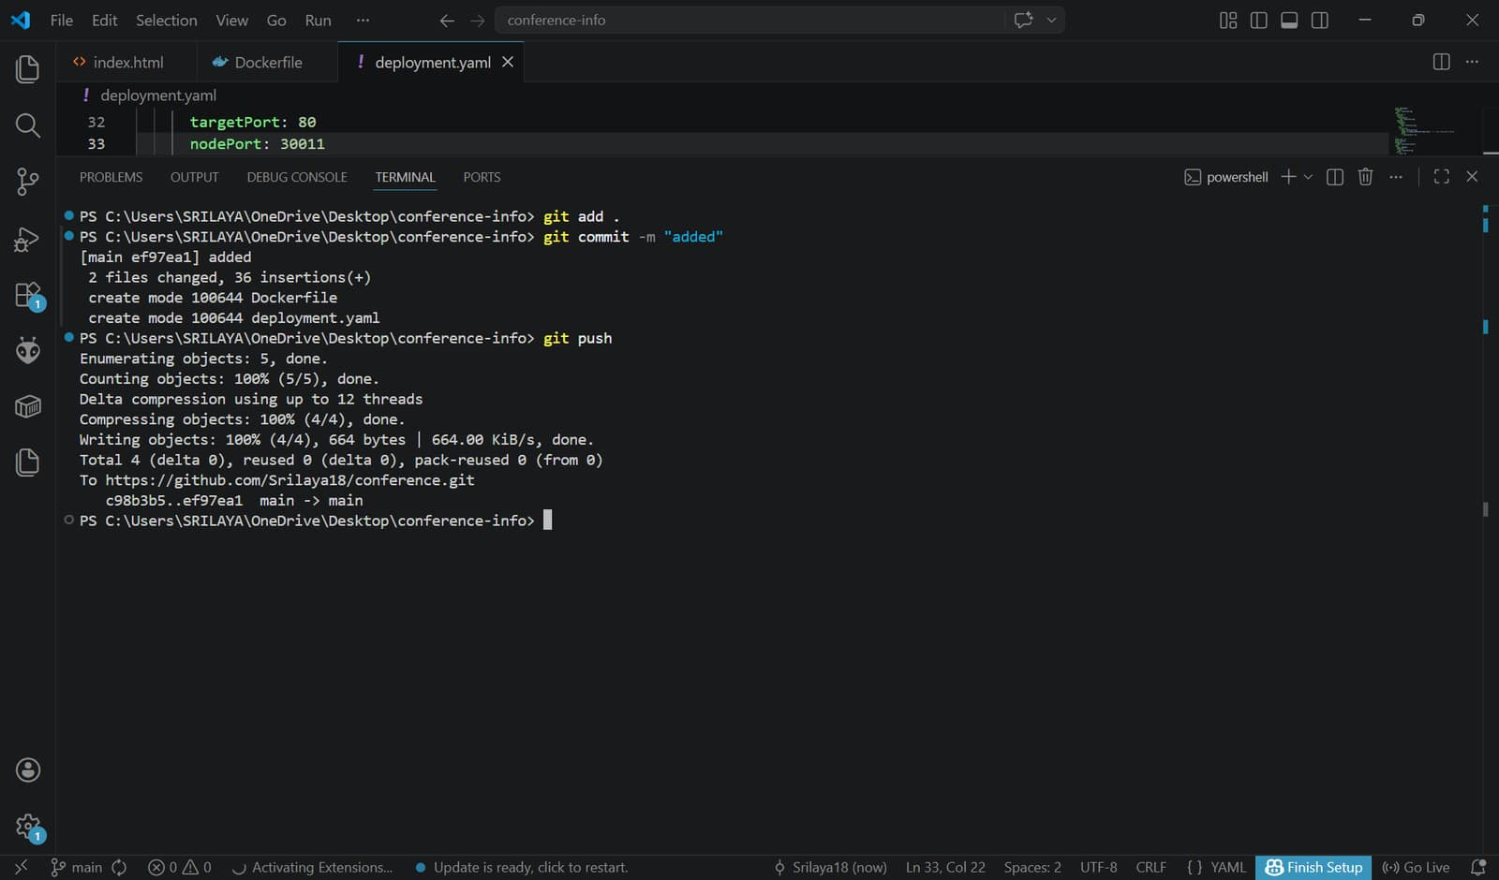

Install Kubernetes CLI plugin, Docker and Docker Pipeline
Steps
Manage Jenkins - Credentials - (System) -Global credentials (unrestricted) - Add Credentials
Fill like this:
Kind: Username with password
Scope: Global
Username: srilayam
Password: sridocker@123
ID: dockerhub-creds
Description: DockerHub Login

Create pipeline and add script
pipeline {
agent any
environment {
DOCKER_IMAGE = "srilayam/conference-app:latest"
}
stages {
stage('Clone Code') {
steps {
git branch: 'main',
url: 'https://github.com/Srilaya18/conference.git'
}
}
stage('Build Docker Image') {
steps {
bat 'docker build -t %DOCKER_IMAGE% .'
}
}
stage('Push Image') {
steps {
withCredentials([usernamePassword(
credentialsId: 'dockerhub-creds',
usernameVariable: 'USER',
passwordVariable: 'PASS'
)]) {
bat 'docker login -u %USER% -p %PASS%'
bat 'docker push %DOCKER_IMAGE%'
}
}
}
stage('Deploy to Kubernetes') {
steps {
bat 'kubectl apply -f deployment.yaml'
}
}
}
post {
success {
echo 'CI/CD Pipeline executed successfully!'
}
failure {
echo 'Pipeline failed. Please check logs.'
}
}
}
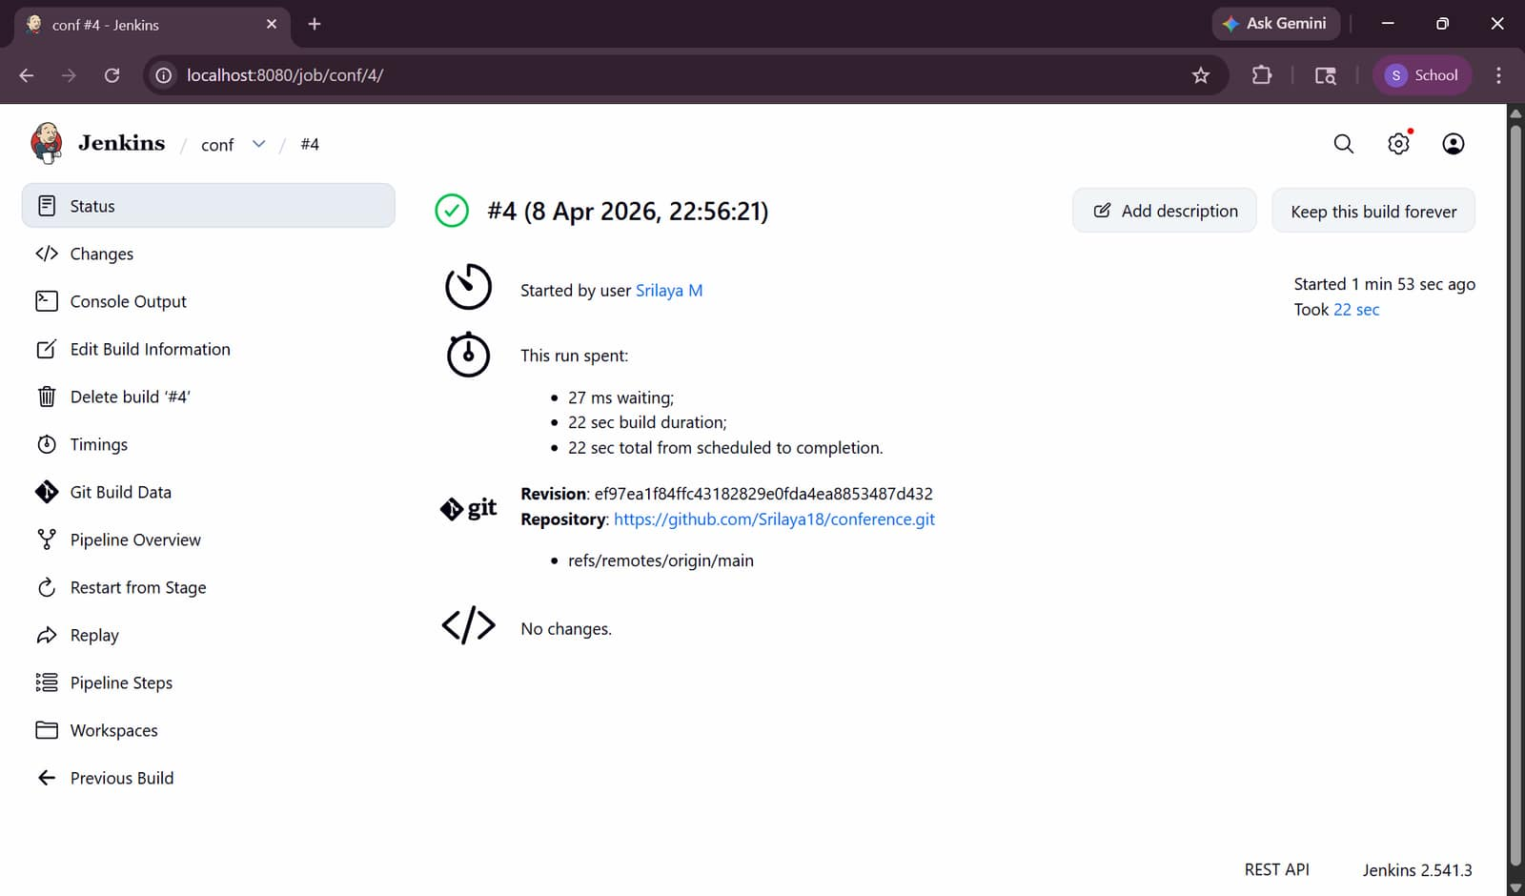
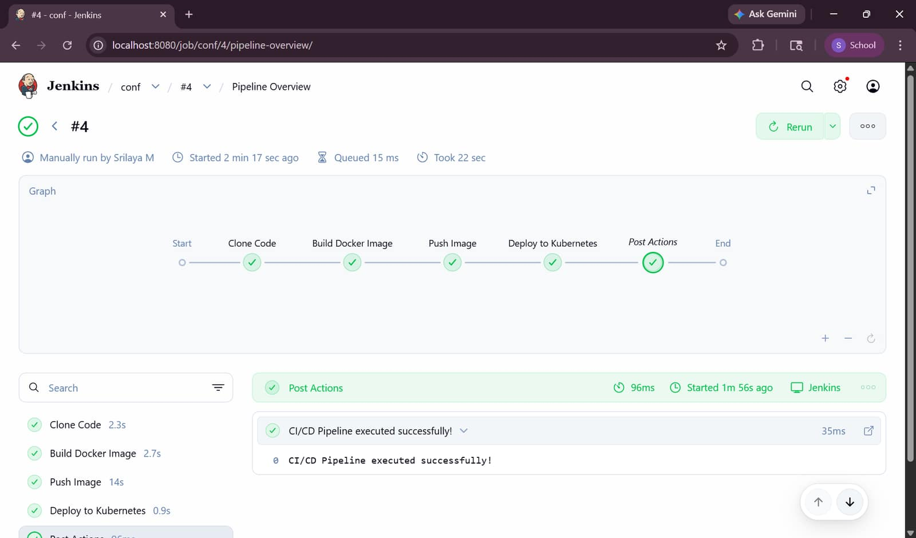
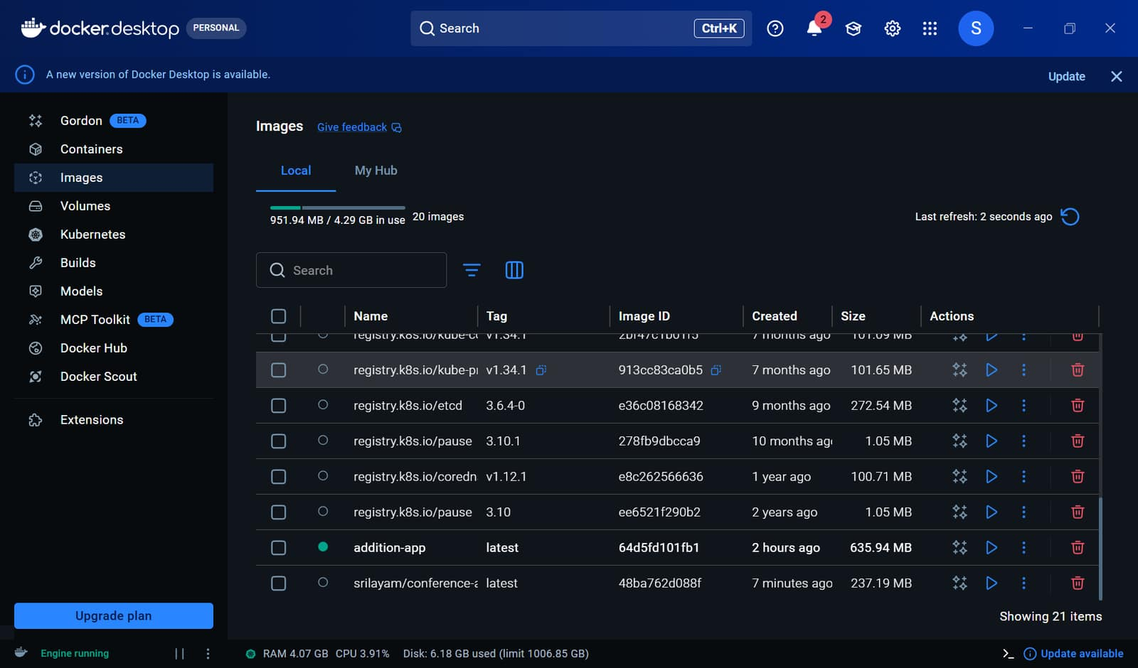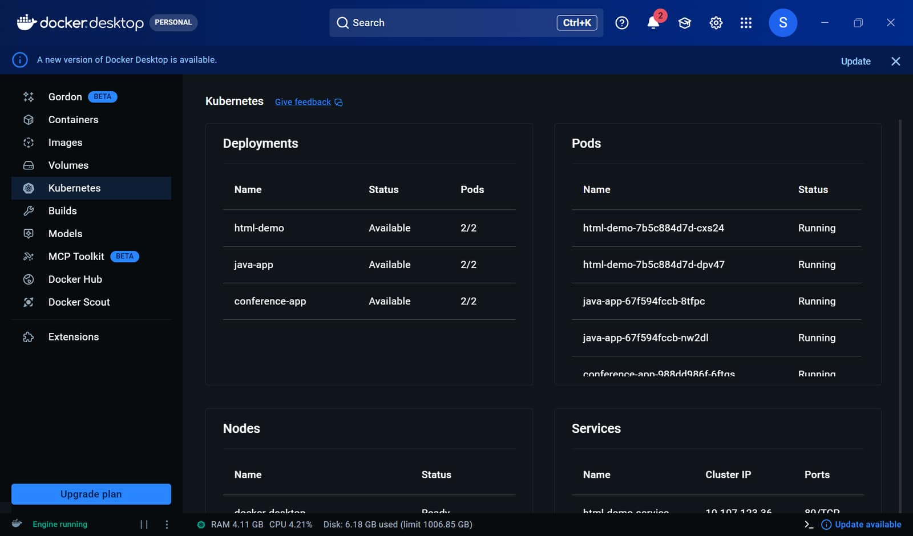
In terminal
Check pods- kubectl get pods (must get 1/1 then only working)
Check service- kubectl get svc

Website link is- http://localhost:30011
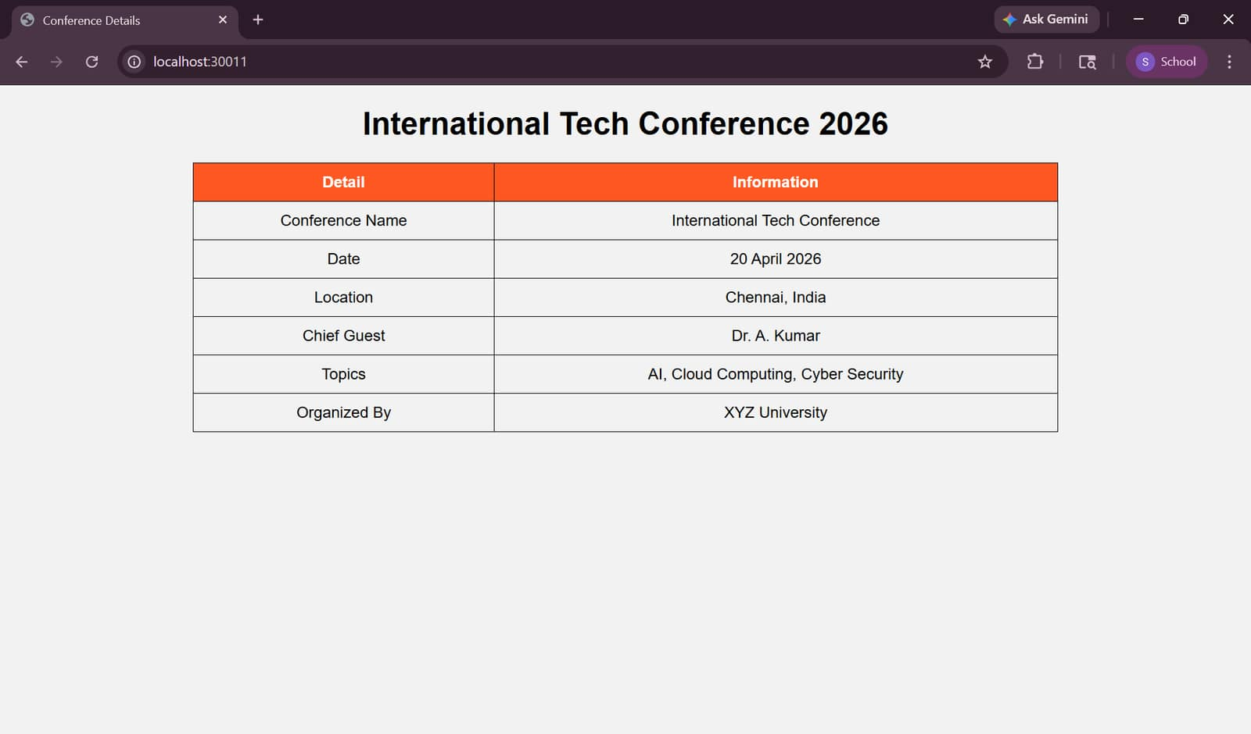
d. The price list of the items
<!DOCTYPE html>
<html>
<head>
<title>Price List</title>
</head>
<body style="text-align:center; font-family:Arial;">
<h1>Price List</h1>
<table border="1" align="center" cellpadding="10">
<tr>
<th>Item</th>
<th>Price</th>
</tr>
<tr>
<td>Notebook</td>
<td>₹50</td>
</tr>
<tr>
<td>Pen</td>
<td>₹10</td>
</tr>
<tr>
<td>Bag</td>
<td>₹500</td>
</tr>
<tr>
<td>Calculator</td>
<td>₹300</td>
</tr>
<tr>
<td>Water Bottle</td>
<td>₹150</td>
</tr>
</table>
</body>
</html>
e. The timetable of a student
<!DOCTYPE html>
<html>
<head>
<title>Student Timetable</title>
</head>
<body style="text-align:center; font-family:Arial;">
<h1>Student Timetable</h1>
<table border="1" align="center" cellpadding="10">
<tr>
<th>Day</th>
<th>Subject</th>
</tr>
<tr>
<td>Monday</td>
<td>Maths</td>
</tr>
<tr>
<td>Tuesday</td>
<td>Science</td>
</tr>
<tr>
<td>Wednesday</td>
<td>English</td>
</tr>
<tr>
<td>Thursday</td>
<td>Computer</td>
</tr>
<tr>
<td>Friday</td>
<td>Physics</td>
</tr>
</table>
</body>
</html>

