

School of Computer Science and Engineering
Course Code:  B22EF0608 |  |  | Mini Project Report – Zeroth Review |  |  | Academic Year:
 |  |  |  |  |  | Semester: 6th
Project Group Members Details
Group No: |  | Group Name:
Sl. No | SRN | Full Name |  | Sec | Mobile No. | Email_ID |  | Sign
1 | R23EF187 | PRANAV AJITH |  | D | 7559192789 | 23020103733@reva.edu.in
2 | R23EF233 | SAJIL S NAIR |  | D | 9883056378 | 23020103902@reva.edu.in
3
4
Task Distribution
Project Leader |  | PRAVAV AJITH
Documenter Lead: |  | PRANAV AJITH
Development Lead: |  | SAJIL S NAIR
Project Details
Project Title: |  | AI-Based Weekly Employee Well-Being Pulse System
Guide Details: |  | Prof. Shankar Rana |  |  |  |  | Mobile No:
Place of Project Work: |  | Department Of Computer Science and Engineering
External Guide : |  | Name:  Designation: |  |  |  |  | Mobile No:
Remarks by Guide: |  |  |  |  |  |  | Guide Signature  Date:

Contents
1. Abstract | 3
2.Problem Statement | 4
3.Objective | 4
4.Project Overview | 5
5.Methodology | 6-7
6.Implementation and Timeline | 8-9
9.Conclusion | 9

1. ABSTRACT:
In today’s fast-paced work environment, front-line employees are frequently exposed to high levels of stress due to continuous customer interaction, heavy workloads, and irregular working hours. Despite these challenges, many organizations lack an efficient and structured mechanism to regularly monitor employee well-being. This often leads to delayed identification of burnout, reduced productivity, and decreased job satisfaction.
The proposed project, AI-Based Weekly Employee Well-Being Pulse System, aims to address this gap by developing an intelligent platform that collects weekly feedback from employees regarding their emotional state, workload, and stress levels. The system utilizes Artificial Intelligence techniques, particularly sentiment analysis and pattern recognition, to evaluate employee responses and identify potential signs of burnout at an early stage.
The application provides a simple and user-friendly interface for employees to submit their feedback, ensuring ease of participation and consistency. On the other hand, managers are provided with analytical dashboards that present insights into team well-being, stress trends, and risk indicators. These insights enable timely intervention, personalized support, and better decision-making.
Furthermore, the system emphasizes real-time monitoring and continuous improvement by tracking weekly patterns instead of relying on occasional surveys. This allows organizations to proactively manage employee well-being rather than reacting to issues after they escalate.
Overall, this project integrates AI-driven analytics with human resource management to enhance workplace productivity, improve employee satisfaction, and create a healthier work environment. It bridges the gap between employee experience and organizational support systems, making well-being management more data-driven, proactive, and effective.

2. PROBLEM STATEMENT:
In modern organizations, employee well-being is often assessed through occasional surveys or informal feedback, which fail to capture real-time emotional and mental states. Front-line employees, in particular, experience high levels of stress due to workload, customer interactions, and time pressure, yet these issues frequently go unnoticed until they affect productivity and job satisfaction.
Employees may also hesitate to share honest feedback due to lack of anonymity, while managers lack structured tools to monitor well-being trends or identify early signs of burnout. This results in delayed interventions, reduced efficiency, and higher employee turnover. Therefore, there is a clear need for a continuous, reliable, and data-driven system that can monitor employee well-being and provide actionable insights in real time.

3. OBJECTIVE:
The main objective of this project is to develop an AI-Based Weekly Employee Well-Being Pulse System that enables continuous monitoring and analysis of employee mental and emotional health.
The specific objectives include:
- To design a weekly feedback system for capturing employee stress levels, mood, and workload experience.
- To ensure anonymity and ease of use to encourage honest participation.
- To apply AI-based sentiment analysis to interpret employee responses effectively.
- To identify stress patterns and early signs of burnout using data analysis techniques.
- To develop a dashboard for managers that provides clear insights and well-being trends.
- To support timely decision-making and interventions for improving employee satisfaction and productivity.
Overall, the project aims to shift from traditional feedback methods to a proactive and intelligent well-being monitoring system.

4. Project Overview:
Employee well-being monitoring has become important due to rising workplace stress and its impact on productivity and retention. Various systems and studies have addressed this area, but with certain limitations.
Existing Systems
- Pulse Survey Tools (Officevibe, TinyPulse):
  - Collect regular employee feedback
  - Improve over traditional annual surveys
  - Lack advanced analysis and predictive insights

- HR Analytics Platforms (Workday, CultureAmp):
  - Provide dashboards and engagement reports
  - Useful for performance tracking
  - Complex, costly, and not suitable for small-scale use

- Technologies Used:
- Artificial Intelligence (AI) & NLP:
  - Used for sentiment analysis of employee feedback
  - Classifies responses as positive, negative, or neutral
  - Helps in identifying emotional patterns

- Limitations in Existing Work
- Lack of real-time and continuous monitoring
- Limited use of AI for proactive decision-making
- No proper integration of feedback + analysis + visualization
- Anonymity issues, reducing honest responses
- Systems are often complex or expensive

RESEARCH GAP:
Despite the availability of pulse survey tools and HR analytics platforms, there is still a lack of a unified system that effectively combines continuous feedback collection with intelligent analysis. Most existing solutions either focus only on data collection or provide complex analytics without ensuring ease of use and anonymity. Additionally, the use of AI is not fully leveraged for early detection of stress and burnout. Therefore, there is a need for a simple, integrated, and AI-driven system that enables real-time monitoring, ensures user comfort, and provides actionable insights for proactive employee well-being management.
5. METHODOLOGY:
The proposed system follows a structured approach to continuously collect, analyze, and present employee well-being data using AI techniques. It is designed as a simple and integrated platform consisting of multiple functional modules that work together to provide meaningful insights.
Overall Approach
The system operates on a weekly feedback cycle, where employees submit their responses, which are then processed using AI to generate insights for managers. The architecture ensures smooth data flow from input to visualization.

Modules of the System
- 1. User Interface (Employee Side):
  - Provides a simple and user-friendly form
  - Employees submit weekly feedback on mood, stress, and workload
  - Ensures anonymity to encourage honest responses
- 2. Data Collection Module:
  - Stores employee responses in a structured format
  - Maintains weekly records for trend analysis
  - Ensures data security and privacy
- 3. AI Analysis Module:
  - Uses Sentiment Analysis (NLP) to evaluate feedback
  - Classifies responses as positive, negative, or neutral
  - Detects patterns indicating stress or burnout over time
- 4. Data Processing & Storage:
  - Organizes collected data for efficient retrieval
  - Prepares data for visualization and reporting
- 5. Dashboard (Manager Side):
  - Displays insights through charts and graphs
  - Shows trends in employee well-being
  - Highlights risk indicators and alerts

Working Flow
- Employee submits weekly feedback
- Data is stored in the system database
- AI model analyzes the feedback
- Results are processed and categorized
- Dashboard displays insights to managers

Key Features of Proposed Architecture
- Continuous weekly monitoring system
- Integration of AI with feedback collection
- Anonymity to ensure honest input
- Simple and clear visualization of results
- Supports early detection of burnout

6. IMPLEMENTATION PLAN AND TIMELINE:
The implementation of the AI-Based Weekly Employee Well-Being Pulse System is carried out in a structured and phased manner to ensure proper development, testing, and deployment. Each phase focuses on a specific part of the system, enabling smooth progress and effective time management.
Implementation Plan:
- Phase 1: Requirement Analysis
  - Understand project objectives and system requirements
  - Identify key features such as feedback collection, AI analysis, and dashboard
  - Study existing systems and finalize tools/technologies
- Phase 2: System Design
  - Design overall architecture and module structure
  - Create UI layouts for employee input and manager dashboard
  - Plan database structure for storing feedback data
- Phase 3: Development
  - Frontend development for user interface (forms and dashboard)
  - Backend development for data handling and storage
  - Integration of AI model for sentiment analysis
- Phase 4: Testing
  - Perform unit testing for individual modules
  - Conduct system testing to ensure smooth workflow
  - Fix bugs and improve performance
- Phase 5: Deployment & Evaluation
  - Deploy the system in a test environment
  - Collect feedback and evaluate system performance
  - Make final improvements and prepare documentation

Timeline (Approximate)
- Week 1–2: Requirement Analysis and Planning
- Week 3–4: System Design and UI Prototyping
- Week 5–7: Development (Frontend + Backend + AI Integration)
- Week 8: Testing and Debugging
- Week 9: Deployment and Final Evaluation

The project follows a clear and systematic implementation plan, ensuring that each stage is completed efficiently within the given timeline. This structured approach helps in developing a reliable and effective system for monitoring employee well-being.

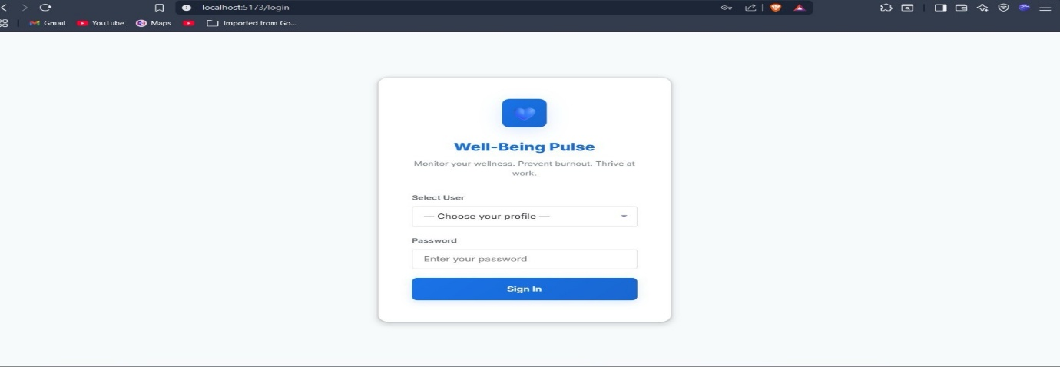
9. PROOF OF CONCEPT:
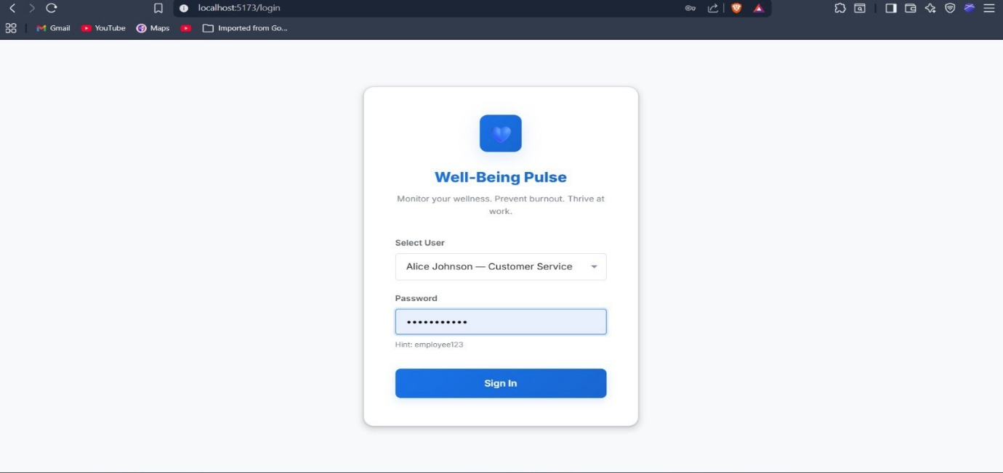
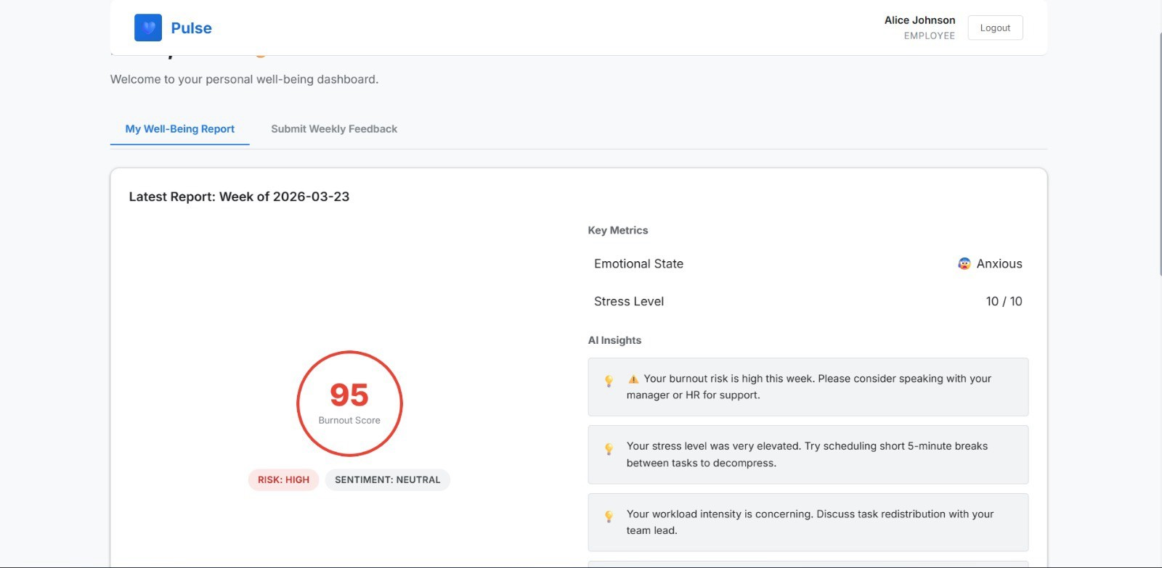
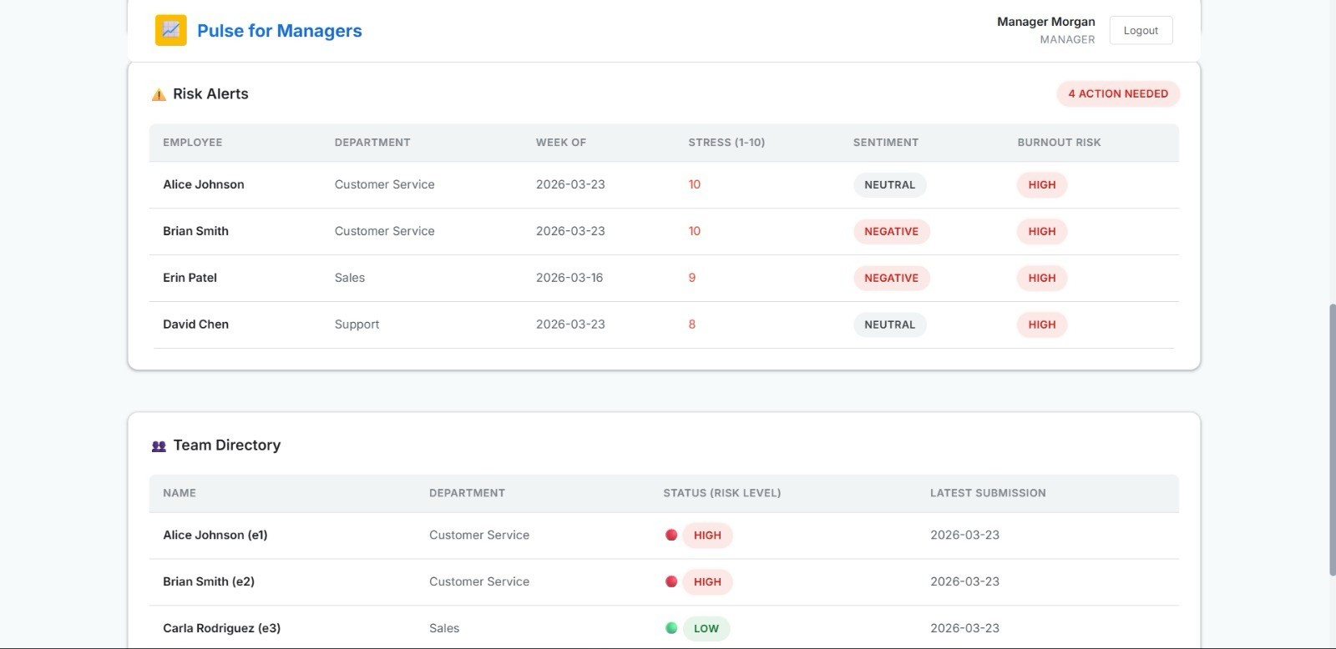
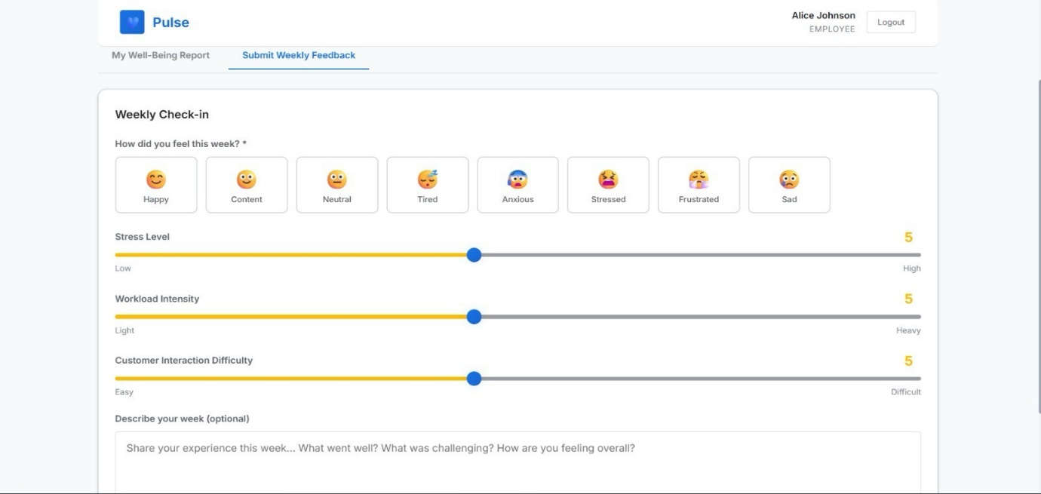
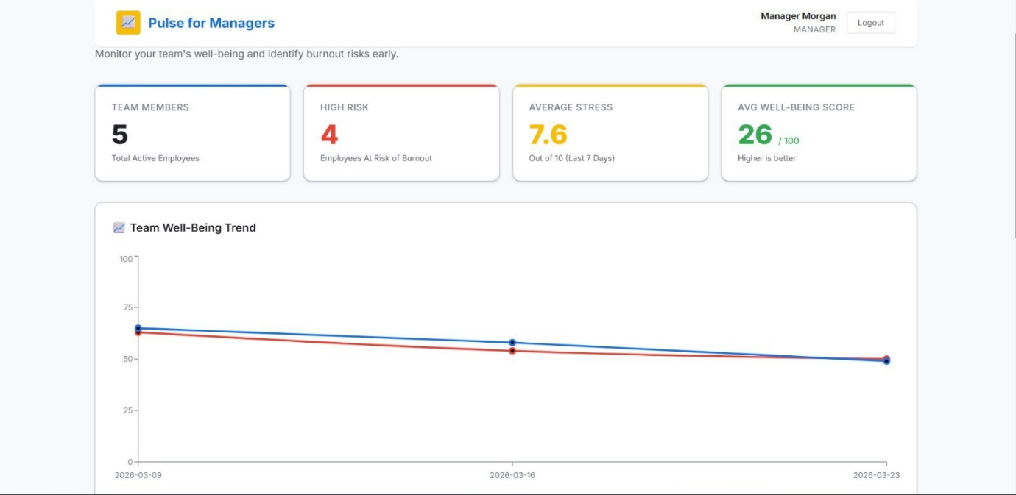
9. CONCLUSION:
The AI-Based Weekly Employee Well-Being Pulse System presents an effective solution for continuously monitoring employee mental and emotional health by integrating weekly feedback with AI-based sentiment analysis. It overcomes limitations of traditional survey methods by enabling real-time insights, early detection of stress and burnout, and data-driven decision-making. With features like anonymity, user-friendly design, and visual dashboards, the system encourages honest participation while helping managers take timely actions. Overall, the project enhances employee satisfaction, productivity, and workplace well-being, demonstrating the practical impact of AI in modern human resource management.

