DAY6 SESSION ASSIGNMENTS (Theory)

1. How do you evaluate the performance of a project in agile?

T he performance of a projct developed through agile manifesto is not simply evaluated on the basis of quality, cost and effort like in the case of the traditional model. In agile model more preference are given to :
- the individals and interactions over processes and tools
  - functional software over comphresive documentation
  - customer collaboration over contract negotiation
  - responding to change over following a plan.
We could say that the agile model is more based on the freequent delivery of a working software , that is a result of proper collocation, daily team meatings and timebox review meetings.
As a part these meetings, we calculate several performance metrics for the project:
- Velocity – measures the rate at which team can produce the working software.
    - The Velocity is predicted during Agile Project initiation for the first Release Plan from histoic data
    - After that the actual Velocity is measured at the end of each Timebox.
    - ActualVelocity is used to predict the Velocity for subsequent Timeboxes in the Release Plan.
- Hit Rate – measures the percentage of work allocated to a Timebox that was actually completed.
- Work remaining on the tasks - Each day the team estimates the work remaining on each active Task
- Project Cost – uses 3 values.
        - Cost Performance Index (CPI)
        - Schedule Performance Index (SPI)
        - Earned Business Value (EBV)
a) CPI - This metric indicates how many cents have been "earned" out of every dollar spent. It measures cost efficiencies.
CPI > 1 is an indication that cost incured for the project is less than what expected .
CPI<1 is an indication that the cost has exceeded the expected value.
b) SPI- This metric measures schedule efficiency. It indicates how fast you are progressing against the rate of progress planned
SPI > 1 is an indication that the project has finished earlier than expected.
SPI < 1 is an indication that the project has finished late than expedcted.
SPI = CPI = 1 : means that the project development is as according to the plan.
c) EBV - In agile methodology CPI and SPI values are not only the necessary criterion to measure the performance.Instead we do also consider the business value.It measures the outcomes rather than outputs.Customer’s satisfation is a measure that improve this value. It accounts for what all features (as demanded by the user) a0re there in the software produced.

2. Compare traditional monitoring & control with agile monitoring & control with respect to metrics generation?

Traditional monitoring & control | Agile monitoring & control
It is all about observing and measuring actual project performance against the plan and fixing it if it varies. | It will also measures project performance against the planned value, but also takes account of business value.
Variance from the plan is considered bad unless it is approved by Change Management. | Variation is not considered bad and changes plan to suit the current position.
Traditional project monitoring focuses on tracking how much effort is expended on each task. | The main Agile monitoring technique is to track what software has been incrementally delivered.
Delivery of the working software is done only after the development. | Frequent delivery allows the Product Owner to declare a product “done” at any time or the Business Sponsor to declare the project finished at any time
Communication can be of any form and does not restrict in any way. | Agile teams try to promote face-to-face communication and to reduce the channels of communication.
Not focused on colocation. | Colocation is done to ensure successful communication between the agile teams.
No burn down charts are created here. | Results are demonstrated using the burn down chart.
Comparing plans is the measure of progress. | Emphasizing customer value and working software are the primary measure of progress.
Delivery of software is only done after the final developement, hence customer is invloved only at the user acceptance testing. | Highest priority is to satisfy the customer  through early and continuous delivery  of valuable software.
Product demo is done at the UAT. | The Product Demonstration at the end of a Timebox

3. With a total project budget of $ 175,000, and having completed one out of
four Iterations, we have this product backlog and these actuals:
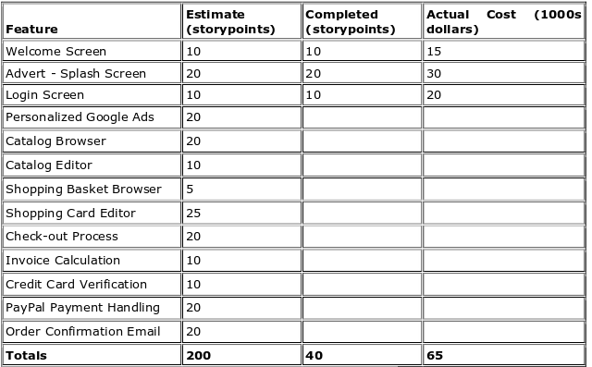

in our example, after Iteration 1 we should be at 25% complete)
Calculate Planned Value
Actual % Complete
Earned Value

soln: BAC (budget at complete) = $ -175000 ie, the budget asssigned to complete the work

Planned percent complete = 25% , here 1 iteration is taken as 1 sprint. So 1/4 of the total is to be completed ie, 25%

Planned value - BAC* planned percent complete

planned value = 175000 * (1/4) = $ 43750

Actual percent complete(APC) - Story points completed / Total planned story points
Total story points = 40
Total planned stories = 200
ie, APC = 40/200 = 0.2 = 20%

Earned value = BAC*APC (The earned value indicates how much value has actually been generated at a particular milestone or point in time.)

ie ,Earned value = 175000*0.2
= $ 35000

