**Assignment 0**

1.WAP a C to add two integers and display the result .

code:

void main () {

int a=20, b=20,c;

c=a+b;

printf("addition of %d",c);

}

Output:

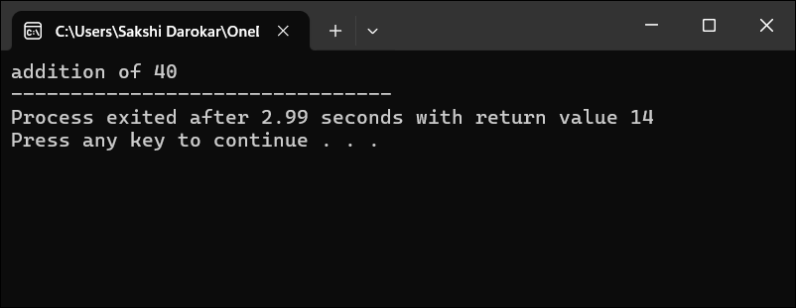

2. Write a C program to find the area of a circle.

Code:

Void main() {

Int r; float pi=3.14,area;

Printf(“Area of circle %f’’,area); }

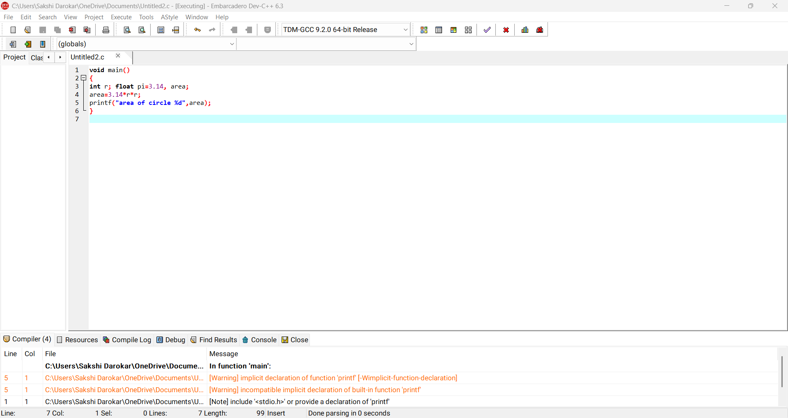

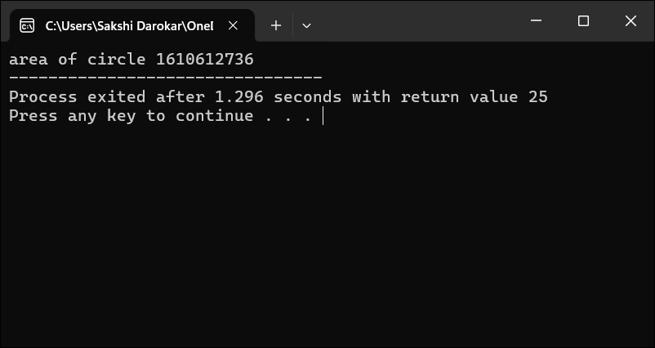

3. Write a C program to convert temperature from Celsius to Fahrenheit using the formula:

F(C*9/5)+32

Code:

int main() {  
 float celsius, fahrenheit;  
 printf("Enter temperature in Celsius: ");  
 scanf("%f", &celsius);  
 fahrenheit = (celsius * 9 / 5) + 32;  
 printf("%.2f Celsius = %.2f Fahrenheit\n", celsius, fahrenheit);  
}

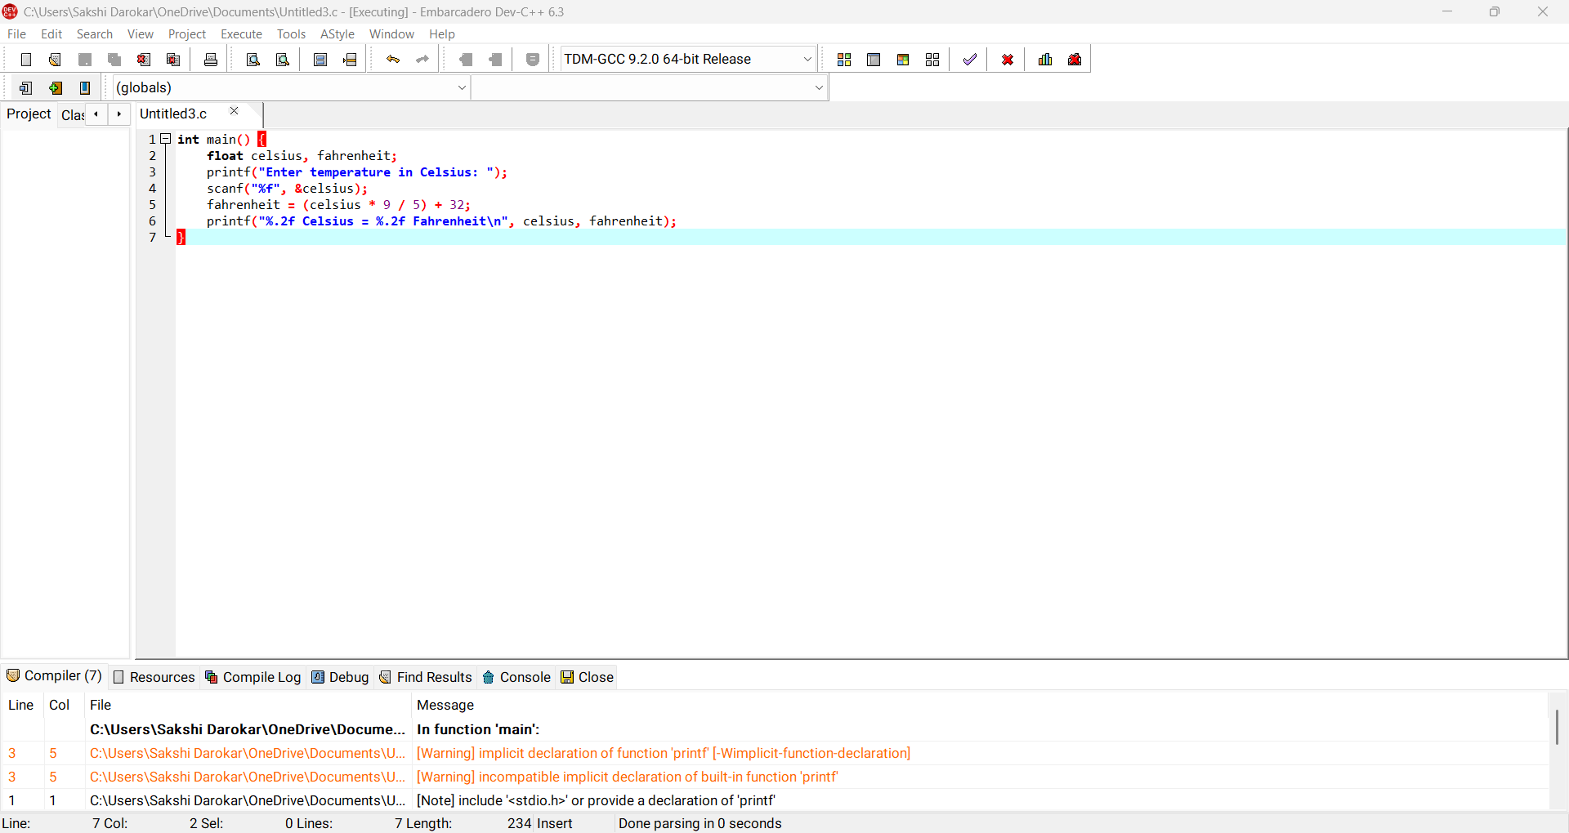

Output:

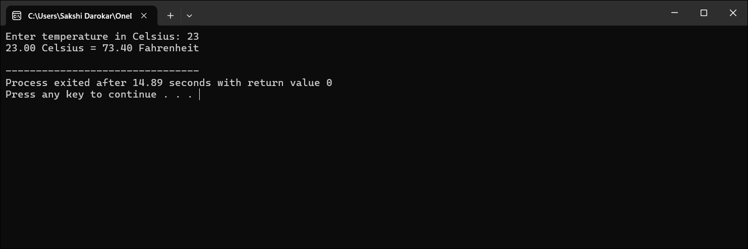

4. Write a C program to swap two numbers using a temporary third variable.

Code:

Void main()

{int a=10,b=20,l=10;

l=a;

a=b;

b=l;

printf("swapping of no %d",a,b,l);

}

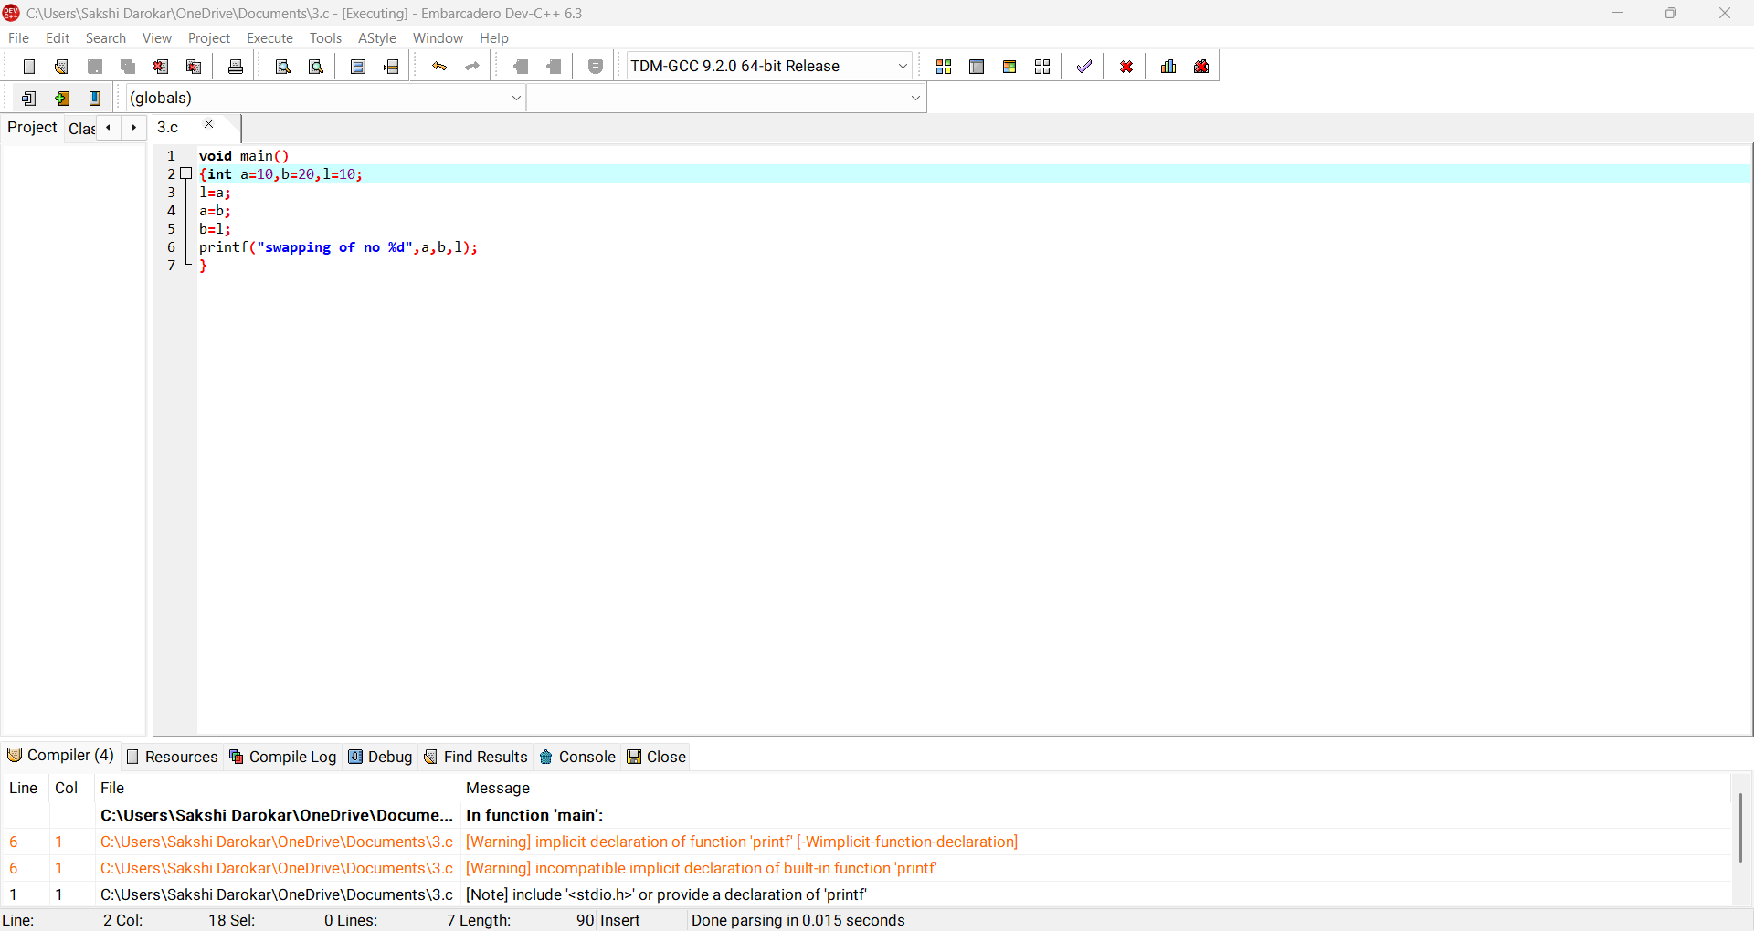ouput: 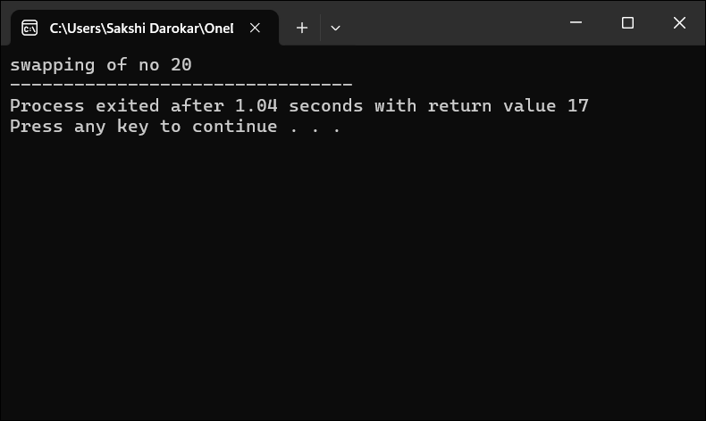

5. Write a C program to input five numbers and find their average.

Code:

void main()

{int no1,no2,no3,no4,no5,average;

average= (no1+no2+no3+no4+no5)/5;

printf("average of no %d,%d,%d,%d,%d",average);

}

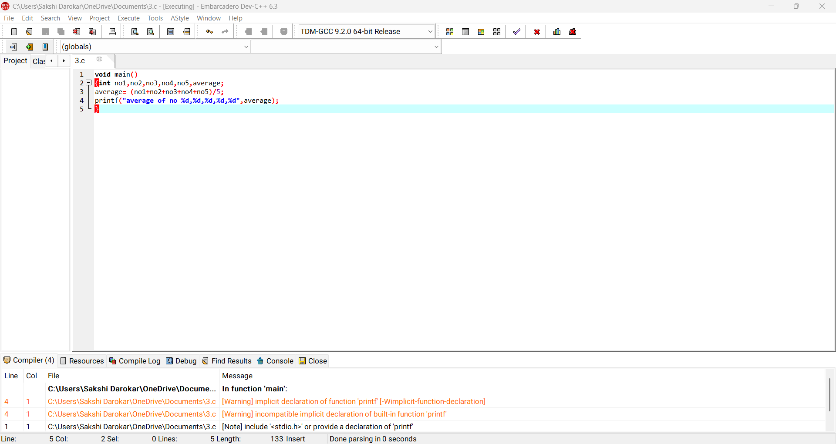

Output:

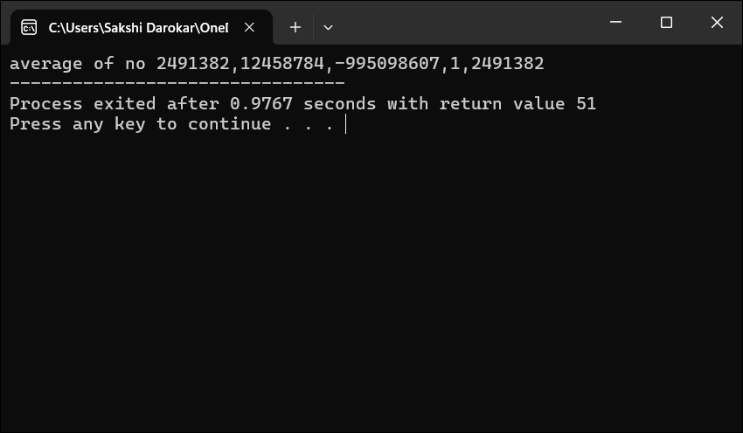

6. Write a C program to find the square and cube of a given number.

Code:

void main()

{

int num,cube,square;

square= num*num;

cube= num*num*num;

printf("enter a no %d",cube);

}

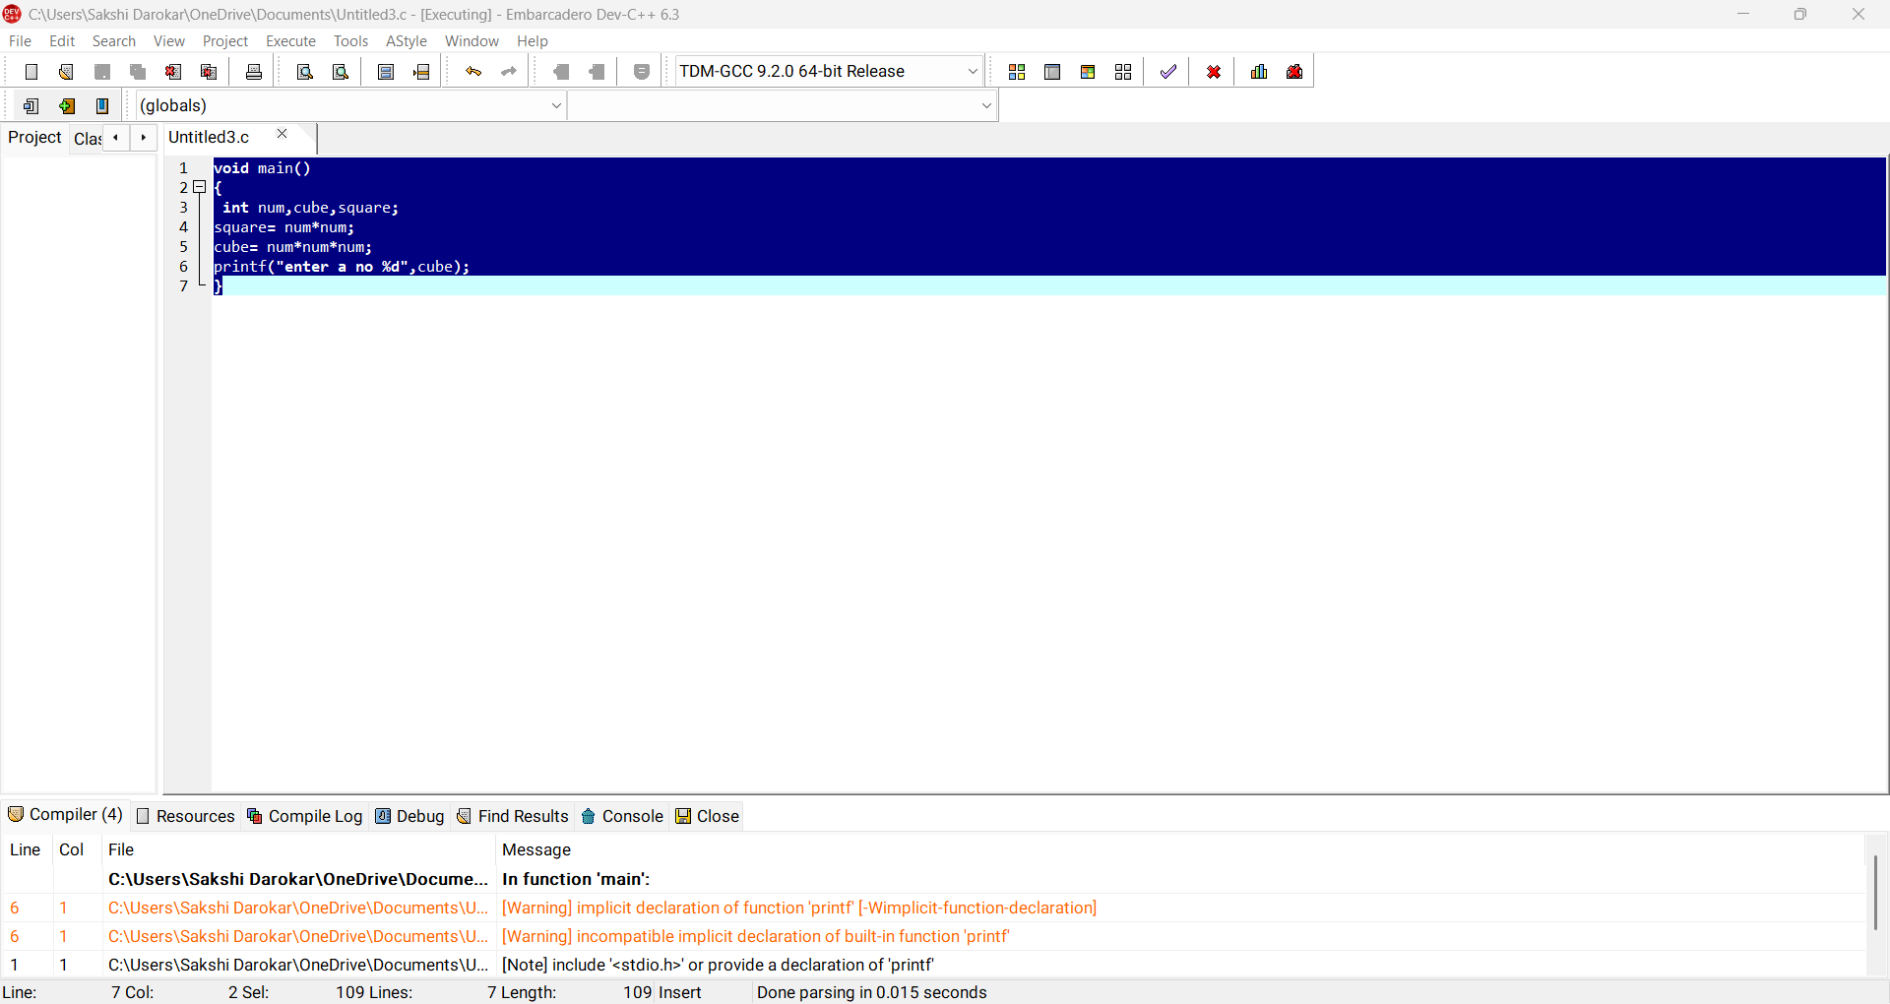

Output:

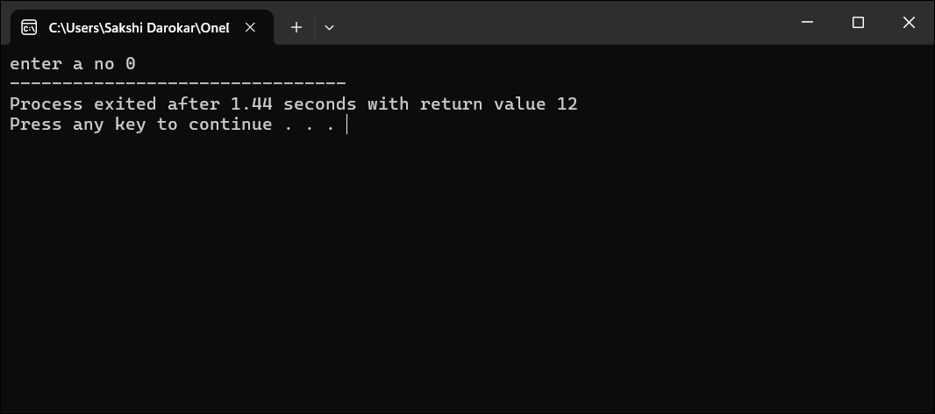

7.Write a C program to convert given minutes into hours and remaining minutes.

Code:

void main()

{

int minutes,hours,remainingMinutes;

hours= minutes/60;

remainingMinutes= minutes%60;

printf("total minutes %d",minutes,hours,remainingMinutes);

}

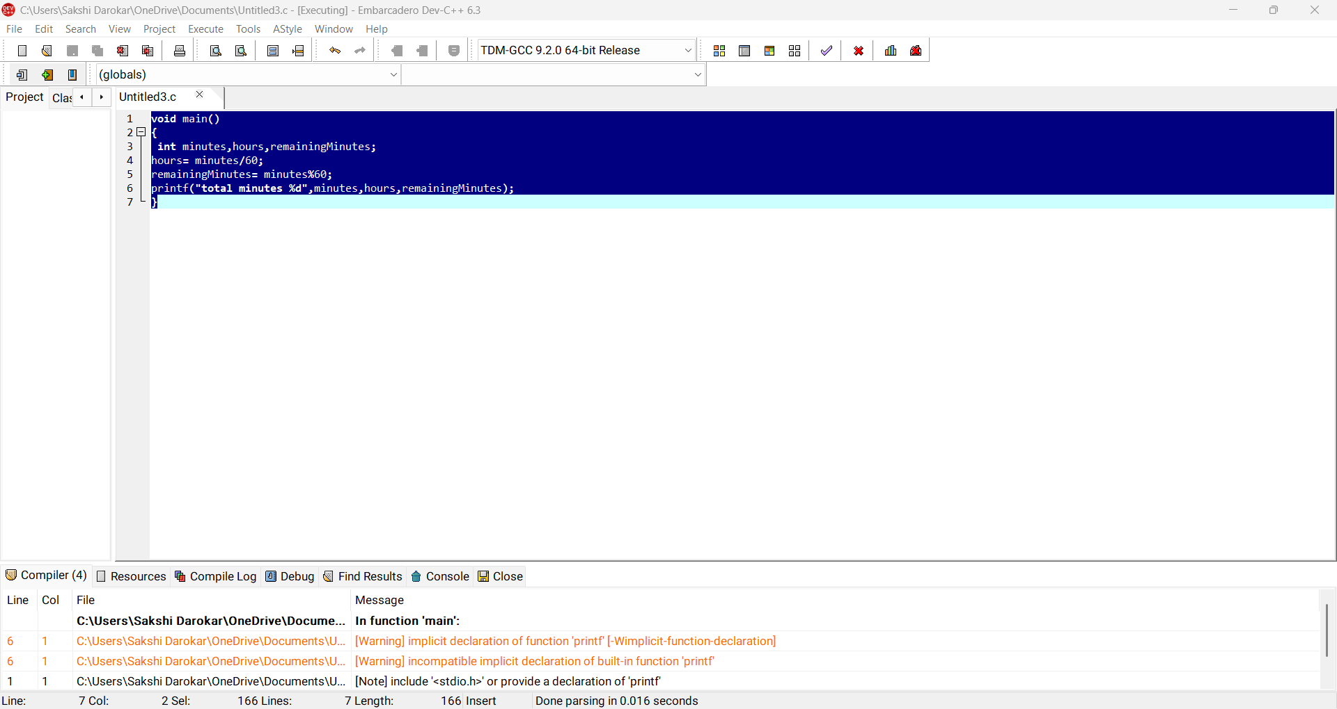

Output:

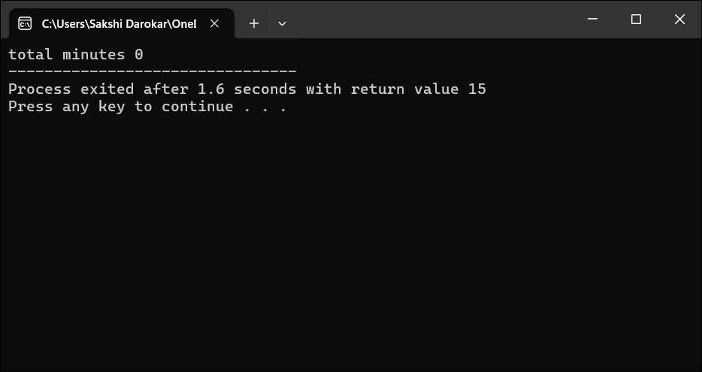

8. Write a C program to input the length and width of a rectangle and find its perimeter.

void main()

{

int l,W;float perimeter;

perimeter=2*(l+W);

printf("rectangle %d,%f",perimeter);

}

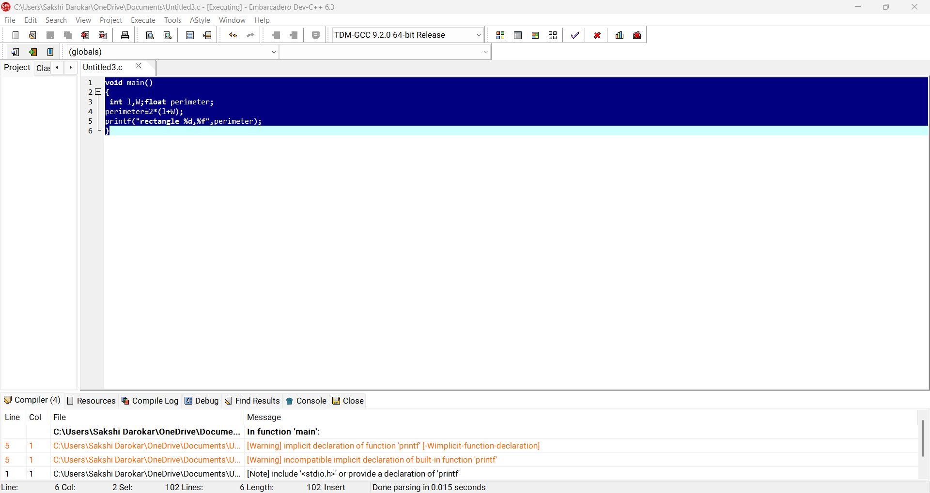

Output:

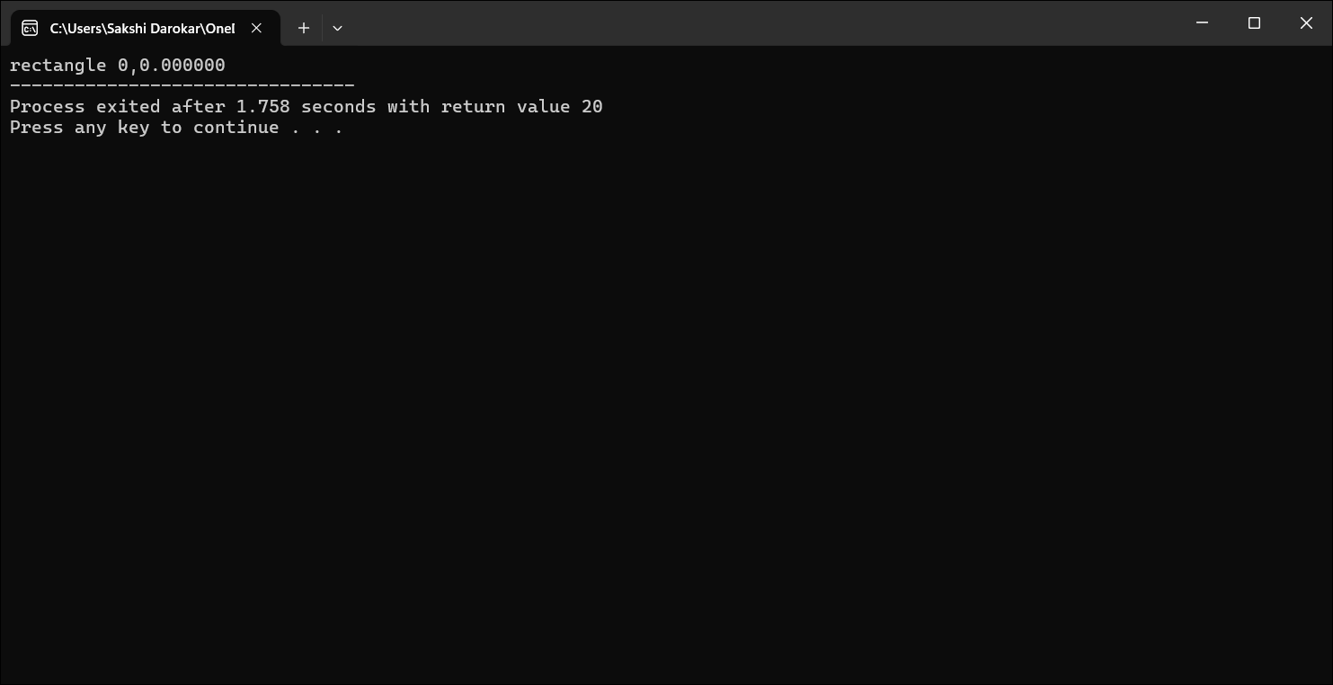

9. Write a C program to input the base and height of a triangle and calculate its area.

Code:

void main()

{

int b,h;float area;

area=0.5*b*h;

printf("triangle %d,%f",area);

}

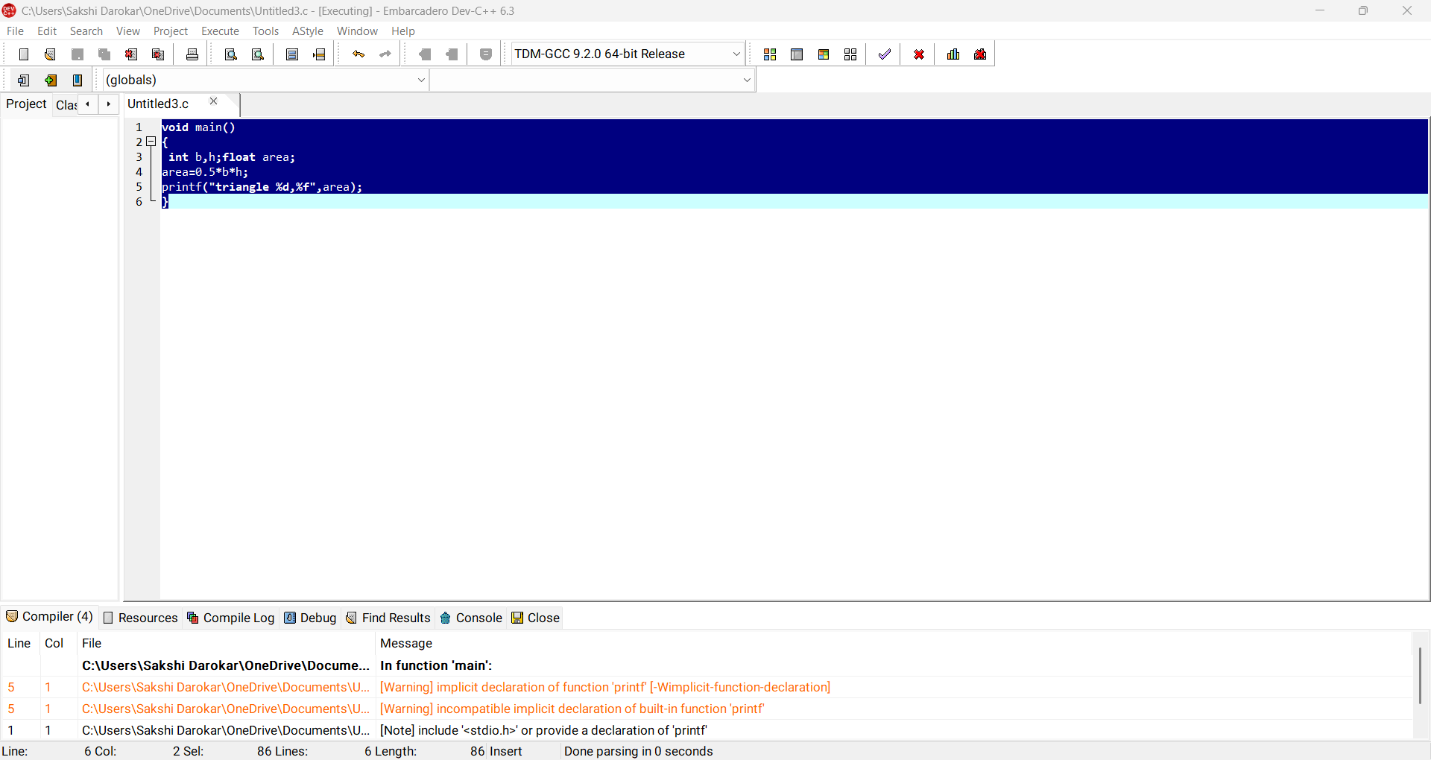

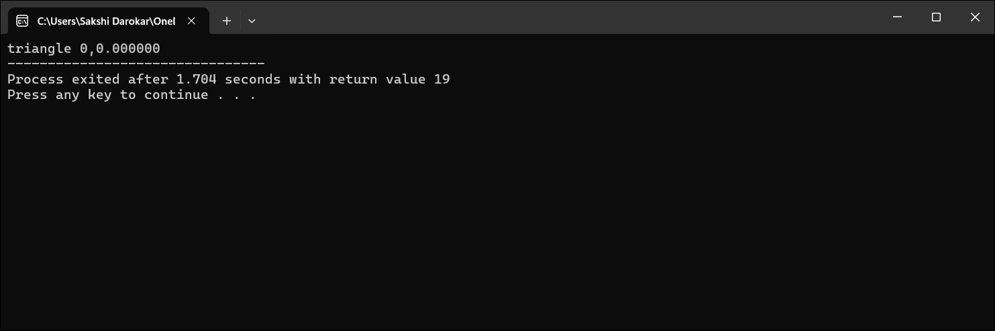

10. Write a C program to input marks of five subjects, find the total marks, and calculate the percentage.

void main()

{

int sub1,sub2,sub3,sub4,sub5,total;float percentage;

total=sub1+sub2+sub3+sub4+sub5;

percentage=(total/500)*100;

printf("add %d,%d,%d,%d,%d,%f",total,percentage);

}

