Saleh abdullah alkhuzayyim
441109092

Part 4:
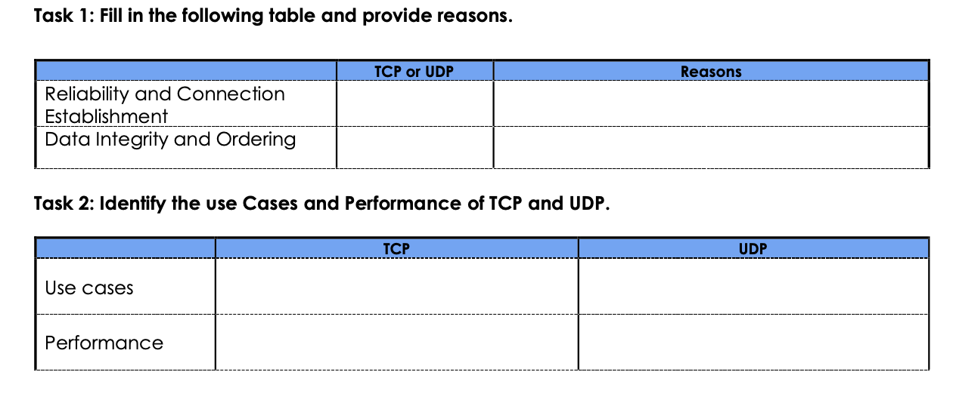
Faster with low delay because it has lightweight headers and no setup time.
Online games, live video streaming, and voice calls.
Slower with more overhead because it checks for errors and lost data.
Web browsing (HTTP), file transfers, email.
Uses 3-way handshake and resends lost data.
Uses sequence numbers to order packets.
TCP
TCP

