Team Members:

|  |  |  |
| --- | --- | --- |
| **Name** | **Division** | **Roll no.** |
| Karuna Jagtap | TE-4 | 14 |
| Shivali Kakade | TE-4 | 21 |
| Diksha Shah | TE-4 | 53 |

**Chapter 1**

**Introduction**

* 1. **Motivation and Objectives**

The Existing power quality monitoring system, mainly to get the data through special acquisition equipment of power quality, it is not for real time monitoring of each user power consumption. It is difficult job for the electricity distributors to manually take meter readings and calculate bill. Domestic energy consumer is unaware of his power usage and also difficult to energy management. Hence considering all these factors it is possible to design a smart meter that is it supports power quality monitoring, energy management and automatic billing. The goal of providing such data is to optimized and reduces the power consumption. The energy Meter proposed here deals with the measurement of current, voltage and consumption of power. GSM is used to send a message to a domestic user with information on billing. This smart meter is user friendly and it makes consumers aware about the amount of energy they utilize and help to save the resources.

* 1. **Basic Concept**

Today, government or private organizations need to personally visit the industries for checking the energy ratings. This is quite difficult to visit and audit the energy ratings. As day-by-day industries are growing, it would be more difficult to audit personally. There may be case of corruption in the audit of energy measurement. To cure these problems wireless energy meter can be installed to accurate and time to time measurement.

So with the emergence of IoT and AI, we can now estimate the total amount of energy required by every block in a day efficiently. This estimation will help powerhouses to determine their electricity supply and counter their losses dramatically. The data received from the smart meter unit which installed in each property of the city would be stored in the database software of the server which is at the electricity supplier company, now this received data from the smart meter is using to train the (ML) machine learning algorithm then after the certain time the whole system will be able to predict the amount of electricity required to the city for the upcoming session even before the session has been started.

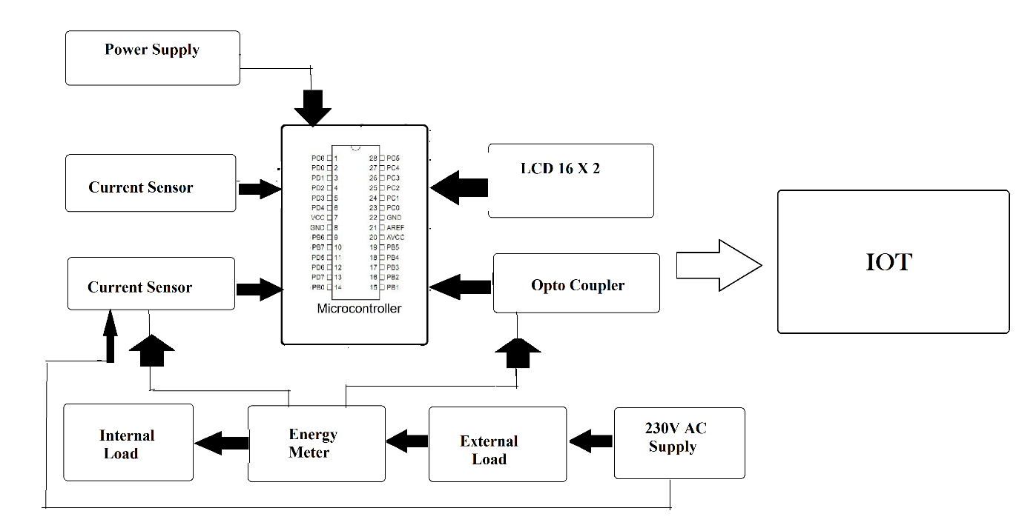

**Chapter 2**

**Literature Survey**

[1]In the year of May 2012 the authors Abhinandan Jain, Dilip Kumar, Jyoti Kedia presented a paper titled “SMART & INTELLIGENT GSM BASED AMR SYSTEM” . This paper represents the development of fully automated energy meter which is having capabilities like remote monitoring & controlling energy meter. Automatic meter reading (AMR) system continuously monitors the energy meter & sends data on request of service provider through SMS. It saves huge human labour.

[2]In the year of June 2012 the authors O. Homa Kesav, B. Abdul Rahim presented a paper titled “AUTOMATED WIRELESS METER READING SYSTEM FOR MONITORING & CONTROLLING POWER CONSUMPTION. In this paper the design presents new method for avoiding high construction & maintenance cost in the existing system. The system is designed in such a way that if the consumer is unable to pay the bill the power connection maybe disconnected automatically from remote server. The ARM 7 based hardware system consist of a processor core board & the peripheral board. The embedded C language is used as programming language in this system.

**Chapter 3**

**Problem Statement**

Today, government or private organizations need to personally visit the industries for checking the energy ratings. This is quite difficult to visit and audit the energy ratings. As day-by-day industries are growing, it would be more difficult to audit personally. There may be case of corruption in the audit of energy measurement. To cure these problems wireless energy meter can be installed to accurate and time to time measurement. Easy and autonomous Audit of energy measurement should be achieved. So to eliminate these problems, build a Wireless Energy Meter based on GSM Modem/iot.

No need to visit personally to the industries for audit all the energy meters are audited remotely.

Potential Impact: 1) Power will be saved. 2) Less financial requirement

3) Fast reading of energy meters 4) All data can be saved directly.