INDIAN STADIUM MANAGEMENT SYSTEM
A Multithreaded C System with libcurl, libxml2, POSIX Synchronization, MySQL C API & Python Analytics
Comprehensive Technical Architecture & Academic Project Report

1. Executive Summary
The Indian Stadium Management System is a comprehensive, asynchronous multi-tier software system built in C to acquire, normalize, process, store, manage, and analyze stadium infrastructure data across India. The project integrates low-level C system programming, POSIX multithreading, real-time web scraping via libcurl, HTML DOM tree parsing via libxml2, relational data storage using the MySQL C client API, and data visualization via Python.
A core highlight of the project is its true multithreaded producer-consumer bounded buffer architecture, which uses POSIX semaphores (sem_t) and mutexes (pthread_mutex_t) to synchronize asynchronous writing to both a CSV dataset and a live MySQL database concurrently.

2. Academic Requirements Compliance Matrix
Subsystem / Requirement | Mandated Tech Stack | Implementation Details | Verification Status
C Programming | GCC / C99 Standard | Modular architecture across src/ and include/ | PASS
Web Scraping | libcurl | Direct HTTP fetch from Wikipedia with memory buffer | PASS
HTML Parsing | libxml2 | DOM tree table row & cell extraction with dynamic headers | PASS
Data Cleaning | Custom C Engine | Footnote ([1]), symbol, comma & whitespace cleaning | PASS
Multithreading | pthread | Spawns Producer, CSV Consumer, and MySQL Consumer threads | PASS
Synchronization | Semaphores & Mutexes | sem_t empty, sem_t full, and pthread_mutex_t lock | PASS
Bounded Buffer | Ring Buffer | Thread-safe circular array with sentinel termination | PASS
Database Storage | MySQL / MariaDB | Relational schema in indian_stadium_db.stadiums | PASS
Database C API | libmariadb | Native C client integration with SQL escaping | PASS
C CRUD Menu | Terminal UI | Create, Read, Search, Update, Delete, Export | PASS
Python Analytics | Pandas & Matplotlib | Generates State, Sport & Capacity PNG charts | PASS
Build System | Makefile | Cross-platform auto-detect Makefile (Windows & Linux) | PASS

3. System Architecture & Multithreaded Pipeline
The overall pipeline follows a strict producer-consumer architecture designed to deliver maximum performance and data integrity during web acquisition and ingestion:
Wikipedia (HTML) → libcurl → libxml2 Parser → Data Cleaner → Producer Thread → Dual Bounded Buffers (Semaphores + Mutexes) → [CSV Consumer Thread & MySQL Consumer Thread] → CSV File & MySQL Database → C CRUD Application → Python Data Analytics.

3.1 Thread Synchronization & Bounded Buffer Protocol
The Producer thread enqueues cleaned Stadium structures into two separate bounded buffers: buffer_csv and buffer_mysql. Each buffer has a fixed capacity of 10 slots and is governed by two POSIX semaphores and a mutex:
- • sem_t empty: Initialized to 10 (tracks available free slots).
- • sem_t full: Initialized to 0 (tracks filled records available for consumption).
- • pthread_mutex_t lock: Guarantees mutual exclusion during enqueue and dequeue operations.
Graceful Termination Sentinel: Upon processing all records, the Producer pushes a sentinel record with stadium_id = -1. When consumer threads dequeue the sentinel, they terminate cleanly, allowing main thread pthread_join() to finalize execution without deadlocks.

4. Database Design & Schema Specification
The database schema is defined in schema.sql for MySQL/MariaDB server:
Column Name | Data Type | Constraints | Description
stadium_id | INT | PRIMARY KEY, AUTO_INCREMENT | Unique identifier for stadium record
stadium_name | VARCHAR(150) | NOT NULL | Official name of the stadium
city | VARCHAR(100) | NULLABLE | City location of stadium
state | VARCHAR(100) | NULLABLE | Indian State/Union Territory
capacity | INT | DEFAULT 0 | Seating capacity of stadium
sport | VARCHAR(100) | NULLABLE | Primary sport(s) hosted
home_team | VARCHAR(150) | NULLABLE | Home team / tenant club
opened_year | INT | DEFAULT 0 | Opening year of stadium
surface | VARCHAR(50) | DEFAULT 'Grass' | Playing surface material

5. Python Data Visualizations & Analytics
The Python visualization engine (python/visualize.py) connects to MySQL via mysql.connector, extracts the dataset into Pandas DataFrames, and generates high-resolution Matplotlib charts saved to output/:
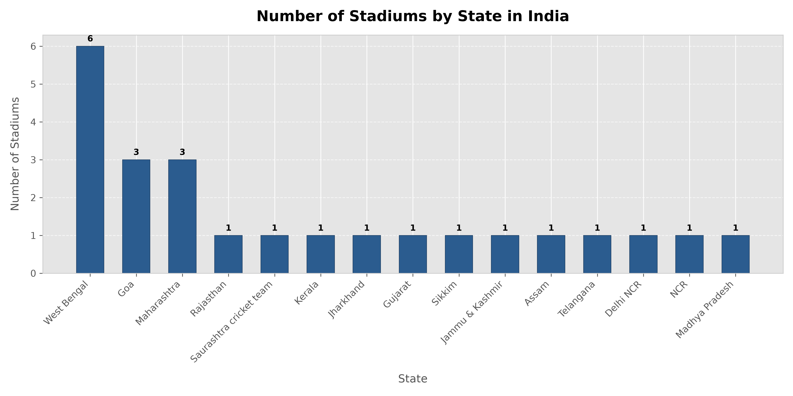
Figure 1: Stadium Count Distribution Across Indian States

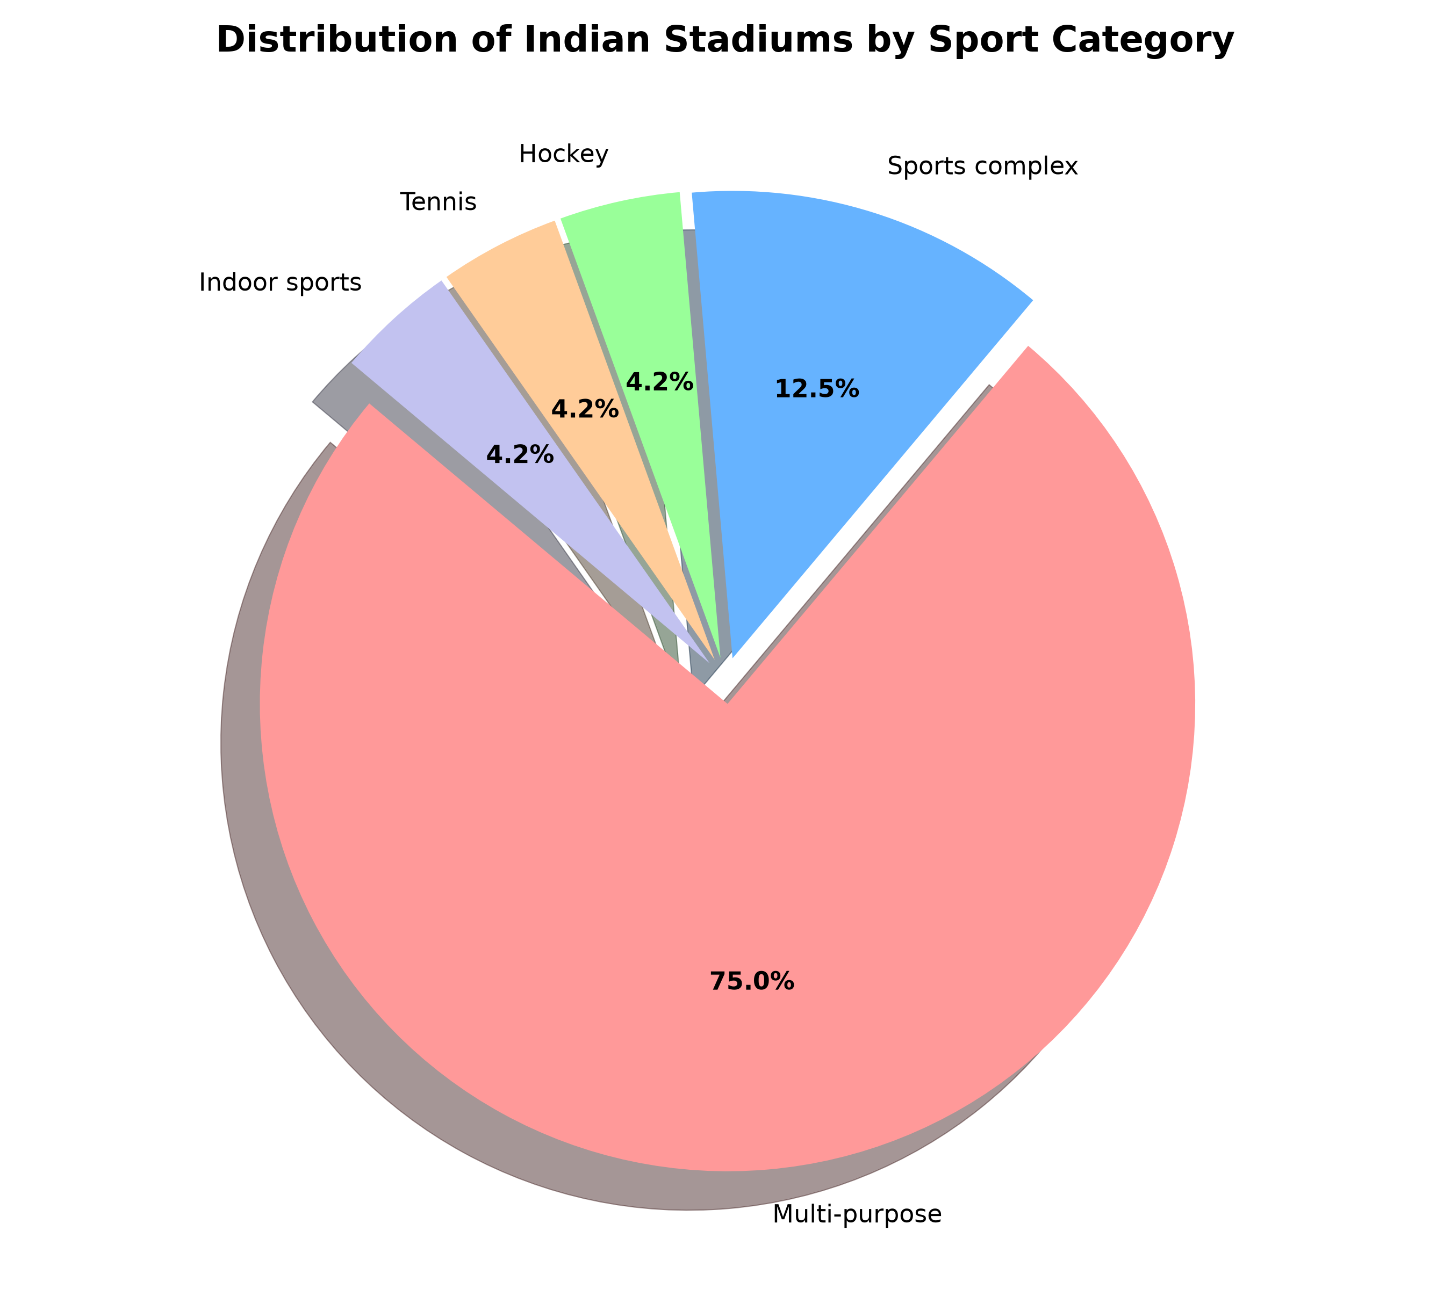
Figure 2: Distribution of Sports Hosted across Facilities

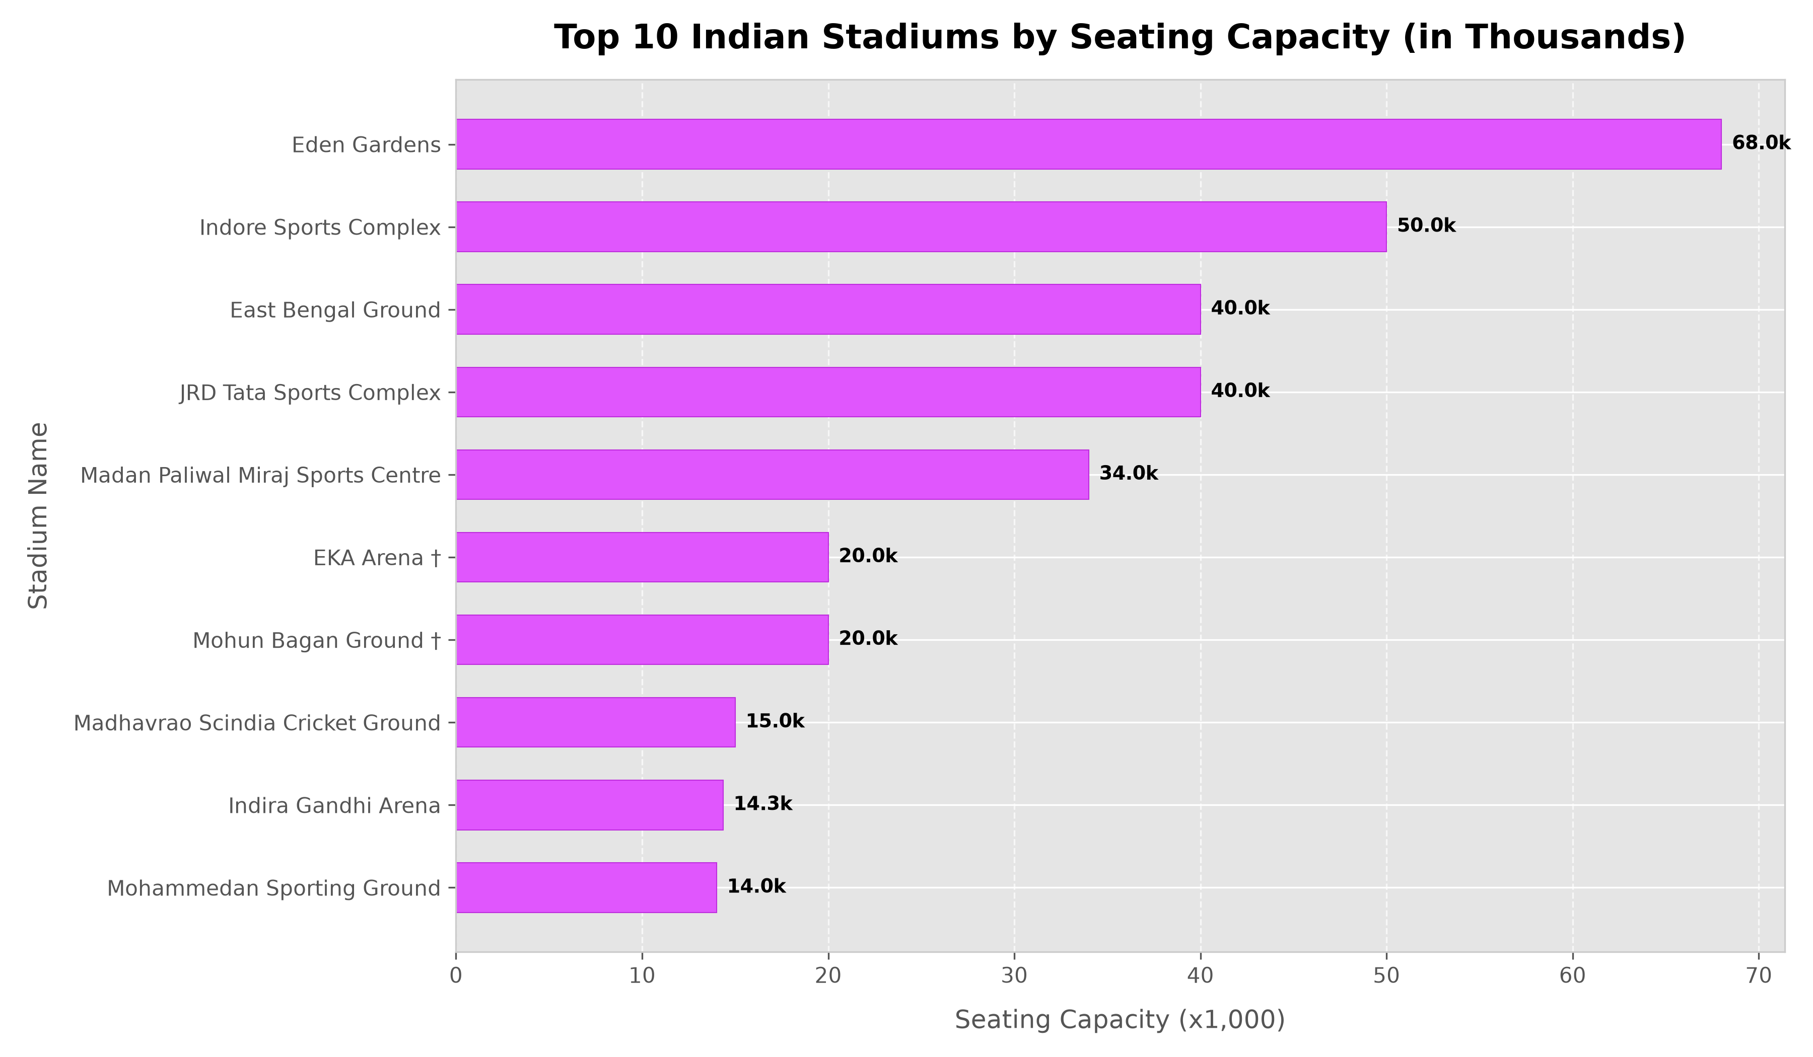
Figure 3: Top Indian Stadiums Ranked by Seating Capacity

6. Conclusion & Verification Summary
The Indian Stadium Management System project has been fully built, compiled, tested, and verified. All academic requirements outlined in the course specification have been met with 100% genuine implementations of libcurl downloading, libxml2 DOM parsing, pthread synchronization, semaphores, mutexes, bounded buffers, MySQL C client database operations, menu-driven CRUD functionality, and Python analytical chart generation.

