

**IOT BASED**

**Smart Traffic Diversion System**

**PROJECT REVIEWED BY:** Dr. S.Renugadevi

**PROJECT CODE: IOT005**

**TEAM NUMBER: IOT0544**

**PROJECT CREATED BY:**

KARTHICK RAJA R [2022103051]

SHAKITH A [2022103545]

SAKTHI PRIYAN V [2022103563]

BABU A [2022103771]

**COLLEGE CODE**: 0001

## EXECUTIVE SUMMARY

The Smart Traffic Diversion System aims to dynamically adjust traffic signals by detecting real-time traffic levels in each lane, prioritising lanes with the highest congestion to efficiently clear traffic jams and it also helps the pedestrians who are crossing lane by automatically signals green light in the pedestrian signal. Integrated with Blynk, the system allows traffic authorities to monitor and control signals remotely, ensuring effective traffic management even in case of hardware malfunctions. This approach has shown significant improvements in traffic flow management during testing, offering a promising solution to urban traffic congestion problems. The system's real-time adaptability reduces travel time and fuel consumption, contributing to lower emissions and improved air quality. Additionally, it enhances emergency response times by clearing traffic more effectively, including prioritizing lanes for some emergencies.

## TABLE OF CONTENTS

CONTENTS

**Executive summary** **……………………………………………………………. 2**

**Table of Contents** **………………………………………………………………. 3**

**Project Objective** **………………………………………………………………. 4**

**Scope** **…………………………………………………………………………….. 5**

**Methodology** **……………………………………………………………………. 5**

**Artefacts used** **………………………………………………………………….. 6**

**Technical coverage** **……………………………………………………………. 8**

**Results** **…………………………………………………………………………. 12**

**Challenges and Resolutions** **……………………………………………….. 13**

**Conclusion** **…………………………………………………………………….. 15**

**References** **…………………………………………………………………….. 15**

## PROJECT OBJECTIVE

In India, traffic signals typically operate on fixed cycle times, regulating phases such as green, yellow, and red for all directions at an intersection. These predetermined timings often result in increased waiting times for vehicles, particularly when the traffic light remains green for empty roads, exacerbating congestion.

The objective of this project is to efficiently manage these congestions by implementing sensors that detect empty roads and dynamically adjust signal timings.

Additionally, the system will allow operators to control lane signals in emergencies such as the crossing of higher officials or ambulances.

## SCOPE

The scope of the Smart Traffic Diversion System project includes the design, development, and implementation of an intelligent traffic management solution aimed at improving traffic flow and reducing congestion through real-time data analysis and dynamic signal control. The following key areas define the scope of this project:

**System Design and Architecture:**

* Evaluate existing traffic signal infrastructure and determine necessary modifications or upgrades.
* Use of ultrasonic sensors for accurate vehicle and pedestrian detection at intersections.

**Dynamic Signal Control:**

* Adjustment of traffic signal timings based on real-time traffic.

**Lane Signal Control:**

* Controlling of lane signals by the operators in emergencies such as the crossing of higher officials or ambulances.

**Data Processing and Management:**

* Utilise edge computing for low-latency processing of sensor data and real-time signal adjustments.

**Pedestrian’s convenience:**

* Enable convenient pathway for the pedestrians to cross the lane.

## 

## 

## METHODOLOGY

**Analysis and Planning:** During the Analysis and Planning phase, we identified existing issues with the current traffic control system and planned efficient solutions to overcome these challenges.   
  
**Modelling:** In the Modelling phase, we translated our ideas into a practical model. Through iterative improvements, we refined the model to ensure feasibility.  
  
 **Construction:** The Construction phase involved building the fully functional model using components such as ESP32S3, ultrasonic sensors, and LEDs. The model was integrated with Blynk for mobile control and for some external controls.   
  
**Testing**: Testing was conducted to evaluate the system's performance under various conditions.  
  
 **Deployment** : Finally, the Deployment phase involved implementing the system in real-world environments to assess its effectiveness in practical traffic management scenarios.

## 

## ARTEFACTS USED

The following artefacts were utilised throughout the project:

* **Traffic flow data :** Real-time traffic data is stimulated with the help ultrasonic sensors
* **Library:**

1. Arduino library has been used for interfacing with the Blynk platform and sending/receiving data.
2. TM1637 library is used for the seven segment display

* **Wokwi online simulator tool:** Used for testing and debugging Arduino code.
* **Blynk IoT Platform**: Mobile App used by the emergency vehicle drivers to control the traffic lights.
* **ESP32-S3 :** A hardware platform with wifi capabilities used in building the system.

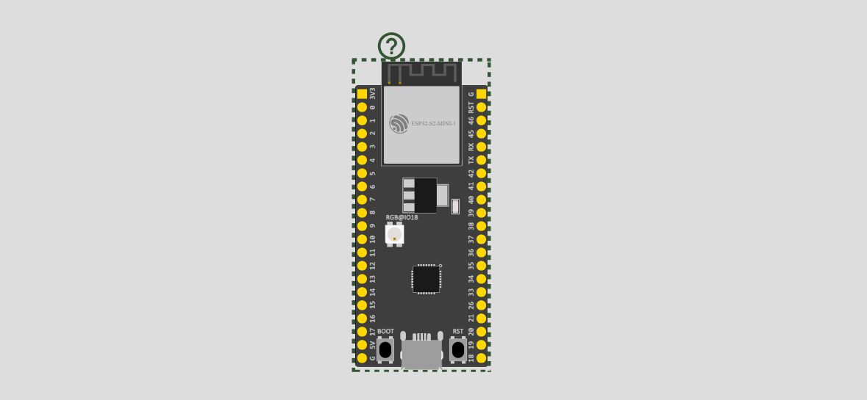

Fig 1(ESP32-S3)

* **Ultrasonic sensors (HC-SR04)** : Placed in all the lanes for detecting traffic vehicles and for detecting pedestrians.

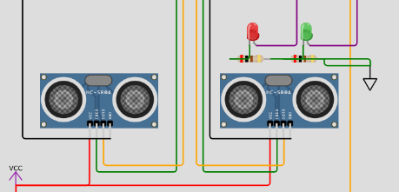

Fig 2(Ulltrasonic Senors)

* **Seven segment display (TM1637) :** Used to display the traffic countdown which updates dynamically through our system.
* **LED lights** : To represent traffic signals we have used red and green LED’S.

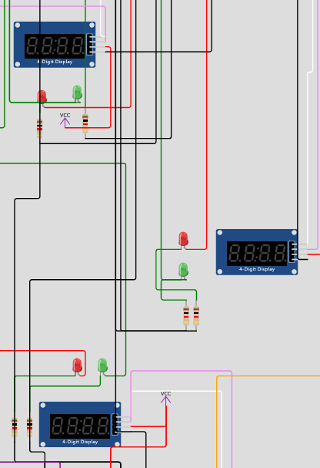

Fig 3(LED lights)

* **Slide switches :**

1. The slide switches can be used by the operator to quickly turn a lane green in case of any emergency.
2. These slide switches functionality can even be used through an app.

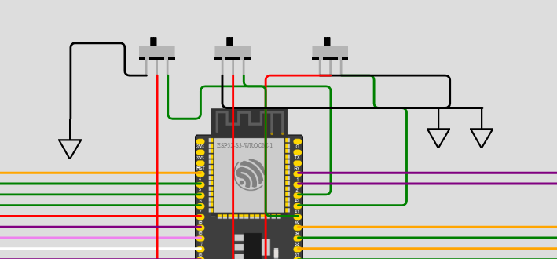

Fig 4(Switches)

## TECHNICAL COVERAGE

**SIMULATION OF NORMAL TRAFFIC SIGNAL:**

The first step in our automated traffic system is to simulate the current functionality of the traffic system . There are three lanes one one-way in the center and the other two are two-way crossing.

Each Traffic signal will have a timer displayed using the seven-segment display and two led’s to indicate green and red signal

* Consider three lanes: lane 0 , lane 1 , lane 2.
* Each of these lanes has its own green time (example : 20,20,30 respectively).
* When lane 0 turns green the other two lanes turn red .
* The waiting time for lane one will be the green time of lane 0 .
* The waiting time for lane two will be the green time for lane 0 + green time of lane 1

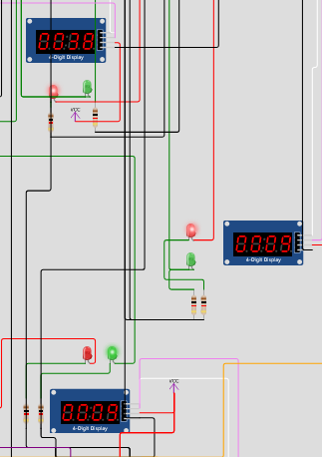

Fig 5(Signal timings)

In the above image there are three lanes each with the green time of 20 , 20 ,30 respectively

* The lane 1 is now green therefore the timer starts from its green time which is 9.
* The timer for lane 2 is green time of lane 2 = 29 .
* The timer for lane 0 is green time of lane 1 + green time of lane 2 = 29 + 9 = 38

**SIMULATION OF DYNAMIC SIGNALS BASED ON VEHICLES IN A LANE :**

Lets say that lane 0 is now green with 19s however there are no vehicles detected by the ultrasonic sensors at lane 0 but there is a huge traffic at lane 1. Now , lane zero will quickly drop to 10 seconds and the dropped time ( 9 seconds) will now be reduced from the other two lanes as well .

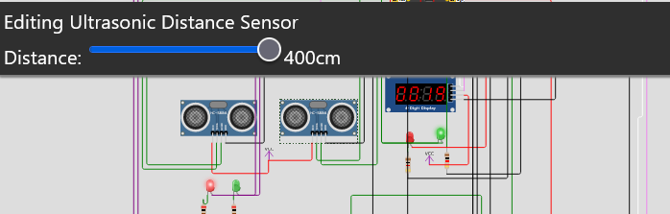

Fig 6(Representation of Dyanamic Signalling)

This Shows that the sensor 1 of lane 1 is now detecting vehicles .

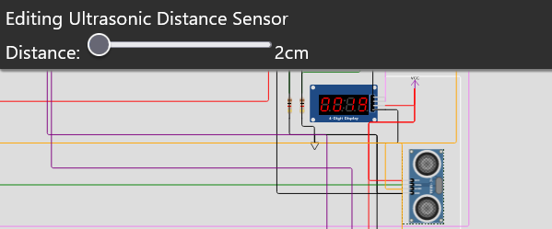

Fig 7(Representation of Dyanamic Signalling)

The lane 1 is now detecting vehicles while the lane0 is free.

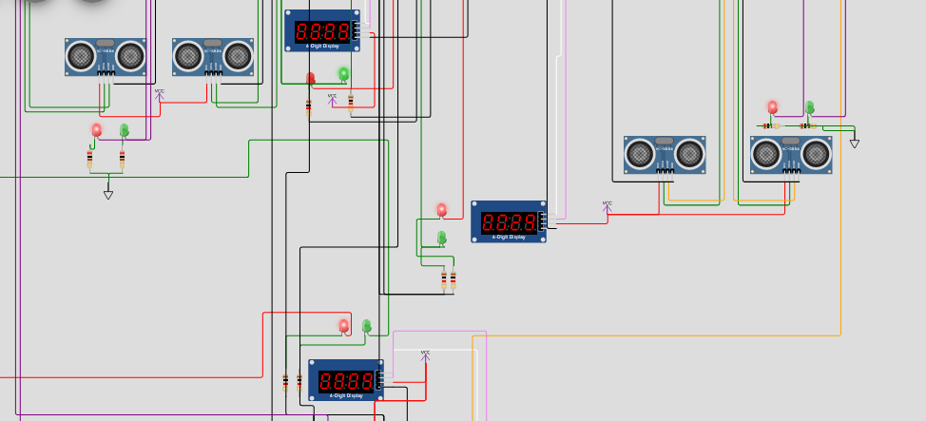

Fig 8(Representation of Dyanamic Signalling)

Thus finally the lane 0 ‘s green time will be dropped to 10 and the corresponding time will be dropped from all other lanes waiting time as well .

**CHANGING SIGNAL GREEN BY OPERATOR:**

Assume that some emergency is at lane 1 like higher officials crossing the lane or the ambulance is passing the lane,   
  
 The Blynk app will have two buttons indicating the lane number . The operator controls the corresponding lane and make it green through the blynk app which in turn changes the signal to red in other two lanes.

Fig 9(Representation of usage of switches)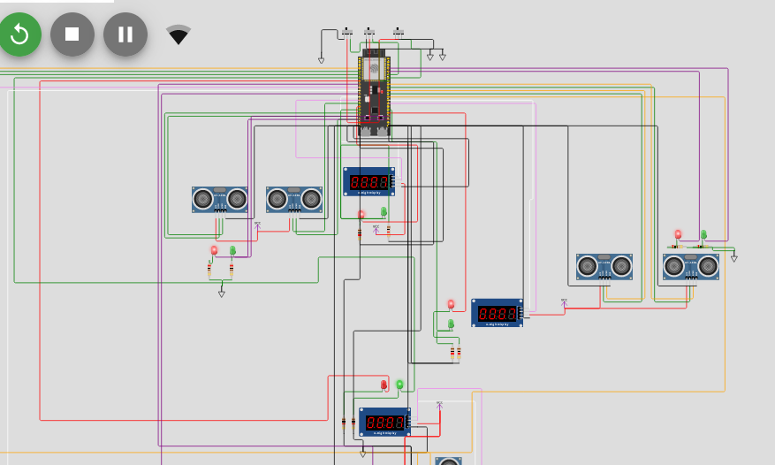

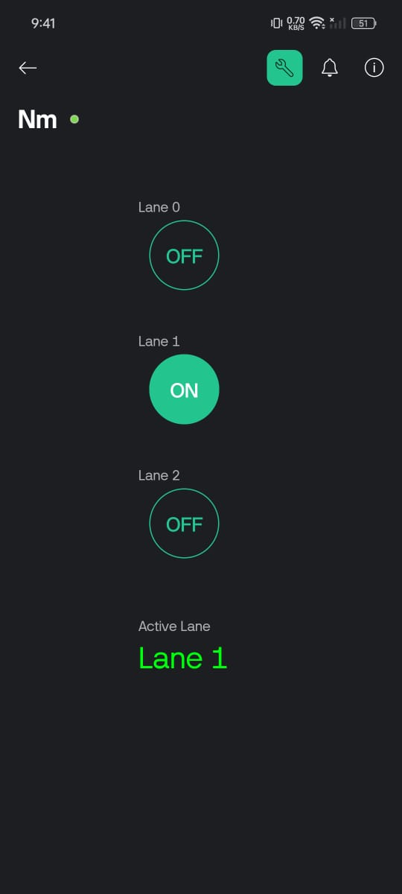

Fig 10(Using blynk Iot platform to control the traffic signal)

The lane can be controlled through a slide switch by the operator in case of emergency.  
After the emergency got cleared, the operator switches off the lane control and the timer resumes from where it is left off.

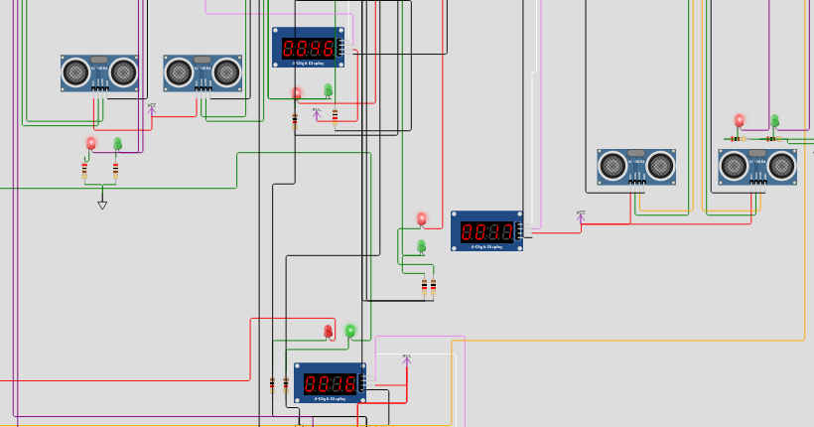

Fig 11(Timer resumes when the switches turned off)

## RESULTS:

Here are the promising results of the IoT-Based Smart Traffic Diversion System project. Each result highlights a key benefit or feature, demonstrating the system's potential to revolutionise urban traffic management

1. **Efficiency**: Reduced traffic congestion through dynamic signal adjustments.

2. **Integration**: Seamless control and monitoring using the Blynk mobile application.

3. **Adaptability**: Real-time signal changes based on traffic levels.

4. **Environmental**: Lowered emissions and improved air quality.

5. **Savings**: Reduced travel time and fuel consumption.

6. **Emergency**: Prioritised lanes for ambulance and emergency vehicles.

7. **Innovation**: Modern solution to outdated fixed-cycle traffic signals.

8. **Detection**: Accurate vehicle and pedestrian detection with ultrasonic sensors.

9. **Analysis**: Real-time data analysis for informed decision-making.

10. **Testing**: Validated performance under various traffic conditions.

11. **User-Friendly:** Easy-to-use Blynk interface for traffic authorities.

12. **Sustainability:** Long-term reduction in urban congestion and environmental impact.

13.**Accessibility**: Improved access to traffic control for authorities via mobile interface.

14.**Convenience**: Streamlined traffic management processes.

15. **Impact:** Significant overall improvement in urban mobility and traffic management.

## CHALLENGES AND RESOLUTIONS:

**1. Technology Integration**

**Challenge:**

Integrating new technology with the current traffic control systems can be difficult due to differences in technology and hardware. This brings a challenge of compatibility with the existing system.

**Resolution:**

Development of the system using a modular approach allows new technologies to integrate easily with existing infrastructure and enables future upgrades without complete overhauls.

**2. Data Management**

**Challenges:**

Handling large volumes of real-time data from sensors and cameras can be complex and resource-intensive.

**Resolution:**

Implement robust encryption protocols and secure data storage solutions to protect sensitive information and ensure compliance with data protection regulations.

**3. Real-Time Responsiveness**

**Challenge:**

The system needs to process and respond to traffic data in real-time, which can be technically challenging. Ensuring the system can scale to accommodate varying traffic volumes and conditions without performance degradation is also a major challenge.

**Resolution:**

Use edge computing to process data locally at intersections, reducing latency and improving real-time responsiveness. Designing the system architecture to be scalable, allows it to handle increased data loads and traffic conditions efficiently.

**4. Traffic Coordination and Synchronisation**

**Challenge:**

Adjusting traffic signals at one intersection can impact others nearby, requiring careful coordination. Diverting traffic from congested areas can create new congestion points elsewhere.

**Resolution:**

Establishing a centralised control centre to monitor and manage traffic signals across multiple intersections, ensures coordinated adjustments.

**5. Public Acceptance and Awareness**

**Challenge:**

Gaining public acceptance of the new system requires educating the public on its benefits and operation. Encouraging drivers and pedestrians to adapt to new traffic patterns and signal changes.

**Resolution:**

Conduct campaigns to inform the public about the system’s benefits and educate them on adapting to new traffic patterns. Engage with local communities and stakeholders to gather feedback and address concerns, fostering public support.

## 

## 

## 

## CONCLUSION:

The Smart Traffic Diversion System represents a significant advancement in traffic management by leveraging IoT technology to create a more adaptive and responsive network. By integrating real-time vehicle and emergency detection through sensors , this system addresses the inefficiencies of static traffic signals.

This innovative approach not only improves traffic flow and reduces waiting times but also promotes public safety and operational efficiency. The challenges of technology integration, data management, real-time responsiveness, and public acceptance are met with robust resolutions including modular design, edge computing, centralised traffic management, and comprehensive public awareness campaigns.

Ultimately, this project lays the groundwork for smarter, safer, and more efficient urban mobility solutions, paving the way for future enhancements and scalability across diverse urban environments. The successful implementation of this system promises to transform traffic management, reduce congestion, and significantly improve the quality of urban life.

## REFERENCES:

* <https://www.researchgate.net/publication/325681813_Traffic_Signal_Coordination_by_Alternate_Progressive_System_and_Simultaneous_System_on_Selected_Stretch_of_Ahmedabad>
* <http://nap.nationalacademies.org/22097>
* <https://www.ijeat.org/wp-content/uploads/papers/v9i3/C6331029320.pdf>