**BANK MANAGEMENT SYSTEM**

**1.Aim of the Project**

The primary aim of the Bank Management System project is to design and develop an efficient and user-friendly system using Python's Object-Oriented Programming (OOP) principles. The system aims to streamline the management of banking operations by providing functionalities such as account creation, transaction handling, and customer information management.

By implementing OOP concepts such as encapsulation, inheritance, and polymorphism, the project seeks to create a modular, secure, and scalable solution. This ensures data integrity, simplifies future maintenance, and enhances the overall efficiency of banking operations while reducing manual errors.

**2.Business Problem and Problem Statement**

In today's fast-paced world, banks manage a massive volume of customer accounts and transactions daily. Manual processes or poorly designed systems often lead to inefficiencies such as data inconsistencies, time delays, security risks, and operational errors. These challenges hinder banks from providing seamless and secure services to their customers, impacting customer satisfaction and operational reliability.

The Bank Management System project addresses these problems by introducing a digital solution designed with Object-Oriented Programming (OOP) principles. This system automates core banking functionalities, including account creation, deposits, withdrawals, and transaction tracking.

**The problem this project aims to solve includes:**

1. **Manual Errors:** Inconsistencies in transaction recording and account management caused by human errors.
2. **Inefficiency:** The time-intensive nature of manual operations reduces productivity and increases turnaround times for customers.
3. **Lack of Security:** Manual record-keeping or basic systems often expose sensitive customer data to breaches.
4. **Scalability Issues: Traditional systems struggle to handle a growing number of customers and transactions.**

**3.Project Description**

The Bank Management System is a software application designed to simulate banking operations like account management, balance inquiries, deposits, withdrawals, and transaction history. Built using Python's Object-Oriented Programming (OOP) principles, the system emphasizes modularity, reusability, and scalability.

**Key Features**

1. **Account Creation and Management**
   * **Create new accounts with unique account numbers.**
   * **Store customer details such as name, address, phone number, and account type (savings/current).**
   * **Update customer information.**
2. **Deposit and Withdrawal**
   * **Perform secure deposits to accounts.**
   * **Allow withdrawals with balance validation to prevent overdrafts.**
3. **Balance Inquiry**
   * **Display the current balance of the customer's account.**
4. **Transaction History**
   * **Record and display transaction logs for deposits and withdrawals.**
5. **Account Closure**
   * **Option to deactivate or permanently delete an account.**
6. **Search Functionality**
   * **Search for accounts using account numbers or customer names.**

**4.Functionalities**

* **__init__(self):**

**Purpose:** Initializes the bank management system with an empty dictionary called accounts, which will store multiple Bank Account objects.

* **Create account(self):**

**Purpose:** Allows the user to create a new account by providing an account number, name, and initial balance. It ensures that the account number is unique.

* **deposit_to_account(self):**

**Purpose:** Allows the user to deposit money into an existing account. The user provides an account number and deposit amount.

* **check_balance(self):**

Allows the user to check the balance of a specific account by entering the account number.

* **display_account(self):**

Displays the details of a specific account by entering the account number.

* **display_all_accounts(self):**

Displays the details of all the accounts stored in the system. If no accounts exist, it prints a message indicating that no accounts are available.

* **start(self):**

The main loop that runs the bank management system. It provides the user with options to create an account, deposit, withdraw, check balances, display accounts, and exit.

**5.Error Handling**

The system handles common errors, such as invalid inputs, insufficient funds, and duplicate account numbers, providing appropriate messages**.**

* **Input Validation**: Checks for invalid inputs (e.g., negative balances, invalid transaction counts).
* **Custom Exception Messages**: Provides specific error messages to guide the user.
* **Graceful Handling of Nonexistent Accounts**: Handles cases where users input icorrect account numbers.
* **Error Feedback**: Ensures users are notified of any errors and can reattempt valid operations.

**6.Code Implementation**

The provided code for a bank management system includes the necessary functions to,

1. Create accounts
2. Perform deposits and withdrawals
3. Check balance
4. Display account details
5. Use of class for creating modular and reusable components.
6. Algorithms for transaction processing and account verification.
7. Data structures like lists or dictionaries for maintaining account and transaction data.

**7.Future Extensions**

* **Authentication**: Add user authentication with PINs or passwords to secure accounts.
* **Interest Calculation**: Implement interest calculation for savings accounts.
* **Transaction History**: Maintain a transaction log for each account to track deposits, withdrawals, and other activities.
* **Graphical User Interface (GUI)**: Develop a GUI using frameworks like Tkinter or PyQt to make the system more user-friendly.
* **Database Integration**: Connect the system to a database (e.g., SQLite or MySQL) for persistent storage of account data.

**8.Results**

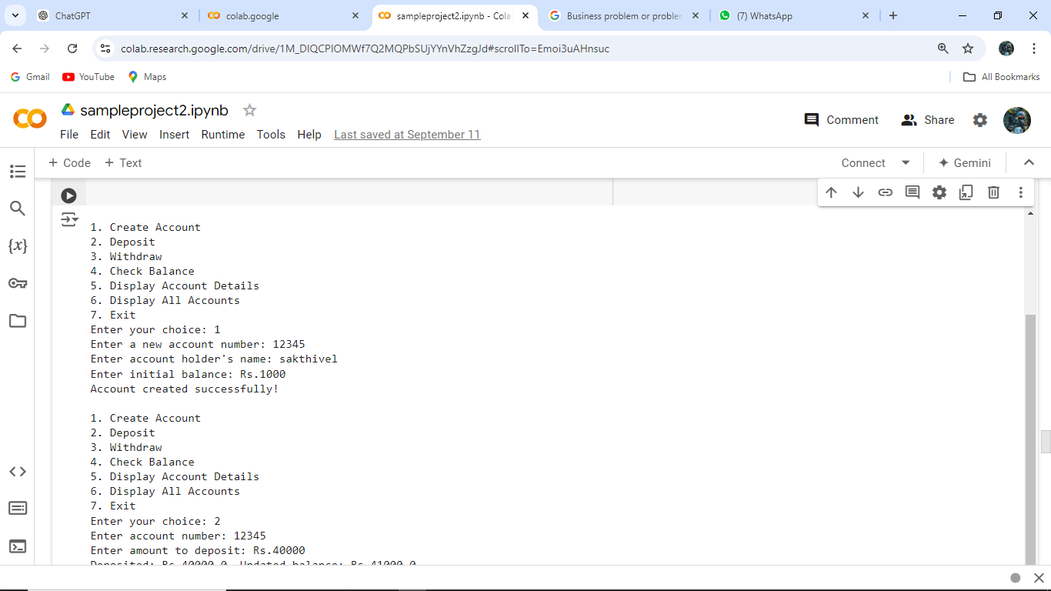

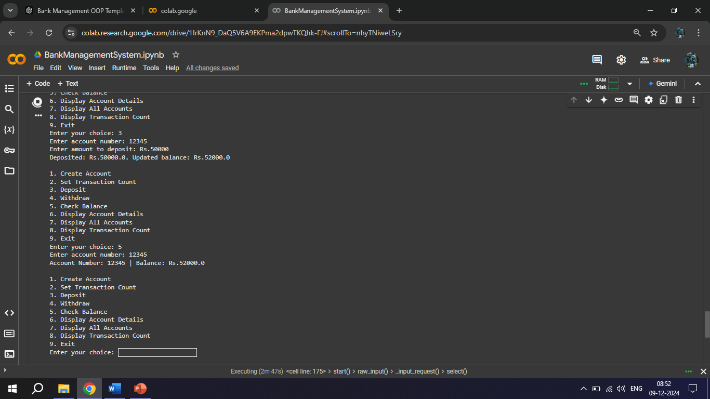

**9.Conclusions**

The Bank Management System project provides a basic simulation of how a real-world bank operates, focusing on account management and transactional operations. This project is ideal for learning object-oriented programming concepts, file handling, and the basics of financial systems. It can be expanded into a more robust system with advanced features such as security and transaction history logging.