# Setup / Configure Active Directory:

## Add new Server roles Active Directory Domain Services.

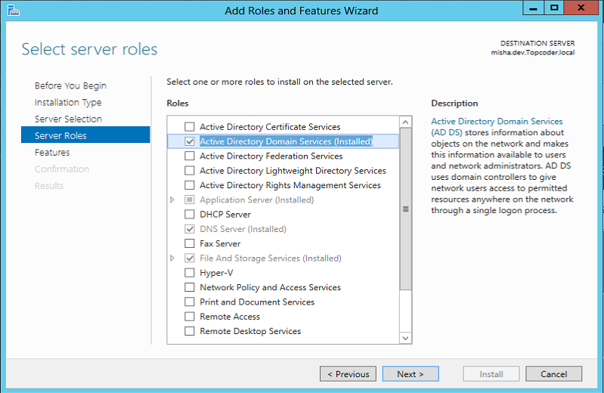

## Configure Active Directory Domain Services:

After install, open AD Administrative Center:

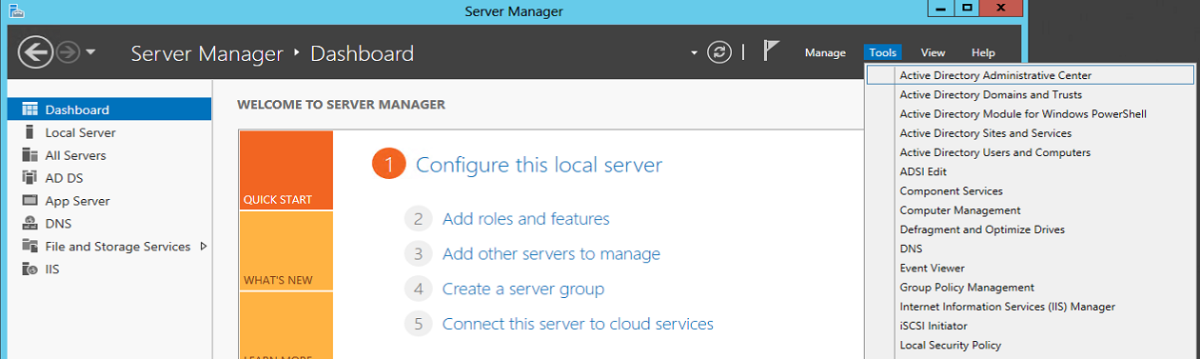

### 4.2.1 After opening, follow the instructions to configure Active Directory Domain Services

#### 4.2.1.1 Add a new forest

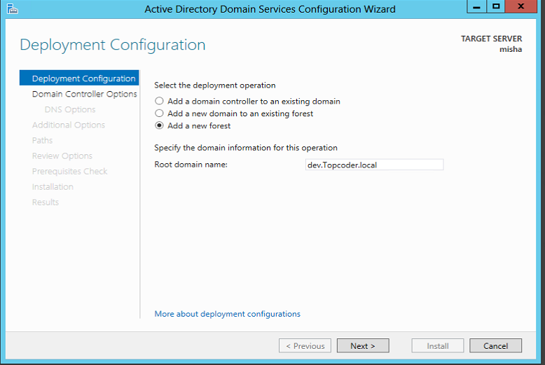

#### 4.2.1.2 Setup the forest functional level and DSRM password:

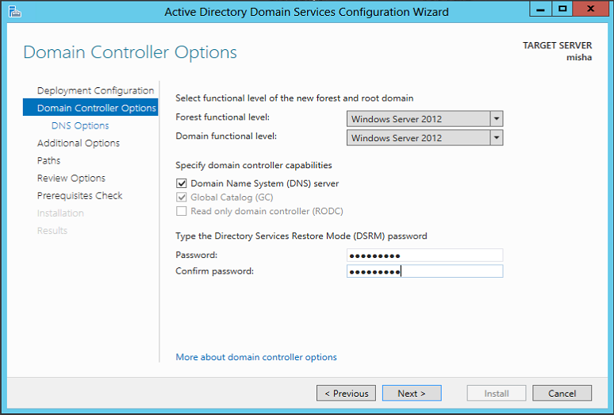

#### 4.2.1.3 DNS delegation options

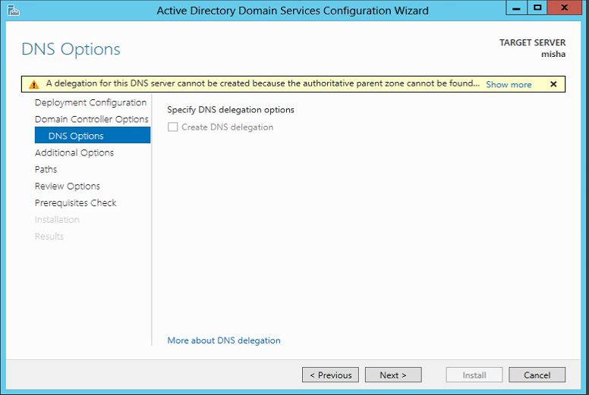

#### 4.2.1.4 Domain Name

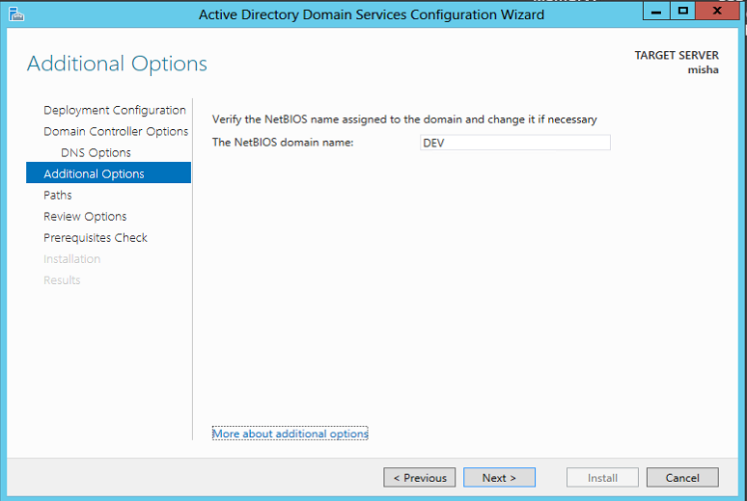

#### 4.2.1.5 Paths

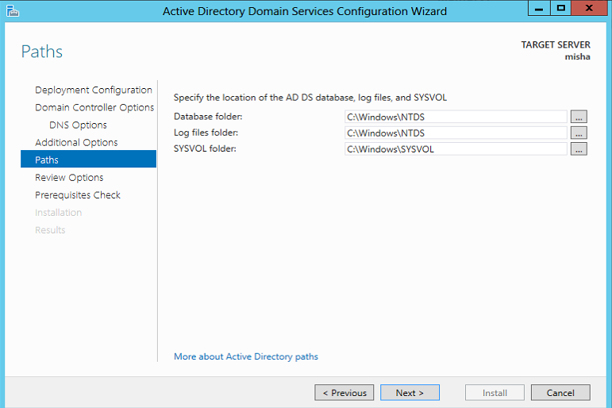

#### 4.2.1.6 Review Options

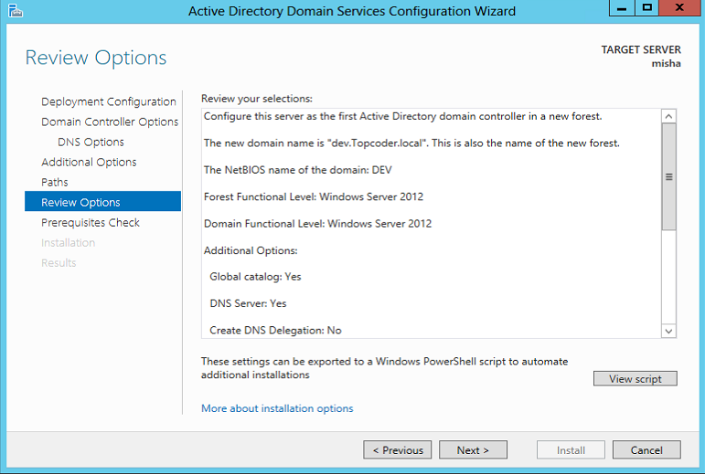

#### 4.2.1.7 Prerequisites and Install

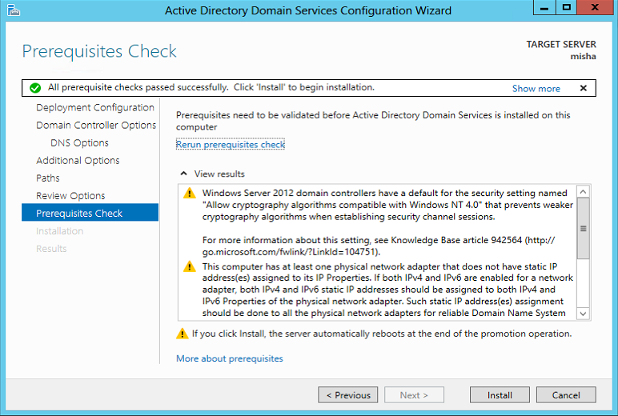

After finishing, it will restart the server to complete installation.

## Configure Users and Roles

Open Active Directory Administrative Center to configure user and roles:

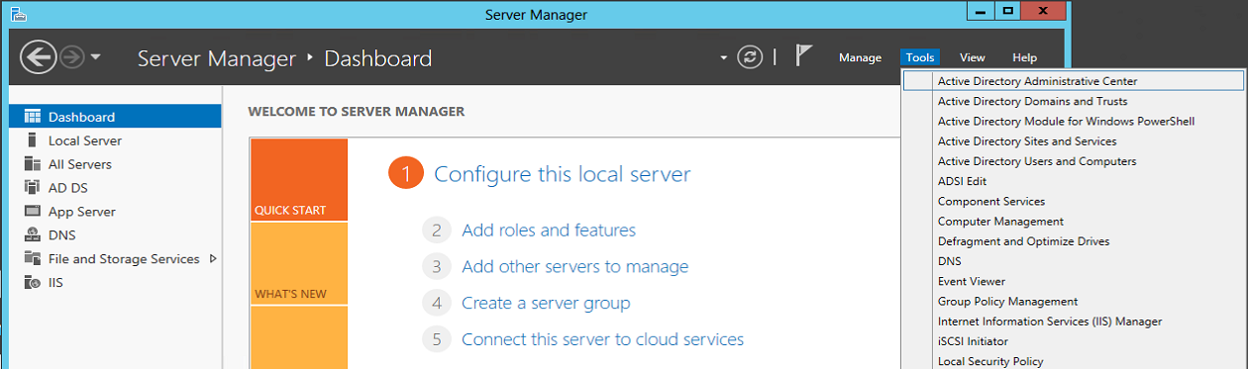

Now you can create users and roles based on need.