VIRTUAL COMPUTE WALLET
Embedded GPU Credit Module
zypl.ai × Zinda Capital
━━━━━━━━━━━━━━━━━━━━━━━━━━━━━━━━━━━━━━━━
On-demand GPU compute access via Zinda Internet Banking
NVIDIA H200 • TJS Wallet • Prepaid & Credit Models
PRODUCT SPECIFICATIONS • CUSTOMER JOURNEY MAP (CJM)
BUSINESS MODEL • SYSTEM ARCHITECTURE • FLOW DIAGRAM

Document version: v2.0 | June 2026
Post-meeting update: Akai Akmal (Visa) feedback incorporated
Confidential

TABLE OF CONTENTS
1. Product Specifications
1.1 Product Identity (v1.0 vs v2.0)
1.2 Value Proposition
1.3 Technical Specifications
1.4 Key Infrastructure Metrics
1.5 Participants & Roles
2. Product Architecture
2.1 System Architecture Diagram
2.2 Backend: TJS Wallet Account
2.3 Frontend: Visual Compute Interface
2.4 API Integration Points
3. Dual Product Models
3.1 Model A: Prepaid Wallet (Recommended)
3.2 Model B: Credit Limit
3.3 Model Comparison
4. Customer Journey Map (CJM)
4.1 Visual Journey Map
4.2 Journey Stage Details
4.3 v1.0 vs v2.0 CJM Changes
4.4 Pain Points & Solutions
5. Business Model
5.1 Business Model Canvas
5.2 Financial Projections
5.3 Competitive Analysis
6. System Flow Diagram
6.1 Process Flow (Swimlane)
6.2 Process Step Descriptions
7. Advantages of New Architecture
8. Implementation Roadmap
9. Open Questions & Next Steps

IMPORTANT: PRODUCT PIVOT NOTICE
Following the meeting with Akai Akmal (Visa representative) on June 2, 2026, the product has been pivoted from a physical co-branded Visa card to an embedded digital module within Zinda's Internet Banking platform.
Constraint | Detail
Visa BIN requirement | Visa requires 10,000+ cards to issue a dedicated BIN — impractical for a niche GPU compute pilot
Per-card compliance | Each printed card requires specific Visa compliance certification
Recommendation | Akai Akmal recommended embedding the product inside Zinda Internet Banking as an "Embedded GPU Credit Module" or "Virtual Compute Wallet"
New form factor | TJS wallet with a front-end visual and back-end on a wallet account — no physical card

1. PRODUCT SPECIFICATIONS
1.1 Product Identity — v1.0 vs v2.0
Parameter | v1.0 (Old) | v2.0 (Current)
Product Name | GPU Credit Card | Virtual Compute Wallet
Working Title | GPU Credit Card | "Cloud Compute" module
Product Type | Physical co-branded Visa card | Embedded module in Zinda Internet Banking
Form Factor | Physical plastic card | Digital wallet with front-end UI
Backend | Card payment rail + Visa BIN | TJS wallet account on Zinda's ledger
Card Issuance | Zinda issues physical card | No card — user activates module in-app
Visa Dependency | Required (BIN, co-branding) | None — fully in-house via Zinda
Regulatory Path | Card product regulation | E-wallet / prepaid instrument regulation
Market | Tajikistan | Tajikistan
Infrastructure Provider | zypl.ai (GPU fleet) | zypl.ai (GPU fleet + scoring)
Target Hardware | NVIDIA H200 (141 GB HBM3e) | NVIDIA H200 (141 GB HBM3e)
Payment Model | Pay-per-use GPU-hours | Prepaid wallet OR credit limit
Currencies | TJS / USD | TJS / USD

1.2 Value Proposition
🎯 Problem: Tajikistan has no domestic GPU-on-demand offering. The Darya cluster serves only zypl.ai and UZCARD. Researchers and startups must use foreign clouds with premium pricing, FX friction, and data sovereignty risks.
💡 Solution: An embedded module inside Zinda Internet Banking provides instant access to NVIDIA H200 GPU compute. Users fund a TJS wallet and click "Launch Server" — no physical card, no FX, no foreign account.
🏆 Competitive Advantage: Zero domestic competition. Sovereign compute rail. Pricing 8-10x lower than major clouds (AWS, GCP, Azure). Leverages Zinda's existing user base — no new KYC needed.
🚀 Scaling Strategy: Pilot with 4 GPUs validates the rail and locks demand. Linear scaling: 100 GPUs = $2.25M-$4.25M/year revenue.
1.3 Technical Specifications
Parameter | Value | Notes
GPU Model | NVIDIA H200 SXM | Flagship AI GPU, Hopper architecture
GPU Memory | 141 GB HBM3e | Largest available on market
Pilot Pool | 4× H200 | Single physical server
Unit of Allocation | 1× H200 per session | Dedicated access
Max Concurrent Sessions | 4 | Limited by pool size
Total GPU-hours/month | 2,880 hrs | 4 GPUs × 720 hours
Market Rate | $3-4 / GPU-hour | Competitive with Lambda Cloud
Billing | Real-time metering | zypl.ai API → Zinda ledger
Wallet Currency | TJS (Tajikistani Somoni) | With USD display equivalent

1.4 Key Infrastructure Metrics
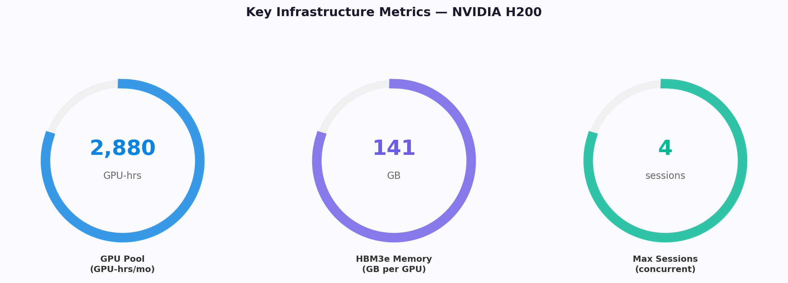

1.5 Participants & Roles
Participant | Role | Responsibilities
Zinda Capital | Platform owner,  wallet issuer | Internet banking UI, wallet management, KYC, billing, credit underwriting, regulatory compliance
zypl.ai | Infrastructure provider,  credit scoring engine,  default guarantor | GPU fleet operations (4× H200), instance provisioning, GPU-hour metering, scoring API, usage reporting. Guarantees 50% of defaulted credit after 90 DPD (Days Past Due).
End User  (Individual) | Consumer  (Mobile Wallet) | Researchers, professors, university teachers of AI — accesses via dedicated mobile wallet app. Wallet is purpose-locked: funds can ONLY be used for GPU compute.
End User  (Company) | Consumer  (Internet Banking) | AI startups, tech companies, financial companies, fintechs — accesses via Zinda Internet Banking. Dedicated e-wallet account purpose-locked for GPU compute only.
Central Bank  of Tajikistan | Regulator | E-wallet/prepaid instrument oversight, credit product licensing (for v2)

2. PRODUCT ARCHITECTURE
The Virtual Compute Wallet is implemented as an embedded module within Zinda's Internet Banking platform. The frontend provides a visual compute interface; the backend runs on a TJS wallet account within Zinda's ledger, integrated with zypl.ai's GPU provisioning API.
2.1 System Architecture Diagram
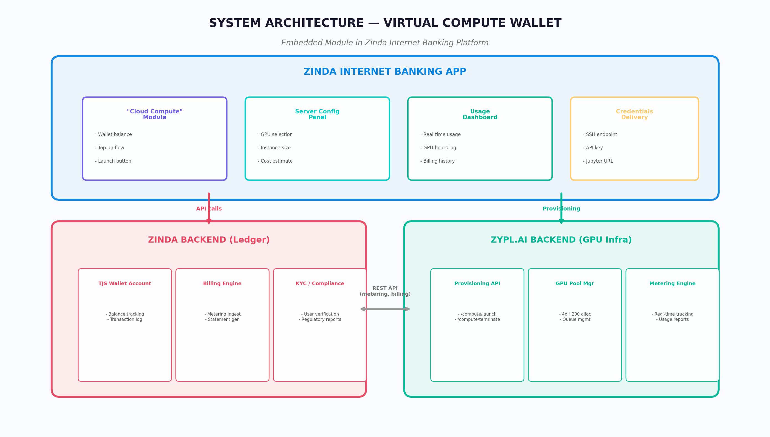

2.2 Backend: TJS Wallet Account
Component | Description
Account Type | Dedicated e-wallet / internet banking account (NOT a general-purpose account)
Purpose Lock | Funds are PURPOSE-LOCKED: can ONLY be used for GPU compute services. Cannot be transferred, withdrawn, or applied to any other purpose.
Currency | TJS (Tajikistani Somoni), with USD display equivalent
Ledger | Zinda's core banking ledger
Balance Types | Prepaid balance (user-funded) OR Credit balance (Zinda-issued limit, scored by zypl.ai)
Transaction Model | Debit from wallet → credit to zypl.ai per GPU-hour consumed
Reconciliation | Real-time metering feed from zypl.ai API → Zinda ledger entries
Channel: Mobile Wallet | For individual researchers, university professors, teachers of AI — dedicated mobile wallet app with purpose-locked GPU compute funds
Channel: Internet Banking | For AI startups, tech companies, financial companies, fintechs — dedicated e-wallet account within Zinda Internet Banking, purpose-locked for GPU compute

2.3 Frontend: Visual Compute Interface
UI Component | Description
Module Entry | "Cloud Compute" tab/section in the main Zinda app navigation
Wallet View | Shows current TJS balance, available GPU-hours equivalent, usage history
Server Launcher | "Launch Server" button that triggers backend API call to zypl.ai
Configuration Panel | GPU type selection (H200), instance size, estimated cost display
Usage Dashboard | Real-time GPU utilization, cost accumulation, session history
Top-up Flow | Add funds from linked bank account or card
Terms & Conditions | One-time acceptance screen on first access to the module

2.4 API Integration Points
API Endpoint | Direction | Purpose
POST /api/v1/compute/launch | Zinda → zypl.ai | Request GPU instance provisioning
POST /api/v1/compute/terminate | Zinda → zypl.ai | Terminate active GPU session
GET /api/v1/compute/status | Zinda → zypl.ai | Check instance status and availability
POST /api/v1/metering/report | zypl.ai → Zinda | Push real-time usage data (GPU-hours, cost)
POST /api/v1/scoring/evaluate | Zinda → zypl.ai | Request credit score for credit model users
GET /api/v1/pool/availability | Zinda → zypl.ai | Check GPU pool availability before showing UI

3. DUAL PRODUCT MODELS
Clients can access GPU compute via two models: a prepaid wallet (recommended for v1 launch) and a credit limit (planned for v2 after validation). Both models operate within the same "Cloud Compute" module in the Zinda app.
3.1 Model A: Prepaid Wallet (★ Recommended for v1)
Parameter | Value
How it works | User tops up TJS wallet → funds converted to GPU-hours at current rate → consumed on use
Minimum top-up | TBD (suggested: 100 TJS / ~$10)
Credit risk | Zero — fully pre-funded by the user
Regulatory path | Simple — standard e-wallet/prepaid instrument
Time to market | 2-3 months
KYC requirements | Standard Zinda KYC (already completed for existing IB users)

3.2 Model B: Credit Limit (Planned for v2)
Parameter | Value
How it works | Zinda extends a credit limit based on zypl.ai scoring → user consumes GPU-hours → pays according to fee schedule
Credit scoring | zypl.ai scoring system (existing infrastructure)
Credit limit | Determined per-user by scoring model
Credit risk | Managed via zypl.ai scoring + usage limits + auto-terminate on limit breach
Default guarantee | zypl.ai GUARANTEES 50% of defaulted loan amounts after 90 DPD (Days Past Due)
Regulatory path | Requires credit product licensing from Central Bank of Tajikistan
Time to market | 6-9 months (after v1 pilot validation)
Max tenor | Up to 24 months

3.2.1 Credit Fee Schedule
The credit product uses a progressive fee structure. The bank fee starts at 0% for the first month and increases gradually over the tenor up to 24 months:
Month | Bank Fee (%) | Cumulative Effect | Notes
Month 1 | 0% | Free trial period | Zero cost to attract users and validate demand
Month 2 | 1% | Low entry fee | Minimal fee to begin revenue generation
Month 3 | 2% | Gradual increase | Encourages timely repayment
Month 6 | 3% | Mid-term rate | Standard fee for medium-term usage
Month 9 | 4% | Increasing incentive | Higher fee incentivizes earlier repayment
Month 12 | 5% | Annual rate | Maximum rate for 12-month tenor
Month 13-24 | 5% (capped) | Extended tenor | Fee remains at 5% cap through month 24

3.2.2 Default Guarantee Mechanism
Parameter | Value
Guarantor | zypl.ai
Guarantee coverage | 50% of defaulted loan principal
Default trigger | 90 DPD (Days Past Due) — loan classified as default after 90 days of non-payment
Guarantee execution | zypl.ai reimburses Zinda Capital 50% of the outstanding principal upon 90 DPD classification
Remaining 50% | Zinda Capital bears the remaining 50% risk (covered by interest income and fee schedule revenue)
Risk mitigation | zypl.ai's credit scoring model pre-screens users to minimize defaults; auto-terminate GPU sessions when credit limit is reached

3.3 Model Comparison
Characteristic | A: Prepaid Wallet  (★ RECOMMENDED for v1) | B: Credit Limit
Principle | User deposits TJS → converts to GPU-hours → consumes | Zinda extends credit line, user consumes, pays at cycle end
Credit risk | None (prepaid) | High (requires underwriting)
Compliance | Simple (standard prepaid) | Complex (credit product)
User attraction | Medium barrier | Low barrier — "train now, pay later"
Launch complexity | Low | High — needs scoring model calibration
Speed to market | 2-3 months | 6-9 months
Recommendation | ★ RECOMMENDED for v1 | For v2 after pilot validation

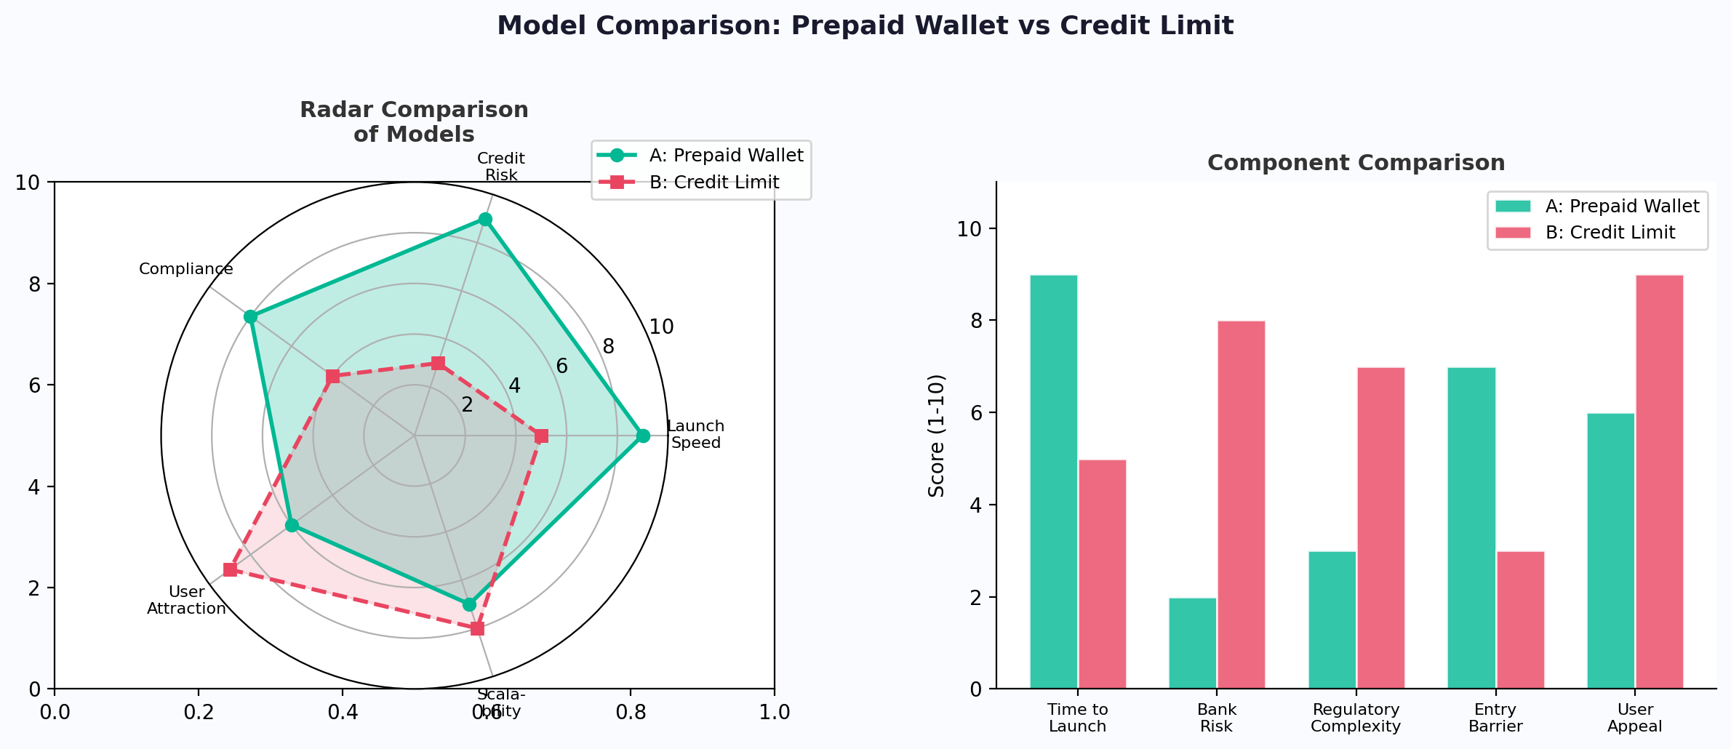

4. CUSTOMER JOURNEY MAP (CJM)
The customer journey has been fundamentally simplified by removing the physical card issuance step. All interactions now happen within the Zinda Internet Banking app. The journey covers the full cycle from discovery to retention.
4.1 Visual Journey Map
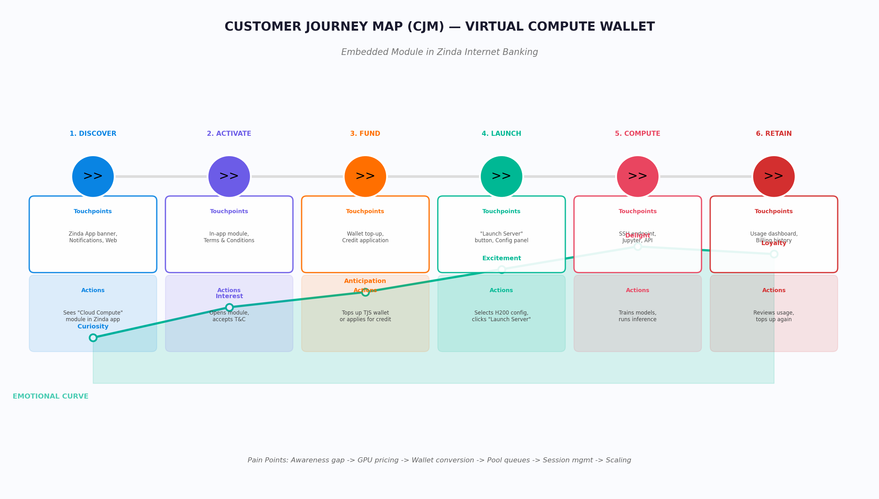

4.2 Journey Stage Details
Step | Action | Actor | Channel | Detail
1 | Navigate to "Cloud Compute" module | User | Zinda IB App | User opens the app, sees the new "Cloud Compute" section
2 | Accept Terms & Conditions | User | In-app modal | One-time acceptance of GPU compute service terms
3 | Choose product model | User | In-app | Select Prepaid (top-up wallet) or Credit (apply for limit)
3a | Top-up wallet (Prepaid) | User | In-app transfer | Transfer TJS from linked bank account to compute wallet
3b | Apply for credit limit (Credit) | User → zypl.ai | Backend scoring | zypl.ai scoring system evaluates and sets credit limit
4 | Configure & Launch Server | User | "Launch Server" button | Select H200 config, click "Launch Server" → triggers API call
5 | Backend authorization | System | Zinda → zypl.ai API | Zinda checks balance/credit → calls zypl.ai provisioning endpoint
6 | GPU provisioned | zypl.ai | Backend | H200 instance allocated, endpoint + credentials generated
7 | Receive access credentials | User | In-app notification | SSH endpoint, API key, and Jupyter URL delivered in-app
8 | Use GPU | User | SSH / Jupyter / API | Train models, run inference, process data on H200
9 | Real-time metering | zypl.ai → Zinda | API feed | GPU-hours consumed, wallet balance decremented in real-time
10 | Session end & billing | System | Automated | Session terminated (user-initiated or balance depleted), final bill settled

4.3 v1.0 vs v2.0 CJM Changes
Aspect | v1.0 (Physical Card) | v2.0 (Embedded Module)
Onboarding | Visit branch → KYC → receive physical card | Open app → navigate to module → accept terms
Authorization | Tap physical card at terminal | Click "Launch Server" button in-app
Payment trigger | Card swipe/tap authorization | Backend API call from Zinda ledger to zypl.ai
Delivery | Wait for card printing & delivery | Instant — already in internet banking
User friction | High (branch visit, card wait, Visa compliance) | Very low (2-3 taps in existing app)
Visa dependency | Required (BIN, 10K+ cards) | None

4.4 Pain Points & Solutions
Pain Point | Current Situation | Virtual Compute Wallet Solution
No domestic GPU | No GPU-on-demand offering in Tajikistan | Sovereign GPU pool (NVIDIA H200) accessible via Zinda app
FX friction | Paying foreign clouds requires currency conversion + fees | All transactions in TJS via Zinda wallet — zero FX
Data sovereignty | Data stored on foreign servers (AWS, GCP, Azure) | All infrastructure located in Tajikistan
High cost | AWS/GCP/Azure: $28-35/hr for H200 equivalent | Virtual Compute Wallet: $3-4/hr (85-90% savings)
Complex access | Register on foreign platforms, foreign KYC, credit card | One-click access in existing Zinda app — no new KYC
Physical card barriers | Visa requires 10K+ cards, BIN issuance, per-card compliance | No physical card needed — embedded digital module

5. BUSINESS MODEL
5.1 Business Model Canvas
Visual representation of all business model components for the Virtual Compute Wallet following the Osterwalder methodology. Updated to reflect the embedded module architecture.
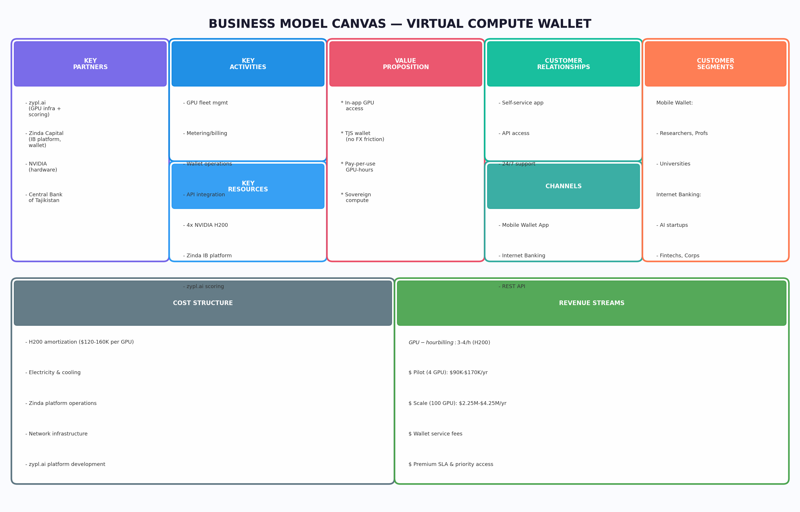

Component | Description
Key Partners | • zypl.ai — GPU infrastructure provider (4× H200), provisioning, metering, credit scoring  • Zinda Capital — Internet banking platform, wallet operations, KYC, billing  • NVIDIA — GPU hardware supplier  • Central Bank of Tajikistan — Regulator
Key Activities | • GPU fleet management and instance provisioning via API  • Real-time GPU-hour metering and wallet balance management  • Credit scoring and limit management (v2)  • KYC verification and regulatory compliance  • API integration between Zinda ledger and zypl.ai infrastructure
Value Proposition | • Instant GPU access via Zinda Internet Banking app  • TJS wallet — no FX friction, no foreign accounts  • Pay only for GPU-hours consumed  • Sovereign compute — data stays in Tajikistan  • 8-10x cheaper than major cloud providers
Customer Segments | MOBILE WALLET (Individuals):  • Researchers, professors, teachers of AI  • University students and academics  INTERNET BANKING (Companies):  • AI startups and tech companies  • Financial companies and fintechs  • Other enterprises
Revenue Streams | • GPU-hour billing: $3-4/hr (H200)  • Pilot (4 GPU): $90K-$170K/year  • Scale (100 GPU): $2.25M-$4.25M/year  • Wallet service/maintenance fees  • Premium SLA and priority access tiers
Cost Structure | • GPU hardware amortization ($120-160K per H200)  • Electricity and cooling for data center  • Zinda platform operations (IB module, wallet system)  • zypl.ai platform development and maintenance  • Compliance and regulatory costs

5.2 Financial Projections
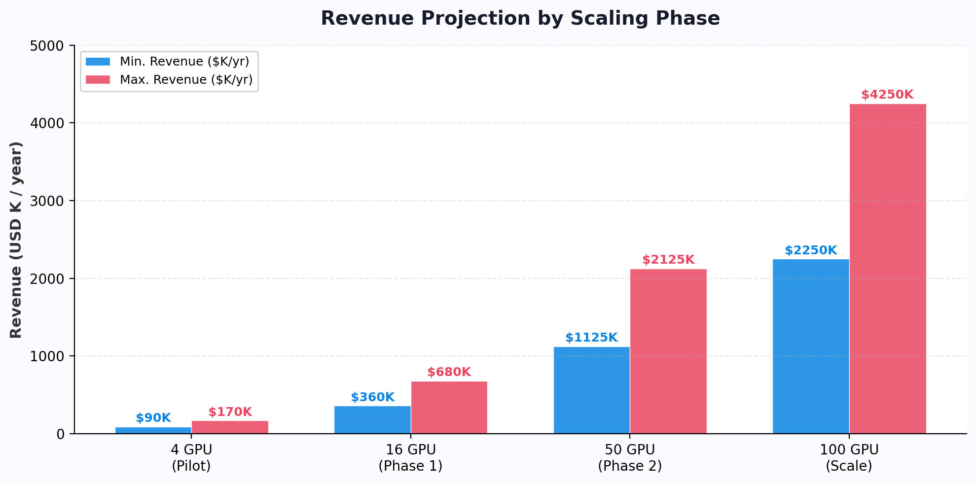

Phase | # GPUs | GPU-hrs/mo | Min Revenue/yr | Max Revenue/yr | Notes
Pilot | 4 | 2,880 | $90K | $170K | Proof of concept, validate the rail
Phase 1 | 16 | 11,520 | $360K | $680K | Initial scaling
Phase 2 | 50 | 36,000 | $1.125M | $2.125M | Regional growth
Scale | 100 | 72,000 | $2.25M | $4.25M | Full deployment
※ Note: The pilot is supply-bound, not demand-bound. Revenue scales linearly with GPU count while maintaining utilization.
5.3 Competitive Analysis
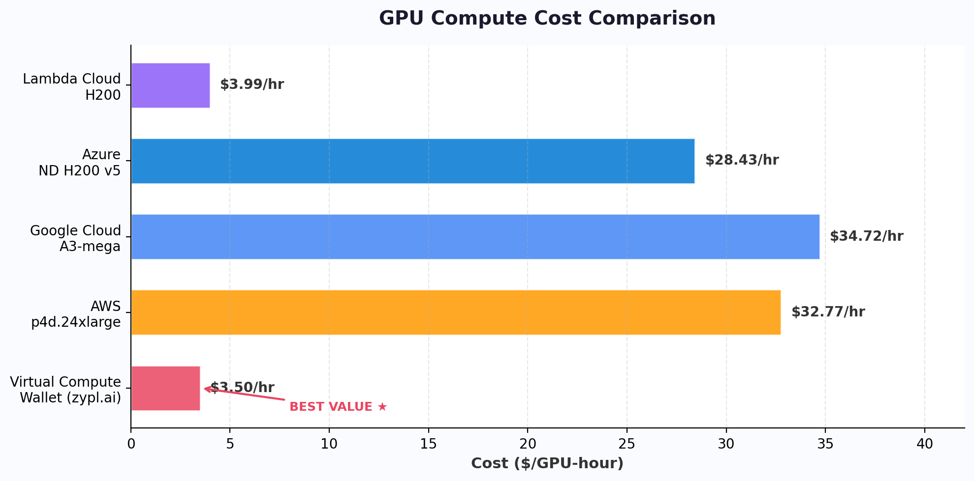

Provider | $/GPU-hr | Available in TJ | Data Sovereignty | Payment Rail
Virtual Compute Wallet | $3-4 | ✅ Yes | ✅ Full | ✅ TJS wallet via Zinda app
AWS (p4d) | $32.77 | ❌ No | ❌ Foreign servers | ⚠️ FX + intl card
Google Cloud (A3) | $34.72 | ❌ No | ❌ Foreign servers | ⚠️ FX + intl card
Azure (ND H200) | $28.43 | ❌ No | ❌ Foreign servers | ⚠️ FX + intl card
Lambda Cloud | $3.99 | ❌ No | ❌ Foreign servers | ⚠️ USD only

6. SYSTEM FLOW DIAGRAM
The diagram shows the complete system flow for the Virtual Compute Wallet — from the user's action in the Zinda Internet Banking app to GPU provisioning by zypl.ai and back. The flow is divided into three swimlanes: User, Zinda Capital (Ledger + API), and zypl.ai (GPU Infra).
6.1 Process Flow (Swimlane)
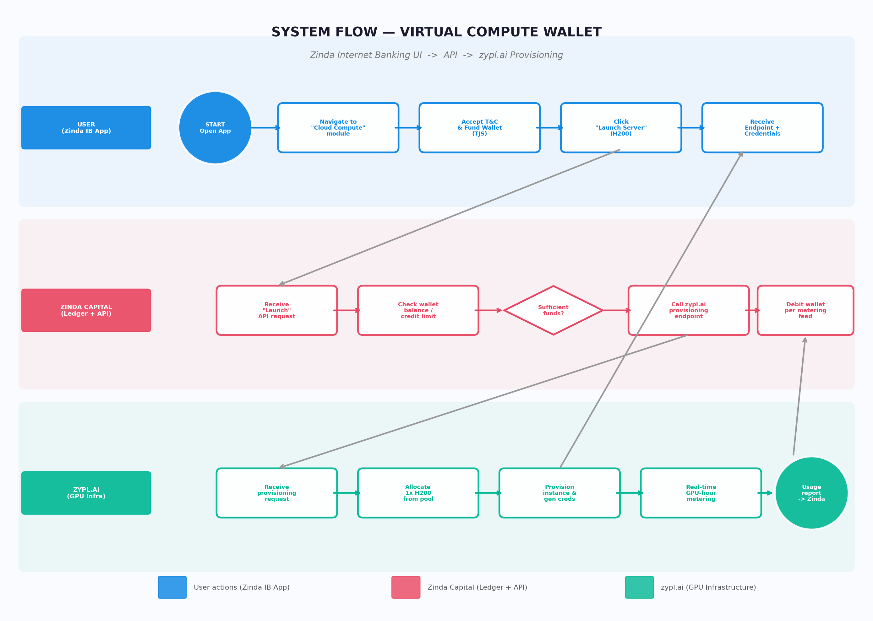

6.2 Process Step Descriptions
Step | Actor | Action | Description
1 | User | Open Zinda IB App | User opens the Zinda Internet Banking application on their device
2 | User | Navigate to "Cloud Compute" | User navigates to the new "Cloud Compute" module/tab within the app
3 | User | Accept T&C & Fund Wallet | Accepts terms (first time), then tops up TJS wallet or checks existing credit limit
4 | User | Click "Launch Server" | Selects H200 GPU configuration and clicks the "Launch Server" button
5 | Zinda | Receive launch request | Backend receives the "Launch Server" API request from the frontend
6 | Zinda | Check balance / credit | Ledger checks if user has sufficient wallet balance or credit limit
7 | Zinda | Call zypl.ai provisioning API | If funds sufficient, calls POST /api/v1/compute/launch on zypl.ai endpoint
8 | zypl.ai | Allocate GPU | Allocates 1× H200 from the 4-GPU pool, checks availability and queue
9 | zypl.ai | Provision instance | Launches the H200 instance, generates SSH endpoint, API key, and Jupyter URL
10 | User | Receive credentials | Gets endpoint + credentials delivered in-app. Begins working with GPU.
11 | zypl.ai | Real-time metering | Tracks GPU-hours consumed in real-time, pushes metering data to Zinda via API
12 | Zinda | Debit wallet | Decrements user wallet balance based on metering feed. Generates billing statements.

7. ADVANTAGES OF NEW ARCHITECTURE
The pivot from a physical co-branded Visa card to an embedded Internet Banking module provides significant advantages across cost, speed, compliance, and user experience:
Advantage | Detail
No Visa dependency | Eliminates BIN requirement, 10K card minimum, and per-card compliance certification
Faster time-to-market | No card printing, no Visa certification — just a software module in existing app
Lower cost | No plastic card manufacturing, no card network fees, no Visa royalties
Better user experience | In-app experience is smoother than physical card workflow — 2-3 taps to launch
Existing user base | Leverages Zinda's existing internet banking users — no new KYC needed
Flexible billing | Wallet-based billing is more granular than card authorization cycles
Dual model support | Easy to offer both prepaid and credit within the same UI without separate card products
Instant delivery | No waiting for card printing and delivery — module available immediately
Simpler regulation | E-wallet/prepaid is simpler to regulate than a co-branded card product

8. IMPLEMENTATION ROADMAP
8.1 Phase 1: MVP (Weeks 1-8)
Week | Task | Owner | Priority
1-2 | Finalize product specifications (this document) | Zinda + zypl.ai | 🔴 Critical
2-3 | Jointly design "Cloud Compute" module UI/UX wireframes | Zinda + zypl.ai | 🔴 Critical
3-4 | Finalize GPU-hour conversion rate & revenue split agreement | Zinda + zypl.ai | 🔴 Critical
3-5 | Build zypl.ai provisioning API endpoints | zypl.ai | 🔴 Critical
4-6 | Integrate Zinda ledger <-> zypl.ai metering API | Zinda + zypl.ai | 🟠 High
5-7 | Build front-end module in Zinda Internet Banking app | Zinda | 🟠 High
6-8 | Regulatory approval for e-wallet compute product | Zinda | 🟠 High
8 | Internal testing & QA | Both | 🟡 Medium

8.2 Phase 2: Pilot Launch (Weeks 8-12)
Week | Task | Owner | Priority
8-9 | Soft launch with 10-20 internal/partner users | Both | 🟠 High
9-10 | Monitor metering accuracy, billing flows, UX feedback | Both | 🟠 High
10-12 | Iterate on UI/UX and API based on pilot feedback | Both | 🟡 Medium

8.3 Phase 3: Public Launch + Credit Model (Weeks 12-24)
Week | Task | Owner | Priority
12-14 | Public launch of prepaid wallet model | Both | 🔴 Critical
14-18 | Develop credit scoring integration for credit model | zypl.ai | 🟠 High
18-20 | Regulatory approval for credit product | Zinda | 🟠 High
20-24 | Launch credit limit model (v2) | Both | 🟡 Medium

9. OPEN QUESTIONS & NEXT STEPS
9.1 Open Questions
# | Question | Impact | Status
1 | What is the agreed revenue split between Zinda (wallet/billing) and zypl.ai (infrastructure)? | Critical — determines financial viability for both parties | To be agreed
2 | What is the exact TJS → GPU-hour conversion rate? Fixed or floating with USD exchange rate? | Critical — affects user pricing and billing accuracy | To be decided
3 | How is the "Cloud Compute" wallet classified under Tajik law? E-money? Prepaid instrument? Service-linked wallet? | High — determines regulatory path and licensing requirements | To be clarified with regulator
4 | For the credit model (v2), will zypl.ai use existing consumer scoring or develop a GPU-specific scoring model? | Medium — affects credit model accuracy and risk | To be decided
5 | What are the minimum and maximum wallet top-up amounts? | Medium — affects user accessibility and risk management | To be decided

9.2 Immediate Next Steps
# | Action | Responsible | Deadline
1 | Finalize and sign off on product specifications (this document) | Zinda + zypl.ai | Week 1
2 | Jointly discuss and design product UI/UX (wireframes, user flows, branding) | Zinda + zypl.ai | Week 2-3
3 | Agree on GPU-hour conversion rate and revenue split model | Zinda + zypl.ai | Week 2-3
4 | Confirm regulatory classification of the compute wallet with Central Bank | Zinda Capital | Week 3-4
5 | Build and document zypl.ai provisioning API endpoints | zypl.ai | Week 3-5
6 | Establish API integration testing environment | Both | Week 4-5
7 | Begin front-end development of the embedded module | Zinda | Week 5-7

━━━━━━━━━━━━━━━━━━━━━━━━━━━━━━━━━━━━━━━━
Document prepared: June 2, 2026 | v2.0 (Post-meeting update)
Virtual Compute Wallet — zypl.ai × Zinda Capital
Embedded GPU Credit Module | Zinda Internet Banking
Confidential | For internal use only

