**Online Shop site**

**Software Requirement Specification**

**Salma EL-Sayed**

\

Contents

1.1 Project Introduction………………………………………………………..…..3

* 1.2 Project purpose………………………………………………………….….....3
* 1.3 Project scope…………………………………………………………….……..3
* 1.4 Use Case………………………………………………………………….…....4
* 1.5 High level scenario…………………………………..………..……….……...4
* 1.6 Context Diagram ……………………………………………………………...5
* 1.7 Class Diagram…………………………………………………………………6
* 1.8 Sequence Diagram……………………………………………………………7
* 1.9 References ……………………………………………………………………9

1. **Chapter 1:**

* 1. **Project Introduction**

.The central concept of the application is to allow the customer to shop virtually using the Internet and allow customers to buy the items and articles of their desire from the store. The Server process the customers and the items are shipped to the address submitted by them. The application was designed into two modules first is for the customers who wish to buy the articles. Second is for the storekeepers who maintains and updates the information pertaining to the articles and those of the customers.

* 1. **Project Purpose**​ ( summary for its impact)

The Purpose of the project is to make an application to purchase items in an existing shop. In order to build such an application complete web support need to be provided. A complete and efficient web application which can provide the online shopping experience is the basic objective of the project

* 1. **Project Scope**​ (nonfunctional and functional requirements)

**Functional Requirements**

i. Secure registration and profile management facilities for Customers

ii. Browsing through the e-Mall to see the items that are there in each category of products like Apparel, Kitchen accessories, Bath accessories, Food items etc

iii. Creating a Shopping cart so that customer can shop no. of items and checkout finally with the entire shopping cart

iv. Customers should be able to mail the Shop about the items they would like to see in the Shop

v. Secured mechanism for checking out from the Shop (Credit card verification mechanism )

vi. Updates to customers about the Recent Items in the Shop

vii. Uploading Most Purchased Items in each category of products in the Shop like Apparel, Kitchen accessories, Bath accessories, Food items etc.

viii. Strategic data and graphs for Administrators and Shop owners about the items that are popular in each category and age group

ix. Give special discounts to Premier customers

x. Shop employees are responsible for internal affairs like processing orders, assure home delivery, getting customer's delivery-time feedback, updating order's status and answering client's queries online.

**Non-Functional Requirements**

i. Secure access of confidential data (users details). SSL can be used.

ii. 24 X 7 availability

iii. Better component design to get better performance at peak time

iv. Flexible service based architecture will be highly desirable for future extension

**Use Case**

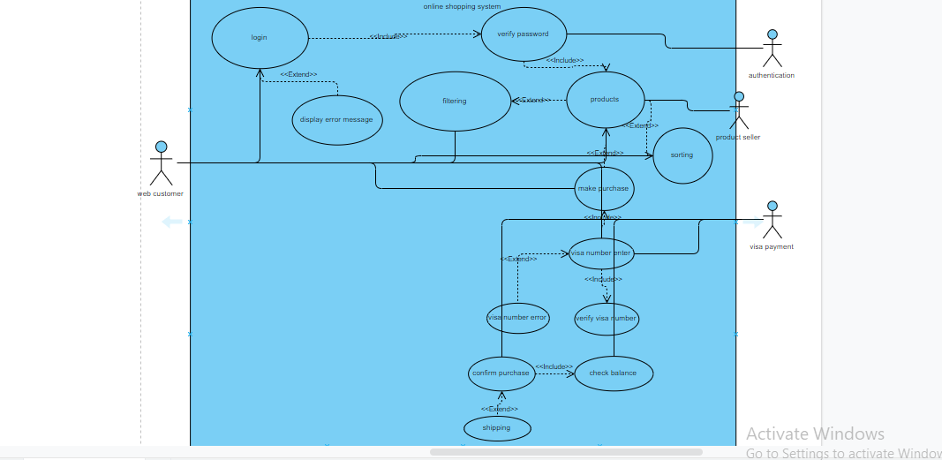

**High level Scenario**

1. The web customer log in into the page he is able to see products across diffrenet categories
2. Verify that all the links and banners are redirecting to correct product/category pages and none of the links are broken.
3. Verify that the company logo is clearly visible
4. Verify that all the text product, category name, price and product description are clearly visible
5. Verify that all the images – product and banner are clearly visible
6. Filtering – Verify that filtering functionality correctly filters product based on the filter applied
7. Sorting – Verify that all the sort options work correctly – correctly sort the products based on the sort option chosen

**Context Diagram**

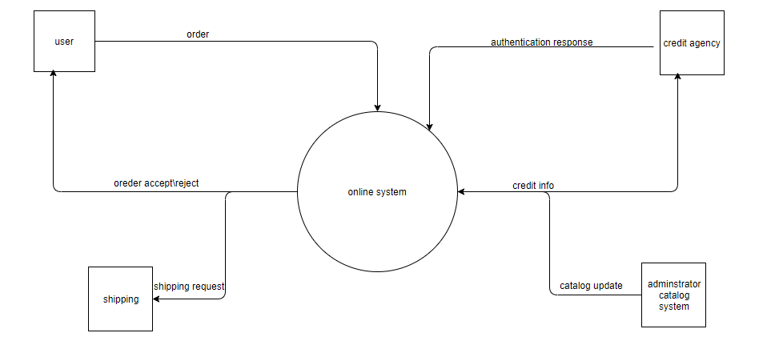

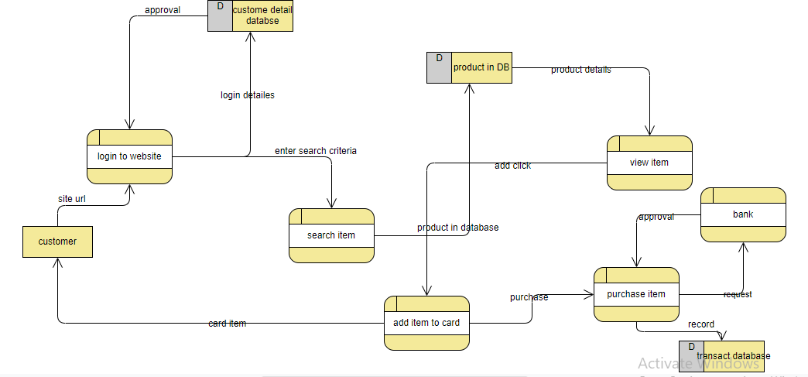

****Sequence Diagrams

1)Login Sequence Diagram

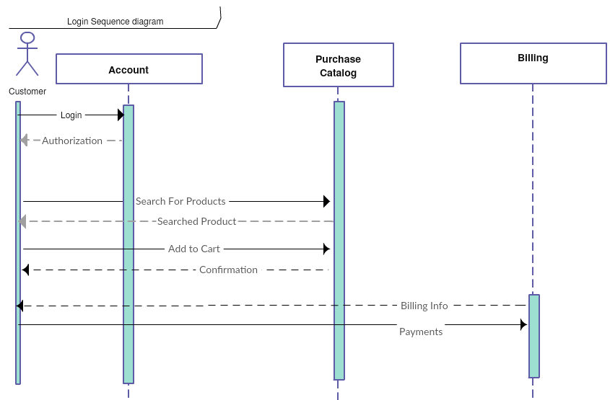

2)Order Sequence Diagram

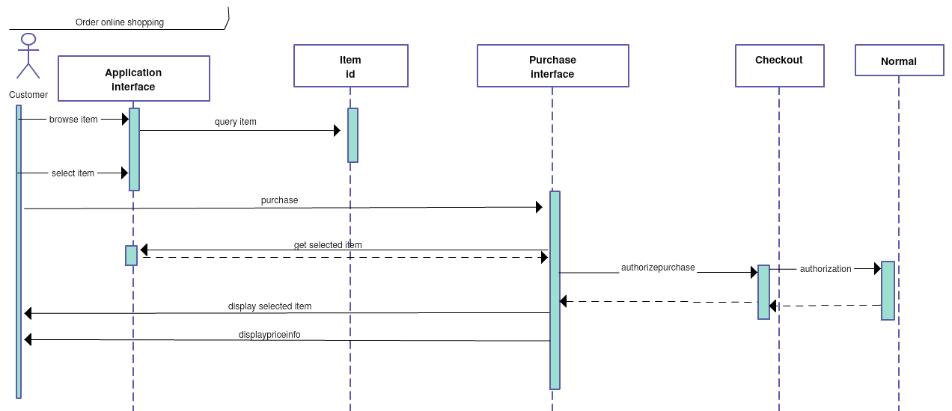

3)Refund Sequence Diagram

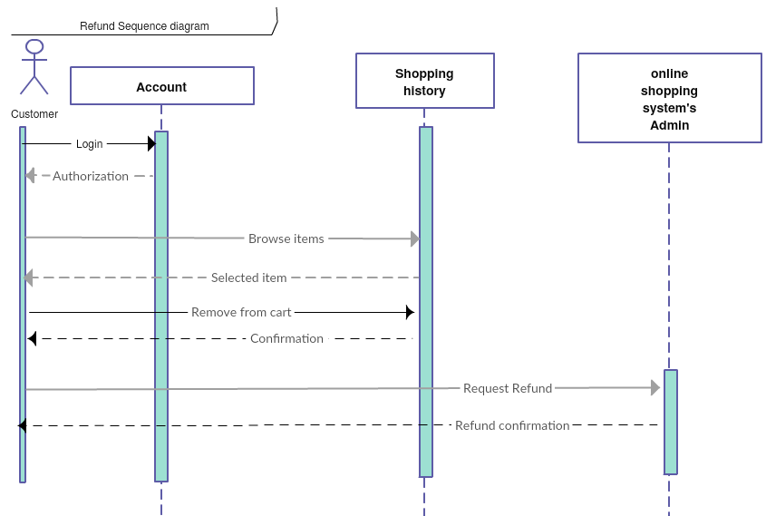

4)Rating Sequence Diagram

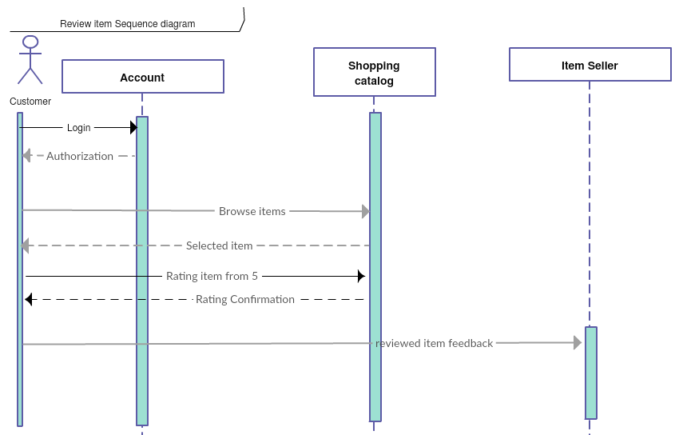

**References**

1)

2)

3)