**GIT Department of Computer Engineering**

**CSE 222/505 - Spring 2021**

**Homework # Report**

**Coşkun Hasan ŞALTU**

**1801042631**

1. **SYSTEM REQUIREMENTS**

First, the company object is created. The name, surname, email and password of the admin are determined.

The **admin** can add and remove branches and branch employees.

Admin also can print employee and branch information.

The **branch employee** can add and remove product to branch.

The **customer** can search product and buy.

1. **USE CASE AND CLASS DIAGRAMS**

2.1 Class Diagram

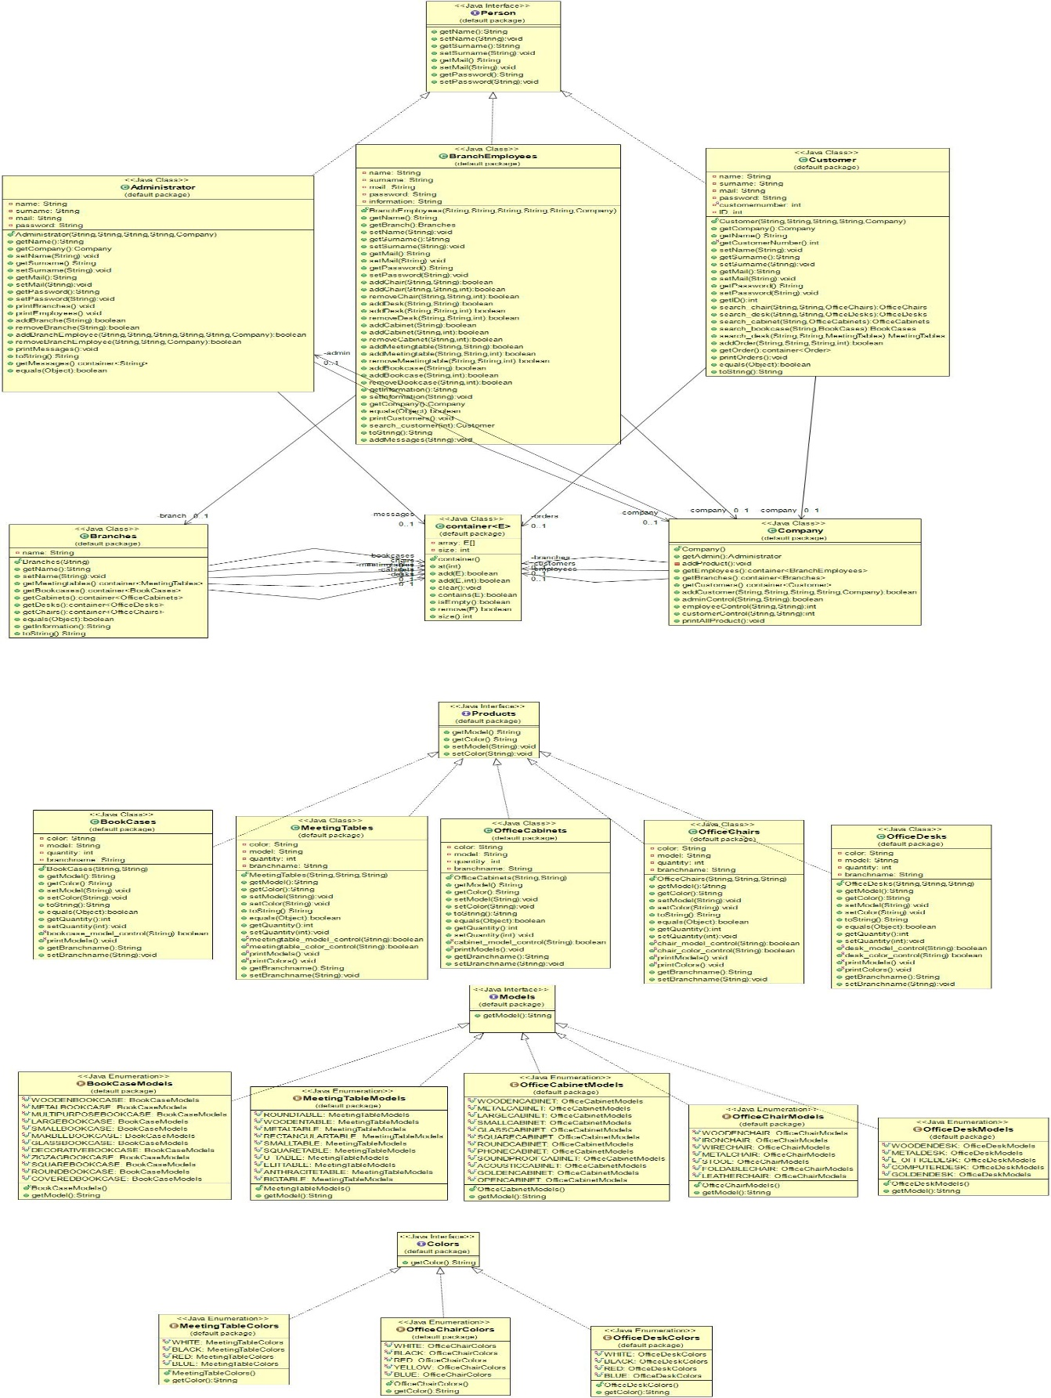

2.2 Use Diagram

2.2 Use Case Diagram

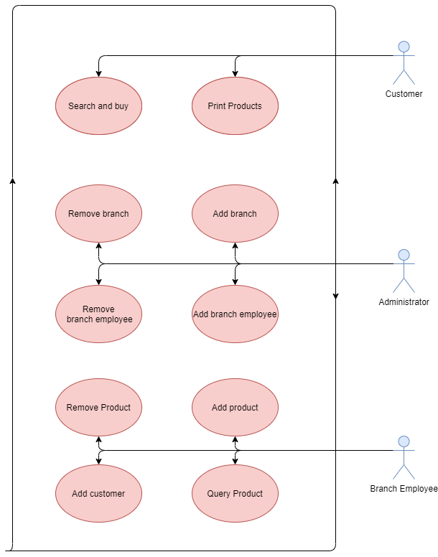

1. **PROBLEM SOLUTION APPROACH**

A container class was created to easily access, store and manipulate data. Generate the data with this class. Model and color types are kept in enum classes. It can be easily seen in which colors and models the products are available. User and product classes are designed using polymorphism principles.Thanks to polymorphism, transformations can be made where necessary.An order class has been created for holding orders.A database class has been created where products and users are kept.

1. **TEST CASES**

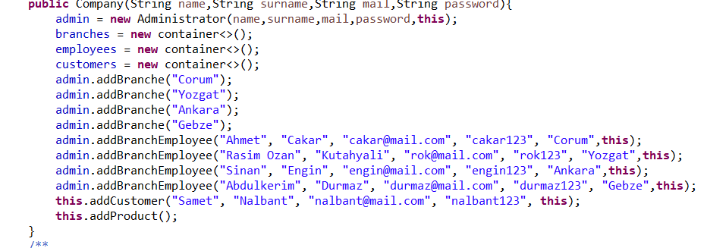

While creating the company object, an admin, 4 workers and automatic products were added automatically.

**5.RUNNING AND RESULTS**

**Admin**

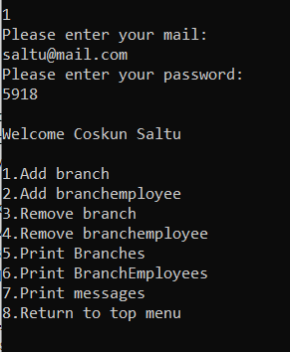

Add Branch

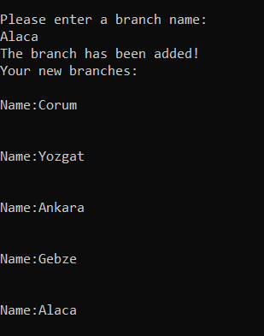

Remove branch

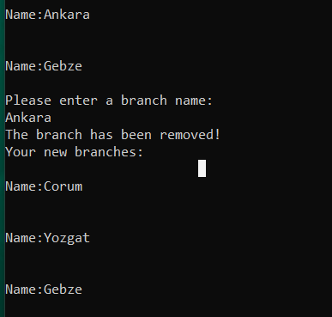

Add Branch employee

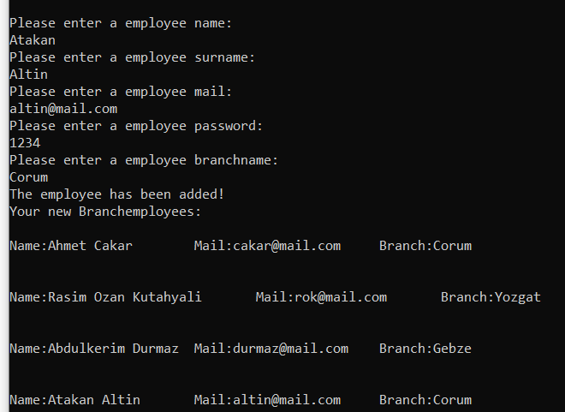

Remove Branch employee

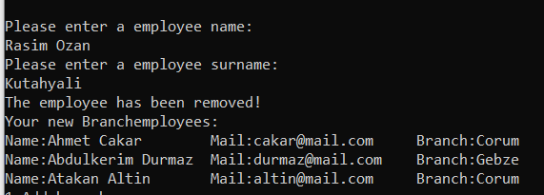

**Branch Employee**

Add Product

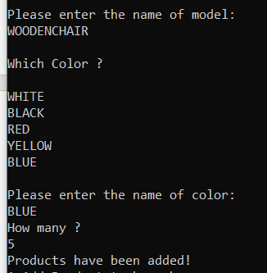

Make Sell

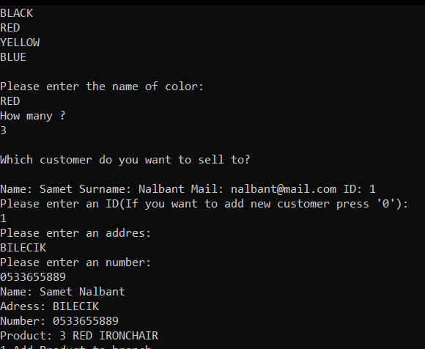

Print Product

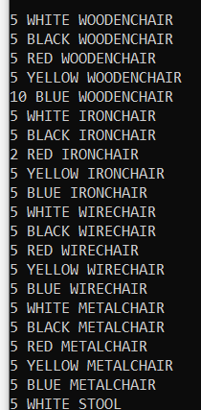

**Customer**

Print product

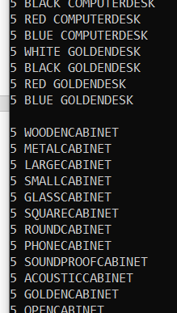

Search and buy

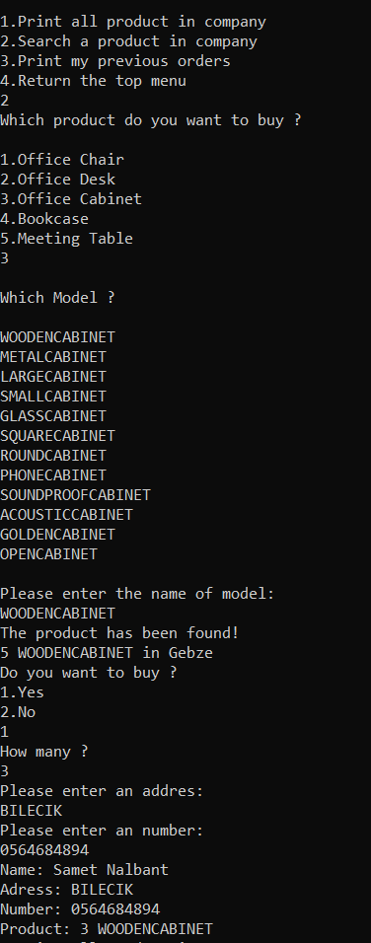

Print previous order

