CIS483/583 Final Project Report
Tarek Eid, Saad Farouqi, Seraj Aldwake, Venkata Sai Vardhan

Abstract
Facial recognition has become an essential component of modern security systems, especially in certain types of environments where identification of authorized individuals is necessary. This project develops a deep-learning–based facial recognition system designed to identify known users while detecting and flagging unknown or intruder faces. Three datasets are used to support this objective: Labeled Faces in the Wild (LFW), the Yale Face Database, and a small custom dataset consisting of team-collected images for testing purposes. A baseline convolutional neural network (CNN) model is implemented and evaluated on the task of multi-class face identification. Building on this baseline, a transfer learning variant using a pretrained convolutional backbone is explored as an improved architecture to enhance recognition accuracy and generalization. The system is additionally evaluated on its ability to distinguish between known and unknown individuals, an essential feature for intruder detection. Metrics such as accuracy, confusion matrices, and assessing misclassifications are used to assess performance. Preliminary results indicate that transfer learning provides a significant improvement over the baseline model, particularly in recognizing faces under varied lighting and pose conditions. This work demonstrates a practical application of deep learning for secure access systems in schools and institutional environments.

Index terms - Facial recognition, deep learning, transfer learning, CNN, security systems, intruder detection

Introduction
Facial recognition has emerged as one of the most widely used applications of deep learning, with use of it a lot in identity verification, access control, and public safety. Modern convolutional and transformer-based architectures have massively improved the ability of machines to extract the key features from facial images, allowing for automated systems to be able to identify and classify faces with high accuracy. As security needs increase across educational institutions and public facilities, the demand for reliable systems that can detect both authorized individuals and potential intruders has grown sharply, and optimizing such models’ performance can be very useful to such institutions.
Ensuring the safety of schools and places with restricted access requires a system capable of successfully determining whether a detected face belongs to a known individual or if he is an intruder. Traditional identification systems, such as ID cards or manual check-ins, are prone to failure, loss, or misuse. On top of that, manual labor can be expensive to companies, hence models which are more accurate and less expensive could be a better choice for them. Facial recognition offers a more robust alternative by enabling passive, real-time identity verification without requiring user interaction. However, designing a system that accurately recognizes known identities while correctly rejecting unfamiliar ones remains a challenging task due to variations in lighting, pose, facial expressions, and dataset imbalance. Such models require a lot of training for the model to understand familiar faces who could be approaching the vicinity in different ways.
This project aims to develop a deep learning based facial recognition system that addresses these challenges using a combination of a baseline convolutional neural network (CNN) and a transfer learning based model. Public datasets such as Labeled Faces in the Wild (LFW) and the Yale Face Database have been used to train and evaluate the system’s ability to classify known individuals. Additionally, a custom dataset containing images of team members is used to test real-world performance and to evaluate the system’s capability in detecting unknown users, an essential feature for intruder identification. With this, it would be very clear if the model would be effective to use or not, as we would be able to clearly see whether it would work in a real life scenario or not.
The primary contributions that played important roles in this work include: Implementation of a baseline deep learning model for multi class facial recognition, exploration of a transfer learning approach to improve performance and generalization, and an evaluation of the system’s ability to distinguish between known and unknown faces for security applications. This project provides a clear and practical example of how deep learning can be applied to a problem in today’s world and highlights the potential face recognition technology has for safety and access control systems. Further research is constantly being carried out to optimize such systems, which could potentially lead to manual security checks being completely unnecessary in the not so distant future.

Related Work

Facial recognition has progressed through several major stages, beginning with classical basic machine learning approaches and evolving into modern deep learning based systems. Early methods such as Eigenfaces and Fisherfaces relied on linear projections of facial images into lower-dimensional spaces [1], [2]. These systems were really useful for controlled environments but struggled with varying lighting, pose changes, partial occlusions, and with all types of real world conditions found in modern datasets. The limitations of these earlier approaches motivated people to work on shifting towards more powerful methods which can learn how to identify faces despite certain features changing on the face it has memorized on its system.
With the rise of deep learning, convolutional neural networks (CNNs) quickly became the foundation of most face-recognition systems. CNNs learn spatial hierarchies of features directly from images, allowing them to capture edges, textures, shapes, and more abstract representations that older classical approaches could not model effectively. Early deep models such as DeepFace [3] and VGG-Face [4] demonstrated that large neural networks trained on millions of images could reach or surpass human-level performance on some benchmarks. These works established CNNs as the standard for face representation and set the stage for more advanced architectures.

Another major development was the introduction of embedding-based systems, such as FaceNet [5], which used triplet loss to map facial images into a feature space where distance directly reflects identity similarity. This approach made recognition more robust and enabled real time verification on a wide range of devices. Embedding models continue to influence and enhance modern face recognition because they have a flexible way to compare known and unknown identities, which is especially useful for improving the accuracy of the main purpose of the system (intruder detection). Due to the advantages embedding based systems provided, facial recognition technology achieved a lot of attention and interest in the years that went by.

Transfer learning has also become a widely used technique in facial recognition. Instead of training a model from scratch, a pretrained network such as ResNet, MobileNet, or EfficientNet can be fine-tuned on a smaller target dataset. Several studies have shown that transfer learning produces higher accuracy with fewer training images and improves generalization to different lighting or change in pose [6], [7]. This is specifically important when working with datasets like LFW and Yale, where image variety is limited compared to larger standard datasets. Because transfer learning makes use of features already learned from millions of images, it serves as an effective improvement over baseline CNNs built from scratch.

A closely related area is open-set recognition, where the system must identify when an image does not belong to any known class. Traditional classification models assume that every input belongs to one of the trained categories, making them less suited for security applications where unknown individuals must be denied access. This is because typically they would try to relate intruder faces to one of the trained categories, and if they notice one similar feature they may misclassify them as a recognized face and give them access, which is a serious security concern. Recent works introduce thresholding strategies, embedding distances, or additional classifiers to separate known from unknown faces [8]. These approaches serve as the foundation for intruder detection, an important goal of this project.

Other modern advancements that played important roles include the use of attention mechanisms, transformer-based vision models, and hybrid CNN–transformer systems. Vision Transformers (ViT), for example, have shown strong results by modeling long-range relationships across image patches [9]. Despite the fact that these models can achieve high accuracy, CNNs remain widely used due to their efficiency and ease of deployment, especially in smaller projects and real-time systems.

Overall, these studies show a clear evolution from classical projection methods, to CNNs, to embedding based models, and finally to transfer learning and transformer architectures. For this project, the baseline CNN provides a foundation for understanding the main mechanisms of face recognition, while the transfer learning model offers a newer and higher performing alternative. The focus on unknown face detection aligns with recent work in open set recognition and security related applications, making this project suitable for both academic research and scenarios where this system may be needed for real world security purposes.

Dataset description

Start here

MethoDOLOGY

In this project we opted for transfer learning using a pretrained FaceNet model for better face representation and verification. We trained a baseline CNN model from scratch which gave around 47% accuracy. To train any model from scratch we need a large dataset and extensive computational resources. Based on the dataset we have we can achieve very low accuracy model. Using a pretrained model will skip the overhead of training and extract features more efficiently.

A. Baseline Model:
-----about CNN

B. Transfer Learning Model:

We are using FaceNet, a model pretrained on VGGFace2 dataset, is a deep CNN designed to map facial images into a 512 dimensional vector. It uses distance metric to identify the similarities between faces. This model is trained on millions of face images that allows it to learn highly discriminative facial features and generalize well.

This model is trained in such a way that the embeddings of same identity or same person will be close in terms of distance while the embeddings of different people will be far apart. This enables to use distance as a way verify rather than classifying based on the classes. Class-based classification is not recommended as the number of people grows.

We are using FaceNet as it is without changing or training its internal weights. One of the reasons for this is that the dataset we have is small to train a model like this one. Other reason is that, this model performs better without training. So, when new people are added to the organization we don’t have to worry about the training anymore.

Face detection and preprocessing:
FaceNet does a great job in extracting the facial features but before fedding the data into FaceNet we first need to identify the face in the given image. To do this we use MTCNN. MTCNN stands for Multi-task Cascaded Convolutional Network, this performs three step to identify faces correctly in given image. First it will detect the face then facial landmark localization and finally face alignment. Each detected face is cropped from the original images and resized to 160 x 160 pixels before sending it to FaceNet.

Authorized or enrolled user data storage:
We consider multiple images for each individual and for each image the following pipeline is used.

This pipeline is used to create embeddings for all the authorized users, and these values are stored in a pickle file. This file can be used in the future without recomputing all the embeddings every time we need to verify a person’s identity. This avoids unnecessary computation and improves runtime performance. When new people need to be added then we simply create embeddings and append them to the pickle file.

Identify verification:
Every time someone tries to access a door, first we’ll create embeddings using FaceNet and then compare them with the embeddings we already have. This comparison is done by calculating Euclidean distance with the newly created embeddings and the known embeddings. When this distance crosses a decision threshold then this new person is an intruder. We will consider the minimum distance we got after all the comparisons as the identity match score. The decision threshold is fixed at the start, or it can be computed dynamically when the embeddings are created. This type of verification will avoid the overhead of training when new people need access.

Summary:
The whole transfer learning implemented in this project can be summarized as follows
- We are using MTCNN to for face detection in the input image.
- A pretrained FaceNet model to generate embeddings for authorized people.
- Averaged facial embeddings for each user is stored for future
- Identity verification using Eculidean distance matching
- A prefixed threshold is used as a decision boundary to identify intruders
FaceNet is not trained or fine-tuned with the custom dataset, because the dataset is really small. The models generalization ability is used directly so that we don’t have to worry too much about retraining when new people need access. This way we can
- Eliminate the need for training
- Reduces computational cost
- Increases run time performance
- Fast enrollment of new people.
This implementation is more scalable and deployment ready facial recognition security system.

TRANSFER LEARNING ARCHITECTURE

The transfer learning model uses two separate sets of operations. First, to generate and store the authorized people’s embeddings. Second, to verify the new input image and classify it as authorized person or intruder.
During the enrollment stage, the first set of operations to store the authorized people’s embeddings, single or multiple images of each person are sent to a deep neural network and a 512-dimensional vector representing the facial features of the person are generated. These vectors are called embeddings for that person. If there are multiple images of a single person, then averaging is done to get a single vector for each identity. All embeddings for authorizes people are stored to a pickle file and this file will be used while verifying the people entering the building or the areas that require access.
During verification, the pretrained model is used to create embedding for the input image. Then this embedding are compared against all known embeddings using a distance based similarity metric. Based on a defined threshold, we’ll decide whether the individual is authorized or unauthorized.

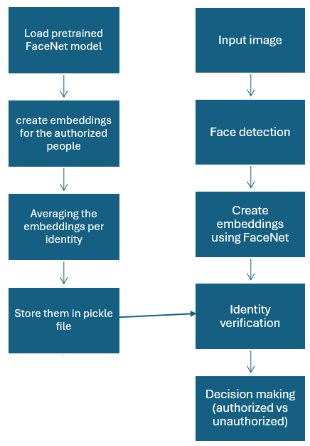

eXPERIMENTAL SETUP
The goal of this project is to build a facial recognition system designed for security applications, such as monitoring access in schools or department buildings. The system has two main objectives: Firstly, to correctly recognize individuals who belong to a predefined authorized set, and secondly, to detect and reject individuals who are not part of this set, meaning that they are intruders.

For this, the dataset was organized into two categories, authorized identities and intruder identities. This structure allows the system to be evaluated in both a recognition and an open-set security setting, closely matching real-world deployment scenarios.

The Labeled Faces in the Wild (LFW) dataset was used as the source of authorized users. The beauty of the LFW dataset is that they have images of people in different conditions, including variations in pose, lighting, facial expression, and background. Multiple images are available per individual, making the dataset well-suited for modeling realistic facial variation.

In order to evaluate the system’s ability to detect unauthorized access in a real world sceario, we created a custom user dataset. This dataset consisted of face images collected outside of LFW to guarantee no overlap with authorized users. One of the team members took images of himself which were intentionally captured under varying conditions to test robustness. Approximately half of the intruder images were taken under difficult conditions such as lower brightness or uneven lighting with different sides of the face, while the remaining images were clear. Only images in which a face could be reliably detected were included in the evaluation.

We implemented a complete data pipeline to support consistent training and evaluation. The datasets were structured using a directory layout compatible with PyTorch’s ImageFolder class, enabling automatic label assignment and reliable loading of images.

The preprocessing pipeline included image resizing, conversion to tensors, and normalization using standard RGB mean and standard deviation values. These steps ensure that all images are presented to the models in a consistent format.

Two main datasets were constructed using this pipeline:
1. A multi-class dataset containing authorized identities, and
2. A separate intruder dataset which was used exclusively for evaluation.

The authorized dataset was split into training and validation subsets using an 80–20 ratio, while intruder images were kept out of the training process to simulate real-world intrusion conditions. 3 DataLoaders were created to manage training, validation, and intruder evaluation efficiently.

Exploratory Data Analysis (EDA) was performed to validate the dataset and preprocessing steps. This included examining class distributions to identify imbalance, visualizing sample images to confirm correct labeling and transformations, and verifying batch dimensions to ensure compatibility with convolutional models. On top of that, an optional statistics routine was also implemented to compute dataset-specific normalization parameters. Together, these steps established a reliable data foundation for subsequent model experiments.

Baseline model (CNN) imput here

To improve performance over the baseline CNN, we decided to implement a transfer learning approach. The system uses a pretrained InceptionResnetV1 model, trained on the VGGFace2 dataset, to extract facial embeddings. Each input face is mapped to a 512-dimensional feature vector that captures distinguishing facial characteristics.

Face detection and alignment were performed using Multi-task Cascaded Convolutional Networks (MTCNN). Faces detected by MTCNN were cropped, aligned, and passed to the embedding network. Then the images for which no face could be reliably detected were excluded, which does reflects realistic behavior in security systems where uncertain inputs are not classified.

For each authorized individual, embeddings from multiple images were averaged to produce a single reference representation stored in an authorized database. Then, during evaluation test images were compared with this database.

The evaluation focused on examining how the system performs in separating authorized users from intruders under realistic conditions. Each test image was processed by itself by extracting it’s embedding and calculating the minimum distance it has to all authorized reference embeddings.

Next, a decision threshold was used to determine whether access should be granted or not. Images with distances below the threshold were accepted as authorized, while those above the threshold were classified as intruders. This evaluation setup accounts for real-world variations, where we are including differences in lighting and shadowing in the custom intruder images.

To better understand the system’s behavior, different thresholds were tested across a range of values. Performance was measured using the following biometric security metrics: False Acceptance Rate (FAR), False Rejection Rate (FRR), True Acceptance Rate (TAR), Receiver Operating Characteristic (ROC) curves, and Equal Error Rate (EER). These metrics provide insight into both system security and usability.

RESULTS
Before applying transfer learning, a baseline convolutional neural network (CNN) was trained from scratch using the authorized dataset. This model resulted in an accuracy of 45% on the validation set. Something positive about this was that it was clear that the CNN was able to learn basic features, but it’s performance was limited due to…

The transfer learning based face recognition system was evaluated using both authorized faces from the LFW dataset and custom intruder images collected outside the dataset. In total, 3417 identities were loaded into the system and 8292 valid face images were loaded. This means that 8292 face images were successfully identified by the model as faces and it’s embeddings were extracted. The intruder evaluation consisted of custom face images, with only those images where a face could be reliably detected included in the analysis.

Our evaluation script managed to give us good results which summarize the system performance at the selected threshold. These results include the number of evaluated samples, the optimal threshold value, the Equal Error Rate, and detailed classification statistics.

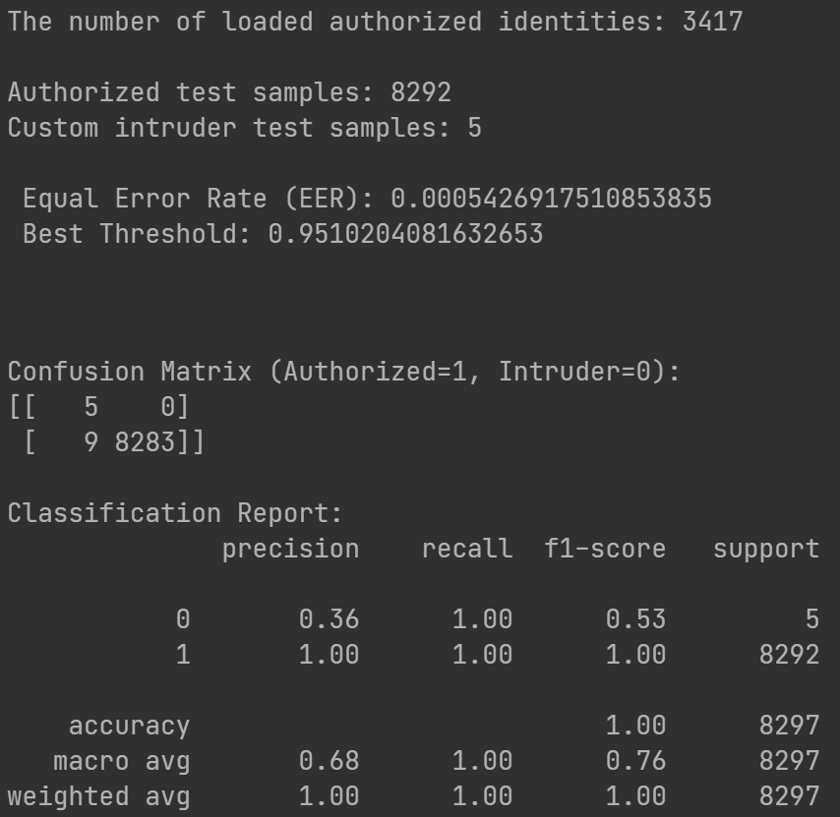

The system evaluated 8292 authorized test images and 5 custom intruder images. The system gave an optimal distance threshold of 0.951…, which gave an equal error rate of 0.00054…, showing that the system is very strong at separating between authorized and unauthorized faces.

To better understand classification performance, we implemented a confusion matrix at the optimal threshold.

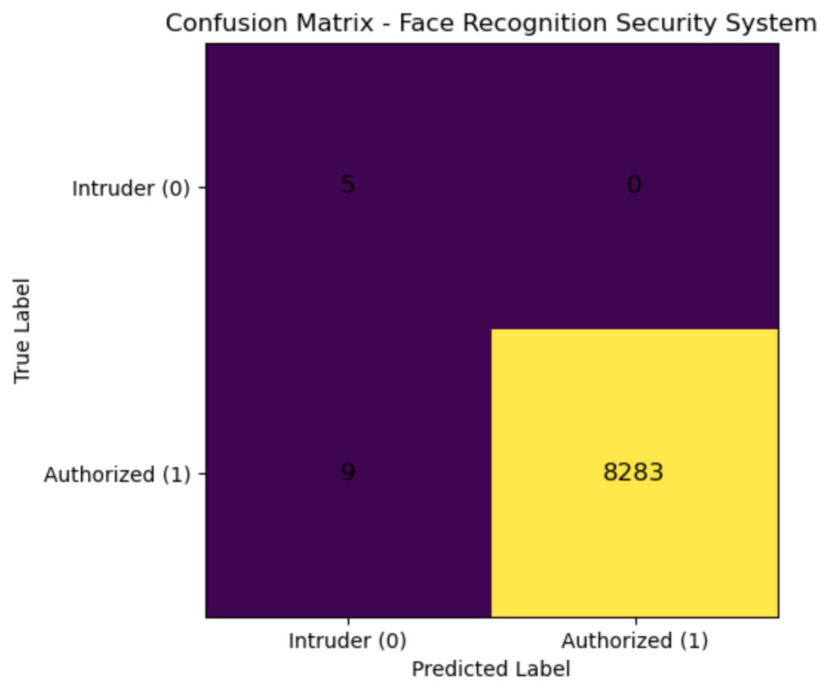

From the confusion matrix above, it is visible that all intruders were correctly classified as unauthorized, meaning nobody got illegal access. The vast majority of authorized images were accepted, however 9 images were incorrectly rejected and classified as intruders. This corresponds to the acceptance rate of 99.9% and a false acceptance rate of 0% for the custom intruder set.

Below, we implemented a Receiver Operating Characteristic (ROC) curve that shows the relationship between the False Acceptance Rate and the True Acceptance Rate across different threshold values.

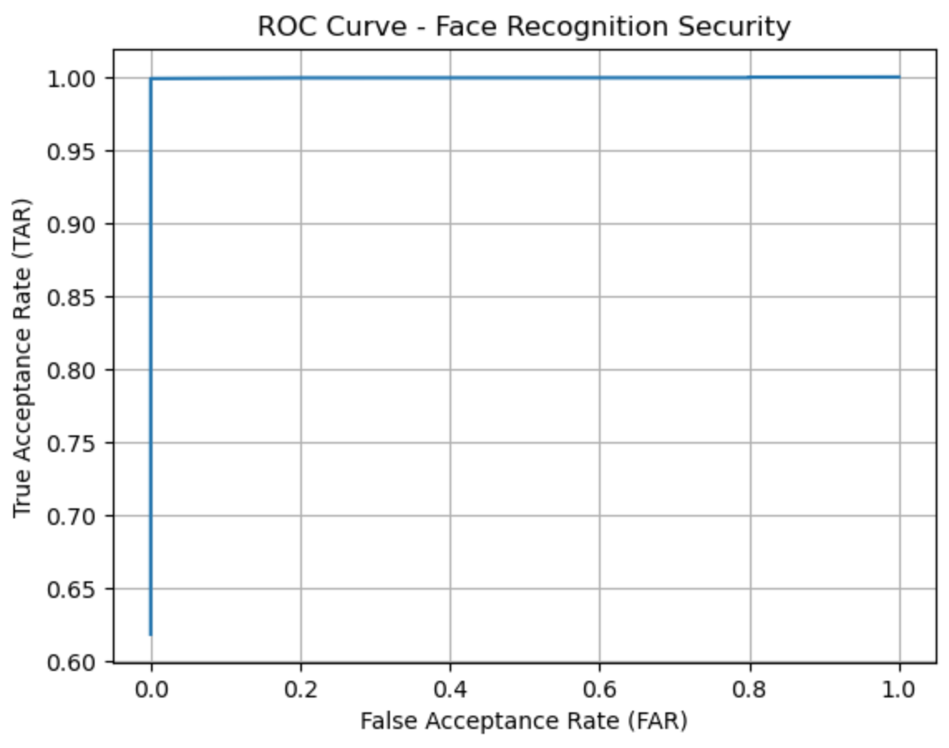

From the ROC curve, we can see a basically ideal shape, a very sharp increase in true acceptance rate while keeping the false acceptance rate at basically zero. These results indicate that there is very minimal overlap between the embeddings distribution of authorized and unautorized users, highlighting how the system is very much capable of distinguishing between the two with high accuracy.

Comparing the baseline CNN to the transfer learning based system shows a incredible improvement in performance. While the baseline CNN achieved only 45% accuracy, the transfer learning model achieved almost perfect recognition of authorized users and successfully rejected all intruders.

This improvement really reveals the effectiveness of transfer learning for face recognition tasks such as this one. It is a sign that transfer learning can be a hidden gem in security applications where accuracy and robustness is absolutely critical. By making use of pretrained facial embeddings, the system overcomes the limitations of training a deep model from scratch.

To summarize, it is clear that the transfer learning based face recognition system demonstrated very strong performance across all metrics. The fact that the results included a very low EER, a very high successful acceptance of authorized users, and successfully rejected all intruders, gives bright evidence that the system is effective for security related face recognition tasks.

cONCLUSION & FUTURE WORK
In this project, we developed and evaluated a facial recognition security system using deep learning. The system is designed to distinguish between authorized individuals and intruders, while attempting to focus on realistic environments where it could be implemented in scenarios such as schools or departmental buildings.
A baseline CNN trained from scratch achieved low accuracy and limited performance, highlighting the difficulty of learning diverse facial features without large scale data. In contrast to CNN’s performance, the transfer learning based approach using pretrained facial embeddings significantly improved performance. The system achieved almost perfect recognition of authorized users, successfully rejected all evaluated intruders, and produced an extremely low Equal Error Rate. These results show the effectiveness of transfer learning for face recognition tasks, especially in security related environments where an implemented security system such as this one needs to be reliable as a top priority.

In the end, it is clear that the system is very robust to variations in light and image quality and provides a realistic and trustworthy framework for facial recognition access control.

While the results are convincing, there can still always be several improvements which can be explored in future work. Firstly, the intruder dataset could be improved to include a larger and more diverse set of unauthorized individuals instead of using the same individual for all faces. This would allow for a more thorough evaluation of false acceptance behavior and could really challenge the model more, allowing to see if it might make a mistake and evaluate the reason for this mistake. Testing under other forms of real world conditions, such as extreme brightness instead of darkness, motion blur, and partial occlusion, could allow for further assessment and understanding of the system’s robustness.

Second, the system could be widened to support real time video based recognition using live camera feeds rather than just images of the individuals. This would better reflect real deployment scenarios and introduce challenges such as frame selection and temporal consistency. In a real world scenarios, the model is going to need to analyze the approaching individual’s face while they are moving, meaning that we could see different results in such cases.

Future work could also focus on fine tuning the embedding model using a domain specific dataset or adjusting the decision threshold based on environmental conditions. These changes could improve the usability of the system and it’s security.

REFERENCES
[1] F.Schroff, D. Kalenichenko, J. Philbin, “FaceNet: A Unified Embedding for Face Recognition and Clustering,” Proceedings of the IEEE Conference on Computer Vision and Pattern Recognition (CVPR), pp. 815–823, 2015.

[2] K. Zhang, Z. Zhang, Z. Li, and Y. Qiao, “Joint Face Detection and Alignment Using Multi-task Cascaded Convolutional Networks,” IEEE Signal Processing Letters, vol. 23, no. 10, pp. 1499–1503, 2016.

[3] J. Deng, J. Guo, N. Xue, and S. Zafeiriou, “ArcFace: Additive Angular Margin Loss for Deep Face Recognition,” Proceedings of the IEEE Conference on Computer Vision and Pattern Recognition (CVPR), 2019.

[4] S. J. Pan and Q. Yang, “A Survey on Transfer Learning,” IEEE Transactions on Knowledge and Data Engineering, vol. 22, no. 10, pp. 1345–1359, 2010.

[5] L. Best-Rowden and A. K. Jain, “Longitudinal Study of Automatic Face Recognition,” IEEE Transactions on Pattern Analysis and Machine Intelligence (TPAMI), vol. 40, no. 1, pp. 148–162, 2018.

[6] Q. Cao, L. Shen, W. Xie, O. M. Parkhi, and A. Zisserman, “VGGFace2: A Dataset for Recognising Faces Across Pose and Age,” 13th IEEE International Conference on Automatic Face & Gesture Recognition (FG 2018), pp. 67–74, 2018.

[7] Y. Taigman, M. Yang, M. Ranzato, and L. Wolf, “DeepFace: Closing the Gap to Human-Level Performance in Face Verification,” Proceedings of the IEEE Conference on Computer Vision and Pattern Recognition (CVPR), 2014.

[8] A. K. Jain, A. Ross, and S. Prabhakar, “An Introduction to Biometric Recognition,” IEEE Transactions on Circuits and Systems for Video Technology, vol. 14, no. 1, pp. 4–20, 2004.

[9] O. M. Parkhi, A. Vedaldi, and A. Zisserman, “Deep Face Recognition,” British Machine Vision Conference (BMVC), 2015.

[10] J. Deng, J. Guo, T. Liu, M. Gong, and S. Zafeiriou, “Sub-center ArcFace: Boosting Face Recognition by Large-Scale Noisy Web Faces,” European Conference on Computer Vision (ECCV), 2020.

[11] S. Bhattacharjee, R. Das, and S. Mukhopadhyay, “Face Recognition in Surveillance Systems: A Survey,” IEEE Access, vol. 8, pp. 21975–22002, 2020.

[12] T. de Freitas Pereira, A. Anjos, J. De Martino, and S. Marcel, “Can Face Anti-Spoofing Countermeasures Work in a Real World Scenario?” IEEE International Conference on Biometrics, 2012.

