FINAL REPORT


RMIT University
COSC2753/COSC2812 - Machine Learning



Assignment 2 Final Report

Fashion Intelligence System

Lecturer: Dr. Nguyen Thien Bao
Student team: SG_G3
Student name & ID: Le Duc Huy - s4040502
Nguyen Gia Khang - s4034066
Le Hoang Dang Khoa - s4030327
Tran Hoang Nguyen - s4054071
Nguyen Doan Trung Truc - s3974820

1. Data Preparation and Analysis
The audit converts 38,617 metadata rows into one manifest shared by all four tasks. It repairs 21 product names split by unquoted commas and links 38,612 rows to readable JPEGs; five rows have no image, including the only Suits record, so the observable articleType taxonomy contains 124 classes. Exact hashes identify 636 duplicate groups spanning 1,399 files. After collapsing consistent copies and resolving 20 conflicting groups, the manifest contains 37,847 unique rows with a duplicate-group key for leakage-safe splitting [13] (Fig. 1).
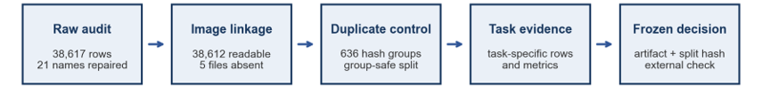
Figure 1 Cleaning and evidence flow used by all four tasks
Observed condition | Count | Treatment and reason
Missing image | 5 rows | Exclude because no image model can use them; this also removes Suits from the observable taxonomy
Non-modal dimensions | 17 images | Keep as valid products; preserve aspect ratio and pad to 60 by 80 instead of cropping or stretching
Grayscale | 343 images | Keep and convert to three-channel RGB; colour format alone is not evidence of a bad sample
Byte-identical duplicates | 636 groups, 1,399 files | Collapse 616 consistent groups; review 20 conflicting groups; split by duplicate group
Missing task labels | 20 season, 72 usage | Filter only for the affected task so other valid labels remain usable

2.1 Outlier treatment
Non-modal sizes, grayscale images and rare labels are valid products, so they are retained. Images are converted to RGB and letterboxed to 60 by 80 without stretching. We remove only missing files, redundant exact copies and irreconcilable duplicate records. If one task label is disputed, that target is set to missing and the row remains available to the other tasks.

2.2 External data status
Two external collections target Task 1's weakest classes: 1,158 screened images across Eyeshadow, Lipstick and Nail Polish, and 699 images across seven types. The second set remains unintegrated because 21 percent failed screening. Neither collection trains a submitted model, and neither overlaps the supplied manifest by SHA-256. A Task 3 arm using external images reduced gender macro-F1 from 0.728 to 0.722, so this negative result is retained as evidence.

2.3 Evaluation and data lineage
Macro-F1 is primary for classification because every class contributes equally; accuracy, per-class F1 and confusion matrices show where performance comes from [2]. Task 1 averages the 110 classes that reach validation and reports 14 as unmeasured. Task 3 averages all eight usage classes, including one without a validation row, whose F1 is zero by definition. Retrieval is selected by mAP@10, supported by Precision@K and coverage [12]. Hyperparameters use inner validation only, and outer or external data score the frozen candidate once.

2.4 Remaining lineage check
Tasks 3 and 4 use 37,745 complete rows. Their 121 observed article types match the three types removed by the filter, but the submission should still store a row-ID hash to prove item-level identity with the audited manifest. All 5,829 unlabelled test images remain, including 88 grayscale files, six non-modal sizes and 11 files identical to training images.

2. Article type and season classification

2.1 Article type classification
Task 1 predicts 124 classes from 37,846 labelled images. On the task-specific split, Tshirts has 6,584 training examples while six classes are singletons; 32 classes contain fewer than ten images and 14 do not reach validation. The taxonomy is retained, so group-aware splitting and macro-F1 prevent frequent classes from determining selection.
On the 30,278/7,568 group-aware split, HOG with a balanced linear SVM at C=0.1 achieves 0.6343 macro-F1 and 0.8056 accuracy. The best completed CNN configuration, learning rate 0.003 and weight decay 0.001, reaches 0.5824 macro-F1 and 0.8605 accuracy. HOG also leads on the 10 to 99 support bucket, 0.634 versus 0.555, while the CNN performs better on frequent classes. The CNN search used 12 epochs rather than the planned 40, and the ResNet and stage-two grids remain incomplete. Task 1 is therefore provisional [5].
HOG is competitive because garment categories depend strongly on silhouette and local gradients. The CNN can learn richer cues, but its short budget currently favours frequent classes. The final decision requires matched training budgets and support-bucket F1 (Fig. 2).

2.2 Season classification
Task 2 retains 37,826 rows after handling 21 missing season labels. One is set to missing because byte-identical sock images carry conflicting seasons and pixels cannot resolve the disagreement. Summer represents about 49.6 percent of the data, and season partly reflects catalogue practice rather than a purely visible property.
Random Forest, EfficientNet-B0 and DenseNet-121 use the same 7,566-row validation set. The neural models start from random weights and share the same image-only preprocessing and training loop, so the comparison does not use external pretraining [3], [4].
Task 2 candidate | Accuracy | Macro-F1 | Interpretation
Majority | 0.4933 | 0.1652 | Shows why accuracy is insufficient
Random Forest | 0.6677 | 0.6840 | Strong non-neural reference
EfficientNet-B0 | 0.7511 | 0.7454 | Close neural runner-up
DenseNet-121 | 0.7561 | 0.7515 | Current same-split winner

DenseNet-121 leads with 0.7515 macro-F1 and 0.7561 accuracy, narrowly ahead of EfficientNet-B0 at 0.7454 macro-F1. Its checkpoint records learning rate 0.001, weight decay 0.001, label smoothing 0.05 and 40 epochs, with the best epoch at 37. Dense feature reuse can preserve sleeve, layering and fabric cues while deeper layers combine them into seasonal evidence [16]. The confusion matrix must still test whether Spring and Autumn collapse into adjacent seasons or whether catalogue backgrounds influence predictions (Fig. 2).
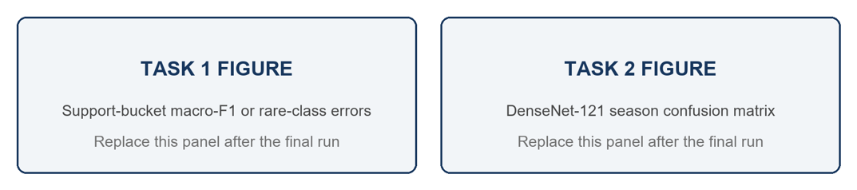
Figure 2 Reserved panels for final Task 1 and Task 2 diagnostics

3. Gender and usage classification
Task 3 uses 37,745 rows with complete gender and usage labels. Usage is severely imbalanced: Casual holds 28,968 examples against Home 1, Party 13, Travel 25 and Smart Casual 55, so four of the eight classes share fifteen validation images between them. Home has no validation image at all, which caps usage macro-F1 at 0.875 before any model is trained (Fig. B1). Gender is imbalanced more mildly, with 3,090 Men and 2,107 Women in validation against 305 Unisex, 93 Boys and 66 Girls. A majority predictor reaches 76.1 percent accuracy on usage for 0.108 macro-F1, and 54.6 percent on gender for 0.141, so accuracy cannot be the selection metric (Fig. 4).
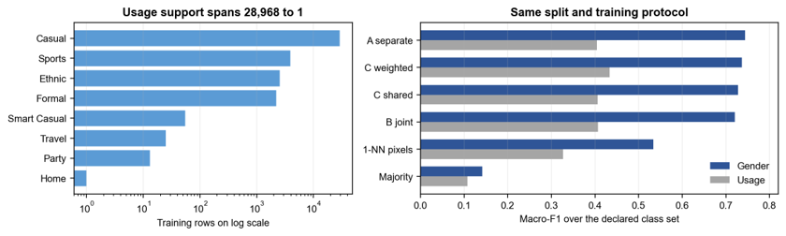
Figure 4 Task 3 class support and the controlled comparison
Design A trains one CNN per target, B predicts a single joint gender-usage label, and C shares one convolutional body between two linear heads [3], [4]. A costs 576,589 parameters across two backbones and gives the strongest gender result, but it learns the same visual structure twice and cannot let either target inform the other. B collapses both targets into one 24-way output, because only 24 of the 40 possible pairs occur in the data, so the sparsity of the joint target is added to the sparsity already present in usage. C keeps task-specific outputs while sharing 99.4 percent of its 289,133 parameters, which halves A's backbone cost and carries the opposite risk: a gradient that improves one head can degrade the other. The table below measures that risk instead of assuming it, with all four candidates scored on one shared validation set.
Candidate | Backbone cost | Gender F1 | Usage F1 | Minority evidence | Decision evidence
A separate | 576,589, two backbones | 0.744 | 0.404 | 0.462 over the 7 classes present | Best gender, double backbone cost
B joint | 290,552, one 24-way head | 0.720 | 0.407 | 0.465 | Sparse joint target adds no benefit
C shared | 289,133, 99.4 percent shared | 0.728 | 0.406 | 0.464; minority mean F1 0.3306 | Efficient baseline
C plus sqrt weights | 289,133 | 0.737 | 0.433 | 0.495; minority mean F1 0.3643 | Best controlled usage result
Usage classes are weighted by the inverse square root of their frequency rather than by inverse frequency, because the unmoderated form would hand a class with one training row the same weight budget as one with 28,968. Weighting raises usage macro-F1 from 0.4056 to 0.4332 while accuracy falls from 0.8901 to 0.8705. That trade is accepted because minority-class mean F1 rises from 0.3306 to 0.3643, so the gain lands in the classes the metric exists to protect. Logit adjustment reaches 0.4256 and articleType pretraining 0.4105 against the same 0.4056 baseline, but both fall below the weighted model, by 0.0076 and 0.0227, and adding mirror averaging to logit adjustment drops usage to 0.4027. They are alternatives to weighting rather than additions to it.
An ImageNet-pretrained ResNet-18, excluded from submission, reaches 0.8228 gender and 0.5964 usage macro-F1. However, 72 percent of the usage gap is concentrated in fifteen validation images, and both models score zero on the two smallest usage classes. The control identifies the benefit of pretraining without claiming that architecture alone fixes classes with almost no data.
A second study separates capacity from pretraining. On the forward split, a legal from-scratch ResNet-18 retains only 23 percent of its random-split gender gain, while ImageNet pretraining retains 97 percent. Three-model ensembles improve forward gender macro-F1 by 0.0045 over the shipped checkpoint, and 5 of 20 triples perform worse. On random validation, the ensemble raises gender by 0.0281 but lowers usage by 0.0292. Because the trade-off changes with the split, the ensemble is not adopted.

Selected model
Weighted design C with mirror augmentation is submitted as one shared pass with two heads, at 289,133 parameters against A's 576,589. It achieves 0.7202 gender and 0.4676 usage macro-F1; usage covers all eight classes, and over the seven measurable ones it is 0.5344. Three repeats span 0.7202 to 0.7501 gender and the shipped run is their median by mean macro-F1, but all three use seed 42 and differ only through nondeterministic execution, so they measure run variability, not independent-seed robustness: six seeded runs span 0.0301. Home, Party, Travel and Smart Casual remain unresolved, and no model tested here recovers them.

4. Visual similarity search

4.1 Stateful Preprocessing
For Task 4, the cleaned 37,745 image set was split into a fixed 90:10 outer train/test partition (33,968/3,777) using iterative multilabel stratification on articleType and gender. This ensures label proportions while keeping the test set untouched for final evaluation. Relevance used the composite label articleType__gender, restricting similarity to the same product type and intended gender. The label encoder was fitted only on outer-training data, assigning the 249 observed class combinations to their relevant encoded IDs, while the test set applied the same encoding config, preventing data leakage. Joint classes with fewer than five training images were excluded, then a shared 10% inner split produced 30,389 training and 3,378 validation images for hyperparameter tuning and training in all five models. Images were converted to RGB and letterboxed to 128×128 with centred white padding to preserve silhouettes. Only train set applied augmentation techniques such as mild horizontal flips and affine perturbations, whereas validation/test transforms were deterministic. Metric models used train-only RGB normalization; the CAE retained [0,1] pixels for sigmoid reconstruction.

4.2 Model Development
All five model candidates (Convolutional Autoencoder, Triplet, SupCon, Multi-Similarity, ArcFace) use the same backbone ResNet-18 encoder trained from scratch, producing L2-normalised 512-dimensional embeddings; therefore, the main controlled difference is how each training objective shapes the embedding space. The CAE is the unsupervised baseline: it reconstructs the letterboxed image using a decoder and pixel-wise mean-squared error, without labels. Its embedding measures how much visual structure can be learned from reconstruction alone. Triplet learning introduces supervision by pulling an anchor towards the same articleType__gender positive and pushing it away from a negative class by a margin. Supervised contrastive learning (SupCon) extends this to multiple positives and negatives within each P–K batch, encouraging class-wise clustering. Multi-Similarity loss assigns greater weight to difficult positive and negative pairs according to their current similarity, focusing learning on ambiguous relationships. Finally, ArcFace learns a persistent proxy for each class and applies an additive angular margin before softmax classification, producing compact and separated class directions. Except for the CAE’s necessary reconstruction decoder, the backbone, preprocessing, sampler and cosine-based retrieval evaluation are shared, enabling a fair comparison of the objectives.

4.3 Hyperparameter Tuning and Model Training

4.4 Common benchmark and reranking

4.5 Selected model and limitations

4.6 External comparison with SOTA model (FashionCLIP)

5. Final model selection and deployment
Table 5 summarises the current candidate for each task and the evidence still required before submission.
Task | Current candidate | Evidence supporting selection | Status before submission
1 articleType | HOG-SVM, provisional | Macro-F1 0.6343 vs CNN 0.5824; CNN accuracy 0.8605 | Rerun the CNN at 40 epochs, then complete ResNet and stage-two
2 season | DenseNet-121 | Macro-F1 0.7515; accuracy 0.7561 | Freeze checkpoint and prediction file
3 gender and usage | Shared two-head CNN with sqrt weights | One-pass deployment; shipped F1 0.7202 and 0.4676 | Run exact checkpoint on external set
4 visual search | ArcFace encoder | Outer reranked mAP@10 0.7755; P@1 0.7986 | Clean stale preflight narrative

5.1 Independent evaluation
External images measure domain shift away from catalogue photography [15], while published studies provide context only when class definitions and evaluation protocols are comparable. Task 3's unweighted model falls from 0.6794 gender macro-F1 to 0.1292 on 261 independent photographs, but the exact shipped checkpoint still requires the same test. Task 1 needs candidate-specific external results with per-class deltas. Task 2 needs an image-only proxy because this catalogue has no published season baseline. Task 4 needs a blinded human Top-K audit and a published mAP@K comparison that states gallery size and relevance.

5.2 Deployment and cost
An uploaded image is standardised once, then passed to the three classifiers and the Task 4 encoder. Retrieval compares an L2-normalised embedding with a precomputed FAISS cosine index [14] and returns four neighbours with their scores. Low-confidence classifications and retrievals without a relevant gallery item return an unknown state. Final deployment evidence should report batch-one mean and p95 latency, checkpoint and index size, peak memory and end-to-end response time.

5.3 Conclusion
DenseNet-121 and ArcFace can be frozen for Tasks 2 and 4 on completed same-split evidence. Task 3 keeps the weighted shared model because it improves usage with half the backbone cost of two networks, and no ensemble produces a stable gain across splits. Task 1 remains provisional because its CNN, ResNet and stage-two comparisons are incomplete. Before submission, the team should store the row-ID hash, remove superseded Task 4 preflight text, add the final Task 1 and Task 2 figures, and evaluate the exact Task 3 checkpoint externally.

References
[1] RMIT University, COSC2753 and COSC3013 Machine Learning Assignment 2 specification and marking rubric, 2026B.
[2] M. Sokolova and G. Lapalme, A systematic analysis of performance measures for classification tasks, Information Processing and Management, vol. 45, no. 4, pp. 427–437, 2009, doi: 10.1016/j.ipm.2009.03.002.
[3] R. Caruana, Multitask learning, Machine Learning, vol. 28, pp. 41–75, 1997, doi: 10.1023/A:1007379606734.
[4] S. Ruder, An overview of multi-task learning in deep neural networks, arXiv:1706.05098, 2017.
[5] Y. Cui, M. Jia, T. Lin, Y. Song and S. Belongie, Class-balanced loss based on effective number of samples, Proc. CVPR, pp. 9268–9277, 2019.
[6] A. K. Menon et al., Long-tail learning via logit adjustment, Proc. ICLR, 2021.
[7] K. He, X. Zhang, S. Ren and J. Sun, Deep residual learning for image recognition, Proc. CVPR, pp. 770–778, 2016.
[8] F. Schroff, D. Kalenichenko and J. Philbin, FaceNet A unified embedding for face recognition and clustering, Proc. CVPR, pp. 815–823, 2015.
[9] P. Khosla et al., Supervised contrastive learning, Advances in Neural Information Processing Systems, vol. 33, pp. 18661–18673, 2020.
[10] X. Wang et al., Multi-similarity loss with general pair weighting for deep metric learning, Proc. CVPR, pp. 5022–5030, 2019.
[11] J. Deng, J. Guo, N. Xue and S. Zafeiriou, ArcFace Additive angular margin loss for deep face recognition, Proc. CVPR, pp. 4690–4699, 2019.
[12] C. D. Manning, P. Raghavan and H. Schütze, Introduction to Information Retrieval. Cambridge University Press, 2008.
[13] K. Sechidis, G. Tsoumakas and I. Vlahavas, On the stratification of multi-label data, ECML PKDD, pp. 145–158, 2011.
[14] J. Johnson, M. Douze and H. Jégou, Billion-scale similarity search with GPUs, IEEE Transactions on Big Data, vol. 7, no. 3, pp. 535–547, 2021.
[15] P. W. Koh et al., WILDS A benchmark of in-the-wild distribution shifts, Proc. ICML, vol. 139, pp. 5637–5664, 2021.
[16] G. Huang, Z. Liu, L. van der Maaten and K. Q. Weinberger, Densely connected convolutional networks, Proc. CVPR, pp. 4700-4708, 2017.
[17] Z. Zhong, L. Zheng, D. Cao and S. Li, Re-ranking person re-identification with k-reciprocal encoding, Proc. CVPR, pp. 1318-1327, 2017.

Appendix

Hyperparameter selection
Hyperparameters are reported as selected only when a saved comparison or checkpoint supports the choice. Fixed settings and incomplete searches are labelled as such.
Task | What was varied | Chosen setting | How the choice was made
1 | HOG C in 0.01, 0.1, 1 with balanced or unweighted loss; CNN lr in 3e-4, 1e-3, 3e-3 and wd in 1e-4, 1e-3 | HOG C=0.1 balanced; CNN lr=0.003, wd=0.001 | Validation macro-F1. HOG reaches 0.6343; CNN reaches 0.5824 under the shorter 12-epoch budget, so the final model remains open
2 | Architecture comparison on one split; final checkpoint settings rather than a documented full search | DenseNet-121; lr=0.001, wd=0.001, label smoothing=0.05; best epoch 37 of 40 | Highest same-split macro-F1, 0.7515. The final submission should retain the complete trial record rather than imply a broader search
3 | A, B and C designs under fixed Adam lr=0.001, 20 epochs, batch 256 and dropout 0.2; then one-variable usage weighting | Shared C with usage weight 1/sqrt(n) and mirror augmentation | Controlled macro-F1 ablation plus parameter cost. Sensitivity runs are reported separately and are not used to pick a favourable validation run
4 | Optuna on inner validation mAP@10 with shared encoder capacity and model-specific loss parameters | Model-specific values shown below; ArcFace selected after the frozen outer comparison | Inner search chooses settings; the common outer hold-out chooses the final model once

Task 4’s hyperparameter search
Model | Search space | Selected value and interpretation
CAE | lr 3e-5 to 1e-3; wd 1e-6 to 1e-3 | lr 8.47e-5; wd 7.11e-4; checkpoint selected by retrieval mAP rather than reconstruction MSE
Triplet | Same lr and wd; margin 0.1 to 1.0 | margin 0.1 is on the lower boundary, so values below 0.1 remain a useful sensitivity check
SupCon | Same lr and wd; temperature 0.05 to 0.20 | temperature 0.075 gives sharper positive weighting for the fixed P-K batches
Multi-Similarity | alpha 1 to 3; beta 20 to 80; base 0.3 to 0.7 | alpha 1.419; beta 51.58; base 0.647; geometry improves but inner mAP does not
ArcFace | Same lr and wd; margin 0.1 to 0.5; scale 16, 32, 48, 64 | lr 2.94e-4; wd 7.39e-5; margin 0.1297; scale 16

Diagnostics and deployment checks
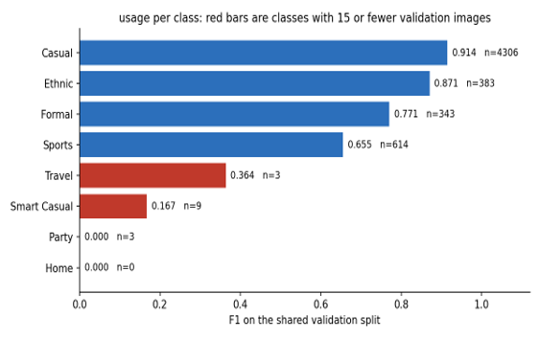
Figure B1 Rare usage support constrains macro-F1. Four of the eight usage classes hold fifteen validation images between them and Home holds none, so the metric is bounded at 0.875 by label evidence before training begins, not by model capacity.
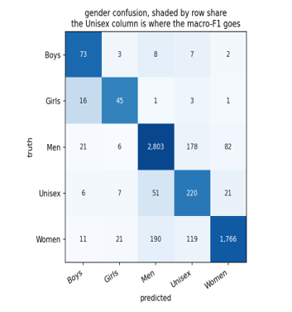
Figure B2 Task 3 gender confusion. Unisex is the bottleneck rather than the smallest classes: 178 Men and 119 Women are predicted Unisex, and it is the only gender class where an articleType lookup beats the CNN.

Template

1. Data preparation and evaluation
The audit converts 38,617 metadata rows into one manifest shared by all four tasks. It repairs 21 product names split by unquoted commas and links 38,612 rows to readable JPEGs; five rows have no image, including the only Suits record, so the observable articleType taxonomy contains 124 classes. Exact hashes identify 636 duplicate groups spanning 1,399 files. After collapsing consistent copies and resolving 20 conflicting groups, the manifest contains 37,847 unique rows with a duplicate-group key for leakage-safe splitting [13] (Fig. 1).
Figure 1 Cleaning and evidence flow used by all four tasks
Observed condition | Count | Treatment and reason
Missing image | 5 rows | Exclude because no image model can use them; this also removes Suits from the observable taxonomy
Non-modal dimensions | 17 images | Keep as valid products; preserve aspect ratio and pad to 60 by 80 instead of cropping or stretching
Grayscale | 343 images | Keep and convert to three-channel RGB; colour format alone is not evidence of a bad sample
Byte-identical duplicates | 636 groups, 1,399 files | Collapse 616 consistent groups; review 20 conflicting groups; split by duplicate group
Missing task labels | 20 season, 72 usage | Filter only for the affected task so other valid labels remain usable

Outlier treatment
Non-modal sizes, grayscale images and rare labels are valid products, so they are retained. Images are converted to RGB and letterboxed to 60 by 80 without stretching. We remove only missing files, redundant exact copies and irreconcilable duplicate records. If one task label is disputed, that target is set to missing and the row remains available to the other tasks.

External data status
Two external collections target Task 1's weakest classes: 1,158 screened images across Eyeshadow, Lipstick and Nail Polish, and 699 images across seven types. The second set remains unintegrated because 21 percent failed screening. Neither collection trains a submitted model, and neither overlaps the supplied manifest by SHA-256. A Task 3 arm using external images reduced gender macro-F1 from 0.728 to 0.722, so this negative result is retained as evidence.

Evaluation and data lineage
Macro-F1 is primary for classification because every class contributes equally; accuracy, per-class F1 and confusion matrices show where performance comes from [2]. Task 1 averages the 110 classes that reach validation and reports 14 as unmeasured. Task 3 averages all eight usage classes, including one without a validation row, whose F1 is zero by definition. Retrieval is selected by mAP@10, supported by Precision@K and coverage [12]. Hyperparameters use inner validation only, and outer or external data score the frozen candidate once.

Remaining lineage check
Tasks 3 and 4 use 37,745 complete rows. Their 121 observed article types match the three types removed by the filter, but the submission should still store a row-ID hash to prove item-level identity with the audited manifest. All 5,829 unlabelled test images remain, including 88 grayscale files, six non-modal sizes and 11 files identical to training images.

2. Article type and season classification

2.1 Task 1 Article type classification

Owner: Task 1 owner Estimated contribution: 280 to 350 words, one comparison table and one diagnostic figure

Task-specific data evidence 70 to 90 words. State the exact task split, 124-class taxonomy, imbalance, singleton classes and validation coverage.

[Write one connected paragraph here]

Model theory and fit 80 to 110 words. Explain why HOG plus linear SVM can suit silhouette-driven categories and why CNNs may need more data or training budget.

[Write one connected paragraph here]

Controlled comparison and hyperparameters 70 to 100 words. List the shared split and preprocessing, HOG C and class weighting, and CNN learning rate, weight decay and epoch budget.

[Write one connected paragraph here]
Candidate | Feature | Key settings | Acc. | Macro F1 | Rare-class result | Status
[HOG-SVM] | [HOG + linear SVM] | [C, weighting] | [value] | [value] | [support bucket] | [status]
[CNN] | [architecture] | [lr, wd, epochs] | [value] | [value] | [support bucket] | [status]
[Other] | [representation] | [settings] | [value] | [value] | [evidence] | [status]

Results and error analysis 80 to 110 words. Compare macro-F1 before accuracy, identify frequent versus rare-class behaviour, and explain what the diagnostic figure adds.

[Write one connected paragraph here]

Selected model and remaining evidence 50 to 70 words. Name the current candidate, say whether it is frozen or provisional, and identify the exact missing comparison.

[Write one connected paragraph here]

[PASTE FIGURE: Support-bucket macro-F1 or rare-class errors]

Caption: Figure X. State what the figure proves, not only what it displays.

Three questions to answer before handoff

1. Does the winning model remain better when classes are grouped by support rather than judged by overall accuracy?

2. Were all candidates compared on the same group-aware split and with a comparable training budget?

3. What exact experiment must be completed before Task 1 can be described as final?

2.2 Task 2 Season classification

Owner: Task 2 owner Estimated contribution: 300 to 380 words, one comparison table and one confusion matrix

Label quality and class balance 60 to 90 words. State missing labels, class shares, conflicting duplicate labels and ambiguity between adjacent seasons.

[Write one connected paragraph here]

Candidate model theory and fit 90 to 120 words. Explain the purpose of Random Forest, EfficientNet-B0 and DenseNet-121. State whether neural models use random or pretrained initialisation.

[Write one connected paragraph here]

Controlled comparison and checkpoint selection 70 to 100 words. Confirm the shared validation set and report architecture, learning rate, weight decay, label smoothing, best epoch and search limitation.

[Write one connected paragraph here]
Candidate | Init. | Same split | Acc. | Macro F1 | Main confusion | Status
[Majority] | [N/A] | [yes/no] | [value] | [value] | [baseline behaviour] | [role]
[Random Forest] | [N/A] | [yes/no] | [value] | [value] | [error] | [role]
[EfficientNet-B0] | [random/pretrained] | [yes/no] | [value] | [value] | [error] | [role]
[DenseNet-121] | [random/pretrained] | [yes/no] | [value] | [value] | [error] | [role]

Confusion analysis 70 to 100 words. Use the matrix to explain which seasons collapse together and whether background cues may influence predictions.

[Write one connected paragraph here]

Selected model 60 to 80 words. Name the same-split winner, quantify the gap to the runner-up and state the evidence still required before submission.

[Write one connected paragraph here]

[PASTE FIGURE: DenseNet-121 season confusion matrix]

Caption: Figure X. State what the figure proves, not only what it displays.

Three questions to answer before handoff

1. Does macro-F1 support the same winner as accuracy, and why does the difference matter?

2. Is the selected checkpoint backed by a complete search or only by saved checkpoint settings?

3. Which confusion pattern or external test could reveal dependence on catalogue backgrounds?

3 Task 3 Gender and usage classification

Owner: Task 3 owner Estimated contribution: 550 to 700 words, one composite figure and one controlled table

Class imbalance and task relationship 90 to 120 words. Report gender and usage supports, majority baselines and the classes with too little validation evidence.

[Write one connected paragraph here]

Architecture comparison 120 to 160 words. Explain separate models, a joint-label model and a shared backbone with two heads. Link each design to cost, sparsity or transfer risk.

[Write one connected paragraph here]
Candidate | Backbone cost | Gender F1 | Usage F1 | Minority evidence | Decision
[A separate] | [cost] | [value] | [value] | [per-class result] | [interpretation]
[B joint] | [cost] | [value] | [value] | [per-class result] | [interpretation]
[C shared] | [cost] | [value] | [value] | [per-class result] | [interpretation]
[C plus weighting] | [cost] | [value] | [value] | [per-class result] | [interpretation]

Imbalance treatment 100 to 130 words. State the weighting or sampling rule, why it is moderated, and its effect on macro-F1, accuracy and minority-class mean F1.

[Write one connected paragraph here]

Pretraining and robustness 100 to 130 words. Separate architecture benefit from ImageNet pretraining, then compare random, forward and external evidence without mixing them.

[Write one connected paragraph here]

Selected model 80 to 110 words. State the deployed design, both task metrics, repeat variability, efficiency benefit and remaining rare-class limitation.

[Write one connected paragraph here]

[PASTE FIGURE: Usage support plus controlled gender and usage comparison]

Caption: Figure X. State what the figure proves, not only what it displays.

Three questions to answer before handoff

1. Does the shared model improve either task enough to justify its effect on the other task?

2. Did the imbalance treatment improve minority classes, or did it only move aggregate metrics?

3. Is the claimed robustness based on the exact submitted checkpoint and a genuinely independent split?

4 Task 4 Visual similarity search

Owner: Task 4 owner Estimated contribution: 500 to 650 words, one development figure and one common benchmark table

Relevance definition 90 to 120 words. Define the articleType-gender proxy, gallery and query sizes, coverage, and the kinds of visual similarity that this proxy cannot measure.

[Write one connected paragraph here]

Model development 120 to 160 words. Explain CAE, Triplet, SupCon, Multi-Similarity and ArcFace in sequence. State which failure motivated each next objective.

[Write one connected paragraph here]

Hyperparameter search 90 to 120 words. State the validation objective, Optuna search space, selected loss-specific values and any boundary value that still needs sensitivity checking.

[Write one connected paragraph here]
Model | Loss parameters | Inner mAP@10 | Hold-out mAP@10 | P@1 | Robust gap | Status
[CAE] | [lr, wd] | [value] | [value] | [value] | [value] | [role]
[Triplet] | [margin] | [value] | [value] | [value] | [value] | [role]
[SupCon] | [temperature] | [value] | [value] | [value] | [value] | [role]
[Multi-Similarity] | [alpha, beta, base] | [value] | [value] | [value] | [value] | [role]
[ArcFace] | [margin, scale] | [value] | [value] | [value] | [value] | [role]

Common benchmark and reranking 90 to 120 words. Confirm that all checkpoints use the same gallery and queries. Separate raw embedding quality from the gain added by reranking.

[Write one connected paragraph here]

Selected model and limitation 70 to 90 words. Name the winner, report raw and reranked retrieval metrics, and restate the relevance-proxy limitation.

[Write one connected paragraph here]

[PASTE FIGURE: CAE to ArcFace development evidence on comparable metrics]

Caption: Figure X. State what the figure proves, not only what it displays.

Three questions to answer before handoff

1. Were all final candidates re-embedded and scored on exactly the same gallery and query set?

2. How much of the final gain comes from the learned embedding, and how much comes from reranking?

3. Would the selected model still appear strong under a blinded human similarity assessment?

5. Final model selection and deployment
Owner: Report integrator Estimated contribution: 450 to 600 main-text words plus two appendix pages
5 Final model selection and deployment
Task | Current candidate | Evidence supporting selection | Status before submission
1 | [model] | [same-split metric and diagnosis] | [status; next action]
2 | [model] | [same-split metric and diagnosis] | [status; next action]
3 | [model] | [two-task metric, cost and robustness] | [status; next action]
4 | [model] | [raw and reranked retrieval evidence] | [status; next action]
5.1 Independent evaluation 130 to 180 words. Specify one valid external or blind evaluation for each task and explain what is measured once the model is frozen.
[Write one connected paragraph here]
5.2 Deployment and cost 100 to 140 words. Describe shared preprocessing, number of model passes, retrieval index, unknown-state behaviour, latency, memory and artifact identity.
[Write one connected paragraph here]
5.3 Conclusion 140 to 190 words. State which models can be frozen, which remain provisional, the largest unresolved risk and the exact pre-submission actions.
[Write one connected paragraph here]

Appendix

Hyperparameter selection
Hyperparameters are reported as selected only when a saved comparison or checkpoint supports the choice. Fixed settings and incomplete searches are labelled as such.
Task | What was varied | Chosen setting | How the choice was made
1 | HOG C in 0.01, 0.1, 1 with balanced or unweighted loss; CNN lr in 3e-4, 1e-3, 3e-3 and wd in 1e-4, 1e-3 | HOG C=0.1 balanced; CNN lr=0.003, wd=0.001 | Validation macro-F1. HOG reaches 0.6343; CNN reaches 0.5824 under the shorter 12-epoch budget, so the final model remains open
2 | Architecture comparison on one split; final checkpoint settings rather than a documented full search | DenseNet-121; lr=0.001, wd=0.001, label smoothing=0.05; best epoch 37 of 40 | Highest same-split macro-F1, 0.7515. The final submission should retain the complete trial record rather than imply a broader search
3 | A, B and C designs under fixed Adam lr=0.001, 20 epochs, batch 256 and dropout 0.2; then one-variable usage weighting | Shared C with usage weight 1/sqrt(n) and mirror augmentation | Controlled macro-F1 ablation plus parameter cost. Sensitivity runs are reported separately and are not used to pick a favourable validation run
4 | Optuna on inner validation mAP@10 with shared encoder capacity and model-specific loss parameters | Model-specific values shown below; ArcFace selected after the frozen outer comparison | Inner search chooses settings; the common outer hold-out chooses the final model once

Task 4 model specific search
Model | Search space | Selected value and interpretation
CAE | lr 3e-5 to 1e-3; wd 1e-6 to 1e-3 | lr 8.47e-5; wd 7.11e-4; checkpoint selected by retrieval mAP rather than reconstruction MSE
Triplet | Same lr and wd; margin 0.1 to 1.0 | margin 0.1 is on the lower boundary, so values below 0.1 remain a useful sensitivity check
SupCon | Same lr and wd; temperature 0.05 to 0.20 | temperature 0.075 gives sharper positive weighting for the fixed P-K batches
Multi-Similarity | alpha 1 to 3; beta 20 to 80; base 0.3 to 0.7 | alpha 1.419; beta 51.58; base 0.647; geometry improves but inner mAP does not
ArcFace | Same lr and wd; margin 0.1 to 0.5; scale 16, 32, 48, 64 | lr 2.94e-4; wd 7.39e-5; margin 0.1297; scale 16

B Diagnostics and deployment checks
Figure B1 Rare usage support constrains macro-F1
Figure B2 Task 3 gender confusion

References
[1] RMIT University, COSC2753 and COSC3013 Machine Learning Assignment 2 specification and marking rubric, 2026B.
[2] M. Sokolova and G. Lapalme, A systematic analysis of performance measures for classification tasks, Information Processing and Management, vol. 45, no. 4, pp. 427–437, 2009, doi: 10.1016/j.ipm.2009.03.002.
[3] R. Caruana, Multitask learning, Machine Learning, vol. 28, pp. 41–75, 1997, doi: 10.1023/A:1007379606734.
[4] S. Ruder, An overview of multi-task learning in deep neural networks, arXiv:1706.05098, 2017.
[5] Y. Cui, M. Jia, T. Lin, Y. Song and S. Belongie, Class-balanced loss based on effective number of samples, Proc. CVPR, pp. 9268–9277, 2019.
[6] A. K. Menon et al., Long-tail learning via logit adjustment, Proc. ICLR, 2021.
[7] K. He, X. Zhang, S. Ren and J. Sun, Deep residual learning for image recognition, Proc. CVPR, pp. 770–778, 2016.
[8] F. Schroff, D. Kalenichenko and J. Philbin, FaceNet A unified embedding for face recognition and clustering, Proc. CVPR, pp. 815–823, 2015.
[9] P. Khosla et al., Supervised contrastive learning, Advances in Neural Information Processing Systems, vol. 33, pp. 18661–18673, 2020.
[10] X. Wang et al., Multi-similarity loss with general pair weighting for deep metric learning, Proc. CVPR, pp. 5022–5030, 2019.
[11] J. Deng, J. Guo, N. Xue and S. Zafeiriou, ArcFace Additive angular margin loss for deep face recognition, Proc. CVPR, pp. 4690–4699, 2019.
[12] C. D. Manning, P. Raghavan and H. Schütze, Introduction to Information Retrieval. Cambridge University Press, 2008.
[13] K. Sechidis, G. Tsoumakas and I. Vlahavas, On the stratification of multi-label data, ECML PKDD, pp. 145–158, 2011.
[14] J. Johnson, M. Douze and H. Jégou, Billion-scale similarity search with GPUs, IEEE Transactions on Big Data, vol. 7, no. 3, pp. 535–547, 2021.
[15] P. W. Koh et al., WILDS A benchmark of in-the-wild distribution shifts, Proc. ICML, vol. 139, pp. 5637–5664, 2021.
[16] G. Huang, Z. Liu, L. van der Maaten and K. Q. Weinberger, Densely connected convolutional networks, Proc. CVPR, pp. 4700-4708, 2017.
[17] Z. Zhong, L. Zheng, D. Cao and S. Li, Re-ranking person re-identification with k-reciprocal encoding, Proc. CVPR, pp. 1318-1327, 2017.

Rubric
Detailed Rubric and Requirements: https://rmit.instructure.com/courses/171525/assignments/1247216
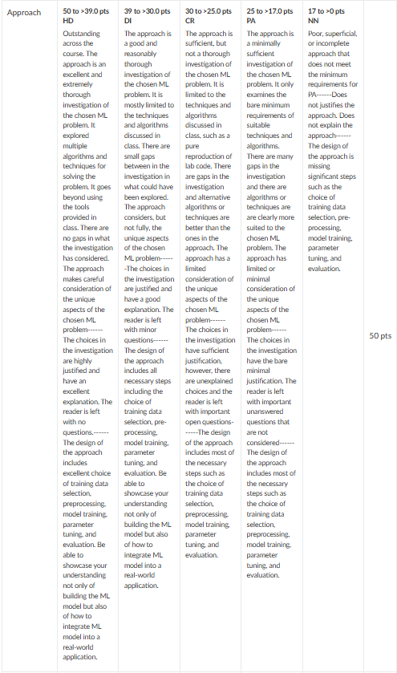
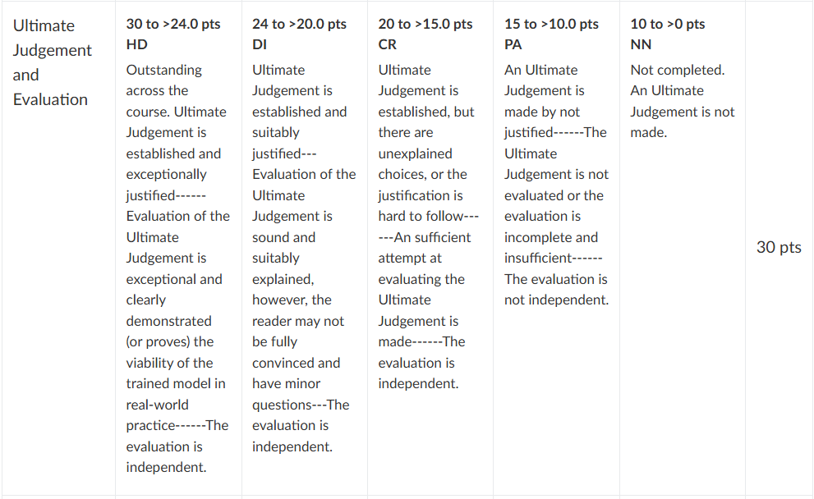
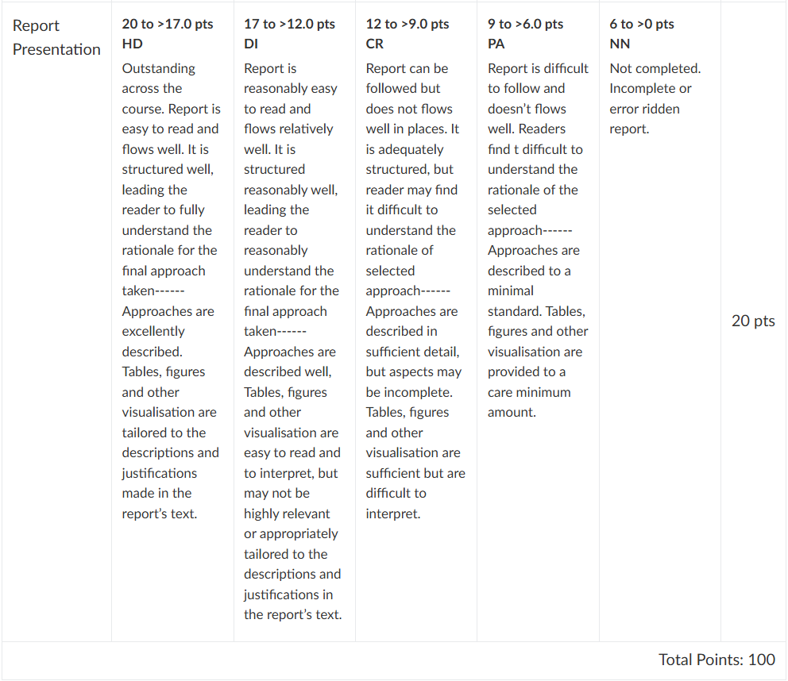

Tab 4
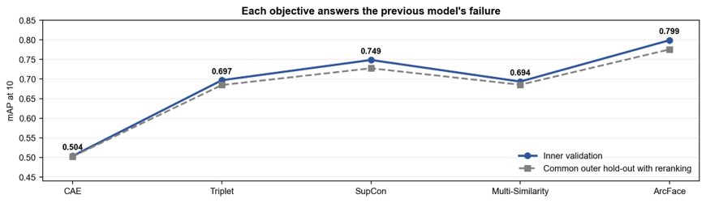
Figure X: Task 4 development evidence and the common hold-out result

