**REPORT-SAUMYA**

User story 1

As a user of OrangeHRM, after logging i should be navigated to the dashboard of the site which should display the working time of user, the tasks, latest posts , and the quick link box for various actions, pie chart which displays the Distribution by Sub Unit and by location and whether the user is on leave or not.

ACCEPTANCE CRITERIA

1. Navigation:
   * Upon logging in, the user should be automatically directed to the dashboard.
2. Dashboard Elements:
   * Working Time: The dashboard should display the user’s total working hours for the current day/week/month.
   * Tasks: A section should list the user’s current tasks, including deadlines and statuses.
   * Latest Posts: The dashboard should show the latest posts or announcements relevant to the user.
   * Quick Links: A quick link box should provide shortcuts to frequently used actions (e.g., apply for leave, timesheets, etc.).
   * Pie Charts:
     + One pie chart should display the distribution of employees by sub-unit.
     + Another pie chart should show the distribution of employees by location.
   * Leave Status: The dashboard should indicate whether the user is currently on leave or not.
3. Usability:
   * All elements should be clearly visible and accessible without excessive scrolling.
   * The dashboard should be responsive and display correctly on different devices (e.g., desktop, tablet, mobile).
4. Performance:
   * The dashboard should load within 3 seconds under normal network conditions.
5. Data Accuracy:
   * All displayed data (working time, tasks, posts, charts, leave status) should be accurate and up-to-date.
6. Security:
   * Only authenticated users should be able to access the dashboard.
   * Sensitive information should be protected and not exposed to unauthorized users.

Estimate : XL

Priority : 1

TEST CASES

Feature: Dashboard Display and Navigation

TC_01

Scenario: Verify the dashboard displays six boxes and the functionality of the "Time at Work" box

Given the user is logged into the OrangeHRM system

When the user navigates to the dashboard

Then the dashboard should display six distinct boxes

And the first box should be labelled "Time at Work"

And the "Time at Work" box should contain a bar graph showing work hours versus working days

And only the clock icon within the "Time at Work" box should be clickable

When the user clicks the clock icon within the "Time at Work" box

Then the user should be navigated to the Time page

TC_02

Feature: Dashboard Display and Navigation

Scenario: Verify the functionality of the "My Tasks" box

Given the user is logged into the OrangeHRM system

When the user navigates to the dashboard

Then the dashboard should display a box labelled "My Tasks"

And the "My Tasks" box should list the user's current tasks

And each task in the "My Tasks" box should be clickable

When the user clicks on a task in the "My Tasks" box

Then the user should be navigated to the Task page of the selected task

Feature: Dashboard Display and Navigation

TC_03

Scenario: Verify the functionality of the "Quick Links" box with clickable icons

Given the user is logged into the OrangeHRM system

When the user navigates to the dashboard

Then the dashboard should display a box labelled "Quick Links"

And the "Quick Links" box should contain the following options with clickable icons:

|  |  |  |
| --- | --- | --- |
| Option | Icon Clickable | Text Clickable |
| Assign Leave | Yes | No |
| Leave list | Yes | No |
| Timesheets | Yes | No |
| Apply Leave | Yes | No |
| My Leave | Yes | No |
| My Timesheet | YEs | No |

When the user clicks on the icon for "Assign Leave"

Then the user should be navigated to the Assign Leave page

When the user clicks on the icon for "Leave List"

Then the user should be navigated to the Leave List page

When the user clicks on the icon for "Timesheets"

Then the user should be navigated to the Timesheets page

When the user clicks on the icon for "Apply Leave"

Then the user should be navigated to the Apply Leave page

When the user clicks on the icon for "My Leave"

Then the user should be navigated to the My Leave page

When the user clicks on the icon for "My Timesheet"

Then the user should be navigated to the My Timesheet page

TC_04

Feature: Dashboard Display and Navigation

Scenario: Verify each feed in the "Buzzfeed" box is clickable and navigates to the Buzzfeed page

Given the user is logged into the OrangeHRM system

When the user navigates to the dashboard

Then the dashboard should display a box labelled "Buzzfeed"

And the "Buzzfeed" box should contain multiple feeds

When the user clicks on any feed in the "Buzzfeed" box

Then the user should be navigated to the Buzzfeed page displaying the selected feed's content

TC_05

Feature: Dashboard Display and Navigation

Scenario: Verify the scroll bar functionality in the "Buzzfeed" box

Given the user is logged into the OrangeHRM system

When the user navigates to the dashboard

Then the dashboard should display a box labelled "Buzzfeed"

And the "Buzzfeed" box should contain a scroll bar

When the user scrolls up and down using the scroll bar in the "Buzzfeed" box

Then the content within the "Buzzfeed" box should scroll up and down properly

And the scroll bar should function smoothly without any glitches

User Story 2

Description: As an administrator, I want to access the maintenance options in OrangeHRM, but I need to ensure that only authorized personnel can access these options. Therefore, the system should prompt for administrator credentials when attempting to access the maintenance section.

User Acceptance Criteria:

1. The username field should be auto filled with “admin” and should not be editable.
2. The password field should be editable to allow the administrator to enter their password.
3. The “Cancel” and “Confirm” buttons should be clickable.
4. Clicking the “Confirm” button with the correct password should grant access to the Administrator functions in OrangeHRM.
5. Clicking the “Confirm” button with an incorrect or empty password should not grant access.
6. Clicking the “Cancel” button should navigate back to the previously used page before clicking on the maintenance tab on the sidebar.

Estimate :L

Priority :2

Test Cases:

Feature: Maintenance Option Requiring Administrator Access

TC_01

Scenario: Username Field is Auto filled and Not Editable

Given I am on the maintenance access page

Then the username field should be auto filled with "admin"

And the username field should not be editable

TC_02

Scenario: Password Field is Editable

Given I am on the maintenance access page

Then the password field should be editable

TC_03

Scenario: Cancel and Confirm Buttons are Clickable

Given I am on the maintenance access page

Then the "Cancel" button should be clickable

And the "Confirm" button should be clickable

TC_04

Scenario: Correct Password Grants Access

Given I am on the maintenance access page

When I enter the correct password in the password field

And I click the "Confirm" button

Then I should be granted access to the Administrator functions

TC_05

Scenario: Incorrect or Empty Password Does Not Grant Access

Given I am on the maintenance access page

When I enter an incorrect or empty password in the password field

And I click the "Confirm" button

Then I should not be granted access to the Administrator functions

TC_06

Scenario: Cancel Button Navigates Back to Previous Page

Given I am on the maintenance access page

When I click the "Cancel" button

Then I should be navigated back to the previously used page before clicking on the maintenance tab

User Story 3

User Story: As an employee, I want to use the Buzz page in OrangeHRM so that I can engage with my colleagues by posting updates, sharing achievements, and commenting on posts.

Acceptance Criteria:

1.Buzz Page Accessibility

The user should be able to access the Buzz page by clicking on the “Buzz” link in the sidebar.

Upon clicking, the user should be redirected to the Buzz page.

2.Post an Update

The user should be able to type a message in the “What’s on your mind?” text box.

The user should be able to upload photos and videos by clicking on "Share photos" or "Share videos

Clicking the “Post” button should add the message to the Buzz feed, making it visible to all employees.

3.Like a Post

The user should be able to click the “Heart” icon on any post to like a post.

The like count on the post should increment, and the post should indicate that the user has liked it.

4.Comment on a Post

The user should be able to click the “Comment” icon on any post to comment on it.

After typing a comment and clicking “Submit,” the comment should be added to the post and visible to all employees.

5. Share a post

The user should be able to click "Share" icon to share it under their name.

6.View Post Details

The user should be able to click on any post to view its details.

The post details should include all comments, likes and shares.

7.Delete Own Post

The user should have the option to delete their own posts.

Clicking the “Delete” button on their post should remove it from the Buzz feed.

8.Edit Own Post

The user should have the option to edit their own posts.

Clicking the “Edit” button, making changes, and saving should update the post with the new content.

Notification for New Posts

Users should receive notifications when new posts are made on the Buzz page.

9.Search Posts

The user should be able to search for posts using a keyword.

The Buzz feed should display posts that match the keyword entered in the search bar.

10.Filter Posts by likes, comments and date.

The user should be able to filter posts by likes, comments or most recent by clicking either "Most Liked Posts", "Most commented Posts", or "Most recent Posts" respectively. displayed on the top.

The Buzz feed should display posts made within the filter

Estimate : XXXL

Priority :4

Test Cases

T001: Buzz Page Accessibility

Given: The user is logged into OrangeHRM. When: The user clicks on the “Buzz” link in the sidebar. Then: The user should be redirected to the Buzz page.

T002: Post an Update

Given: The user is on the Buzz page. When: The user types a message in the “What’s on your mind?” text box and clicks the “Post” button. Then: The message should be added to the Buzz feed and visible to all employees. Test Data:

* Message: “Excited to share our team’s latest achievement!”

T003: Upload Photos and Videos

Given: The user is on the Buzz page. When: The user clicks on “Share photos” or “Share videos” and uploads a file. Then: The photo or video should be attached to the post. Test Data:

* Photo: “team_photo.jpg”
* Video: “project_demo.mp4”

T004: Like a Post

Given: The user is on the Buzz page. When: The user clicks the “Heart” icon on a post. Then: The like count on the post should increment, and the post should indicate that the user has liked it.Test Data:

* Post ID: 12345

T005: Comment on a Post

Given: The user is on the Buzz page. When: The user clicks the “Comment” icon on a post, types a comment, and clicks “Submit”. Then: The comment should be added to the post and visible to all employees. Test Data:

* Post ID: 12345
* Comment: “Great job, team!”

T006: Share a Post

Given: The user is on the Buzz page. When: The user clicks the “Share” icon on a post. Then: The post should be shared under the user’s name. Test Data:

* Post ID: 12345

T007: View Post Details

Given: The user is on the Buzz page. When: The user clicks on a post. Then: The post details should be displayed, including all comments, likes, and shares. Test Data:

* Post ID: 12345

T008: Delete Own Post

Given: The user is on the Buzz page and has a post. When: The user clicks the “Delete” button on their post. Then: The post should be removed from the Buzz feed. Test Data:

* Post ID: 12345

T009: Edit Own Post

Given: The user is on the Buzz page and has a post. When: The user clicks the “Edit” button, makes changes, and saves. Then: The post should be updated with the new content. Test Data:

* Post ID: 12345
* New Content: “Updated achievement details!”

T010: Notification for New Posts

Given: The user is on the Buzz page. When: A new post is made by any employee. Then: The user should receive a notification about the new post.

T011: Search Posts

Given: The user is on the Buzz page. When: The user enters a keyword in the search bar. Then: The Buzz feed should display posts that match the keyword. Test Data:

* Keyword: “achievement”

T012: Filter Posts by Likes, Comments, and Date

Given: The user is on the Buzz page. When: The user clicks “Most Liked Posts”, “Most Commented Posts”, or “Most Recent Posts”. Then: The Buzz feed should display posts based on the selected filter.

Bug Report

Bug ID: B001

Title: Heart Icon Does Not Change Color on Hover

Description: When the user hovers over the “Heart” icon to like a post, the icon does not change color to indicate that it is clickable.

Steps to Reproduce:

1. Log in to OrangeHRM.
2. Navigate to the Buzz page.
3. Hover over the “Heart” icon on any post.

Expected Result: The “Heart” icon should change color on hover to indicate that it is clickable.

Actual Result: The “Heart” icon does not change color on hover.

Severity: Minor

Priority: Medium

Environment:

* Browser: Chrome 92.0
* OS: Windows 10

Attachments: 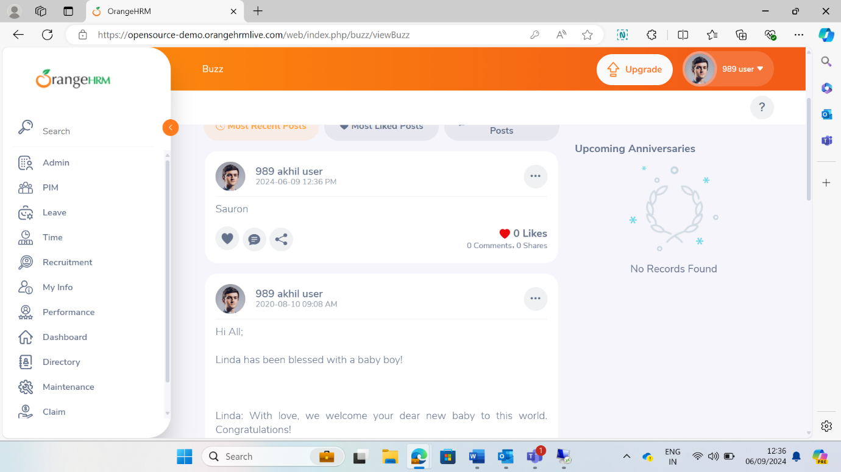

User Story 4:

Title: User profile Dropdown menu

As a user of OrangeHRM website, when I click on the profile button a dropdown menu should appear.

ACCEPTANCE CRITERIA:

* The profile button should display the user’s avatar and name.
* When clicked the dropdown menu should appear with the following options – About, Support, Change Password, Logout
* Each sub option should be clickable and lead to respective functionality

Estimate: L

Priority: 1

TEST CASES:

TC001-

Description: Verify that the profile button with the user's avatar and name is visible when the user is logged in.

Given the user is logged into the application.

When the user navigates to the homepage or dashboard.

Then the profile button with the user's avatar and name should be visible in the top right corner of the screen.

TC002-

Description: Verify that clicking the profile button opens the dropdown menu.

Given the user is logged in, and the profile button is visible.

When the user clicks on the profile button.

Then the dropdown menu should appear, displaying options: "About," "Support," "Change Password," and "Logout."

TC003-

Description: Verify that the dropdown menu closes when the user clicks outside of it.

Given the profile dropdown menu is open.

When the user clicks outside of the dropdown menu.

Then the dropdown menu should close.

TC004-

Description: Verify that clicking on the "Logout" option logs the user out of the application.

Given the user is logged in, and the profile dropdown menu is open.

When the user clicks on the "Logout" option.

Then the user should be logged out and redirected to the login page.

TC005 –

Description: Verify that clicking the "Change Password" option opens the change password interface.

Given the profile dropdown menu is open.

When the user clicks on the "Change Password" option.

Then the change password interface should be displayed, allowing the user to input current password, password and confirm password.

User Story 5

MY INFO PAGE

As a user, after logging in into the orangeHRM application, upon clicking on the ‘My Info’ option in the sidebar, a list of user’s personal details and link options should be available in the left sidebar (User image, name, Personal details, Contact Details, Emergency Contacts, Dependents, Immigration, Job, Salary, Report-to, Qualifications and Memberships).

USER ACCEPTANCE CRITERIA: Upon clicking my info page, a sidebar with personal and job detail links should appear and every link should be clickable and relevant information should be displayed upon selecting a particular link.

Estimation: XXL  
priority: 3

Test Cases:

Test case 06- Check if all the details are displayed upon clicking my Info

Given user is logged I into the Application

When the user clicks on ‘My info’ in the sidebar

Then user personal details and job information links should appear as sidebar.

Test case 07- Check validity of dates entered in the ‘Personal details’ sidebar

Given user clicked on ‘My info’ in the sidebar

When the user clicks on ‘personal details’ options

And the user enters a particular date for DOB and License Expiry Date

Then only valid dates should be accepted and saved.

And for invalid dates, warning message should be displayed.

Bug ID: BR-002

Title: License Expiry Date Updates with Invalid Dates in ‘My Info’ Page

Description: When a user enters an invalid date for the License Expiry Date in the ‘Personal Details’ section of the ‘My Info’ page, the date is still accepted and saved without displaying a warning message. This issue allows invalid dates to be stored in the system.

Steps to Reproduce:

1. Navigate to the ‘My Info’ page from the sidebar.
2. Click on the ‘Personal Details’ option.
3. Enter an invalid date (e.g., 31/02/2024) in the License Expiry Date field.
4. Save the changes.

Expected Result:

* Only valid dates should be accepted and saved.
* A warning message should be displayed for invalid dates.

Actual Result:

* Invalid dates are accepted and saved without any warning message.

Severity: High

Priority: Medium

Environment:

* OS: Windows 10
* Browser: Google Chrome Version 92.0.4515.107
* Application Version: OrangeHRM 4.8

Attachments

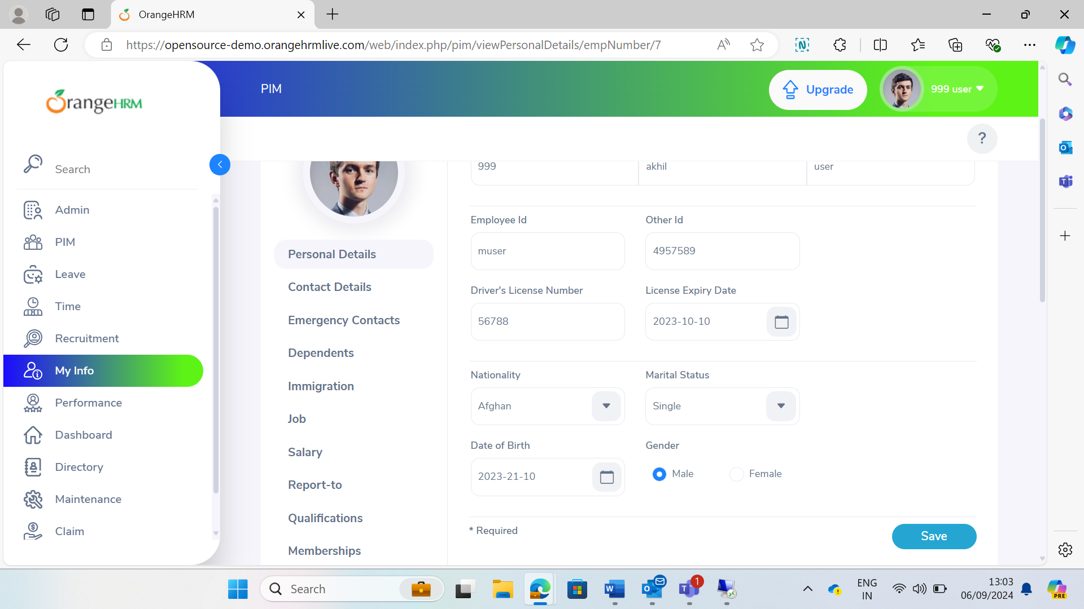

Test case 08- Check if text fields can be edited in the ‘Personal Details’ options

Given user clicked on the ‘my info’ in the sidebar

When the user clicks on the ‘Personal details’ option

And clicks on any text field

Then the user should be able to type or change the information in the fields.

Test case 09- Check if details are updated in the ‘Personal Details’ page upon clicking save

Given the user clicked on the ‘my info’ in the side page

When the user clicks on ‘Personal Details’ page

And the user edits any editable text field

And the user click on the save button

Then the details should be updated and ‘saved successfully’ information should be displayed.

Test case 10- Change background color of button on hover

Given the user clicked on the ‘my info’ in the side page

When the user hovers over any of the options in the sidebar

Then the background color of the option button should change from grey to orange on hovering on the option.

And the background color of the option button should change from orange to gray on hovering away from the option.

**Screenshots for Azure Devops**

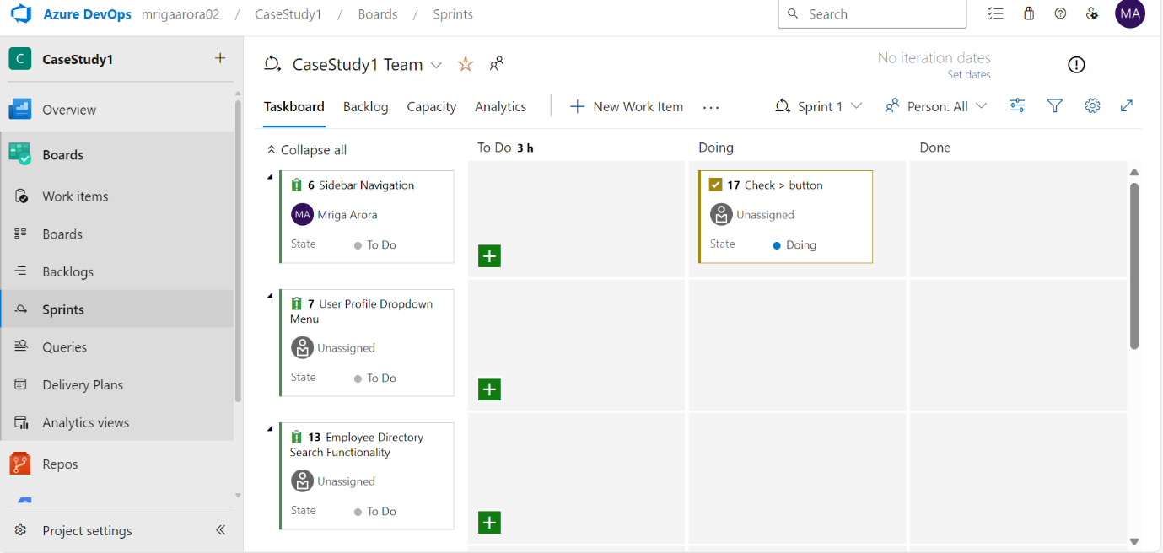

**Screenshots for VM Creation**

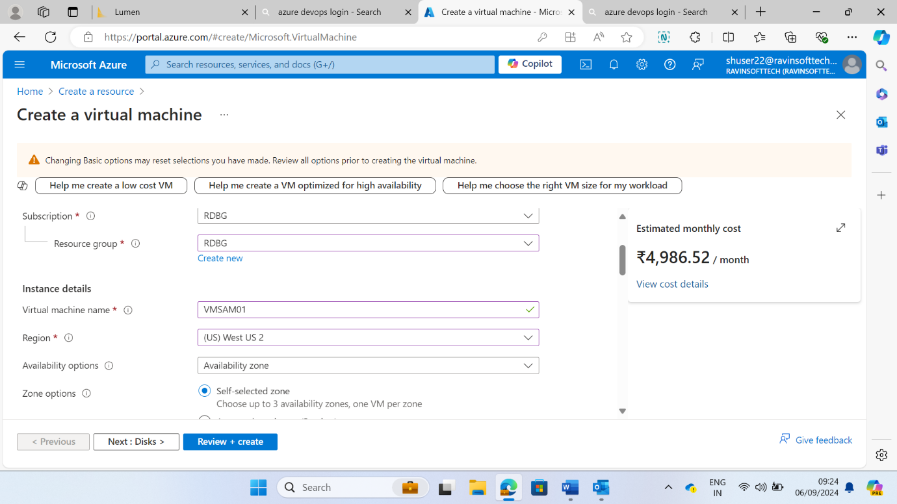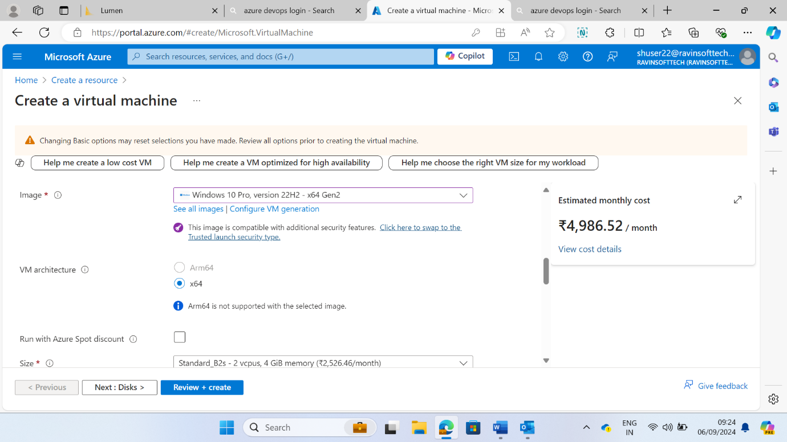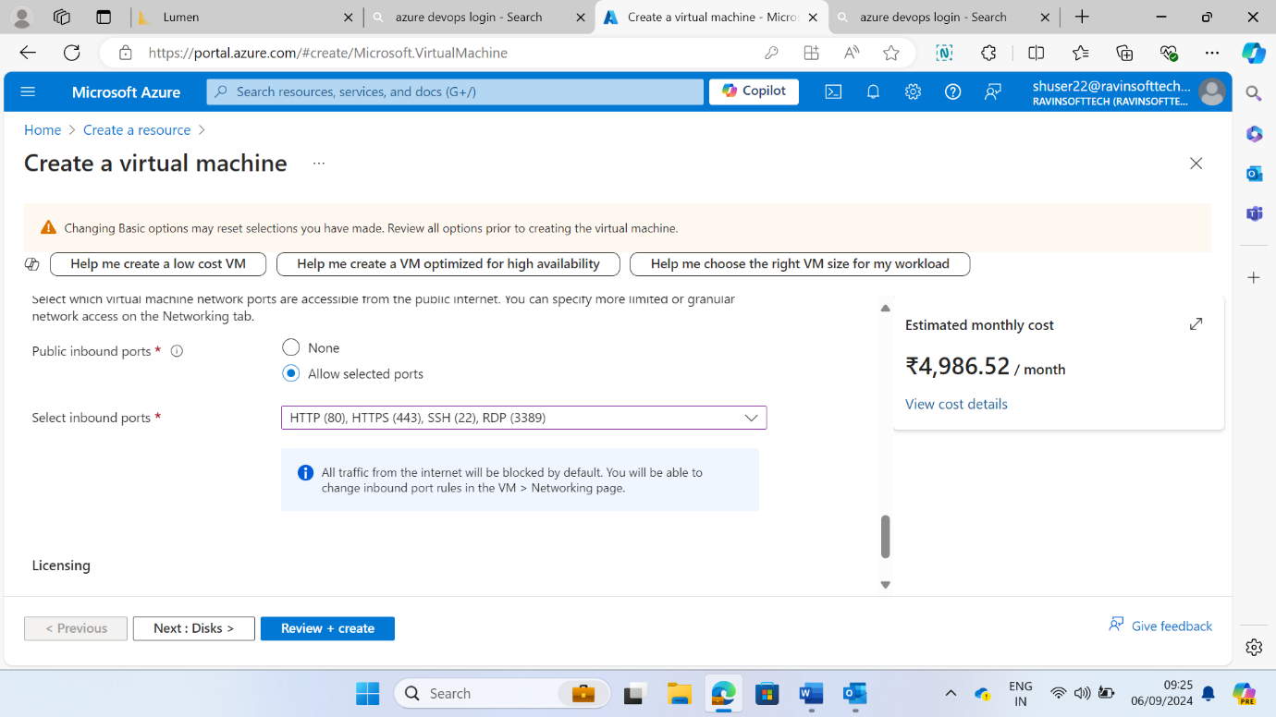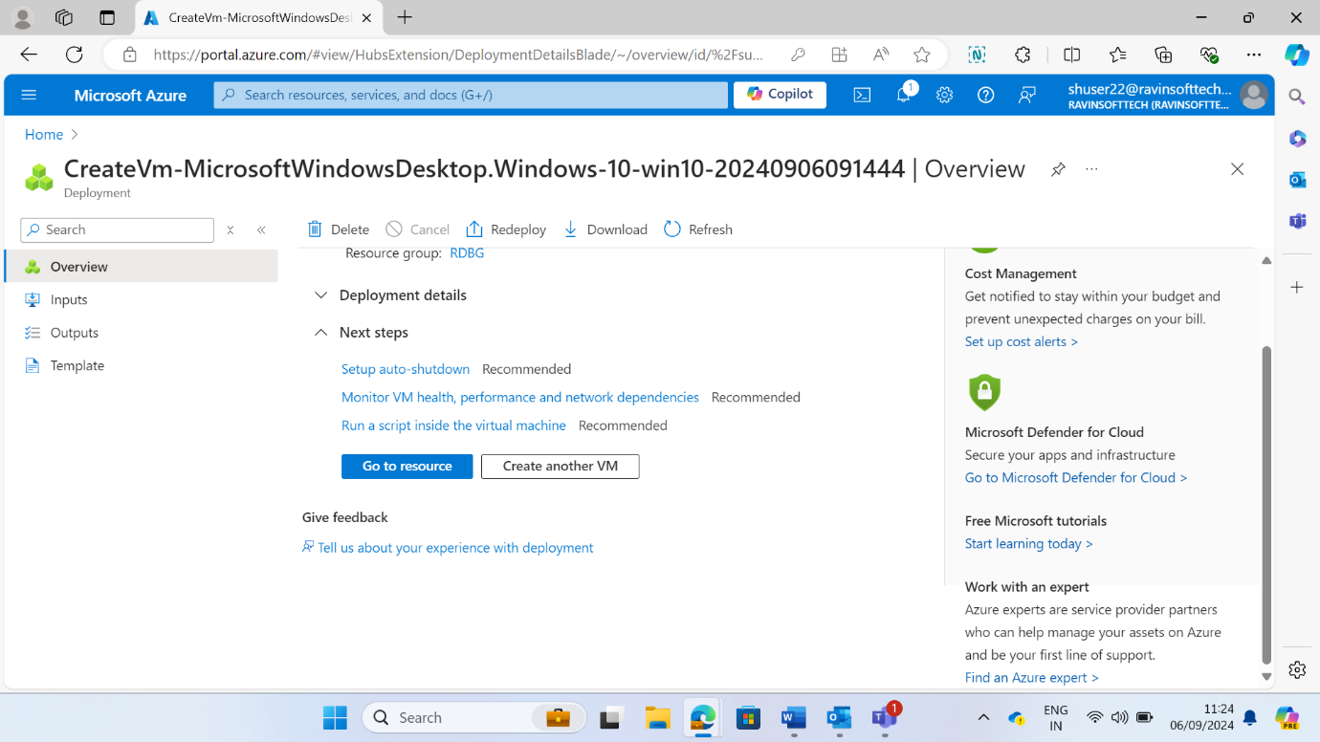

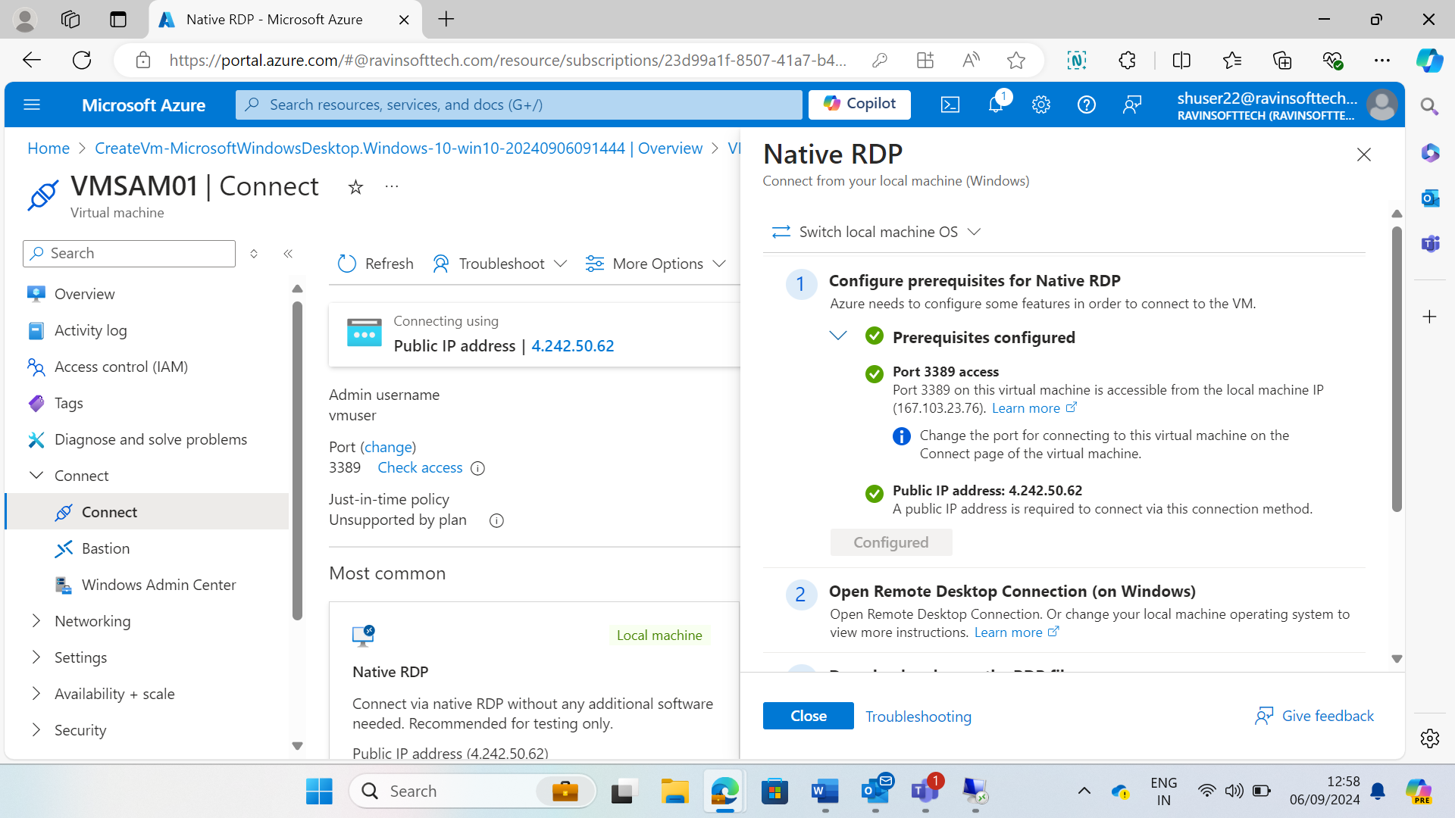

**Screenshots for GitHub Actions**

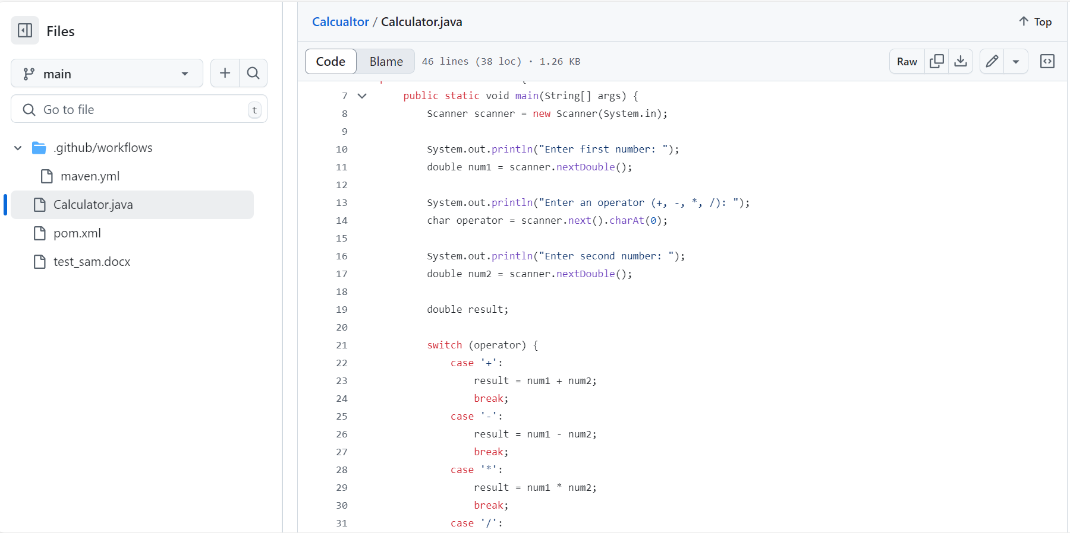

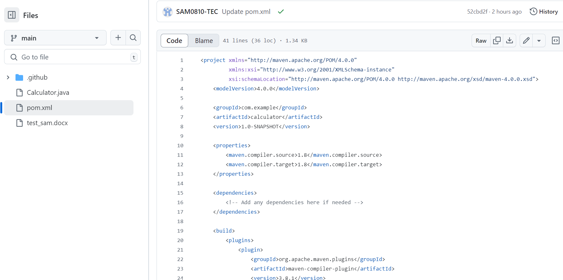

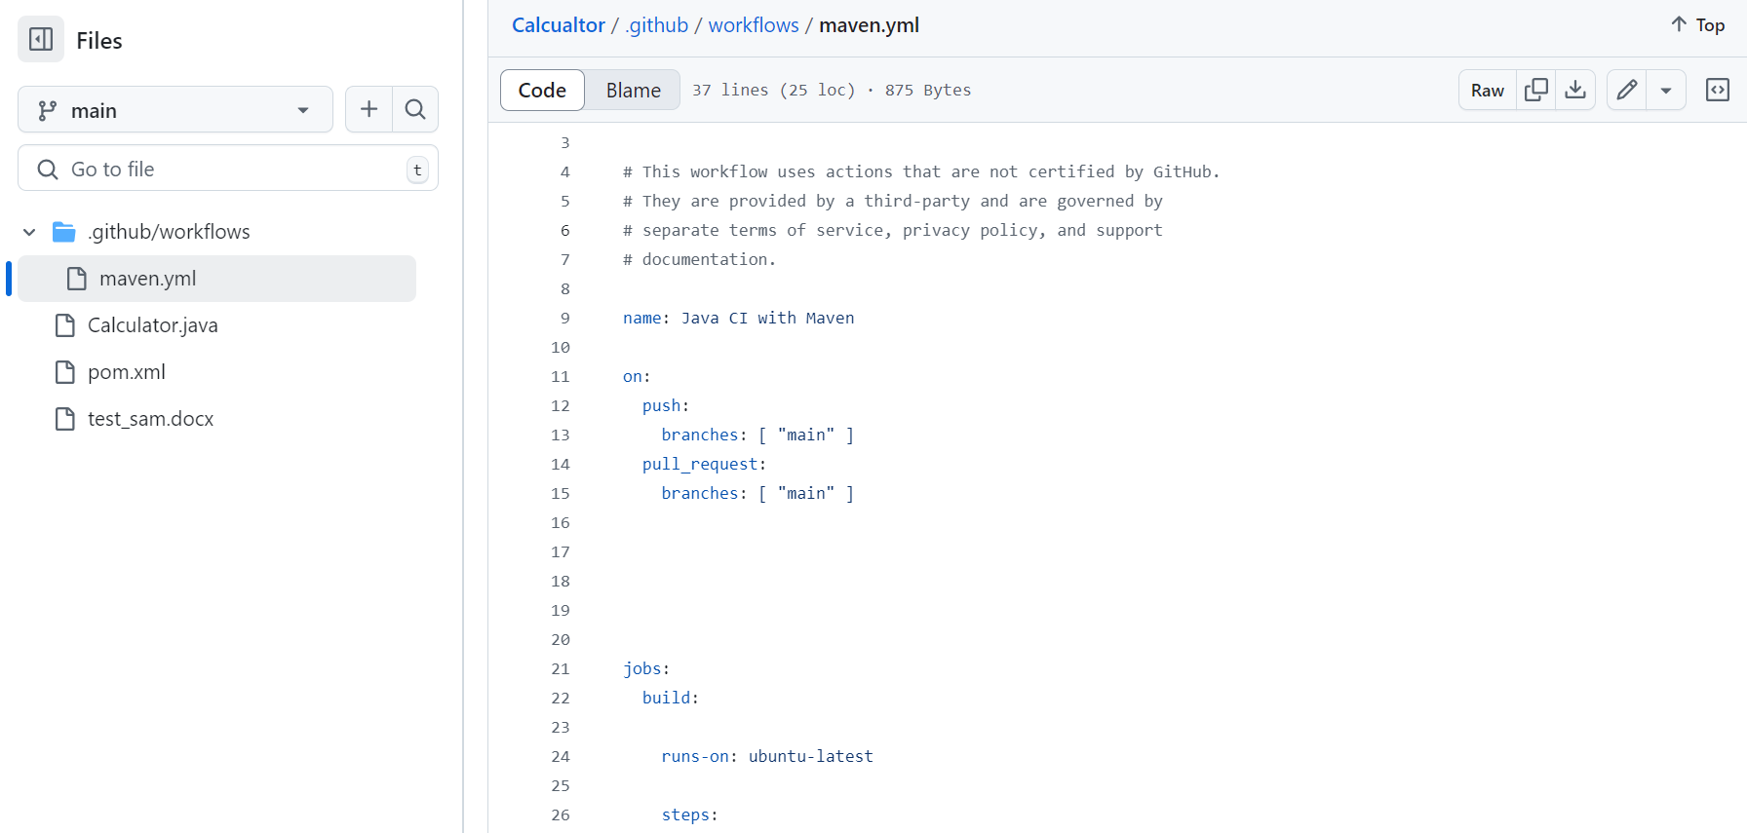

**GitHub repo for case study**

[SAM0810-TEC/Calcualtor (github.com)](https://github.com/SAM0810-TEC/Calcualtor)