IT_SERVICES_GENERAL_BI

-- NUMERIC NULL VALUE TO AVG IPDATE

SELECT AVG(Hours_Billed)

FROM IT

---NULL VALUES FIND

SELECT COUNT(*) FROM IT

WHERE Hours_Billed IS NULL

--- UPFDATE NULL VALUES

UPDATE IT

SET Hours_Billed = '1045'

WHERE Hours_Billed IS NULL

-- Avg. Resource Utilization

SELECT AVG(Resource_Utilization) AS AVG_RESOURCE

FROM IT



-- Total Hours Billed

SELECT SUM( Hours_Billed) AS TOTAL_HOURS

FROM IT

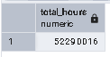

-- Bugs Reported per Project

SELECT PROJECT_ID AS PROJECT, SUM(Bugs_Reported) AS REPOURTE

FROM IT

GROUP BY PROJECT_ID

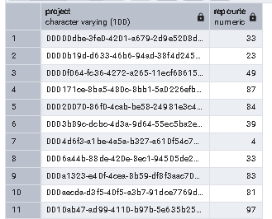

-- Project Duration (End Date - Start Date)

SELECT PROJECT_ID,START_DATE,END_DATE, END_DATE - START_DATE AS ProjectDurationDays

FROM IT

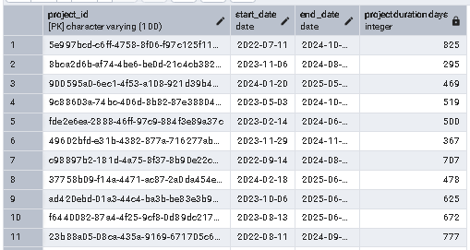

-- Utilization vs Bugs Utilization

SELECT SUM(Resource_Utilization) AS Utilization ,SUM(Bugs_Reported)AS Utilization

FROM IT



# --Work / Analysis

SELECT * FROM IT

-- KPI cards for Utilization, SLA, Hours

SELECT SLA_MET, SUM(RESOURCE_UTILIZATION) AS Utilization, SUM(Hours_Billed) AS HOURS

FROM IT

GROUP BY SLA_MET

ORDER BY SLA_MET DESC

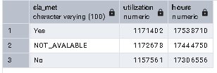

# -- Gantt chart style project timeline

-- Cluster chart: Bugs vs Hours Billed

SELECT SUM(BUGS_REPORTED) AS BUGS, SUM(HOURS_BILLED) AS HOURS_BILLED

FROM IT

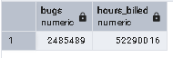

# -- Client-wise filters to monitor project delivery

-- Identify long-running or overdue projects