Week 3 Task: Advanced Data Analysis and Visualization in Logistics
Python-based Exploratory Data Analysis of a Hypothetical Dataset

1. Introduction
This report demonstrates how Python can be used to examine logistics performance through exploratory data analysis (EDA), descriptive statistics, correlation analysis, and visualizations. The dataset is hypothetical and was generated for this task. It contains 120 shipment records with distance, shipment volume, transportation mode, delivery time, transportation cost, and delivery status.

2. Dataset Structure and Methodology
The dataset contains the following fields: Shipment_ID (unique shipment identifier), Delivery_Distance_km (route distance), Shipment_Volume_units (shipment quantity), Transportation_Mode (Road, Rail, or Air), Delivery_Time_hours (simulated time), Transportation_Cost_INR (simulated cost in rupees), and Delivery_Status (On Time or Delayed based on a simulated rule).
The workflow used Pandas to load and inspect data, NumPy to simulate values, and Matplotlib to create charts. The analysis checked dataset dimensions and missing values, calculated descriptive statistics, grouped performance by transportation mode, and calculated correlations between numeric variables.

3. Exploratory Data Analysis
The dataset contains 120 records and 7 columns. Missing values by column were checked; this generated dataset contains 0 missing values.
Average delivery time is 13.88 hours, while the median is 14.98 hours. Average transportation cost is ₹4,367.07, and the median cost is ₹4,283.66. The average shipment distance is 477.15 km.
Descriptive statistics for the principal numerical variables are shown below.
Metric | Mean | Median | Minimum | Maximum
Distance (km) | 477.15 | 477.00 | 26.00 | 878.00
Volume (units) | 39.12 | 39.50 | 1.00 | 79.00
Delivery time (hours) | 13.88 | 14.98 | 1.49 | 27.05
Cost (INR) | 4367.07 | 4283.66 | 550.00 | 15479.36

4. Visualizations and Interpretation
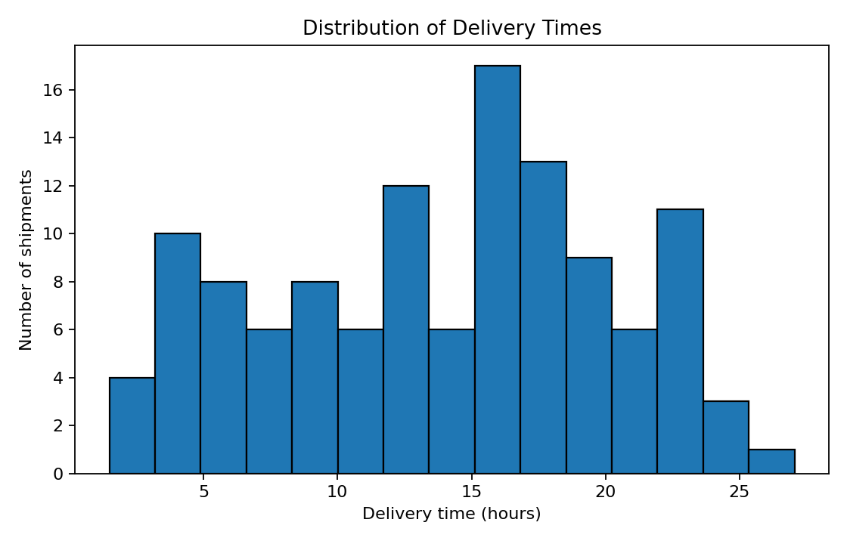
Figure 1. Distribution of delivery times.
The histogram shows how delivery durations are distributed. A long right tail would indicate a smaller number of shipments taking much longer than typical deliveries. Such cases should be reviewed for route, scheduling, handling, or capacity issues.
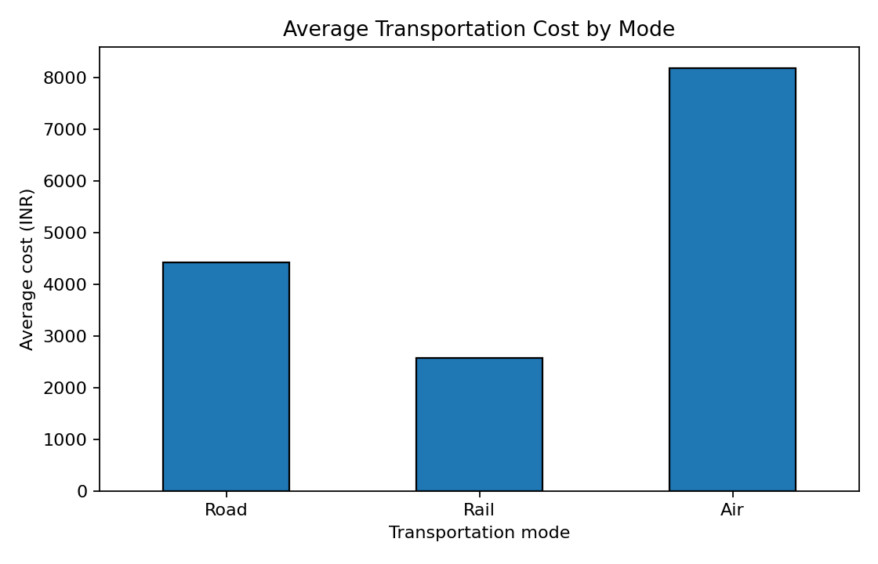
Figure 2. Average transportation cost by mode.
The bar chart compares average costs for road, rail, and air shipments. In this simulated dataset, mode costs reflect different cost rates, so the chart illustrates why transportation mode should be considered when planning budgets. The figures are illustrative, not actual market prices.
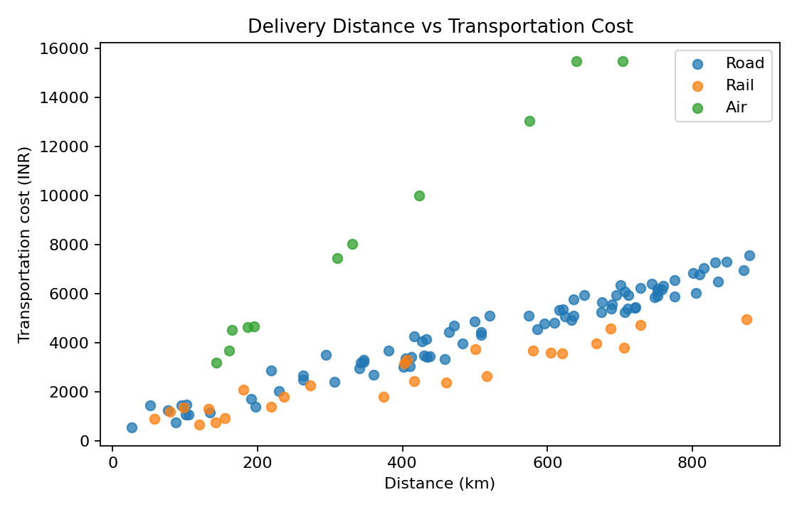
Figure 3. Delivery distance versus transportation cost.
The scatter plot examines whether costs tend to increase with distance and shows how observations vary by transport mode. The distance-cost correlation in this dataset is 0.68. Differences between modes and shipment volumes mean distance is not the only cost driver.
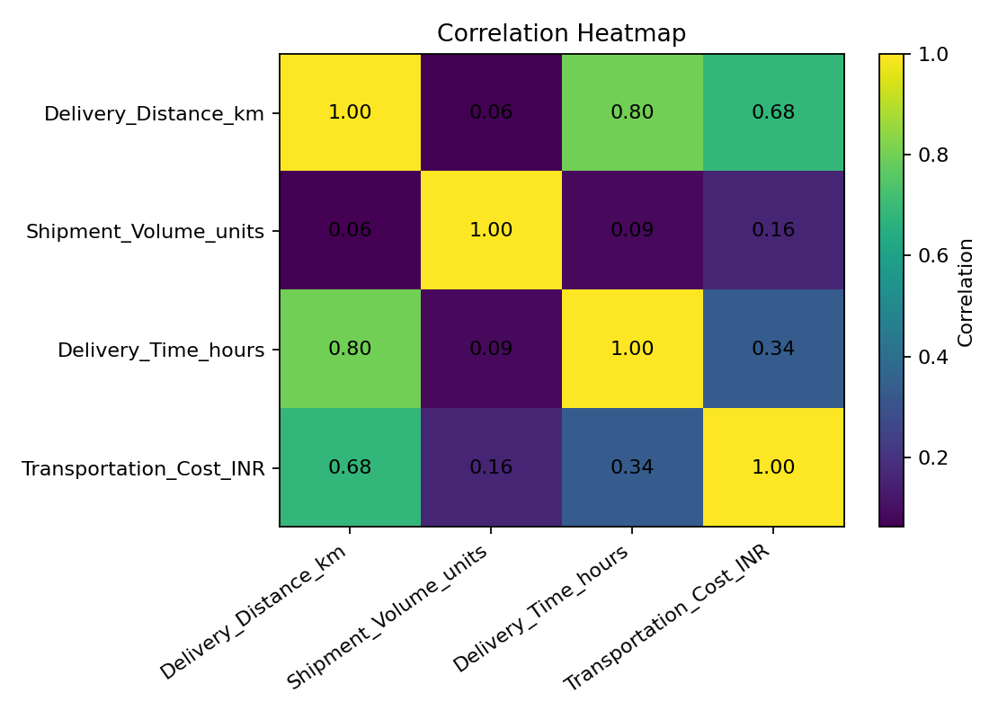
Figure 4. Correlation heatmap.
The heatmap summarizes linear relationships among distance, shipment volume, delivery time, and cost. Values closer to +1 indicate stronger positive linear relationships, values near 0 indicate weak linear relationships, and values closer to -1 indicate negative relationships. Correlation alone does not prove causation.

5. Comparison by Transportation Mode
Mode | Average delivery time (hours) | Average cost (INR)
Air | 5.10 | ₹8,192.33
Rail | 11.33 | ₹2,571.18
Road | 15.84 | ₹4,422.68
This comparison helps show trade-offs between speed and cost. The most suitable mode depends on the delivery deadline, distance, shipment size, and budget. Because the dataset is simulated, the results should not be treated as a universal ranking of transport modes.

6. Key Findings
- The simulated average delivery time is 13.88 hours, with a median of 14.98 hours.
- The simulated average transportation cost is ₹4,367.07.
- 20.0% of records are labelled 'Delayed' under the dataset's illustrative rule.
- The correlation between distance and transportation cost is 0.68, suggesting the strength and direction of a linear relationship in this sample.

7. Recommendations
- Track delivery time distributions and investigate shipments at the extreme end of the range.
- Compare transport modes using total cost, delivery urgency, shipment volume, and route distance.
- Monitor cost per kilometre and cost per unit, not only total cost, to make fair comparisons.
- Review high-cost and long-duration shipments to identify process or planning improvements.
- Repeat the analysis with validated real operational data and clearly defined service-level targets before making business decisions.

8. Python Code Excerpt
import pandas as pd
import matplotlib.pyplot as plt
df = pd.read_csv("logistics_data.csv")
print(df.describe(numeric_only=True))
print(df.groupby("Transportation_Mode")["Transportation_Cost_INR"].mean())
plt.hist(df["Delivery_Time_hours"], bins=15, edgecolor="black")
plt.xlabel("Delivery time (hours)")
plt.ylabel("Number of shipments")
plt.title("Distribution of Delivery Times")
plt.tight_layout()
plt.show()
The complete runnable script is provided separately as logistics_analysis.py.

9. Conclusion
This task demonstrates a complete introductory EDA workflow for a logistics dataset: data inspection, descriptive statistics, grouping, correlation analysis, visualization, interpretation, and recommendations. The visualizations make performance patterns easier to communicate and can help teams ask focused questions about delays and costs. All results are based on simulated data and are intended for learning and demonstration.

Appendix: Files Included
- logistics_data.csv — simulated shipment dataset.
- logistics_analysis.py — runnable Python analysis script.
- charts/ — four generated visualization images.
- README.md — repository overview and summarized findings.

