**MATLAB & Simulink Assignment Report**

**Submitted by:** KURAKULA SAMBA SIVA REDDY  
**Course/Module:** MATLAB and Simulink Applications  
**Date:** [27/10/2024]

# 1. Introduction

This report details the design, simulation, and analysis of various systems using MATLAB and Simulink. The assignment explores MATLAB State flow for state-based systems, MATLAB programming for physical simulations, Simulink for circuit and temperature modelling, and control system analysis using PID in MATLAB/Simulink. Each section illustrates the methods, results, and insights gained from the project.

# 2. MATLAB State flow

## 2.1 Washing Machine Cycle Simulation

**Objective:**  
To simulate a washing machine's cycle, using State flow to define sequential states: Fill, Wash, Rinse, Spin, and Done.

**Methodology:**  
Each state in the cycle is defined with entry actions, transition conditions, and durations, with visual indicators for the current state. Transitions occur based on logical conditions or time intervals.

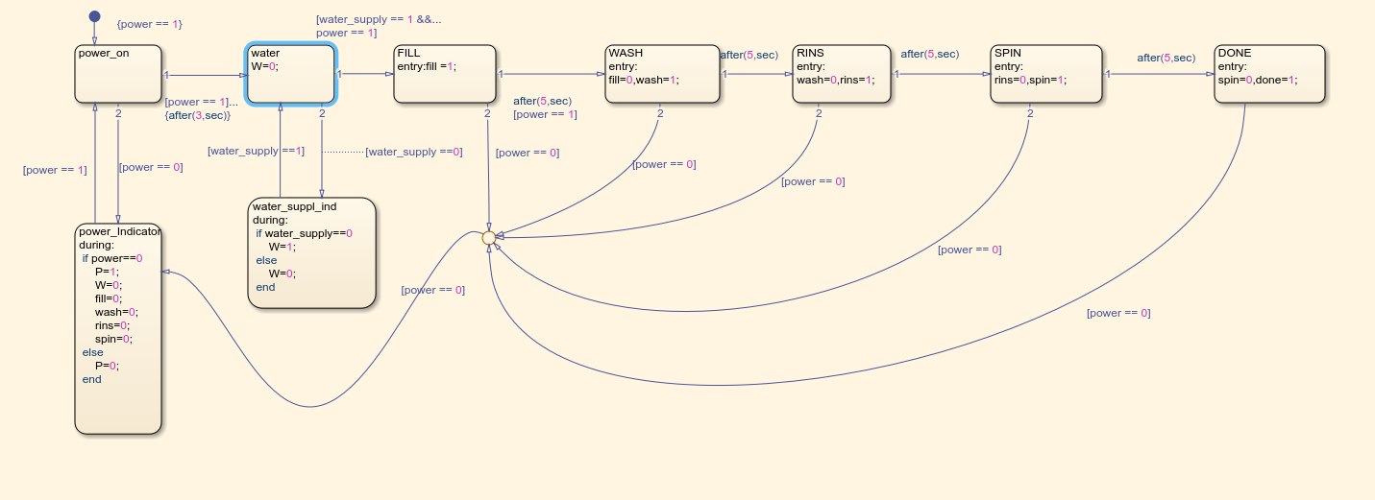

**Results:**  
The simulation accurately transitions through each state, demonstrating a complete washing machine cycle from start to end.

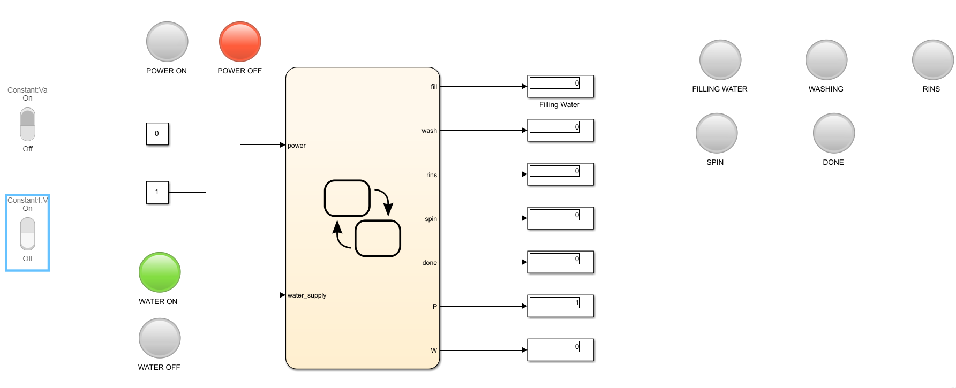

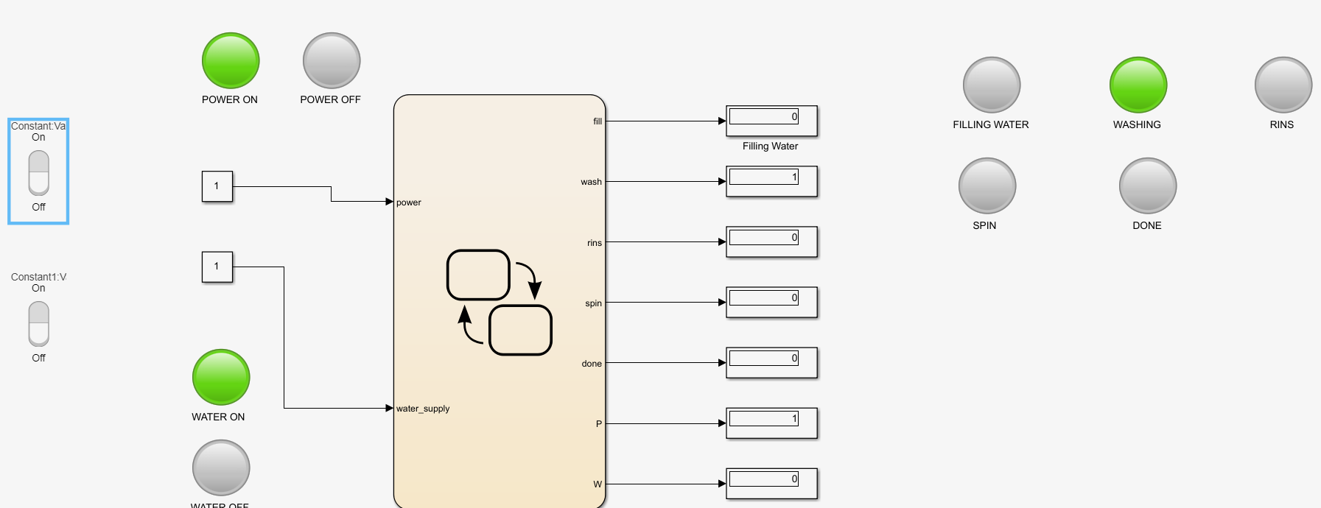

**Insights:**  
This exercise provided insights into hierarchical state management and real-time process simulation using MATLAB State flow.

## 2.2 Elevator Control System

**Objective:**  
To design a state flow chart for an elevator with floor-specific states and door control.

**Methodology:**  
The elevator system was designed with states for each floor and transitions for movement (Up and Down). Door states were incorporated for open and close commands on each floor.

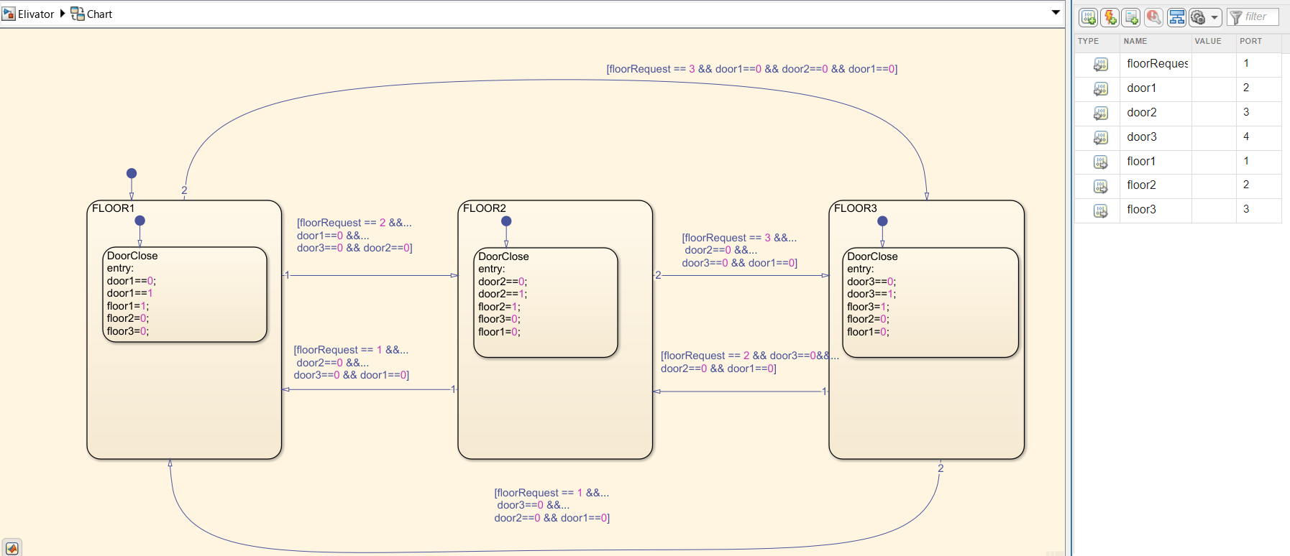

**Results:**  
The elevator control system successfully navigates between floors, with smooth transitions and appropriate door actions.

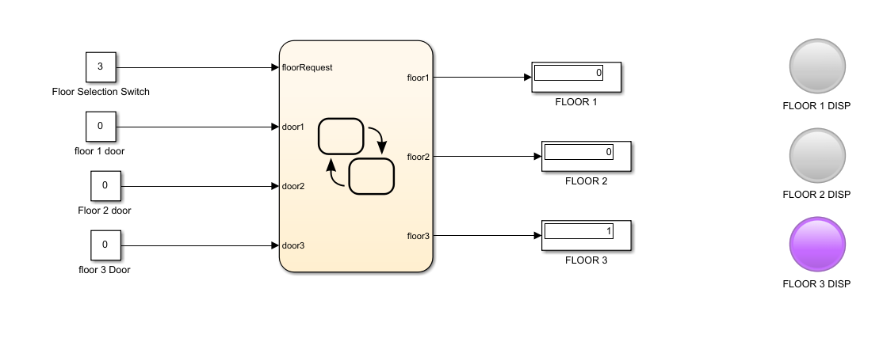

**Insights:**  
State flow effectively managed multi-state systems with conditional transitions, allowing complex behaviours such as door management and floor-specific actions.

# 3. MATLAB Programming

## 3.1 Projectile Trajectory Simulation

**Objective:**  
To simulate and plot the trajectory of a projectile based on initial velocity, launch angle, and gravitational acceleration.

**Methodology:**  
A MATLAB script was written to calculate the range and maximum height of the projectile, using equations of motion and plotting the resulting trajectory.

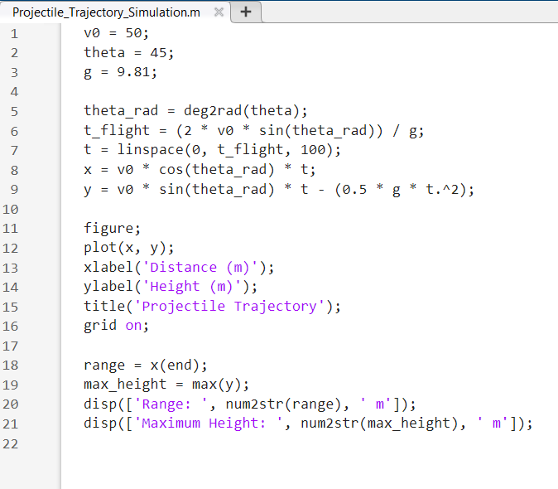

**Results:**  
The trajectory was accurately plotted, showing expected parabolic behaviour, with clear maximum height and range points.



**Insights:**  
This simulation reinforced knowledge of kinematics and MATLAB's plotting capabilities for dynamic simulations.

## 3.2 Random Number Sequence Plotting

**Objective:**  
To generate and plot a sequence of random numbers.

**Methodology:**  
A MATLAB script was created to generate a series of random numbers and plot them in a line graph.

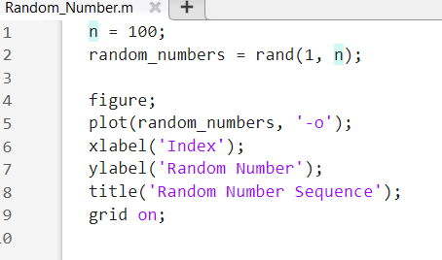

**Results:**  
The random number sequence was successfully generated and plotted, demonstrating fluctuations and randomness in the dataset.



**Insights:**  
This task highlighted MATLAB's capabilities in data visualization and randomness generation, useful for simulating stochastic processes.

# 4. Simulink Modelling

## 4.1 RC Circuit Simulation

**Objective:**  
To simulate the charging and discharging behaviour of an RC circuit in response to a step input.

**Methodology:**  
A Simulink model of an RC circuit was built, applying a step voltage input and monitoring the capacitor's charging and discharging behaviour over time.

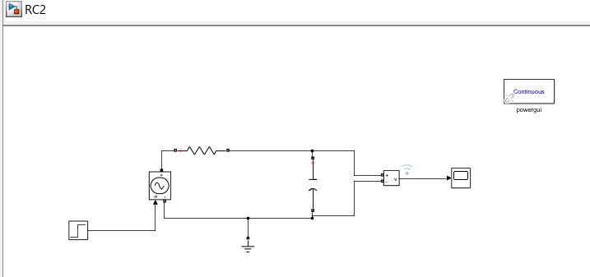

**Results:**  
The simulation produced a charging and discharging curve, and the time constant was analysed, showing expected exponential behaviour.

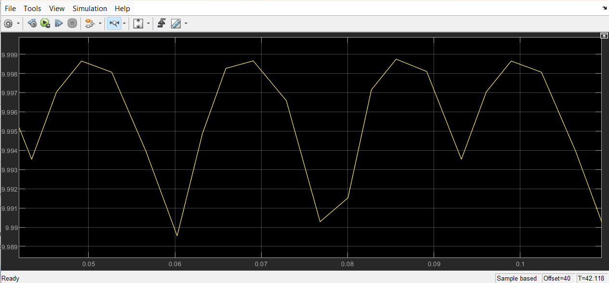

**Insights:**  
This exercise illustrated the power of Simulink for circuit analysis, enabling visualization of dynamic responses in electrical systems.

## 4.2 Temperature Change Simulation in Water Tank

**Objective:**  
To simulate temperature rise in a water tank with a basic heat source over time.

**Methodology:**  
A thermal model of the tank was built in Simulink, applying a constant heat source and monitoring temperature increase.

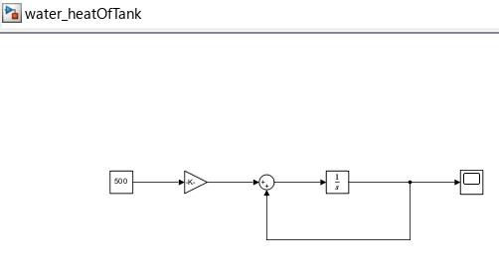

**Results:**  
The temperature rose as expected, with a steady curve demonstrating the heating effect over time.

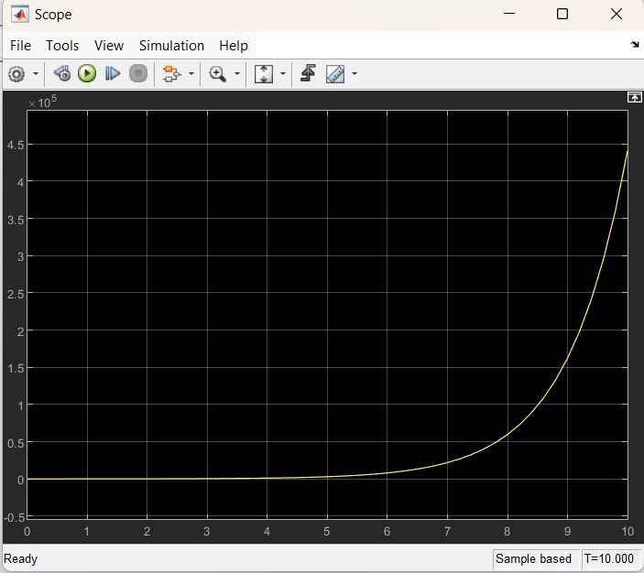

**Insights:**  
This model underscored Simulink’s utility in thermal systems analysis, supporting insights into heat transfer and accumulation over time.

# 5. PID Control in MATLAB/Simulink

## 5.1 Analysis of Transfer Functions

**Objective:**  
To analyse given transfer functions using MATLAB's PID control capabilities.

**Methodology:**  
Two transfer functions were implemented, and MATLAB was used to apply PID control, observing system response.

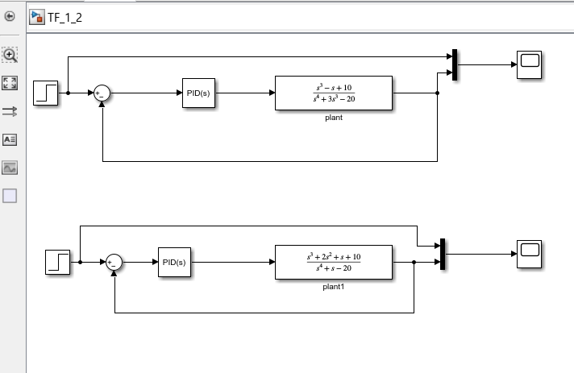

**Results:**  
The transfer functions displayed characteristic responses under PID control, demonstrating stable and controlled behaviour under designed parameters.

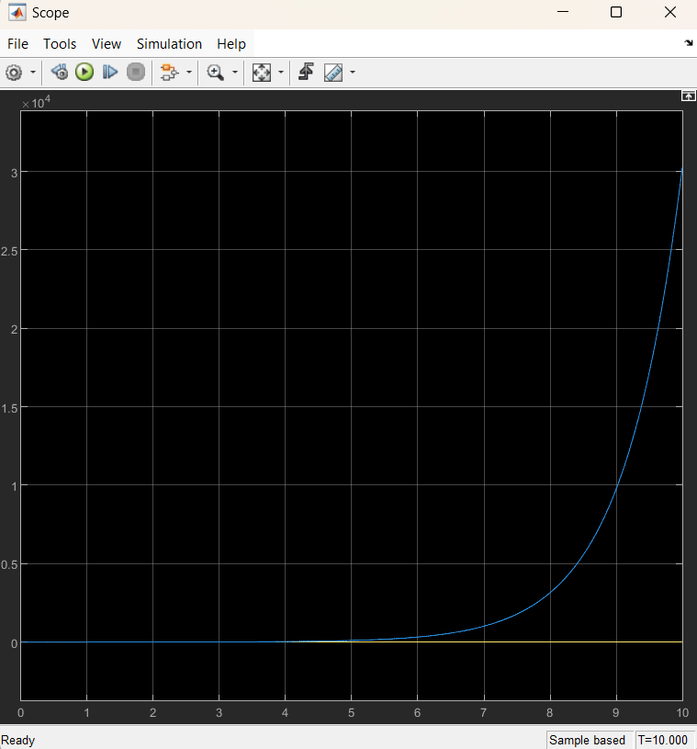

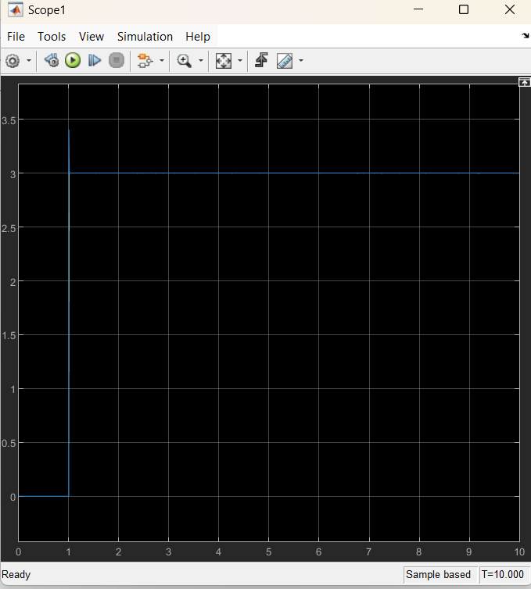

**Insights:**  
This task provided experience in control system design and analysis using MATLAB, highlighting PID's effectiveness in managing complex system responses.

# 6. Conclusion

This assignment enhanced proficiency in MATLAB and Simulink, covering diverse applications in state-based simulations, physical modelling, and control systems. Each task deepened understanding of MATLAB's versatility and Simulink's modelling capabilities, valuable for engineering simulations.

# 7. References

1. MATLAB Documentation: State flow, Simulink, PID Control Toolbox.