**ABSTRACT:**

A region-based Deep Convolutional Neural Network framework is provided in this paper for learning document structure. Effective region-based classifier training and ensembling for document image classification are two key contributions of this work. By considering the RVL-CDIP dataset as a reference and the train_csv file, the 16,000 images are classified into 16 classes (letter, email, invoice, advertisement, etc). Hence the images are categorized based on their class label. Applying common Convolutional Network architectures with DeepDocClassifier. Exporting weights from model architectures that have already been trained on the dataset is used to train a document classifier on complete document images, which is the first level of "inter-domain" transfer learning. Utilizing a region's unique characteristics to quickly train deep learning, transfer learning is utilized. Now shuffle the categorized images and split them into train and test. Now, this test and train are applied to each of the following individual models (document-image-transfer (DIT), VGG-16, LILT-only-base, LayoutLMv2) and store their predicted values in P1, P2, P3, and P4 respectively. These models are integrated to get a new model using multi-model integration and predicted values (P1, P2, P3, and P4) are stacked into a 1D array using stacked-generalization with ML. Now the final predicted values are validated with the validation set to find the performance metrics.

**LAYOUT:**

**INTRODUCTION:**

Due to its efficient model design and the benefit of large-scale unlabeled scanned/digital documents, pre-training of text and layout has demonstrated effectiveness in a range of visually complex document interpretation tasks. To simulate the interaction between text, layout, and image in a single multi-modal framework, we suggest the LayoutLMv2 architecture with novel pre-training tasks. In particular, LayoutLMv2 uses a two-stream multi-modal Transformer encoder that not only the new text-image alignment and text-image matching tasks but as well as the current masked visual-language modeling job, improves the pre-training stage's ability to capture the interplay between different modes. The Transformer architecture also has a spatial-aware self-attention mechanism so that the model may completely comprehend the relationship between various text blocks' relative positions. In the document-level classification task RVL-CDIP, we employ the [CLS] output along with a pooled representation of visual tokens as global features.

Fine-tuning for Document Image Classification:

Since this task requires detailed visual information, we deliberately use picture characteristics during the fine-tuning phase. We combine the visual embeddings into a pre-encoder feature that is available globally. LayoutLMv2's visual component outputs representations as a global post-encoder feature. the prior and post-encoder capabilities in addition to the [CLS] Concatenated output features are fed into the last layer of categorization

**CONTRIBUTIONS:**

1. As new pre-training tactics to enforce the alignment among various modalities, we also include text-image alignment and text-image matching in addition to the masked visual-language model.
2. In the pre-training step, we suggest using a multi-modal Transformer model to integrate the document's text, layout, and visual information. This integrates end-to-end learning of the cross-modal interaction into a single framework. Meanwhile, A self-attention system with spatial awareness in the Transformer architecture has it included.
3. LayoutLMv2 greatly outperforms traditional visually-rich document understanding tasks (VrDU) as well as the visual question answering (VQA) and reaches new outcomes. A job for document photos, demonstrating the enormous potential for the VrDU's pre-training.

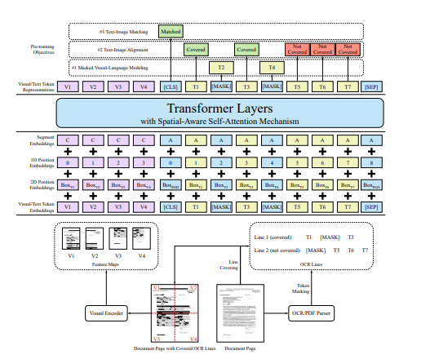

**An illustration of the model architecture and pre-training strategies for LayoutLMv2**

**DiT:**

**Introduction:**

DiT is a self-supervised document image transformer model that was trained using massive amounts of unlabelled text pictures. Due to the lack of human-labeled documents, supervised analogs never exist for jobs involving document AI. Analysis of document layouts or optical Character Recognition (OCR) still significantly relies on supervised computer vision backbone models using human-labeled training data. With either supervised pre-training on ImageNet or self-supervised pre-training, Image Transformer has recently shown remarkable success with natural image understanding tasks like classification, detection, and segmentation. The results that pre-trained Transformer models can produce compared to CNN-based pre-trained models with a similar parameter size, and comparable and even superior performance was achieved.

For generic Document AI tasks, we provide DiT, a self-supervised pre-trained Document Image Transformer model that doesn't rely on any human-labeled document images. The DiT model simply uses large-scale unlabeled data to understand the global patch relationship within each document image and does not rely on any human-labeled document images. We assess the previously trained data using four openly accessible Document AI benchmarks, DiT models, comprising the PubLayNet dataset [46] for document layout analysis, and the RVL-CDIP dataset [16] for document image classification. According to experiment results, the pre-trained DiT model outperformed the existing supervised and self-supervised pre-trained models, and new state-of-the-art was attained on these tasks.

**CONTRIBUTIONS:**

1) We suggest DiT, a self-supervised pre-trained document image Transformer model that can benefit from massive amounts of unlabeled document photos.

2) We use the previously trained DiT models as the foundation for different Document AI tasks, such as document image classification, analysis of document layout, table detection, as well as and text identification for OCR, and create brand-new cutting-edge outcomes.

**The model architecture of DiT with MIM pre-training.**

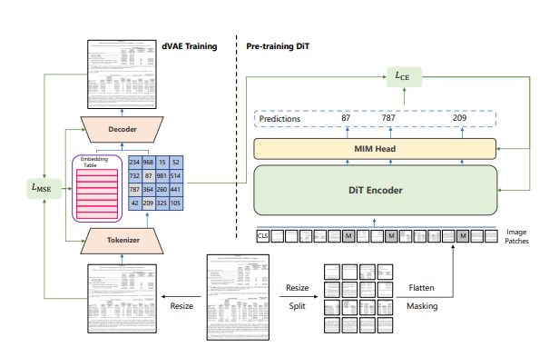

**Illustration of applying DiT as the backbone network in different detection frameworks.**

