**Area report:**

Selected Part: xc7a35tcsg324-1 (Artix 7 Series)

Synthesized top_quicksort.v file only

Vivado Tool:

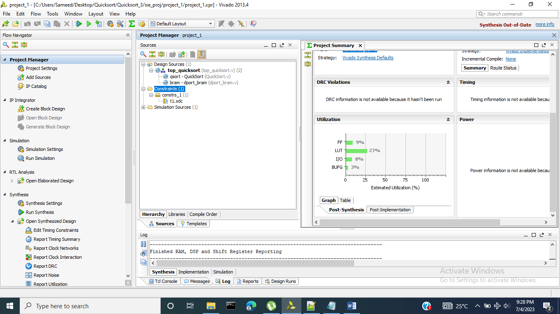

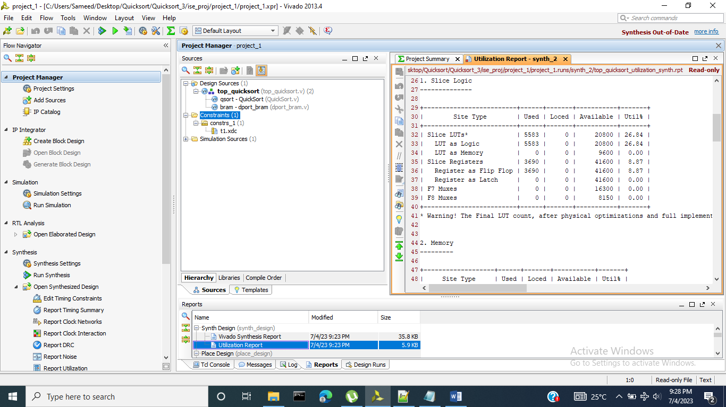

**Timing Summary:**

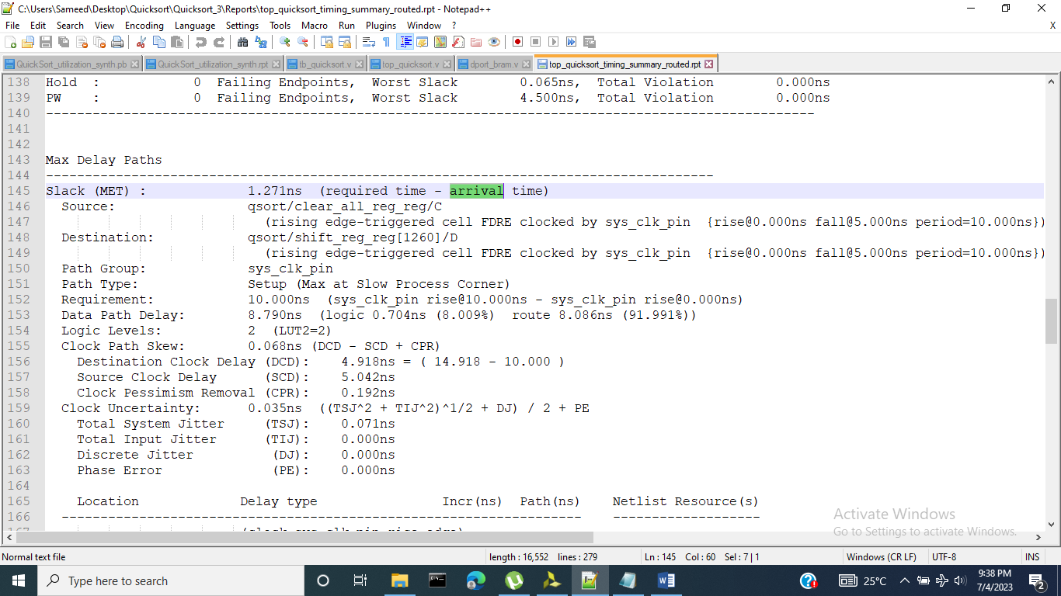

Best Setup time against a 100MHz Clock

As setup time slack is +ve, means a faster clock than 100Mhz can be used. That clock is:

Fmax = 1/ (10ns – 1.271ns)

Fmax = ~114.5MHz

