Project 6: Chatbot Deployment with IBM Cloud Watson Assistant

Phase 2: INNOVATION

Innovation Idea: Chatbot with text recognition

**1.Set Up IBM Watson Assistant:**

* Sign in to your IBM Cloud account or create one if you don't have it.
* Create a new Watson Assistant instance.

**2.Create an Assistant:**

* Within your Watson Assistant instance, create a new assistant.
* Configure the assistant's settings and name it.

**3.Design the Dialog Flow:**

* Create the conversation flow for your chatbot using the Watson Assistant Dialog Builder.
* Define intents, entities, and dialog nodes based on the expected user inputs and responses.

**4.Integrate Text Recognition:**

* Decide which text recognition service you want to use (e.g., IBM Watson Language Translator or IBM Watson Natural Language Understanding).
* Set up the selected service in your IBM Cloud account if you haven't already.

**5.Connect Watson Services:**

* In the Watson Assistant interface, go to "Integrations" or "Options."
* Add the desired Watson service integration (e.g., Language Translator or Natural Language Understanding).
* Configure the integration by providing credentials and setting up endpoints.

**6.Enhance Dialog Nodes:**

* Within your dialog nodes, incorporate actions that call the text recognition service. For example, you might use a "webhook" action to make API calls to the service.

**7.Define Recognition Triggers:**

* Determine when you want the text recognition to be triggered. This could be based on specific user inputs or conversation context.

**8.Handle Recognized Text:**

* After the text recognition service processes the user input, you'll receive the results. You can use these results to tailor your chatbot's responses or trigger specific actions.

**9.Test the Chatbot:**

* Thoroughly test your chatbot to ensure that it correctly recognizes and processes text inputs and provides appropriate responses.

**10.Iterate and Refine:**

* Based on user feedback and testing results, refine your chatbot's dialog flow, text recognition triggers, and responses.

**11.Deploy the Chatbot:**

* Once you're satisfied with your chatbot's performance, deploy it to the platform where you intend to use it (e.g., a website, messaging app, etc.).

**12.Monitor and Maintain:**

* Continuously monitor your chatbot's performance and make updates as necessary to improve its accuracy and effectiveness.

STEPS TO BE FOLLOWED IN CHATBOT DEPLOYMENT WITH IBM CLOUD WATSON ASSISTANT:

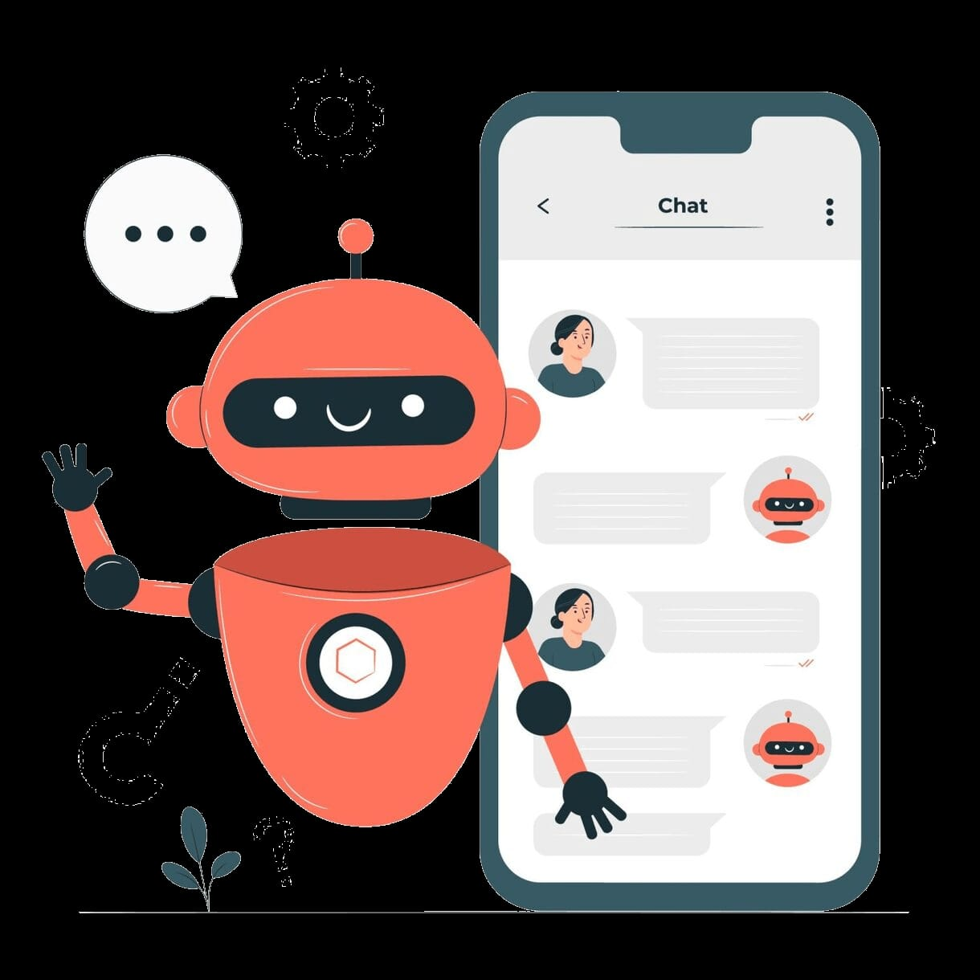

1.Create the assistant service

2.Create a workspace

3.Create intents

4.Test the intents

5.Add entities

6.Build the dialog

7.Complete advance dialog work

8.Use the API