**Project 6: Chatbot Deployment with IBM Cloud Watson Assistant**

**Phase 3: Development Part 1**

**Chatbot persona:**

1. A chatbot's persona includes factors like its name, gender, job, back story, tone, and personality traits.

2. A persona embodies preferences and expectations of your product, as well as a way of interacting with your bot.

3. Personalized chatbots focus on endowing chatbots with a consistent personality to behave like real users, give more informative responses, and further act as personal assistants.

**CONVERSATION FLOW DESIGN:**

A chatbot conversation flow represents a decision tree that guides a us through their journey when they land on a chatbot. Like any other conversation, a chatbot flow has certain logical elements, such as:

* Greeting
* Asking
* Informing
* Suggesting
* Checking
* Apologizing
* Error
* Goodbye

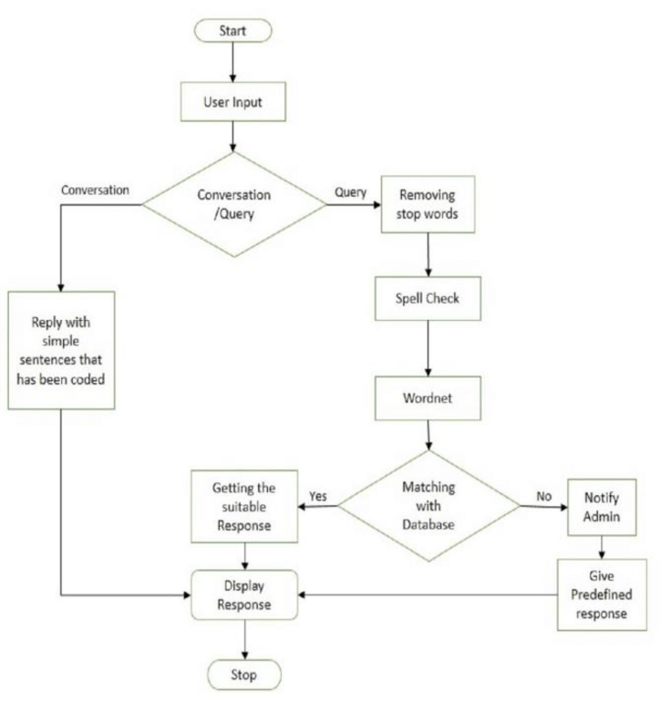

**SETUP OF WATSON ASSISTANT IN IBM CLOUD:**

STEP 1 -- The Dashboard of IBM cloud

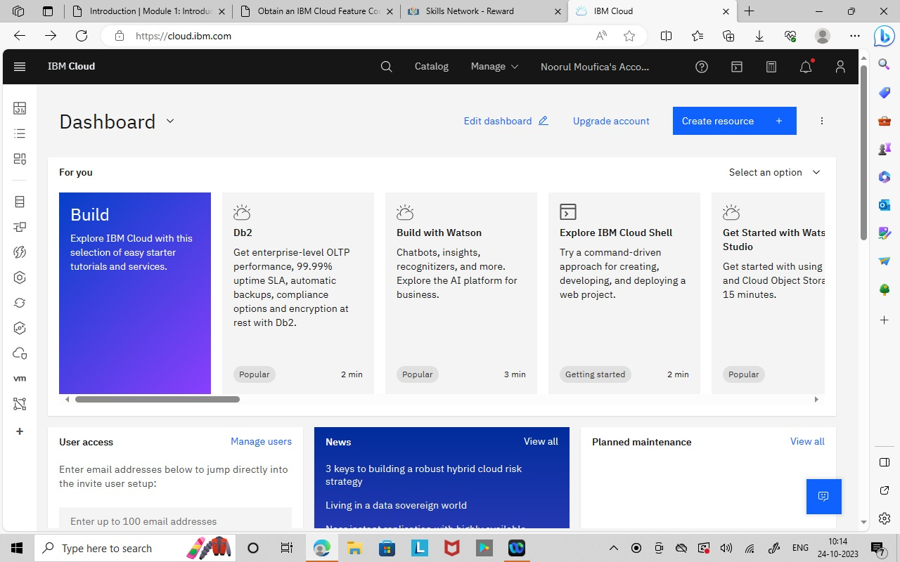

STEP 2 -- Select the Watson assistant in the catalog

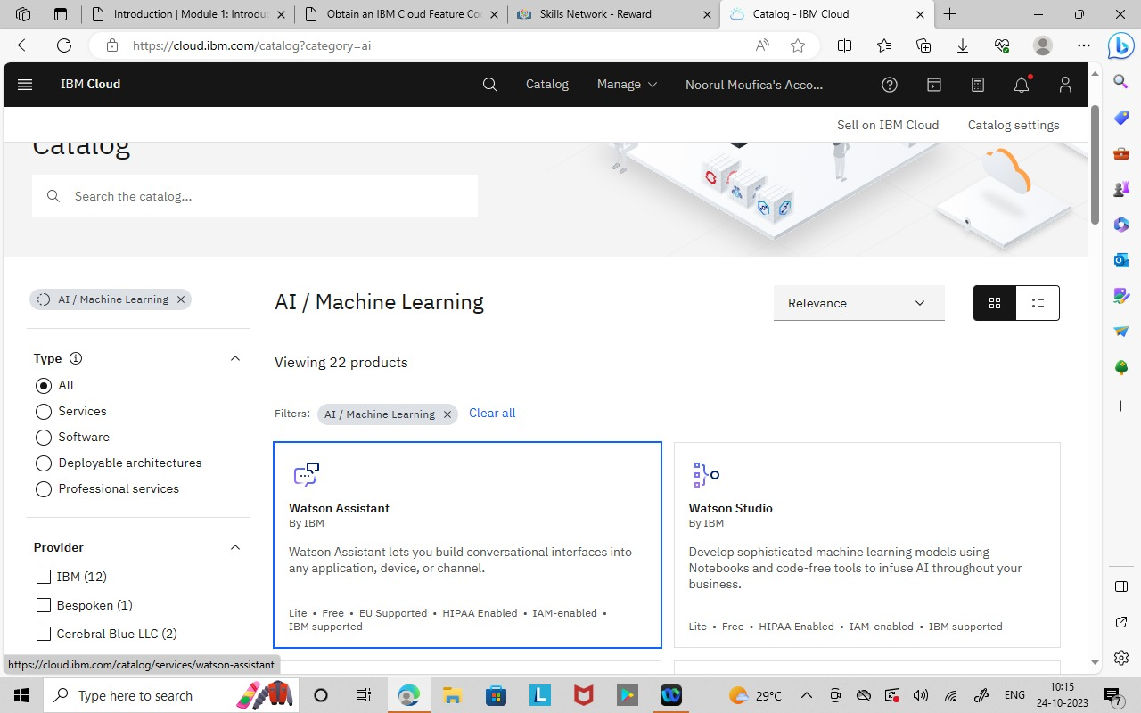

STEP 3 -- Enable the condition and create a watson assistant

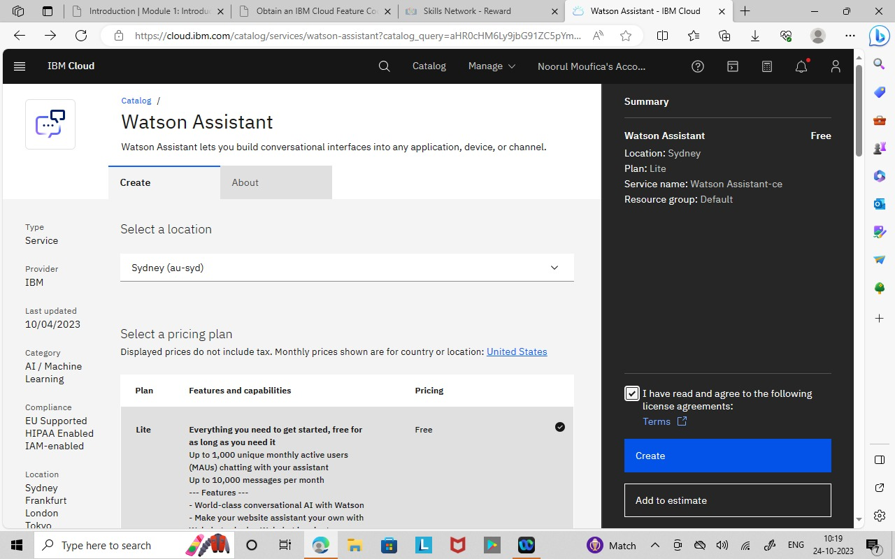

STEP 4 -- Launch the Watson Assistant Tool

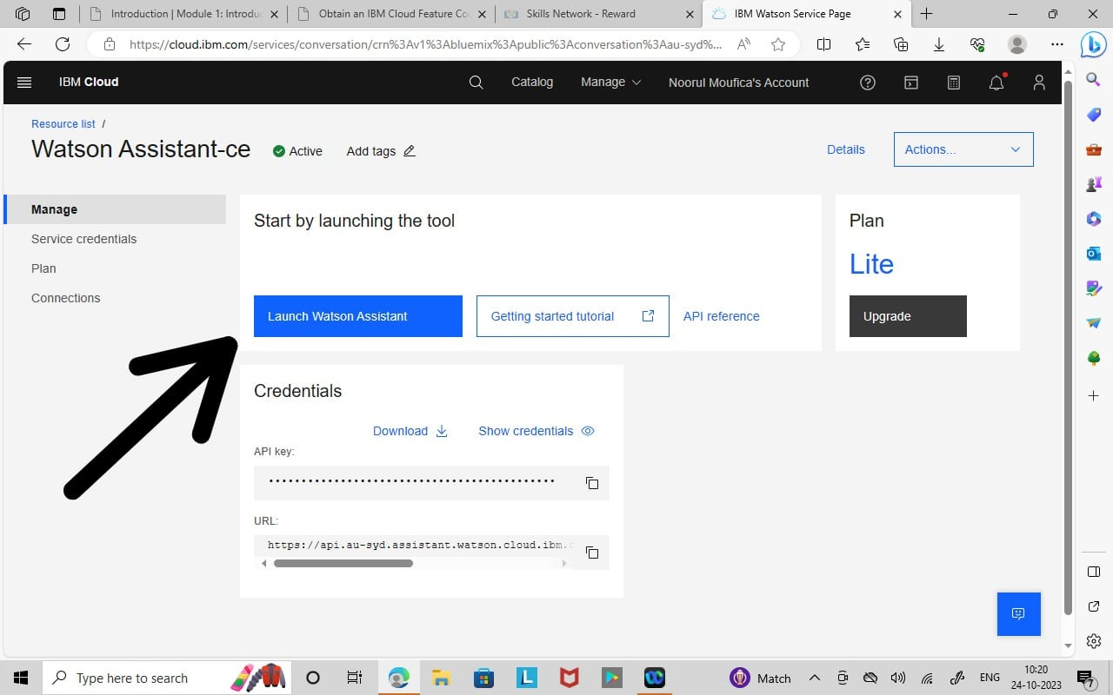

STEP 5 -- we can use the Watson Assistant by resource list in menu Under AI/Machine Learning.

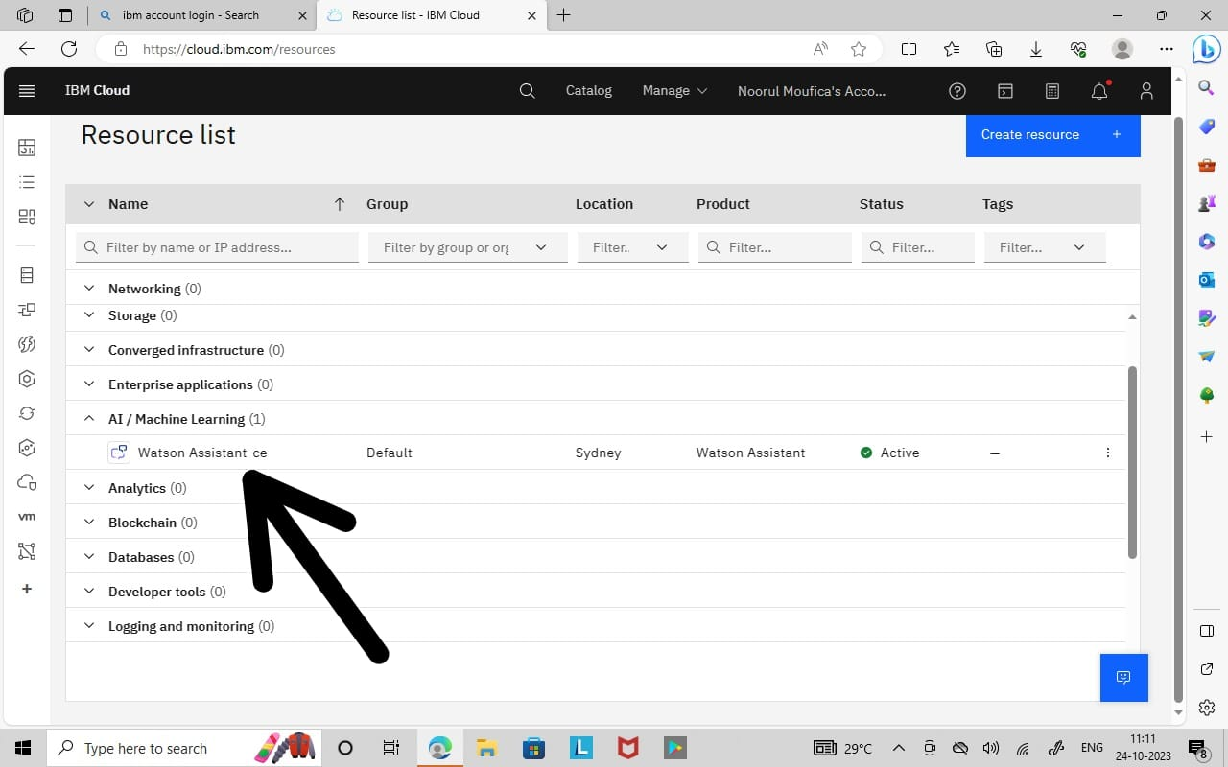

STEP 6 -- Create a Assistant

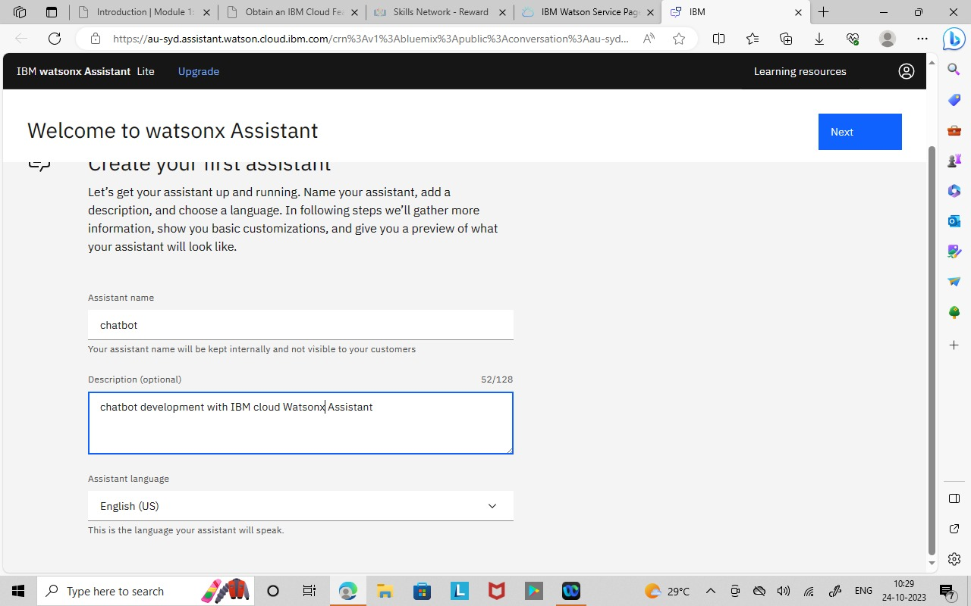

STEP 7 -- The watson assistant is created successfully

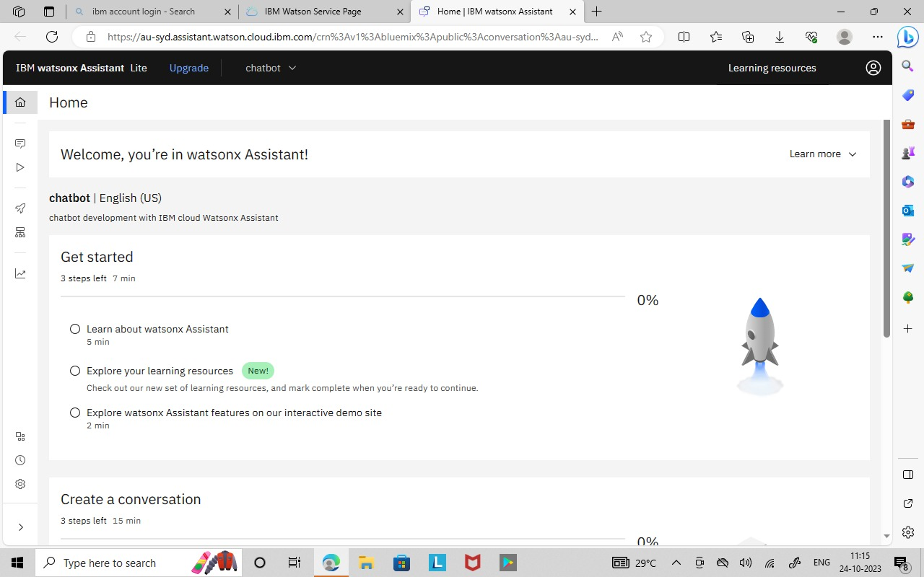

STEP 8 -- Activate the Dialog Feature which includes INTENTS,ENTITIES, DIALOG Nodes.

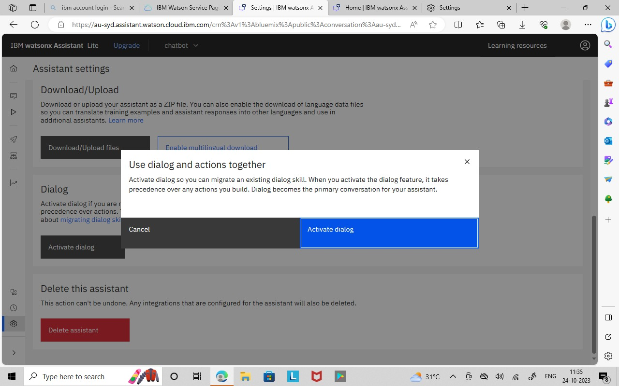

**CREATION OF INTENTS**

STEP 1 -- Create a intents.

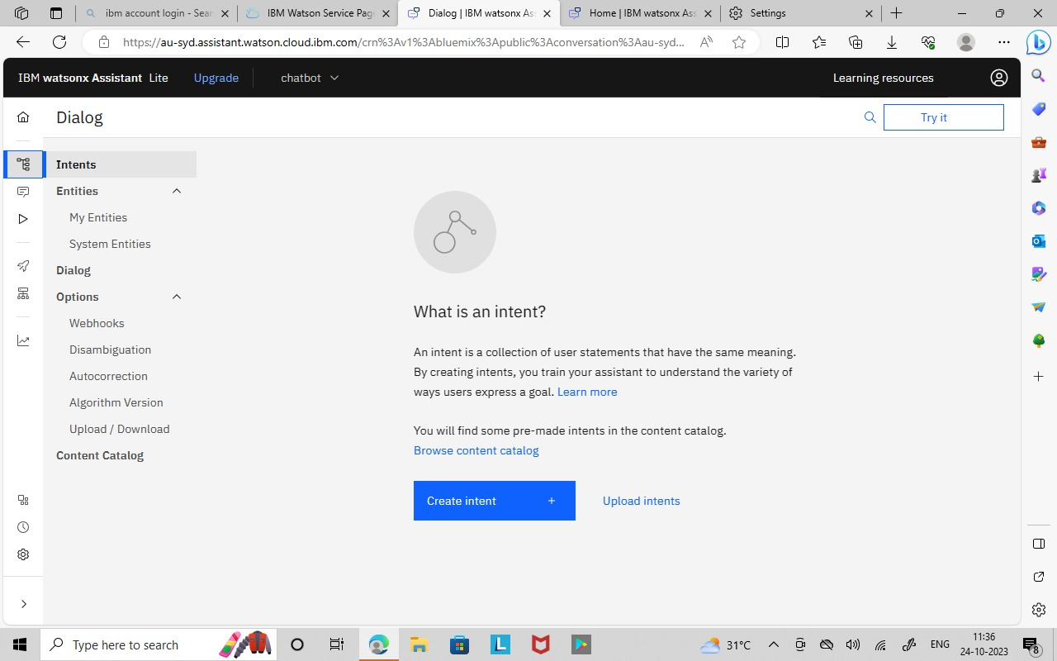

STEP 2 -- Create a #greetings intent with examples Hi , Hello.

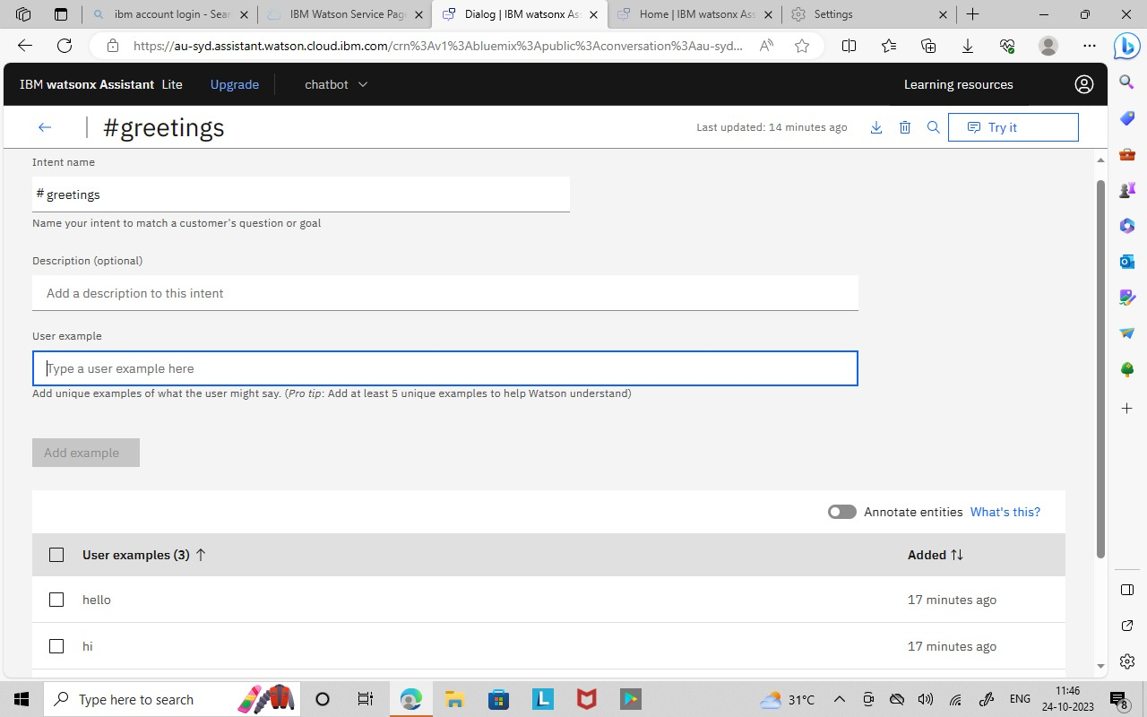

STEP 3 -- #greetings, #thank_yous, #goodbyes Intent is created and it is tested using Try it which is shown in below Image.

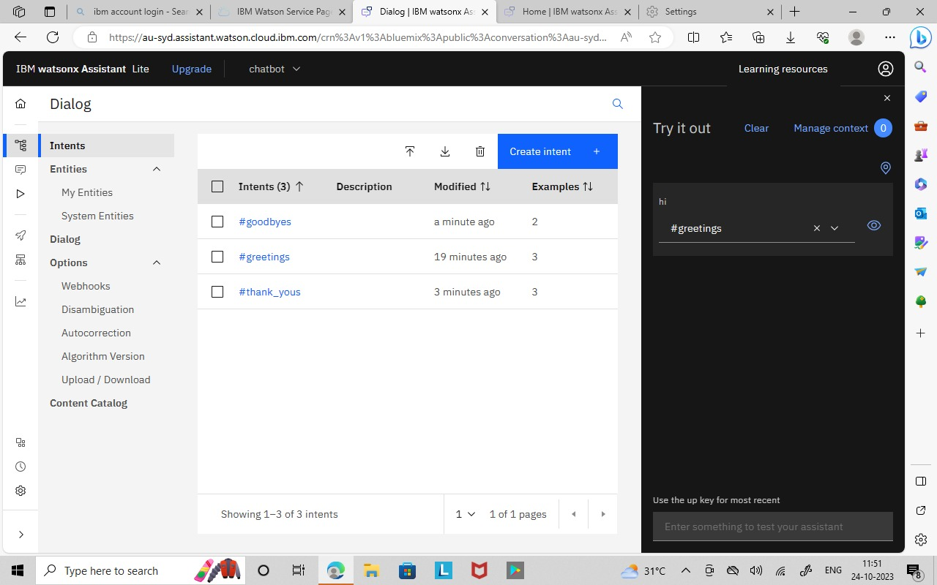

**CREATION OF ENTITIES**

STEP 1 -- Create Entities.

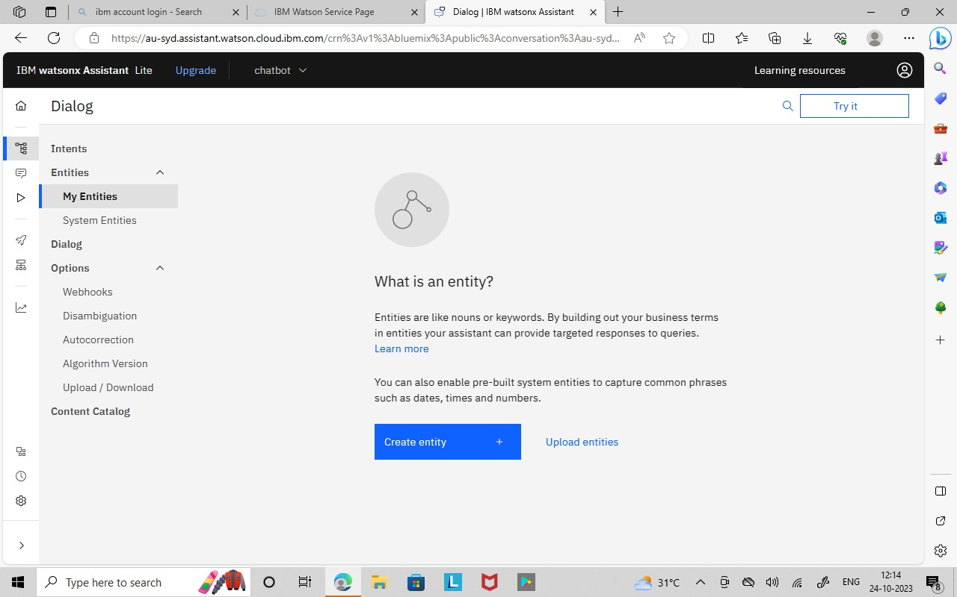

STEP 2 -- @Name Entities is created with some values such as Javid,Sameeha,Moufi,Jisra,Raseedha,Shahana.

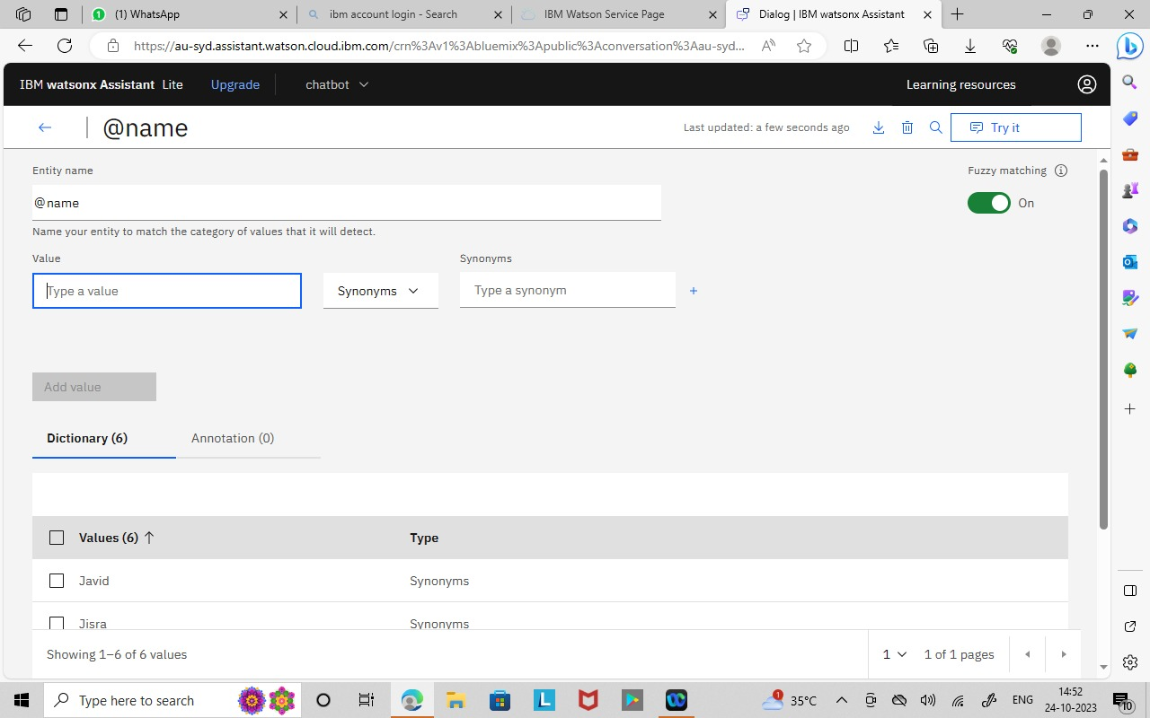

**CREATION OF DIALOG NODES**

Step 1: Create a Dialog node

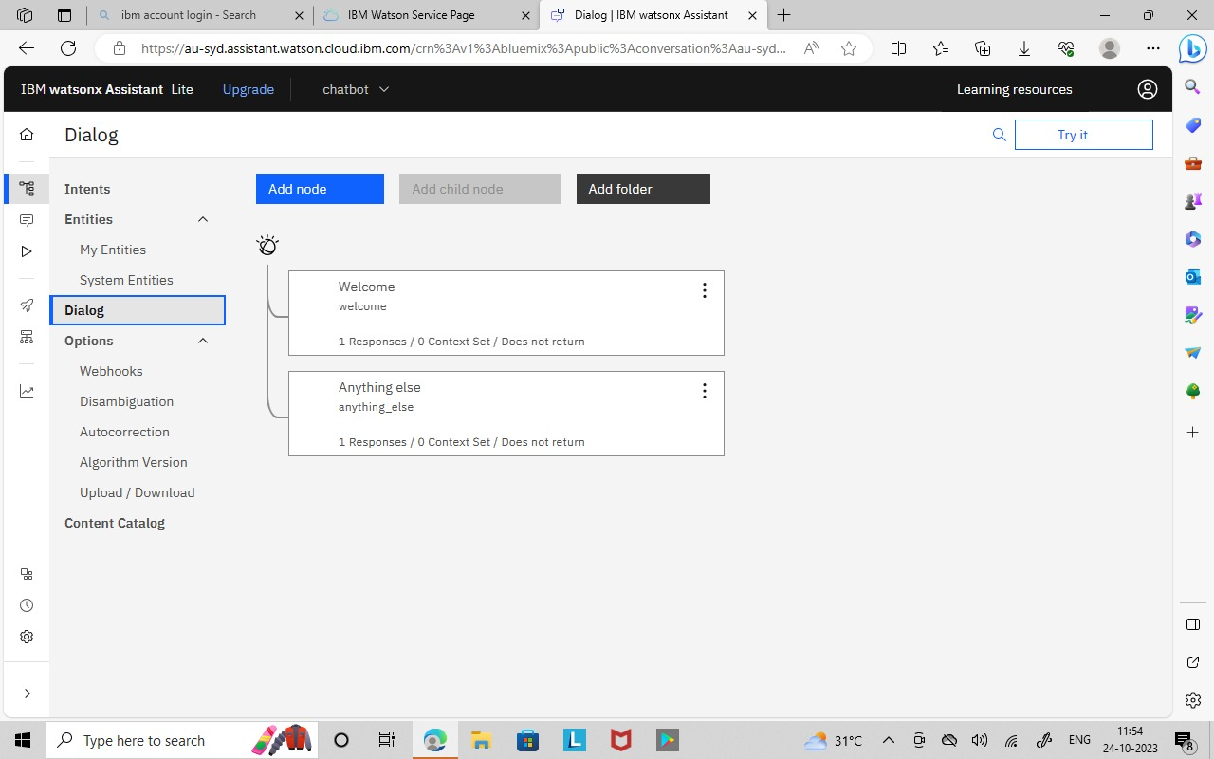

Step 2: hello Dialog node which identifies the #greeting message and replies to it.

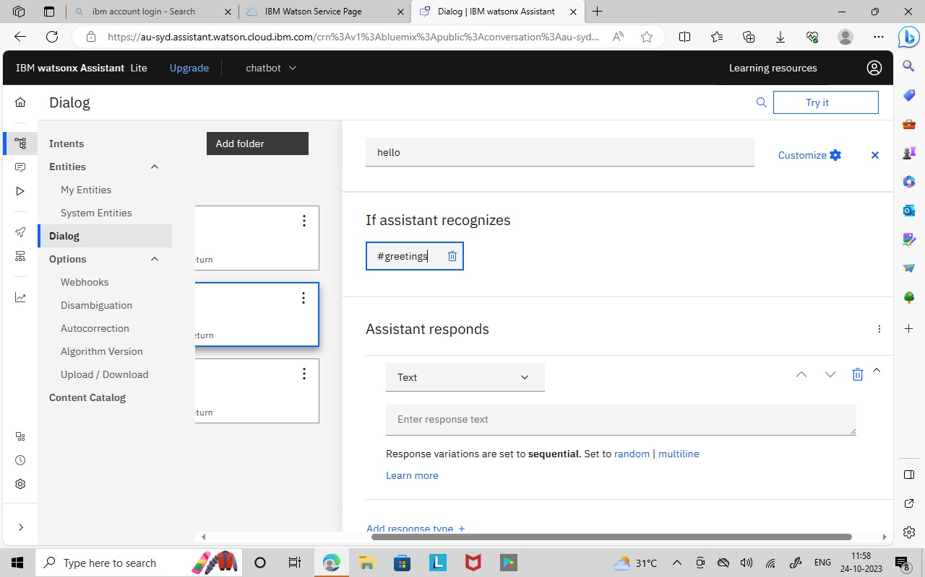

Step 3: hello, thank you(#thank_yours) and goodbyes(#goodbyes) Dialog node is created.

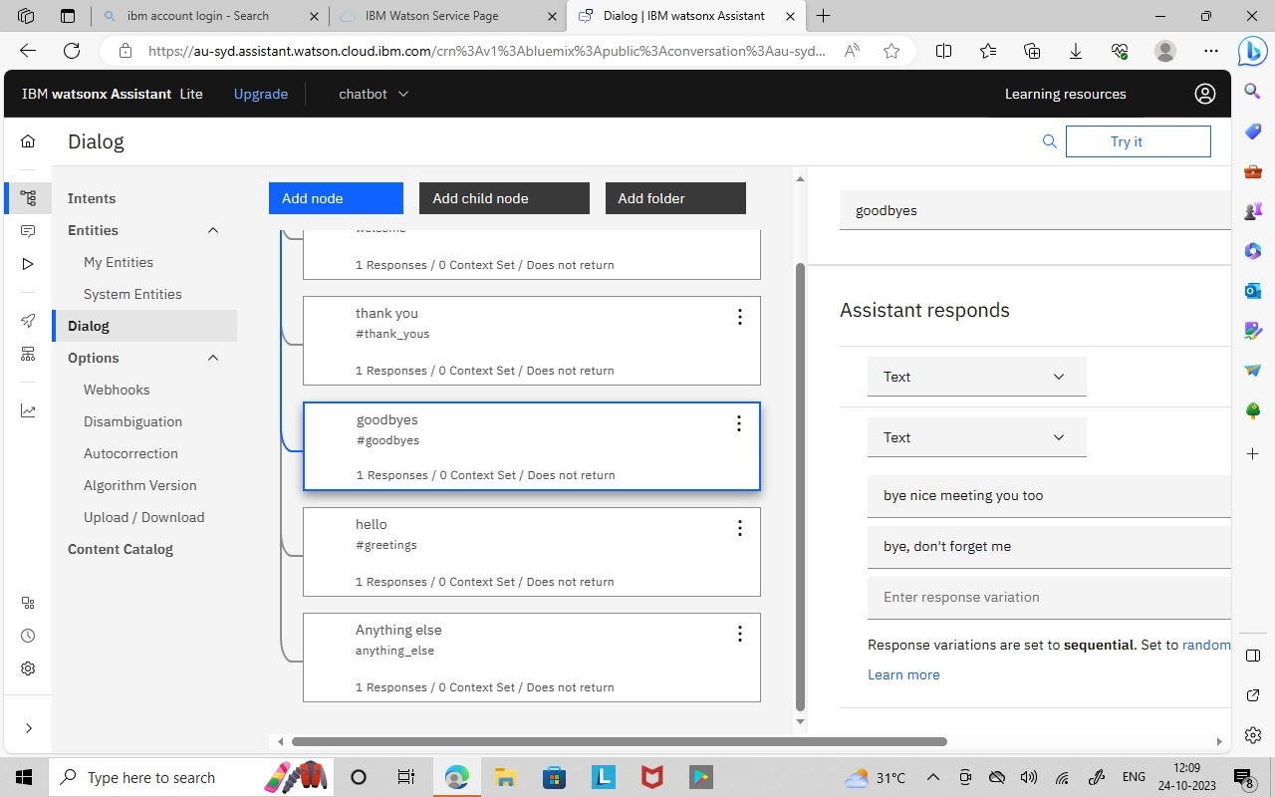

Step 4: Dialog nodes are tested using the Try it option which is shown in below image.

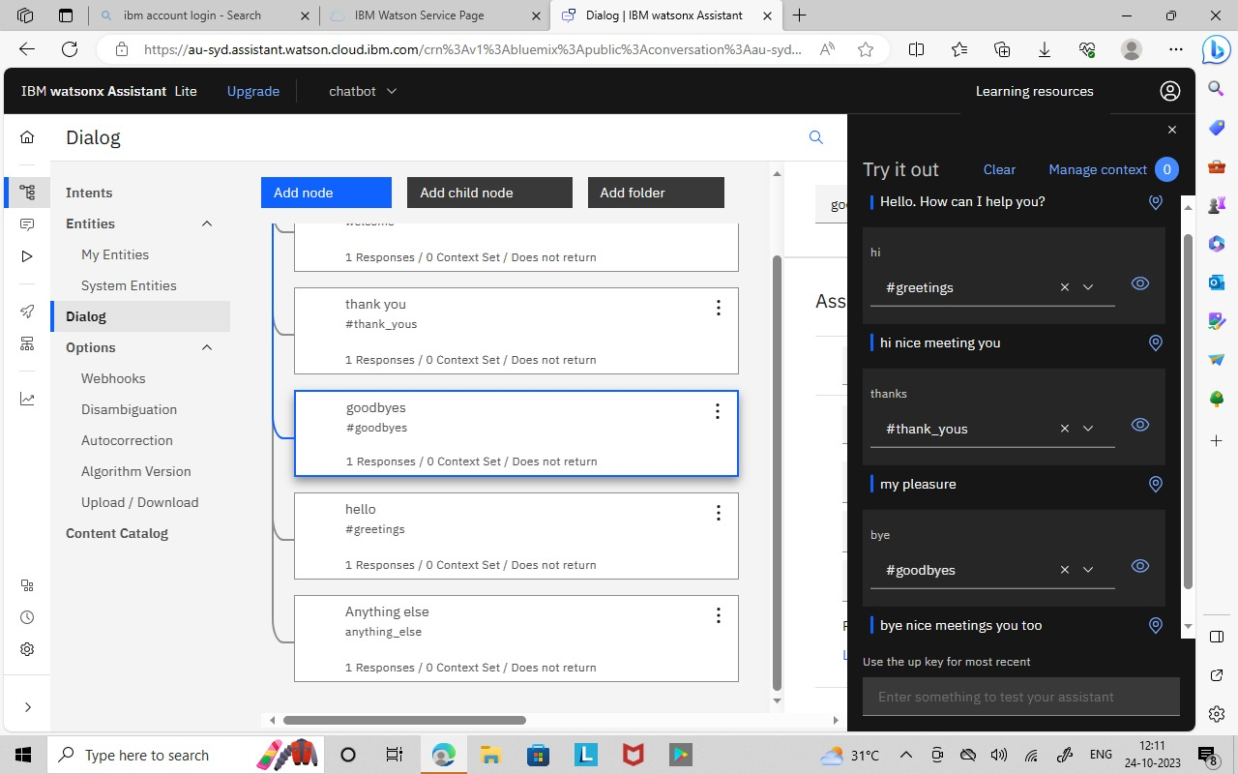

**Conclusion:**

Configure intents, entities, and dialog nodes in Watson Assistant to handle user queries has been created successfully.