**Project 6: Chatbot Deployment with IBM** **Cloud Watson Assistant**

Phase 5: DOCUMENTATION & SUBMISSION

**Problem Deﬁnition and Design Thinking**

|  |  |
| --- | --- |
| **Problem Deﬁnition:** | The project involves creating a chatbot using IBM Cloud Watson Assistant. |

The goal is to develop a virtual guide that assists users on messaging platforms like Facebook Messenger and Slack. The chatbot should provide helpful information, answer frequently asked questions (FAQs), and oﬀer a friendly conversational experience. The project includes designing the chatbot's persona, conﬁguring responses, integrating with messaging platforms, and ensuring a seamless user experience.

**Design Thinking:**

**1. Persona Design:**

* Deﬁne the chatbot's persona, including its name, tone, and style of communication.

**2. User Scenarios:**

* Identify common user scenarios and FAQs that the chatbot should be able to address.

**3. Conversation Flow:**

* Design the conversation ﬂow, outlining how the chatbot responds to user queries and prompts.

**4. Response Conﬁguration:**

* Conﬁgure the chatbot's responses using Watson Assistant's intents, entities, and dialog nodes

**5. Platform Integration:**

* Integrate the chatbot with popular messaging platforms like Facebook

Messenger and Slack.

**6. User Experience:**

|  |  |
| --- | --- |
| • | Ensure a seamless and user-friendly experience, with clear prompts and informative responses. |

INNOVATION

Innovation Idea: Chatbot with text recognition

**1.Set Up IBM Watson Assistant:**

* Sign in to your IBM Cloud account or create one if you don't have it.
* Create a new Watson Assistant instance.

**2.Create an Assistant:**

* Within your Watson Assistant instance, create a new assistant.
* Configure the assistant's settings and name it.

**3.Design the Dialog Flow:**

* Create the conversation flow for your chatbot using the Watson Assistant Dialog

Builder.

* Define intents, entities, and dialog nodes based on the expected user inputs and responses.

**4.Integrate Text Recognition:**

* Decide which text recognition service you want to use (e.g., IBM Watson

Language Translator or IBM Watson Natural Language Understanding).

* Set up the selected service in your IBM Cloud account if you haven't already.

**5.Connect Watson Services:**

* In the Watson Assistant interface, go to "Integrations" or "Options."
* Add the desired Watson service integration (e.g., Language Translator or Natural

Language Understanding).

* Configure the integration by providing credentials and setting up endpoints.

**6.Enhance Dialog Nodes:**

* Within your dialog nodes, incorporate actions that call the text recognition service. For example, you might use a "webhook" action to make API calls to the service.

1

**7.Define Recognition Triggers:**

* Determine when you want the text recognition to be triggered. This could be based on specific user inputs or conversation context.

**8.Handle Recognized Text:**

* After the text recognition service processes the user input, you'll receive the results. You can use these results to tailor your chatbot's responses or trigger specific actions.

**9.Test the Chatbot:**

* Thoroughly test your chatbot to ensure that it correctly recognizes and processes text inputs and provides appropriate responses.

**10.Iterate and Refine:**

* Based on user feedback and testing results, refine your chatbot's dialog flow, text recognition triggers, and responses.

**11.Deploy the Chatbot:**

* Once you're satisfied with your chatbot's performance, deploy it to the platform where you intend to use it (e.g., a website, messaging app, etc.).

**12.Monitor and Maintain:**

* Continuously monitor your chatbot's performance and make updates as necessary to improve its accuracy and effectiveness.

STEPS TO BE FOLLOWED IN CHATBOT DEPLOYMENT WITH IBM CLOUD WATSON ASSISTANT:

1.create the assistant service

2.create the workspace

3.create intents

4.test the intents

5.add entities

6.build the dialog

7.complete advance dialog work

8.use the API

**Development Part 1**

**Chatbot persona:**

1. A chatbot's persona includes factors like

its name, gender, job, back story, tone, and personality traits.

2. A persona embodies preferences and

expectations of your product, as well as a way of interacting with your bot.

3. Personalized chatbots focus on endowing

chatbots with a consistent personality to behave like real users, give more informative responses, and further act as personal assistants.

**CONVERSATION FLOW DESIGN:**

A chatbot conversation ﬂow represents a

decision tree that guides a us through their journey when they land on a chatbot. Like any other conversation, a chatbot ﬂow has certain logical elements, such as:

. Greeting

. Asking

. Informing

. Suggesting

. Checking

. Apologizing

. Error

. Goodbye

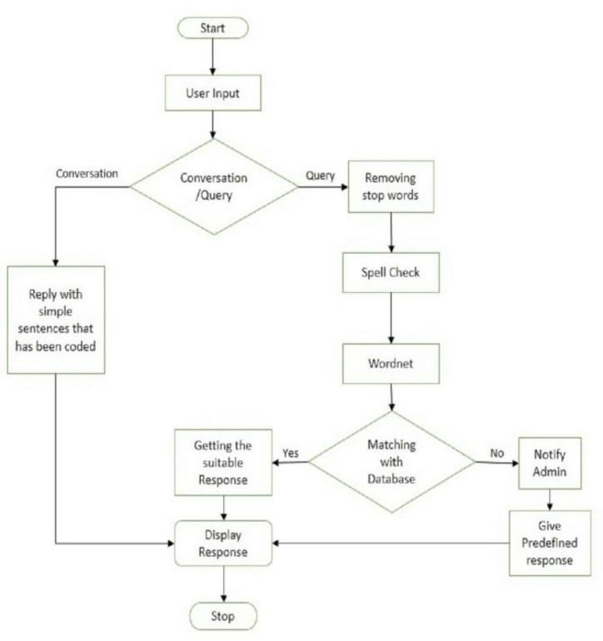

**SETUP OF WATSON ASSISTANT IN IBM** **CLOUD:**

STEP 1 -- The Dashboard of IBM cloud

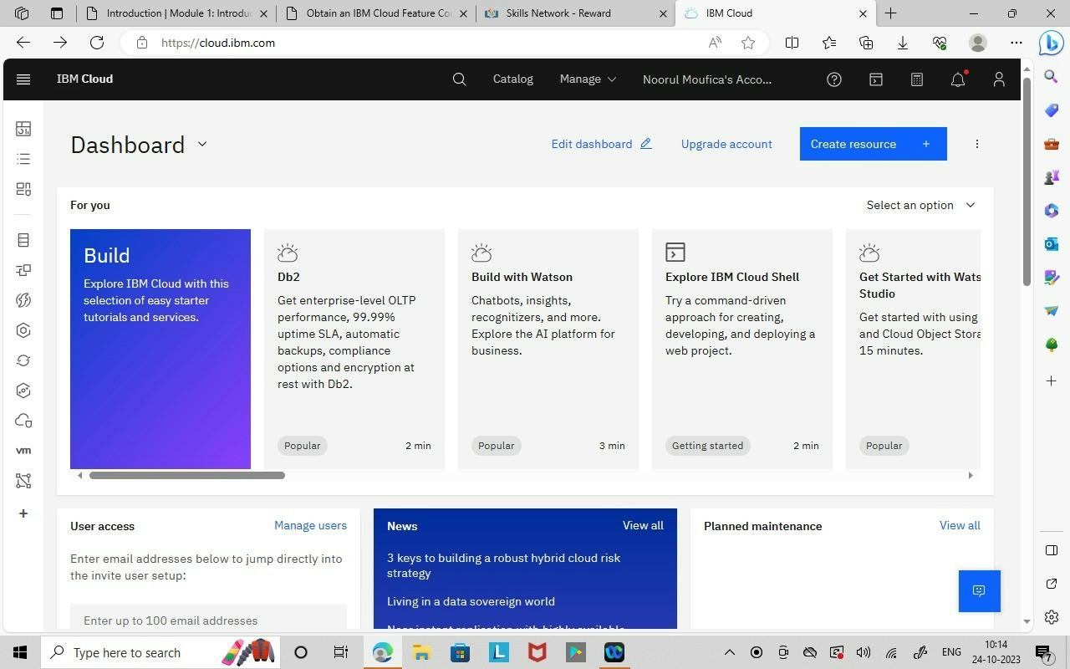

STEP 2 -- Select the Watson assistant in the catalog

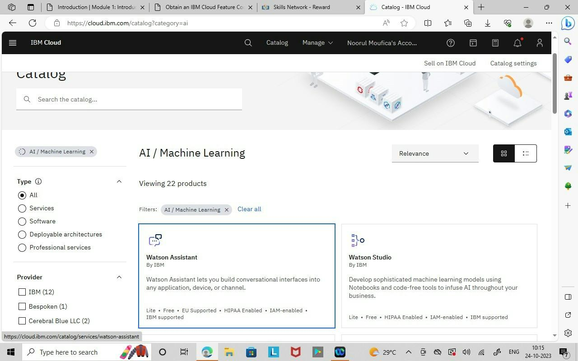

STEP 3 -- Enable the condition and create a watson assistant

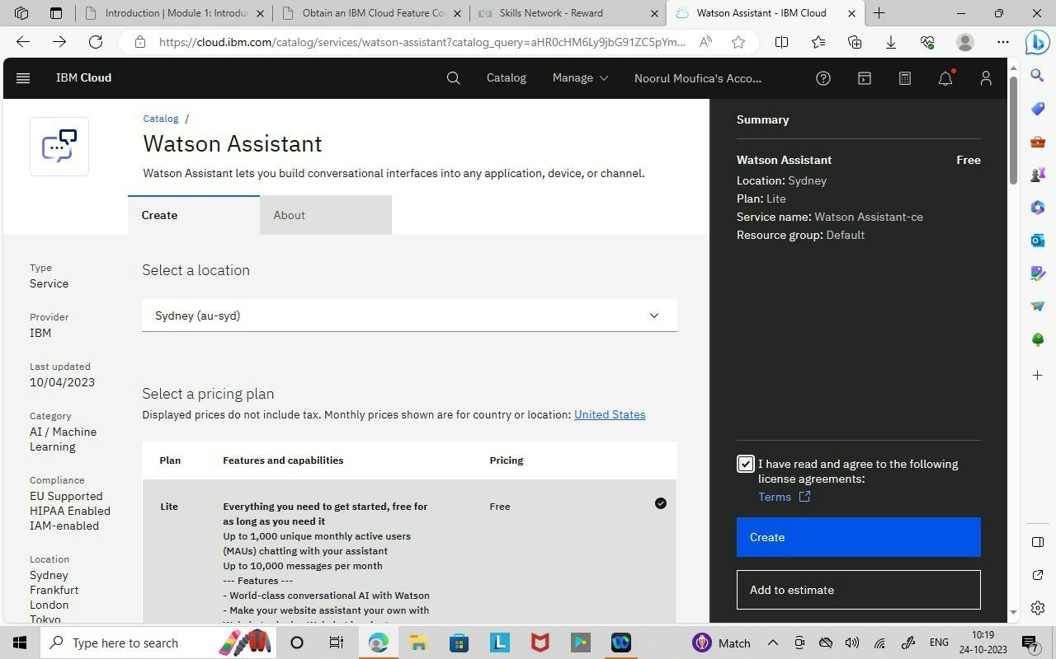

STEP 4 -- Launch the Watson Assistant Tool

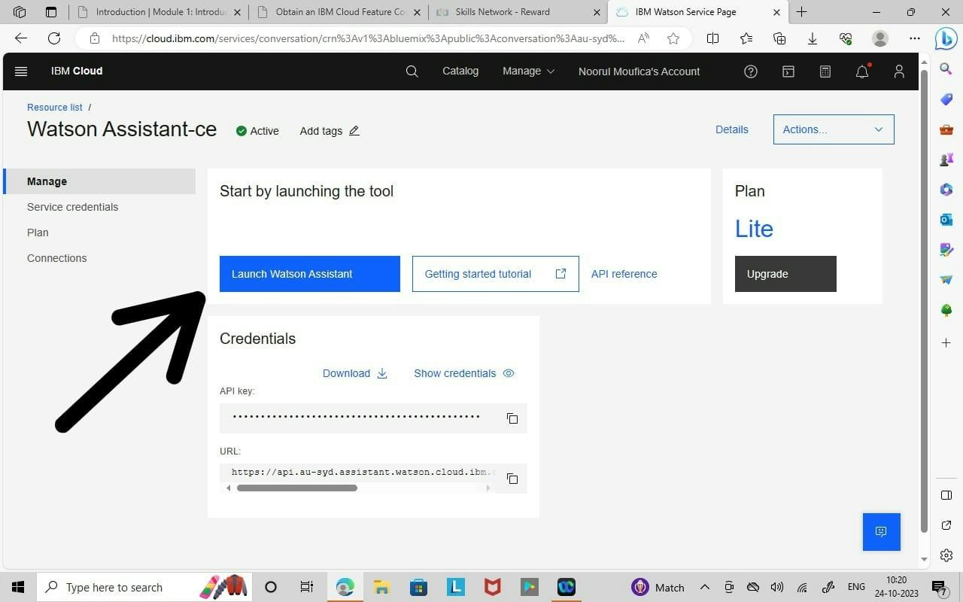

STEP 5 -- we can use the Watson Assistant by resource list in menu Under AI/Machine Learning.

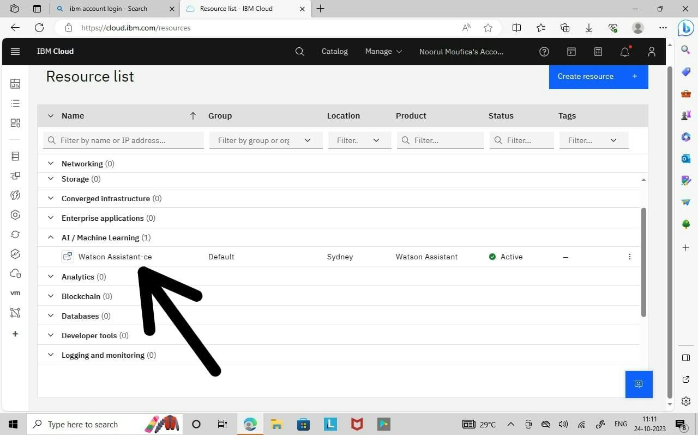

STEP 6 -- Create a Assistant

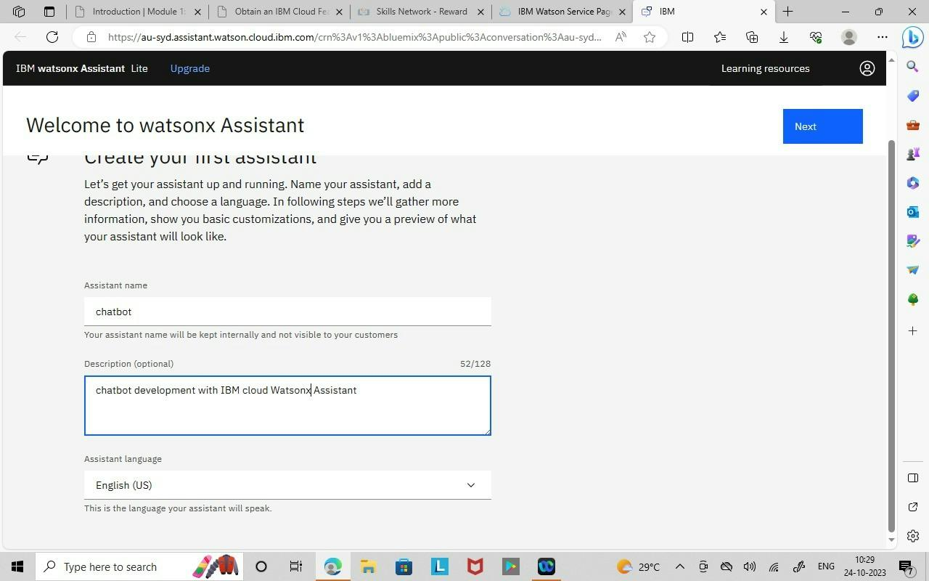

STEP 7 -- The watson assistant is created successfully

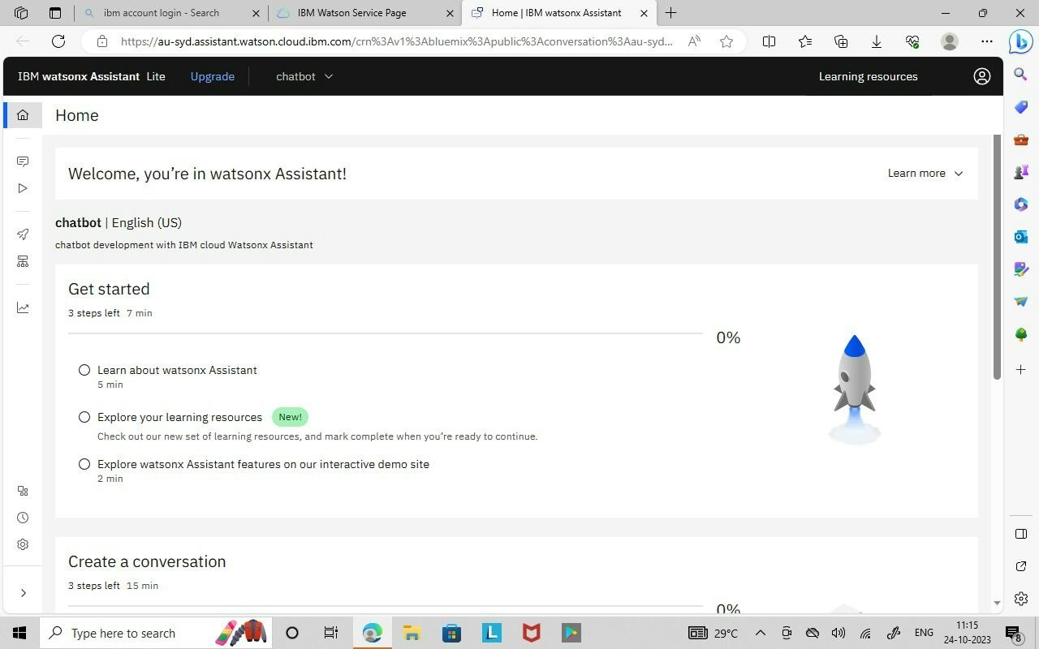

STEP 8 -- Activate the Dialog Feature which includes INTENTS,ENTITIES, DIALOG Nodes.

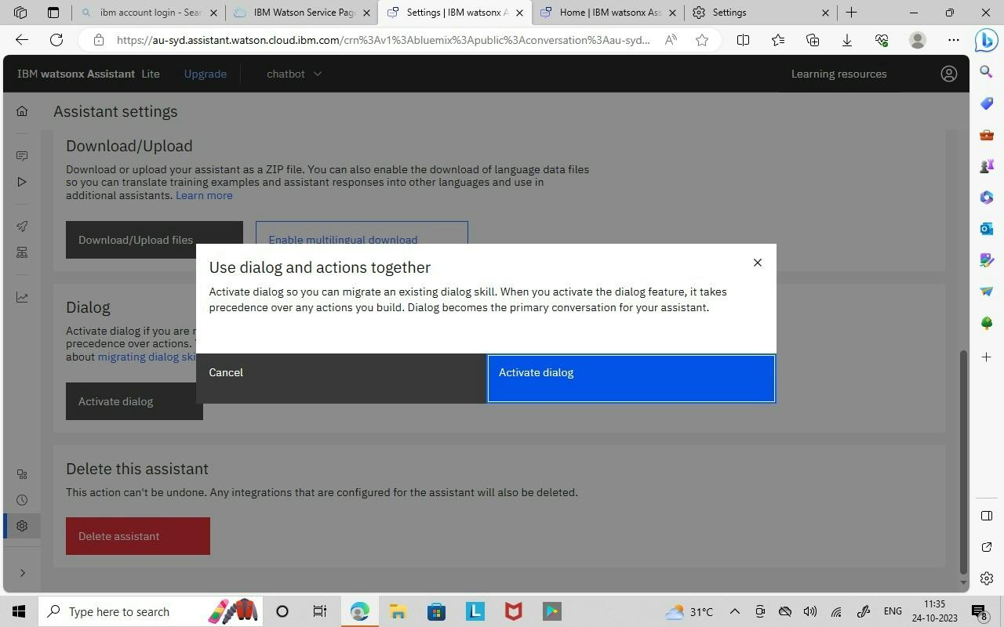

**CREATION OF INTENTS**

STEP 1 -- Create a intents.

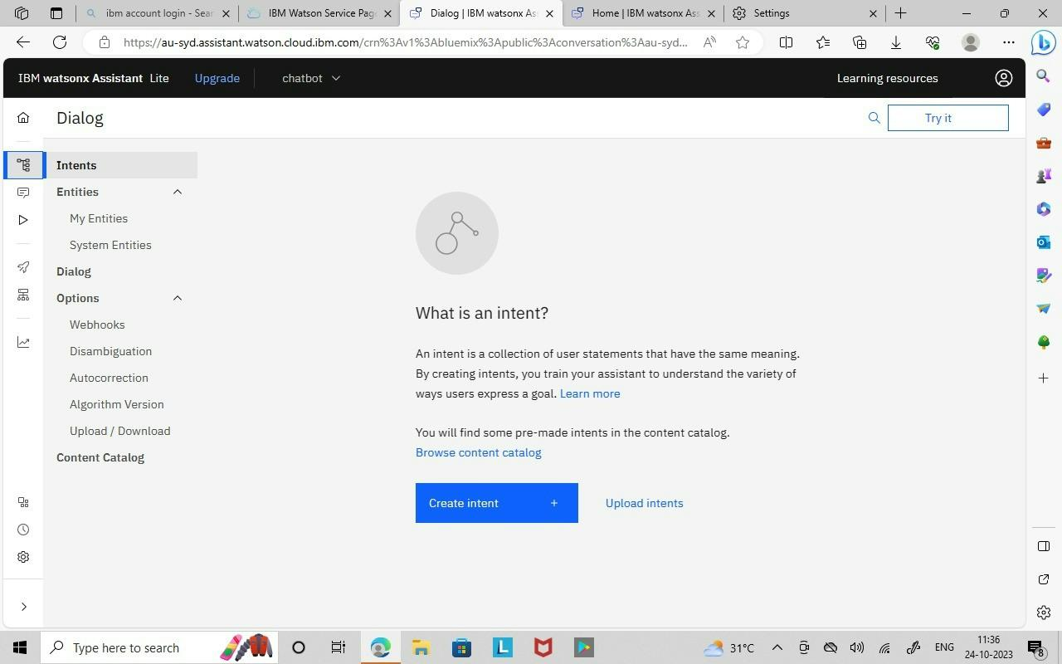

STEP 2 -- Create a #greetings intent with examples Hi , Hello.

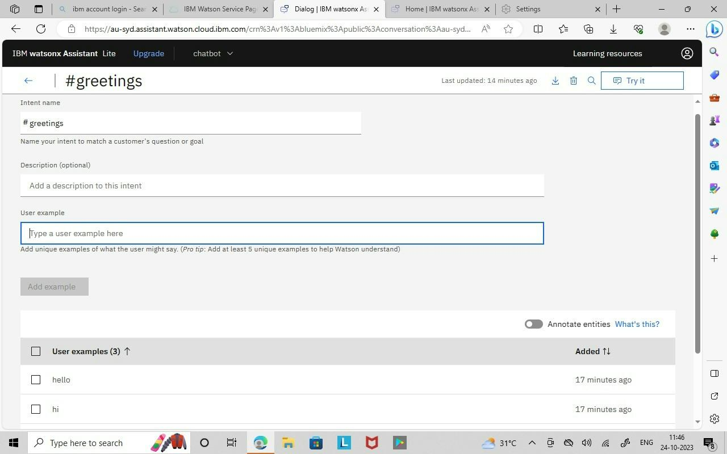

STEP 3 -- #greetings, #thank_yous, #goodbyes Intent is created and it is tested using Try it which is shown in below Image.

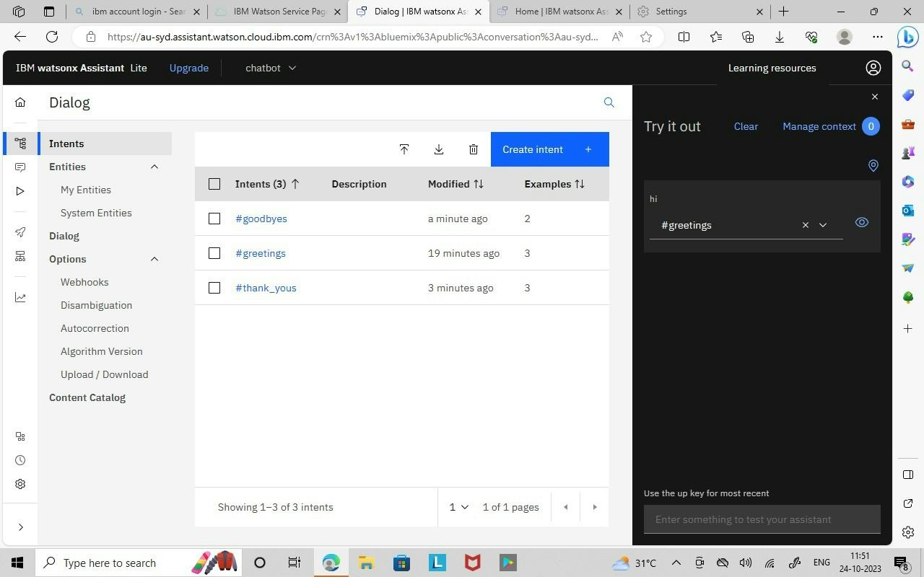

**CREATION OF ENTITIES**

STEP 1 -- Create Entities.

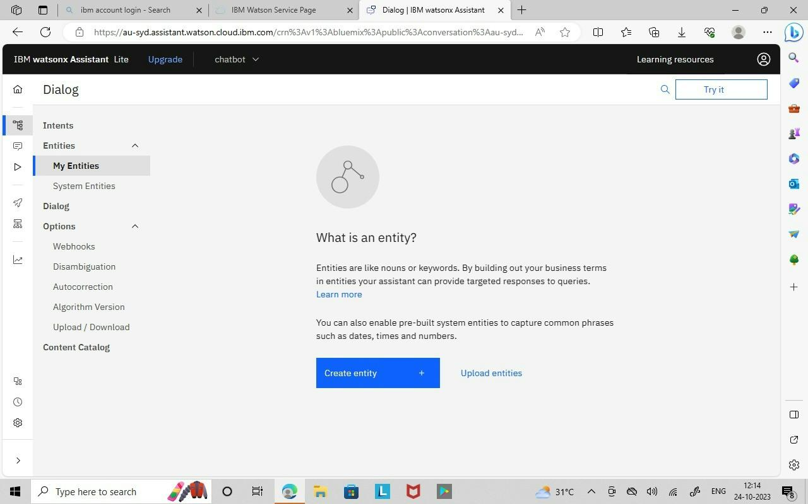

STEP 2 -- @Name Entities is created with some values such as Javid,Sameeha,Mouﬁ,Jisra,Raseedha,Shahana.

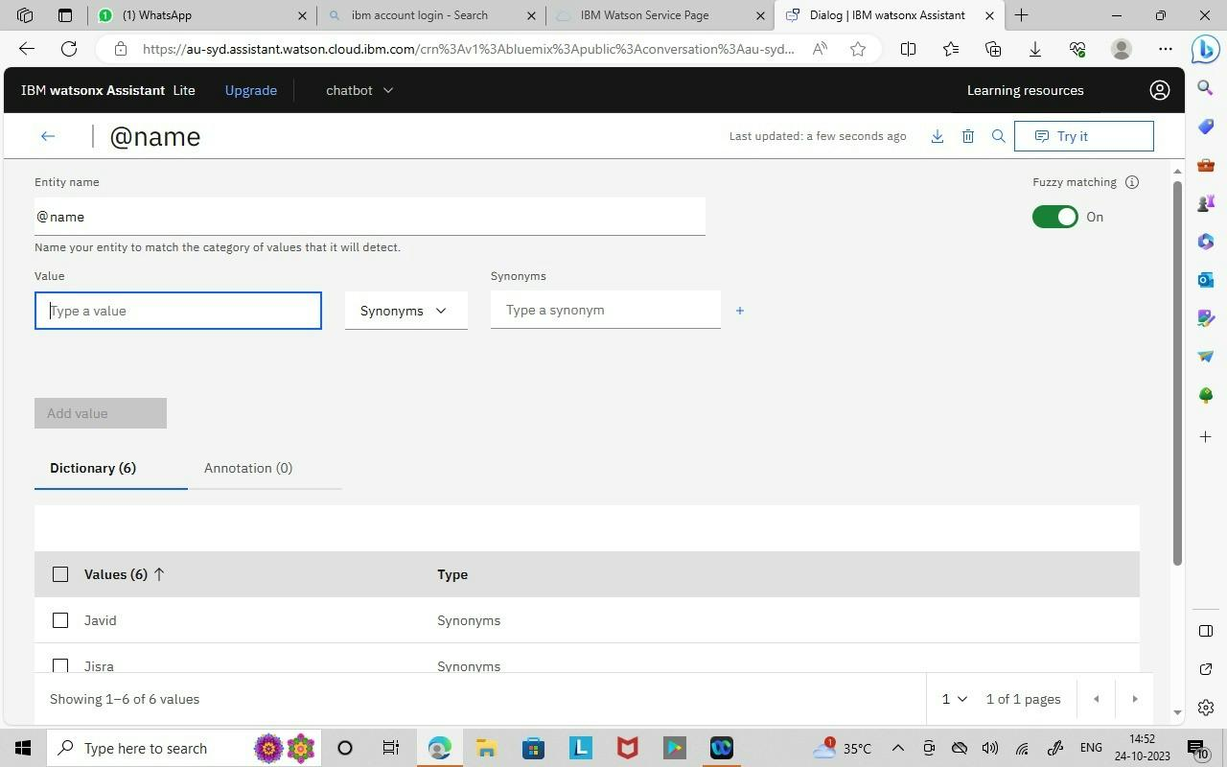

**CREATION OF DIALOG NODES**

Step 1: Create a Dialog node

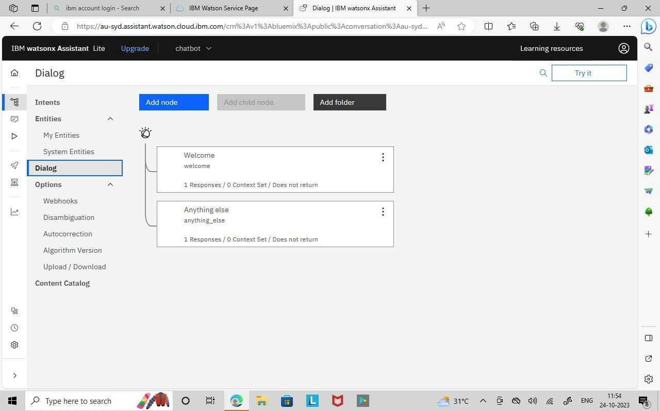

Step 2: hello Dialog node which identiﬁes the #greeting message and replies to it.

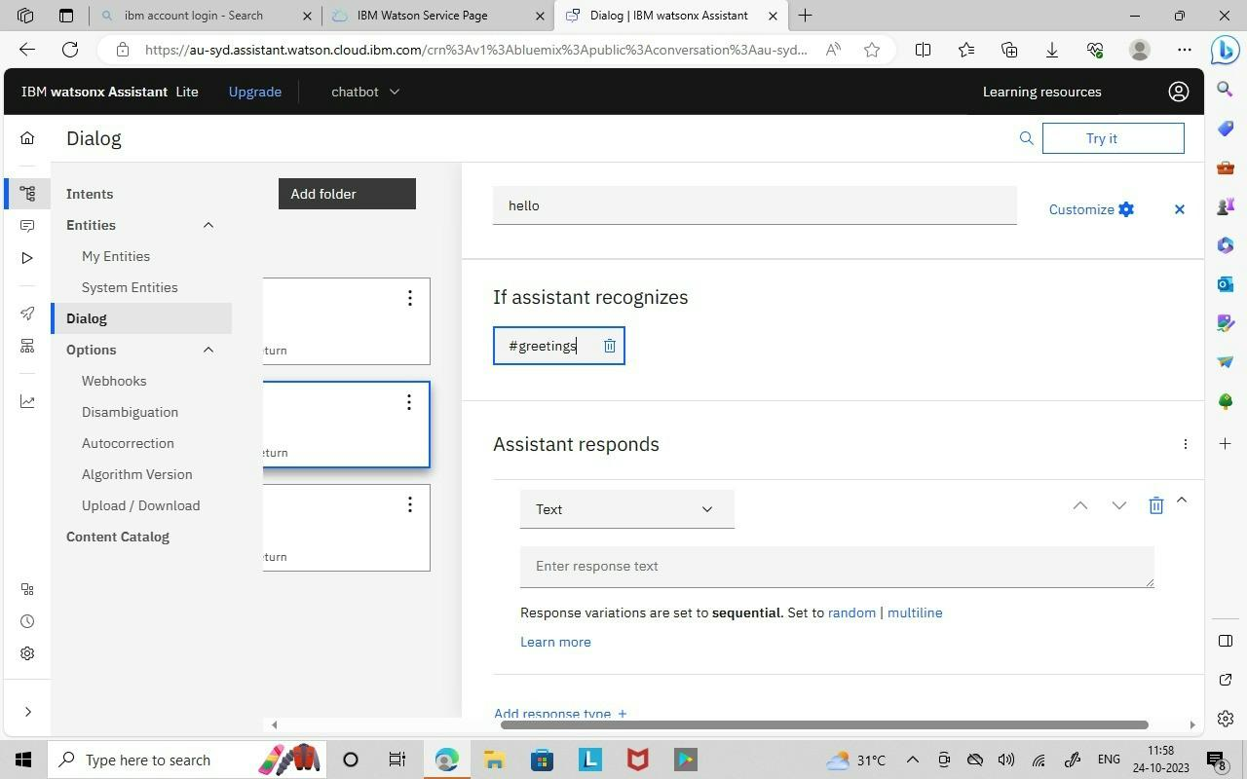

Step 3: hello, thank you(#thank_yours) and goodbyes(#goodbyes) Dialog node is created.

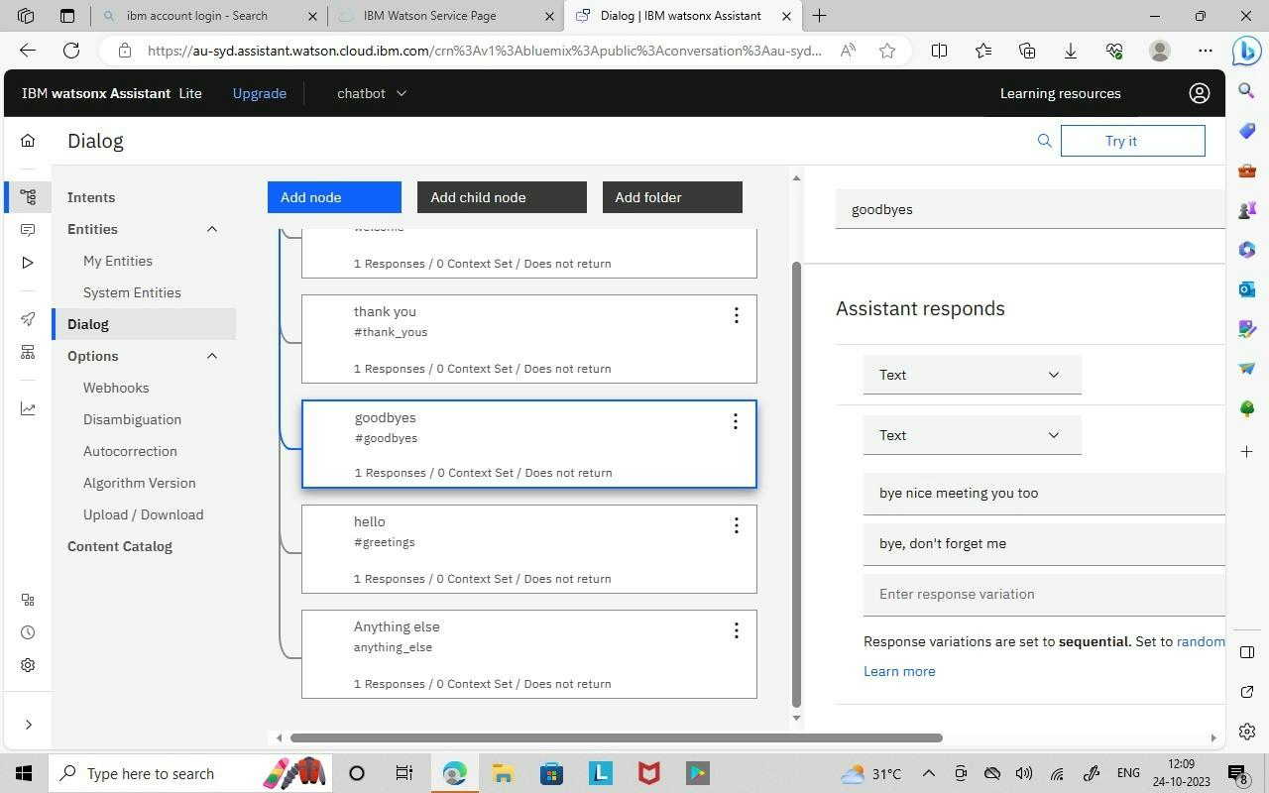

Step 4: Dialog nodes are tested using the Try it option which is shown in below image.

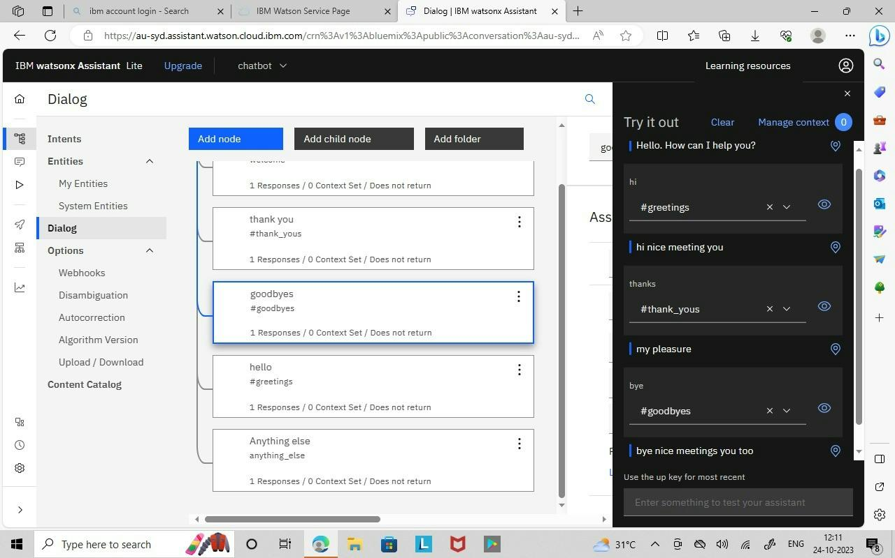

**Build a chatbot**

"In this project, we are planning to create a plot booking chatbot named **Real Estate**, and here are some of its features:"

**1.Find a place to book our plot:** Provide users with a comprehensive list of plot places, on our personal wish. **2.plot Selection:** Enable users to choose their preferred plots

**3.select cost:** Enable the user to choose their preferred cost for their plots

**4.Select number of plots:** Enable the user to choose their preferred number of plots.

**5.Queries from customer side:** Customer ask their queries about their plots (eg. Is it government approved?)

**6.Sending bought plot details to their mail:** Send entire plot details to their mail.

**Create a chatbot**

After launching Watson assistant set up your chatbot assistant.

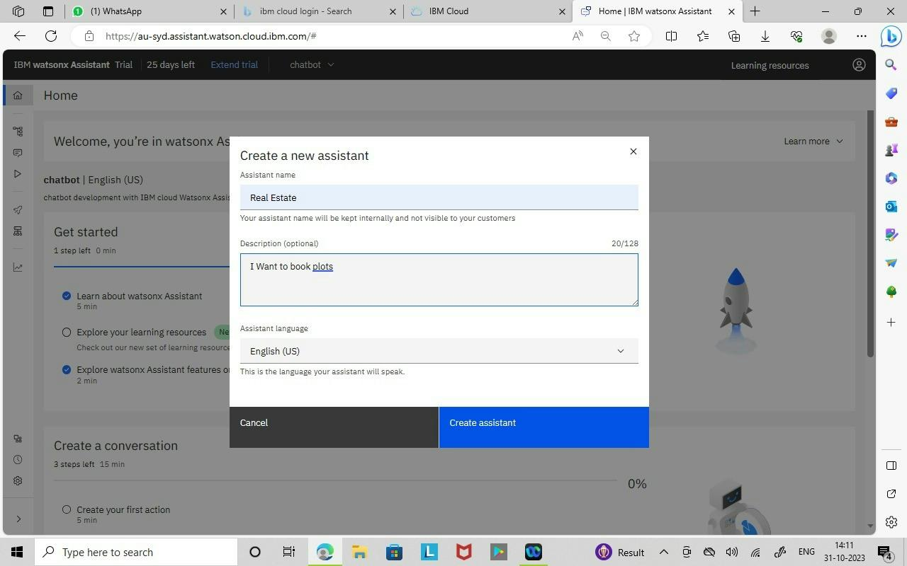

**Setup action**

Train your assistant by creating actions.

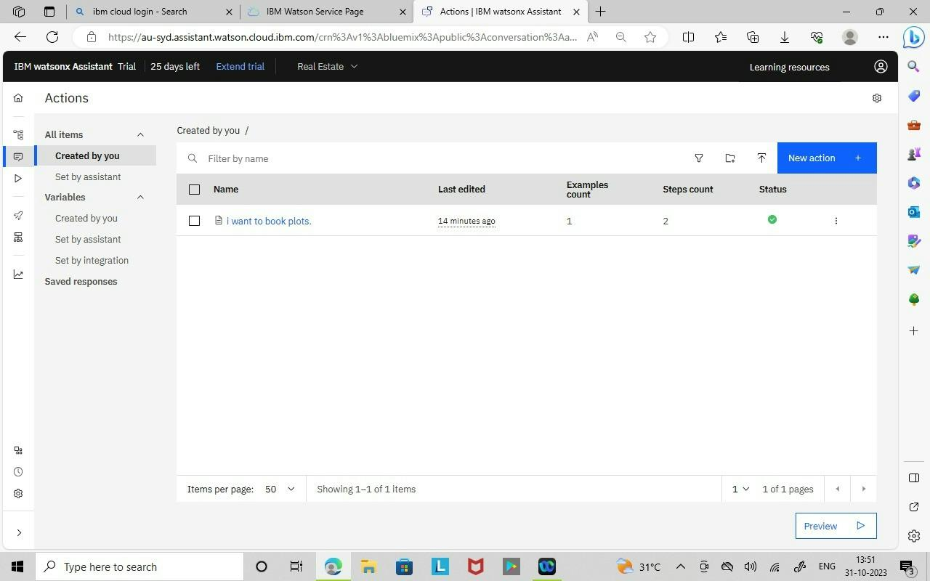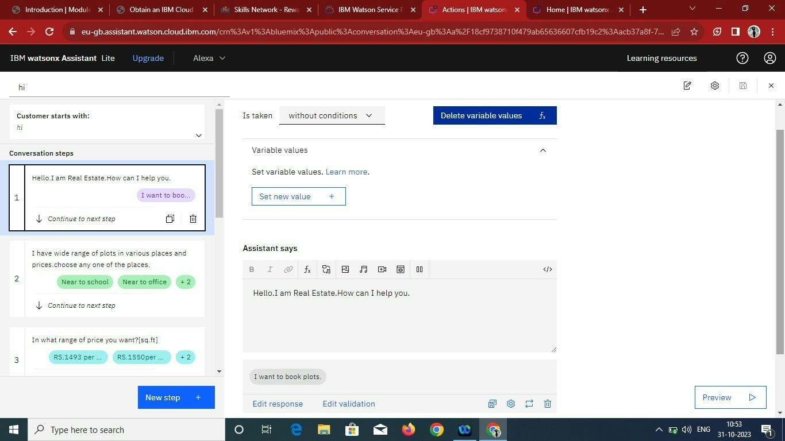

**Preview**

After completing feed actions to your chatbot use preview option for viewing our chatbot.

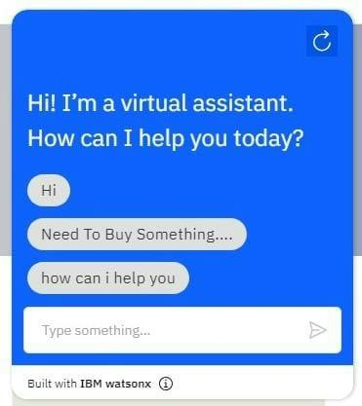

**Preview link for our chatbot:**

[https://web-chat.global.assistant.watson.appdomain.cloud/preview.html?backgroundImageURL=https%3A%2F%2Feu-](https://web-chat.global.assistant.watson.appdomain.cloud/preview.html?backgroundImageURL=https%3A%2F%2Feu-gb.assistant.watson.cloud.ibm.com%2Fpublic%2Fimages%2Fupx-acb37a8f-71f8-4a11-8c49-8478eb50adb8%3A%3A61a758f8-1340-4793-873b-34b65d912bcb&integrationID=907c50d2-3211-415b-be00-8f9e6df3e09d&region=eu-gb&serviceInstanceID=acb37a8f-71f8-4a11-8c49-8478eb50adb8) [gb.assistant.watson.cloud.ibm.com%2Fpublic%2Fimages%2Fupx-acb37a8f-71f8-4a11-8c49-8478eb50adb8%3A%3A61a758f8-1340-4793-](https://web-chat.global.assistant.watson.appdomain.cloud/preview.html?backgroundImageURL=https%3A%2F%2Feu-gb.assistant.watson.cloud.ibm.com%2Fpublic%2Fimages%2Fupx-acb37a8f-71f8-4a11-8c49-8478eb50adb8%3A%3A61a758f8-1340-4793-873b-34b65d912bcb&integrationID=907c50d2-3211-415b-be00-8f9e6df3e09d&region=eu-gb&serviceInstanceID=acb37a8f-71f8-4a11-8c49-8478eb50adb8)

873b-34b65d912bcb&integrationID=907c50d2-3211-415b-be00-8f9e6df3e09d&region=eu-gb&serviceInstanceID=acb37a8f-71f8-4a11-

[8c49-8478eb50adb8](https://web-chat.global.assistant.watson.appdomain.cloud/preview.html?backgroundImageURL=https%3A%2F%2Feu-gb.assistant.watson.cloud.ibm.com%2Fpublic%2Fimages%2Fupx-acb37a8f-71f8-4a11-8c49-8478eb50adb8%3A%3A61a758f8-1340-4793-873b-34b65d912bcb&integrationID=907c50d2-3211-415b-be00-8f9e6df3e09d&region=eu-gb&serviceInstanceID=acb37a8f-71f8-4a11-8c49-8478eb50adb8)

**Screen shots:**

|  |  |
| --- | --- |
|  |  |

|  |  |
| --- | --- |
|  |  |

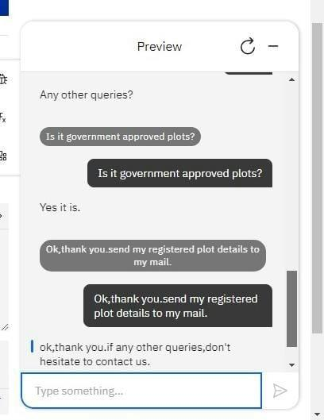

**Development part 2**

**Building a chatbot by integrating it with messaging platforms and**

**refining the process.**

**Create a Watson Assistant Skill:**

• Log in to your IBM Cloud account and access IBM Watson Assistant.

• Create a new skill or use an existing one.

• Build your chatbot using the IBM Watson Assistant's service.

• Train your chatbot by providing example user inputs.

**Set Up Integration:**

• In your Watson Assistant skill, navigate to the "Options" menu and select

"Integration."

• Click to the “Channels” and view messaging platforms.

**Configure the Messaging Platform:**

• Selecting a platform for example Facebook messenger

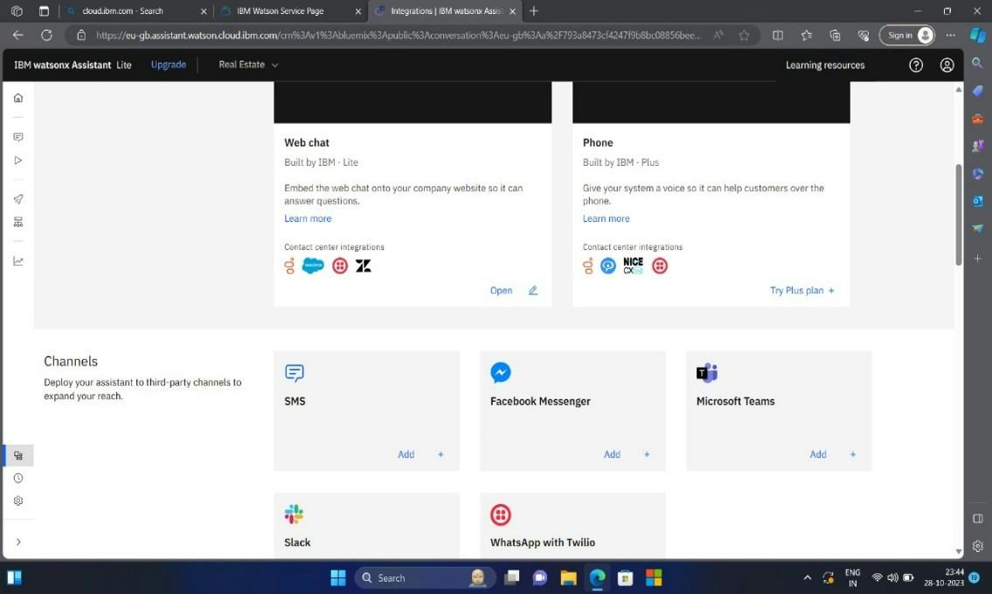

**Creating a Facebook application**

• Go to Facebook for developers and log into Facebook account.

• Register a developer account and add necessary details complete registration.

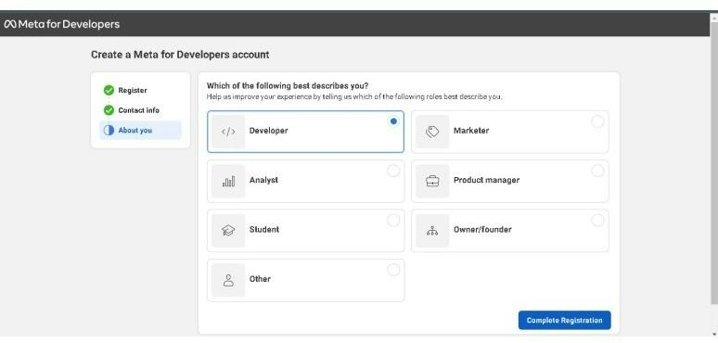

**Creating an app**

• Click Add a New App and complete the steps to create a new app ID.

• Add app name and contact details for create an app

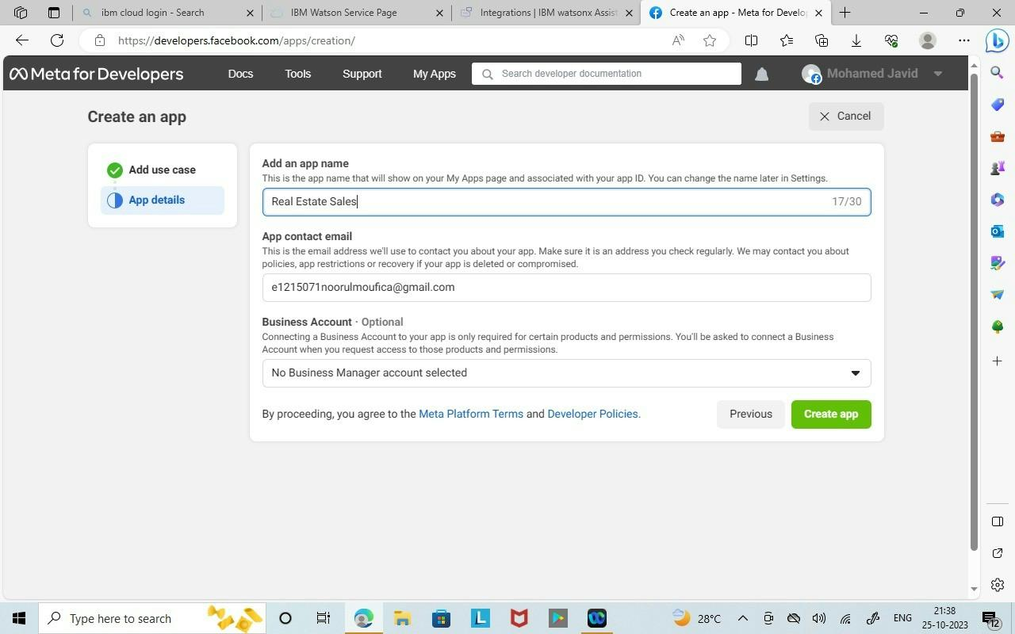

• In the dashboard, click App settings select Basic.

• Select App Secret, click Show. Copy the app secret.

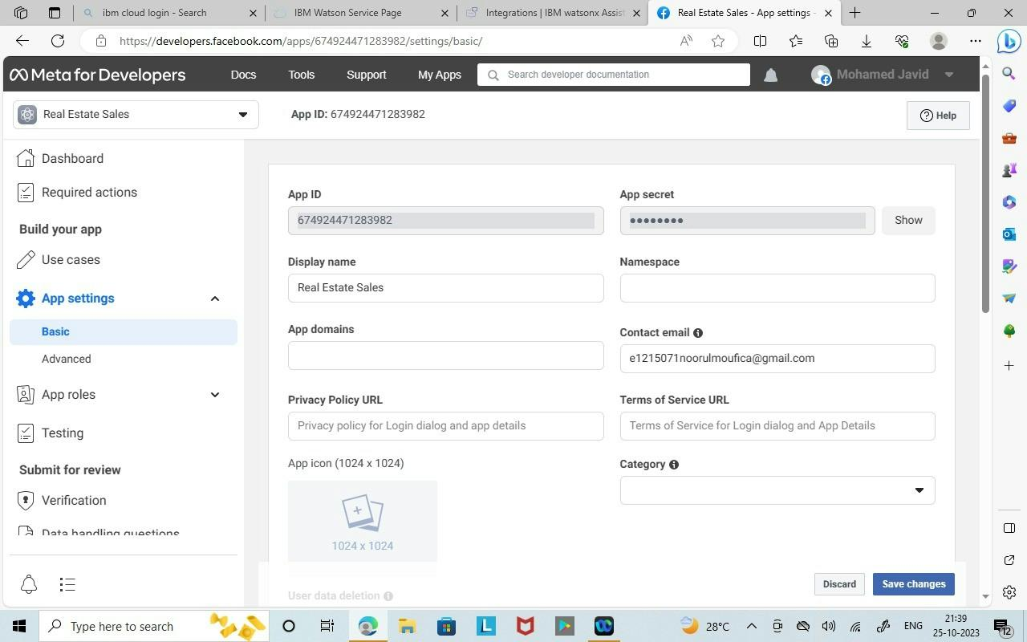

• Copied app secret pasted into IBM Watson assistant Facebook messenger

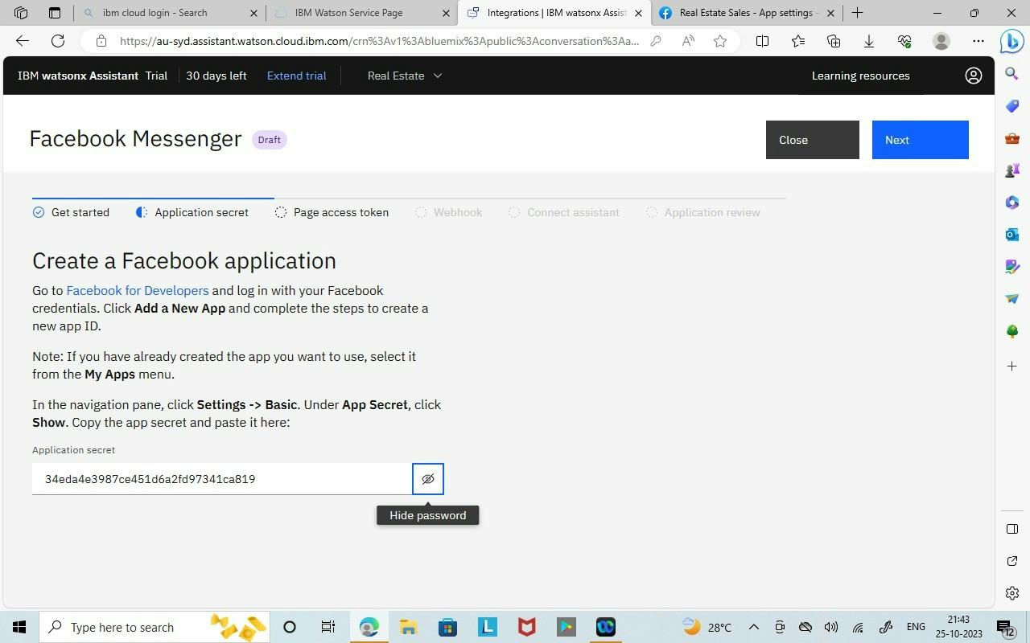

**Creating a Facebook page**

• On the Facebook app page, click the Products in the left side navigation.

• find the Messenger tile and click Set Up

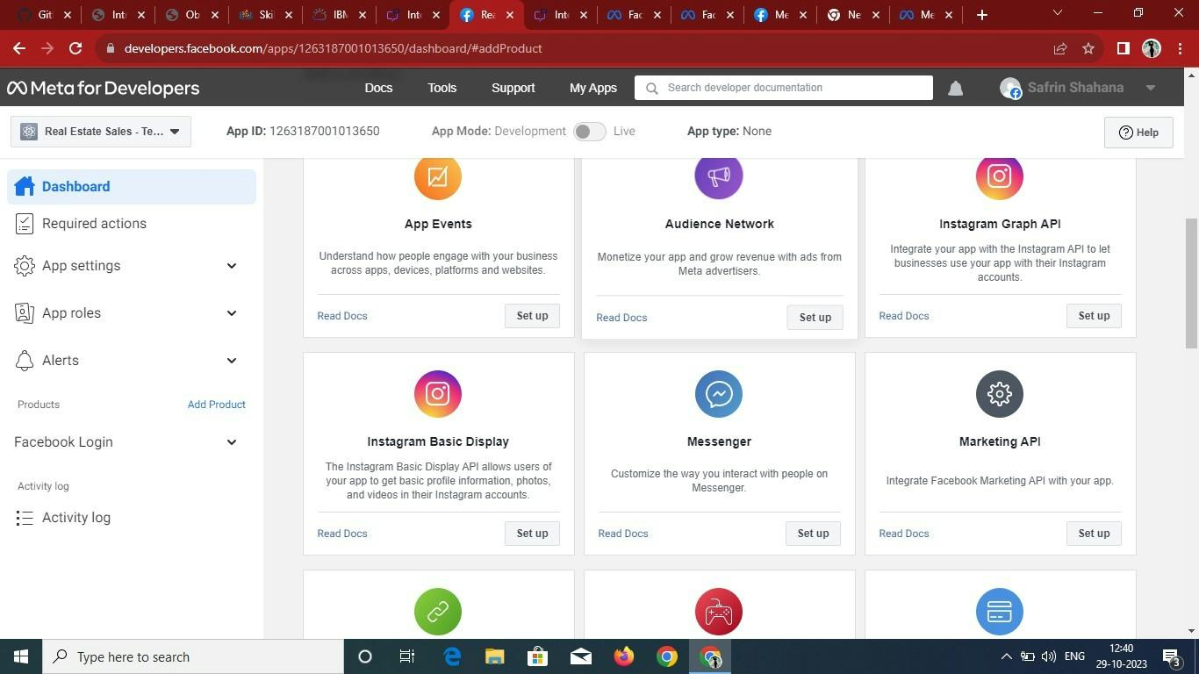

• Click Add or Remove Pages and choose the Facebook page you want to use for your app.

• Click Generate Token and check the I Understand checkbox to generate the page access token

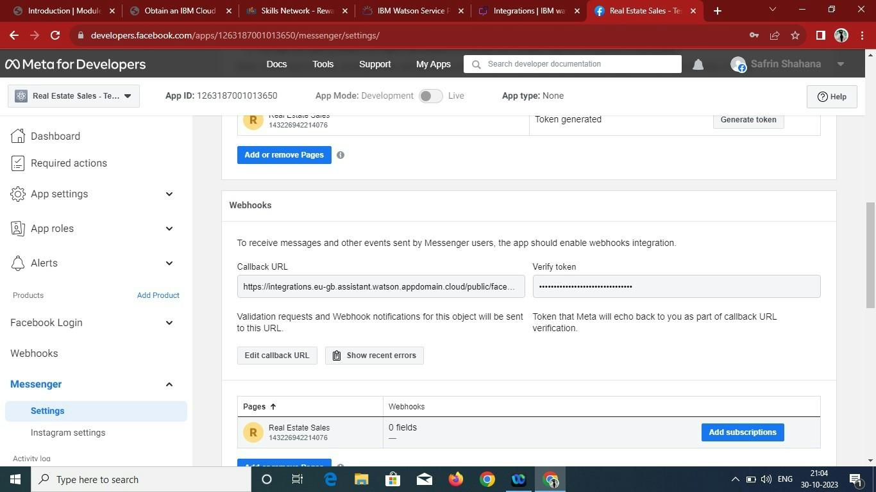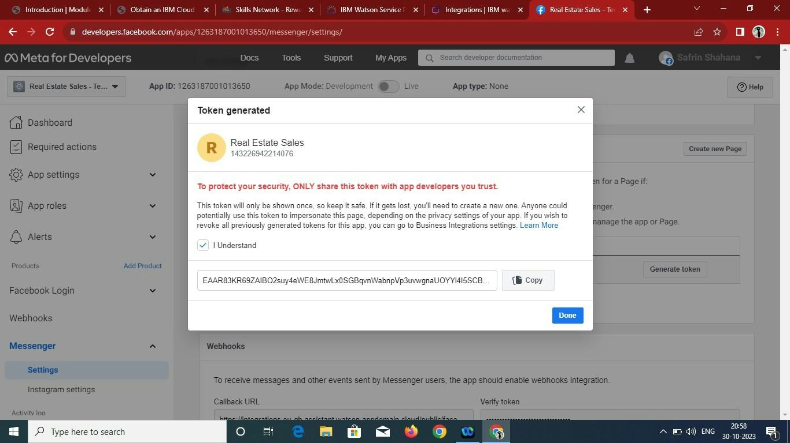

• Copy the page access token and paste into IBM Watson Facebook messenger page.

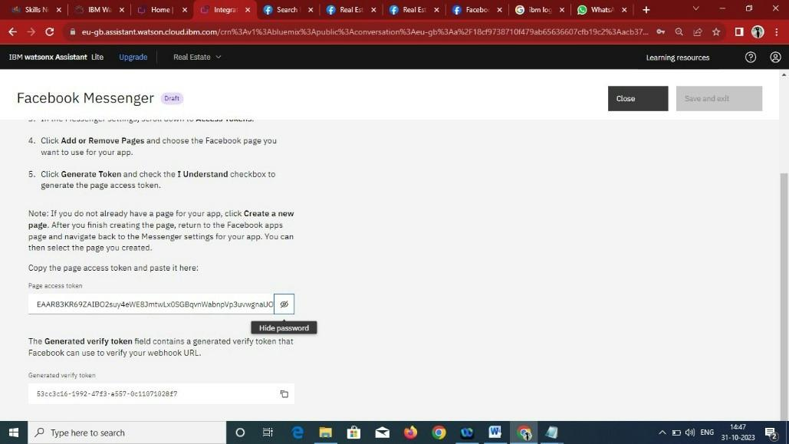

**Configure Facebook webhooks**

• Copy the generated URL in IBM Watson Facebook messenger

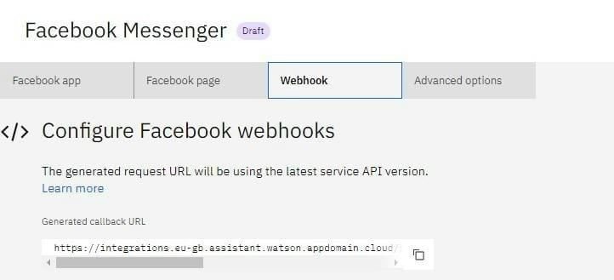

• In the Meta developers Facebook Messenger settings, scroll to the

Webhooks section. Click Setup Webhooks.

• In the Edit Callback URL window, paste the generated callback URL into

the Callback URL field.

• In the Verify Token field, paste the verify token that was generated for you

in Facebook page in IBM Watson Facebook messenger page.

• Click Verify and Save

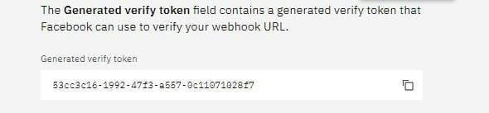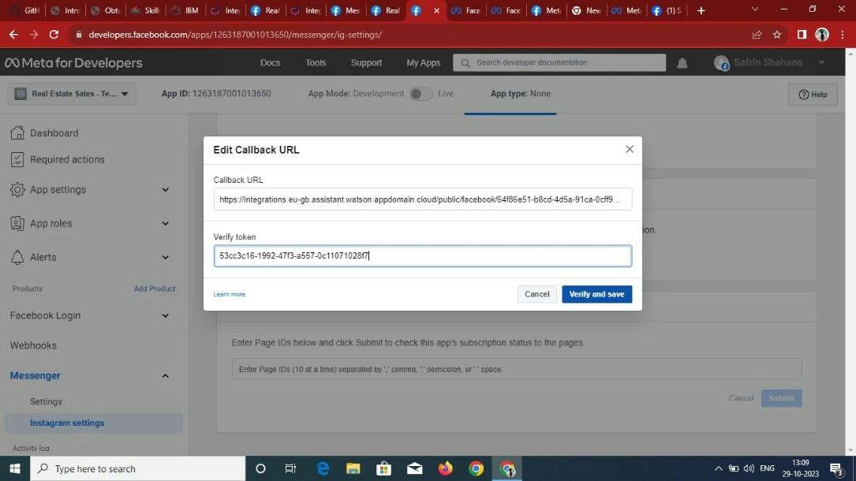

• Click Add Subscriptions. In the Edit Page Subscriptions window under

Subscription Fields, select messages and messaging_postbacks. And click

Save

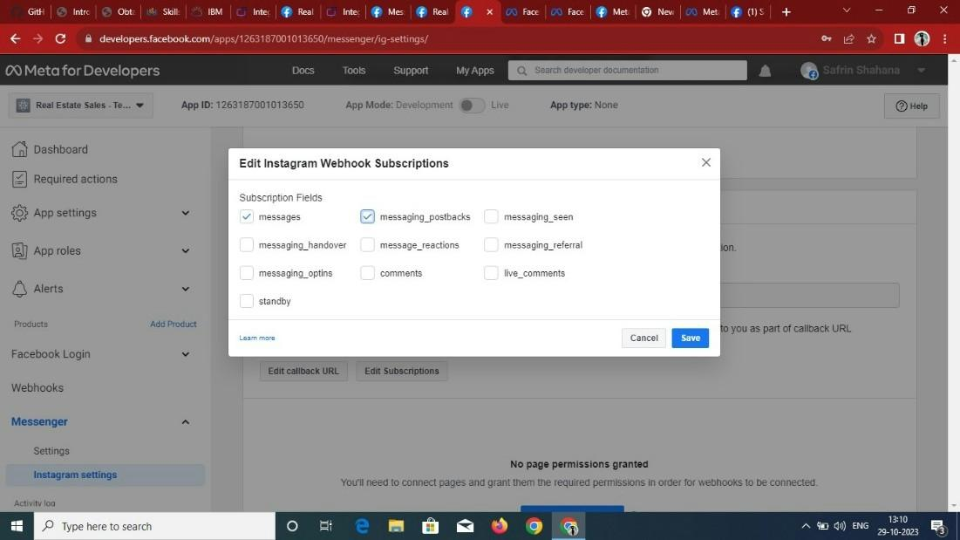

**Connect your assistant**

• After successfully completing the above procedure, your chatbot is now successfully integrated into messaging platforms like Facebook Messenger **screenshots:**

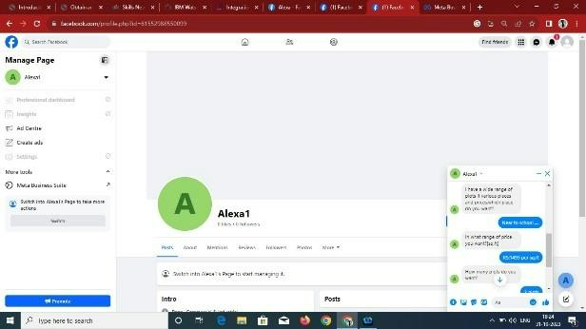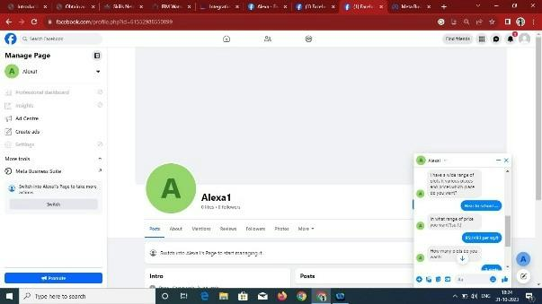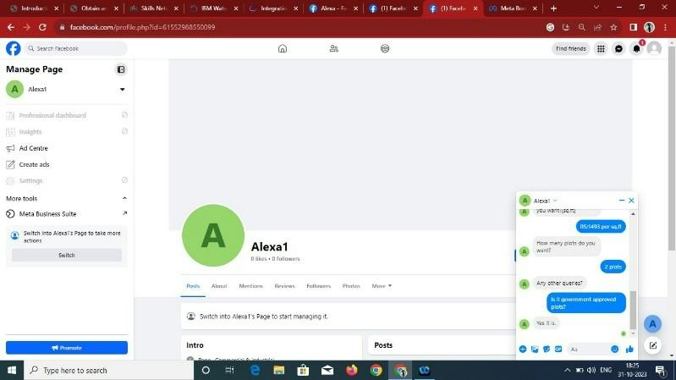

**INTEGRATING CHATBOT WITH SLACK:**

Step 1: Select Slack Add+

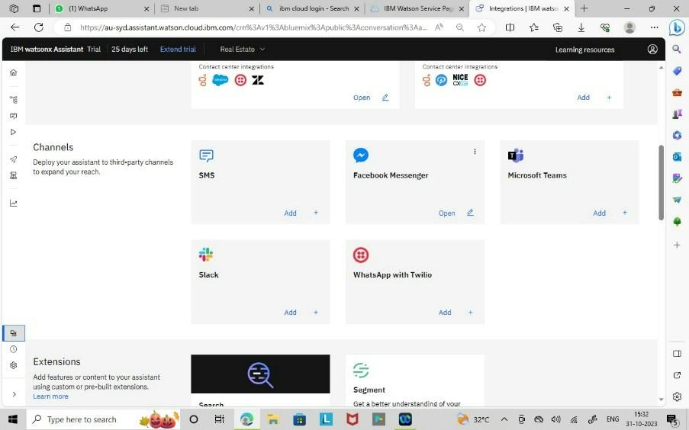

Step 2: Start the Setup for Integrating slack to IBM Watson Assistant

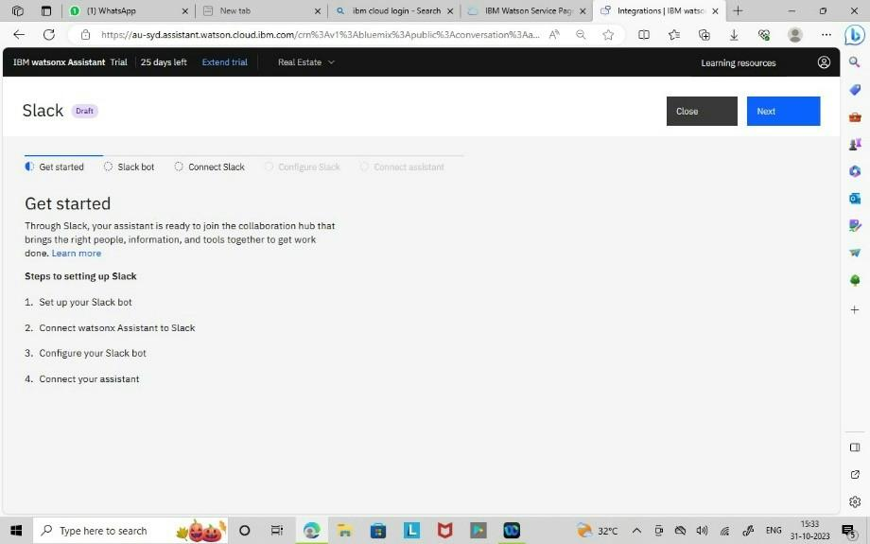

Step 3: Create a Slack app and open your apps page

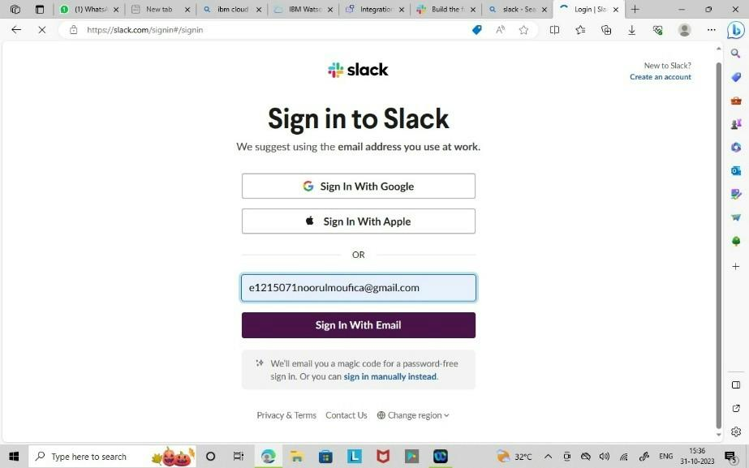

Step 4: Create a app and add the chatbot in the workspace

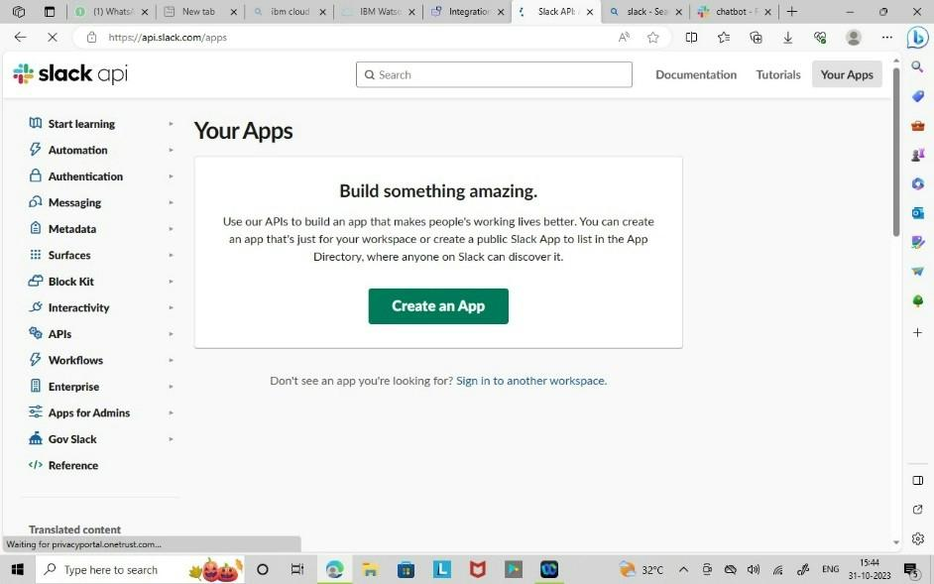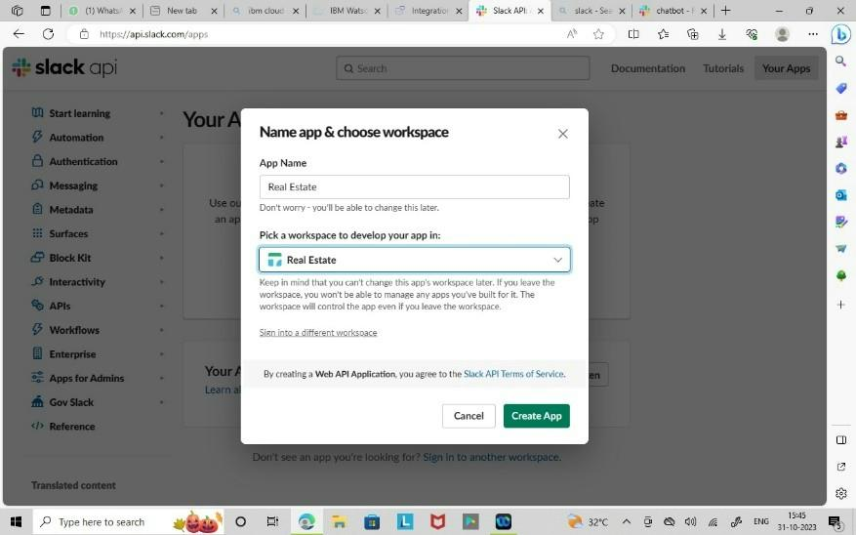

Step 5: On the Slack app settings page, go to the Basic Information tab and ﬁnd the App Credentials section. Copy your veriﬁcation token from that section to the ﬁeld below

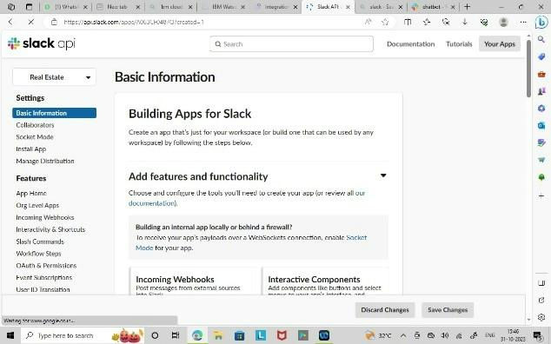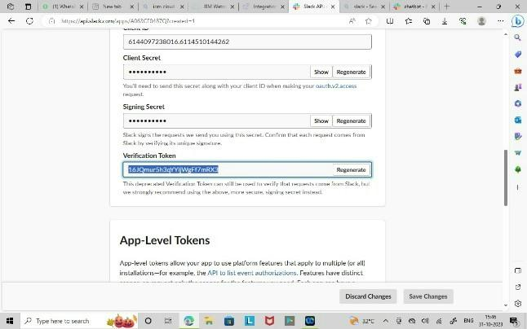

Step 6: Go to the OAuth & Permissions tab. In the Bot Token Scopes section click Add an OAuth Scope, and then select the following scopes:

• app_mentions:read

• chat:write

• im:history

• <im:read>

• <im:write>

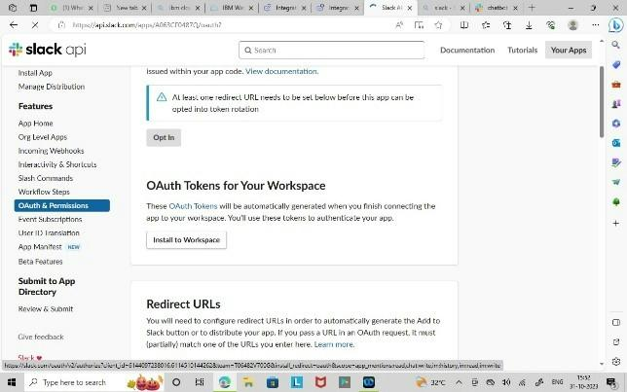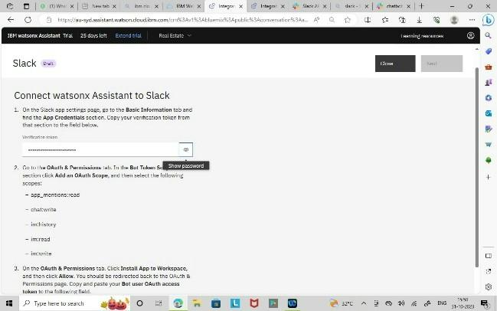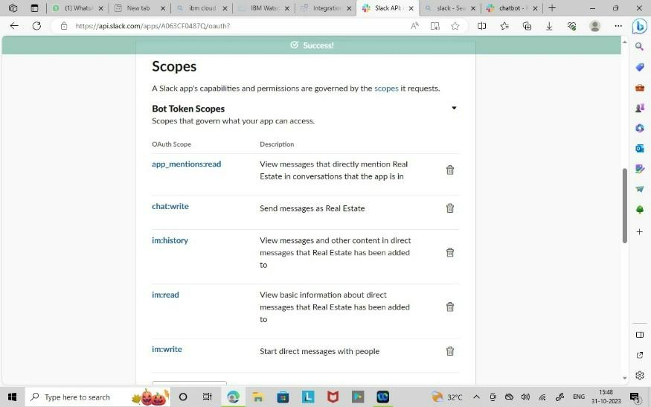

Step 7: On the OAuth & Permissions tab. Click Install App to Workspace, and then click Allow. You should be redirected back to the OAuth & Permissions page. Copy and paste your Bot user OAuth access token to the following ﬁeld

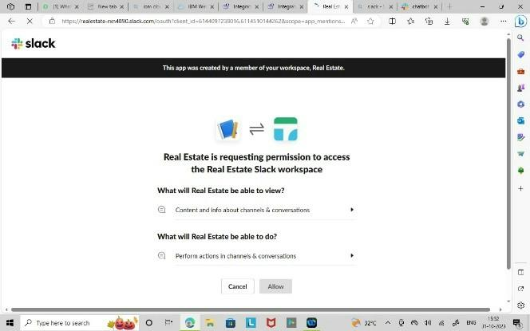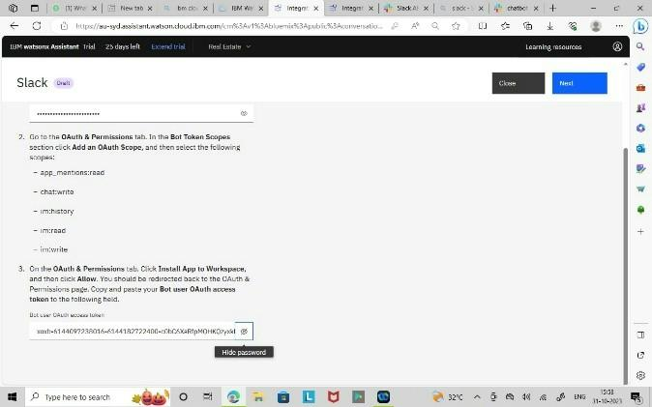

Step 8: On the Slack app settings page, go to the Event Subscriptions tab. Switch the Enable Events toggle to the On position. In the provided text entry ﬁeld, paste your request URL

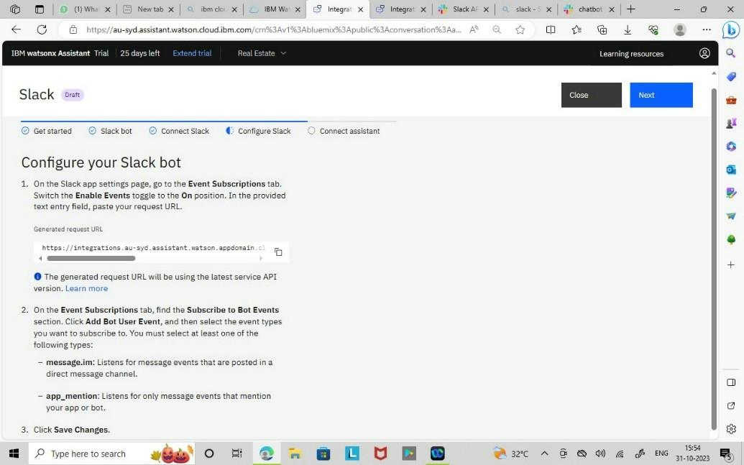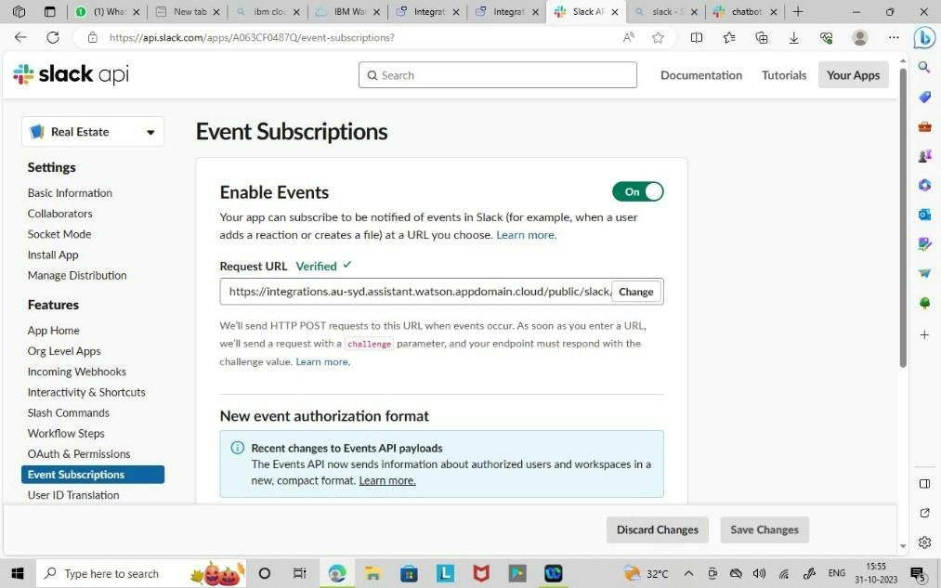

Step 9: On the Event Subscriptions tab, ﬁnd the Subscribe to Bot Events section.

Click Add Bot User Event, and then select the event types you want to subscribe to. You must select at least one of the following types:

**1.message.im:** Listens for message events that are posted in a direct message channel. **2.app_mention**: Listens for only message events that mention your app or bot

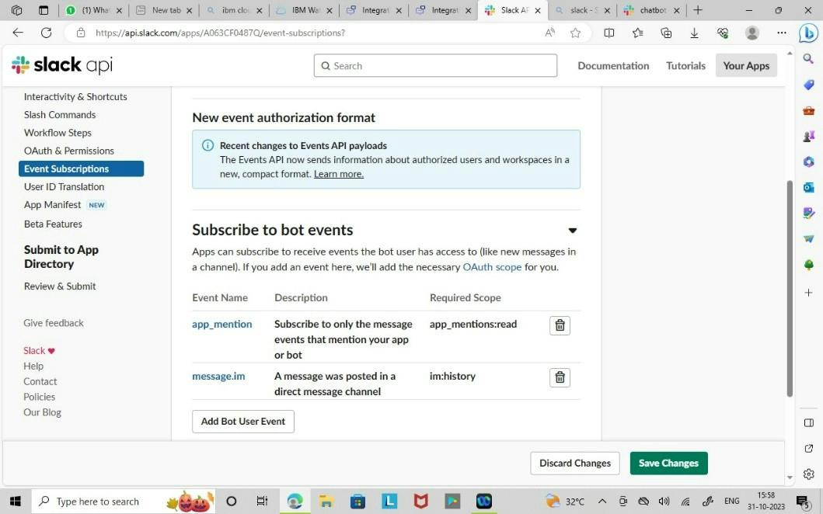

Step 10: On the App Home tab, click Edit and enter a display name and default username for your virtual assistant and then click Save. Enable the Always Show My Bot as Online toggle

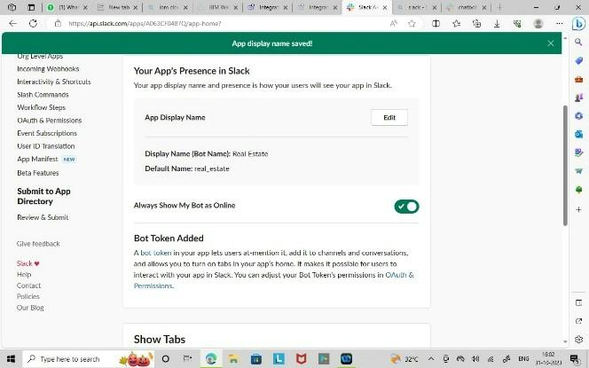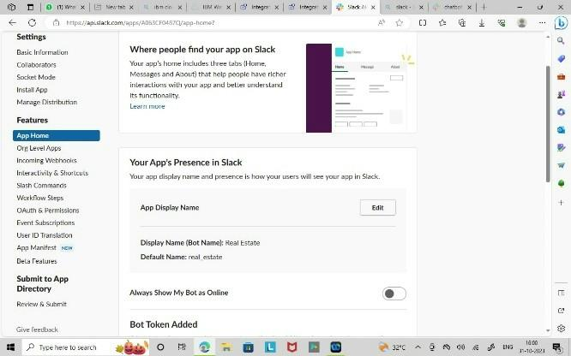

Step 11: On the App Home tab, ﬁnd the Show Tabs section. Enable the Messages Tab toggle and check the Allow users to send Slash commands and messages from the messages tab checkbox.

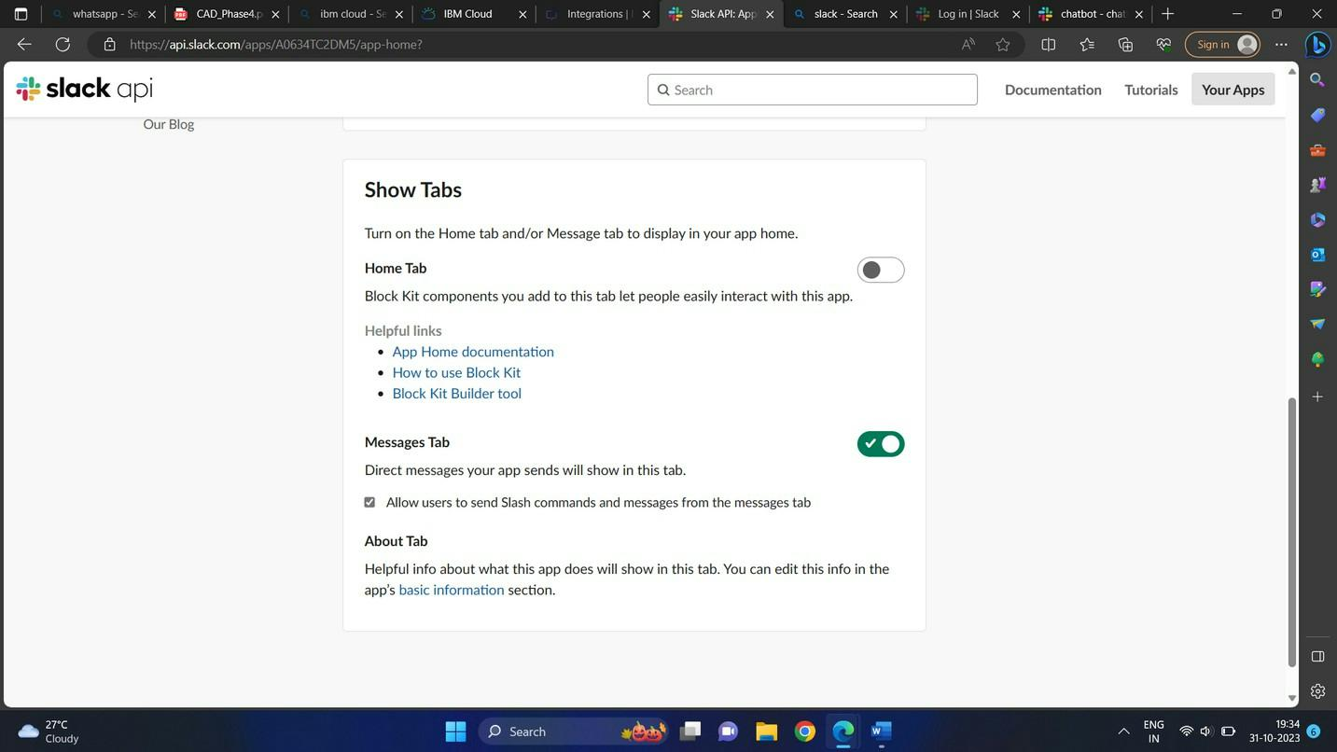

Step 12: To add support for showing buttons, menus, and disambiguation options in the Slack app, go to the Interactivity & Shortcuts tab and enable the feature. Paste your request URL in the provided text entry ﬁeld, and then click Save Changes.

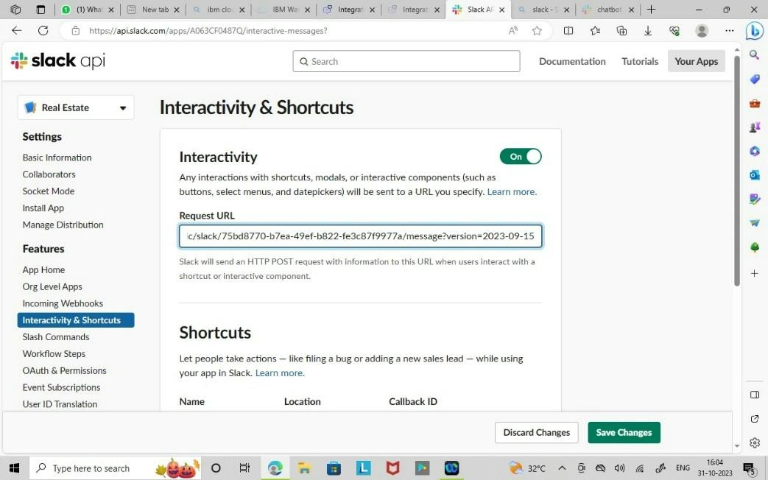

Step 13: Create a channel and review the chatbot.

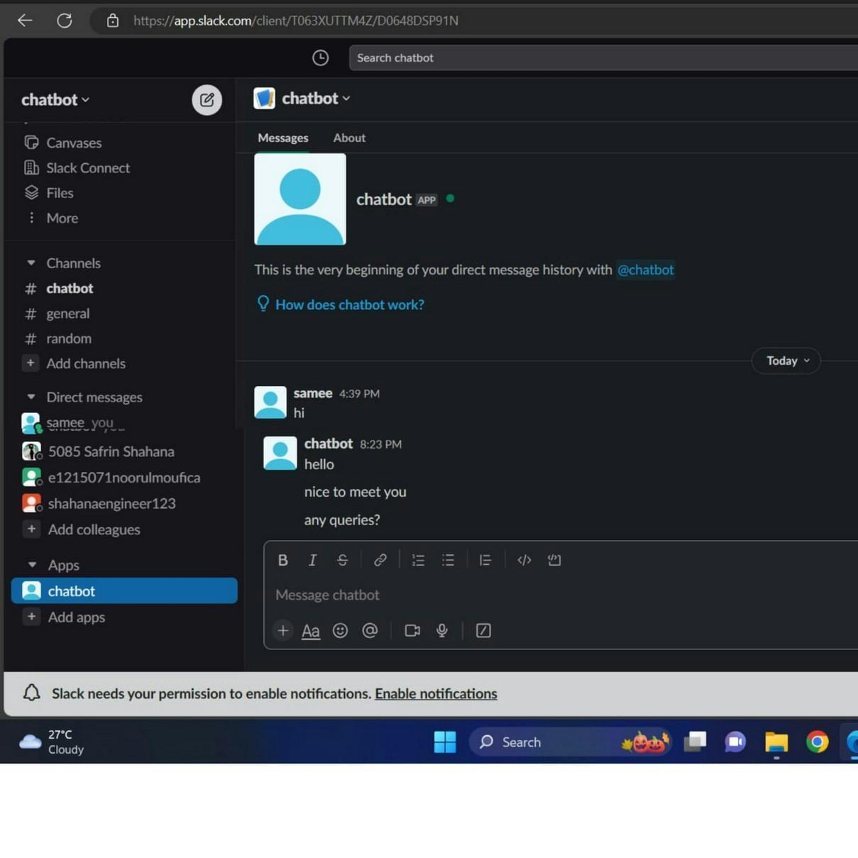

\

**CONCLUSION:**

* Thus the outline the projects objective, design thinking process and development phases.
* Describe the chatbot’s persona, conversational flow, technical implementation using Watson assistant.
* Providing examples of user queries and chatbot’s responses are executed successfully on facebook messenger and slack.