PROJECT PRESENTATION
Detecting and Responding to SSH Brute-Force Attacks
using the Wazuh SIEM in a Kali Linux + Ubuntu Server Lab
Presented by
Sameeha Shajahan
Student at Brototype

Lab component | Details
Attacker machine | Kali Linux 2026.1 (VirtualBox) - 192.168.56.102
Target server | Ubuntu Server "secops-server" (VirtualBox) - 192.168.56.101
SIEM server | Wazuh v4.14.8 OVA (VirtualBox) - 192.168.56.104
Focus | Detect > Observe > Block > Document

All attacks were performed only on my own isolated virtual lab, with permission and for learning.
Table of Contents
Flowchart: How the SSH Brute-Force Attack Is Detected 3
1. Introduction 4
What is this project? 4
Purpose 4
Problem it solves 4
2. Project Overview 5
Scope 5
Objectives 5
Lab architecture 5
3. Development Process 6
Step 1: Network setup and connectivity test 6
Step 2: SSH service verification 7
Step 3: Attack simulation (failed login attempts) 9
Step 4: Log collection on the Ubuntu server 9
Step 5: Verifying the logs reached Wazuh 10
Step 6: Wazuh dashboard analysis 12
4. Key Features 14
5. Incident Response Phase: Observe, Block and Document 15
5.1 Observing the events 15
5.2 Blocking criteria (when do we block an IP?) 16
5.3 Documentation criteria (what must be written after the incident?) 17
Severity classification 18
Incident report (fill this after your final test) 18
6. Technologies Used 21
7. Challenges Faced 22
8. Achievements 22
9. Future Plans 22
10. Personal Contribution 22
11. Lessons Learned 23
12. Conclusion 23
Appendix A: Abbreviations 24

Flowchart: How the SSH Brute-Force Attack Is Detected
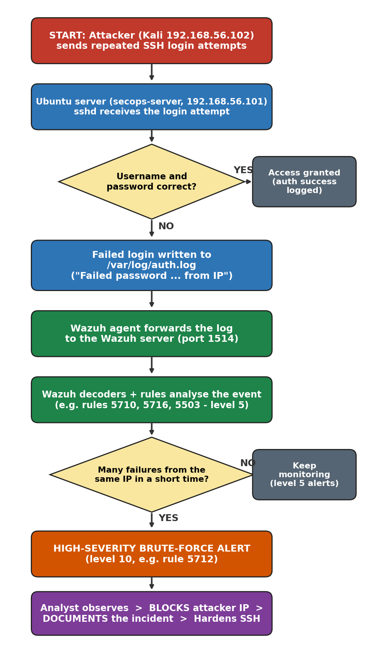
Figure 1: SSH brute-force attack and Wazuh detection/response flow

1. Introduction

What is this project?
This project builds a small security operations lab and uses it to simulate, detect, block and document an SSH brute-force attack. A brute-force attack means an attacker keeps guessing usernames and passwords until one works. The attacker (Kali Linux) targets an Ubuntu server, while Wazuh, an open-source SIEM (Security Information and Event Management) platform, watches the server logs and raises alerts.

Purpose
- Understand how a brute-force attack looks from the attacker side and, more importantly, from the defender side.
- Learn how log collection, correlation and alerting work in a real SIEM.
- Practise the full incident-response cycle: detect, observe, contain (block the IP) and document.

Problem it solves
Any server with SSH open to a network is constantly probed by password-guessing attempts. Without central monitoring, an admin may never notice thousands of failed logins hidden in /var/log/auth.log, and the one successful guess is the one that leads to a breach. Wazuh turns those raw log lines into clear alerts so the attack can be stopped early.

2. Project Overview

Scope
In scope | Out of scope
SSH password guessing against one Ubuntu server | Attacks on real / internet-facing systems
Log collection (auth.log) and forwarding to Wazuh | Malware, ransomware or web-application attacks
Alert analysis in the Wazuh dashboard and alert files | Large-scale distributed (botnet) attacks
Blocking the attacker IP and writing an incident report | Enterprise-scale deployment and tuning

Objectives
- Build a three-machine virtual lab and confirm every machine can reach the others.
- Verify that the SSH service is running and check its authentication settings.
- Simulate failed SSH logins from Kali against the Ubuntu server.
- Collect the resulting log entries on the Ubuntu server and in Wazuh.
- Observe the alerts, MITRE ATT&CK mapping and event details in the Wazuh dashboard.
- Block the attacking IP address using a clear blocking criteria.
- Document the incident using a clear documentation criteria.

Lab architecture
Machine | Role | OS / Software | IP address
Kali VM | Attacker | Kali Linux 2026.1, OpenSSH 10.3p1 | 192.168.56.102
secops-server | Target + Wazuh agent | Ubuntu Server, OpenSSH server (user: samee) | 192.168.56.101
wazuh-server | SIEM manager, indexer, dashboard | Wazuh v4.14.8 OVA (also NAT adapter 10.0.2.15) | 192.168.56.104

Network type: all three VMs sit on a VirtualBox host-only network (192.168.56.0/24), so they can talk to each other and to the host laptop, but the attack never leaves the laptop.

3. Development Process
Methodology: I followed an iterative (Agile-style) lab approach: plan a small step, build it, test it, observe the result and fix problems before moving on. Each step below was verified with a screenshot before starting the next, so any fault was found early instead of at the end (unlike Waterfall, where testing happens last).
Tools used: VirtualBox (virtualisation), Linux terminal commands (ping, ssh, sshd -T, tail, grep, ip a), Wazuh dashboard (browser), Snapshots (to roll back the VMs).

Step 1: Network setup and connectivity test
Before any attack, every VM must reach every other VM. I used ping (ICMP echo) between Ubuntu, Wazuh and Kali in both directions. Replies with 0% packet loss prove the network and IP addressing are correct. A working network is required because the Wazuh agent sends logs over the network and Kali must reach the SSH port.
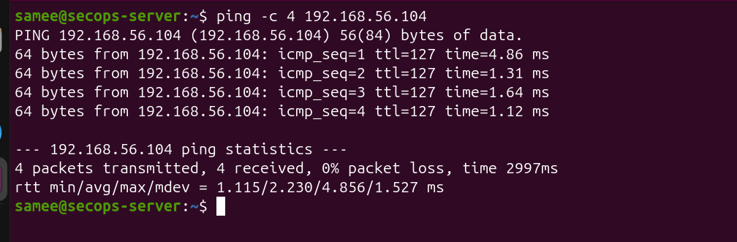

Figure 2: Ubuntu to Wazuh: ping -c 4 192.168.56.104
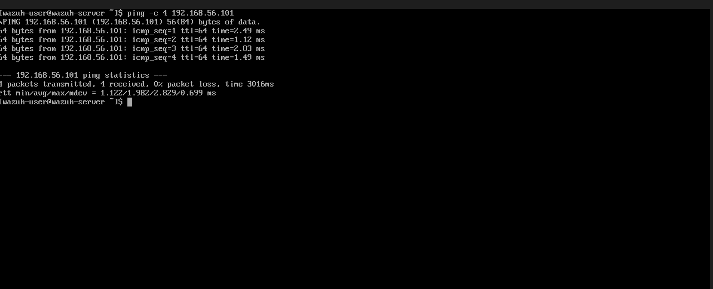

Figure 3: Wazuh to Ubuntu: ping -c 4 192.168.56.101
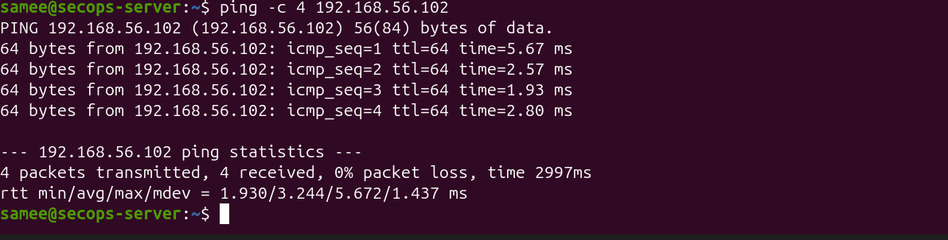

Figure 4: Ubuntu to Kali: ping -c 4 192.168.56.102
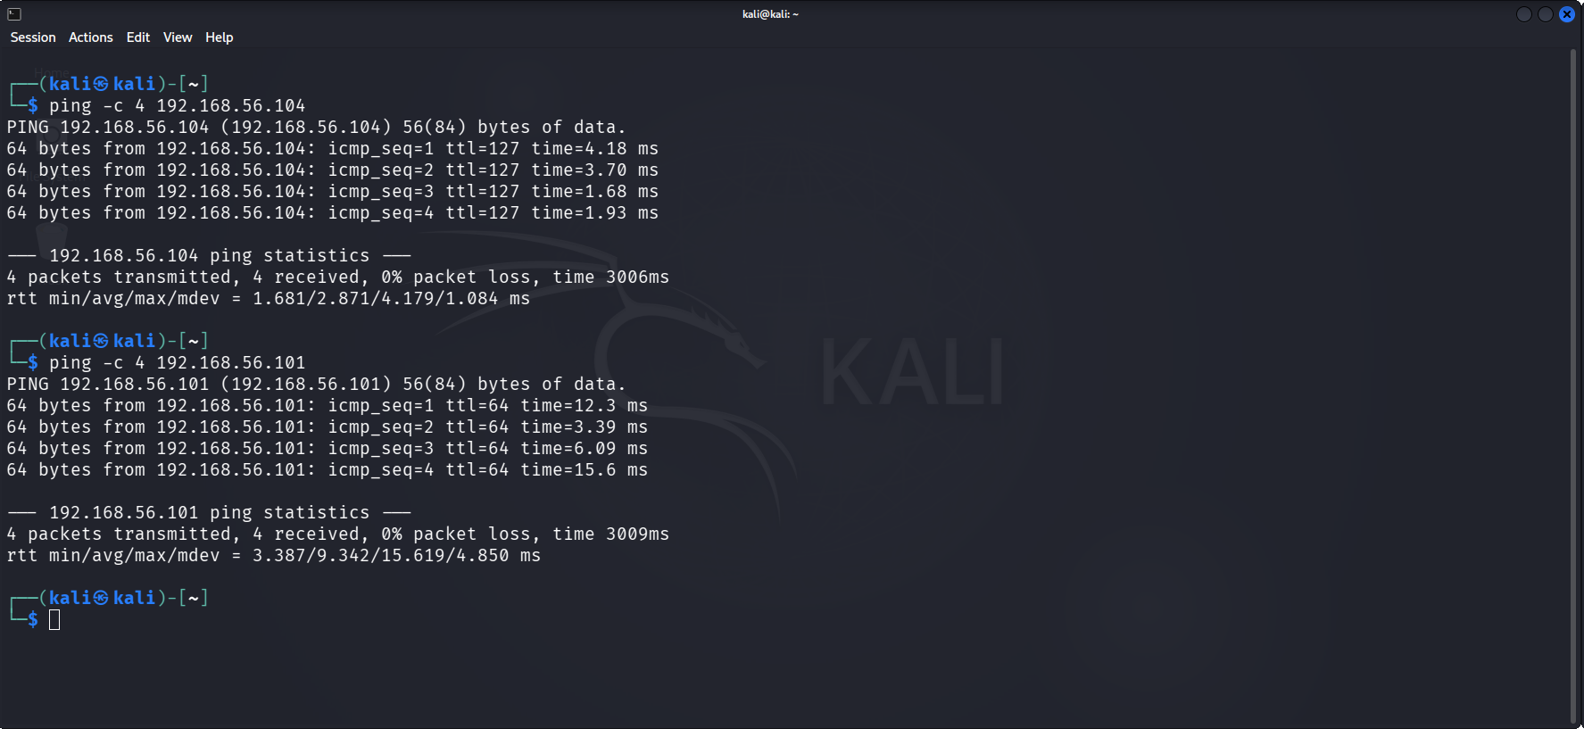
Figure 5: Kali to Wazuh (.104) and Kali to Ubuntu (.101): 4 packets sent, 4 received, 0% loss
HOW TO READ THIS SCREENSHOT
4 transmitted, 4 received, 0% packet loss = the target is reachable.
time=1.6 to 15 ms = very low delay, normal for machines on the same host.
ttl=64 on 192.168.56.101 = TTL is the "Time To Live" counter of a packet; 64 is the usual starting value on Linux systems, so it fits an Ubuntu machine.

Step 2: SSH service verification
SSH (Secure Shell) is the encrypted remote-login service on port 22. I checked that the SSH client on Kali works (ssh -V shows OpenSSH_10.3p1) and that the SSH server on Ubuntu is configured. Using sudo sshd -T I printed the effective configuration and filtered the authentication settings.
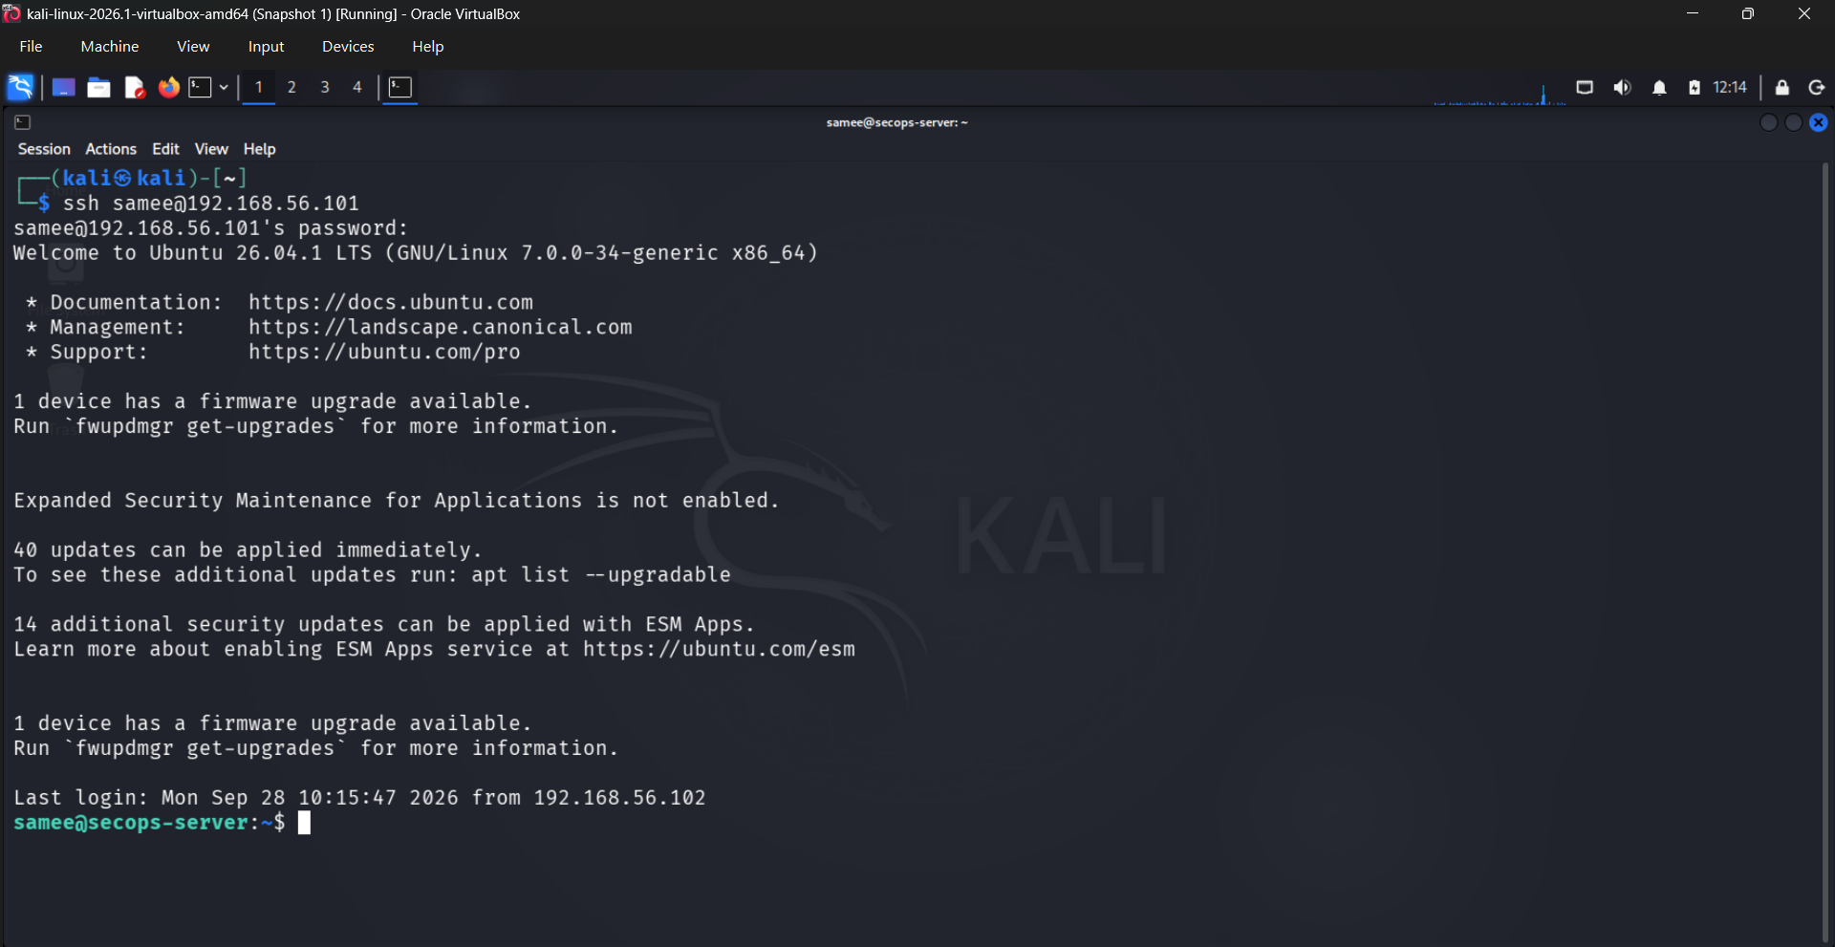
Figure 6: SSH connection test: Kali connects to Ubuntu with the correct password
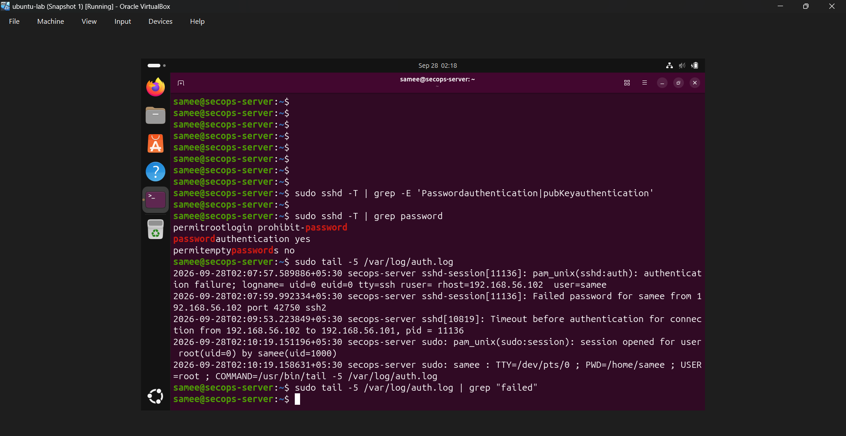
Figure 7: Ubuntu: sshd -T shows the effective SSH settings, then auth.log is read
Setting | Value seen | Meaning
passwordauthentication | yes | Users can log in with a password. This is what a brute-force attack targets.
permitrootlogin | prohibit-password | Root cannot log in with a password (only with a key). Good default.
permitemptypasswords | no | Accounts with blank passwords are refused.

Step 3: Attack simulation (failed login attempts)
From Kali I attempted SSH logins with wrong passwords. I tried two cases: a user that does not exist (wronguser) and a real user with a wrong password (samee). These generate two different kinds of log entries, which is useful for detection because both patterns appear in real attacks.
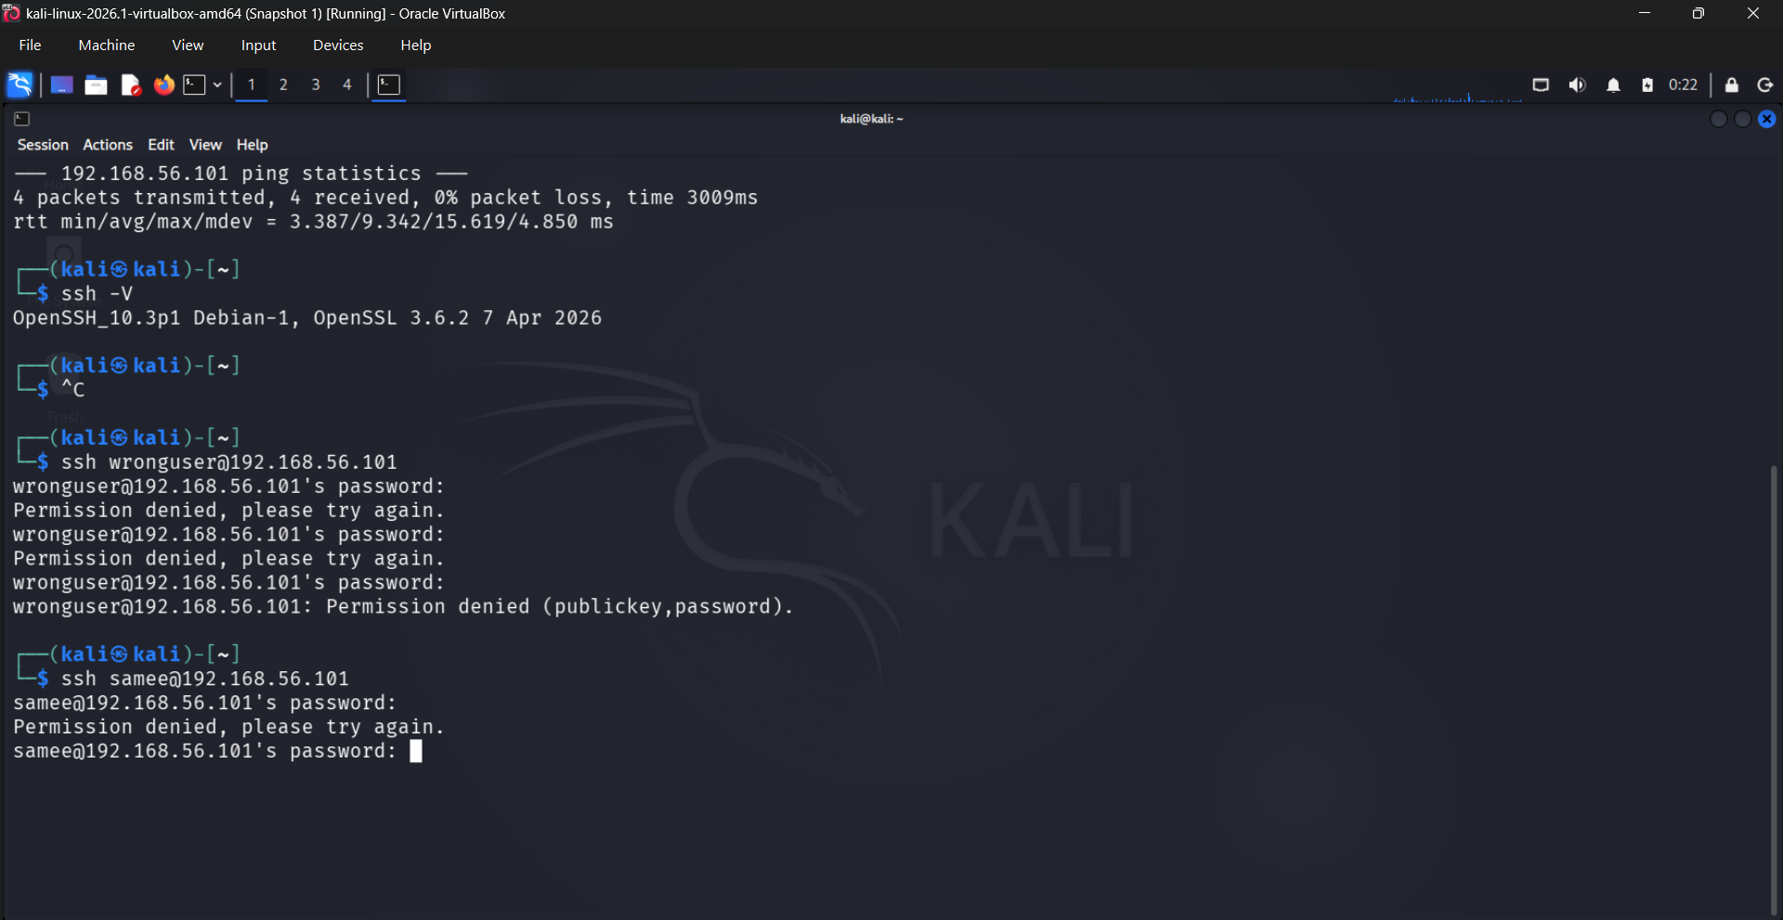
Figure 8: Kali: repeated "Permission denied" for wronguser and samee on 192.168.56.101
HOW TO READ THIS SCREENSHOT
Permission denied, please try again appears after each wrong password. After 3 wrong tries the client stops with Permission denied (publickey,password): the server offered two login methods, key and password, and both failed.
wronguser = username-guessing case (invalid user).
samee = valid username with a wrong password.

ETHICS NOTE
These attempts were run only against my own Ubuntu VM in an isolated lab. Doing this on any system without written permission is illegal.

Step 4: Log collection on the Ubuntu server
Every SSH login attempt is written by the system to /var/log/auth.log. I read the last lines with sudo tail -5 /var/log/auth.log and filtered for the word "failed" using grep.
Figure 9: Ubuntu auth.log: authentication failure and Failed password for samee from 192.168.56.102
Anatomy of one log line (from the screenshot):
Part | Example from screenshot | What it tells us
Timestamp | 2026-09-28T02:07:59 | When the attempt happened
Host | secops-server | Which machine recorded it
Process | sshd-session[11136] | The SSH server process and its process ID
Event | Failed password for samee | What happened (a failed login) and for which user
Source IP | from 192.168.56.102 | WHO attacked (the key detail for blocking)
Port / protocol | port 42750 ssh2 | Source port of the attacker and the SSH version used
PAM line | authentication failure; rhost=192.168.56.102 user=samee | PAM (Pluggable Authentication Modules) also records the failure
Timeout line | Timeout before authentication for connection from 192.168.56.102 | The attacker connected but did not finish logging in

Step 5: Verifying the logs reached Wazuh
On the Wazuh server (IP 192.168.56.104 on eth0) I searched the alert files. The same failed-password events from Ubuntu were present, proving that the Wazuh agent forwards the logs and the manager analyses them.
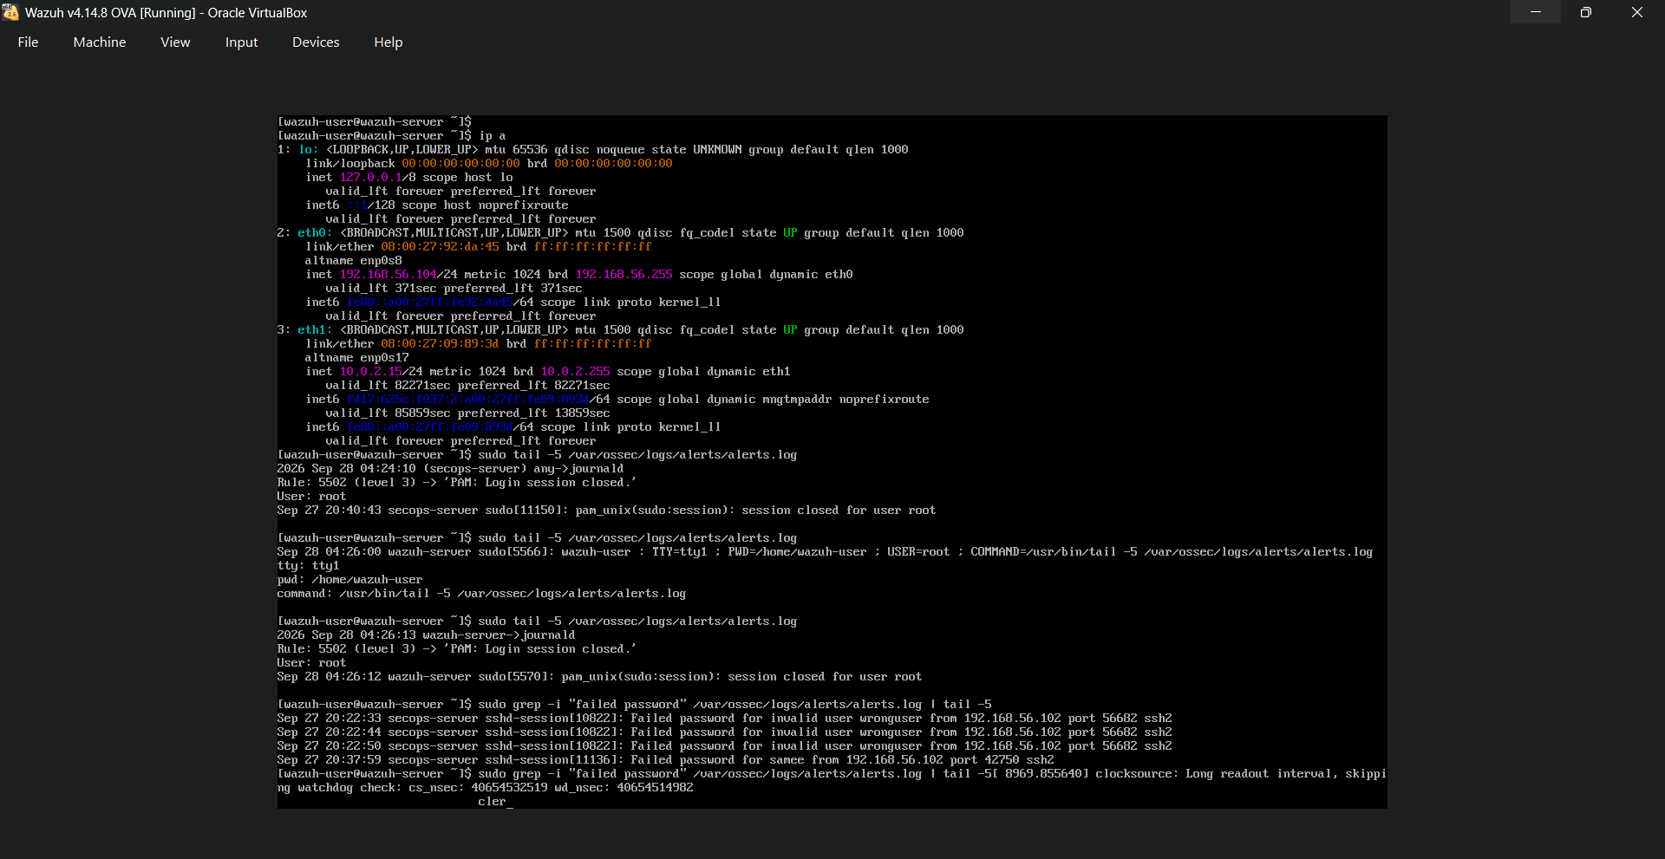
Figure 10: Wazuh server: ip a and grep of "failed password" in alerts.log
KEY EVIDENCE IN THIS SCREENSHOT
Three lines: Failed password for invalid user wronguser from 192.168.56.102 (20:22:33, 20:22:44, 20:22:50), then Failed password for samee at 20:37:59.
The source IP is the same in every line: 192.168.56.102 (the Kali attacker).
The log came from secops-server but was read on wazuh-server, so log forwarding works.

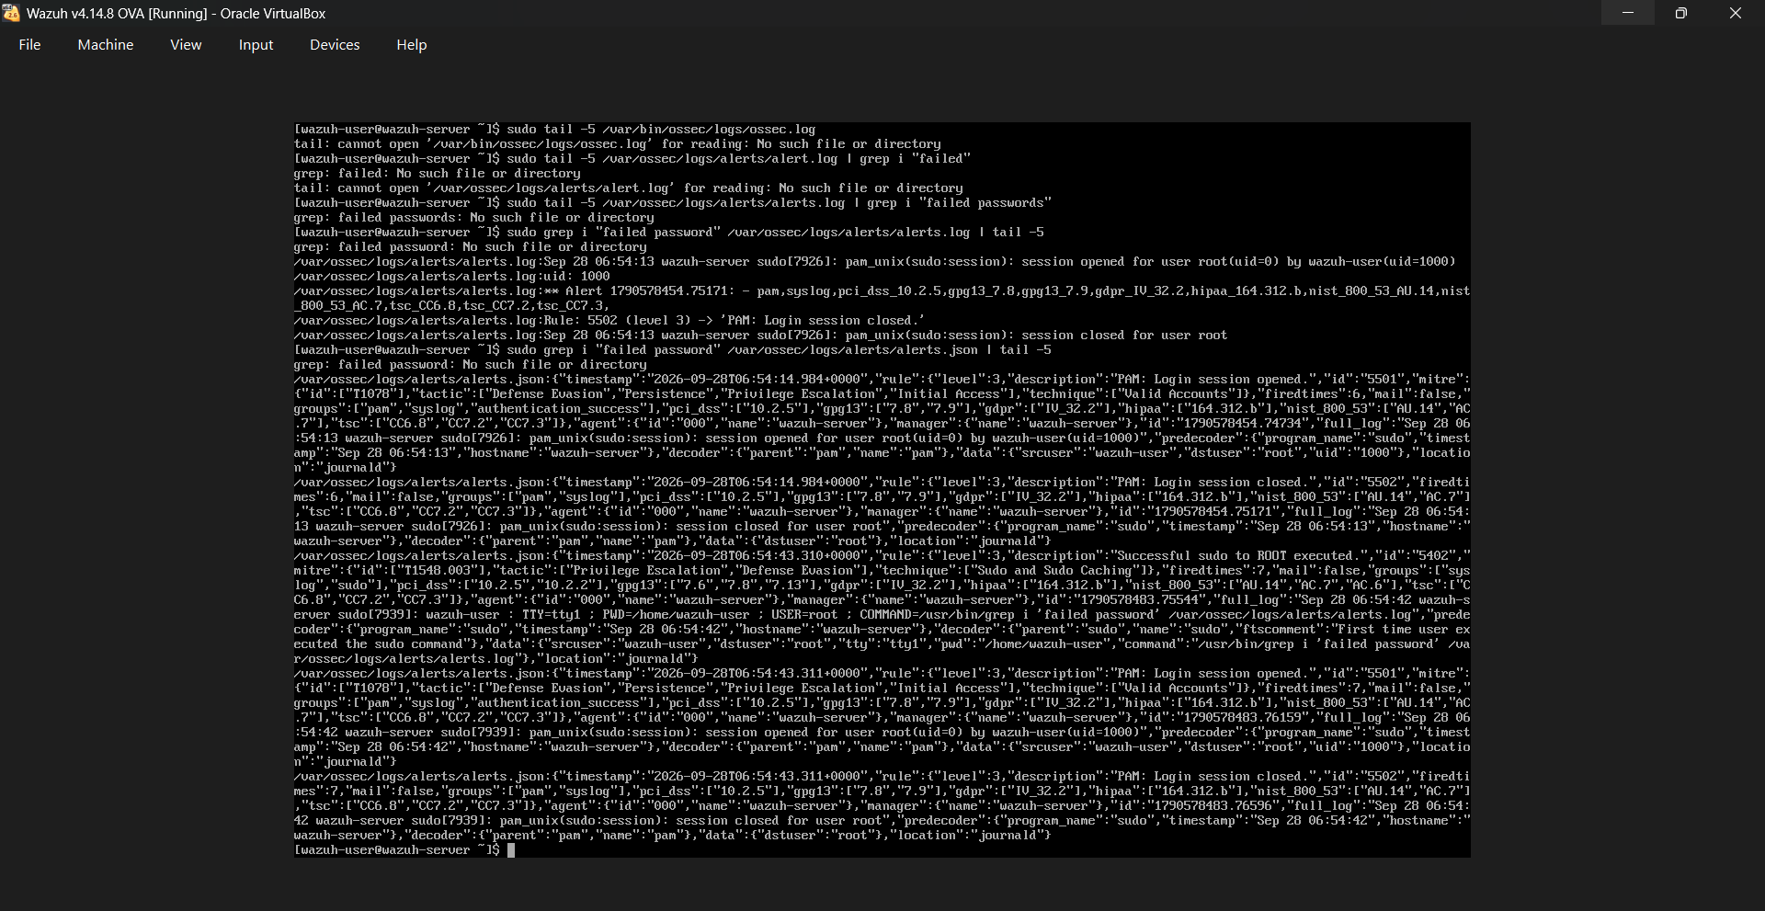
Figure 11: Wazuh alerts.json: structured alerts with rule id, level, MITRE technique and full_log
The JSON alert format is more detailed than alerts.log. Each alert has a rule.id, rule.level, the MITRE ATT&CK tactic and technique, the agent name and the original full_log. For example rule 5501 "PAM: Login session opened", rule 5502 "Login session closed" and rule 5402 "Successful sudo to ROOT executed" (MITRE T1548.003).

Step 6: Wazuh dashboard analysis
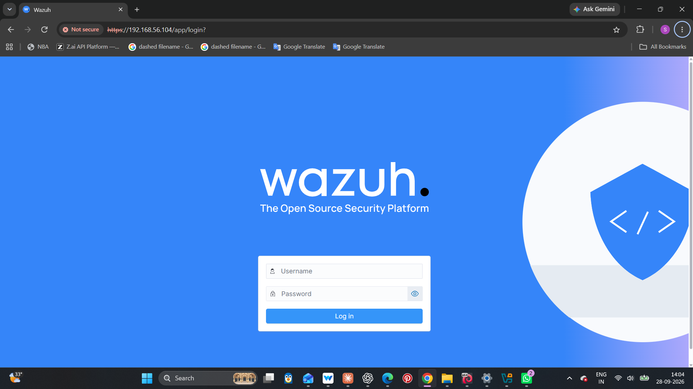
Figure 12: Wazuh web dashboard login at https://192.168.56.104 (self-signed certificate, so the browser says "Not secure")
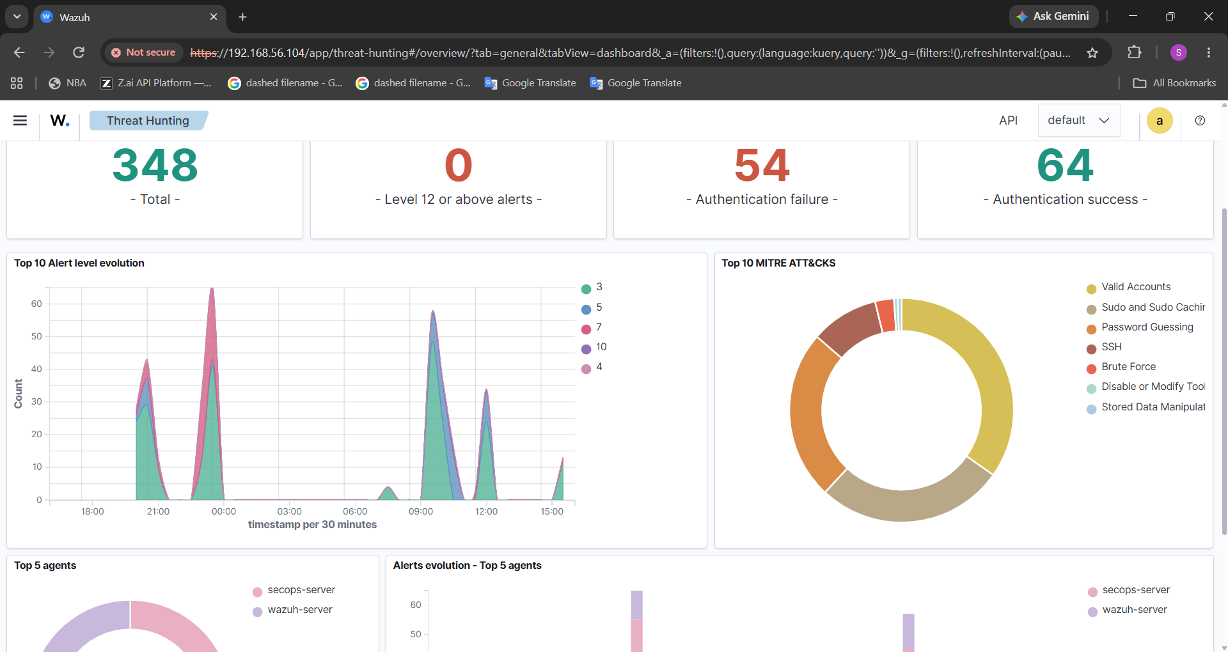
Figure 13: Threat Hunting overview: 348 alerts, 54 authentication failures, MITRE ATT&CK donut chart
Dashboard item | Value seen | Meaning
Total alerts (24 h) | 348 | All events that matched a Wazuh rule
Level 12 or above | 0 | No critical alerts; nothing severe happened
Authentication failure | 54 | Failed logins, including my attack attempts
Authentication success | 64 | Normal successful logins and sudo sessions
Top MITRE ATT&CK | Valid Accounts, Sudo, Password Guessing, SSH, Brute Force | Attack techniques the alerts map to
Top 5 agents | secops-server, wazuh-server | Which machines produced the alerts

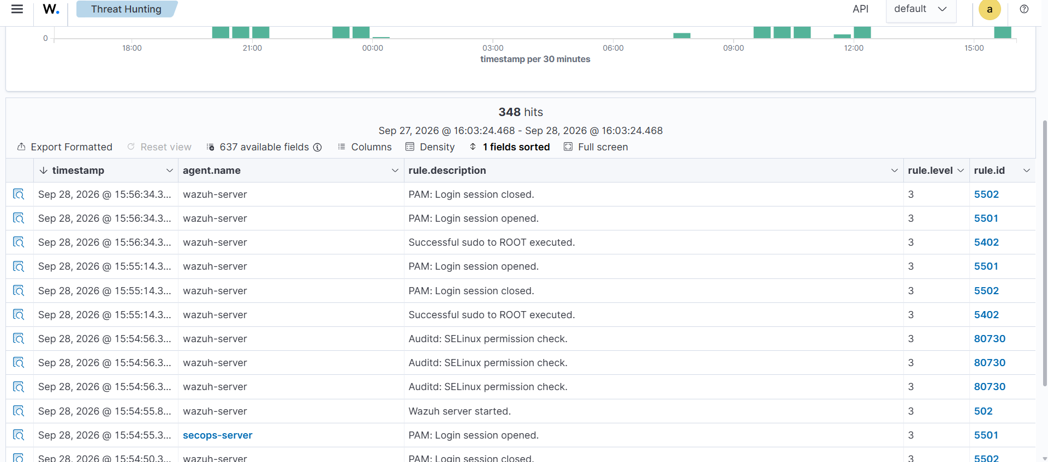
Figure 14: Threat Hunting Events tab: 348 hits with rule description, level and rule ID

4. Key Features
Feature | How it works | Problem it solves
Centralised log collection | Wazuh agent on Ubuntu sends auth.log events to the Wazuh server | Admin no longer needs to read logs on each machine by hand
Real-time alerting | Decoders and rules turn log lines into levelled alerts (level 3 info, 5 warning, 10 high) | Attacks are noticed in seconds, not days
MITRE ATT&CK mapping | Every alert is tagged with a tactic and technique (e.g. Brute Force, Password Guessing) | Uses a global standard language to describe the attack
Dashboard and threat hunting | Charts, counters and searchable events | Easy investigation of who, when and how many
Source-IP identification | Every failed login records the attacker IP and port | Gives the exact information needed to block the attacker
Response and blocking | Firewall rule or Wazuh Active Response bans the IP | Stops the attack instead of only watching it
Incident documentation | Structured report with timeline and evidence | Provides proof, accountability and learning

5. Incident Response Phase: Observe, Block and Document

5.1 Observing the events
After the attempts, I watched the alerts in the Wazuh dashboard (Threat Hunting > Events) and looked for the following signs of brute force:
- Many "Failed password" or "authentication failure" events in a short time.
- The same source IP repeated in all events (here 192.168.56.102).
- Attempts against invalid users (wronguser) and against real users (samee).
- A jump in the alert-level graph and in the MITRE techniques Brute Force and Password Guessing.
- Any success from the same IP after many failures, which would mean the attack worked.
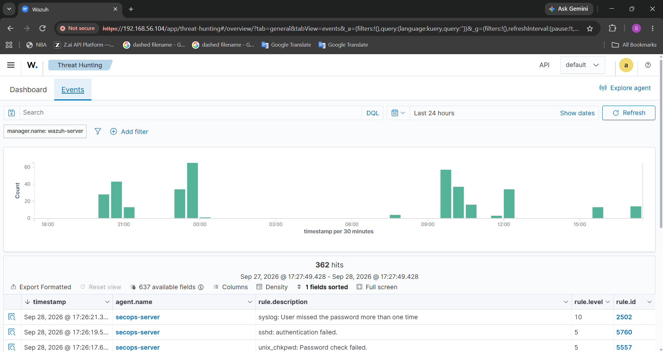
Figure 15: Observing the events in Wazuh after the attack
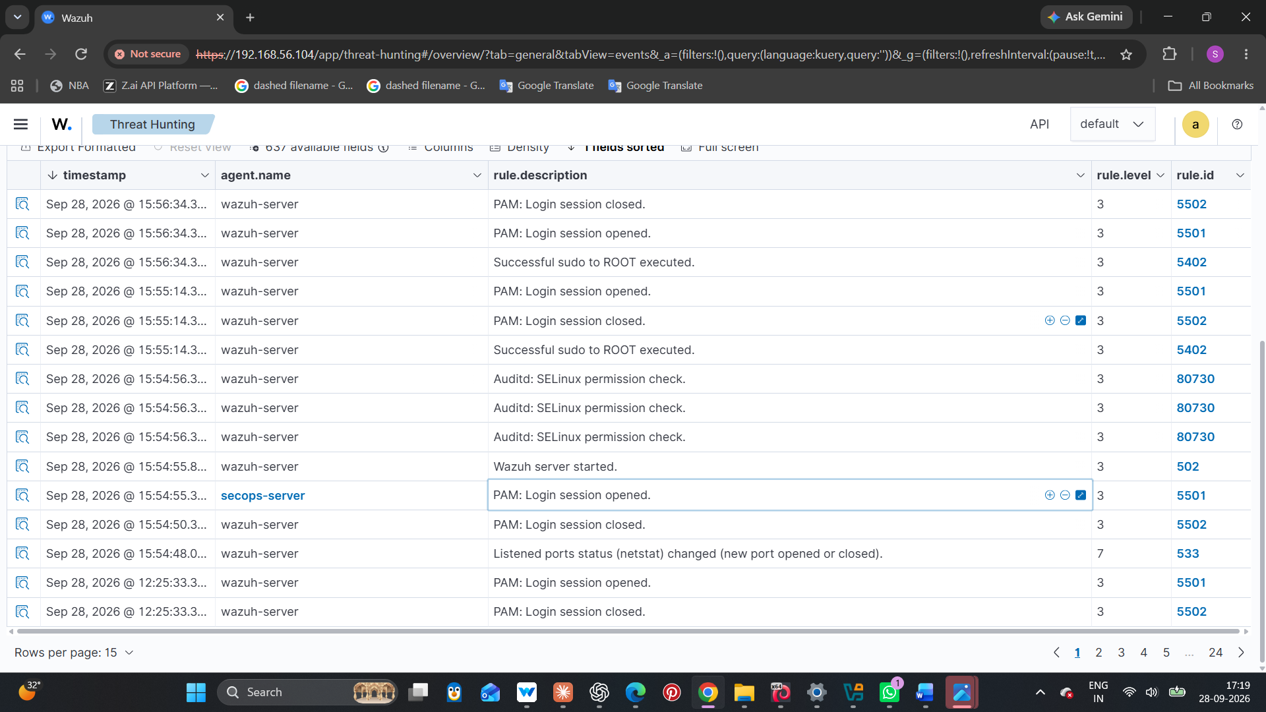E ]

Figure 16: Wazuh alert details for the brute-force attempt (expand one event)

5.2 Blocking criteria (when do we block an IP?)
We should not block on a single wrong password, because real users mistype passwords. A clear rule (criteria) avoids blocking innocent people and still stops real attackers. The following criteria was used in this project:
Criteria | Condition | Action
1. Repeated failures | 5 or more failed logins from the same IP within 2 minutes | Mark as suspicious and raise a high-severity alert
2. Invalid-user guessing | Attempts using usernames that do not exist (e.g. wronguser) | Treat as reconnaissance; block IP if repeated
3. Success after failures | Successful login from an IP that just failed many times | Treat as compromise: block, lock the account, investigate
4. Known-safe IPs | Admin IP or trusted management host | Never auto-block; whitelist and only alert
5. Block duration | First offence 10 minutes (auto-unblock); repeat offender permanent block | Reduces damage from false positives

How the IP is blocked. Option A: manual firewall rule on the Ubuntu server (simple and good for a demo):
sudo ufw deny from 192.168.56.102 to any port 22
sudo ufw status numbered # verify the rule exists
Option B: Wazuh Active Response (automatic). Wazuh has a built-in firewall-drop command. Adding a block like this to the manager ossec.conf makes it drop the IP on the agent when the brute-force rule fires, and unblock after the timeout:
<active-response>
<command>firewall-drop</command>
<location>local</location>
<rules_id>5712</rules_id>
<timeout>600</timeout>
</active-response>

IMPORTANT TERMS
Active Response = Wazuh automatically runs a script (like blocking an IP) when a rule triggers.
timeout 600 = the block lasts 600 seconds (10 minutes), then it is removed automatically.
False positive = a harmless event wrongly treated as an attack (for example an admin who forgot a password). Whitelisting and timeouts reduce this.

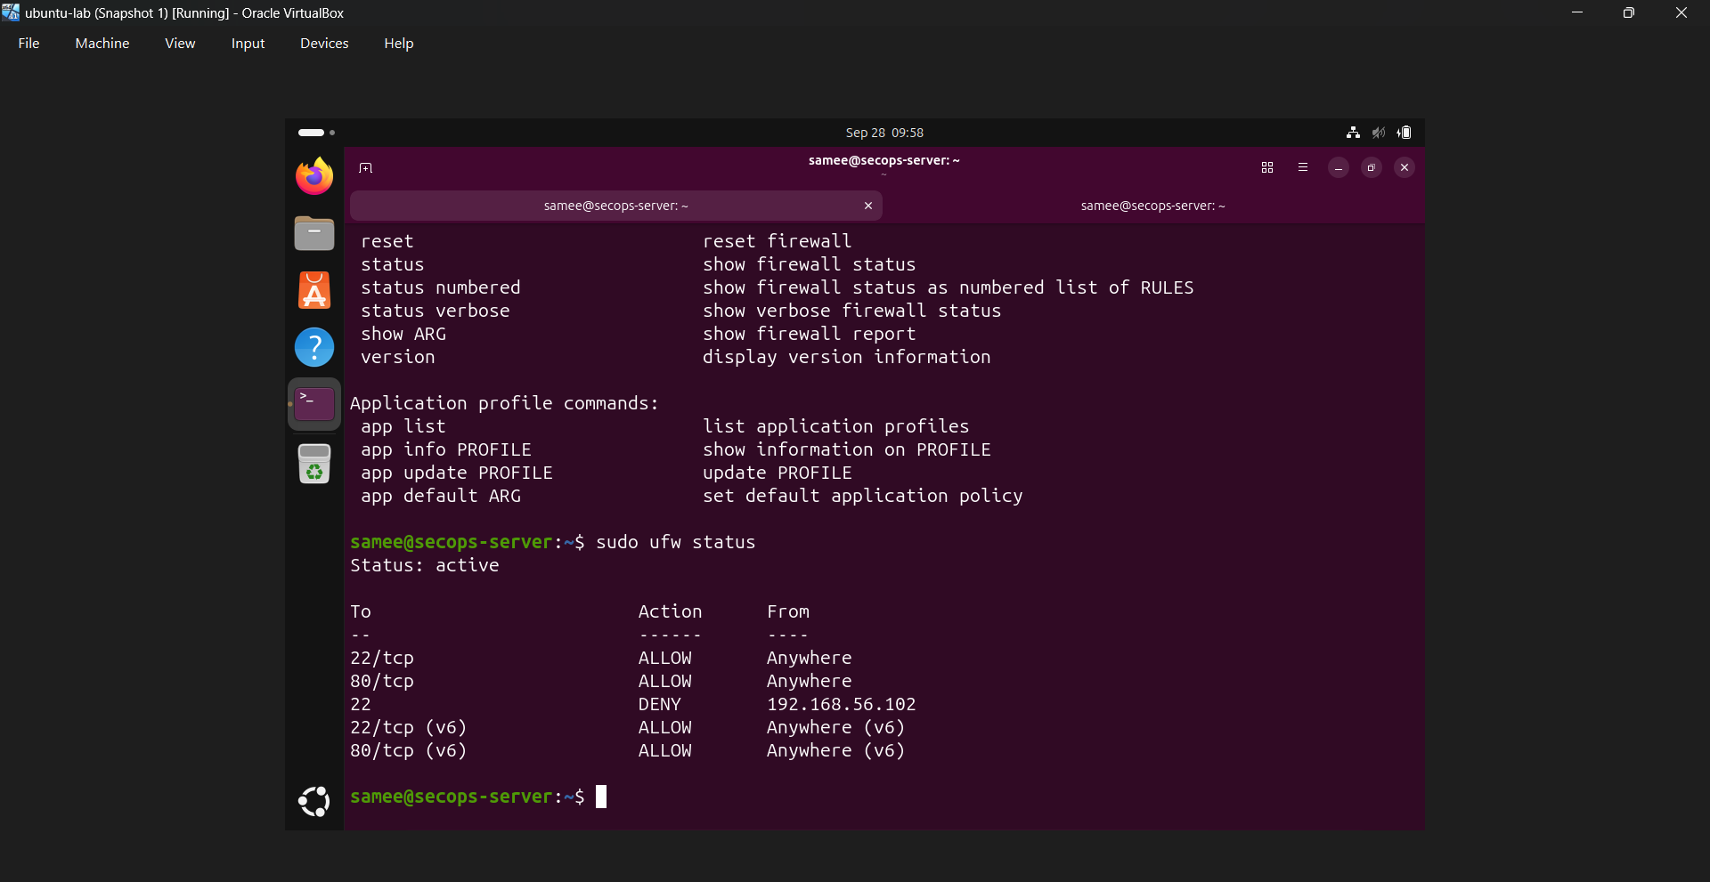
Figure 17: Blocking the attacker IP (192.168.56.102)
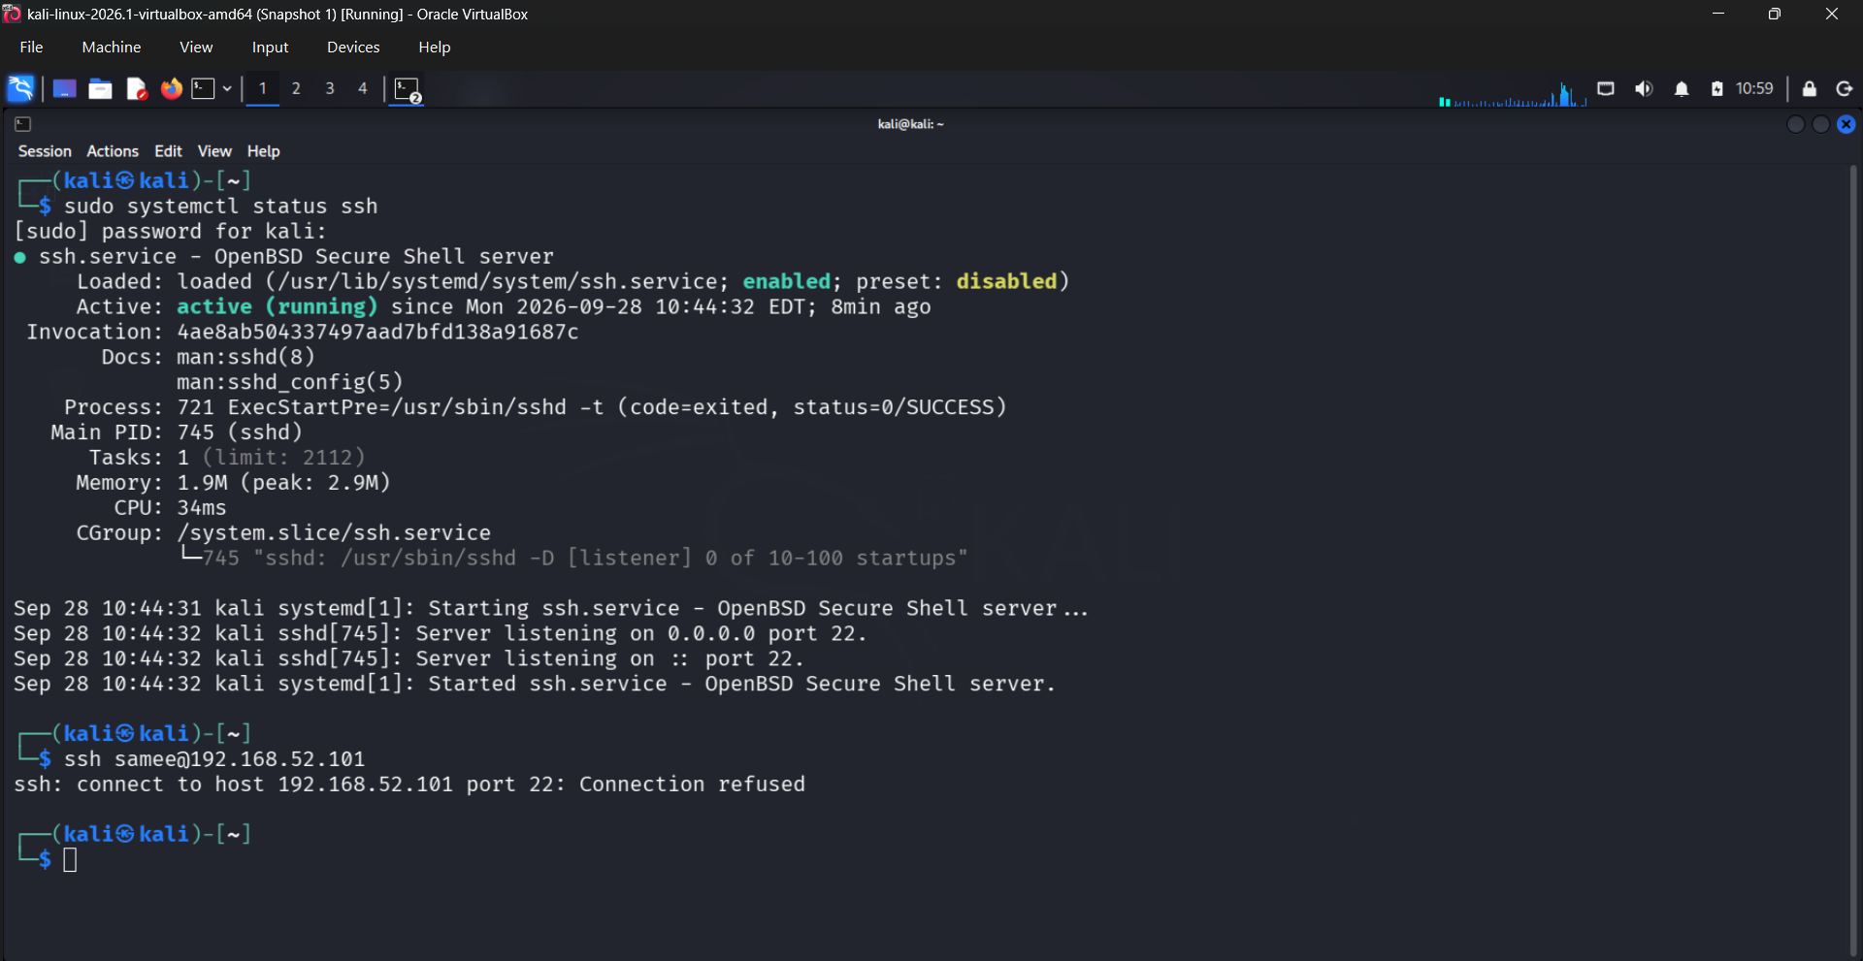
Figure 18: Proof that the block works

5.3 Documentation criteria (what must be written after the incident?)
A security incident is not finished until it is documented. Good documentation proves what happened, helps the next analyst, and is required for audits and lessons learned. The documentation must be Accurate, Complete, Timely, Clear and backed by Evidence.
Criteria | What to record | Why it matters
Who | Attacker IP 192.168.56.102, targeted users (wronguser, samee), analyst name | Identifies the source and the responsible person
What | SSH brute-force / password-guessing attempts | Defines the type of incident
When | Start and end time from logs (e.g. Sep 27 20:22 onward) | Builds the timeline
Where | Target secops-server 192.168.56.101, detected by wazuh-server 192.168.56.104 | Shows which assets were affected
How detected | Wazuh agent forwarded auth.log; rules 5710 / 5716 / 5503 and MITRE Brute Force | Explains the detection method
Evidence | Screenshots, log lines, alert IDs, dashboard counts | Proof that can be verified later
Impact | No successful attacker login, no level 12+ alerts, no data loss | Measures the damage
Action taken | IP blocked (command, time, duration) | Shows containment was done
Root cause + fix | Password authentication enabled; move to keys, fail2ban, rate limits | Prevents the incident from repeating

Severity classification
Severity | Wazuh level | Example | Response
Low | 3 to 4 | Session opened / closed, single sudo | Log only
Medium | 5 to 7 | Single failed password, invalid user attempt | Monitor
High | 10+ | Multiple failures from one IP (brute force) | Block IP + document
Critical | 12+ | Successful login after brute force / root compromise | Isolate host, full investigation

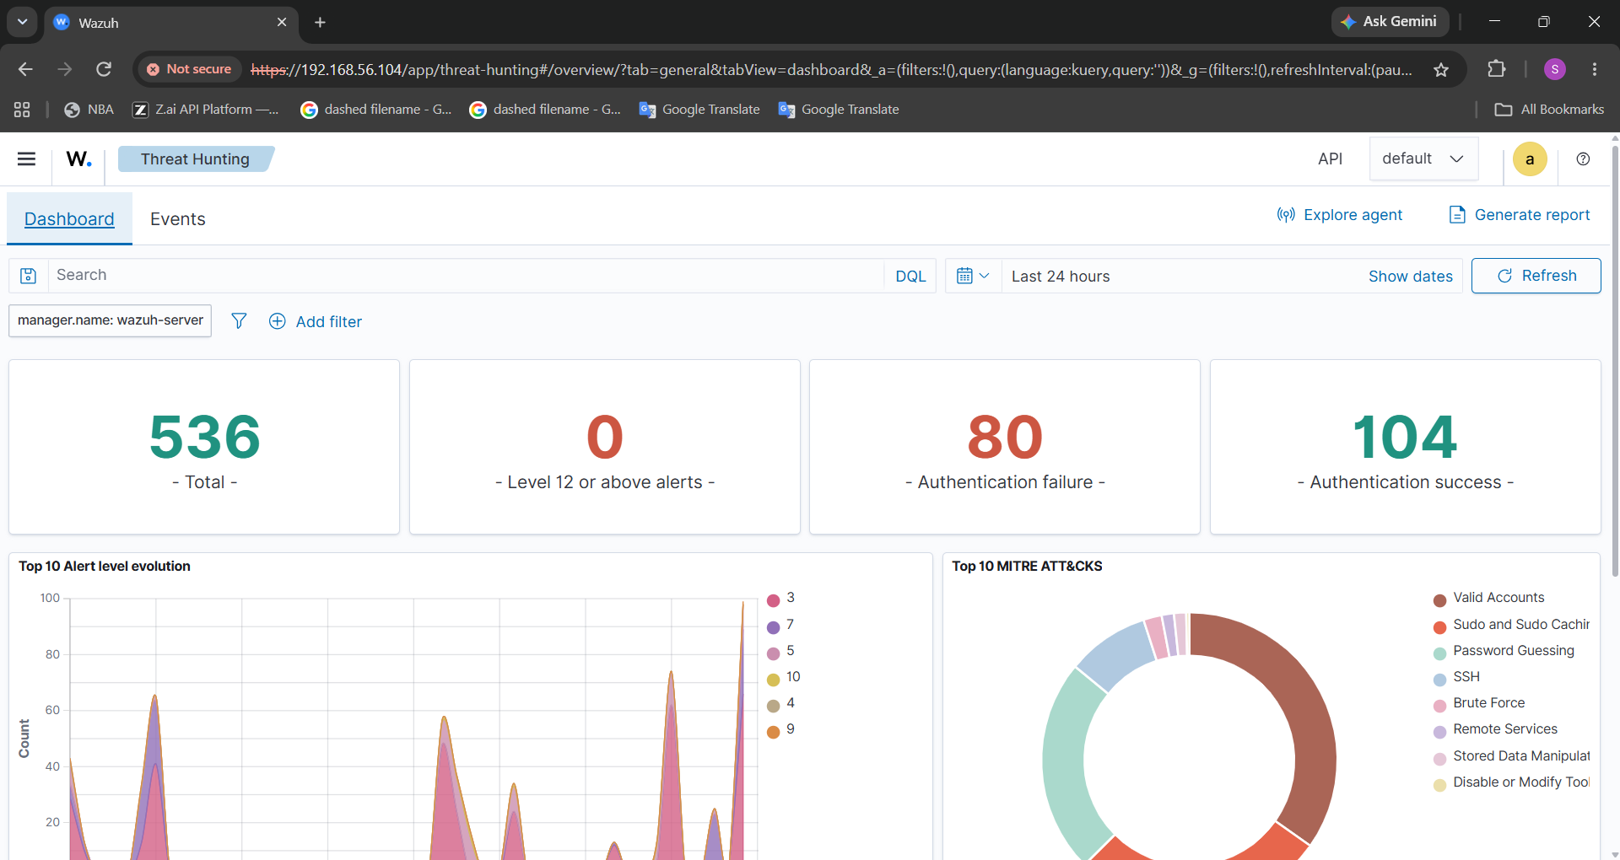
Figure 19: Documentation after the incident: Wazuh alerts/summary for the final report

SSH Brute-Force Incident Report

Field | Details
Incident | SSH Brute-Force Attack
Target | Ubuntu Server (192.168.56.101)
Attacker IP | 192.168.56.102
Service | SSH
Port | 22
Detection Tool | Wazuh
Response Tool | UFW Firewall
Incident Timeline
Step | Event | Result
1 | Multiple failed SSH login attempts were generated from 192.168.56.102. | Wazuh detected the suspicious SSH activity.
2 | The source IP was identified as 192.168.56.102. | Attacker IP identified.
3 | UFW rule was created to block the IP on SSH port 22. | 22 DENY IN FROM 192.168.56.102
4 | The UFW rule was verified. | Firewall status showed the deny rule as active.
5 | A new SSH connection was attempted from Kali to Ubuntu. | Connection was refused.
6 | The block was confirmed. | SSH access from 192.168.56.102 was successfully prevented.

FINAL RESULT
The suspicious IP address 192.168.56.102 was successfully blocked from accessing the Ubuntu server through SSH port 22 using UFW. A new SSH connection attempt from Kali resulted in Connection refused, confirming that the firewall response was effective.
Evidence
- Wazuh SSH alert
- UFW deny rule
- UFW status showing the active rule
- Kali SSH attempt showing Connection refused
Figure 20: Completed SSH brute-force incident report

6. Technologies Used
Technology | Used for | Why it was chosen
VirtualBox | Running 3 virtual machines on one laptop | Free, supports host-only networks and snapshots for safe testing
Kali Linux | Attacker machine and SSH client | Standard penetration-testing distribution
Ubuntu Server | Victim server with the SSH service | Very common real-world server OS
OpenSSH | Remote login service (port 22) | Most widely used SSH implementation, and the usual brute-force target
Wazuh v4.14.8 | SIEM: log collection, rules, alerts, dashboard | Free, open source, has MITRE mapping and active response
Linux commands | ping, ssh, sshd -T, tail, grep, ip a | Fast way to verify network, configuration and logs
auth.log / alerts.json | Raw evidence and structured alerts | Original logs plus enriched SIEM data
UFW / iptables | Blocking the attacker IP | Built-in Linux firewall, simple to use
MITRE ATT&CK | Naming attack techniques | Global standard used by security teams

7. Challenges Faced
Challenge | How it was solved
Wrong log file names: alerts.log versus alerts.json (tail and grep returned "No such file") | Listed /var/ossec/logs/alerts/ and used the correct file names; alerts.json holds the detailed JSON alerts
grep for "failed password" found nothing in some files because of case and wording | Used grep -i (ignore case) and searched with smaller, exact words
Making three VMs reach each other | Used a host-only network (192.168.56.0/24) and confirmed each IP with ip a and ping
Too many level 3 events (PAM sessions, sudo) hiding the real attack events | Filtered by rule description, source IP and level
Kernel message "clocksource: Long readout interval" on the Wazuh console | Recognised it as a harmless VirtualBox timing message, not a Wazuh fault
Limited laptop RAM while running Kali, Ubuntu and Wazuh together | Used VM snapshots and started only the machines needed for each step

8. Achievements
- Built a working three-VM SOC (Security Operations Center) lab.
- Confirmed two-way connectivity with 0% packet loss.
- Generated real failed-login events and traced them from Kali, to Ubuntu auth.log, to Wazuh alerts.
- Identified the attacker IP, targeted usernames and MITRE techniques from the evidence.
- Defined clear blocking and documentation criteria and completed the incident report.
- Finished the complete detect, observe, block and document cycle.

9. Future Plans
- Enable Wazuh Active Response so blocking is fully automatic.
- Add fail2ban and SSH key-only login with password authentication disabled.
- Use larger, automated attack simulations and tune the Wazuh rule thresholds.
- Add email or Slack alerts for level 10 and above.
- Extend to other attacks: web logins, port scans, file integrity monitoring and vulnerability detection.
- Connect this project with PacketVision, my PCAP analysis project, so network captures support the log evidence.

10. Personal Contribution
I did this project individually, so I carried out every stage myself:
- Designed and built the lab: Kali, Ubuntu server and Wazuh OVA on VirtualBox.
- Tested the network with ping in all directions and checked the SSH configuration with sshd -T.
- Performed the SSH login attempts and collected the logs on Ubuntu and Wazuh.
- Analysed the alerts in the terminal (alerts.log, alerts.json) and in the Wazuh dashboard.
- Prepared the flowchart, blocking criteria, documentation criteria and the final incident report.

11. Lessons Learned
- Technical: how SSH authentication is logged, how a SIEM decodes logs, how rule levels map to severity, and how MITRE ATT&CK describes attacker behaviour.
- Technical: attack and defence are two sides of the same log line: the same "Failed password" entry is the attacker's attempt and the defender's evidence.
- Practical: always verify each step (network, service, logs) before moving on; small errors like a wrong file name waste time.
- Personal: patience and documentation are as important as tools; a screenshot taken at the moment is worth more than memory later.
- Security mindset: a strong password policy and key-based SSH prevent most brute-force attacks before monitoring is even needed.

12. Conclusion
This project shows that a brute-force attack can be simulated, detected, blocked and documented using free open-source tools. Wazuh turned scattered log lines into clear, mapped alerts, the source IP 192.168.56.102 was identified, and clear blocking and documentation criteria made the response consistent and evidence-based. The key message is that detection alone is not enough: defenders must also respond and record. This lab is a strong base for a real SOC analyst workflow.

Appendix A: Abbreviations
Abbreviation | Full form | Simple meaning
SIEM | Security Information and Event Management | Central system that collects and analyses security logs
SSH | Secure Shell | Encrypted remote login (port 22)
SOC | Security Operations Center | Team/room that monitors security alerts
IP | Internet Protocol | Address of a machine on a network
ICMP | Internet Control Message Protocol | Protocol used by ping
TTL | Time To Live | How many hops a packet may travel; hints at the OS
PAM | Pluggable Authentication Modules | Linux login framework that writes auth events
OVA | Open Virtual Appliance | Ready-made virtual machine file
MITRE ATT&CK | Adversarial Tactics, Techniques and Common Knowledge | Catalogue of attacker methods
UFW | Uncomplicated Firewall | Easy front-end for Linux firewall rules
MFA | Multi-Factor Authentication | Login needs more than a password
CIDR | Classless Inter-Domain Routing | Notation like /24 for the network size
Thank You
Detecting and Responding to SSH Brute-Force Attacks using Wazuh
Any questions?
Sameeha shajahan | Student at Brototype

