Software Design

Specification

Chrome Extension Creation (ADDICT)  
*Revision 1.0*

Table of Contents

Table of Contents ii

Revision History iii

Approved By iii

1. Introduction 1

1.1 Purpose 1

1.2 System Overview 1

2. Software/Language Used 1

2.1 HTML 1

2.2 CSS 2

2.3 JavaScript 2

3. Functional Requirements 2

4. Non-Fucntional Requirements 3

5. Architecture 4

5.1 Chrome Extension 4

5.2 API 4

5.3 Pop-up Window 4

6. Design 4

6.1 User Interface 4

6.2 Highlighting Functionality 4

6.3 Pop-up Window 4

6.4 Extension Icon 4

6.5 Diagram 4

7. Testing 4

7.1 Unit Testing 4

7.2 Integration Testing 4

7.3 System Testing 4

**8. Privacy Policy………………………………………………………………………………….4**

**9. Conclusion……………………………………………………………………………………4**

Revision History

|  |  |  |  |
| --- | --- | --- | --- |
| **Version** | **Name** | **Reason for Changes** | **Date** |
| *1.0* | *Abdul Basit Allahwala*  *Sameer Uddin* | *Initial Revision* | *04/30/2023* |
|  |  |  |  |

Approved By

Approvals should be obtained for project manager, and all developers working on the project.

|  |  |  |  |
| --- | --- | --- | --- |
| **Name** | **Signature** | **Department** | **Date** |
| Ms. Sania Urooj |  | FSE-Development |  |
|  |  |  |  |

# Introduction

The ADDICT chrome extension is designed to provide users with the definition, part of speech, phonetics, and two example sentences of any highlighted word on a webpage. This Software Design Specification (SDS) outlines the functional and non-functional requirements, architecture, design, and testing plan of the extension.

## Purpose

The ADDICT chrome extension allows users to quickly access the definition, part of speech, phonetics, and two example sentences of any highlighted word on a webpage. Its purpose is to help users improve their language skills, learn new words, or understand the meaning of a word while browsing the internet.

## System Overview

The ADDICT chrome extension is a system that retrieves and displays word information to users when they highlight a word on a webpage. It consists of a chrome extension that interacts with the browser, an API that retrieves the word information, and a pop-up window that displays the information. The system is designed to be user-friendly, lightweight, and privacy-focused, and can be used to enhance language skills and improve vocabulary.

# Software/Language Used

## HTML (Hypertext Markup Language)

HTML is a markup language that is used to structure content on the web. It provides a set of tags that can be used to define the structure and layout of a webpage. In this case HTML would be used to structure the popup window that appears when a user highlights a word.

## CSS (Cascading Style Sheets)

CSS is a styling language that is used to define the visual appearance of a webpage. It allows developers to control the layout, fonts, colors, and other visual elements of a webpage. In this case CSS would be used to style the popup window and ensure that it looks visually appealing and consistent with the overall design of the extension.

## JavaScript

JavaScript is a programming language that is used to add interactivity and dynamic behavior to webpages. It allows developers to create animations, respond to user input, and manipulate the content of a webpage. In this case JavaScript would be used to handle user input, communicate with the API to retrieve word information, and display the information in the popup window.

The language used to communicate with the API and retrieve word information may be in JSON format. JSON (JavaScript Object Notation) is a lightweight data interchange format that is easy for both humans and machines to read and write. It is commonly used to transfer data between a web application and a server. The API itself could be developed using various programming languages, such as Python, Java, or Node.js, depending on the implementation.

# Functional Requirements

The ADDICT chrome extension shall provide the following functionalities:

* The extension shall retrieve the definition, part of speech, phonetics, and example sentences of a highlighted word from an API.
* The extension shall display the retrieved word information in a customizable pop-up window.
* The extension shall trigger the API when a word is highlighted.
* The extension shall not support multiple languages.
* The extension shall be lightweight and not negatively impact the browser's performance.
* The extension shall be user-friendly and easy to use.

The above functional requirements describe the core features and capabilities of the ADDICT chrome extension. The extension is designed to provide users with quick access to word information in a simple and intuitive way. Additionally, it's important to note that the extension only supports one language (English), which is a limitation to consider when using the extension.

# Non-Functional Requirements

The ADDICT chrome extension shall adhere to the following non-functional requirements:

* Performance: The extension shall not significantly impact the browser's performance and shall operate quickly and efficiently.
* Usability: The extension shall be easy to use, with an intuitive user interface that allows users to quickly access and view word information.
* Privacy: The extension shall not collect or transmit any user data or browsing history, ensuring user privacy and security.
* Reliability: The extension shall operate reliably and consistently, with minimal errors or crashes.
* Compatibility: The extension shall be compatible with the latest version of Google Chrome browser.
* Maintainability: The extension shall be designed with a modular and extensible architecture, allowing for easy maintenance and updates.

These non-functional requirements describe the qualities and attributes that the ADDICT chrome extension should possess, beyond its basic functional requirements. These qualities are important for ensuring that the extension operates effectively, is user-friendly, and can be maintained over time.

# Architecture

The ADDICT chrome extension architecture consists of the following components:

## Chrome Extension

The chrome extension is responsible for interacting with the browser and providing the user interface for the ADDICT.

## API

The API is responsible for retrieving the word information based on the user's highlighted word.

## Pop-up Window

The pop-up window is responsible for displaying the retrieved word information in a user-friendly manner.

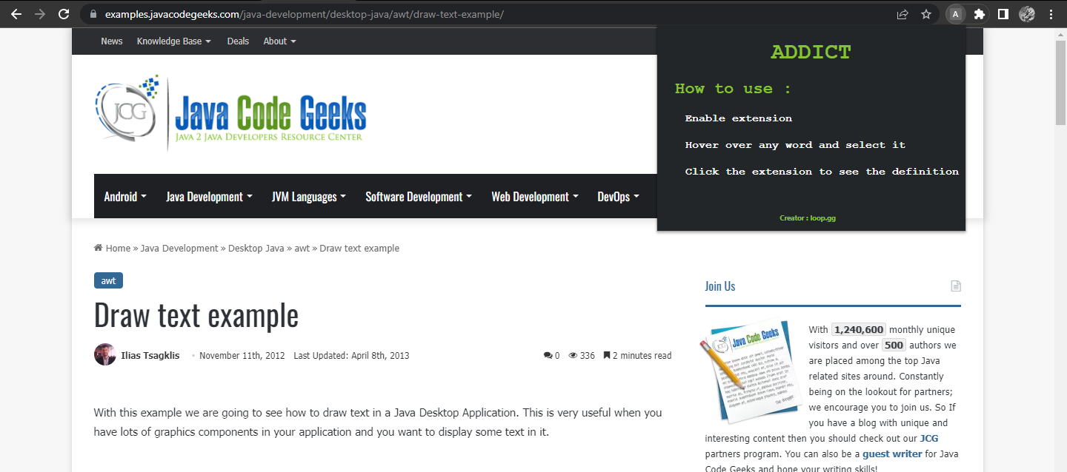

Fig 1 Default Window

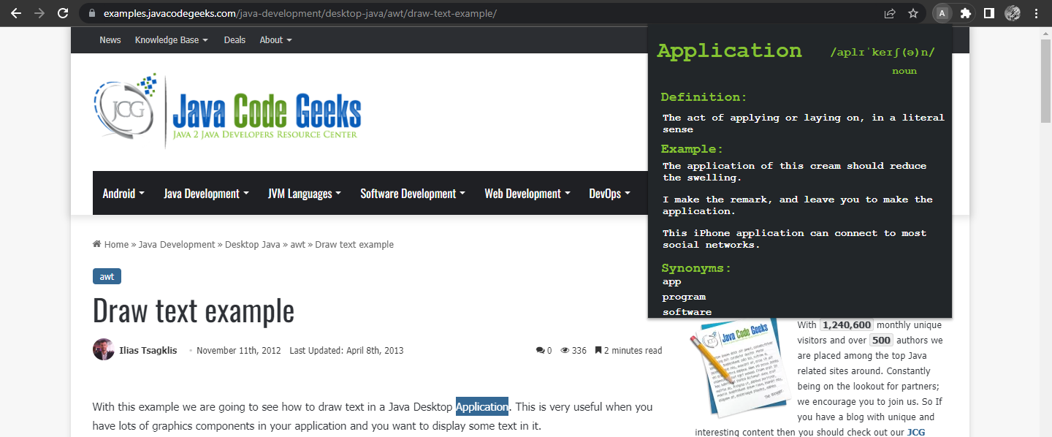Fig 2 Definition Window

# Design

## User Interface

The user interface of the ADDICT chrome extension consists of the following components:

1. Highlighting functionality
2. Pop-up window
3. Extension icon

## Highlighting Functionality:

When a user highlights a word on a webpage, the chrome extension triggers the API to retrieve the word information. Once the information is retrieved, the pop-up window is displayed with the information.

## Pop-up window:

The pop-up window displays the following information:

Definition

Part of speech

Phonetics

Two example sentences

## Extension Icon:

The extension icon appears in the browser toolbar and allows users to turn the extension on or off, view the extension's options, and access help documentation.

## Diagram

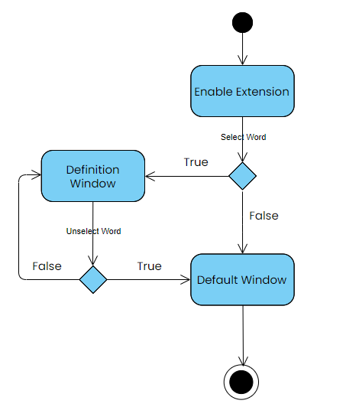

Fig 3. Activity Diagram

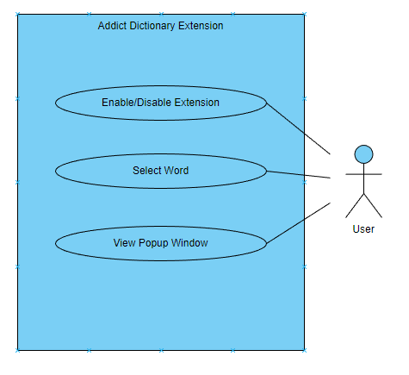Fig 4 Use Case Diagram

# Testing

The ADDICT chrome extension shall undergo the following testing procedures:

## Unit Testing

Unit testing shall be performed on the individual components of the extension, including the chrome extension, API, and pop-up window.

## Integration Testing

Integration testing shall be performed to ensure that the components of the extension work together as expected.

## System Testing

System testing shall be for testing of the highlighting functionality, API integration, pop-up window display, extension icon functionality, performance, compatibility, and reliability. These tests will help ensure the extension is working correctly, is user-friendly, and is reliable.

# Privacy Policy

The ADDICT chrome extension shall not collect any personal information. The extension only requests access to the webpages you visit to perform its functionalities. The data retrieved from the API is not stored or shared with any third-party services.

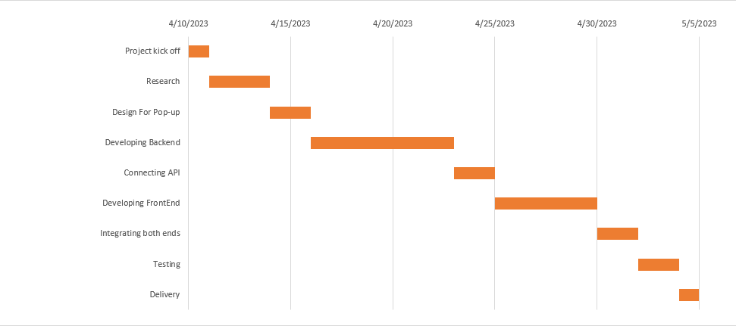

# Conclusion

The ADDICT chrome extension provides users with a convenient way to get the definition, part of speech, phonetics, and two example sentences of any highlighted word on a webpage. The extension is designed to be user-friendly, customizable, and privacy-focused. The SDS outlines the functional and non-functional requirements, architecture, design, and testing plan of the extension to ensure high-quality