**Dr.Babasaheb Ambedkar Marathwada University, Chh.Sambhajinagar**



A Project Report on

***Drivewave***

In plant Training at

**Dynomerk**

Submitted By

***Samiksha Balkishor Dasarwad***

*Submitted in partial Fulfillment of the requirement For the Degree of*

**Master of Computer Application**

Submitted To

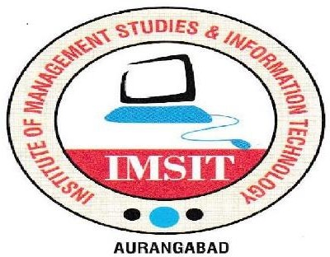

Vivekanand Shikshan Sanstha’s

Institute of Management Studies and Information Technology

Samarth Nagar, Chhatrapati Sambhajinagar

(2023-2024)

**Certificate**

This is to certify that, the In-plant Training Report Submitted by

**Samiksha Balkishor Dasarwad**

Is Completed as per the requirement of Dr. Babasaheb Ambedkar Marathwada University, Chh.Sambhajinagar for partial fulfillment of degree of

***‘Master of Computer Application’*** For the Academic Year **2023-24**

**Project Guide Director**

**Project Approval Sheet**

Ms***. Samiksha Balkishor Dasarwad***  has Successfully completed an internship project with appropriate acceptable standards and in adequate is scope and Quality impartial fulfillment of requirement for the

***Master of Computer Application*** Student of the

**Institute of Management Studies and information Technology**, **Chh.Sambhajinagar**

affilited to Dr.Babasaheb Ambedkar Marathwada University Chh.Sambhajinagar.

**Project Guide Examiner**

**Mr. Ajay Rajhans**

**INDEX**

|  |  |  |
| --- | --- | --- |
| **Sr. No.** | **Title** | **Page No.** |
| 1. | Acknowledgement |  |
| 2. | Abstract |  |
| 3. | Project Introduction |  |
| 4. | Project Requirement |  |
| 4.5 | H/w Requirement |  |
| 4.6 | S/w Requirement |  |
| 5. | Feasibility Study |  |
| 6. | Diagrammatic Representation |  |
| 6.1 | ER Diagram(ERD) |  |
| 6.2 | Data flow Diagram(DFD) |  |
| 6.3 | Functional Flow Diagram(FDD) |  |
| 6.4 | Activity Diagram |  |
| 7. | Project Screenshot |  |
| 8. | Project Code |  |
| 9. | Conclusion |  |
| 10. | Bibliography |  |

**Acknowledgement**

I would like to express my immense gratitude towards this institution Institute of management studies and information technology, Chh.Sambhajinagar, which created a great platform to attain profound technical skills in the Degree of M.C.A., there by fulfilling our most cherished goal.

I would thanks to our guide Mr. Ajay Rajhans for guiding and helping me in successful completion of the project.

I sincerely express my gratitude to the Director Dr. Ashok Gaikwad for his inspiration and Timely support in successful completion of my project work.

I am also thankful to our course coordinator Mr. Rizwan Shaikh for extending their valuable Cooperation.

Last but not least, I would like to convey my thanks to my loves parents, friends and my Faculties who helped me directly or indirectly in completing this project successfully.

**Student Name & Sign**

**Abstract**

Our Aim is to design and create a data management System for a car rental company.

This enables admin can rent a vehicle that can be used by a customer This system increases customer retention and simplify vehicle and staff Management in an efficient way.

This software car Rental System has a very user friendly interface. Thus the users will feel very easy to work on it.

By using this system admin can manage customer confirm and cancel booking request, customer Testimonials, customer issues. The car information can be added to the system.

Or existed car information can be edited or deleted too by Administrator.

There is no delay in the availability of any car information, whenever needed, car information can be Captured very quickly and easily.

The customers can also use the system to get car rent. The customer should create a new account before logging in or

he / she can log into the System with his/her created account.

Then he/she can book the available cars and can book this car.

**Introduction**

It’s a Car rental project that offers vehicles for short-term use, typically ranging from a few hours to several weeks. These maintain fleets of vehicles that customers can rent for various purposes, including business trips, vacations, or temporary transportation needs.

Car rental provide a range of vehicle options to suit different preferences and requirements, such as economy cars, SUVs, vans, luxury vehicles, and specialty vehicles like trucks or convertibles. They typically offer services such as:

* **Reservation**: Customers can book vehicles in advance through online platforms, mobile apps, or by contacting the rental company directly.
* **Pickup and Return:** Rental locations are set up where customers can pick up their reserved vehicles and return them at the end of the rental period. Some companies offer options for one-way rentals between different locations.
* **Insurance and Protection Plans:** Car rental companies often offer insurance coverage and protection plans to mitigate financial risks associated with accidents, damage, or theft during the rental period.
* **Additional Services:** Rental companies may provide additional services such as GPS navigation systems, car seats for children, roadside assistance, and fuel options.
* **Customer Support:** They offer customer support services to assist with booking inquiries, vehicle issues, and any other concerns that customers may have during the rental period.

**Project Requirement**

**Hardware Specification :**

* Processor : Dual Core Processor or above.
* Hard disk space : 100 GB or above.
* RAM : 512 MB or above.
* Other standard physical devices like keyboard, mouse etc.

**Software Specification :**

* + Operating System : Windows 95/98/NT/2000, Linux, Mint.
  + Front end : HTML, CSS, ANGULAR TS
  + Back end : JAVA SpringBoot Framework
  + DataBase : MYSQL
  + Browser : IE, Chrome, Microsoft Edge, Opera.

**Feasibility Study**

Preliminary investigation examine project feasibility, the likelihood the system

will be useful to the organization. The main objective of the feasibility study is

to test the Technical, Operational and Economical feasibility for adding new modules and debugging old running system.

All system is feasible if they are unlimited resources and infinite time. There are aspects in the feasibility study portion of the preliminary investigation:

* Technical Feasibility
* Operation Feasibility
* Economical Feasibility

**1] Technical Feasibility :-**

The technical issue usually raised during the feasibility stage of the investigation includes the following:

* Do the proposed equipments have the technical capacity to hold the data required to use the new system?
* Will the proposed system provide adequate response to inquiries, regardless of the number or location of users?
* Are there technical guarantees of accuracy, reliability, ease of access and data security?

**2] Operation Feasibility :-**

Proposed projects are beneficial only if they can be turned out into information system. That will meet the organization’s operating requirements.

Operational feasibility aspects of the project are to be taken as an important part of the project implementation.

Some of the important issues raised are to test the operational feasibility of a project includes the following: -

* Is there sufficient support for the management from the users?
* Will the system be used and work properly if it is being developed and implemented?
* Will there be any resistance from the user that will undermine the possible application benefits?

**3] Economical Feasibility :-**

A system can be developed technically and that will be used if installed must still be a good investment for the organization.

In the economical feasibility, the development cost in creating the system is evaluated against the ultimate benefit derived from the new systems.

Financial benefits must equal or exceed the costs.

**Diagrammatic Representation**

It is a technique of presenting numeric data through pictograms, cartograms, bar diagrams, and pie diagrams. It is the most attractive and appealing way to represent statistical data.

**ER Diagram(ERD)**

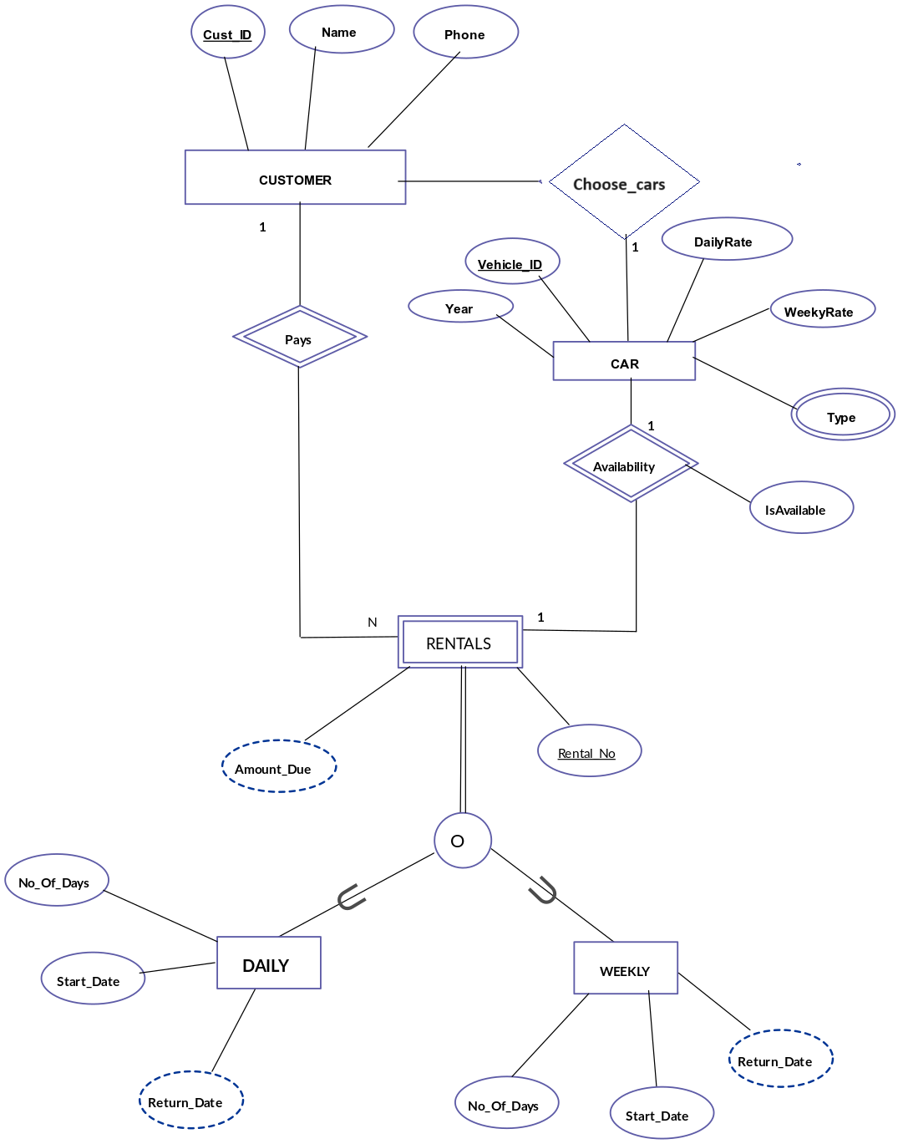

**Data flow Diagram(DFD)**

